CARE SIGNAL

INTRODUCTION:
The Elderly and Special Needs Assistance System is a simple and effective solution to help elderly individuals, children with special needs, and those who are deaf or mute communicate their basic needs. This system is specifically designed to cater to the needs of individuals with hearing and speech impairments, as well as those requiring additional support, such as the elderly and people with disabilities. Using buttons, sensors, and notifications, the system enables users to request food, bathroom assistance, or urgent help, even in low-light conditions. This project not only enhances the quality of life for users but also alleviates the workload of caregivers, ensuring that every need is met promptly and effectively.

PROJECT COMPONENTS:
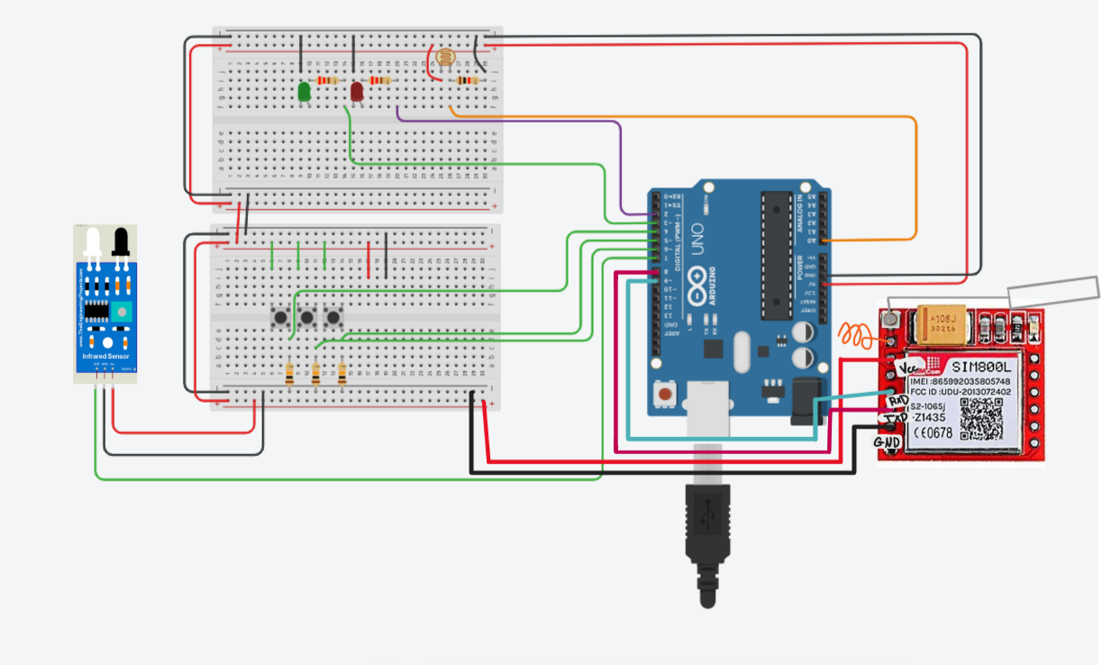

A brief overview of the circuit components and their purpose:
- Buttons:
  - Food Button (btn_food): Used to request food.
  - Bathroom Button (btn_bath): Used to request bathroom assistance.
  - Help Button (btn_help): Used to request urgent help.
  - Purpose: Enables users to request their basic needs easily using a dedicated button for each need.
- LEDs (Light-Emitting Diodes):
  - Red LED (RedLED): Lights up in low-light conditions as an alert.
  - Green LED (GreenLED): Lights up to confirm that a request has been successfully sent.
  - Purpose: Enhances visual communication with the user to confirm actions or alert them.
- Light Sensor (LDR):
  - Measures the surrounding light level.
  - Purpose: Automatically activates the red LED when light levels are low.
- Infrared Sensor (IR Sensor):
  - Detects touch beneath the red LED to request assistance.
  - Purpose: Provides an additional way to request help when needed.
- GSM Module:
  - Sends text messages when buttons or sensors are activated.
  - Purpose: Facilitates direct communication with the caregiver via phone to fulfill requests.
- Arduino Microcontroller:
  - Serves as the brain of the system, controlling all components (buttons, sensors, LEDs, and GSM module).
  - Purpose: Ensures seamless integration and operation of the entire system.

CODE EXPLANATION:
//////////////////////////////////////////////////////////////////////////////////

//define led pins:
int RedLED = 2;
int GreenLED = 3;

// define buttons pins
int btn_food = 4;
int btn_bath = 5;
int btn_help = 6;

// define ir snensor and ldr pin and threshold
int IR_Sensor = 7;
int LDRPin = A0;
int lightThreshold = 450;

//////////////////////////////////////////////////////////////////////////////////////
// define GSM library
#include <SoftwareSerial.h>
SoftwareSerial sim(8, 9); // gsm tx to 8 , gsm rx to 9
String recipientNumber= "+966500000000";
//start here:
void setup() {

Serial.begin(9600);

//gsm config
sim.begin(9600);

//led as output
pinMode(GreenLED, OUTPUT);
pinMode(RedLED, OUTPUT);

//buttons as input
pinMode(btn_food, INPUT);
pinMode(btn_bath, INPUT);
pinMode(btn_help, INPUT);

//ir as input
pinMode(IR_Sensor, INPUT);
}
//start the loop:
void loop() {
// light detect and red led on/off
int lightLevel = analogRead(LDRPin);
Serial.print("Light Level: ");
Serial.println(lightLevel);

if (lightLevel < lightThreshold) {
digitalWrite(RedLED, HIGH);
Serial.println("Low light detected - Red LED ON");
} else {
digitalWrite(RedLED, LOW);
}
//////////////////////////////////////////////////////////////////////////////////

//read buttons and send msg
int btn_food_read = digitalRead(btn_food);
int btn_bath_read = digitalRead(btn_bath);
int btn_help_read = digitalRead(btn_help);

if (btn_food_read == HIGH) {
Serial.println("btn_food_read Activated");
send_sms("I Need food !");
// green led after sending msg
digitalWrite(GreenLED, HIGH);
delay(2000);
digitalWrite(GreenLED, LOW);
}
if (btn_bath_read == HIGH) {
Serial.println("btn_bath_read Activated");
send_sms("I Need Bath !");
// green led after sending msg
digitalWrite(GreenLED, HIGH);
delay(2000);
digitalWrite(GreenLED, LOW);
}
if (btn_help_read == HIGH) {
Serial.println("btn_help_read Activated");
send_sms("I Need Help !");
// green led after sending msg
digitalWrite(GreenLED, HIGH);
delay(2000);
digitalWrite(GreenLED, LOW);
}

//////////////////////////////////////////////////////////////////////////////////

//read ir sos
int irState = !digitalRead(IR_Sensor);
Serial.print("IR Sensor State: ");
Serial.println(irState);

if (irState == HIGH) {
Serial.println("IR Sensor Triggered");
send_sms("I need Help!!!");
// green led after sending msg
digitalWrite(GreenLED, HIGH);
delay(2000);
digitalWrite(GreenLED, LOW);
}

delay(1000);
}

void send_sms(String msg) {
Serial.print(">>>>>> send sms >>>>>> : ");
Serial.print("Number: ");
Serial.print(recipientNumber);
Serial.print(" msg: ");
Serial.println(msg);

sim.println("AT+CMGF=1");
delay(500);
sim.println("AT+CMGS=\"" + recipientNumber + "\"\r");
delay(500);
sim.println(msg);
delay(500);
sim.println((char)26);
}

