Satellite evidence for progressive weakening of condensation-driven moisture transport along tropical forest corridors

Ali Bin Shahid
Independent Scientist, Islamabad, Pakistan

Abstract
The biotic pump hypothesis proposes that forest evapotranspiration drives condensation-generated low pressure that sustains inland moisture transport. We test this mechanism using 25 years of satellite data along two tropical moisture corridors: Bel–m–Manaus (Amazon) and Gulf of Guinea–Kisangani (Congo). Comparing 2019 with the 2023 drought, we find that outgoing longwave radiation (OLR) increased (+2.9 W/m² over the Eastern Amazon, +1.3 W/m² over the Congo), cloud fraction decreased (−2.3% Amazon, −0.5% Congo), evapotranspiration declined (−16 mm/yr Amazon), and column water vapour accumulated at the coast rather than penetrating inland. These signals amplify with distance from the coast: interior OLR increased +4.3 W/m² versus +2.7 W/m² at the coast, and the coast-to-interior water vapour gradient steepened by −1.2 kg/m². The signal concentrates in September–November, when forest transpiration should initiate the wet season; interior OLR during SON increased by +24.5 W/m². Over 2001–2025, the Amazon cloud fraction gradient declined at −0.17%/yr (p = 0.001 after ENSO removal). NDVI confirms that 88% of intact forest cells experienced greenness decline (t = −15.4, p < 10⁻⁶), establishing drought stress in standing forest. The Congo corridor shows the same trends at weaker magnitudes. These results provide spatially resolved satellite evidence for the biotic pump mechanism and document its progressive failure in the two largest tropical forests.

1. Introduction
Tropical forests cycle enormous quantities of water between the land surface and the atmosphere. In the Amazon basin, approximately half of the precipitation that falls on the forest is returned to the atmosphere through evapotranspiration, where it is available to generate precipitation further downwind (Salati et al., 1979; Eltahir and Bras, 1996). This moisture recycling sustains precipitation deep into the continental interior, far beyond the reach of oceanic moisture alone.
The mechanism by which this inland moisture transport is maintained remains debated. The prevailing view attributes it to large-scale pressure gradients driven by differential heating between the ocean and the continent. However, Makarieva and Gorshkov (2007) proposed an alternative mechanism - the biotic pump - in which the condensation of water vapour itself generates the low-pressure anomaly that draws moist air inland.
The biotic pump hypothesis has been refined in subsequent theoretical work (Makarieva et al., 2013) and finds indirect support from several lines of evidence. The Amazon wet season initiates before the southward migration of the Intertropical Convergence Zone (ITCZ), suggesting that vegetation-atmosphere interactions drive early convective onset (Li and Fu, 2004; Wright et al., 2017). The Eurasian boreal forest sustains inland moisture transport during the growing season that collapses during dormancy (Makarieva et al., 2009). Deforestation experiments in climate models consistently reduce precipitation in deforested regions and downwind (Spracklen et al., 2012; Staal et al., 2018; Nobre et al., 2016).
Despite this theoretical and modelling evidence, direct observational testing of the biotic pump at the corridor scale has been limited. If the biotic pump operates, its weakening should produce specific, observable satellite signatures: (1) reduced evapotranspiration, (2) decreased cloud cover, (3) increased outgoing longwave radiation, and (4) steepening of the coast-to-interior moisture gradient as oceanic moisture fails to penetrate inland. These signals should amplify with distance from the coast and concentrate in the seasonal transition periods when forest-driven convection, rather than the ITCZ, is the primary moisture driver.
The years 2019 and 2023 provide an opportunity for such a test. The Amazon and Congo basins experienced record or near-record drought in 2023 (Espinoza et al., 2024; Wongchuig et al., 2025), offering a natural experiment in which the biotic pump was stressed.
We focus on two corridors: the Belém–Manaus corridor in the Amazon, connecting the Atlantic coast to the western interior; and the Gulf of Guinea–Kisangani corridor in the Congo. Here we show that the predicted signatures of biotic pump weakening are present in satellite data from four independent instruments (CERES, MODIS, AIRS), that they amplify with distance from the coast, concentrate in the dry-to-wet transition season, and represent a progressive 25-year trend independent of ENSO variability.
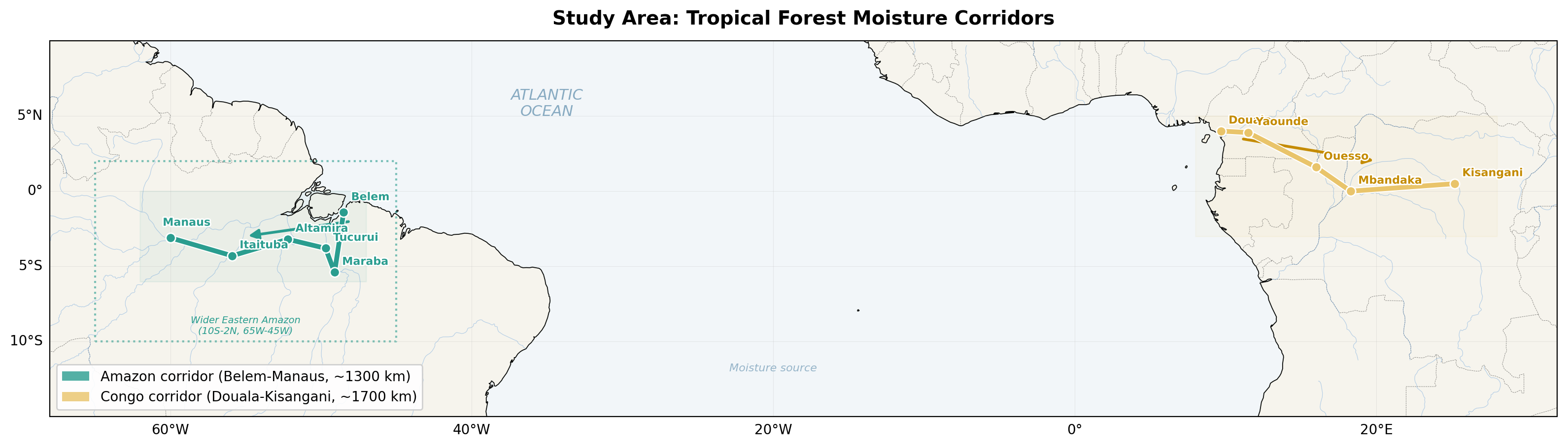
Figure 1. Study area showing the two tropical moisture corridors. Green: Amazon (Belem-Manaus, ~1,300 km). Yellow: Congo (Douala-Kisangani, ~1,700 km). Dotted rectangle: wider Eastern Amazon domain for spatial correlation.
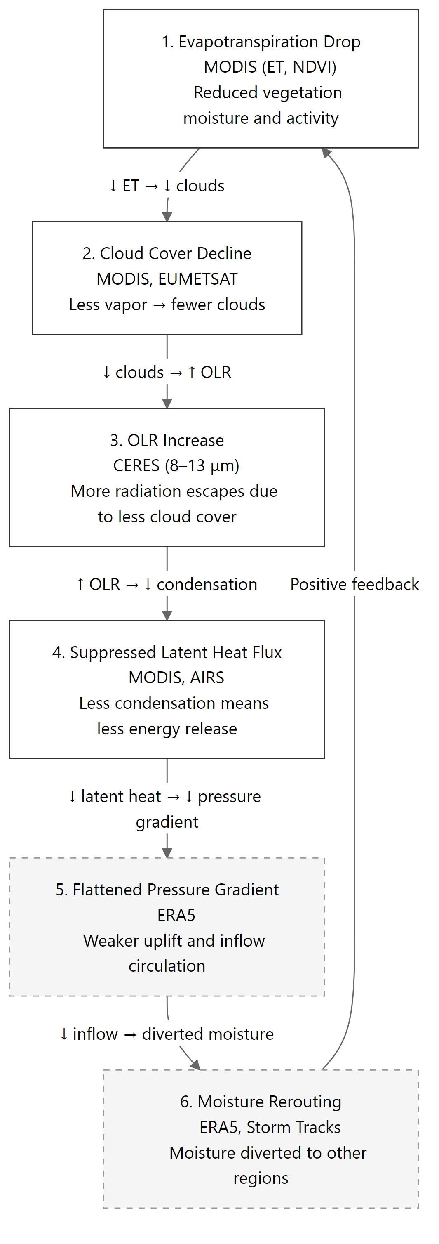
Figure 2. Diagnostic chain of biotic pump breakdown. Each step shows the mechanism, the observing instrument, and a one-line description. Steps 1-4 are addressed in this study; steps 5-6 (dashed) require ERA5 reanalysis and are identified as future work.

2. Data and Methods

2.1 Study regions and corridor definition
We define two tropical moisture corridors. The Amazon corridor runs from Belém (1.4°S, 48.5°W) to Manaus (3.1°S, 60.0°W), ~1,300 km, averaged over 6°S–0°N. The Congo corridor runs from Douala (4.0°N, 9.7°E) to Kisangani (0.5°N, 25.2°E), ~1,700 km, averaged over 3°S–5°N. For spatial correlation, a wider Eastern Amazon domain (10°S–2°N, 65°W–45°W, ~240 cells at 1°) is used.
Segment | Amazon | Congo
Coast | 50°W–47°W | 8°E–12°E
Mid-corridor | 53°W–49°W | 15°E–20°E
Interior | 62°W–58°W | 22°E–27°E

2.2 Satellite data
CERES EBAF-TOA Edition 4.2.1 (Loeb et al., 2018): monthly 1° OLR, clear-sky OLR, and cloud area fraction, March 2000–January 2026. CRE_LW = OLR_clear − OLR_all.
MODIS MOD16A3GF v061 (Running et al., 2019): annual ET at 500 m, reprojected from sinusoidal to geographic coordinates, aggregated to 1-degree by 2D binned statistics.
MODIS MOD13C2 v061: monthly NDVI at 0.05-degree global. Cells with NDVI > 0.6 in 2019 classified as dense forest. Block-averaged to 1-degree for comparison.
AIRS L3 v7.0 (Tian et al., 2020): total column water vapour at 1°, monthly. NOAA ONI: annual mean for ENSO regression; years classified by peak absolute ONI.

2.3 Analysis methods
Corridor transects: cosine-latitude-weighted mean within the latitude band. Seasonal decomposition: DJF, MAM, JJA, SON. Multi-year trends: OLS over 2001-2025. ENSO control: regression on annual ONI, residual trend analysis. Spatial correlation: Pearson r between ET and OLR change across 1-degree cells. Forest integrity: one-sample t-test on NDVI change in cells with 2019 NDVI > 0.6.

3. Results

3.1 Regional overview
Global mean OLR increased by 0.16 W/m² between 2019 and 2023. The Eastern Amazon showed +2.9 W/m² (18x global mean), the Congo +1.3 W/m² (Table 1). Cloud fraction declined 2.3% (Amazon) and 0.5% (Congo). ET declined 16 mm/yr across the wider Eastern Amazon and 66 mm/yr (−4.5%) in the Marabá subregion.
Variable | Amazon 2019 | Amazon 2023 | Change | Congo 2019 | Congo 2023 | Change
OLR (W/m²) | 236.6 | 239.5 | +2.9 | 220.6 | 221.9 | +1.3
Cloud (%) | 72.5 | 70.3 | −2.3 | 79.1 | 78.6 | −0.5
CRE (W/m²) | 44.6 | 43.0 | −1.5 | 55.4 | 54.6 | −0.7
ET (mm/yr) | 1419 | 1403 | −16 | 1298 | 1310 | +13

Table 1. Regional means and changes, 2019 vs 2023.
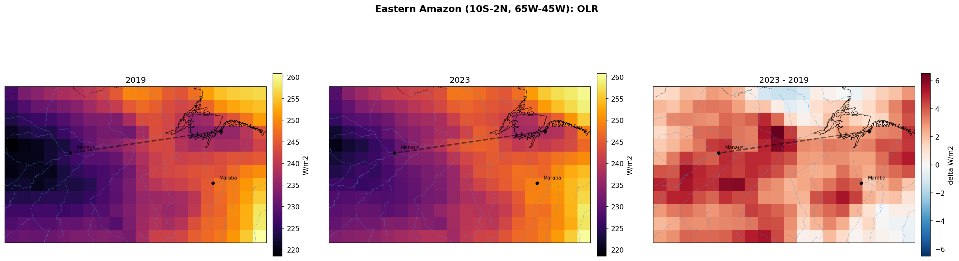
Figure 3. Eastern Amazon OLR: 2019 (left), 2023 (centre), difference (right). Dashed line shows the Belem-Manaus corridor. Nearly the entire domain shows increased OLR, with strongest signal in the arc from Maraba toward the interior.

3.2 Corridor transect analysis
Along the Belém–Manaus corridor, OLR increased at every longitude but the increase was larger at the interior (+4.3 W/m²) than the coast (+2.7 W/m²). Cloud fraction declined most at mid-corridor (−3.6%). AIRS water vapour showed a striking asymmetry: the coast gained moisture (+0.8 kg/m²) while the interior lost moisture (−0.4 kg/m²), steepening the gradient by −1.2 kg/m². The Congo corridor showed more uniform, smaller changes (Supplementary Figures S15–S19).
Variable | Coast | Δ | Mid | Δ | Interior | Δ
OLR (W/m²) | 241.5→244.2 | +2.70 | 240.5→243.2 | +2.76 | 225.9→230.2 | +4.26
Cloud (%) | 70.9→68.3 | −2.55 | 74.7→71.0 | −3.64 | 78.4→77.2 | −1.14
CRE (W/m²) | 42.2→40.3 | −1.94 | 41.3→39.0 | −2.39 | 52.7→50.3 | −2.43
WV (kg/m²) | 48.9→49.7 | +0.82 | 49.1→49.3 | +0.21 | 46.4→46.0 | −0.41

Table 2. Amazon corridor segment values, 2019 vs 2023.
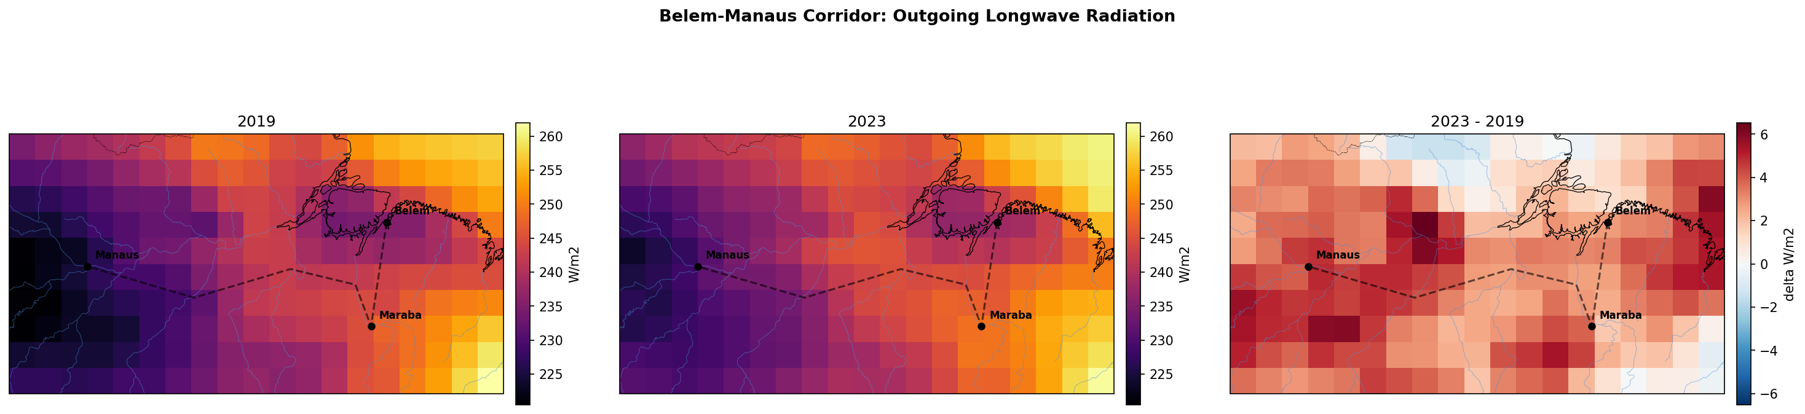
Figure 4. Amazon corridor OLR in geographic context: 2019, 2023, and difference. The corridor path (dashed) connects Belem, Maraba, and Manaus. Red in the difference panel intensifies toward the interior.
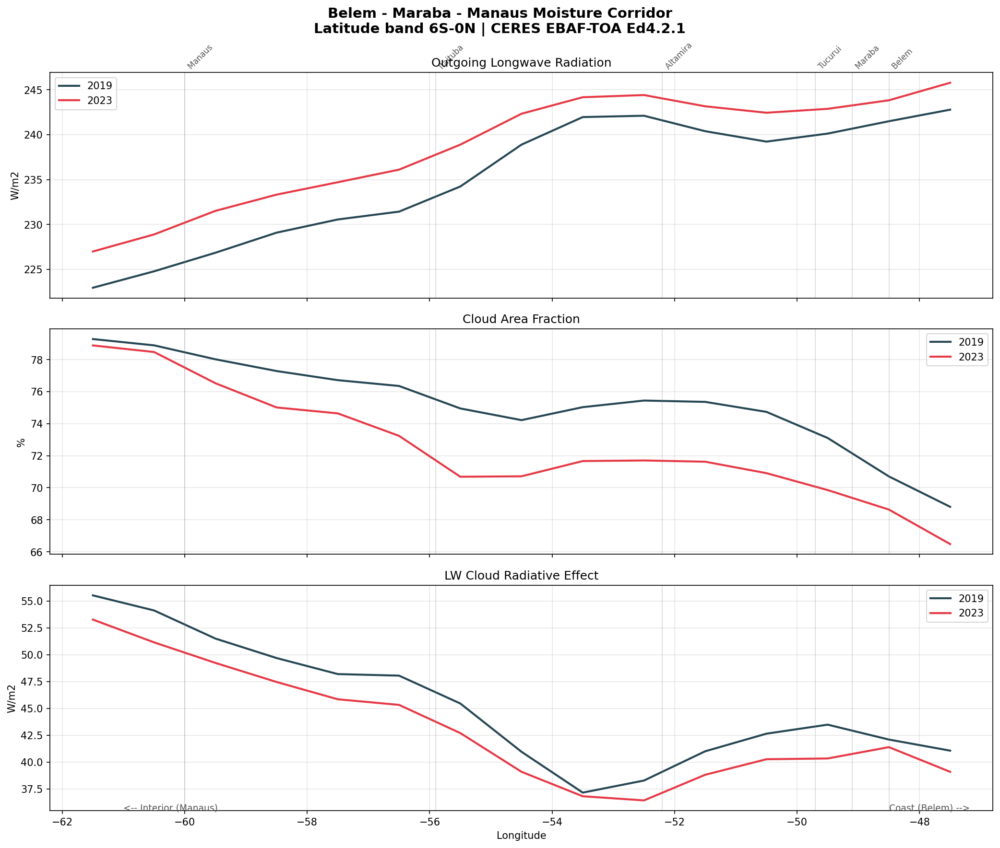
Figure 5. Belem-Manaus corridor transects: OLR, cloud fraction, and CRE averaged over the 6S-0N latitude band. The red (2023) line separates from the blue (2019) line, with the gap widening toward the interior.
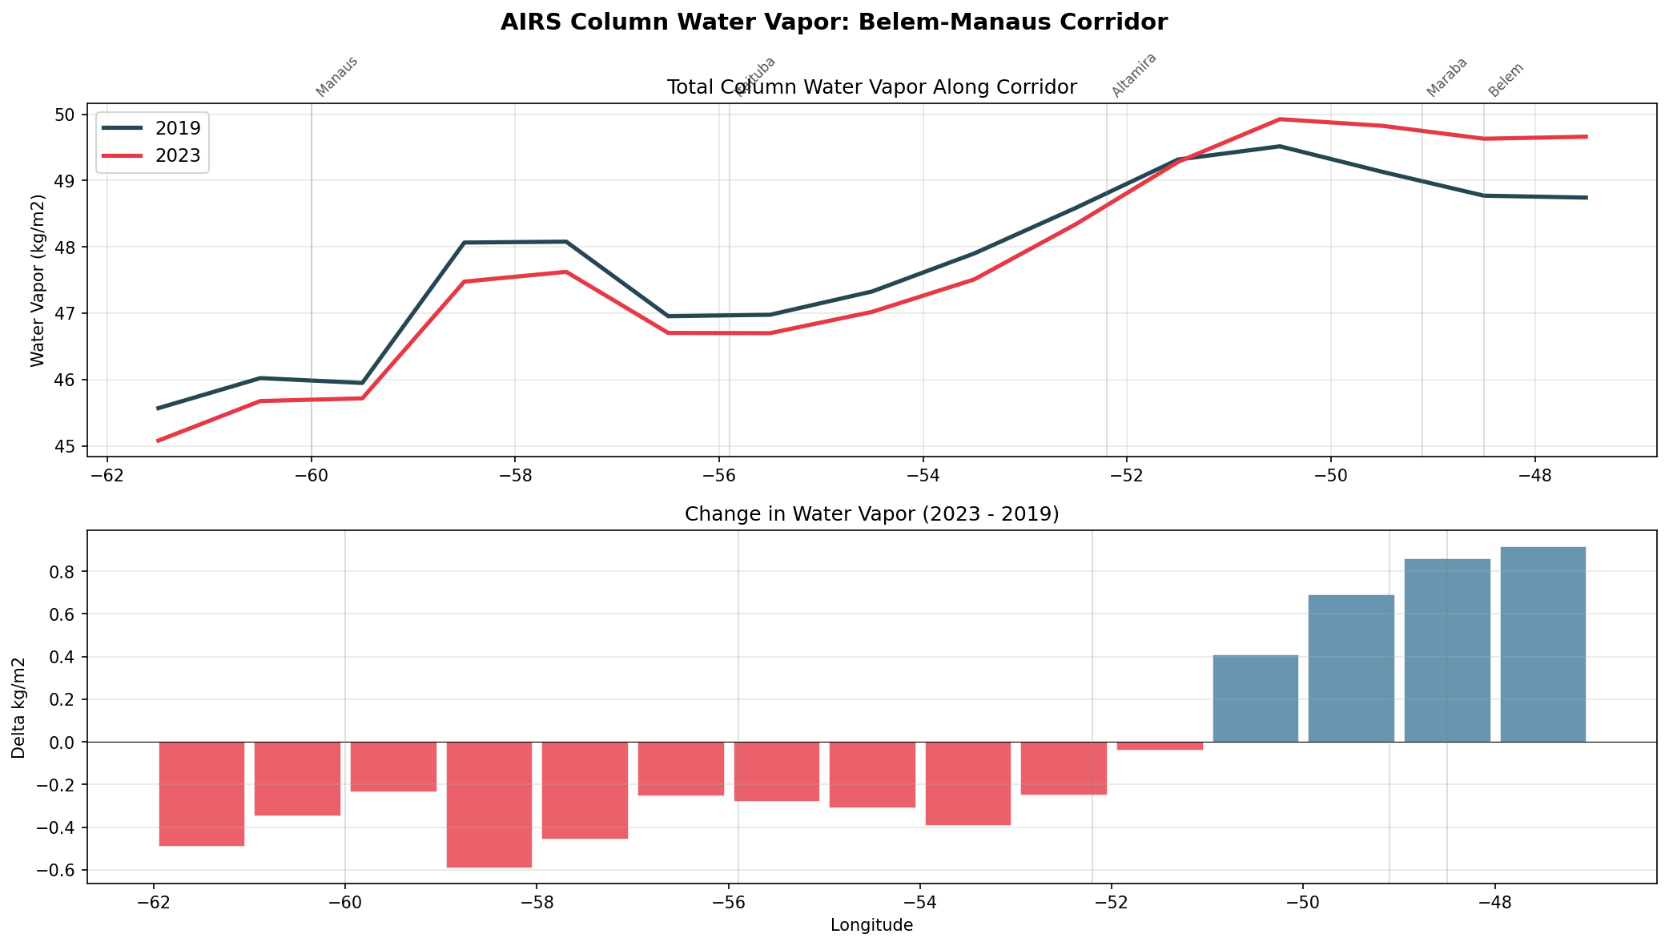
Figure 6. AIRS column water vapour along the corridor. Top: absolute values showing coast gained moisture while interior lost it. Bottom: change bars showing the asymmetry (blue = wetter, red = drier).
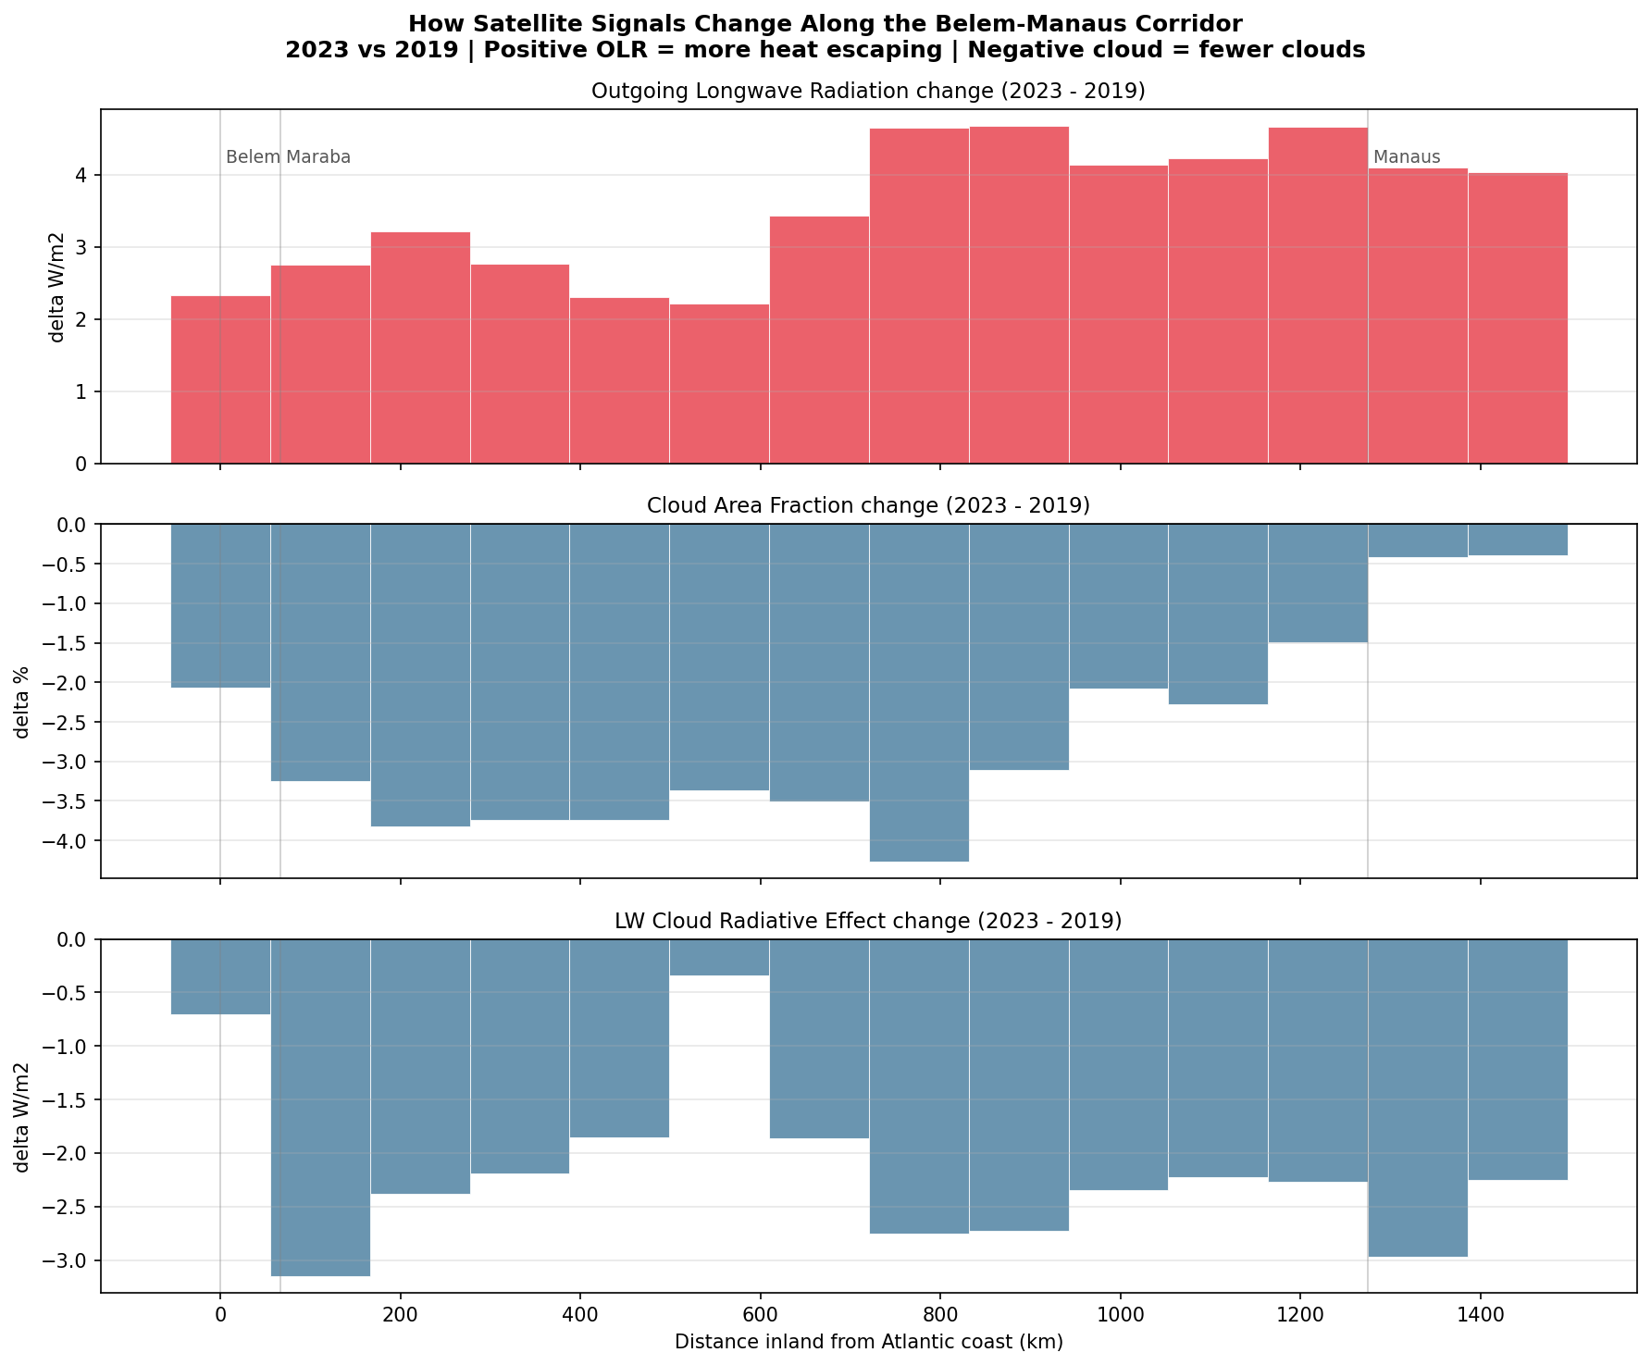
Figure 7. Change in satellite signals vs distance inland from the Atlantic coast. OLR increase (red bars) grows taller toward Manaus. Cloud fraction decline and CRE decline intensify with distance. This amplification pattern is the signature of inland moisture transport failure.

3.3 Seasonal decomposition
SON dominates the annual signal. Interior OLR increased +24.5 W/m² during SON versus +10.6 during JJA and −8.5 during DJF. Cloud fraction during SON declined 9.0% at the interior. During DJF, when the ITCZ provides geophysical forcing, the corridor partially recovered.
Season | Coast | Mid | Interior
DJF (wet) | +0.3 | −4.5 | −8.5
MAM | −0.7 | −2.1 | −9.7
JJA (dry) | +7.5 | +7.6 | +10.6
SON (dry–wet) | +10.5 | +14.5 | +24.5

Table 3. Seasonal OLR change (W/m²) along the Amazon corridor.
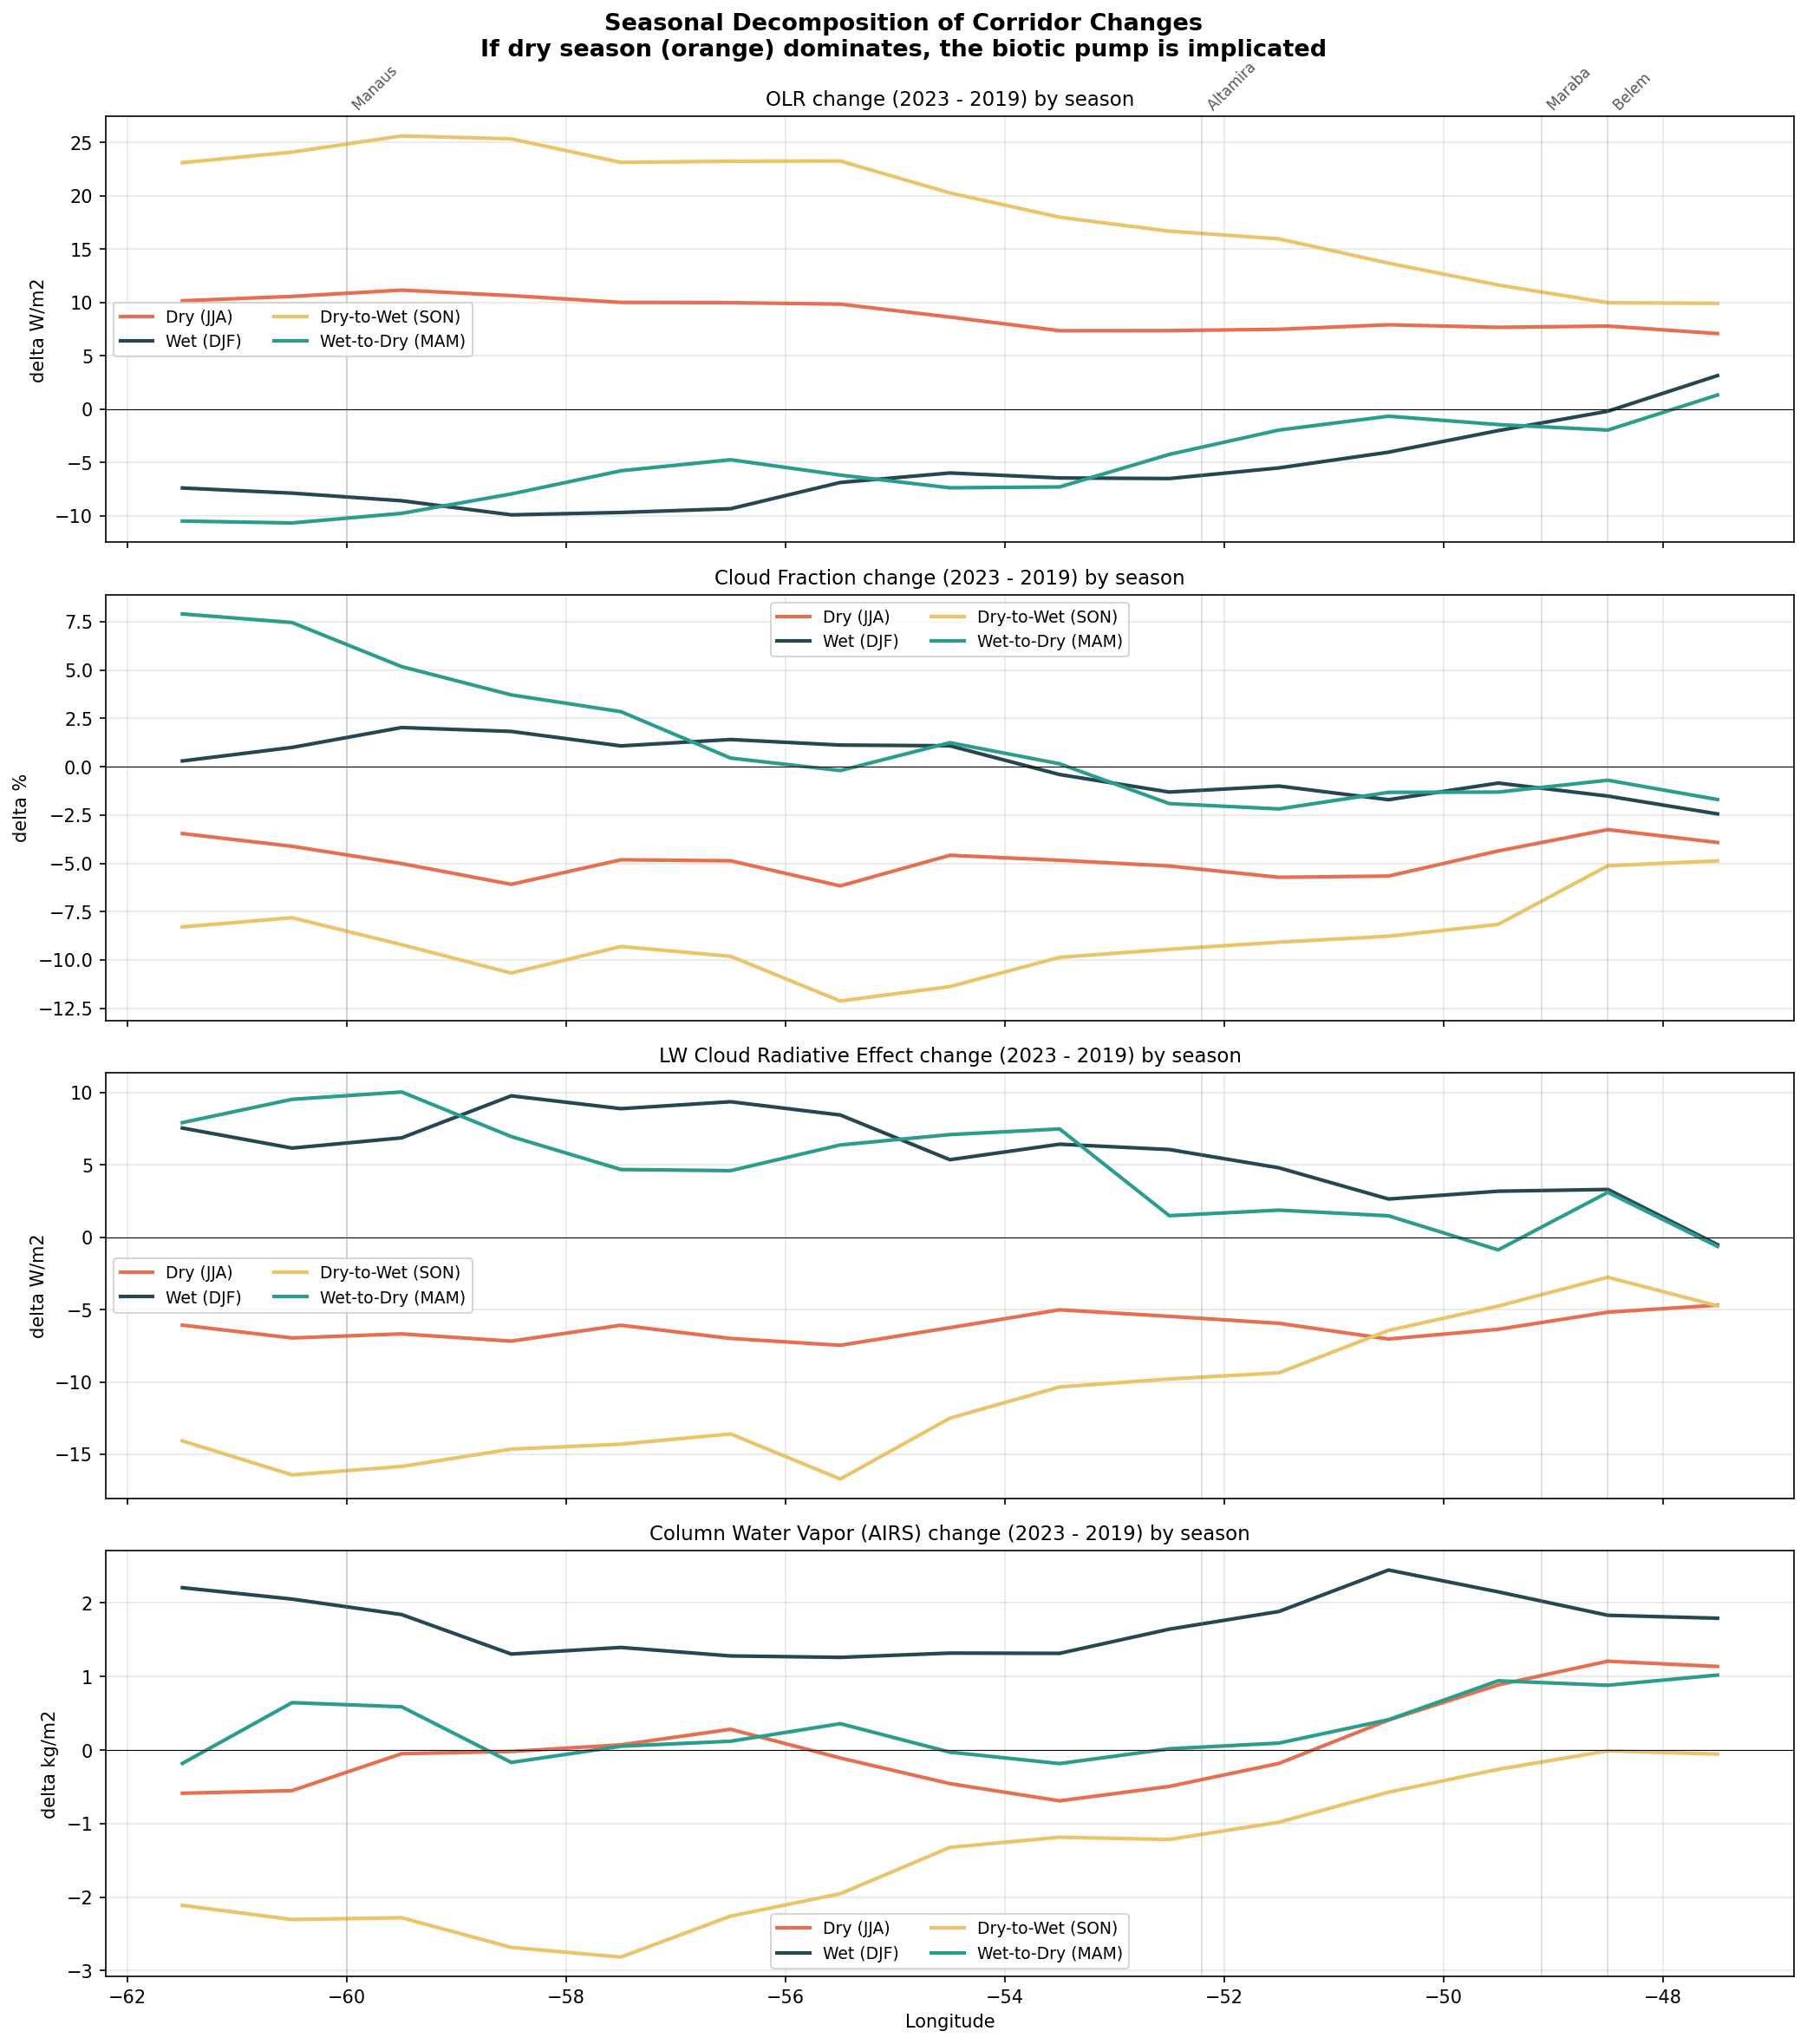
Figure 8. Seasonal decomposition of corridor changes. SON (yellow) dominates at every longitude, with the signal amplifying toward the interior. DJF (dark blue) shows partial recovery from ITCZ-driven geophysical forcing.

3.4 Multi-year trends and ENSO independence
Over 2001–2025, the Amazon cloud fraction gradient declined at −0.17%/yr and the CRE gradient at −0.12 W/m²/yr. The ONI explains <1% of variance in the cloud fraction gradient (r = 0.015, p = 0.94). ENSO-adjusted trends are virtually unchanged (Table 4). 2023 is not anomalous among El Niño years.
Metric | Raw trend | ENSO-adjusted | p-value
Cloud fraction | −0.170%/yr | −0.170%/yr | 0.001
CRE | −0.116 W/m²/yr | −0.117 W/m²/yr | 0.033
OLR | +0.074 W/m²/yr | +0.075 W/m²/yr | 0.201

Table 4. Amazon corridor gradient trends, raw and ENSO-adjusted.
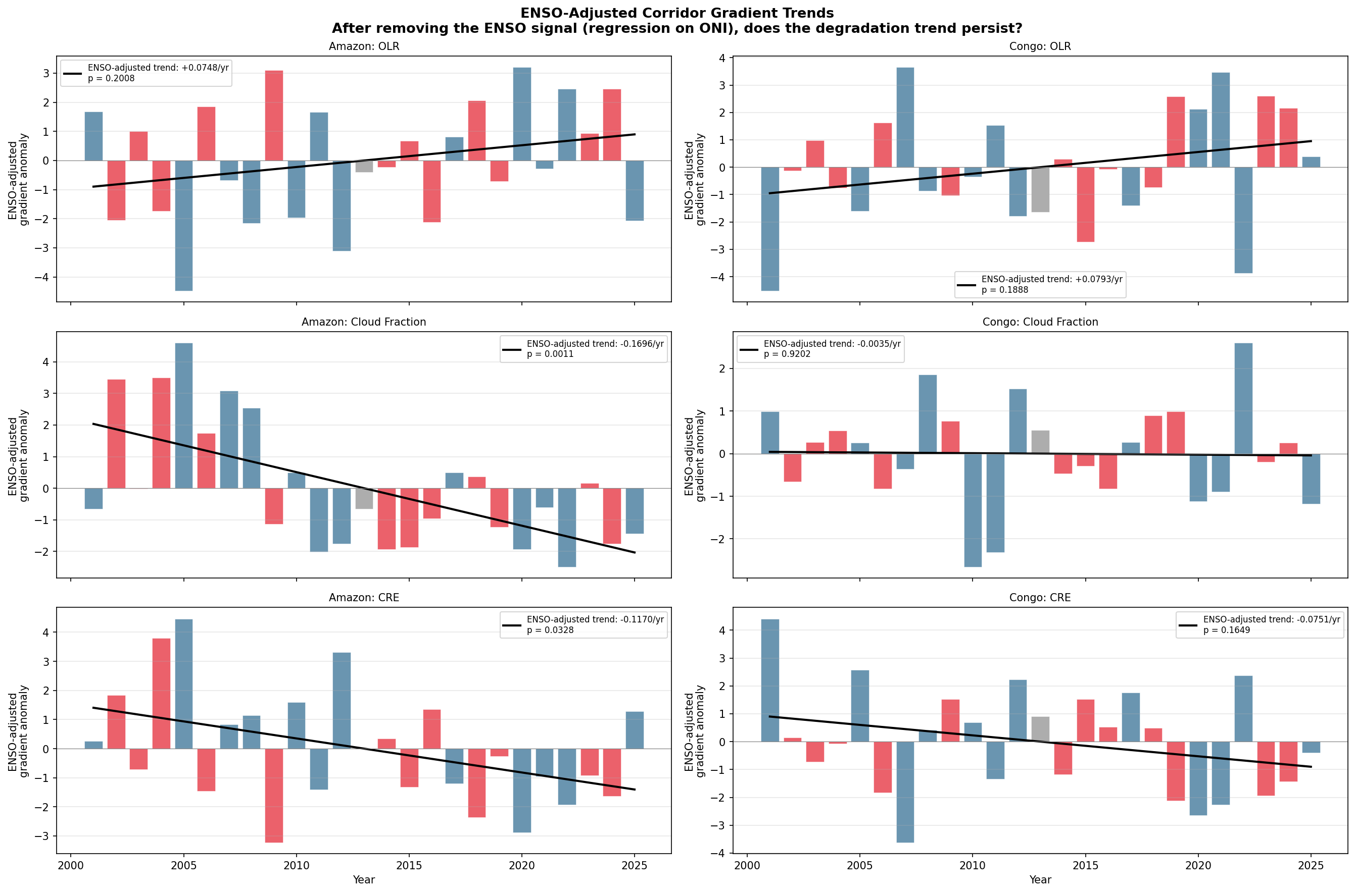
Figure 9. ENSO-adjusted corridor gradient trends for the Amazon (left) and Congo (right). After removing the ONI signal, the Amazon cloud fraction trend persists at p = 0.001. Bars coloured by ENSO phase (red = El Nino, blue = La Nina).

3.5 Forest integrity: drought stress, not deforestation
Among 225 forest cells (NDVI > 0.6 in 2019), 88.4% showed NDVI decline. Mean change: −0.009 (t = −15.4, p < 10⁻⁶). The Congo showed the opposite: NDVI increased (+0.008, 78.5% greening). NDVI and ET are correlated (r = 0.29, p = 0.0006), confirming drought stress in standing forest.
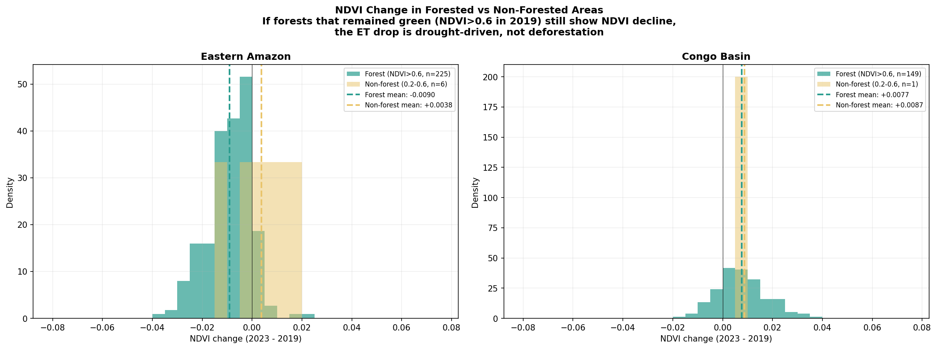
Figure 10. NDVI change in intact forest (green) vs non-forest (yellow) cells. Eastern Amazon: 88% of dense forest cells browned. Congo: 78% greened. The ET decline reflects drought-driven transpiration suppression, not deforestation.

3.6 Spatial correlation between ET and OLR
Across 159 cells in the wider Eastern Amazon, ET change and OLR change are correlated (r = 0.32, p < 0.0001). 47% of cells fall in the pump failure quadrant (ET < 0, OLR > 0). The biotic pump operates at circulation scale; the corridor analyses provide a more appropriate spatial framework.
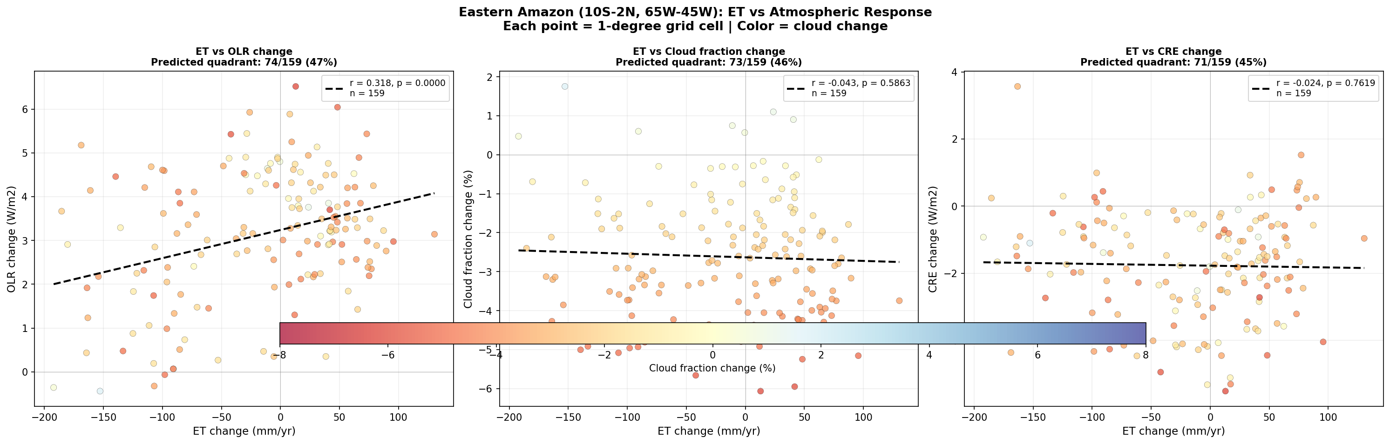
Figure 11. ET vs OLR change per 1-degree grid cell in the Eastern Amazon. Colour = cloud fraction change. Dashed line: linear fit (r = 0.32, p < 0.0001). Upper-right quadrant (ET down, OLR up) = pump failure signature.

4. Discussion

4.1 Satellite signatures of the biotic pump
Our results show all four predicted signatures of biotic pump weakening along the Belém–Manaus corridor, and critically, they amplify with distance from the coast. Interior OLR increased +4.3 W/m² versus +2.7 at the coast; interior water vapour declined while the coast gained. This amplification is the distinctive signature of a transport failure mechanism, not a spatially uniform climate forcing.

4.2 The SON transition
The corridor signal concentrates in SON, when interior OLR increased +24.5 W/m². During DJF, geophysical forcing partially compensated. This contrast - biotic pump failure in SON, recovery in DJF - is difficult to explain by any mechanism other than reduced vegetation-driven moisture convergence.

4.3 A progressive trend
The 25-year record shows a ratchet: drought events degrade the corridor, recovery is incomplete. Interior cloud fraction fell from 82.7% (2005) to 77.2% (2023). This is consistent with the positive feedbacks proposed in tipping point studies (Lenton et al., 2008; Staal et al., 2020; Zemp et al., 2017).

4.4 Basin-wide trends versus corridor-specific signals
MODIS-derived ET anomalies for the Amazon basin as a whole show an increasing trend over the past decade. This appears to contradict our finding of ET decline along the corridor. However, the basin-wide average masks spatial heterogeneity. The eastern corridor shows declining ET (−66 mm/yr in Marabá, 88% of intact forest browned) while the western Amazon partially compensated. The biotic pump is a corridor-scale mechanism, and basin-averaged metrics may remain stable while the critical moisture relay is degrading.

4.5 Amazon and Congo
The Congo occupies an earlier position on the same degradation trajectory. Its declining CRE gradient (−0.07 W/m²/yr) suggests the atmospheric response is beginning to decouple from the still-active forest.

4.6 Moisture displacement and extreme weather
During September 2023, OLR showed positive anomalies of +12.5 W/m² over the Amazon and +5.0 over the Congo, while the eastern Mediterranean showed −4.6 W/m² coinciding with Storm Daniel. A similar dipole appeared in September 2024 with Storm Boris (Figure 12; Supplementary S1–S7). This spatial coincidence warrants investigation through back-trajectory analysis (Stein et al., 2015).
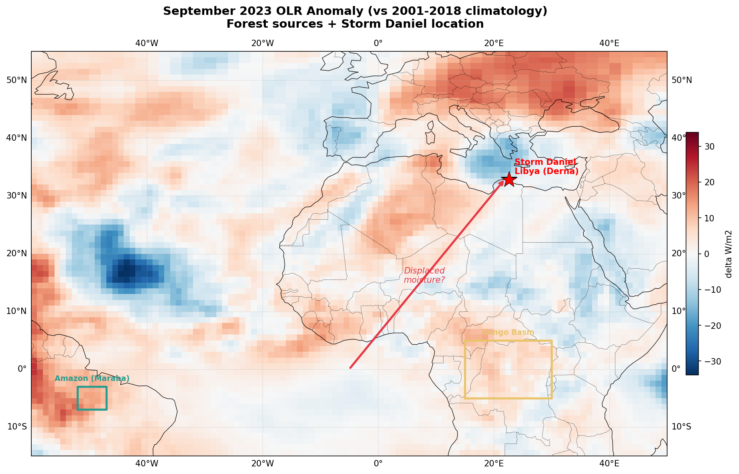
Figure 12. September 2023 OLR anomaly (vs 2001-2018 climatology). Forest source regions (green = Amazon, yellow = Congo) show strong positive anomalies (drier), while the eastern Mediterranean (Storm Daniel, red star) shows negative anomalies (enhanced convection). The spatial dipole is consistent with moisture displacement.

4.7 Limitations
The 2019–2023 comparison captures the drought signal but not full variability; the 25-year trend partially addresses this. CERES at 1° cannot resolve sub-grid processes. MODIS ET has known biases in tropical forests (Mu et al., 2011). Other climate modes (AMO, IOD) could contribute. Satellite observations alone cannot establish causality; Earth system model experiments are needed.

5. Conclusions
1. Four independent satellite instruments show spatially coherent weakening of moisture transport along both corridors, consistent with biotic pump predictions.
2. Signals amplify inland: interior OLR +4.3 vs +2.7 W/m² at coast; water vapour gradient steepened by −1.2 kg/m².
3. The breakdown concentrates in SON, when the forest should initiate the wet season. Interior SON OLR increased +24.5 W/m².
4. The Amazon corridor has weakened progressively over 25 years: cloud fraction gradient −0.17%/yr (p = 0.001), CRE gradient −0.12 W/m²/yr (p = 0.033), both ENSO-independent.
5. 88% of intact forest cells show NDVI decline (p < 10⁻⁶): drought stress, not deforestation.
6. The Congo shows the same direction at weaker magnitude, consistent with earlier-stage degradation.
7. A September 2023 OLR dipole (tropical surplus, Mediterranean deficit) coincides with Storm Daniel and warrants trajectory analysis.
These findings provide the first spatially resolved, multi-instrument satellite documentation of biotic pump weakening along defined moisture corridors.

Supplementary Materials
40 supplementary figures are provided in a separate document, organized in 10 sections: S1 storm displacement (7 figs), S2 ENSO control (2), S3 multi-year time series (3), S4 monthly time series (2), S5 Congo corridor details (5), S6 Amazon corridor details (6), S7 regional comparison maps (7), S8 wider Amazon analysis (2), S9 NDVI and ET details (4), S10 ET-OLR scatter details (2).

Data Availability
CERES EBAF-TOA from NASA LaRC ASDC. MODIS products from NASA LP DAAC. AIRS from NASA GES DISC. ONI from NOAA CPC. All accessed via NASA Earthdata (earthdata.nasa.gov).

References
Eltahir, E. A. B. and Bras, R. L. (1996). Precipitation recycling in the Amazon basin. Q.J.R. Meteorol. Soc., 122, 539-555.
Espinoza, J. C., et al. (2024). The new record of drought and warmth in the Amazon in 2023. Scientific Reports, 14, 8107. doi:10.1038/s41598-024-58782-5
Fu, R., et al. (2013). Increased dry-season length over southern Amazonia. PNAS, 110, 18110-18115.
Lenton, T. M., et al. (2008). Tipping elements in the Earth's climate system. PNAS, 105, 1786-1793.
Li, W. and Fu, R. (2004). Transition from dry to wet season over Amazonia. J. Climate, 17, 2637-2651.
Loeb, N. G., et al. (2018). CERES EBAF TOA Ed4.0. J. Climate, 31, 895-918.
Makarieva, A. M. and Gorshkov, V. G. (2007). Biotic pump of atmospheric moisture. HESS, 11, 1013-1033.
Makarieva, A. M., et al. (2009). Precipitation on land vs distance from ocean. Ecol. Complexity, 6, 302-307.
Makarieva, A. M., et al. (2013). Where do winds come from? ACP, 13, 1039-1056.
Mu, Q., et al. (2011). Improvements to MODIS ET algorithm. Remote Sens. Environ., 115, 1781-1800.
Nobre, C. A., et al. (2016). Land-use and climate change risks in the Amazon. PNAS, 113, 10759-10768.
Running, S. W., et al. (2019). MODIS ET Product User's Guide, Collection 6.1.
Salati, E., et al. (1979). Recycling of water in the Amazon basin. Water Resour. Res., 15, 1250-1258.
Spracklen, D. V., et al. (2012). Increased tropical rainfall preceded by air passage over forests. Nature, 489, 282-285.
Staal, A., et al. (2018). Forest-rainfall cascades buffer against drought. Nat. Clim. Change, 8, 539-543.
Staal, A., et al. (2020). Hysteresis of tropical forests. Nat. Commun., 11, 4978.
Stein, A. F., et al. (2015). NOAA's HYSPLIT system. BAMS, 96, 2059-2077.
Tian, B., et al. (2020). AIRS/Aqua L3 Monthly V7.0. NASA GES DISC.
Wongchuig, S., et al. (2025). Drying in Central Congo Basin linked to weakened Walker circulation. npj Clim. Atmos. Sci., 8, 331. doi:10.1038/s41612-025-01225-3
Wright, J. S., et al. (2017). Rainforest-initiated wet season onset. PNAS, 114, 8481-8486.
Zemp, D. C., et al. (2017). Self-amplified Amazon forest loss. Nat. Commun., 8, 14681.

