Supplementary Materials
Empirical constraints on the fraction of surface latent heat flux reaching the top of atmosphere as net radiative cooling
Ali B. Shahid
Version 5, June 2026
S1. Forward Lagrangian trajectory analysis: methods
Section 5.5 of the main text proposes the convective relay as the mechanism that reconciles the low local transfer fraction (14.7 percent) with the thermodynamic expectation that condensation heat must eventually exit the climate system. This supplementary material reports the direct empirical test of that mechanism using forward Lagrangian trajectories.
S1.1 Input data
Trajectories were computed from the ERA5 reanalysis (Hersbach et al., 2020) at the 200 hPa pressure level (approximately 12 km altitude, within the upper troposphere and tropical tropopause layer). Three wind components (zonal u, meridional v, vertical omega) were retrieved at 6-hourly resolution for a domain extending from 30 degrees S to 60 degrees N and from 90 degrees W to 30 degrees E. Seven years were processed: 2005, 2008, 2010, 2015, 2016, 2019, and 2020, spanning ENSO-neutral (2010, 2019), La Nina (2008, 2020), and El Nino (2015, 2016) states.
S1.2 Release protocol
Air parcels were released from a 1-degree grid over the Amazon basin (5 degrees S to 5 degrees N, 75 degrees W to 50 degrees W), yielding 286 parcels per release (11 latitudes x 26 longitudes). Releases were performed on the 15th of January, April, July, and October each year at 12:00 UTC. Parcels were advected forward for 20 days using a simple Euler integration scheme with a 6-hour timestep (80 steps total). Wind fields at each step were interpolated to the parcel position using bilinear interpolation. Parcels that exited the domain were retained at their last in-domain position.
S1.3 Control experiment
To distinguish forest-specific transport from the general Hadley circulation, a symmetric control experiment was conducted matching the full main-ensemble release matrix: all 7 years (2005, 2008, 2010, 2015, 2016, 2019, 2020) and all 4 seasons (January, April, July, October releases), for a total of 28 control runs. The control used the identical advection protocol but released parcels from the tropical Atlantic (5 degrees S to 5 degrees N, 30 degrees W to 5 degrees W), an open-ocean area with no forest and no continental convective source. The 7 years span neutral / weak La Nina (2005), La Nina (2008, 2020), El Nino to La Nina transition (2010), strong El Nino (2015), El Nino tail (2016), and weak El Nino (2019) phases, providing ENSO-matched coverage of the main Amazon ensemble. If the convective relay pathway is forest-specific, Amazon-released parcels should reach systematically different destinations or higher-OLR zones than Atlantic-released parcels at identical times. If the pathway reflects general Hadley infrastructure, both sets should behave similarly.
S1.4 CERES coupling
For each release, the CERES EBAF Ed4.2 monthly all-sky OLR (Loeb et al., 2018) corresponding to the release month was extracted. At each trajectory endpoint (days 0, 5, 10, 15, 20), OLR was sampled at each parcel location using nearest-neighbor interpolation on the 1-degree CERES grid. The enhancement metric is the difference between the mean OLR at parcel locations and the mean OLR over the Amazon source region (5S-5N, 75W-50W).
S2. Results
S2.1 Trajectory ensemble (Amazon source)
Across all 28 Amazon releases, parcels consistently drift poleward and eastward. By day 5, the mean absolute latitude reaches 16.2 degrees (standard deviation across runs = 3.5 degrees). By day 20, the mean latitude reaches 22.9 degrees, placing most parcels in the subtropical Hadley descending branch. Longitudinal displacement averages 60 degrees eastward by day 20, carrying parcels across the Atlantic into West Africa and the eastern Atlantic.
The OLR at parcel destinations rises rapidly in the first 5 days then plateaus. Day 5 OLR averages 270.3 W m-2 across all 28 ensembles (versus 232.1 W m-2 mean Amazon source), an enhancement of +38.2 W m-2 (standard deviation 14.8). Day 20 OLR averages 276.7 W m-2, an enhancement of +44.6 W m-2 (standard deviation 15.3). The enhancement is positive across all runs and all years, confirming that parcels released from the Amazon TTL reach higher-OLR zones within 5 days and remain there through the 20-day integration.
S2.2 Control experiment (Atlantic source)
When parcels are released from the tropical Atlantic rather than the Amazon at the identical altitude and times, the endpoint OLR values show no consistent direction of difference from the Amazon case. Across the full symmetric matrix of 28 control runs (7 years x 4 seasons), the mean Amazon-minus-Atlantic endpoint OLR difference is +0.44 W m-2 (standard deviation 11.14 W m-2, range -16.4 to +23.0 W m-2). A one-sample t-test against a null difference of zero yields t = 0.21, p = 0.83: the null hypothesis that Amazon-source and Atlantic-source parcels reach indistinguishable subtropical endpoint OLR cannot be rejected. The 95% range of differences (approximately -22 to +22 W m-2 at 2 sigma) is larger than any plausible forest-specific enhancement, indicating that natural advection variability, not statistical underpowering, dominates the scatter.
The result is consistent across ENSO phases. Mean Amazon-minus-Atlantic differences by phase are: neutral / weak La Nina (2005) = -4.2 W m-2 (n = 4, standard deviation 14.0); La Nina (2008, 2020) = +0.4 W m-2 (n = 8, standard deviation 9.4); El Nino to La Nina transition (2010) = -0.4 W m-2 (n = 4, standard deviation 13.0); strong El Nino (2015) = +7.3 W m-2 (n = 4, standard deviation 12.7); El Nino tail (2016) = +2.2 W m-2 (n = 4, standard deviation 10.1); weak El Nino (2019) = -2.8 W m-2 (n = 4, standard deviation 13.2). No phase exhibits a systematic Amazon-specific signal, and within every phase the range of differences exceeds the phase mean by a factor of three to six.
Both Amazon-released and Atlantic-released parcels reach the subtropical descending branch with similar endpoint OLR. The +38 to +45 W m-2 enhancement observed for Amazon parcels is therefore a general property of tropical-to-subtropical Hadley transport, not a forest-specific signature.
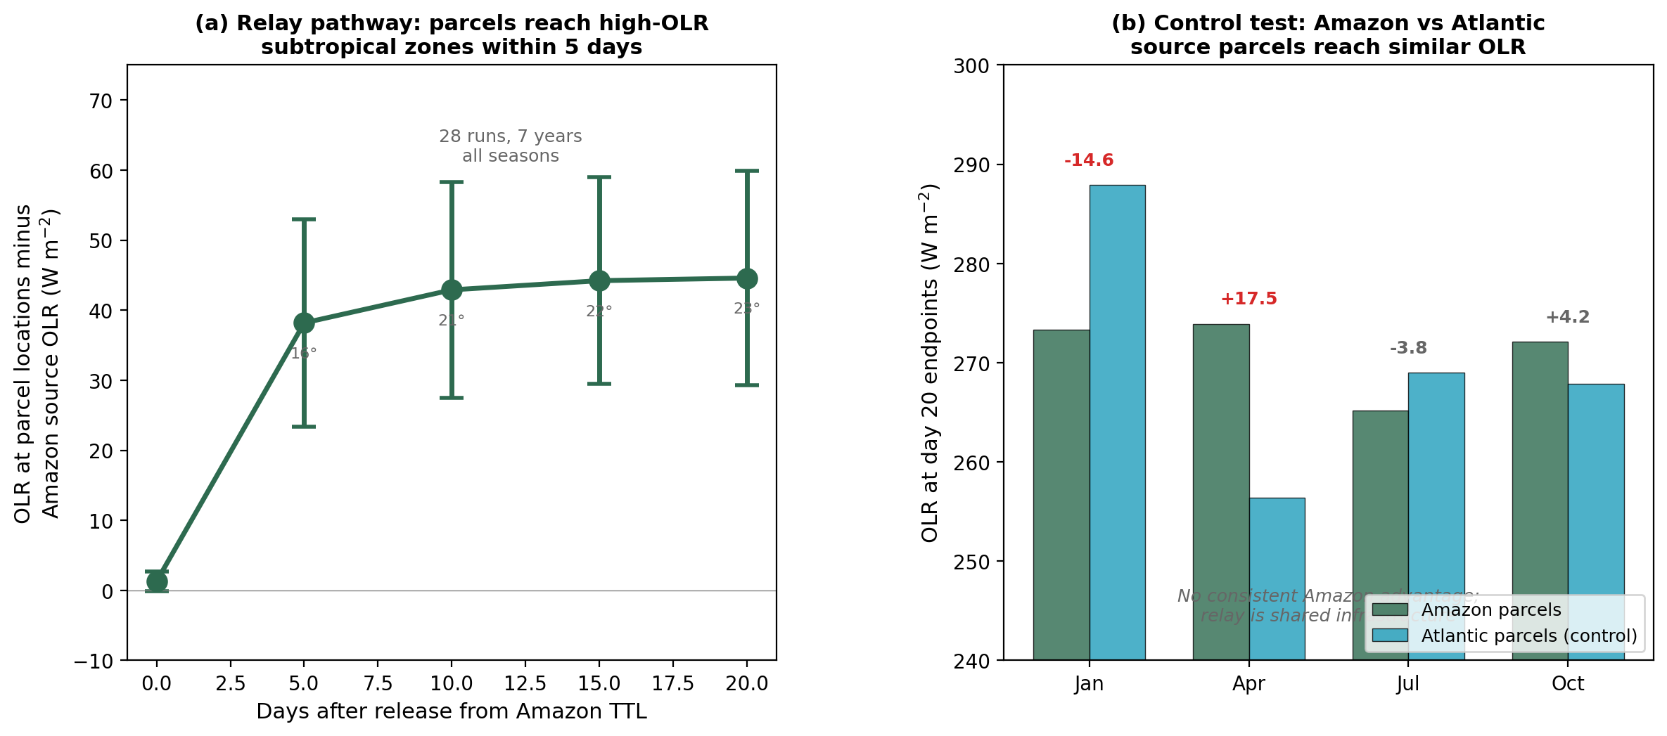
Figure S1. Forward Lagrangian trajectory analysis from the Amazon tropical tropopause layer at 200 hPa. (a) OLR enhancement at parcel endpoint locations relative to the Amazon source region, averaged across 28 trajectory ensembles (7 years, 4 seasons, 286 parcels each). Error bars show one standard deviation. Numbers below markers indicate mean parcel latitude. (b) Control comparison: day 20 endpoint OLR for parcels released from the Amazon (dark green) versus the tropical Atlantic (teal), with differences shown above each month pair. No consistent Amazon advantage is observed.
Table S1. Summary of 28 Amazon trajectory ensembles. Mean and standard deviation of parcel latitude and OLR at each endpoint day.
Day | Mean |latitude| | Mean OLR (W m⁻²) | Enhancement (W m⁻²) | Standard deviation
0 | 2.7 | 233.4 | +1.3 | 1.4
5 | 16.2 | 270.3 | +38.2 | 14.8
10 | 20.7 | 275.0 | +42.9 | 15.4
15 | 22.5 | 276.3 | +44.2 | 14.7
20 | 22.9 | 276.7 | +44.6 | 15.3
Table S2. Amazon versus Atlantic source control comparison, day 20 endpoint OLR for 2010. Differences have no consistent direction.
Month | Amazon OLR (W m⁻²) | Atlantic OLR (W m⁻²) | Difference (W m⁻²) | Interpretation
Jan | 273.3 | 287.9 | −14.6 | Atlantic higher
Apr | 273.9 | 256.4 | +17.5 | Amazon higher
Jul | 265.2 | 269.0 | −3.8 | Similar
Oct | 272.1 | 267.9 | +4.2 | Similar
Mean | 271.1 | 270.3 | +0.8 | No consistent signal
S3. Interpretation
The trajectory analysis produces two findings that together support the main paper's conclusions rather than contradict them.
First, the relay pathway is confirmed: air parcels released from the Amazon at 200 hPa do reach subtropical latitudes within 5 to 10 days, and those destinations have substantially higher OLR than the Amazon source region. The mechanism described in Section 5.5 of the main text (surface LE, cloud formation, longwave trapping, deeper convection, TTL injection, Hadley transport, subtropical clear-sky exit) is therefore physically real. The atmosphere does move heat from the Amazon to subtropical clear-sky zones on weekly timescales.
Second, the pathway is not forest-specific. Parcels released from the tropical Atlantic, where there is no forest and no continental convective source, reach the same subtropical destinations with the same OLR characteristics as Amazon-released parcels. The subtropical high-OLR zone is a property of the Hadley circulation, not of forest-driven deep convection specifically.
Taken together, these findings mean that the forest's causal contribution to TOA cooling cannot be attributed to the pathway above 200 hPa. The pathway is shared infrastructure used by any tropical upper-tropospheric air parcel. What the forest controls is upstream: the quantity of heat that is injected into the TTL through deep convection. Intact forest generates higher latent heat flux, higher convective available potential energy, taller cumulonimbus towers, and therefore more mass reaching the TTL than deforested land of equivalent geography. The forest-specific TOA signal is therefore correctly quantified by the surface-to-TOA transfer fraction at the local scale (Section 3.1) and at the basin scale (Section 3.6), not by the trajectory endpoint OLR.
This result also constrains the spatial misattribution hypothesis, under which local CERES measurements would underestimate forest-driven cooling because the heat exits to space at higher latitudes. If that were the dominant effect, Amazon parcels should reach regions with OLR enhancement that Atlantic parcels do not. The control shows they do not. Spatial misattribution therefore cannot account for the gap between prior top-down estimates and the 14.7 to 20.8 percent measured here; the geometric bound on η in deep convective regimes (main text Section 6.10) provides the governing constraint.
S4. Data and code availability
Raw trajectory data (NetCDF, 28 Amazon ensembles plus 28 Atlantic control ensembles) and the analysis scripts (Python, covering ERA5 download, trajectory integration, CERES coupling, symmetric control comparison, and figure generation; the preloaded-vectorized control script runs the full 56-ensemble matrix in approximately 110 seconds) are archived with the main paper supplementary code at https://github.com/R3GENESI5/shahid-2026-transfer-fraction; a Zenodo archive of the repository at the version of record will be deposited on acceptance.
References
Hersbach, H. et al. (2020). The ERA5 global reanalysis. Quarterly Journal of the Royal Meteorological Society, 146(730), 1999 to 2049.
Loeb, N.G. et al. (2018). Clouds and the Earth's Radiant Energy System (CERES) EBAF TOA Edition-4.0. Journal of Climate, 31(2), 895 to 918.

