Q.1) Lines, angles, and triangles

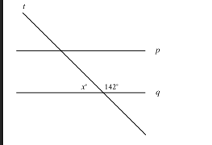
In the figure, line $p$ is parallel to line $q$ and line $t$ intersects both lines. What is the value of $z+142$ ?
A. 52
B. 90
C. 142
D. 180
Answer:180
Explanation:
Choice D is correct. In the figure shown, the angle marked $z^{*}$ and the angle marked ${142}^{*}$ form a linear pair of angles. If two angles form a linear pair of angles, the sum of the measures of the angles is ${180}^{∘}$. Therefore, the value of $π+142$ is $180$
Choice A is incorrect. This is 90 less than $142$, not the sum of $2$ and $142$.
Choice B is incorrect and may result from conceptual or calculation errors.
Choice C is incorrect. This is the measure, in degrees, of one of the angles shown.

Q.2) Lines, angles, and triangles
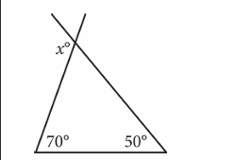
In the figure above, two sides of a triangle are extended. What is the value of $x$ ?
A)110
B)120
C)130
D)140
Answer: B
Explanation:
Choice B is correct. The sum of the interior angles of a triangle is ${180}^{∘}$. The measures of the two interior angles of the given triangle are shown. Therefore, the measure of the third interior angle is ${180}^{∘}-{70}^{∘}-{50}^{∘}={60}^{∘}$. The angles of measures $x^{''}$ and ${60}^{''}$ are supplementary, so their sum is ${180}^{∘}$. Therefore, $x=180-60=120$.
Choice A is incorrect and may be the result of misinterpreting $x^{*}$ as supplementary to ${70}^{*}$. Choice C is incorrect and may be the result of misinterpreting $x^{''}$ as supplementary to ${50}^{''}$. Choice $D$ is incorrect and may be the result of a calculation error.

Q.3) Lines, angles, and triangles
In a right triangle, the measure of one of the acute angles is ${51}^{∘}$. What is the measure, in degrees, of the other acute angle?
A)6
B)39
C)49
D)51
Answer: B
Explanation:
Choice B is correct. The sum of the measures of the interior angles of a triangle is 180 degrees. Since the triangle is a right triangle, it has one angle that measures 90 degrees. Therefore, the sum of the measures, in degrees, of the remaining two angles is $180-90$, or 90 . It's given that the measure of one of the acute angles in the triangle is 51 degrees. Therefore, the measure, in degrees, of the other acute angle is $90-51$, or $39$.
Choice A is incorrect and may result from conceptual or calculation errors.
Choice C is incorrect and may result from conceptual or calculation errors.
Choice D is incorrect. This is the measure, in degrees, of the acute angle whose measure is given.

Q.4) Lines, angles, and triangles

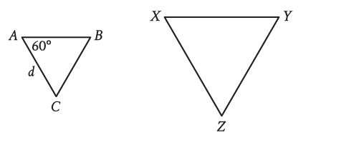
For the triangles shown, triangle $ABC$ is dilated by a scale factor of 3 to obtain triangle $XYZ$, where $d=16$. What is the measure, in degrees, of angle $X$ ?
A)$20$
B)57
C)60
D)63
Answer: C
Explanation:
Choice C is correct. It's given that triangle $XYZ$ is obtained by a dilation of triangle $ABC$. It follows that triangle $ABC$ is similar to triangle $XYZ$, where $A$ corresponds to $X$. Since corresponding angles in similar triangles have the same measure and the measure of angle $A$ is 60 degrees, it follows that the measure of angle $X$ is also 60 degrees.
Choice A is incorrect and may result from conceptual errors.
Choice B is incorrect and may result from conceptual errors.
Choice D is incorrect and may result from conceptual errors.
Q.5) Lines, angles, and triangles
In triangle $ABC,AB=4,680$ millimeters $(mm)$ and $BC=4,680 mm$. Which statement is sufficient to prove that triangle $ABC$ is equilateral?
A)$AC=4,680 mm$
B)$AC=468 mm$
C)$AC=46.8 mm$
D)$AC=4.68 mm$
Answer: A
Explanation:
Choice A is correct. In an equilateral triangle, all three sides have the same length. It's given that in triangle $ABC$, $AB=4,680 mm$ and $BC=4,680 mm$. Therefore, if $AC=4,680 mm$, then all three sides of triangle $ABC$ have the same length, so triangle $ABC$ is equilateral. Therefore, $AC=4,680 mm$ is sufficient to prove that triangle $ABC$ is equilateral.
Choice B is incorrect and may result from conceptual or calculation errors.
Choice C is incorrect and may result from conceptual or calculation errors.
Choice D is incorrect and may result from conceptual or calculation errors.

Q.6) Lines, angles, and triangles
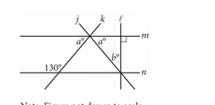
In the figure above, lines $m$ and $n$ are parallel.
What is the value of $b$ ?
A)40
B)50
C)65
D)80
Answer: A
Explanation:
Choice A is correct. Given that lines m and n are parallel, the angle marked ${130}^{∘}$ must be supplementary to the leftmost angle marked $a^{∘}$ because they are same-side interior angles. Therefore, ${130}^{∘}+a^{∘}={180}^{∘}$, which yields $a={50}^{∘}$. Lines $l$ and m intersect at a right angle, so lines $j,l$, and m form a right triangle where the two acute angles are $a^{∘}$ and $b^{∘}$. The acute angles of a right triangle are complementary, so $a^{∘}+b^{∘}={90}^{∘}$, which yields ${50}^{∘}+b^{∘}={90}^{∘}$, and $b=40$.
Choice B is incorrect. This is the value of a , not b .
Choice C is incorrect and may be the result of dividing ${130}^{∘}$ by 2 . Choice D is incorrect and may be the result of multiplying b by 2 .

Q.7) Lines, angles, and triangles
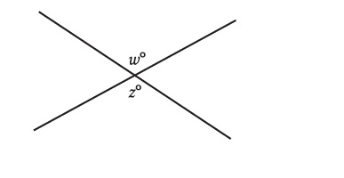
In the figure, two lines intersect at a point. If $w=136$, what is the value of $z$ ?
A)36
B)44
C)68
D)136
Answer: D
Explanation:
Choice D is correct. In the figure shown, the angles with measures $w^{∘}$ and $z^{∘}$ are vertical angles. Since vertical angles are congruent, $w=z$. Therefore, if $w=136$, the value of $z$ is $136$.
Choice A is incorrect and may result from conceptual or calculation errors.
Choice B is incorrect. This is the measure, in degrees, of an angle that's supplementary, not congruent, to the angle with measure $w^{∘}$.
Choice C is incorrect and may result from conceptual or calculation errors.

Q.8) Lines, angles, and triangles
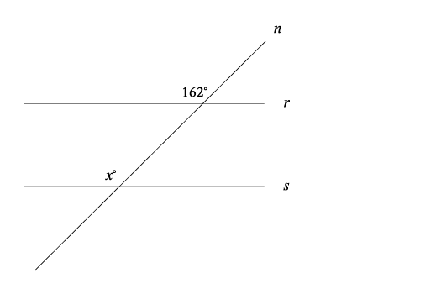
In the figure, line $n$ intersects lines $r$ and $s$. Line $r$ is parallel to line $s$. What is the value of $x$ ?
A)162
Answer: A
Explanation:
The correct answer is 162 . It's given that line $r$ is parallel to line $s$. Since line $n$ intersects both lines $r$ and $s$, it's a transversal. The angles in the figure marked as ${162}^{∘}$ and $x^{∘}$ are on the same side of the transversal, where one is an interior angle with line $s$ as a side, and the other is an exterior angle with line $r$ as a side. Thus, the marked angles are corresponding angles. When two parallel lines are intersected by a transversal, corresponding angles are congruent and, therefore, have equal measure. It follows that the value of $x$ is $162$.

Q.9) Lines, angles, and triangles

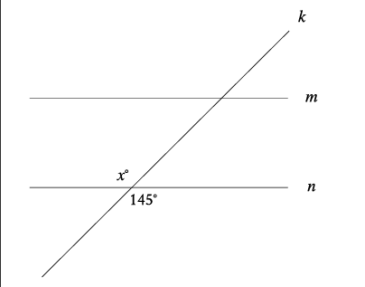

In the figure, line $m$ is parallel to line $n$, and line $k$ intersects both lines. Which of the following statements is true?
A)The value of $x$ is less than $145$.
B)The value of $x$ is greater than 145 .
C)The value of $x$ is equal to $145$.
D)The value of $x$ cannot be determined.
Answer: C
Explanation:
Choice C is correct. Vertical angles, or angles that are opposite each other when two lines intersect, are congruent. It's given that line $k$ intersects line $n$. Based on the figure, the angle with measure $x^{∘}$ and the angle with measure ${145}^{∘}$ are vertical angles. Therefore, the value of $x$ is equal to 145 .
Choice A is incorrect and may result from conceptual or calculation errors.
Choice B is incorrect and may result from conceptual or calculation errors.
Choice D is incorrect and may result from conceptual or calculation errors.

Q.10) Lines, angles, and triangles
Triangles $ABC$ and $DEF$ are congruent, where $A$ corresponds to $D$, and $B$ and $E$ are right angles. The measure of angle $A$ is ${18}^{∘}$. What is the measure of angle $F$ ?
A)${18}^{∘}$
B)${72}^{∘}$
C)${90}^{∘}$
D)${162}^{∘}$
Answer: B
Explanation:
Choice B is correct. It's given that triangle $ABC$ is congruent to triangle $DEF$. Corresponding angles of congruent triangles are congruent and, therefore, have equal measure. It's given that angle $A$ corresponds to angle $D$, and that the measure of angle $A$ is ${18}^{∘}$. It's also given that the measures of angles $B$ and $E$ are ${90}^{∘}$. Since these angles have equal measure, they are corresponding angles. It follows that angle $C$ corresponds to angle $F$. Let $x^{∘}$ represent the measure of angle $C$. Since the sum of the measures of the interior angles of a triangle is ${180}^{∘}$, it follows that ${18}^{∘}+{90}^{∘}+x^{∘}={180}^{∘}$, or ${108}^{∘}+x^{∘}={180}^{∘}$. Subtracting ${108}^{∘}$ from both sides of this equation yields $x^{∘}={72}^{∘}$. Therefore, the measure of angle $C$ is ${72}^{∘}$. Since angle $C$ corresponds to angle $F$, it follows that the measure of angle $F$ is also ${72}^{∘}$.
Choice A is incorrect. This is the measure of angle $D$, not the measure of angle $F$.
Choice C is incorrect. This is the measure of angle $E$, not the measure of angle $F$.
Choice D is incorrect. This is the sum of the measures of angles $E$ and $F$, not the measure of angle $F$.

Q.11) Lines, angles, and triangles

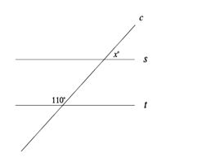
In the figure shown, line $c$ intersects parallel lines $s$ and $t$. What is the value of $x$ ?
A)70
Answer: A
Explanation:
The correct answer is 70 . Based on the figure, the angle with measure ${110}^{∘}$ and the angle vertical to the angle with measure $x^{∘}$ are same side interior angles. Since vertical angles are congruent, the angle vertical to the angle with measure $x^{∘}$ also has measure $x^{∘}$. It's given that lines $s$ and $t$ are parallel. Therefore, same side interior angles between lines $s$ and $t$ are supplementary. It follows that $x+110=180$. Subtracting $110$ from both sides of this equation yields $x=70$.

Q.12) Lines, angles, and triangles
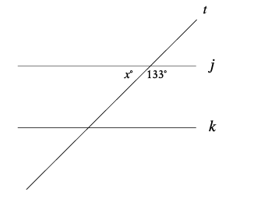
In the figure, line $j$ is parallel to line $k$. What is the value of $x$ ?
A)47
Answer: A
Explanation:
The correct answer is $47$. Based on the figure, the angle with measure $x^{∘}$ and the angle with measure ${133}^{∘}$ together form a straight line. Therefore, these two angles are supplementary, so the sum of their measures is ${180}^{∘}$. It follows that $x+133=180$ . Subtracting 133 from both sides of this equation yields $x=47$.

Q.13) Lines, angles, and triangles
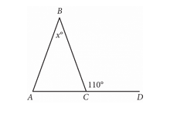
In the given figure, $AC$ extends to point $D$. If the measure of $∠BAC$ is equal to the measure of $∠BCA$, what is the value of $x$ ?
A. 110
B. 70
C. 55
D. 40
Answer: D
Explanation:
Choice D is correct. Since $∠BCD$ and $∠BCA$ form a linear pair of angles, their measures sum to ${180}^{∘}$. It's given that the measure of $∠BCD$ is ${110}^{∘}$. Therefore, ${110}^{∘}+∠BCA={180}^{∘}$. Subtracting ${110}^{∘}$ from both sides of this equation gives the measure of $∠BCA$ as ${70}^{∘}$. It's also given that the measure of $∠BAC$ is equal to the measure of $∠BCA$. Thus, the measure of $∠BAC$ is also ${70}^{∘}$. The measures of the interior angles of a triangle sum to ${180}^{∘}$. Thus, ${70}^{∘}+{70}^{∘}+x^{∘}={180}^{∘}$. Combining like terms on the left-hand side of this equation yields ${140}^{∘}+x^{∘}={180}^{∘}$. Subtracting ${140}^{∘}$ from both sides of this equation yields $x^{∘}={40}^{∘}$, or $x=40$.
Choice A is incorrect. This is the value of the measure of $∠BCD$. Choice B is incorrect. This is the value of the measure of each of the other two interior angles, $∠BCA$ and $∠BAC$.
Choice C is incorrect and may result from an error made when identifying the relationship between the exterior angle of a triangle and the interior angles of the triangle.

Q.14) Lines, angles, and triangles
In triangle $ABC$, the measure of angle $B$ is ${52}^{∘}$ and the measure of angle $C$ is ${17}^{∘}$. What is the measure of angle $A$ ?
A)${21}^{∘}$
B)${35}^{∘}$
C)${69}^{∘}$
D)${111}^{∘}$
Answer: D
Explanation:
Choice D is correct. The sum of the angle measures of a triangle is ${180}^{∘}$. Adding the measures of angles $B$ and $C$ gives $52+17={69}^{∘}$. Therefore, the measure of angle $A$ is $180-69={111}^{∘}$.
Choice A is incorrect and may result from subtracting the sum of the measures of angles $B$ and $C$ from ${90}^{∘}$, instead of from ${180}^{∘}$.
Choice B is incorrect and may result from subtracting the measure of angle $C$ from the measure of angle $B$.
Choice C is incorrect and may result from adding the measures of angles $B$ and $C$ but not subtracting the result from ${180}^{∘}$.

Q.15) Lines, angles, and triangles
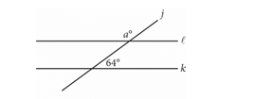
In the figure above, lines $l$ and $k$ are parallel.
What is the value of $a$ ?
A)26
B)64
C)116
D)154
Answer: C
Explanation:
Choice C is correct. Since lines $l$ and k are parallel, corresponding angles formed by the intersection of line j with lines $l$ and k are congruent. Therefore, the angle with measure a must be the supplement of the angle with measure ${64}^{∘}$. The sum of two supplementary angles is ${180}^{∘}$, so $a=180-64=116$.
Choice A is incorrect and likely results from thinking the angle with measure $a^{∘}$ is the complement of the angle with measure ${64}^{∘}$. Choice B is incorrect and likely results from thinking the angle with measure $a^{∘}$ is congruent to the angle with measure ${64}^{∘}$. Choice D is incorrect and likely results from a conceptual or computational error.

Q.16) Lines, angles, and triangles
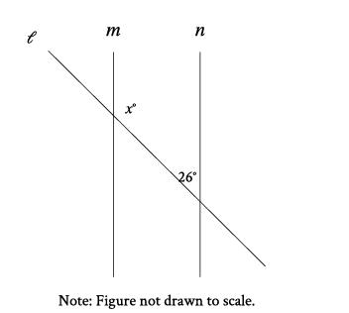

In the figure shown, line $m$ is parallel to line $n$. What is the value of $x$ ?
A. $13$
B. 26
C. 52
D. 154
Answer: D
Explanation:
Choice D is correct. The sum of consecutive interior angles between two parallel lines and on the same side of the transversal is 180 degrees. Since it's given that line $m$ is parallel to line $n$, it follows that $x+26=180$. Subtracting 26 from both sides of this equation yields 154 . Therefore, the value of $x$ is 154 .
Choice A is incorrect. This is half of the given angle measure.
Choice B is incorrect. This is the value of the given angle measure.
Choice C is incorrect. This is twice the value of the given angle measure.

Q.17) Lines, angles, and triangles
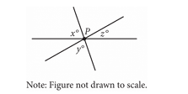
In the figure, three lines intersect at point $P$. If $x=65$ and $y=75$, what is the value of $z$ ?
A)140
B)80
C)40
D)20
Answer: C
Explanation:
Choice C is correct. The angle that is shown as lying between the $y^{∘}$ angle and the $z^{∘}$ angle is a vertical angle with the $x^{∘}$ angle. Since vertical angles are congruent and $x=65$, the angle between the $y^{∘}$ angle and the $z^{∘}$ angle measures ${65}^{∘}$. Since the ${65}^{∘}$ angle, the $y^{∘}$ angle, and the $z^{∘}$ angle are adjacent and form a straight angle, it follows that the sum of the measures of these three angles is ${180}^{∘}$, which is represented by the equation ${65}^{∘}+y^{∘}+z^{∘}={180}^{∘}$. It's given that $y=75$. Substituting 75 for y yields ${65}^{∘}+{75}^{∘}+z^{∘}={180}^{∘}$, which can be rewritten as ${140}^{∘}+z^{∘}={180}^{∘}$. Subtracting ${140}^{∘}$ from both sides of this equation yields $z^{∘}={40}^{∘}$. Therefore, $z=40$.
Choice A is incorrect and may result from finding the value of $x+y$ rather than $z$. Choices B and D are incorrect and may result from conceptual or computational errors.

Q.18) Lines, angles, and triangles
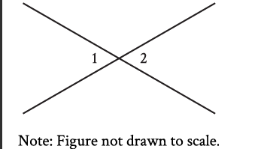
In the figure, two lines intersect at a point. Angle 1 and angle 2 are vertical angles. The measure of angle 1 is ${72}^{∘}$. What is the measure of angle 2?
A)${72}^{∘}$
B)${108}^{∘}$
C)${144}^{∘}$
D)${288}^{∘}$
Answer: A
Explanation:
Choice A is correct. It's given that angle $1$ and angle $2$ are vertical angles, and the measure of angle $1$ is ${72}^{∘}$. Vertical angles have equal measures. Therefore, the measure of angle $2$ is ${72}^{∘}$.
Choice B is incorrect. This is the measure of an angle that is supplementary, not congruent, to angle 1 .
Choice C is incorrect. This is the sum of the measures of angle $1$ and angle $2$.
Choice D is incorrect and may result from conceptual or calculation errors.

Q.19) Lines, angles, and triangles

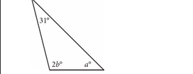
In the triangle above, $a=45$. What is the value of $b$ ?
A)52
B)59
C)76
D)104
Answer: A
Explanation:
Choice A is correct. The sum of the measures of the three interior angles of a triangle is ${180}^{∘}$. Therefore, $31+2b+a=180$. Since it's given that $a=45$, it follows that $31+2b+45=180$, or $2b=104$. Dividing both sides of this equation by 2 yields $b=52$.
Choice B is incorrect and may result from a calculation error. Choice C is incorrect. This is the value of $a+31$. Choice D is incorrect. This is the value of $2b$.

Q.20) Lines, angles, and triangles

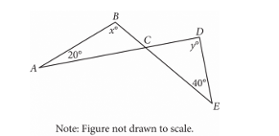
In the figure above, $AD$ intersects $BE$ at $C$. If $x=100$, what is the value of $y$ ?
A)100
B)90
C)80
D)60
Answer: C
Explanation:
Choice $C$ is correct. It's given that $x=100$; therefore, substituting 100 for $x$ in triangle $ABC$ gives two known angle measures for this triangle. The sum of the measures of the interior angles of any triangle equals ${180}^{∘}$. Subtracting the two known angle measures of triangle ABC from ${180}^{∘}$ gives the third angle measure: ${180}^{∘}-{100}^{∘}-{20}^{∘}={60}^{∘}$. This is the measure of angle BCA . Since vertical angles are congruent, the measure of angle DCE is also ${60}^{∘}$. Subtracting the two known angle measures of triangle CDE from ${180}^{∘}$ gives the third angle measure: ${180}^{∘}-{60}^{∘}-{40}^{∘}={80}^{∘}$. Therefore, the value of y is 80 .
Choice A is incorrect and may result from a calculation error.
Choice B is incorrect and may result from classifying angle CDE as a right angle.
Choice D is incorrect and may result from finding the measure of angle BCA or DCE instead of the measure of angle CDE.

Q.21) Lines, angles, and triangles
At a certain time and day, the Washington Monument in Washington, DC, casts a shadow that is 300 feet long. At the same time, a nearby cherry tree casts a shadow that is 16 feet long. Given that the Washington Monument is approximately 555 feet tall, which of the following is closest to the height, in feet, of the cherry tree?
A)10
B)20
C)30
D)35
Answer: C
Explanation:
Choice C is correct. There is a proportional relationship between the height of an object and the length of its shadow. Let c represent the height, in feet, of the cherry tree. The given relationship can be expressed by the proportion $\frac{555}{300}=\frac{c}{16}$. Multiplying both sides of this equation by 16 yields $c=29.6$. This height is closest to the value given in choice $C,30$.
Choices A, B, and D are incorrect and may result from calculation errors.

Q.22) Lines, angles, and triangles
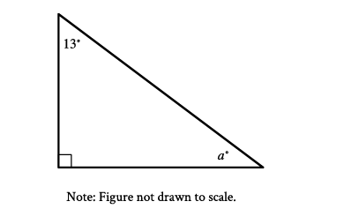
In the right triangle shown, what is the value of $a$ ?
A)$13$
B)77
C)90
D)103
Answer: B
Explanation:
Choice B is correct. The triangle shown is a right triangle, where the interior angle shown with a right angle symbol has a measure of ${90}^{∘}$. It's shown that the other two interior angles measure ${13}^{∘}$ and $a^{∘}$. The sum of the measures of the interior angles of a triangle is ${180}^{∘}$; therefore, $90+13+a=180$. Combining like terms on the left-hand side of this equation yields $103+a=180$. Subtracting 103 from both sides of this equation yields $a=77$.
Choice A is incorrect. This is the measure, in degrees, of the other acute interior angle of the right triangle, not the value of $a$.
Choice C is incorrect. This is the measure, in degrees, of the right angle of the right triangle, not the value of $a$.
Choice D is incorrect. This is the sum of the measures, in degrees, of the other two interior angles of the right triangle, not the value of $a$.

Q.24) Lines, angles, and triangles
In $△RST$, the measure of $∠R$ is ${63}^{∘}$. Which of the following could be the measure, in degrees, of $∠S$ ?
A)116
B)118
C)126
D)180
Answer: A
Explanation:
Choice A is correct. The sum of the measures of the angles of a triangle is ${180}^{∘}$. Therefore, the sum of the measures of $∠R,∠S$, and $∠T$ is ${180}^{∘}$. It's given that the measure of $∠R$ is ${63}^{∘}$. It follows that the sum of the measures of $∠S$ and $∠T$ is $(180-63)^{∘}$ , or ${117}^{∘}$. Therefore, the measure of $∠S$, in degrees, must be less than 117 . Of the given choices, only 116 is less than 117 . Thus, the measure, in degrees, of $∠S$ could be 116 .
Choice B is incorrect. If the measure of $∠S$ is ${118}^{∘}$, then the sum of the measures of the angles of the triangle is greater than, not equal to, ${180}^{∘}$.
Choice C is incorrect. If the measure of $∠S$ is ${126}^{∘}$, then the sum of the measures of the angles of the triangle is greater than, not equal to, ${180}^{∘}$.
Choice D is incorrect. This is the sum of the measures of the angles of a triangle, in degrees.

Q.25) Lines, angles, and triangles
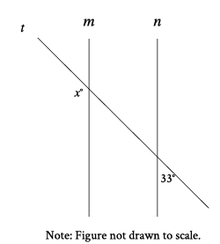
In the figure, line $m$ is parallel to line $n$, and line $t$ intersects both lines. What is the value of $x$ ?
A)33
B)57
C)$123$
D)147
Answer: D
Explanation:
Choice D is correct. It's given that line $m$ is parallel to line $n$, and line $t$ intersects both lines. It follows that line $t$ is a transversal. When two lines are parallel and intersected by a transversal, exterior angles on the same side of the transversal are supplementary. Thus, $x+33=180$. Subtracting 33 from both sides of this equation yields $x=147$. Therefore, the value of $x$ is 147.
Choice A is incorrect and may result from conceptual or calculation errors.
Choice B is incorrect and may result from conceptual or calculation errors.
Choice C is incorrect and may result from conceptual or calculation errors.

Q.26) Lines, angles, and triangles
In $△XYZ$, the measure of $∠X$ is ${23}^{∘}$ and the measure of $∠Y$ is ${66}^{∘}$. What is the measure of $∠Z$ ?
A)${43}^{∘}$
B)${89}^{∘}$
C)${91}^{∘}$
D)${179}^{∘}$
Answer: C
Explanation:
Choice C is correct. The triangle angle sum theorem states that the sum of the measures of the interior angles of a triangle is ${180}^{∘}$. It's given that in $△XYZ$, the measure of $∠X$ is ${23}^{∘}$ and the measure of $∠Y$ is ${66}^{∘}$. It follows that the measure of $∠Z$ is $(180-23-66)^{∘}$, or ${91}^{∘}$.
Choice A is incorrect and may result from conceptual or calculation errors.
Choice B is incorrect. This is the sum of the measures of $∠X$ and $∠Y$, not the measure of $∠Z$.
Choice D is incorrect and may result from conceptual or calculation errors.

Q.27) Lines, angles, and triangles
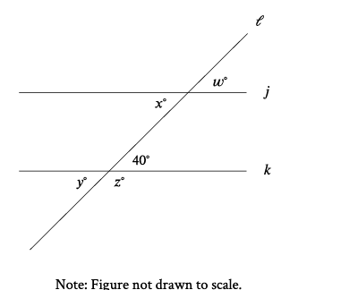
In the figure shown, line $l$ intersects lines $j$ and $k$. Which additional piece of information is sufficient to prove that lines $j$ and $k$ are parallel?
A)$w=40$
B)$x=140$
C)$y=40$
D)$z=140$
Answer: A
Explanation:
Choice A is correct. In the figure shown, lines $j$ and $k$ are parallel if and only if a pair of corresponding angles are congruent. It's given that one angle has a measure of ${40}^{∘}$ and that the corresponding angle has a measure of $w^{∘}$. Therefore, $w=40$ is sufficient to prove that lines $j$ and $k$ are parallel.
Choice B is incorrect. The angle measuring $x^{∘}$ and the angle measuring ${40}^{∘}$ are alternate interior angles. Thus, if lines $j$ and $k$ are parallel, $x$ is equal to $40$, not 140 .
Choice C is incorrect. The angle measuring $y^{∘}$ and the angle measuring ${40}^{∘}$ are vertical angles. Thus, $y=40$, whether lines $j$ and $k$ are parallel or not.
Choice D is incorrect. The angle measuring $z^{∘}$ is supplementary to the angle measuring ${40}^{∘}$. Thus, $z=180-40$, or $z=140$ , whether lines $j$ and $k$ are parallel or not.

Q.28) Lines, angles, and triangles
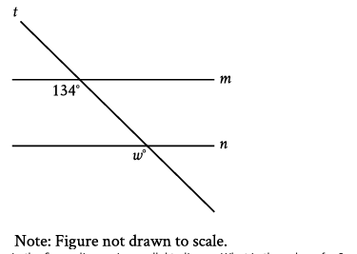
In the figure, line $m$ is parallel to line $n$. What is the value of $w$ ?
A)13
B)34
C)66
D)$134$
Answer: D
Explanation:
Choice D is correct. It's given that lines $m$ and $n$ are parallel. Since line $t$ intersects both lines $m$ and $n$, it's a transversal. The angles in the figure marked as ${134}^{∘}$ and $w^{∘}$ are on the same side of the transversal, where one is an interior angle with line $m$ as a side, and the other is an exterior angle with line $n$ as a side. Thus, the marked angles are corresponding angles. When two parallel lines are intersected by a transversal, corresponding angles are congruent and, therefore, have equal measure. It follows that $w^{∘}={134}^{∘}$. Therefore, the value of $w$ is $134$.
Choice A is incorrect and may result from conceptual or calculation errors.
Choice B is incorrect and may result from conceptual or calculation errors.
Choice C is incorrect and may result from conceptual or calculation errors.

Q.29) Lines, angles, and triangles
In $△XYZ$, the measure of $∠X$ is ${24}^{∘}$ and the measure of $∠Y$ is ${98}^{∘}$. What is the measure of $∠Z$ ?
A)${58}^{∘}$
B)${74}^{∘}$
C)${122}^{∘}$
D)${212}^{∘}$
Answer: A
Explanation:
Choice A is correct. The triangle angle sum theorem states that the sum of the measures of the interior angles of a triangle is ${180}^{∘}$. It's given that in $△XYZ$, the measure of $∠X$ is ${24}^{∘}$ and the measure of $∠Y$ is ${98}^{∘}$. It follows that the measure of $∠Z$ is $(180-24-98)^{∘}$, or ${58}^{∘}$.
Choice B is incorrect and may result from conceptual or calculation errors.
Choice C is incorrect. This is the sum of the measures of $∠X$ and $∠Y$, not the measure of $∠Z$.
Choice D is incorrect and may result from conceptual or calculation errors.

Q.30) Lines, angles, and triangles
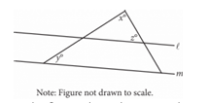

In the figure above, lines $l$ and $m$ are parallel, $y=20$, and $z=60$. What is the value of $x$ ?
A)120
B)100
C)90
D)80
Answer: B
Explanation:
Choice B is correct. Let the measure of the third angle in the smaller triangle be $a^{∘}$. Since lines $l$ and m are parallel and cut by transversals, it follows that the corresponding angles formed are congruent. So $a^{∘}=y^{∘}={20}^{∘}$. The sum of the measures of the interior angles of a triangle is ${180}^{∘}$, which for the interior angles in the smaller triangle yields $a+x+z=180$. Given that $z=60$ and $a=20$, it follows that $20+x+60=180$. Solving for x gives $x=180-60-20$, or $x=100$.
Choice A is incorrect and may result from incorrectly assuming that angles $x+z=180$. Choice $C$ is incorrect and may result from incorrectly assuming that the smaller triangle is a right triangle, with x as the right angle. Choice D is incorrect and may result from a misunderstanding of the exterior angle theorem and incorrectly assuming that $x=y+z$.

Q.31) Lines, angles, and triangles
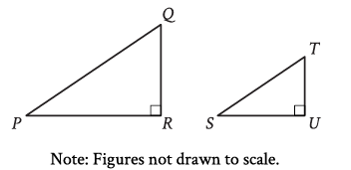
Right triangles $PQR$ and $STU$ are similar, where $P$ corresponds to $S$. If the measure of angle $Q$ is ${18}^{∘}$, what is the measure of angle $S$ ?
A)${18}^{∘}$
B)${72}^{∘}$
C)${82}^{∘}$
D)${162}^{*}$
Answer: B
Explanation:
Choice B is correct. In similar triangles, corresponding angles are congruent. It's given that right triangles $PQR$ and $STU$ are similar, where angle $P$ corresponds to angle $S$. It follows that angle $P$ is congruent to angle $S$. In the triangles shown, angle $R$ and angle $U$ are both marked as right angles, so angle $R$ and angle $U$ are corresponding angles. It follows that angle $Q$ and angle $T$ are corresponding angles, and thus, angle $Q$ is congruent to angle $T$. It's given that the measure of angle $Q$ is ${18}^{*}$, so the measure of angle $T$ is also ${18}^{∘}$. Angle $U$ is a right angle, so the measure of angle $U$ is ${90}^{∘}$. The sum of the measures of the interior angles of a triangle is ${180}^{∘}$. Thus, the sum of the measures of the interior angles of triangle $STU$ is 180 degrees. Let $s$ represent the measure, in degrees, of angle $S$. It follows that $s+18+90=180$, or $s+108=180$. Subtracting 108 from both sides of this equation yields $s=72$. Therefore, if the measure of angle $Q$ is $18$ degrees, then the measure of angle $S$ is $72$ degrees.
Choice A is incorrect. This is the measure of angle $T$.
Choice C is incorrect and may result from conceptual or calculation errors.
Choice D is incorrect. This is the sum of the measures of angle $S$ and angle $U$.

Q.33) Lines, angles, and triangles

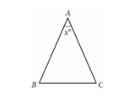

In the given triangle, $AB=AC$ and $∠ABC$ has a measure
of ${67}^{∘}$. What is the value of $x$ ?
A)36
B)46
C)58
D)70
Answer: B
Explanation:
Choice B is correct. Since $AB=AC$, the measures of their corresponding angles, $∠ABC$ and $∠ACB$, are equal. Since $∠ABC$ has a measure of ${67}^{∘}$, the measure of $∠ACB$ is also ${67}^{∘}$. Since the sum of the measures of the interior angles in a triangle is ${180}^{∘}$, it follows that $67+67+x=180$, or $134+x=180$. Subtracting by 134 on both sides of this equation yields $x=46$.
Choices A, C, and D are incorrect and may result from calculation errors.

Q.34) Lines, angles, and triangles
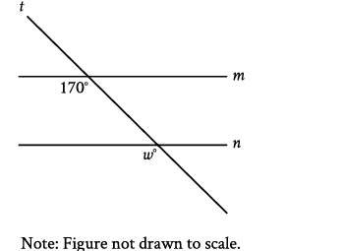
In the figure, line $m$ is parallel to line $n$. What is the value of $w$ ?
A)17
B)30
C)70
D)$170$
Answer: D
Explanation:
Choice D is correct. It's given that lines $m$ and $n$ are parallel. Since line $t$ intersects both lines $m$ and $n$, it's a transversal. The angles in the figure marked as ${170}^{∘}$ and $w^{∘}$ are on the same side of the transversal, where one is an interior angle with line $m$ as a side, and the other is an exterior angle with line $n$ as a side. Thus, the marked angles are corresponding angles. When two parallel lines are intersected by a transversal, corresponding angles are congruent and, therefore, have equal measure. It follows that $w^{∘}={170}^{∘}$. Therefore, the value of $w$ is 170 .
Choice A is incorrect and may result from conceptual or calculation errors.
Choice B is incorrect and may result from conceptual or calculation errors.
Choice C is incorrect and may result from conceptual or calculation errors.

Q.35) Lines, angles, and triangles
Triangles $EFG$ and $JKL$ are congruent, where $E,F$, and $G$ correspond to $J,K$, and $L$, respectively. The measure of angle $E$ is ${45}^{∘}$ and the measure of angle $F$ is ${20}^{∘}$. What is the measure of angle $J$ ?
A)${20}^{∘}$
B)${45}^{∘}$
C)${135}^{∘}$
D)${160}^{∘}$
Answer: B
Explanation:
Choice B is correct. It's given that triangles $EFG$ and $JKL$ are congruent such that angle $E$ corresponds to angle $J$.
Corresponding angles of congruent triangles are congruent, so angle $E$ and angle $J$ must be congruent. Therefore, if the measure of angle $E$ is ${45}^{∘}$, then the measure of angle $J$ is also ${45}^{∘}$.
Choice A is incorrect. This is the measure of angle $K$, not angle $J$.
Choice C is incorrect and may result from conceptual or calculation errors.
Choice D is incorrect and may result from conceptual or calculation errors.

