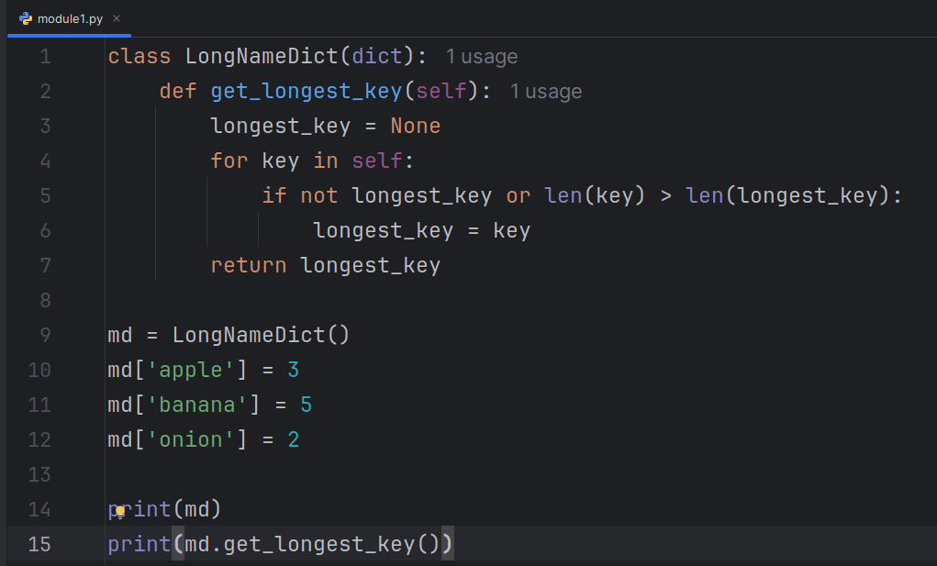

1 volunteer shares the screen and everyone should work together

Write another method to help LongNameDict get the largest value get_largest_value()

- Assume that all values are integers

