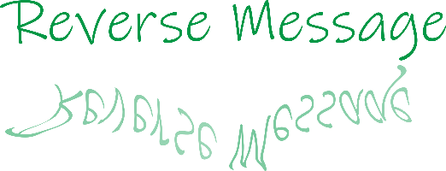

**Documentation**

**Content**

1. Task…………………………………………………………………………3
2. Description………………………………………………………………….4
3. Features……………………………………………………………………..5
4. Functionality………………………………………………………………..9
   1. End to Start…………………………………………………………..9
   2. Numeric……………………………………………………………...9
   3. Numeric reverse…………………………………………………….10
   4. Binary……………………………………………………………….11
   5. Numeric coded……………………………………………………...12
   6. ASCII……………………………………………………………….13
   7. Hexazecimal………………………………………………………..13
   8. Buttons……………………………………………………………..14
5. Source Code……………………………………………………………….17

**1.Task**

Create a mobile application who can edit texts in different ways (Binary, Hexadecimal,etc).

Tehnoligies used:

* Java;
* XML;
* CorelDRAW.

**2.Description**

Application allows user to add a text into an EditText and use an option from menu to convert this text. The converted text will appear into second EditText. User can choose one of the following actions:

* Copy converted text(it will be copied into clipboard);
* Delete text(it will free both fields).

**3.Features**

The app can convert with following options:

* **End to Start**: it will reverse text(last will be first)

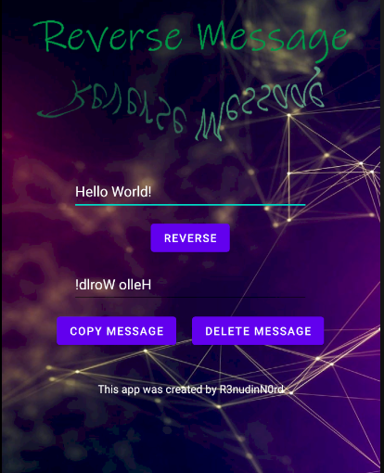

* 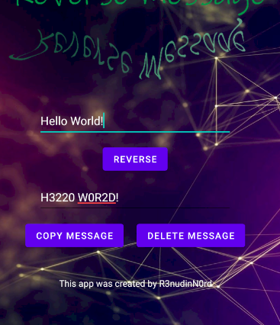**Numeric**: will change some letters in digits(a=4,B=8,E=3 etc) with some similarity

Note: list with all

similarities will be

display at the end of

list.

* **Numeric reverse:** it actually combine the first 2 options(will convert text like in previous option but will display it from last to first)

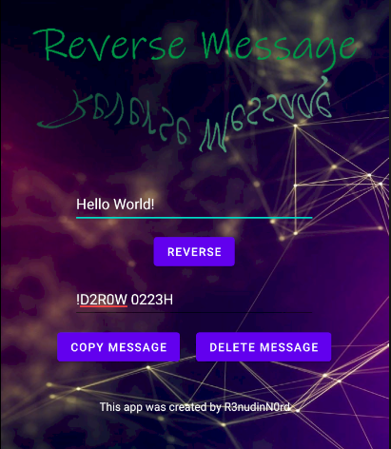

* **Binary:** it takes characters one by one , converts to ASCII code and calculate binary number. (I will explain more in the “Functionality” chapter)

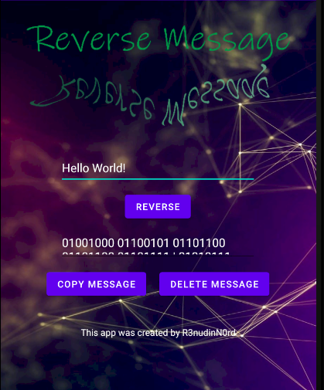

Full text: 01001000 01100101 01101100 01101100 01101111 | 01010111 01101111 01110010 01101100 01100100 00100001

* **Numeric coded:** convert text from letters to numbers. Every character have a specific code(a=1,b=2,c=3, etc)

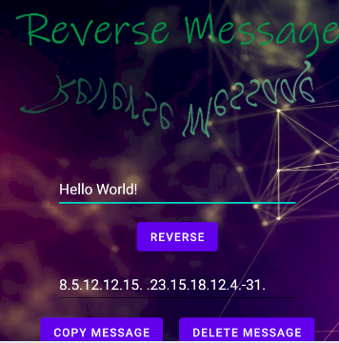

* 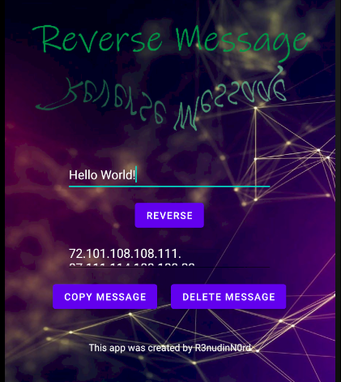**ASCII:** converts every character to it’s ASCII code.

Fulltext: 72.101.108.108.111. 87.111.114.108.100.33.

* **Hexazecimal:** converts every character to ASCII code and after , ASCII code to hexadecimal code.

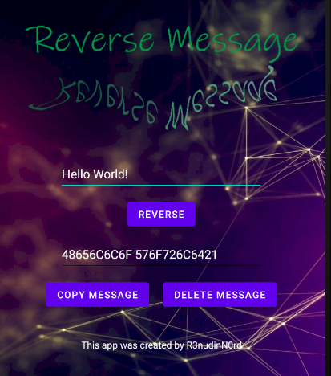

List of all similarities between letters and digits:

A=4,B=8, E=3,O=0,I=1,L=2,S=5,G=6,T=7,P=9

**4.Functionality**

User can write or paste a text to first EditText and after it should open menu to select the converter option. Every option have an ID who will be passed to a variable(named “decizie”) after option was pressed.

There is 7 options to convert so it’s 7 different ID’s.(By pressing first option decizie will get 1, by pressing second option decizie will get 2… by pressing last option decizie will get 7).

**4.1 decizie=1: End to Start**

For this option was very simple to convert the text. I used function “reverse()” from StringBuffer type. So I read the text from EditText , create a buffer with this text and display text with “buffer.reverse()”.



**4.2 decizie=2: Numeric**

To make this option possible , I choose to make all characters uppercase. The program get the text from EditText , stores the length of it into an int variable and cover all text character by character. If one of these letters: A,B,E,O,I,L,S,G,T,P is find, it will be replaced with a digit(0,1,2,3,4,5,6,7,8,9). The replacement is performed with function ”substring()”.

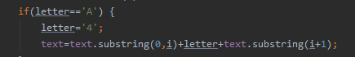

To translate what the code above does:

The text receives the text up to the letter found(in this case the letter is ‘A’) ;

The letter is replaced with digit(in this case ‘4’) who is added to position i(i is the position where we find the specific letter: A);

The text receives the text from postion i+1to the end.

Bassicly we just pulled out the letter and entered the digit on it’s position.

**4.3 decizie=3: Numeric reverse**

As I said above, this option is a combination between first and second option.

I change the text exactly as in option 2 and display it reversed as in option 1.

**4.4 decizie=4: Binary**

There is a little more to explain about this option.

I get the text from EditText, I calculate it’s length and stored into an int variable.

I cover all text characters one by one using a ‘for’structure. Every time when I find a SPACE character I will save into a String(textToDisplay) character ’| ’ to see difference between characters after conversion.

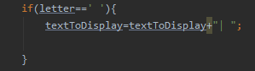  
If the character isn’t a white space, I store the ASCII code of character to int variable and. The binary number will be stored to a String(to prevent losing of 0 character before number => 00110011 to int will look like 110011).

Binry number is calculated using a ‘while’ cycle(it will be calculated reversed).

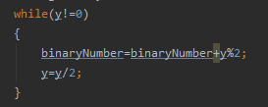

After this we have to verify how many characters has the new string(binaryNumber) to know how many characters we have to add(I decided to display with 8 bits). So I cover the binary number while length of String is below than 8 adding ‘0’ after every step.

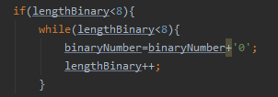

At the end I put into textToDisplay the binaryNumber reversed using like at first option “buffer.reverse();”

**4.5 decizie=5: Numeric coded**

I decided to make a function who returns value of every character after convert.

Every character is verified :

* If character is a white space textToDisplay will get SPACE
* Otherwise textToDisplay will get value returned by function “returnNumber()”

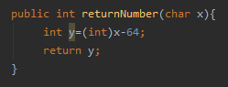

The function get a character and return the ASCII value – 64. This means everyone character will be replaced with it’s position in alphabet(A=1,B=2 etc).

**4.6 decizie=6:ASCII**

This option replace every character with it’s ASCII code.

Again , I decided to use a function called “returnASCII()”.

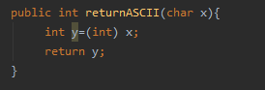

If I find a white space I will add SPACE. Otherwise I will add the ASCII code of character.

**4.7 decizie=7:Hexazecimal**

I proceed similarly to binary conversion, but in this case I will divide with 16 instead of 2. Again, the text will be calculated reversed.

If the rest of the division is lower than 10, then “textToDisplay” will get the rest. Otherwise , “textToDisplay” will get the corresponding value(10=A, 11=B, 12=C, 13=D, 14=E, 15=F).

I verify it by using a switch.

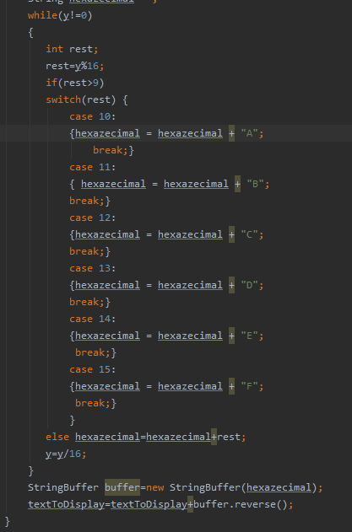At the end , the text will be displayed but reversed.

User can convert text only using the “REVERSE” button. All conversions shown will be applied just by pressing this button.

**4.8 Buttons:**

**Copy Button:**

For copy button I choose to make a function. Every time when the button is pressed , the following will happened:

* I get the text from second EditText =>
* A clipboard object is created =>
* Converted text is added to ClipData =>
* The ClipData is set to primary //

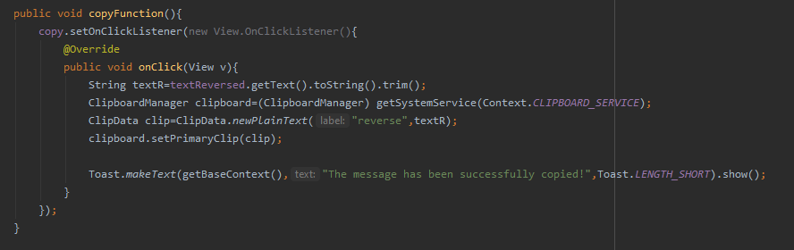

**Delete Button:**

The delete button set the text from second EditText to null.

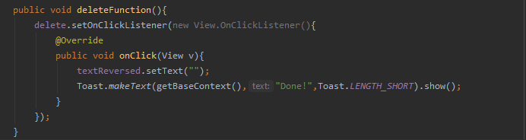

**Images used**

I don’t own the background image. I downloaded it from Goggle Images.



The green logo (Reverse Message) was made by me with Corel DRAW.



**5.Sorce Code**

**MainActivity.java :**

package com.example.reversechat;  
  
import androidx.annotation.NonNull;  
import androidx.appcompat.app.AppCompatActivity;  
  
import android.content.ClipData;  
import android.content.ClipboardManager;  
import android.content.Context;  
import android.os.Bundle;  
import android.view.Menu;  
import android.view.MenuInflater;  
import android.view.MenuItem;  
import android.view.View;  
import android.widget.Button;  
import android.widget.EditText;  
import android.widget.Toast;  
  
public class MainActivity extends AppCompatActivity {  
  
 Button reverse,copy,delete;  
 EditText textToReverse,textReversed;  
 String text;  
 int decizie=1;  
 @Override  
 protected void onCreate(Bundle savedInstanceState) {  
 super.onCreate(savedInstanceState);  
 setContentView(R.layout.*activity_main*);  
  
 copy=(Button) findViewById(R.id.*copyButton*);  
 delete=(Button) findViewById(R.id.*deleteButton*);  
 reverse=(Button) findViewById(R.id.*reverse_btn*);  
 textReversed=(EditText) findViewById(R.id.*reverse_text*);  
 textToReverse=(EditText) findViewById(R.id.*text*);  
 reverseFunction();  
 copyFunction();  
 deleteFunction();  
 }  
  
 @Override  
 public boolean onCreateOptionsMenu(Menu menu) {  
 MenuInflater inflater= getMenuInflater();  
 inflater.inflate(R.menu.*menu_rc*,menu);  
 return true;  
 }  
  
 @Override  
 public boolean onOptionsItemSelected(@NonNull MenuItem item) {  
  
 switch (item.getItemId()) {  
 case R.id.*endToStart*:  
 decizie = 1;  
 Toast.*makeText*(this, "End to Start mode was selected!", Toast.*LENGTH_SHORT*).show();  
 return true;  
 case R.id.*numeric*:  
 decizie=2;  
 Toast.*makeText*(this,"Numeric mode was selected!",Toast.*LENGTH_SHORT*).show();  
 return true;  
 case R.id.*reverse_numeric*:  
 decizie=3;  
 Toast.*makeText*(this, "Numeric reverse was selected!", Toast.*LENGTH_SHORT*).show();  
 return true;  
 case R.id.*binary*:  
 decizie=4;  
 Toast.*makeText*(this, "Binary was selected!", Toast.*LENGTH_SHORT*).show();  
 return true;  
 case R.id.*numericCode*:  
 decizie=5;  
 Toast.*makeText*(this,"Numeric Code was selected!",Toast.*LENGTH_SHORT*).show();  
 return true;  
 case R.id.*ascii*:  
 decizie=6;  
 Toast.*makeText*(this, "ASCII mode was selected!", Toast.*LENGTH_SHORT*).show();  
 return true;  
 case R.id.*hexa*:  
 decizie=7;  
 Toast.*makeText*(this, "Hexazecimal was selected!", Toast.*LENGTH_SHORT*).show();  
 }  
  
  
 return super.onOptionsItemSelected(item);  
 }  
  
 public void reverseFunction(){  
 reverse.setOnClickListener(new View.OnClickListener(){  
 @Override  
 public void onClick(View v){  
 if(decizie==1){  
 text=textToReverse.getText().toString().trim();  
 StringBuffer buffer=new StringBuffer(text);  
 textReversed.setText(buffer.reverse());  
 textToReverse.setText("");  
 }  
 else if(decizie==2){  
 text=textToReverse.getText().toString();  
 text=text.toUpperCase();  
 int length=text.length();  
 char letter;  
 for(int i=0;i<length;i++)  
 {  
 letter=text.charAt(i);  
 if(letter=='A') {  
 letter='4';  
 text=text.substring(0,i)+letter+text.substring(i+1);  
 }  
 else if(letter=='B'){  
 letter='8';  
 text=text.substring(0,i)+letter+text.substring(i+1);  
 }  
 else if(letter=='E'){  
 letter='3';  
 text=text.substring(0,i)+letter+text.substring(i+1);  
 }  
 else if(letter=='O'){  
 letter='0';  
 text=text.substring(0,i)+letter+text.substring(i+1);  
 }  
 else if(letter=='I'){  
 letter='1';  
 text=text.substring(0,i)+letter+text.substring(i+1);  
 }  
 else if(letter=='L'){  
 letter='2';  
 text=text.substring(0,i)+letter+text.substring(i+1);  
 }  
 else if(letter=='S'){  
 letter='5';  
 text=text.substring(0,i)+letter+text.substring(i+1);  
 }  
 else if(letter=='G'){  
 letter='6';  
 text=text.substring(0,i)+letter+text.substring(i+1);  
 }  
 else if(letter=='T'){  
 letter='7';  
 text=text.substring(0,i)+letter+text.substring(i+1);  
 }  
 else if(letter=='P'){  
 letter='9';  
 text=text.substring(0,i)+letter+text.substring(i+1);  
 }  
 }  
 textReversed.setText(text);  
 textToReverse.setText("");  
 }  
 else if(decizie==3){  
 text=textToReverse.getText().toString();  
 text=text.toUpperCase();  
 int length=text.length();  
 char letter;  
 for(int i=0;i<length;i++)  
 {  
 letter=text.charAt(i);  
 if(letter=='A') {  
 letter='4';  
 text=text.substring(0,i)+letter+text.substring(i+1);  
 }  
 else if(letter=='B'){  
 letter='8';  
 text=text.substring(0,i)+letter+text.substring(i+1);  
 }  
 else if(letter=='E'){  
 letter='3';  
 text=text.substring(0,i)+letter+text.substring(i+1);  
 }  
 else if(letter=='O'){  
 letter='0';  
 text=text.substring(0,i)+letter+text.substring(i+1);  
 }  
 else if(letter=='I'){  
 letter='1';  
 text=text.substring(0,i)+letter+text.substring(i+1);  
 }  
 else if(letter=='L'){  
 letter='2';  
 text=text.substring(0,i)+letter+text.substring(i+1);  
 }  
 else if(letter=='S'){  
 letter='5';  
 text=text.substring(0,i)+letter+text.substring(i+1);  
 }  
 else if(letter=='G'){  
 letter='6';  
 text=text.substring(0,i)+letter+text.substring(i+1);  
 }  
 else if(letter=='T'){  
 letter='7';  
 text=text.substring(0,i)+letter+text.substring(i+1);  
 }  
 else if(letter=='P'){  
 letter='9';  
 text=text.substring(0,i)+letter+text.substring(i+1);  
 }  
 }  
 StringBuffer buffer=new StringBuffer(text);  
 textReversed.setText(buffer.reverse());  
 textToReverse.setText("");  
 }  
 else if(decizie==4){  
 char letter;  
 text=textToReverse.getText().toString();  
 String textToDisplay="";  
 int length=text.length();  
 for(int i=0;i<length;i++)  
 {  
 letter=text.charAt(i);  
 if(letter==' '){  
 textToDisplay=textToDisplay+"| ";  
  
 }  
 else{  
 int y=(int) letter;  
 String binaryNumber="";  
 while(y!=0)  
 {  
 binaryNumber=binaryNumber+y%2;  
 y=y/2;  
 }  
 int lengthBinary=binaryNumber.length();  
 if(lengthBinary<8){  
 while(lengthBinary<8){  
 binaryNumber=binaryNumber+'0';  
 lengthBinary++;  
 }  
 }  
 StringBuffer buffer=new StringBuffer(binaryNumber);  
 textToDisplay=textToDisplay+buffer.reverse()+" ";  
 }  
 }  
 textReversed.setText(textToDisplay);  
 textToReverse.setText("");  
  
 }  
 else if(decizie==5){  
 String textToDisplay="";  
 text=textToReverse.getText().toString();  
 text=text.toUpperCase();  
 int length=text.length();  
 char letter;  
  
 for(int i=0;i<length;i++)  
 {  
 letter=text.charAt(i);  
 if(letter==' '){  
 textToDisplay=textToDisplay+" .";  
  
 }  
 else{  
 textToDisplay=textToDisplay+returnNumber(letter)+".";  
 }  
 }  
 textReversed.setText(textToDisplay);  
 textToReverse.setText("");  
 }  
 else if(decizie==6){  
 String textToDisplay="";  
 text=textToReverse.getText().toString();  
 int length=text.length();  
 char letter;  
  
 for(int i=0;i<length;i++) {  
 letter = text.charAt(i);  
 if(letter==' ') textToDisplay=textToDisplay+" ";  
 else textToDisplay=textToDisplay+returnASCII(letter)+".";  
 }  
 textReversed.setText(textToDisplay);  
 textToReverse.setText("");  
 }  
 else if(decizie==7){  
 String textToDisplay="";  
 text=textToReverse.getText().toString();  
 int length=text.length();  
 char letter;  
  
 for(int i=0;i<length;i++)  
 {  
 letter=text.charAt(i);  
 if(letter==' ') textToDisplay=textToDisplay+" ";  
 else{  
 int y=(int) letter;  
 String hexazecimal="";  
 while(y!=0)  
 {  
 int rest;  
 rest=y%16;  
 if(rest>9)  
 switch(rest) {  
 case 10:  
 {hexazecimal = hexazecimal + "A";  
 break;}  
 case 11:  
 { hexazecimal = hexazecimal + "B";  
 break;}  
 case 12:  
 {hexazecimal = hexazecimal + "C";  
 break;}  
 case 13:  
 {hexazecimal = hexazecimal + "D";  
 break;}  
 case 14:  
 {hexazecimal = hexazecimal + "E";  
 break;}  
 case 15:  
 {hexazecimal = hexazecimal + "F";  
 break;}  
 }  
 else hexazecimal=hexazecimal+rest;  
 y=y/16;  
 }  
 StringBuffer buffer=new StringBuffer(hexazecimal);  
 textToDisplay=textToDisplay+buffer.reverse();  
 }  
 }  
  
 textReversed.setText(textToDisplay);  
 textToReverse.setText("");  
 }  
 }  
 });  
 }  
  
 public int returnNumber(char x){  
 int y=(int)x-64;  
 return y;  
 }  
  
 public int returnASCII(char x){  
 int y=(int) x;  
 return y;  
 }  
  
 public void copyFunction(){  
 copy.setOnClickListener(new View.OnClickListener(){  
 @Override  
 public void onClick(View v){  
 String textR=textReversed.getText().toString().trim();  
 ClipboardManager clipboard=(ClipboardManager) getSystemService(Context.*CLIPBOARD_SERVICE*);  
 ClipData clip=ClipData.*newPlainText*("reverse",textR);  
 clipboard.setPrimaryClip(clip);  
  
 Toast.*makeText*(getBaseContext(),"The message has been successfully copied!",Toast.*LENGTH_SHORT*).show();  
 }  
 });  
 }  
  
 public void deleteFunction(){  
 delete.setOnClickListener(new View.OnClickListener(){  
 @Override  
 public void onClick(View v){  
 textReversed.setText("");  
 Toast.*makeText*(getBaseContext(),"Done!",Toast.*LENGTH_SHORT*).show();  
 }  
 });  
 }  
}

**menu_rc.xml :**

<?xml version="1.0" encoding="utf-8"?>  
<menu xmlns:android="http://schemas.android.com/apk/res/android"  
 xmlns:app="http://schemas.android.com/apk/res-auto">  
 <item  
 android:id="@+id/reverse_type"  
 android:title="Reverse Type"  
 app:showAsAction="never">  
  
 <menu>  
 <item android:id="@+id/endToStart"  
 android:title="End to Start (tratS)"/>  
 <item android:id="@+id/numeric"  
 android:title="Numeric (574R7)"/>  
 <item android:id="@+id/reverse_numeric"  
 android:title="Numeric reverse (7RA75)"/>  
 <item android:id="@+id/binary"  
 android:title="Binary (A = 01100001)"/>  
 <item android:id="@+id/numericCode"  
 android:title="Numeric coded (ABC= 1.2.3)"/>  
 <item android:id="@+id/ascii"  
 android:title="ASCII (a=97)"/>  
 <item android:id="@+id/hexa"  
 android:title="Hexazecimal (10=A)"/>  
 </menu>  
  
 </item>  
  
  
</menu>

**activity_main.xml :**

<?xml version="1.0" encoding="utf-8"?>  
<androidx.constraintlayout.widget.ConstraintLayout xmlns:android="http://schemas.android.com/apk/res/android"  
 xmlns:app="http://schemas.android.com/apk/res-auto"  
 xmlns:tools="http://schemas.android.com/tools"  
 android:layout_width="match_parent"  
 android:layout_height="match_parent"  
 android:background="@drawable/background_app"  
 tools:context=".MainActivity">  
  
  
 <ImageView  
 android:id="@+id/logo"  
 android:layout_width="400dp"  
 android:layout_height="190dp"  
 android:maxWidth="400dp"  
 android:maxHeight="190dp"  
 android:src="@drawable/reverse"  
 android:layout_marginTop="20dp"  
 android:adjustViewBounds="true"  
 android:scaleType="fitCenter"  
 app:layout_constraintTop_toTopOf="parent"  
 app:layout_constraintLeft_toLeftOf="parent"  
 app:layout_constraintRight_toRightOf="parent" />  
  
 <EditText  
 android:id="@+id/text"  
 android:layout_width="300dp"  
 android:layout_height="50dp"  
 android:layout_marginTop="20dp"  
 android:width="250dp"  
 android:hint="Put here your message"  
 android:textColor="@color/white"  
 android:textColorHint="@color/white"  
 app:layout_constraintHorizontal_bias="0.496"  
 app:layout_constraintLeft_toLeftOf="parent"  
 app:layout_constraintRight_toRightOf="parent"  
 app:layout_constraintTop_toBottomOf="@id/logo" />  
  
 <Button  
 android:id="@+id/reverse_btn"  
 android:layout_width="wrap_content"  
 android:layout_height="wrap_content"  
 android:text="Reverse"  
 android:layout_marginTop="10dp"  
 app:layout_constraintTop_toBottomOf="@+id/text"  
 app:layout_constraintLeft_toLeftOf="@id/text"  
 app:layout_constraintRight_toRightOf="@id/text"  
 />  
  
   
 <EditText  
 android:id="@+id/reverse_text"  
 android:layout_width="wrap_content"  
 android:layout_height="wrap_content"  
 android:width="300dp"  
 android:height="50dp"  
 android:layout_marginTop="10dp"  
 android:hint="Press REVERSE to get the text"  
 android:textColor="@color/white"  
 android:textColorHint="@color/white"  
 app:layout_constraintRight_toRightOf="@id/text"  
 app:layout_constraintLeft_toLeftOf="@id/text"  
 app:layout_constraintTop_toBottomOf="@id/reverse_btn"  
 />  
 <Button  
 android:id="@+id/copyButton"  
 android:layout_width="wrap_content"  
 android:layout_height="wrap_content"  
 android:text="copy message"  
 android:layout_marginTop="10dp"  
 android:layout_marginRight="10dp"  
 app:layout_constraintLeft_toLeftOf="@+id/reverse_text"  
 app:layout_constraintTop_toBottomOf="@id/reverse_text"  
 app:layout_constraintRight_toLeftOf="@id/deleteButton"  
 />  
  
 <Button  
 android:id="@+id/deleteButton"  
 android:layout_height="wrap_content"  
 android:layout_width="wrap_content"  
 android:text="delete message"  
 android:layout_marginTop="10dp"  
 android:layout_marginLeft="10dp"  
 app:layout_constraintRight_toRightOf="@id/reverse_text"  
 app:layout_constraintTop_toBottomOf="@id/reverse_text"  
 app:layout_constraintLeft_toRightOf="@id/copyButton"  
 />  
  
 <TextView  
 android:layout_width="wrap_content"  
 android:layout_height="wrap_content"  
 android:textColor="@color/white"  
 android:text="This app was created by R3nudinN0rd"  
 android:layout_marginTop="40dp"  
 app:layout_constraintRight_toRightOf="parent"  
 app:layout_constraintLeft_toLeftOf="parent"  
 app:layout_constraintTop_toBottomOf="@id/copyButton"  
  
 />  
  
</androidx.constraintlayout.widget.ConstraintLayout>