**INPUT FUNCTION : (24-07-2024)**

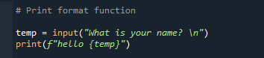

OUTPUT:

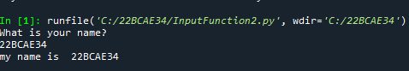

**INPUT FUNCTION 2: (24-07-2024)**

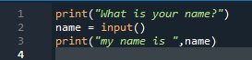

OUTPUT:

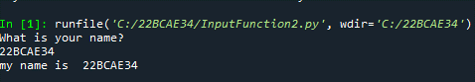

OPEN FILE:

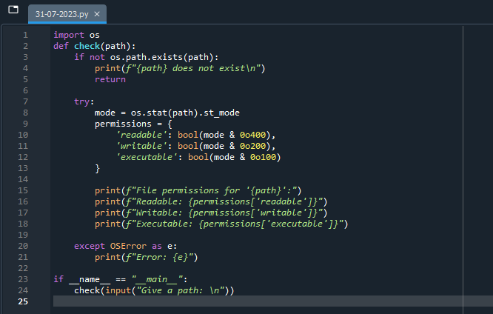

OUTPUT:

