This is a intro into forensics and analysting boot and image drive dumps

The example file can be found at https://www.root-me.org/en/Challenges/Forensic/Find-the-cat

Once the file is downloaded we have a file
Extract the file until you reach it as a .bin file

Run file on the .bin file
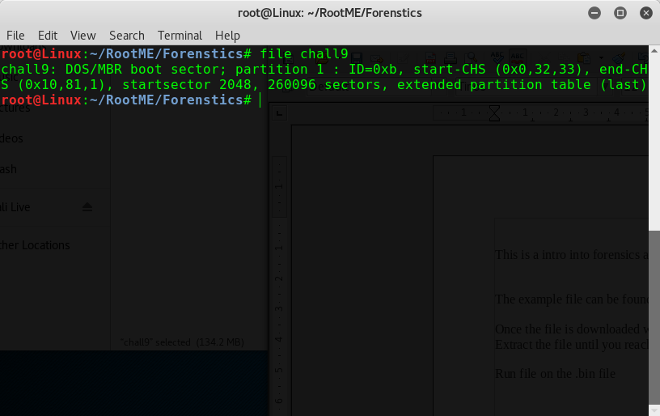
So we have a DOS/MBR Boot sector with a startsector of 2048 which is interesting

Lets double check and see if thats correct
Documentation: http://www.sleuthkit.org/sleuthkit/man/mmls.html
Run sleuth kit (mmls)
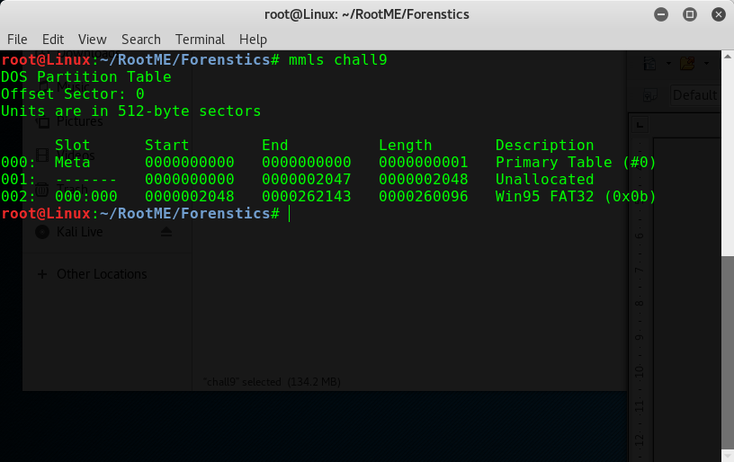
We see that theres a Win95 FAT32 (0x0b) Table and the rest are standard and like we thought the boot start section was 2048, Its better to double check in case something you might have had missed.

Now we have the start sector we can run fls (http://www.sleuthkit.org/sleuthkit/man/fls.html)
you can run fls -o (startsector) == 2048 chall9

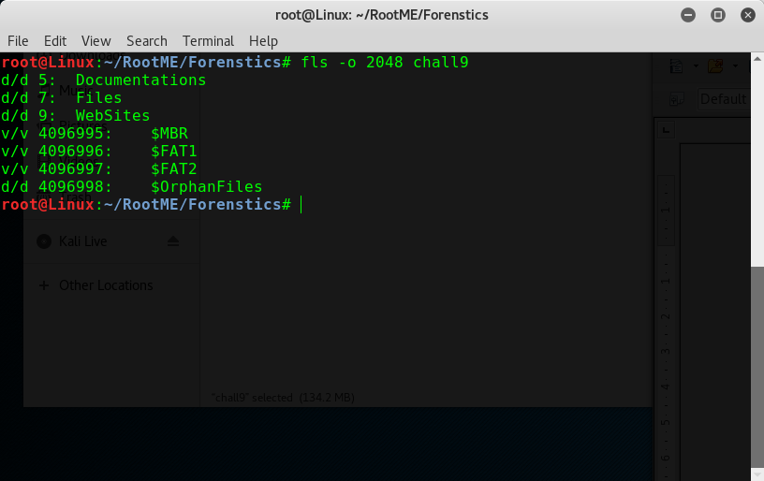
But we want a full dump so run fls -o 2048 chall9 -r -p -u

-r = Recursively display directories. This will not follow deleted directories, because it can’t
-p = Display the full path for each entry. By default it denotes the directory depth on recursive runs with a ’+’ sign.
-u= Display undeleted entries only

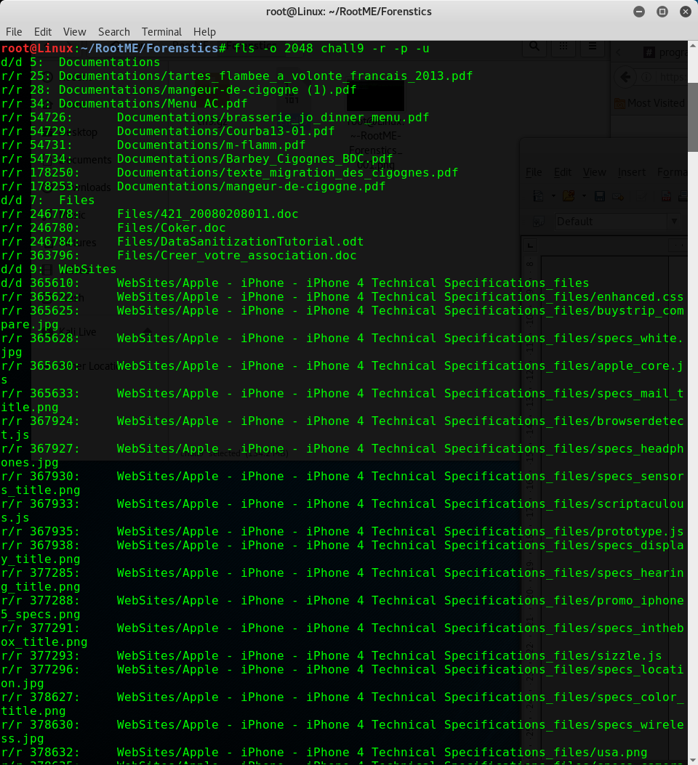

So theres a few files in there

