# Read Me – How to Use our Program

## Logging In

To see the results of our program, run AVS.jar in the main directory. This will run our project.

A window will appear with the title of *Login*. There will be two text fields for a username and password. To enter the program, it needs to match with an existing staff in the Database. The entry available for use is “**user**” for username and “**pass**” for password.

Note: If the screen is blank, please resize the window.

Then press the Login button to proceed to the next screen.

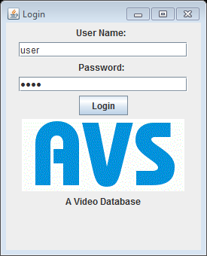

An example of the login screen.

## Main Menu

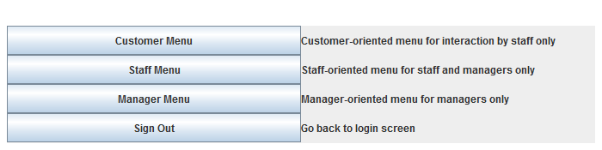

This is our Main Menu. From here, you can go to the three categories, or you can sign out.

## Customer Menu

The Customer Menu allows the renting and returning of videos, which is done at this screen:

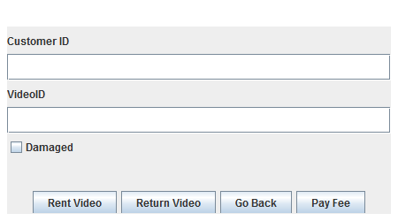

The Customer ID and Video ID must be entered into the text fields. It will then perform the action requested by the button. The Damaged check box only works for returning videos.

The **Pay Fee** button reduces the Fee of the Customer ID to 0.

Note: If either Customer ID or Video ID cannot be matched in the Database, nothing will happen. Also, pressing the button will perform the operation without clearing the fields.

## Staff Menu

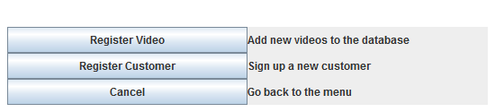

The Staff Menu will lead you to Registering a new Video and a new Customer. Each screen has input boxes and a submit button. When submitting, the entry is added to the database.

## Manager Menu

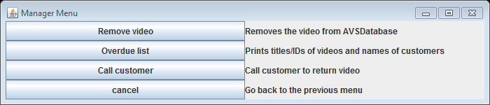

Lastly, the Manager Menu brings up Manager functions. These functions can only be done if the Staff user is a Manager. Removing a video will remove the matching Video ID from the database.

The Overdue list will return a list of all the Overdue Videos in the system.

Call customer allows a manager to call anyone by entering a number.

The back-end CSV files have been populated with information, so Overdue List will generate information. Likewise, the Customer Menu can act on existing data.

This existing data exists in the “**src/**” directory. The associated files are **videos.csv** and **customers.csv**. These files have all the videos and customers that the **AVS.jar** program use.

## IDE Used

The IDE our group used to program our AVS system was Eclipse.

To manually run our code, run the main method inside the Tester Class in the code folder.