AJS outbreak report

# Introduction to this template

This is a template which can be used to create an automated outbreak situation report for acute jaundice syndrome (AJS).

* It is organised by time, place and person. For a more detailed explanation of this template, please visit <https://r4epis.netlify.com/outbreaks>
* Feedback and suggestions are welcome at the [GitHub issues page](https://github.com/R4EPI/sitrep/issues)
* Text within <! > will not show in your final document. These comments are used to explain the template. You can delete them if you want.

## Installing and loading required packages

## filter: no rows removed

## filter: removed 209 rows (97%), 6 rows remaining

## filter: no rows removed

## mutate: no changes

## mutate: new variable 'epiweek' (double) with 19 unique values and 0% NA

## new variable 'epiweek_date' (Date) with 19 unique values and 0% NA

## mutate: converted 'age_years' from integer to double (16 fewer NA)

## converted 'age_months' from integer to double (2 fewer NA)

## mutate: new variable 'age_group_mon' (factor) with 4 unique values and 96% NA

## mutate: new variable 'age_group' (factor) with 5 unique values and 0% NA

## mutate: new variable 'obs_days' (double) with 78 unique values and 0% NA

## mutate: new variable 'DIED' (logical) with 2 unique values and 0% NA

## mutate: new variable 'exit_status2' (character) with 4 unique values and 0% NA

## mutate: new variable 'case_def' (character) with 3 unique values and 0% NA

## mutate: changed 88 values (29%) of 'sex' (88 new NA)

## mutate: no changes

## Warning: Outer names are only allowed for unnamed scalar atomic inputs  
  
## Warning: Outer names are only allowed for unnamed scalar atomic inputs  
  
## Warning: Outer names are only allowed for unnamed scalar atomic inputs  
  
## Warning: Outer names are only allowed for unnamed scalar atomic inputs  
  
## Warning: Outer names are only allowed for unnamed scalar atomic inputs  
  
## Warning: Outer names are only allowed for unnamed scalar atomic inputs  
  
## Warning: Outer names are only allowed for unnamed scalar atomic inputs

## mutate: no changes

## filter: no rows removed

### Person

From the start of the outbreak up until 2019 W25 there were a total of 300 cases. There were 105 (35.0%) females and 107 (35.7%) males.

The most affected age group was 45+ years.

#### Demographics

Cases by age group and definition

## select: dropped one variable (variable)

## rename: renamed one variable (Age group)

| Age group | Confirmed cases (n) | % | Probable cases (n) | % | Suspected cases (n) | % | Total |
| --- | --- | --- | --- | --- | --- | --- | --- |
| 0-2 | 6 | 5.8 | 6 | 6.5 | 4 | 3.9 | 16 |
| 3-14 | 19 | 18.3 | 19 | 20.4 | 25 | 24.3 | 63 |
| 15-29 | 27 | 26.0 | 17 | 18.3 | 29 | 28.2 | 73 |
| 30-44 | 26 | 25.0 | 18 | 19.4 | 11 | 10.7 | 55 |
| 45+ | 26 | 25.0 | 33 | 35.5 | 34 | 33.0 | 93 |
| Total | 104 | 100.0 | 93 | 100.0 | 103 | 100.0 | 300 |

Cases by age group and sex

## select: dropped one variable (variable)

## rename: renamed one variable (Age group)

| Age group | Male cases (n) | % | Female cases (n) | % | Missing cases (n) | % | Total |
| --- | --- | --- | --- | --- | --- | --- | --- |
| 0-2 | 4 | 1.3 | 8 | 2.7 | 4 | 1.3 | 16 |
| 3-14 | 22 | 7.3 | 22 | 7.3 | 19 | 6.3 | 63 |
| 15-29 | 26 | 8.7 | 26 | 8.7 | 21 | 7.0 | 73 |
| 30-44 | 22 | 7.3 | 16 | 5.3 | 17 | 5.7 | 55 |
| 45+ | 33 | 11.0 | 33 | 11.0 | 27 | 9.0 | 93 |
| Total | 107 | 35.7 | 105 | 35.0 | 88 | 29.3 | 300 |

Age pyramid

There were 88 (29.3%) cases missing information on sex and 0 (0.0%) missing age group.

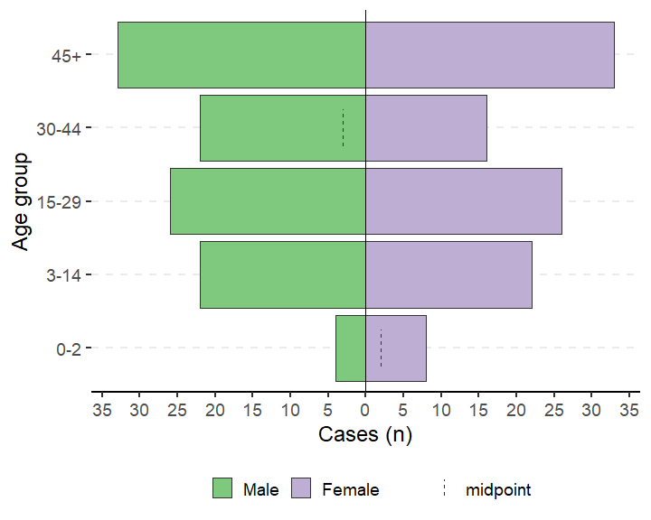

Of the patients, 146 (48.7%) were seen as outpatients and 154 (51.3%) were inpatients. Among inpatients, the median number of days admitted was 20, with a range between 1 and 112 days.

Cases by symptoms

## Note: Using an external vector in selections is ambiguous.  
## i Use `all_of(SYMPTOMS)` instead of `SYMPTOMS` to silence this message.  
## i See <https://tidyselect.r-lib.org/reference/faq-external-vector.html>.  
## This message is displayed once per session.  
## select: dropped one variable (value)  
##   
## mutate: changed 13 values (100%) of 'variable' (0 new NA)

| variable | n | % |
| --- | --- | --- |
| History of fever | 144 | 48.0 |
| Fever | 142 | 47.3 |
| Nausea anorexia | 156 | 52.0 |
| Vomiting | 157 | 52.3 |
| Epigastric pain heartburn | 163 | 54.3 |
| Generalized itch | 140 | 46.7 |
| Headache | 153 | 51.0 |
| Joint pains | 145 | 48.3 |
| Diarrhoea | 159 | 53.0 |
| Bleeding | 138 | 46.0 |
| Convulsions | 163 | 54.3 |
| Mental state | 141 | 47.0 |
| Other symptoms | 144 | 48.0 |

Cases by lab results

## Note: Using an external vector in selections is ambiguous.  
## i Use `all_of(LABS)` instead of `LABS` to silence this message.  
## i See <https://tidyselect.r-lib.org/reference/faq-external-vector.html>.  
## This message is displayed once per session.  
## mutate: converted 'variable' from factor to character (0 new NA)  
##   
## rename: renamed one variable (Lab test)

| Lab test | Positive (n) | % | Negative (n) | % | Not done (n) | % |
| --- | --- | --- | --- | --- | --- | --- |
| Hep b rdt | 104 | 34.7 | 104 | 34.7 | 92 | 30.7 |
| Hep c rdt | 92 | 30.7 | 101 | 33.7 | 107 | 35.7 |
| Hep e rdt | 104 | 34.7 | 95 | 31.7 | 101 | 33.7 |
| Test hepatitis a | 108 | 36.0 | 89 | 29.7 | 103 | 34.3 |
| Test hepatitis b | 98 | 32.7 | 99 | 33.0 | 103 | 34.3 |
| Test hepatitis c | 107 | 35.7 | 89 | 29.7 | 104 | 34.7 |
| Test hepatitis e igg | 86 | 28.7 | 120 | 40.0 | 94 | 31.3 |
| Test hepatitis e igm | 94 | 31.3 | 89 | 29.7 | 117 | 39.0 |
| Test hepatitis e genotype | 101 | 33.7 | 88 | 29.3 | 111 | 37.0 |
| Test hepatitis e virus | 112 | 37.3 | 100 | 33.3 | 88 | 29.3 |
| Malaria rdt at admission | 109 | 36.3 | 88 | 29.3 | 103 | 34.3 |
| Malaria blood film | 88 | 29.3 | 105 | 35.0 | 107 | 35.7 |
| Dengue | 98 | 32.7 | 102 | 34.0 | 100 | 33.3 |
| Dengue rdt | 106 | 35.3 | 86 | 28.7 | 108 | 36.0 |
| Yellow fever | 102 | 34.0 | 98 | 32.7 | 100 | 33.3 |
| Typhoid | 97 | 32.3 | 93 | 31.0 | 110 | 36.7 |
| Chikungunya onyongnyong | 110 | 36.7 | 98 | 32.7 | 92 | 30.7 |
| Ebola marburg | 82 | 27.3 | 129 | 43.0 | 89 | 29.7 |
| Lassa fever | 100 | 33.3 | 94 | 31.3 | 106 | 35.3 |
| Other arthropod transmitted virus | 104 | 34.7 | 93 | 31.0 | 103 | 34.3 |
| Other pathogen | 93 | 31.0 | 98 | 32.7 | 109 | 36.3 |

#### Case fatality ratio

Of 154 (51.3%) inpatients, there have been 38 (12.7%) deaths, of which 37 (12.3%) were dead on arrival.

Among inpatients who died, the time to death is shown below.

| Time (hours) | Deaths (n) | % |
| --- | --- | --- |
| 0-4 hours | 9 | 23.7 |
| >4-24 hours | 12 | 31.6 |
| >24-48 hours | 9 | 23.7 |
| >48 hours | 8 | 21.1 |
| Total | 38 | 100.0 |

The case fatality ratio among inpatients with known outcomes is below.

| Deaths | Cases | CFR (%) | 95%CI |
| --- | --- | --- | --- |
| 38 | 154 | 24.7 | (18.54–32.05) |

The case fatality ratio by sex among inpatients with known outcomes is below.

| Sex | Deaths | Cases | CFR (%) | 95%CI |
| --- | --- | --- | --- | --- |
| Male | 13 | 56 | 23.2 | (14.10–35.77) |
| Female | 12 | 51 | 23.5 | (14.00–36.76) |
| - | 13 | 47 | 27.7 | (16.94–41.76) |
| Total | 38 | 154 | 24.7 | (18.54–32.05) |

CFR by age group among inpatients with known outcomes

| Age group | Deaths | Cases | CFR (%) | 95%CI |
| --- | --- | --- | --- | --- |
| 0-2 | 1 | 6 | 16.7 | (3.01–56.35) |
| 3-14 | 8 | 27 | 29.6 | (15.85–48.48) |
| 15-29 | 7 | 37 | 18.9 | (9.48–34.20) |
| 30-44 | 7 | 36 | 19.4 | (9.75–35.03) |
| 45+ | 15 | 48 | 31.2 | (19.95–45.33) |
| Total | 38 | 154 | 24.7 | (18.54–32.05) |

#### Attack rate

The attack rate per 10,000 population is below (based on available population data available for the catchment area/region of interest).

Below gives the attack rate per 10,000 population (N = 4,999.5)

## rename: renamed 4 variables (Cases (n), Population, AR (per 10,000), 95%CI)

## select: dropped one variable (Population)

| Cases (n) | AR (per 10,000) | 95%CI |
| --- | --- | --- |
| 300 | 600.1 | (537.54–669.33) |

Here, we can see that the attack rate for a population of 4,999.5 was 600.06 (CI 537.54–669.33).

To give attack rate by age group, with appropriate population denominators, use the following code.

## count: now 5 rows and 2 columns, ungrouped

## left_join: added 2 columns (proportions, population)

## > rows only in x 0

## > rows only in y (0)

## > matched rows 5

## > ===

## > rows total 5

## select: dropped 3 variables (n, proportions, population)

## rename: renamed 5 variables (Age group, Cases (n), Population, AR (per 10,000), 95%CI)

| Age group | Cases (n) | Population | AR (per 10,000) | 95%CI |
| --- | --- | --- | --- | --- |
| 0-2 | 16 | 340.0 | 470.6 | (291.71–750.67) |
| 3-14 | 63 | 1,811.0 | 347.9 | (272.84–442.60) |
| 15-29 | 73 | 1,380.0 | 529.0 | (422.82–659.98) |
| 30-44 | 55 | 808.0 | 680.7 | (526.68–875.59) |
| 45+ | 93 | 660.5 | 1,408.0 | (1163.49–1694.10) |

#### Mortality attributable to AJS

## filter: no rows removed

## summarise: now one row and one column, ungrouped

Mortality rate attributable to AJS per 10,000 population

## rename: renamed 4 variables (Deaths, Population, Mortality (per 10,000), 95%CI)

| Deaths | Population | Mortality (per 10,000) | 95%CI |
| --- | --- | --- | --- |
| 84 | 4999.5 | 168 | (135.92–207.53) |

Crude mortality rate attributable to AJS per 10,000 population per day

## rename: renamed 4 variables (Deaths, Person-days, Mortality (per 10,000/day), 95%CI)

| Deaths | Person-days | Mortality (per 10,000/day) | 95%CI |
| --- | --- | --- | --- |
| 84 | 2654735 | 0.3 | (0.26–0.39) |

Mortality rate attributable to AJS per 10,000 patients per day

## rename: renamed 4 variables (Deaths, Person-days, Mortality (per 10,000/day), 95%CI)

| Deaths | Person-days | Mortality (per 10,000/day) | 95%CI |
| --- | --- | --- | --- |
| 84 | 9533 | 88.1 | (71.23–108.95) |

### Time

There were 0 (0.0%) cases missing dates of onset.

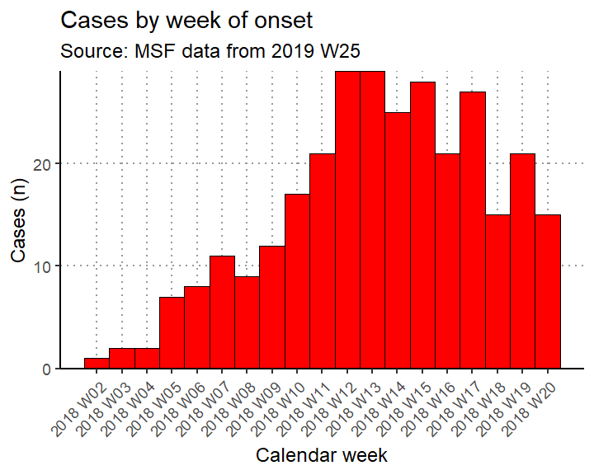

The peak of the outbreak was in 2018 W12

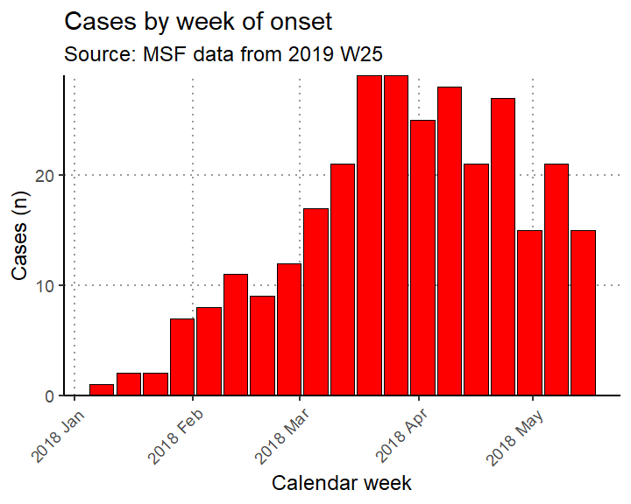

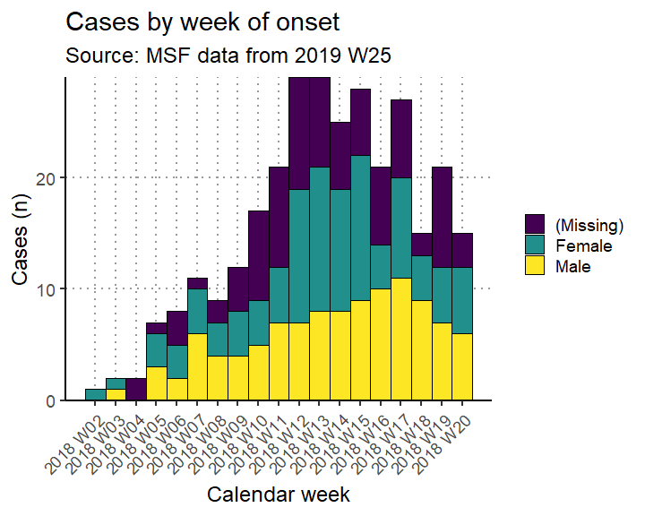

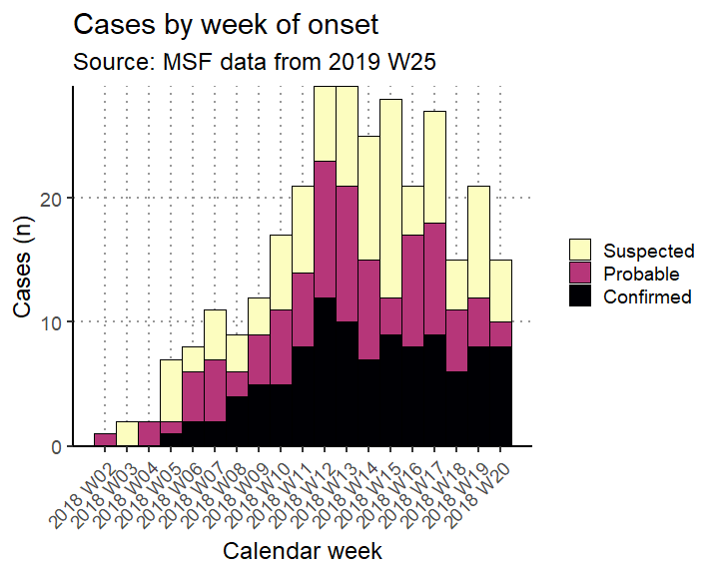

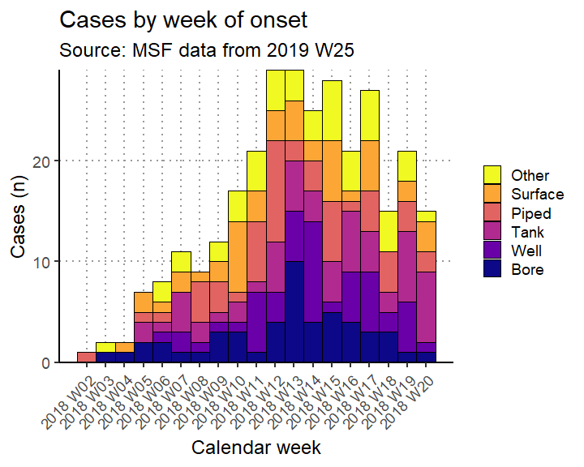

Cases by week of onset among inpatients by sex

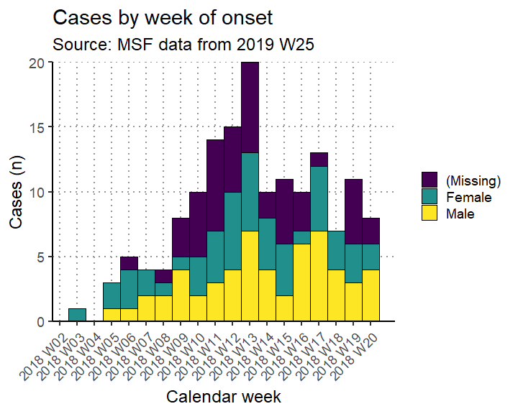

Attack rate per 10,000 population by week

| Epiweek | Cases (n) | Population | AR (per 10,000) | 95%CI |
| --- | --- | --- | --- | --- |
| 2018 W02 | 1 | 4999.5 | 2 | (0.35–11.32) |
| 2018 W03 | 2 | 4999.5 | 4 | (1.10–14.58) |
| 2018 W04 | 2 | 4999.5 | 4 | (1.10–14.58) |
| 2018 W05 | 7 | 4999.5 | 14 | (6.78–28.88) |
| 2018 W06 | 8 | 4999.5 | 16 | (8.11–31.55) |
| 2018 W07 | 11 | 4999.5 | 22 | (12.29–39.36) |
| 2018 W08 | 9 | 4999.5 | 18 | (9.47–34.18) |
| 2018 W09 | 12 | 4999.5 | 24 | (13.74–41.91) |
| 2018 W10 | 17 | 4999.5 | 34 | (21.24–54.39) |
| 2018 W11 | 21 | 4999.5 | 42 | (27.49–64.13) |
| 2018 W12 | 29 | 4999.5 | 58 | (40.42–83.18) |
| 2018 W13 | 29 | 4999.5 | 58 | (40.42–83.18) |
| 2018 W14 | 25 | 4999.5 | 50 | (33.89–73.72) |
| 2018 W15 | 28 | 4999.5 | 56 | (38.78–80.83) |
| 2018 W16 | 21 | 4999.5 | 42 | (27.49–64.13) |
| 2018 W17 | 27 | 4999.5 | 54 | (37.14–78.46) |
| 2018 W18 | 15 | 4999.5 | 30 | (18.19–49.45) |
| 2018 W19 | 21 | 4999.5 | 42 | (27.49–64.13) |
| 2018 W20 | 15 | 4999.5 | 30 | (18.19–49.45) |

Cumulative attack rate per 10,000 population per week

## select: dropped 2 variables (n, cumulative)

## rename: renamed 5 variables (Epiweek, Cases (n), Population, AR (per 10,000), 95%CI)

| Epiweek | Cases (n) | Population | AR (per 10,000) | 95%CI |
| --- | --- | --- | --- | --- |
| 2018 W02 | 1 | 4999.5 | 2.0 | (0.35–11.32) |
| 2018 W03 | 3 | 4999.5 | 6.0 | (2.04–17.63) |
| 2018 W04 | 5 | 4999.5 | 10.0 | (4.27–23.39) |
| 2018 W05 | 12 | 4999.5 | 24.0 | (13.74–41.91) |
| 2018 W06 | 20 | 4999.5 | 40.0 | (25.91–61.71) |
| 2018 W07 | 31 | 4999.5 | 62.0 | (43.72–87.88) |
| 2018 W08 | 40 | 4999.5 | 80.0 | (58.81–108.76) |
| 2018 W09 | 52 | 4999.5 | 104.0 | (79.41–136.13) |
| 2018 W10 | 69 | 4999.5 | 138.0 | (109.21–174.29) |
| 2018 W11 | 90 | 4999.5 | 180.0 | (146.69–220.75) |
| 2018 W12 | 119 | 4999.5 | 238.0 | (199.28–284.08) |
| 2018 W13 | 148 | 4999.5 | 296.0 | (252.54–346.74) |
| 2018 W14 | 173 | 4999.5 | 346.0 | (298.84–400.38) |
| 2018 W15 | 201 | 4999.5 | 402.0 | (351.03–460.12) |
| 2018 W16 | 222 | 4999.5 | 444.0 | (390.36–504.73) |
| 2018 W17 | 249 | 4999.5 | 498.0 | (441.13–561.88) |
| 2018 W18 | 264 | 4999.5 | 528.1 | (469.42–593.55) |
| 2018 W19 | 285 | 4999.5 | 570.1 | (509.12–637.79) |
| 2018 W20 | 300 | 4999.5 | 600.1 | (537.54–669.33) |

Case fatality ratio as a proportion among inpatients by week

## Error in `chr_as_locations()`:  
## ! Can't rename columns that don't exist.  
## x Column `epiweek` doesn't exist.

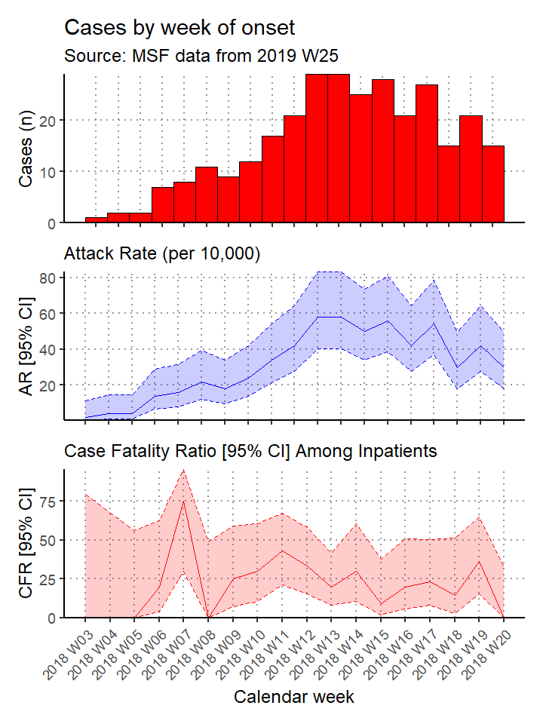

Inpatient admissions by case definition and week

## filter: removed 146 rows (49%), 154 rows remaining

## select: dropped one variable (variable)

| value | Confirmed (n) | % | Probable (n) | % | Suspected (n) | % | Total |
| --- | --- | --- | --- | --- | --- | --- | --- |
| 2018 W03 | 0 | 0.0 | 0 | 0.0 | 1 | 1.7 | 1 |
| 2018 W05 | 0 | 0.0 | 0 | 0.0 | 3 | 5.1 | 3 |
| 2018 W06 | 0 | 0.0 | 3 | 6.8 | 2 | 3.4 | 5 |
| 2018 W07 | 1 | 2.0 | 1 | 2.3 | 2 | 3.4 | 4 |
| 2018 W08 | 0 | 0.0 | 1 | 2.3 | 3 | 5.1 | 4 |
| 2018 W09 | 3 | 5.9 | 3 | 6.8 | 2 | 3.4 | 8 |
| 2018 W10 | 4 | 7.8 | 2 | 4.5 | 4 | 6.8 | 10 |
| 2018 W11 | 6 | 11.8 | 2 | 4.5 | 6 | 10.2 | 14 |
| 2018 W12 | 6 | 11.8 | 6 | 13.6 | 3 | 5.1 | 15 |
| 2018 W13 | 5 | 9.8 | 9 | 20.5 | 6 | 10.2 | 20 |
| 2018 W14 | 4 | 7.8 | 3 | 6.8 | 3 | 5.1 | 10 |
| 2018 W15 | 4 | 7.8 | 1 | 2.3 | 6 | 10.2 | 11 |
| 2018 W16 | 3 | 5.9 | 4 | 9.1 | 3 | 5.1 | 10 |
| 2018 W17 | 3 | 5.9 | 4 | 9.1 | 6 | 10.2 | 13 |
| 2018 W18 | 4 | 7.8 | 2 | 4.5 | 1 | 1.7 | 7 |
| 2018 W19 | 4 | 7.8 | 1 | 2.3 | 6 | 10.2 | 11 |
| 2018 W20 | 4 | 7.8 | 2 | 4.5 | 2 | 3.4 | 8 |
| Total | 51 | 100.0 | 44 | 100.0 | 59 | 100.0 | 154 |

Inpatient discharges by reason for exit and week

## filter: removed 146 rows (49%), 154 rows remaining

## select: dropped one variable (variable)

## rename: renamed one variable (Week)

| Week | Died (n) | % | Discharged (n) | % | Left (n) | % | Transferred (n) | % | Total |
| --- | --- | --- | --- | --- | --- | --- | --- | --- | --- |
| 2018 W03 | 0 | 0.0 | 0 | 0.0 | 0 | 0.0 | 1 | 1.8 | 1 |
| 2018 W05 | 0 | 0.0 | 0 | 0.0 | 1 | 3.1 | 2 | 3.6 | 3 |
| 2018 W06 | 1 | 2.6 | 1 | 3.4 | 1 | 3.1 | 2 | 3.6 | 5 |
| 2018 W07 | 3 | 7.9 | 0 | 0.0 | 0 | 0.0 | 1 | 1.8 | 4 |
| 2018 W08 | 0 | 0.0 | 2 | 6.9 | 1 | 3.1 | 1 | 1.8 | 4 |
| 2018 W09 | 2 | 5.3 | 0 | 0.0 | 3 | 9.4 | 3 | 5.5 | 8 |
| 2018 W10 | 3 | 7.9 | 1 | 3.4 | 1 | 3.1 | 5 | 9.1 | 10 |
| 2018 W11 | 6 | 15.8 | 1 | 3.4 | 3 | 9.4 | 4 | 7.3 | 14 |
| 2018 W12 | 5 | 13.2 | 2 | 6.9 | 4 | 12.5 | 4 | 7.3 | 15 |
| 2018 W13 | 4 | 10.5 | 8 | 27.6 | 2 | 6.2 | 6 | 10.9 | 20 |
| 2018 W14 | 3 | 7.9 | 3 | 10.3 | 1 | 3.1 | 3 | 5.5 | 10 |
| 2018 W15 | 1 | 2.6 | 2 | 6.9 | 3 | 9.4 | 5 | 9.1 | 11 |
| 2018 W16 | 2 | 5.3 | 2 | 6.9 | 3 | 9.4 | 3 | 5.5 | 10 |
| 2018 W17 | 3 | 7.9 | 2 | 6.9 | 3 | 9.4 | 5 | 9.1 | 13 |
| 2018 W18 | 1 | 2.6 | 2 | 6.9 | 3 | 9.4 | 1 | 1.8 | 7 |
| 2018 W19 | 4 | 10.5 | 1 | 3.4 | 2 | 6.2 | 4 | 7.3 | 11 |
| 2018 W20 | 0 | 0.0 | 2 | 6.9 | 1 | 3.1 | 5 | 9.1 | 8 |
| Total | 38 | 100.0 | 29 | 100.0 | 32 | 100.0 | 55 | 100.0 | 154 |

### Place

#### Descriptive

Cases by region and facility type

## select: dropped one variable (variable)

## rename: renamed one variable (Region)

| Region | Outpatient (n) | % | Inpatient (n) | % | Total |
| --- | --- | --- | --- | --- | --- |
| Village A | 47 | 32.2 | 41 | 26.6 | 88 |
| Village B | 36 | 24.7 | 40 | 26.0 | 76 |
| Village C | 29 | 19.9 | 31 | 20.1 | 60 |
| Village D | 34 | 23.3 | 42 | 27.3 | 76 |
| Total | 146 | 100.0 | 154 | 100.0 | 300 |

Inpatient discharges by reason for exit and region

## filter: removed 146 rows (49%), 154 rows remaining

## select: dropped one variable (variable)

## rename: renamed one variable (Region)

| Region | Died (n) | % | Discharged (n) | % | Left (n) | % | Transferred (n) | % | Total |
| --- | --- | --- | --- | --- | --- | --- | --- | --- | --- |
| Village A | 10 | 26.3 | 8 | 27.6 | 8 | 25.0 | 15 | 27.3 | 41 |
| Village B | 8 | 21.1 | 10 | 34.5 | 10 | 31.2 | 12 | 21.8 | 40 |
| Village C | 5 | 13.2 | 4 | 13.8 | 7 | 21.9 | 15 | 27.3 | 31 |
| Village D | 15 | 39.5 | 7 | 24.1 | 7 | 21.9 | 13 | 23.6 | 42 |
| Total | 38 | 100.0 | 29 | 100.0 | 32 | 100.0 | 55 | 100.0 | 154 |

Attack rage per 10,000 population by region

## count: now 4 rows and 2 columns, ungrouped

## left_join: added 2 columns (proportions, population)

## > rows only in x 0

## > rows only in y (0)

## > matched rows 4

## > ===

## > rows total 4

## select: dropped 3 variables (n, proportions, population)

## rename: renamed 6 variables (Region, Cases (n), Population, AR (per 10,000), Lower 95%CI, …)

## rename: renamed one variable (95%CI)

| Region | Cases (n) | Population | AR (per 10,000) | 95%CI |
| --- | --- | --- | --- | --- |
| Village A | 88 | 1,105 | 796.4 | (650.93–970.96) |
| Village B | 76 | 870 | 873.6 | (703.62–1079.79) |
| Village C | 60 | 1,775 | 338.0 | (263.51–432.68) |
| Village D | 76 | 1,225 | 620.4 | (498.53–769.67) |

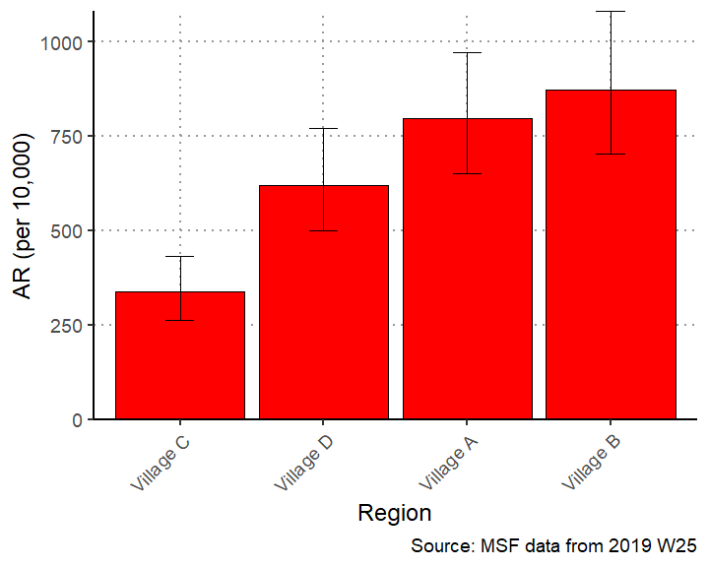

Mortality rate per 10,000 population by region

## group_by: one grouping variable (patient_origin)

## filter (grouped): removed 216 rows (72%), 84 rows remaining

## summarise: now 4 rows and 2 columns, ungrouped

## left_join: added 2 columns (proportions, population)

## > rows only in x 0

## > rows only in y (0)

## > matched rows 4

## > ===

## > rows total 4

## select: dropped 3 variables (deaths, proportions, population)

## rename: renamed 5 variables (Region, Deaths, Population, Mortality (per 10,000), 95%CI)

| Region | Deaths | Population | Mortality (per 10,000) | 95%CI |
| --- | --- | --- | --- | --- |
| Village A | 24 | 1105 | 217.2 | (146.38–321.15) |
| Village B | 21 | 870 | 241.4 | (158.41–366.19) |
| Village C | 14 | 1775 | 78.9 | (47.04–131.96) |
| Village D | 25 | 1225 | 204.1 | (138.61–299.54) |

#### Maps

