## methods

### Data management and analysis

Data was collected using Kobo Collect on Android tablets. Databases were automatically generated from the data entry in the tablets at the time of the interview. Data monitoring was conducted to check for inconsistencies in data entry and responses.

The main outcome of the analysis is the vaccination coverage in Béboto district among children aged 6 months to 9 years following an MSF vaccination campaign. Secondary outcomes were the vaccination coverage of children aged 6 months to 9 years from other vaccination activities (i.e. routine vaccination and supplementary vaccination activity), and the reasons for non-vaccination.

Data cleaning and analysis were conducted using R 3.6.2 (2019-12-12). One cluster was excluded from analysis. This was because the selected cluster was a nomadic village, but when the team arrived the village had moved on; the team therefore selected a nearby nomadic village as a replacement but still weren’t able to complete the 10 interviews required for one cluster. They continued to another nearby (non-nomadic) village to finish the cluster. Of note, in the initial cluster calculations before the survey began, buffers were added to account for possible access issues. Therefore, this team did not need to replace the cluster. It was decided to drop this cluster for simplicity and to follow steps outlined in the protocol regarding what to do in case of an inaccessible cluster.

Survey weights were calculated by multiplying the inverse chances of a cluster being selected within the district by the inverse chances of a household being selected within a cluster.

Only households with children of eligible age (6 months to 9 years) were included in the analysis. The study population’s age and sex distribution were described, and weighted coverage estimates for MSF mass vaccination, routine vaccination, SIA vaccination were calculated. Reasons for non-vaccination were described. Reasons that were classified as “other” with a free text option were reclassified into new categories based on theme. The number of children with a previous previous measles diagnosis were also described.

Overall vaccination coverage was calculated by combining all three vaccination opportunities into one variable. Immunity for the population was calculated by combining children who had either already been vaccinated or had been previously diagnosed with measles.

## RESULTS

### Study Sample

In total, teams visited 448 households in the 13 health zones of Béboto district. Of those households, 48 (10.7%) required a second visit, either because the household was empty (n = 17, 3.8%), or there was no adult present who could consent to the interview (n = 31, 6.9%). In either case, teams returned later in the day to these households. Of households visited a second time, 8 (16.7%) were still empty and 19 (40.0%) still had no one who could consent.

Only one household did not consent to be interviewed because the head of household was absent. In addition, 75 (16.7%) households visited were not interviewed because they did not have any children of eligible age (6 months to 9 years).

In total, teams completed interviews with 321 households of the 438 households visited, giving a response rate of 73.2%.

Data for table # below was obtained from a mixture of paper forms and electronic data collection. However, this resulted in a discrepancy: there are 14 households included in the total number of households visited that are missing from the exclusions. This means that the sum of households interviewed plus the sum of all exclusions does not equal the total households visited.

One possible reason for this is data entry error. During the survey, it was noticed that teams did not always enter data into the tablet when they encountered a house that they would not interview. So it’s possible that occasionally, when teams encountered households without any children aged 6 months to 9 years, they replaced the household per the study protocol but neglected to enter this data into their tablet. Therefore, the count of households without children of eligible age may be an underestimate.

|  |  |  |  |  |  |  |  |  |  |  |  |  |  |  |  |  |  |  |  |  |  |  |  |  |  |  |  |
| --- | --- | --- | --- | --- | --- | --- | --- | --- | --- | --- | --- | --- | --- | --- | --- | --- | --- | --- | --- | --- | --- | --- | --- | --- | --- | --- | --- |
| | Characteristic | Count (n) | | | --- | --- | --- | | Total households interviewed: | 321 | | | Households interviewed - 1st visit | 300 | | | Households interviewed - 2nd visit | 21 | | | Exclusions: |  | | | Households not possible to interview after two visits | | 27 | | Households without eligible children | | 75 | | Households that did not consent | | 1 | | Total households visited | 438 | |   Table 1. Characteristics of the households visited during the vaccination coverage survey for measles in Béboto district, Logone Oriental province, Chad |

### Demographic information:

We included 321 households across 31 clusters in this survey analysis, amounting to 985 children. The median number of children per household was 3 (range: 1–10, standard deviation: 1.6). Among survey respondents, the median age was 32 years, and the majority self-identified as either the father or the mother (Table #).

Table 3. Breakdown of survey respondents by family role

| Caretaker | Count (n) | % |
| --- | --- | --- |
| Father | 495 | 50.3 |
| Mother | 432 | 43.9 |
| Grandmother | 22 | 2.2 |
| Sister | 20 | 2.0 |
| Uncle | 8 | 0.8 |
| Brother | 5 | 0.5 |
| Grandfather | 3 | 0.3 |

Among the 985 surveyed individuals, there were 470 (47.7%) females and 515 (52.3%) males (unweighted). The median age of surveyed individuals was five years (Q1-Q3 of 3-8 years), with 401 children under five years of age (40.7%) and only 3.4% of children under one year of age.

Figure 1. Distribution of individuals surveyed by age-group and gender (N=985)

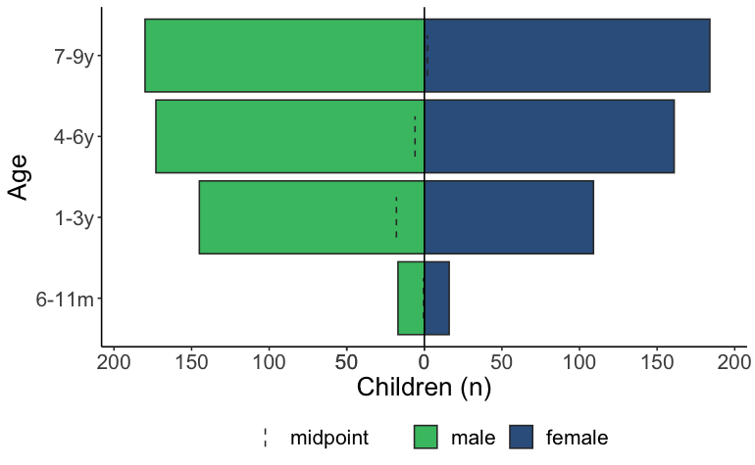

### Vaccination coverage – MSF Vaccination Campaign

Information on the MSF mass vaccination campaign was collected from 985 children aged 6 months to 9 years. Of those children, 95.8% (95% CI: 93.0–97.5) reported receiving a measles vaccination from MSF, either by showing their vaccination card or by verbal confirmation (Table #). The measles vaccination coverage among children who were able to show their vaccination card was 89.4% (95% CI: 84.2–93.1).

Table 4. Measles vaccination coverage among children aged 6 months to 9 years during the MSF mass vaccination campaign in Béboto district, Logone Oriental province, Chad (weighted analysis)

| **MSF vaccination status** | **Children (n)** | **% (95% CI)** | **Design effect** |
| --- | --- | --- | --- |
| Yes – card and verbal | 937 | 95.8 (93.0--97.5) | 2.8 |
| No | 47 | 4.1 (2.4--6.9) | 2.8 |
| Don't know | 1 | 0.1 (0.0--0.6) | 0.7 |

Of the 937 individuals who provided information on the location of their MSF vaccination, most people (97.1%) reported receiving it in their own village.

### Reasons for non vaccination (MSF)

As outlined in Figure #, 4.1% (95% CI: 2.4–6.9) of children were not vaccinated against measles during the MSF mass vaccination campaign. The main reason for this was that the family was away during time of vaccination (n=39). Figure # provides a detailed overview of the reasons for not vaccinating the child during the MSF vaccination campaign, including a breakdown of nine reasons listed as “other”.

Figure 2. Reasons for not receiving measles vaccination during the MSF vaccination campaign in Béboto district (N=47) (weighted analysis)

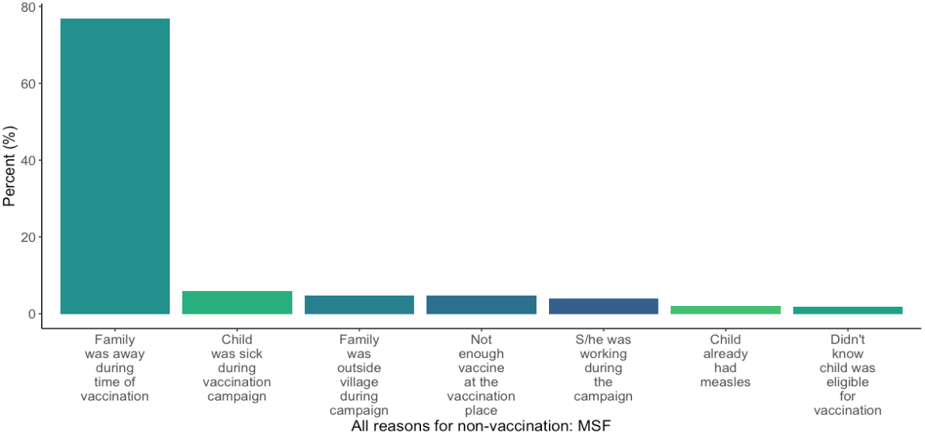

### Vaccination coverage – routine Vaccination (9 months)

Information on routine vaccination status (i.e. the routine vaccination normally administered at 9 months of age) was collected from 985 children aged 6 months to 9 years. Of those children, 45.4% (95% CI: 35.0–56.1) reported receiving a routine measles vaccination, either by showing their vaccination card or by verbal confirmation (Table #). Most of the affirmative responses were through verbal confirmation; the measles vaccination coverage among children who were able to show their vaccination card was 2.1% (95% CI 1.1–3.9).

Table 5. Measles vaccination coverage among children aged 6 months to 9 years during routine vaccination at 9 months in Béboto district, Logone Oriental province, Chad (weighted analysis)

| **Routine vaccination status** | **Children (n)** | **% (95% CI)** | **Design effect** |
| --- | --- | --- | --- |
| Yes | 405 | 45.4 (35.0--56.1) | 11.1 |
| No | 417 | 38.6 (29.5--48.6) | 9.5 |
| Don't know | 160 | 15.6 (9.3--25.0) | 11.1 |
| No answer | 3 | 0.4 (0.1--2.6) | 3.4 |

Of the 405 individuals who provided information on the location of their routine vaccination, most people (78.8%) reported receiving it at the health centre in their health zone. The rest (21.2%) stated that they had to visit a site that was more than 5km away.

### Reasons for non-vaccination (routine)

Of the 985 children included in this survey 417 (38.6%) of children did not receive their routine vaccination against measles at 9 months of age. The primary reason for this (n=209) was that the family was not aware the child should be vaccinated against measles at 9 months. The next most common reason was re-classified as “no reason” (n=62) from the “other” free text category. The majority of responses that were classified as “no reason” had stated “I don’t know” as the response. Figure # provides a detailed overview of the reasons for not vaccinating the child during routine vaccination, including a breakdown of 350 reasons originally listed as “other”.

Figure 3. Reasons for not receiving measles vaccination during the routine (9 months) vaccination in Béboto district (N=417) (weighted analysis)

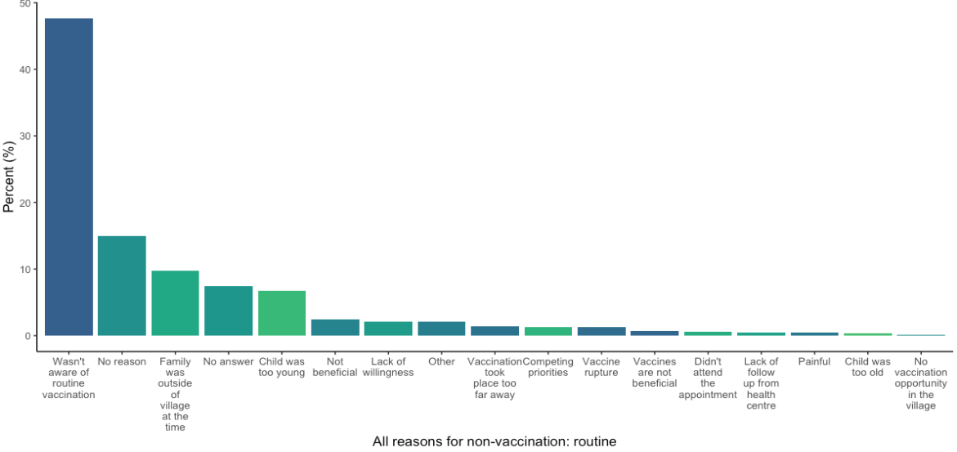

### Vaccination coverage – supplementary vaccination activities (SIA)

Information on supplementary vaccination activities (SIA) was collected from 985 children aged 6 months to 9 years. Of those children, 48.0% (95% CI: 38.3–56.1) reported receiving measles vaccination through previous SIA, either by showing their vaccination card or by verbal confirmation (Table #). Most of the affirmative responses were through verbal confirmation; the measles vaccination coverage among children who were able to show their vaccination card was 1.7% (95% CI 0.6–4.5).

Table 6. Measles vaccination coverage among children aged 6 months to 9 years during other vaccination opportunities in Béboto district, Logone Oriental province, Chad (weighted analysis)

| **SIA vaccination status** | **Children (n)** | **% (95% CI)** | **Design effect** |
| --- | --- | --- | --- |
| Yes | 478 | 48.0 (38.3--57.8) | 9.3 |
| No | 377 | 39.6 (33.8--45.7) | 3.6 |
| Don't know | 122 | 12.4 (7.1--20.8) | 9.7 |
| No answer | 8 | 1.1 (0.3—3.4) | 3.6 |

place_sia_vacc – mostly free text that still needs categorizing.

### Reasons for non-vaccination (SIA)

Of the 985 children included in this survey, 377 (39.6%) did not receive vaccination against measles during any other supplementary immunization activity. Most respondents (n=187) stated the reason for this was that the child was not yet born or was too young to receive a vaccine when a campaign occurred. The next most commonly cited reason (n=83) was that there was no vaccination campaign that had occurred. See figure # for a detailed breakdown of reasons for not vaccinating a child during supplementary immunization activities, including 295 responses that were originally listed as “other”.

Figure 4. Reasons for not receiving measles vaccination during the SIA in Béboto district (N=377) (weighted analysis)

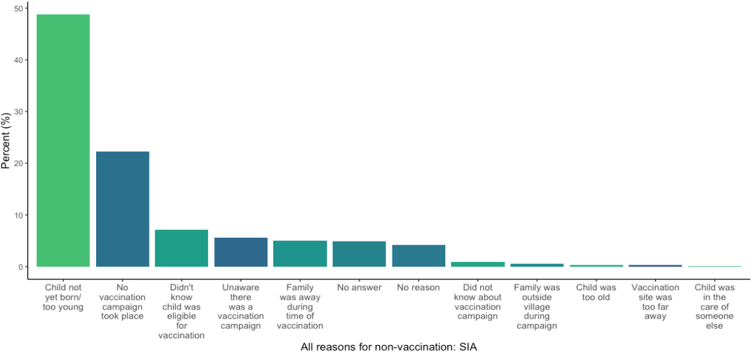

### overall measles vaccination coverage

To calculate overall measles vaccination coverage in Béboto district, all vaccination opportunities were taking into account for the 985 children aged 6 months to 9 years. Of those children, 98.1% (95% CI: 96.3–99.1) reported receiving vaccination in their lifetime, either by showing their vaccination card or by verbal confirmation (Table #).

Table 7. Overall measles vaccination coverage among children aged 6 months to 9 years in Béboto district, Logone Oriental province, Chad (weighted analysis)

| **Overall vaccination status** | **Children (n)** | **Vaccination coverage (95% CI)** | **Design effect** |
| --- | --- | --- | --- |
| Vaccinated | 964 | 98.1% (96.3--99.1) | 2.2 |
| Not vaccinated | 21 | 1.9% (0.9--3.7) | 2.2 |

Figure # presents the vaccination coverage among children aged 6 months to 9 years by the different vaccination opportunities, and the overall vaccination coverage for measles in the 13 health zones where the MSF vaccination campaign and coverage survey took place.

Figure 5. Measles coverage by vaccination opportunity among children aged 6 months to 9 years in Béboto district, Logone Oriental province, Chad (weighted analysis)

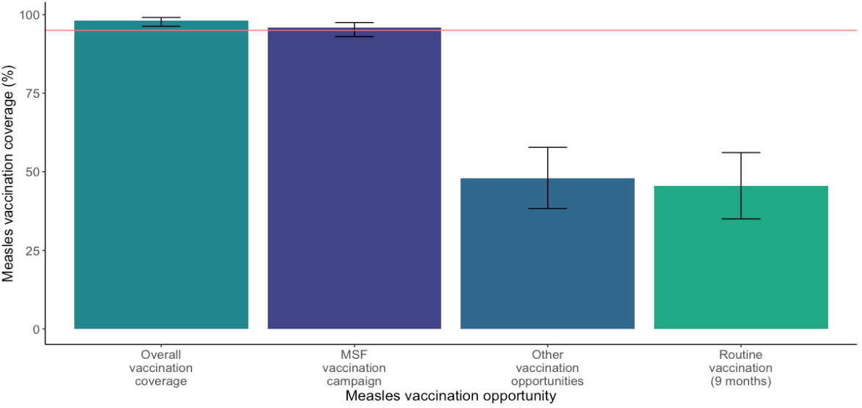

### Previous measles diagnosis

Information on previous measles diagnosis (as reported by caretaker) was collected from 985 children aged 6 months to 9 years. Of those children, 21.5% (95% CI: 16.4–27.6) reported previously having measles.

Of the children who reported previously having measles, the median age the child became ill was 4 years. However, 747 (75.8%) individuals were missing information on age in this category.

Table 8. Previous measles diagnosis among children aged 6 months to 9 years in Béboto district, Logone Oriental province, Chad (weighted analysis)

| **Previous measles diagnosis** | **Children (n)** | **Percent (95% CI)** | **Design effect** |
| --- | --- | --- | --- |
| Yes | 238 | 21.5% (16.4--27.6) | 4.4 |
| No | 718 | 75.5% (70.4--80.0) | 3.0 |
| Don’t know | 29 | 3.0% (1.3--6.6) | 4.8 |

Based on overall vaccination history and previous measles diagnosis (as reported by the caretaker), the estimated immunity in children aged 6 months to 9 years is 98.7% (95% CI: 97.5–99.4).

Table 9. Immune status among children aged 6 months to 9 years in Béboto district, Logone Oriental province, Chad (weighted analysis)

| **Immune status** | **Children (n)** | **Immunity (95% CI)** | **Design effect** |
| --- | --- | --- | --- |
| Immune | 971 | 98.7% (97.5--99.4) | 1.4 |
| Susceptible | 14 | 1.3% (0.6--2.5) | 1.4 |

## Discussion

The vaccination coverage survey results indicate that the MSF vaccination campaign achieved 95.8% vaccination coverage (95% CI: 93.0–97.5) for children aged 6 months to 9 years in Béboto district, Logone Oriental Province, Chad. This level of coverage provides the population in that age group with herd immunity, protecting them from further measles outbreaks in the region, and reducing morbidity and mortality associated with the disease.

Because the vaccination coverage survey was conducted directly following the MSF vaccination campaign in Béboto, this likely reduced recall bias regarding whether or not the child had been vaccinated and reasons for non-vaccination. In addition, many respondents were able to produce their vaccination card as confirmation that their child had received the vaccination.

This survey also examined coverage for the routine vaccination that children should receive at nine months of age. The coverage for this was low at 45.4% (95% CI: 35.0–56.1). The overwhelming reason cited for non-vaccination was that the caregiver was unaware that children should receive routine vaccination at nine months. According to the most recent UNICEF data on Chad, only about 22% of women give birth in a health facility,[1] which means that the majority of women in Chad are giving birth at home. Furthermore, only about 20% of deliveries in Chad are attended by a skilled birth attendant.[2] Women who give birth at home, without a skilled attendant, may not receive valuable information related to the health of their child, such as the importance of getting routine vaccinations at nine months. This appointment includes vaccination against other diseases such as _______ , so coverage for these diseases may also be low. Additional awareness-raising activities in Béboto would be extremely beneficial in order to inform parents and caretakers about this health milestone.

Still, even if parents or caretakers were better informed, it’s uncertain whether they would have sufficient access to routine vaccinations for their child. The low coverage from the supplementary immunisation activities combined with a lack of concrete information on previous mass vaccinations organized by the Ministry of Public Health indicate a poorly functioning Expanded Programme on Immunization (EPI).

Data was also collected on other measles vaccination opportunities for children aged 6 months to 9 years in Béboto. Coverage for these opportunities was low, at 48% (95% CI: 8.3–57.8). The main reason provided by caretakers for non-vaccination was that the child was either too young or not yet born when a vaccination opportunity occurred in their village (n=187). There is no definitive information on exactly when the last mass measles vaccination campaign took place in Béboto district; the last national campaign took place in 2015, but there is data suggesting vaccination campaigns took place since then, in 2016 and 2017. If that’s the case, with 59.3% of children in this study aged five or older (i.e. able to be vaccinated in the last five years), we would hope to see a slightly higher vaccination coverage. This discrepancy is difficult to interpret, but two possibilities are that: 1) there is a lack of awareness about one or more vaccination campaigns that took place in Béboto; or 2) no vaccination campaign took place in recent years. More concrete data on previous vaccination campaigns in Béboto would be helpful in better understanding this result.

Although 21.5% of children had a previous measles diagnosis (as reported by the caretaker), most of the respondents did not know (or left blank) the age the child fell ill. This makes it difficult to know whether the child fell ill during the recent outbreak or if this was an earlier illness, because measles is endemic in Chad and overall vaccination coverage before the MSF campaign was low. Without specific ages, it is difficult to ask additional questions. For example: did a recent measles diagnosis prompt caretakers to vaccinate the child when the MSF opportunity arose? One response in the survey data stated the parent or caretaker didn’t think the child needed to be vaccinated if they weren’t already sick.

The MSF vaccination campaign played a vital role in providing Béboto district with sufficient coverage to protect children aged 6 months to 9 years from measles for the time being. Without it, coverage would not have been close to the 95% required to achieve herd immunity, and the population would have remained at risk. However, the lack of knowledge about routine vaccination (and potential unavailability of routine vaccination opportunities) as well as few or irregular supplementary immunisation activities, mean that as the population continues to grow in Béboto, the next generation of children will once again be at risk in the near future.

### limitations

* Routine vaccination: recall bias
* SIA: recall bias, confusing with other opportunities
* Immunity: confusing with other illness.
* Design effect:
  + We noticed that the design effects for coverage of routine vaccination and supplementary immunisation activities were quite high (11.1 and 9.3 respectively). We suspect the reason for this is….
* Discrepancies between paper forms of households visited and electronic data collection: Increased training focusing on entering data of empty households.

1. UNICEF Data: Monitoring the situation of children and women. 2015. Available at: https://data.unicef.org/country/tcd/
2. UNICEF Data: Monitoring the situation of children and women. 2015. Available at: https://data.unicef.org/country/tcd/