Routine Jonglei State CBMC data analysis

## Summary

This is monthly summary of CBMC data from Lankien. This report contains data up to 2020 Sep and provides information on consultation numbers, malaria, awd, respiratory tract infections and highlights some data quality issues.

* Consultations  
  In 2020 Sep there were 468, 241, 206, 538 and 408 consultations in Nyambor, Nyatim, Pathai, Riang and Yuai respectively. Clear differences in consultation patterns across the CBMC sites with Nyambor showing regular numbers over the time period. The other sites seem to show greater or lesser effects of seasons on consultation numbers.

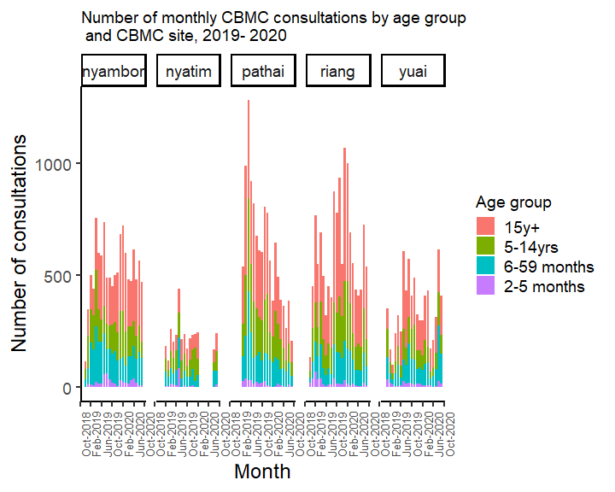

* Malaria  
  In 2020 Sep there were 57, 75, 15, 63 and 94 malaria positive consultations in Nyambor, Nyatim, Pathai, Riang and Yuai respectively. Much larger and clearer malaria peaks in Pathai, Riang and Yuai compared to Nyambor and Nyatim.

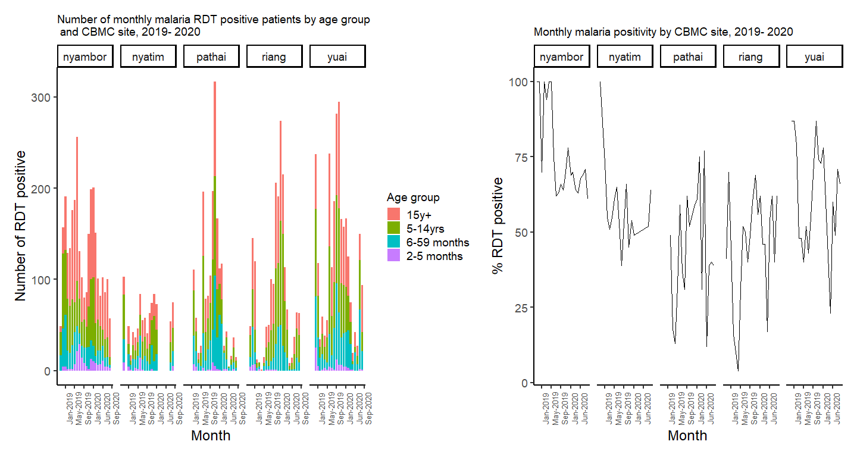

* **Proportional malaria morbidity:** In 2020 Sep, the proportional malaria morbidity was 12, 31, 7, 12 and 23 in Nyambor, Nyatim, Pathai, Riang and Yuai respectively.

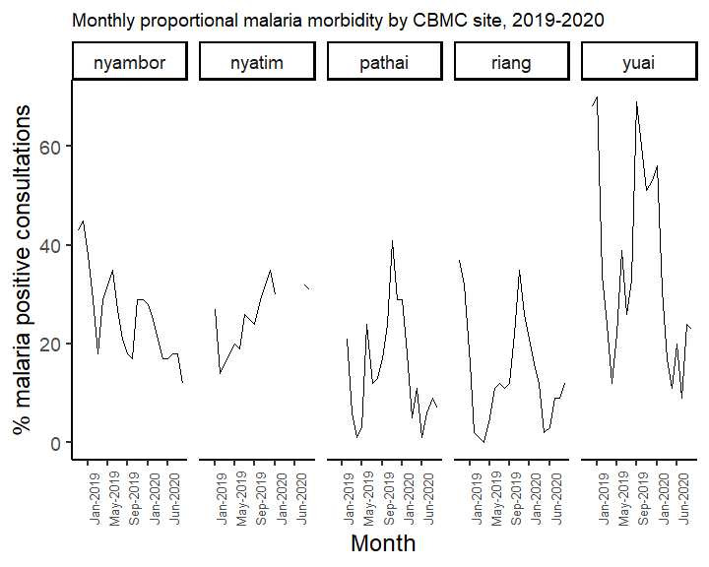

* **Data quality for malaria diagnoses**: The months where there more or fewer malaria diagnoses compared to number of RDT positive malaria cases are highlighted in red. In 2020, we see that there were 6, 1, 2, 6 and 5 months with discrepancies in the number of malaria diagnoses and number of RDT positive cases in Nyambor, Nyatim, Pathai, Riang and Yuai respectively.

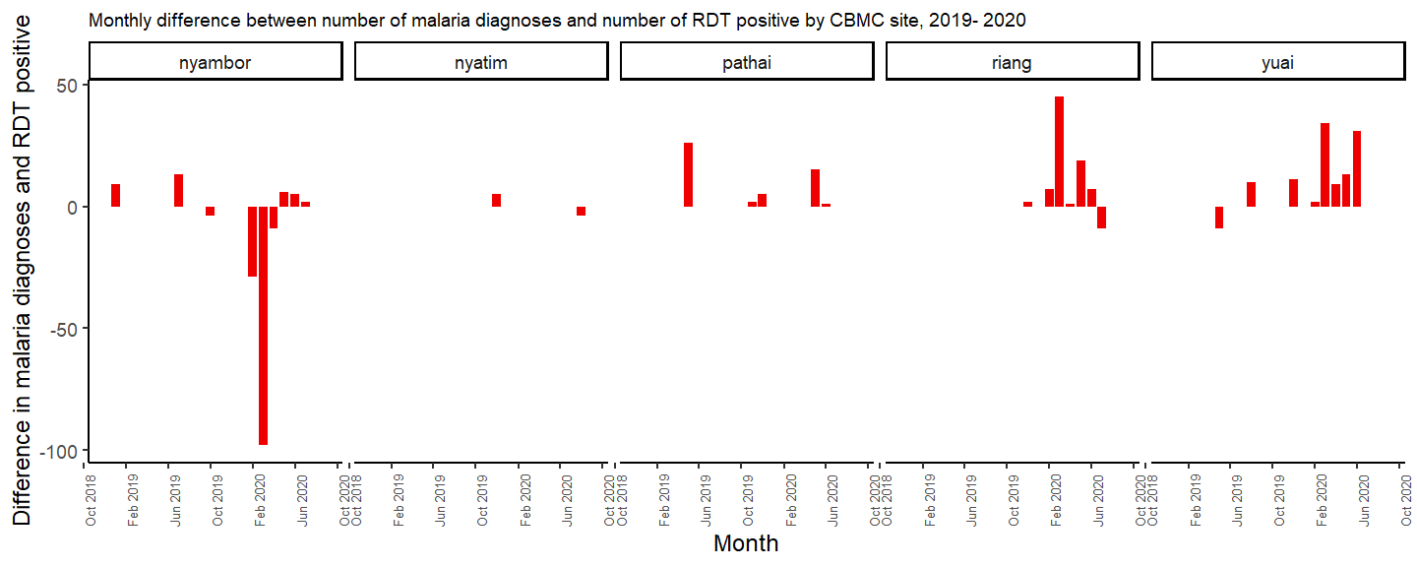

* AWD  
  In 2020 Sep, there were 96, 26, 10, 31 and 52 AWD cases in Nyambor, Nyatim, Pathai, Riang and Yuai respectively.

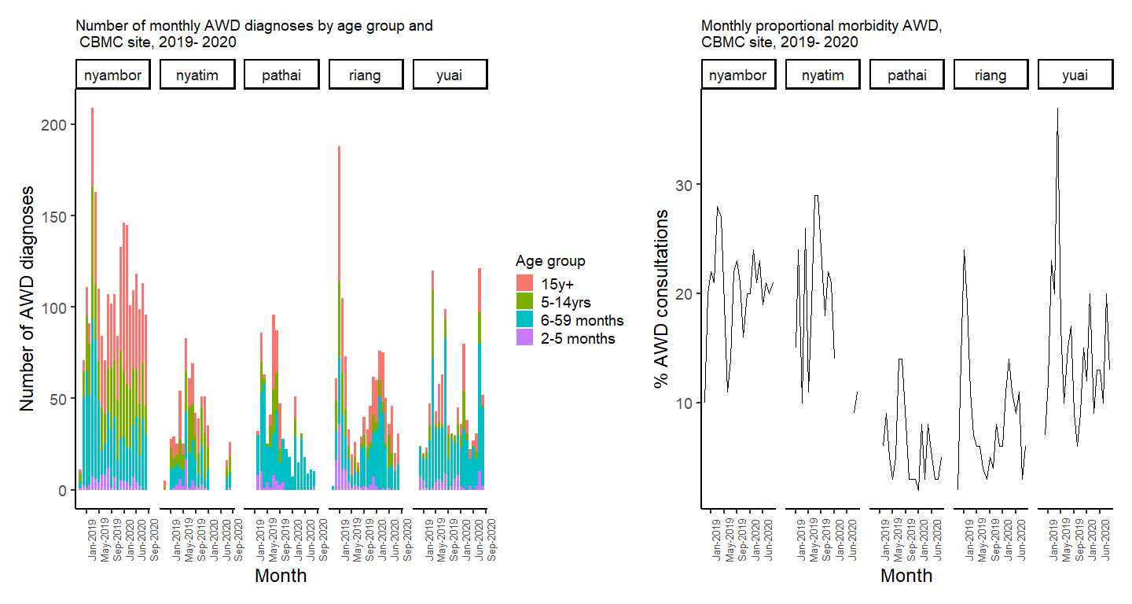

* Respiratory tract infections  
  In 2020 Sep, there were 120, 109, 97, 28 and 186 respiratory tract infections (uncomplicated pneumonia/cough/cold) cases in Nyambor, Nyatim, Pathai, Riang and Yuai respectively.

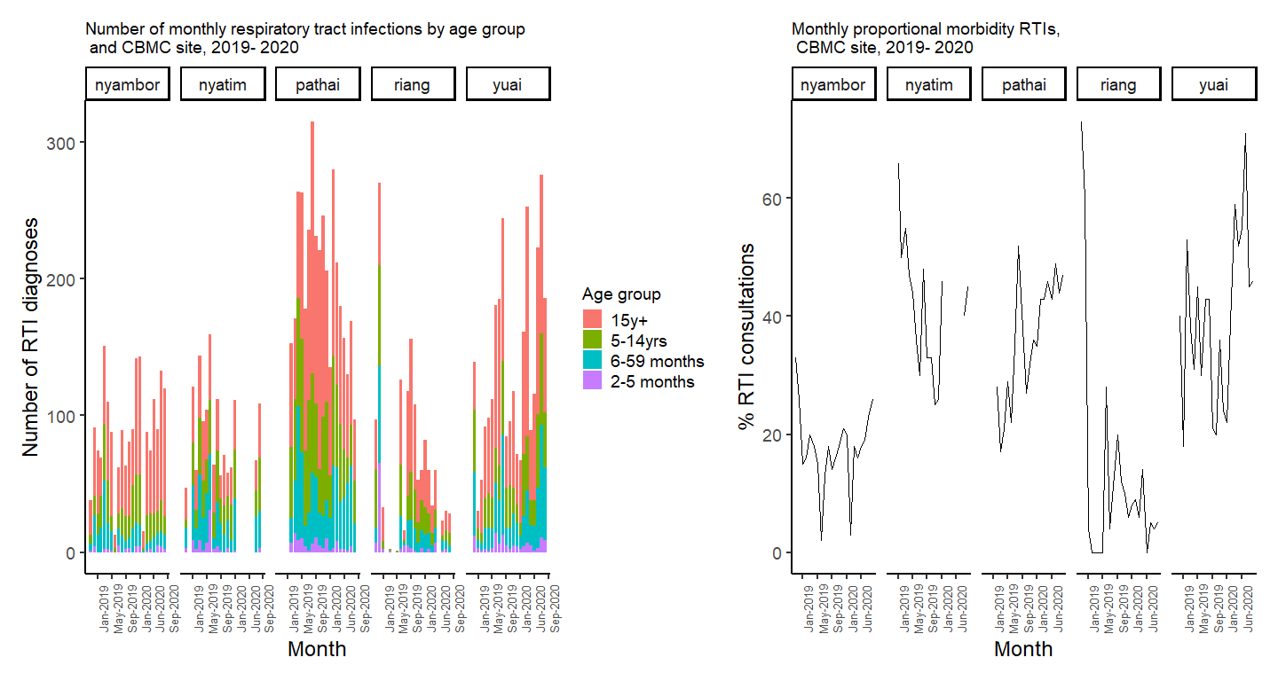

* Malnutrition

In 2020 Sep, there were 21, 0, 0, 0 and 2 children aged 6-59m with severe acute malnutrition based on MUAC or oedema in Nyambor, Nyatim, Pathai, Riang and Yuai respectively. Nyambor shows a higher stable rate of malnutrition compared to the other sites, but it could be related to the population size of the catchment area of the Nyambor CBMC.

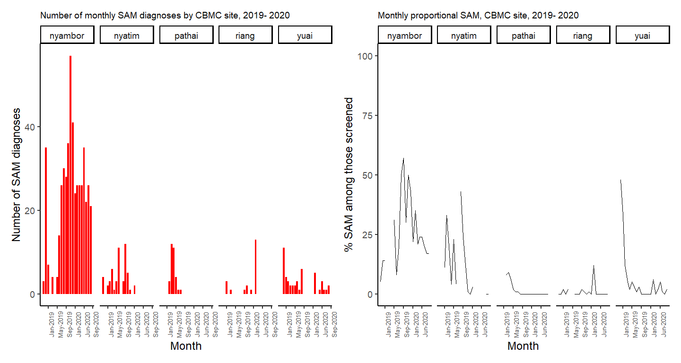

* **Data quality for severe acute malnutrition**: Normally all children aged between 6-59 months should receive a MUAC screening. As can be seen below, the proportion that are screened has improved over time in all projects but the team need support in providing accurate figures as many times the proportion of children aged 6-59m screened by a MUAC exceeds the total number of children aged 6-59m consulted (red line set to 100%). Riang seems to have improved a lot whereby earlier reports showe less than ideal MUAC screening of children aged 6-59m.
* As can be seen in the graph showing the monthly difference between reported SAM diagnoses and the number of SAM patients based on MUAC/oedema, the team in Nyambor are consistently having problems harmonising their numbers (i.e. above or below the red line set at 0 for no difference). The other CBMC sites also have difficulty but less extreme and less often compared to Nyambor.

