# [Alembic](https://alembic.darn.es/)

[Gem Version](https://badge.fury.io/rb/alembic-jekyll-theme)

â A Jekyll boilerplate theme designed to be a starting point for any Jekyll website.

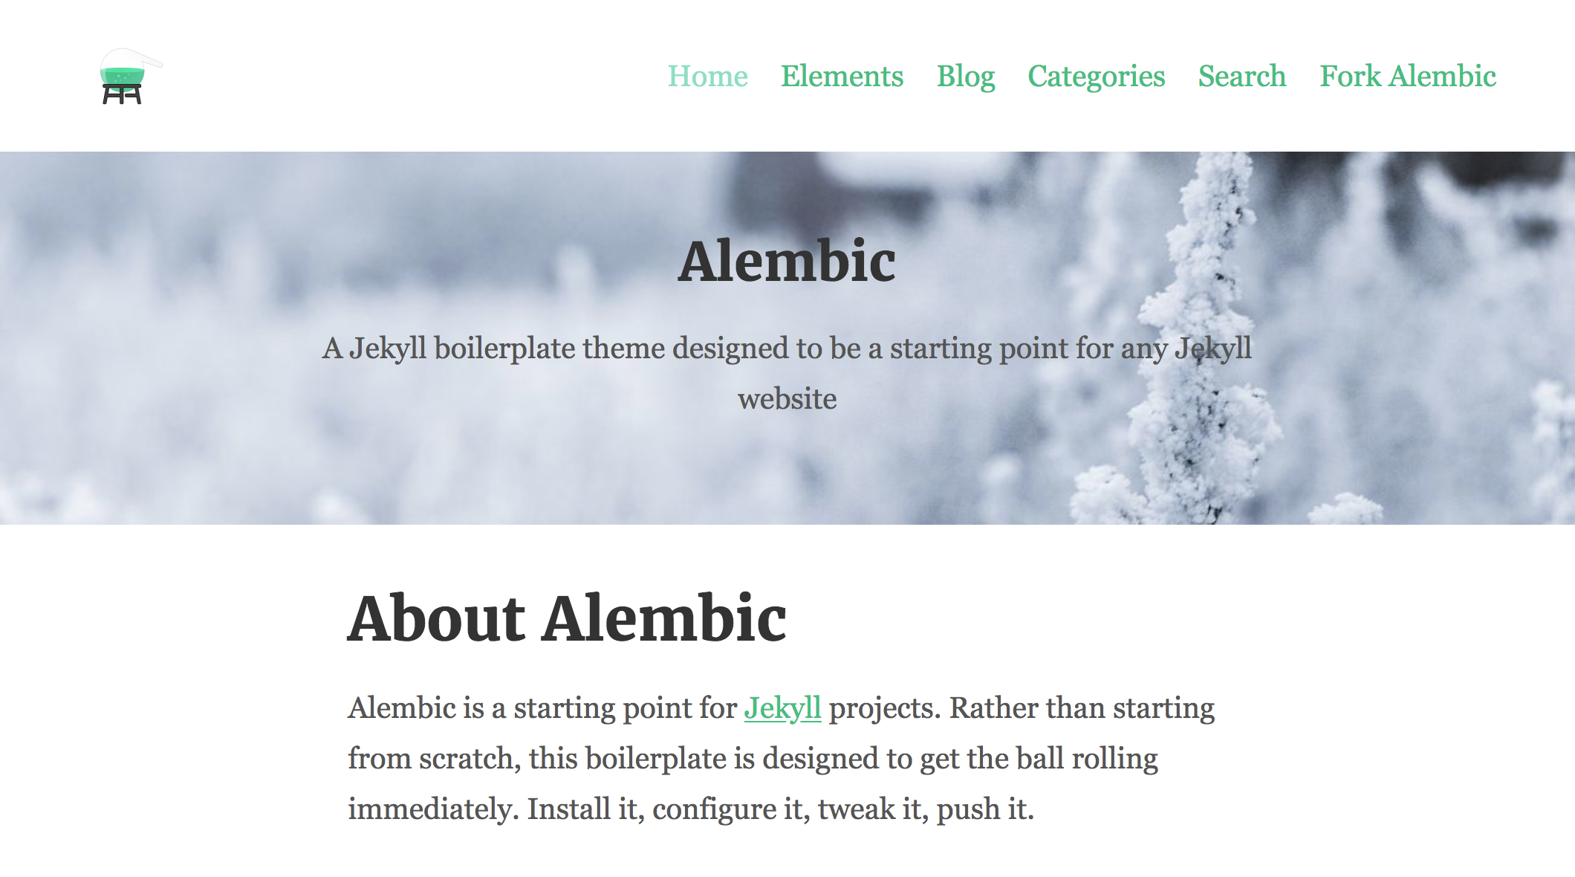

Screenshot

[Tweet it](https://twitter.com/intent/tweet/?url=https://alembic.darn.es&text=Alembic%20-%20A%20Jekyll%20boilerplate%20theme&via=DavidDarnes) | [Tip me $5 ð¸](https://www.paypal.me/daviddarnes/5usd)

## Contents

* About
* Features
* Examples
* Installation
* Customising
* Configuration
* Gem dependency settings
* Site settings
* Site navigation
* Using includes
* Page layouts
* Page and Post options
* Credits

## About

**Alembic is a starting point for** [**Jekyll**](https://jekyllrb.com/) **projects. Rather than starting from scratch, this boilerplate theme is designed to get the ball rolling immediately. Install it, configure it, tweak it, push it.**

## Features

* Available as a **theme gem** and **GitHub Pages** theme
* Simple and elegant design that can be used out of the box or as solid starting point
* Tested in all major browsers, including **IE and Edge**
* **Configurable colours** and typography in a single settings file
* Extensive set of **shortcodes** to include various elements; such as buttons, icons, figure images and more
* Solid **typographic framework** from [Sassline](https://sassline.com/)
* Configurable navigation via a single file
* Modular Jekyll components
* Post category support in the form of a single post index page grouped by category
* Built in live search using JavaScript
* **Contact form** built in using [Formspree](https://formspree.io/)
* Designed with [**Siteleaf**](http://www.siteleaf.com/) in mind
* Has 9 of the most popular networks as performant sharing buttons
* Has documentation

## Examples

Here are a few examples of Alembic out in the wild being used in a variety of ways:

* [bitpodcast.com](https://bitpodcast.com/)
* [joelcagedesign.com](https://joelcagedesign.com/)
* [bawejakunal.github.io](https://bawejakunal.github.io/)
* [case2111.github.io](http://case2111.github.io/)
* [www.10people.co.uk](http://www.10people.co.uk/)
* [hrkeni.me](http://hrkeni.me/)
* [venuthatikonda.github.io](https://venuthatikonda.github.io/)
* [ccs17.bsc.es](https://ccs17.bsc.es/)
* [karateca.org](http://www.karateca.org/)

## Installation

### As a Jekyll theme

1. Add gem "alembic-jekyll-theme" to your Gemfile to add the theme as a dependancy
2. Run the command bundle install in the root of project to install the theme and its dependancies
3. Add theme: alembic-jekyll-theme to your _config.yml file to set the site theme
4. Run bundle exec jekyll serve to build and serve your site
5. Done! Use the configuration documentation and the example [_config.yml](https://github.com/daviddarnes/alembic/blob/master/_config.yml) file to set things like the navigation, contact form and social sharing buttons

### As a GitHub Pages remote theme

1. Add gem "jekyll-remote-theme" to your Gemfile to add the theme as a dependancy
2. Run the command bundle install in the root of project to install the jekyll remote theme gem as a dependancy
3. Add jekyll-remote-theme to the list of plugins in your _config.yml file
4. Add remote_theme: daviddarnes/alembic to your _config.yml file to set the site theme
5. Run bundle exec jekyll serve to build and serve your site
6. Done! Use the configuration documentation and the example [_config.yml](https://github.com/daviddarnes/alembic/blob/master/_config.yml) file to set things like the navigation, contact form and social sharing buttons

### As a Boilerplate / Fork

*(deprecated, not recommended)*

1. [Fork the repo](https://github.com/daviddarnes/alembic#fork-destination-box)
2. Replace the Gemfile with one stating all the gems used in your project
3. Delete the following unnecessary files/folders: CODE_OF_CONDUCT.md, CONTRIBUTING.md, LICENSE, screenshot.png, CNAME and alembic-jekyll-theme.gemspec
4. Run the command bundle install in the root of project to install the jekyll remote theme gem as a dependancy
5. Run bundle exec jekyll serve to build and serve your site
6. Done! Use the configuration documentation and the example [_config.yml](https://github.com/daviddarnes/alembic/blob/master/_config.yml) file to set things like the navigation, contact form and social sharing buttons

## Customising

When using Alembic as a theme means you can take advantage of the file overriding method. This allows you to overwrite any file in this theme with your own custom file, simply by matching the file name and path. The most common example of this would be if you want to add your own styles or change the core style settings.

To add your own styles copy the [styles.scss](https://github.com/daviddarnes/alembic/blob/master/assets/styles.scss) into your own project with the same file path (assets/styles.scss). From there you can add your own styles, you can even optionally ignore the theme styles by removing the @import "alembic"; line.

If you’re just looking to set your own colours and fonts copy the [_settings.scss](https://github.com/daviddarnes/alembic/blob/master/_sass/_settings.scss) file into your project at the same file path (_sass/_settings.scss) and change variables however you wish. The settings are a mixture of custom variables and settings from [Sassline](https://medium.com/@jakegiltsoff/sassline-v2-0-e424b2881e7e) - follow the link to find out how to configure the typographic settings.

## Configuration

There are a number of optional settings for you to configure. Use the example [_config.yml](https://github.com/daviddarnes/alembic/blob/master/_config.yml) file in the repo and use the documentation below to configure your site:

### Gem dependency settings

twitter, author and social values will need to be changed to the projects’ social information or removed. Look for the Gem settings comment within the /_config.yml file. These values are for the [jekyll-seo-tag](https://github.com/jekyll/jekyll-seo-tag) - follow the link to find out more.

### Site settings

You’ll need to change the description, title and url to match with the project. You’ll also need to replace the /assets/logo.svg and /assets/default-social-image.png with the project logo and default social image. Setting the site language can be done with lang, the theme will default to en-US. The email needs to be changed to the email you want to receive contact form enquires with. The disqus value can be changed to your project username on [Disqus](https://disqus.com), remove this from the /_config.yml file if you don’t want comments enabled. Look for the Site settings comment within the /_config.yml file. The repo setting is optional, for now, and can be removed entirely, if you wish.

### Site navigation

There are a total of 4 different navigation types:

* navigation_header: The links shown in the header (it is also used on the 404 page)
* navigation_footer: The links shown in the footer
* social_links: The social icon links that are shown in the sidebar
* sharing_links: The social sharing buttons that are shown at the bottom of blog posts

All navigations can be edited using the _config.yml file. To see example usage either look for the Site navigation comment within the /_config.yml file or see the nav-share.html include.

If there are no items for the navigation_header or navigation_footer, they will fallback to a list of pages within the site. The social_navigation properties should either be one that is already in the list (so Twitter or Facebook) or simply link, this is so an icon can be set for the link.

## Using includes

There are 2 main types of includes: ones designed for the site and ones that are designed as shortcodes. Here are a list of the shortcode includes:

### button.html

A button that can link to a page of any kind.

Example usage: {% include button.html text="I'm a button" link="https://david.darn.es" %}

Available options: - text: The text of the button *required* - link: The link that the button goes to *required* - icon: The icon that is added to the end of the button text - color: The colour of the button

### figure.html

An image with optional caption.

Example usage: {% include figure.html image="/uploads/feature-image.jpg" caption="Check out my photo" %}

Available options: - image: The image shown *required* - caption: A caption to explain the image - position: The position of the image, left or right

### icon.html

An icon.

Example usage: {% include icon.html id="twitter" %}

Available options: - id: The reference for the icon *required* - title: The accessible label for the icon - color: The desired colour of the icon

### nav-share.html

A set of buttons that share the current page to various social networks, which is controlled within the _config.yml file under the sharing_links keyword.

Example usage: {% include nav-share.html %}

Available options:

Twitter: "#1DA1F2"  
facebook: "#3B5998"  
Google+: "#DC4E41"  
Pinterest: "#BD081C"  
LinkedIn: "#0077B5"  
tumblr: "#36465D"  
Reddit: "#FF4500"  
Hacker News: "#ff6600"  
Designer News: "#2D72D9"  
Email: ""

*The first item is the name of the network (must be one of the ones stated above) and the second is the colour of the button. To remove a button just remove the line of the same name.*

### video.html

A YouTube video.

Example usage: {% include video.html id="zrkcGL5H3MU" %}

Available options: - id: The YouTube ID for the video *required*

### map.html

A Google map. *See Google* [*My Maps*](https://www.google.com/mymaps)

Example usage: {% include map.html id="1UT-2Z-Vg_MG_TrS5X2p8SthsJhc" %}

Available options: - id: The map ID for the video *required*

### site-form.html

Adds a contact form to the page.

Example usage: {% include site-form.html %}

This include has no options. Use the email option in the /_config.yml to change to the desired email.

### site-search.html

Adds a search form to the page.

Example usage: {% include site-search.html %}

This include has no options. This include will add a block of javascript to the page and javascript reference in order for the search field to work correctly.

## Page layouts

As well as page, post, blog, there are a few alternative layouts that can be used on pages:

* categories: Shows all posts grouped by category, with an index of categories in a left hand sidebar
* search: Adds a search field to the page as well as a simplified version of the sidebar to allow more focus on the search results

## Page and Post options

There are some more specific options you can apply when creating a page or a post:

* aside: true: Adds a sidebar to the page or post, this is false by default and will not appear
* comments: false: Turns off comments for that post
* feature_image: "/uploads/feature-image.jpg": Adds a full width feature image at the top of the page
* feature_text: "Example text": Adds text to the top of the page as a full width feature with solid colour; supports markdown. This can be used in conjunction with the feature_image option to create a feature image with text over it
* indexing: false: Adds a noindex meta element to the <head> to stop crawler bots from indexing the page, used on the 404 page

**Note:** The Post List Page options are actually in the collection data within the _config.yml file.

## Credits

* Thanks to [Simple Icons](https://simpleicons.org/) for providing the brand icons, by [Dan Leech](https://twitter.com/bathtype)
* Thanks to [Sassline](https://sassline.com/) for the typographic basis, by [Jake Giltsoff](https://twitter.com/jakegiltsoff)
* Thanks to [Flexbox mixin](https://github.com/mastastealth/sass-flex-mixin) by [Brian Franco](https://twitter.com/brianfranco)
* Thanks to [Normalize](https://necolas.github.io/normalize.css/) by [Nicolas Gallagher](https://twitter.com/necolas) and [Jonathan Neal](https://twitter.com/jon_neal).
* Thanks to [pygments-css](http://richleland.github.io/pygments-css/) for the autumn syntax highlighting, by [Rich Leland](https://twitter.com/richleland)