**Assignment 2 Task**

Q2) Use Jupyter Notebook to execute following code, try to guess what is happening in this code.

Ans:

It is used to plot a graph showing the height distribution of various people.

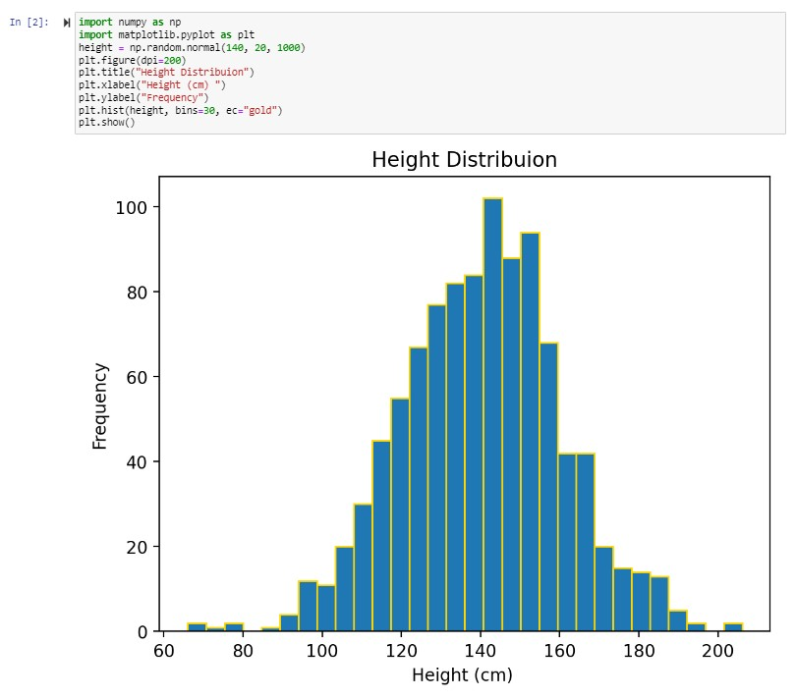

Q3) Write down above code using vim on same working directory, and execute using python interpreter, tell us difference between Jupyter and notepad.

Ans: In Jupyter Numpy and matplotlib already installed but in notepad we have to install this library.

Q4) Write down difference between compiler and interpreter.

Ans:

|  |  |
| --- | --- |
| Interpreter | Compiler |
| Translates program one statement at a time. | Scans the entire program and translates it as a whole into machine code. |
| Interpreters usually take less amount of time to analyse the source code. However, the overall execution time is comparatively slower than compilers. | Compilers usually take a large amount of time to analyze the source code. However, the overall execution time is comparatively faster than interpreters. |
| No Object Code is generated,hence are memory efficient. | Generates Object Code which furthers requires linking,hence requires more memory. |
| Programming languages like JavaScript, Python, Ruby use interpreters. | Programming languages like C, C++, Java use compilers. |

Q5) What is Data Structure, why we need one in programs?

Ans: Data structure explains how data is going to organized in computer memory, and what will be the cost performing different operations like traversing, insertion, deletion, searching and sorting on that data.Data structures provide a way to organize and store data in a way that allows for efficient retrieval, manipulation, and storage of data. Data structures play a crucial role in algorithm design and analysis. Data structures also plays a crucial role in algorithm design and analysis.