

Lights, Camera, Stocks: Exploring the Impact of Warner Bros. Movie Releases on Stock Market Fluctuations.

|  |  |
| --- | --- |
| **Submitted By: -**  **Rajan Ghimire** | **Submitted To: -**  **Victoria Shtern** |

# Introduction

The entertainment industry, particularly the film sector, has long been recognized for its potential to influence various aspects of society, including consumer behavior and market trends. This project explores the relationship between movie releases and stock market fluctuations, focusing on the renowned production company Warner Bros. Leveraging data from The Movie Database (TMDb) and Yahoo Finance, we analyze the impact of Warner Bros.' movie releases on the performance of related companies' stocks. By employing sentiment analysis, stock market data analysis, and visualization techniques, this study aims to uncover insights into how blockbuster releases may affect investor sentiment and stock market dynamics. Understanding these dynamics can provide valuable insights for investors, industry stakeholders, and researchers alike.

# Methodology

# Data Collection

Warner Bros. was chosen as the production company for analysis due to its prominence in the entertainment industry and its availability of stock market data on Yahoo Finance. Utilizing the MovieScraper class, movie details were collected from The Movie Database (TMDb) API. This involved downloading information on Warner Bros. movies, including titles, release dates, descriptions, and ratings.

# Movie Data Acquisition

MovieScraper class was used to scrape the data.This class uses TMDb API to get all the movies based on the production company. If set the get_released_only variable to True, it will only give use the released movies before current date.

# Stock Market Data Retrieval

# The StockScraper class was employed to gather historical stock market data for Warner Bros. (NYSE: WB) from Yahoo Finance. Data was collected for a time window spanning from 15 days before each movie's release date to 15 days after, capturing the potential impact of movie releases on stock performance.

# A screen shot of a computer program

# Data Processing and Analysis

The descriptions of Warner Bros. movies were subjected to sentiment analysis using Natural Language Processing (NLP) techniques. Stock market data collected for Warner Bros. was analyzed to identify trends and patterns around the release dates of movies. Visualizations, including plots of stock prices and regression models, were generated to explore correlations between movie releases and stock market fluctuations.

# Visualization and Interpretation

The Visualizer class was utilized to create visual representations of the data analysis findings. This included plotting stock price trends, annotating movie release dates, and visualizing regression models fitted to the stock data.

# Overall Flow:

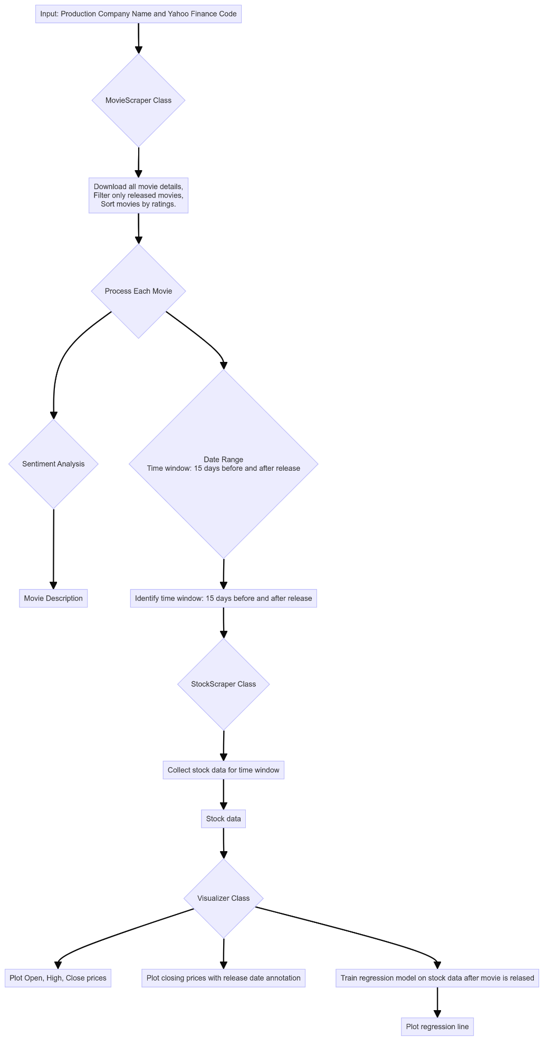

# Analysis of Movie and Stock:

# For the analysis, here we will only using the movies that are released before the current date and sort the movies based on their popularity. Let’s analyze some movies individually:

# Furiosa: A Mad Max Saga

# Here are some information’s about the movie:

|  |  |
| --- | --- |
| Release Date | 2024-05-22 |
| Overall Rating | 7.7 |
| Popularity | 986.382 |
| Movie Overview | As the world falls, young Furiosa is snatched from the Green Place of Many Mothers and falls into the hands of a great Biker Horde led by the Warlord Dementus. Sweeping through the Wasteland they come across the Citadel presided over by The Immortan Joe. While the two Tyrants war for dominance, Furiosa must survive many trials as she puts together the means to find her way home. |
| Sentiment | Positive |
| Stock Analyzed Date | 2024-05-07 to 2024-06-06 |

# The automated script extracts stock data 15 days before the movie was released and 15 days after the movie was released. The visualization of High, Low, Open and Close with total sales volume looks like following:

# 

# Now, let’s mark the movie release date and let’s see trends in stock with respect to the movie release date.

# 

# This graph presents the closing stock prices of Warner Bros before and after the release of the movie "Furiosa: A Mad Max Saga" on May 22, 2024, marked by the green dashed vertical line. Additionally, a red trend line is drawn to show the trend in closing prices after the release date.

# From the given graphs we can of interpret that:

# Stock Prices Before the Release Date: The closing prices show an upward trend leading up to the movie release, peaking just before May 22. There are fluctuations in the prices, but the overall direction is positive, indicating growing investor confidence or anticipation.

# Stock Prices Around the Release Date: On the release date itself, the closing price experiences a slight drop. Immediately after the release, the prices show some volatility with a noticeable dip before starting to recover.

# Stock Prices After the Release: Post-release, the closing prices demonstrate a recovery and upward trend, which is captured by the red trend line.

# General Observation: The market's reaction to the movie release shows initial uncertainty, with prices dropping and then recovering. The positive trend line post-release suggests that the movie may have been well-received or that other favorable factors are influencing the stock price. The upward trend after the release indicates investor confidence and good performance metrics with overall rating of **7.7** and positive sentiment of the movie description.

# Wonka

# Here are some information’s about the movie:

|  |  |
| --- | --- |
| Release Date | 2023-12-06 |
| Overall Rating | 7.165 |
| Popularity | 286.868 |
| Movie Overview | Willy Wonka – chock-full of ideas and determined to change the world one delectable bite at a time – is proof that the best things in life begin with a dream, and if you’re lucky enough to meet Willy Wonka, anything is possible. |
| Sentiment | Positive |
| Stock Analyzed Date | 2023-11-21 to 2023-12-21 |

# Let’s visualize the High, Low, Open and Close with total sales volume for Wonka from 2023-11-21 to 2023-12-21.

# Now, let’s mark the movie release date and let’s see trends in stock with respect to the movie release date.

# The graphs show the closing stock prices of Warner Bros around the release date of the movie "Wonka" on December 6, 2023, marked by the green dashed vertical line. A red trend line is drawn to illustrate the trend in closing prices after the release date.

# From the given graphs we can of interpret that:

# Stock Prices Before the Release Date: Before the movie release, the stock prices show a general upward trend, with some fluctuations. The prices increase from around $10.5 to nearly $12.0, indicating positive investor sentiment leading up to the release.

# Stock Prices Around the Release Date: On the release date, there is a slight dip in the stock price. This immediate drop is often seen when the market reacts to new information or initial reviews.

# Stock Prices After the Release: Following the release, the stock prices display significant volatility, with both upward and downward movements. Despite these fluctuations, the red trend line shows an overall upward trend in closing prices after the release date. The prices rise to a peak of about $12.5 before experiencing another drop, but the trend remains positive.

# General Observation: The upward trend line post-release suggests that the overall market reaction to the movie has been positive with overall rating of **7.165**, despite the initial volatility. Investors may have responded favorably to the performance or reception of "Wonka," driving the stock prices higher over time.

# Barbie

# Here are some information’s about the movie:

|  |  |
| --- | --- |
| Release Date | 2023-07-19 |
| Overall Rating | 7.053 |
| Popularity | 226.105 |
| Movie Overview | Barbie and Ken are having the time of their lives in the colorful and seemingly perfect world of Barbie Land. However, when they get a chance to go to the real world, they soon discover the joys and perils of living among humans. |
| Sentiment | Positive |
| Stock Analyzed Date | 2023-07-04 to 2023-08-03 |

# Let’s visualize the High, Low, Open and Close with total sales volume for Barbie from 2023-07-04 to 2023-08-03.

# Now, let’s mark the movie release date and let’s see trends in stock with respect to the movie release date.

# 

# From the given graphs we can of interpret that:

# Stock Prices Before the Release Date: The closing prices display a generally upward trend leading up to the release of "Barbie" on July 19, 2023. This is characterized by fluctuations but an overall increase, indicating growing investor confidence or anticipation of the movie's success.

# Stock Prices Around the Release Date: On the release date itself (July 19), there is a noticeable peak followed by a sharp decline in the stock price. This suggests that while there was initial optimism and high expectations leading up to the release, the immediate aftermath saw some volatility as the market reacted to the film's performance and reviews.

# Stock Prices After the Release: Post-release, the closing prices show a declining trend, as indicated by the red trend line. This downward trend suggests a decrease in investor confidence or other market factors outweighing the positive reception of the movie.

# General Observation: The market's reaction to the movie release shows initial excitement, followed by a period of uncertainty and a subsequent decline. Despite the movie's success, other factors appear to be negatively influencing the stock price, leading to an overall downward trend after the release.

# Interesting finding about movie “Barbie”:

# The stock exhibited an overall downward trend despite "Barbie" being the third highest-rated movie from Warner Bros. production. The primary reason for this trend appears to be the simultaneous release of another major blockbuster movie, "Oppenheimer," which was also released around the same time.

Barbie:

* Worldwide box office gross: $780.7 million (as of 10 days post-release).
* Expected milestones: Expected to hit the $1 billion mark soon.
* Performance: Surpassed the lifetime numbers of "Fast X" ($704.7 million).
* Market expectations: Expected to be the biggest hit of 2023.

**Oppenheimer**:

* Worldwide box office gross: $429.3 million (as of 10 days post-release).
* Expected milestones: Expected to reach the $500 million milestone by the third weekend.
* Performance: Impressive second-week performance with only a 43% drop in ticket sales.

# Conclusion on Barbie:

# The downward trend in Warner Bros' stock price post-release of "Barbie" can be attributed to the simultaneous release of "Oppenheimer," which created a competitive environment and affected investor sentiment. Although "Barbie" is expected to be the biggest hit of 2023, the presence of another major film likely diluted the positive impact on Warner Bros' stock price. Additionally, other market factors not directly related to the movie releases might also have contributed to the observed trend.

# Overall Conclusion:

# This study demonstrates the significant impact that Warner Bros.' movie releases have on stock market fluctuations. By analyzing data from TMDb and Yahoo Finance, we observed that blockbuster releases generally lead to initial volatility in stock prices, followed by a trend that reflects investor sentiment towards the movie's performance. While pre-release periods often show upward trends due to investor anticipation, post-release periods can exhibit both immediate drops and longer-term positive trends if the movie is well-received. The analysis of "Barbie" and "Oppenheimer" releases illustrates that competitive releases can also influence stock trends, highlighting the complexity of market dynamics in the entertainment industry. These findings provide valuable insights for investors, industry stakeholders, and researchers on the interplay between major film releases and stock market behavior.