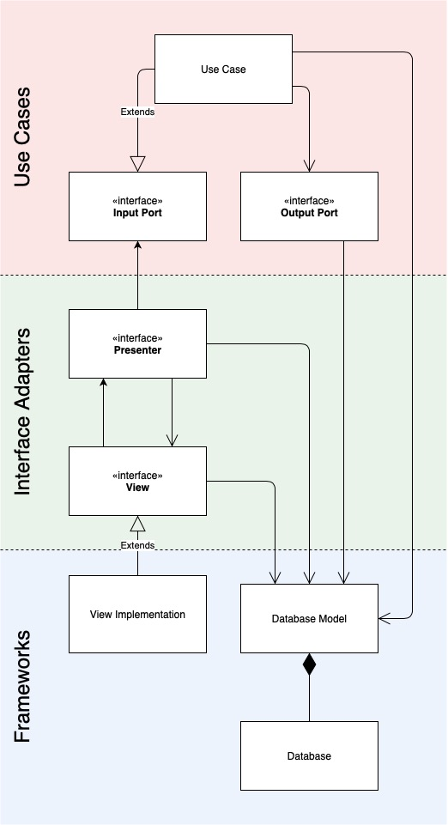

Figure : shared_database_model_across_boundaries.jpg

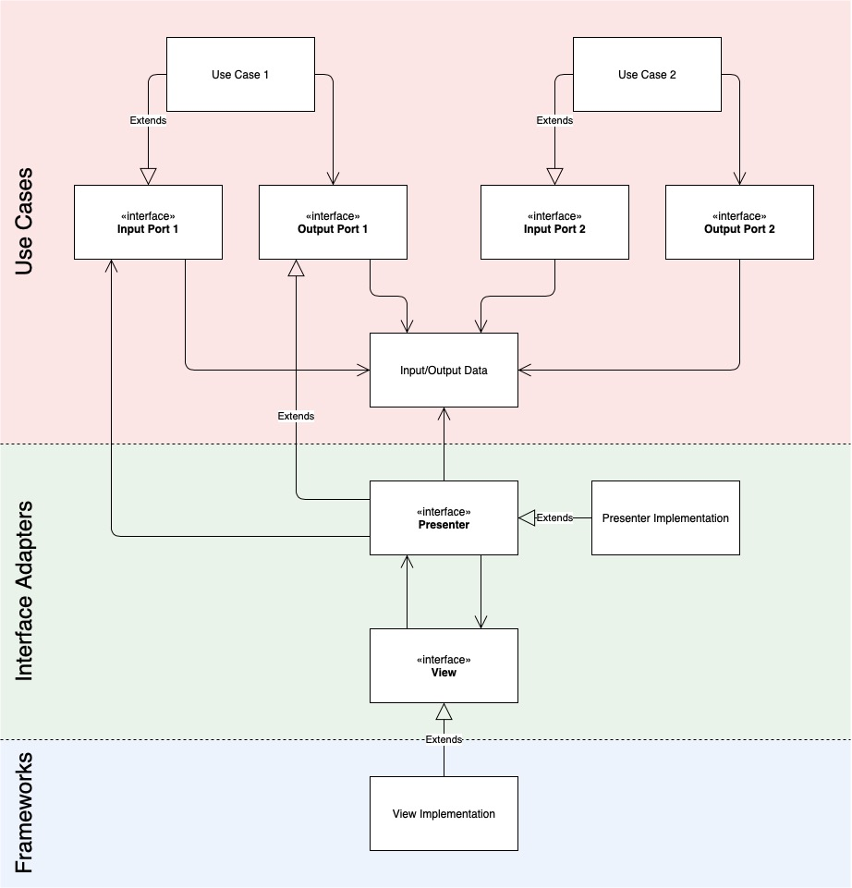

Figure : shared_input_output_data.jpg

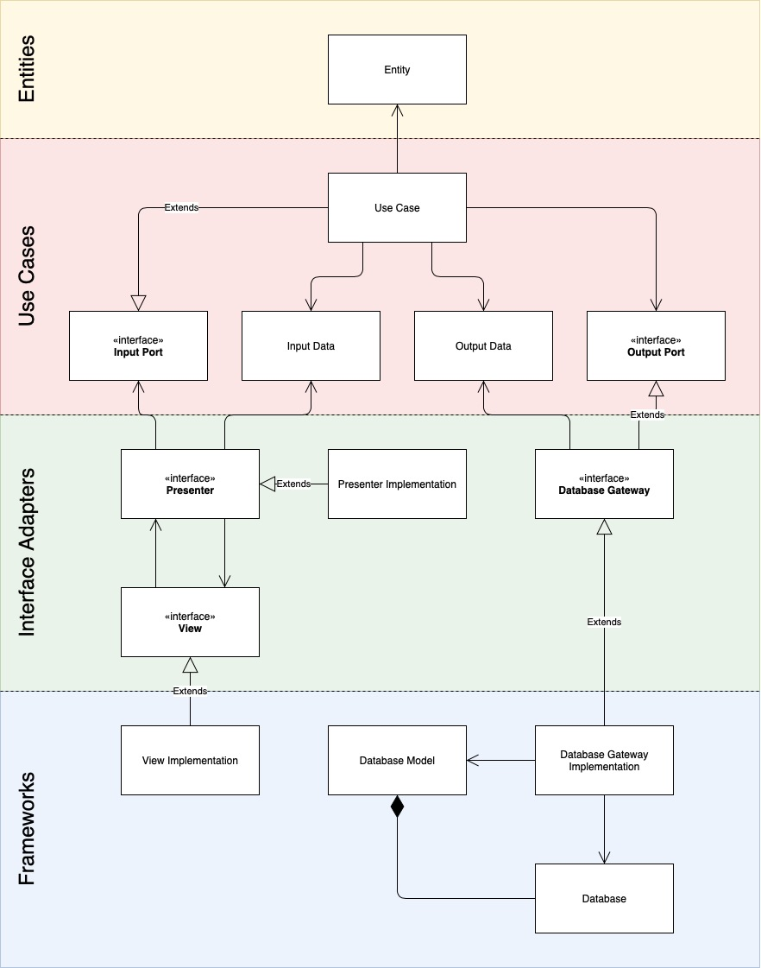

Figure : a-simple-clean-architecture-class-diagram.jpg

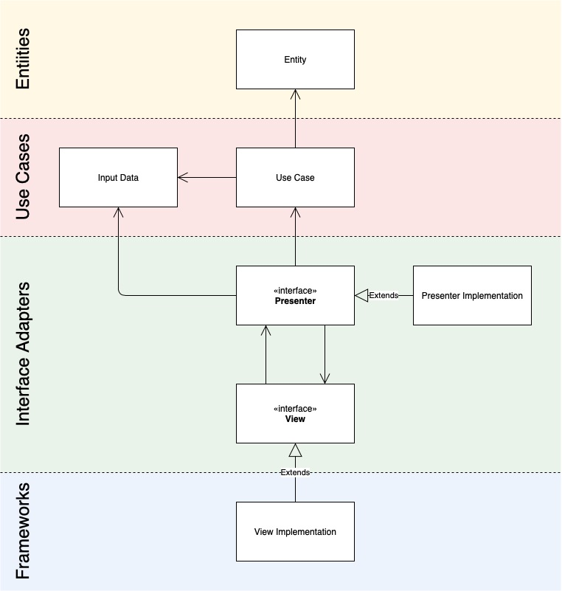

Figure : no_input_port.jpg

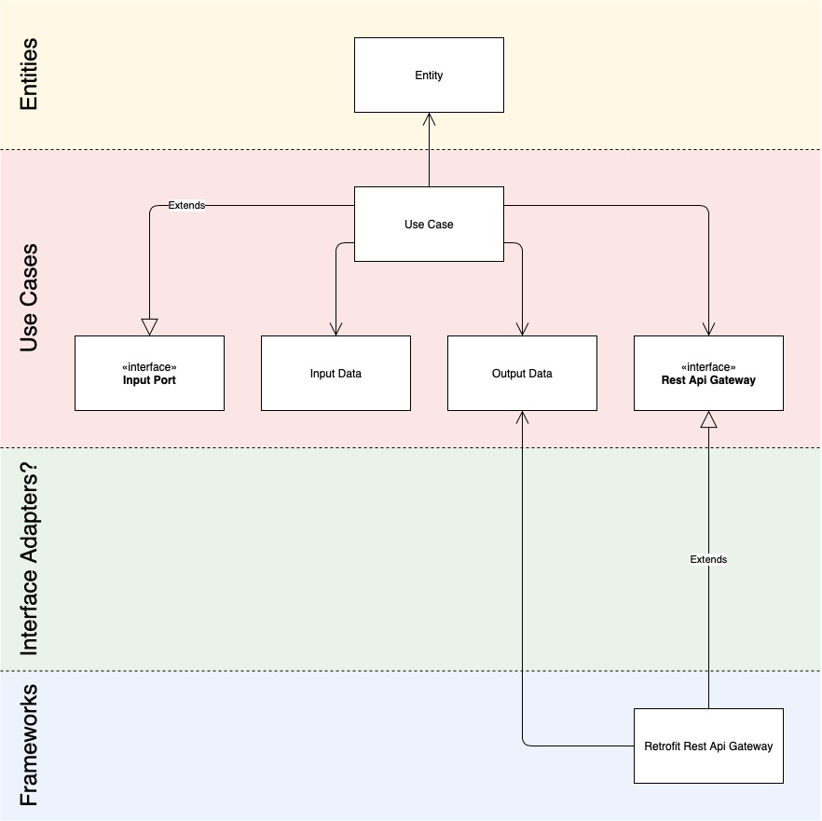

Figure : specific_output_port.jpg

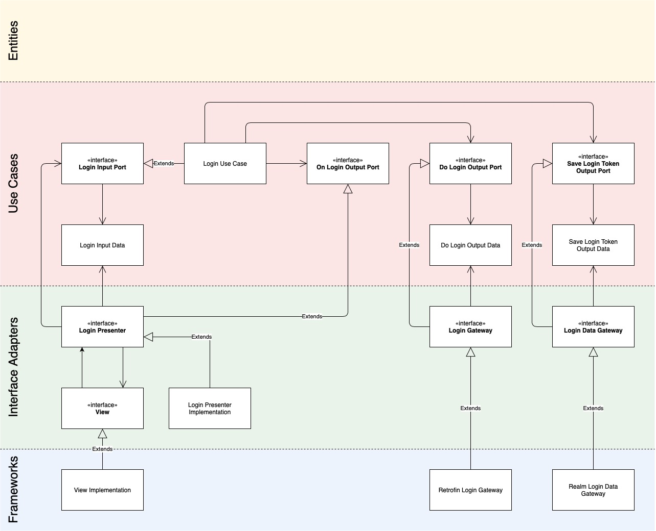

Figure : simple-login-use-case-class-diagram.jpg

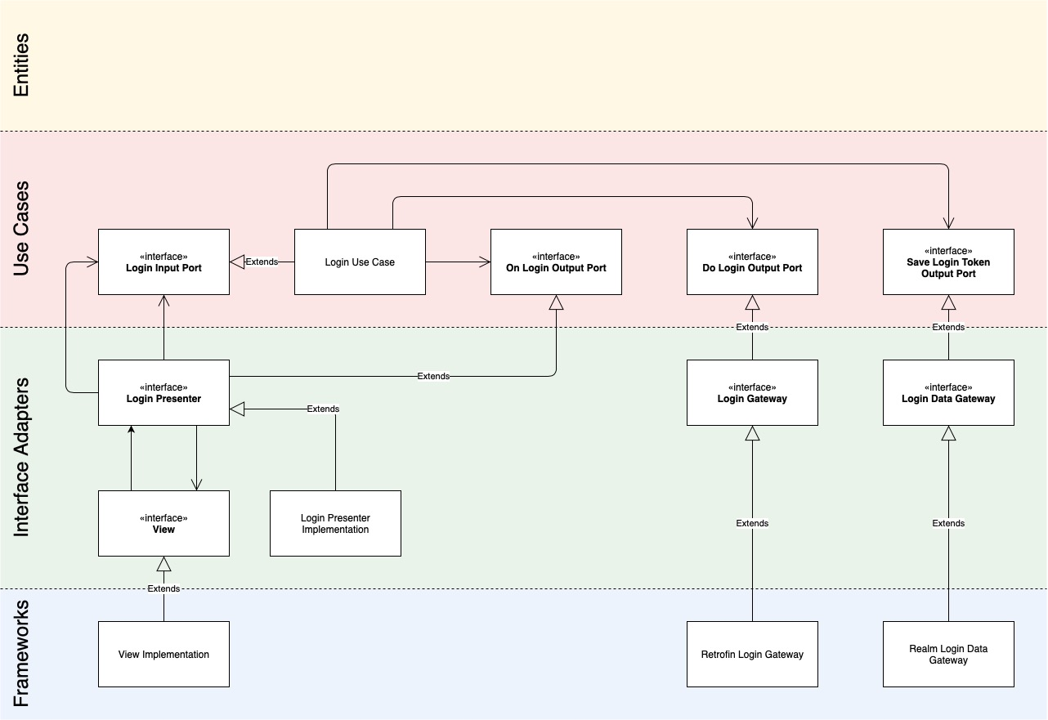

Figure : simple-login-use-case-without-input-output-data-class-diagram.jpg

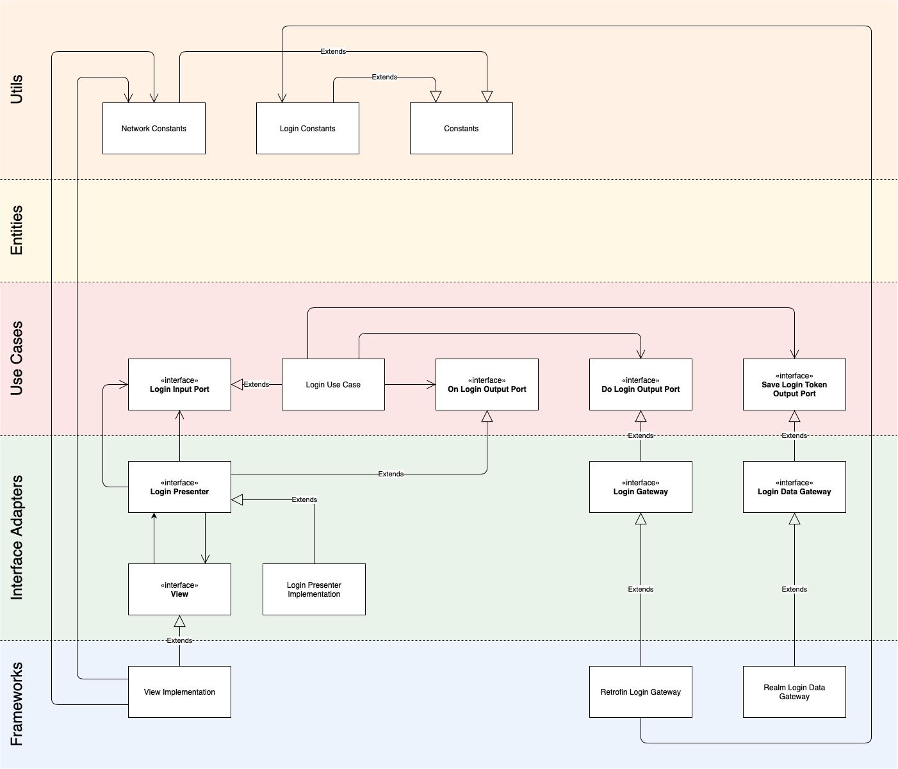

Figure : simple-login-use-case-with-utils-boundary-class-diagram.jpg

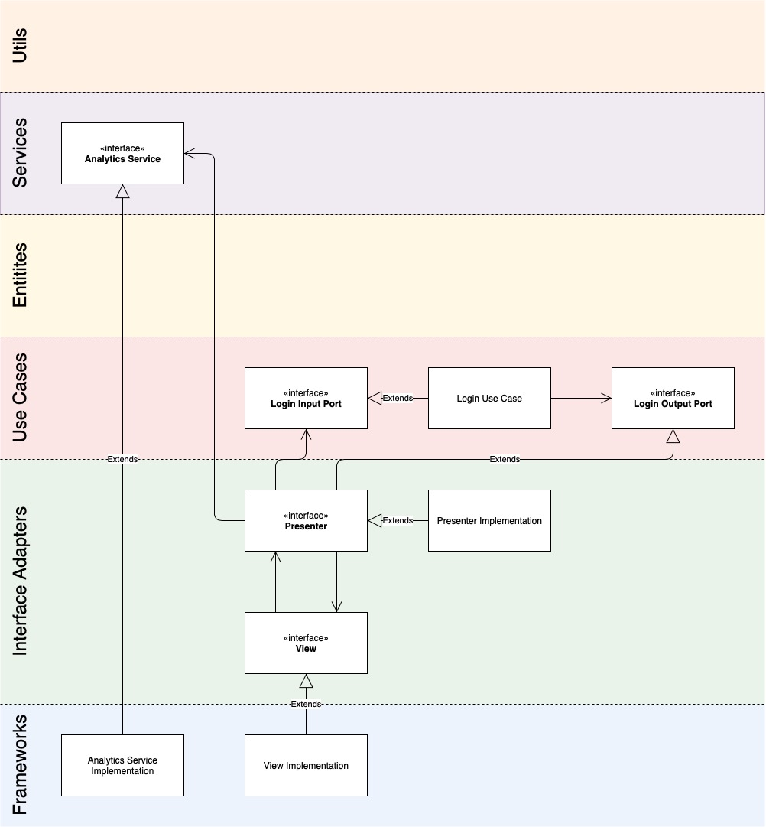

Figure : simple-login-use-case-with-services-boundary-class-diagram.jpg

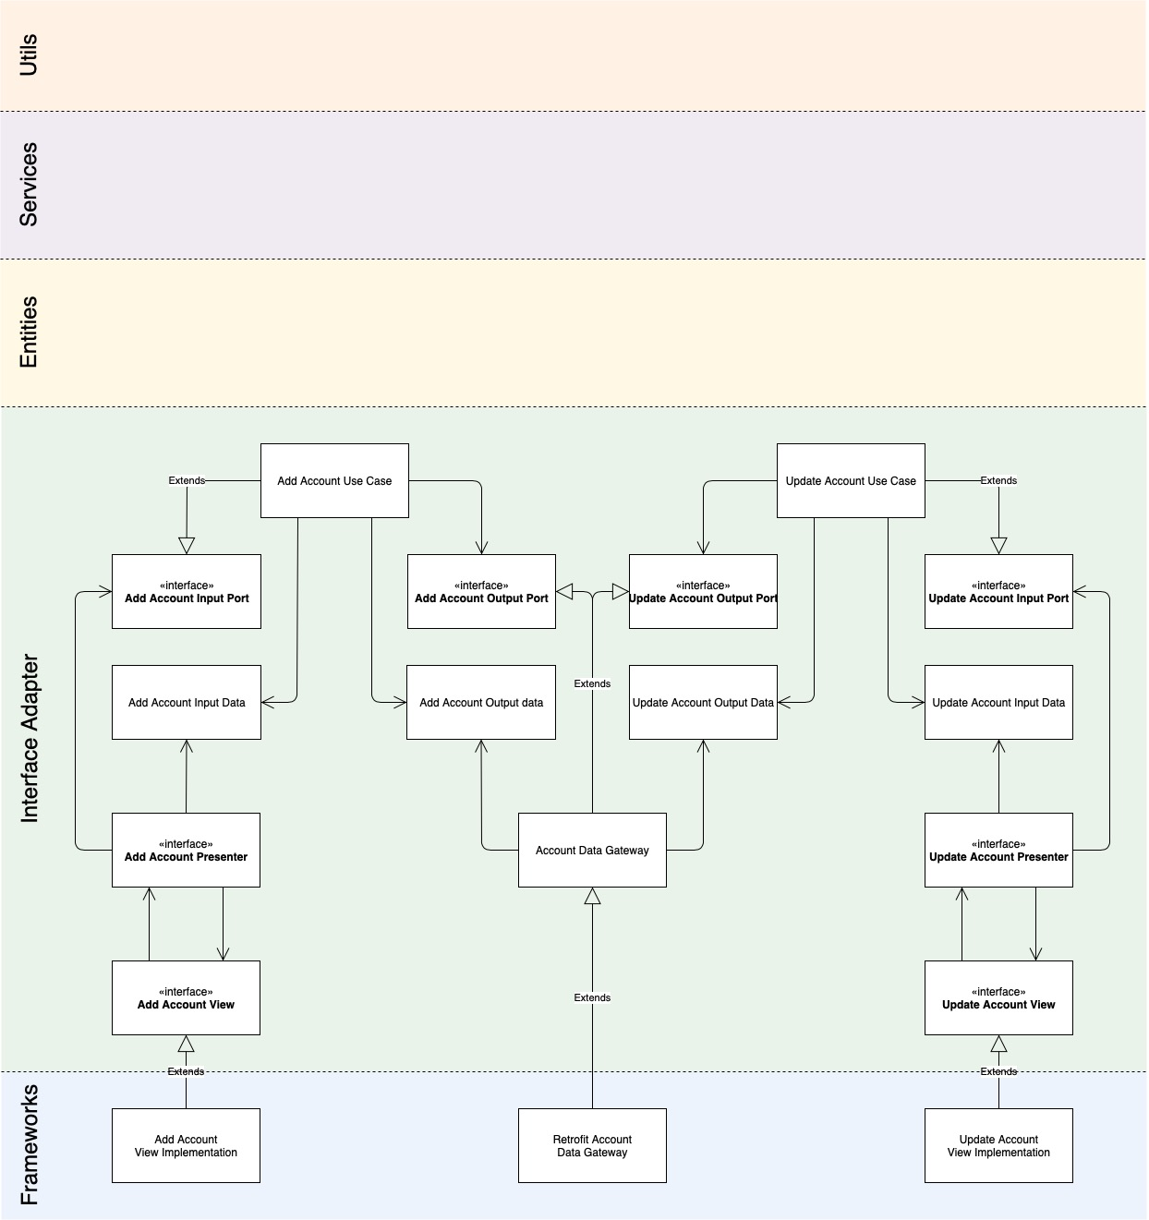

Figure : interface-segregation-principle.jpg

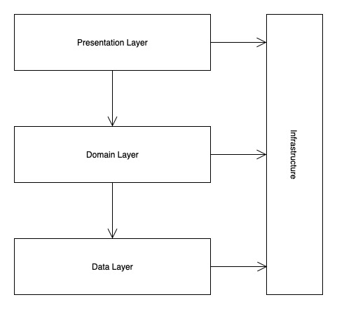

Figure : n-tier-architecture.jpg

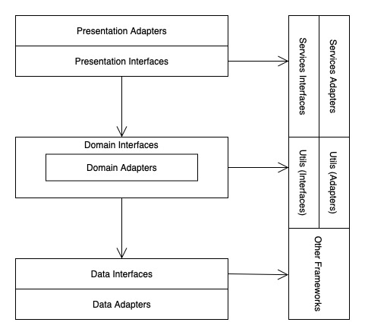

Figure : n-tier-architecture-subdivided.jpg