VOLTGRID
A Proposed OCPP Based Charging Station Management System
with Safe Site Load Balancing
CAPSTONE PROJECT PHASE-1
Phase - I Report
Submitted by

TEAM MEMBERS
1. 23BCE10263 Ronak Kamboj
2. 23BCE10237 Aditya Chaudhary
3. 23BCE10224 Siddharth Sharma
4. 23BCE10296 Yuvraj Singh
5. 23BCE10210 Mohd Hammad

in partial fulfillment of the requirements for the degree of
Bachelor of Engineering and Technology



VIT Bhopal University
Bhopal
Madhya Pradesh

September 2026



Bonafide Certificate

Certified that this project report titled ‘VoltGrid: A Proposed OCPP Based Charging Station Management System with Safe Site Load Balancing’ is the bonafide work of Ronak Kamboj (23BCE10263), Aditya Chaudhary (23BCE10237), Siddharth Sharma (23BCE10224), Yuvraj Singh (23BCE10296), and Mohd Hammad (23BCE10210), who carried out the project work under my supervision.

This project report (DSN4091 Capstone Project Phase-I) is submitted for the Project Viva-Voce examination held on [Date].

Supervisor: Dr. G. R. Hemalakshmi

Table of content

Sl. No. Topic Page No.

1. Introduction 1
1.1 Motivation 1
1.2 Objective 1
2. Existing Work and Literature Review 2
3. Frontend Backend and System Requirements 3
4. Methodology 5
Individual Contribution by Members 11
5. Conclusion 16
Reference and Publication 17

List of figures
Fig. 1 VoltGrid system architecture 5
Fig. 2 OCPP charger communication flow 6
Fig. 3 Smart load balancing example 7
Fig. 4 Charging sessions and billing flow 8
Fig. 5 Monitoring and reliability controls 9

List of Tables
Table 1 Existing systems and relation to VoltGrid 2
Table 2 System requirements and selected technologies 3
Table 3 Component responsibilities and data boundaries 5
Table 4 Reproducible 100 kW allocation example 7
Table 5 Phase-I acceptance criteria 9

List of Abbreviation

Abbreviation | Meaning
API | Application Programming Interface
CSMS | Charging Station Management System
EV | Electric Vehicle
EVSE | Electric Vehicle Supply Equipment
HTTP | Hypertext Transfer Protocol
JSON | JavaScript Object Notation
OCPP | Open Charge Point Protocol
TLS | Transport Layer Security
UI | User Interface

CHAPTER 1: INTRODUCTION
An electric vehicle charging station is both an electrical load and a networked software endpoint. It reports authorization events, connector status, transaction state, and meter values. A charging station management system receives these messages, records durable facts, and returns control instructions. When several vehicles use one site connection, the same system must also keep their combined demand within the site power limit.

1.1 Motivation
Operators need one current view of charger availability, active sessions, faults, meter readings, and assigned power. Drivers need a clear record of the energy delivered and the tariff used for each invoice. If these records drift apart, the dashboard becomes stale, billing becomes difficult to reproduce, and simultaneous charging can exceed the configured site budget.
India's charging-infrastructure guidance also makes interoperability, safety, and grid-aware operation relevant design goals. VoltGrid treats these concerns as one coordination problem. The project connects simulated chargers, maintains session and meter records, produces invoices from stored tariff data, and allocates a fixed charging budget across active connectors.

1.2 Objective
The objective is to design and implement a compact OCPP-based CSMS that can be inspected through repeatable charger simulations. Phase 1 establishes the working CSMS foundation, while Phase 2 extends it with smart site-power allocation. The report covers the following planned outcomes:
• connect multiple simulated chargers through an OCPP-style WebSocket endpoint;
• store sites, chargers, connectors, OCPP messages, sessions, meter readings, tariffs, and invoices in PostgreSQL;
• provide a Next.js dashboard with operator controls, charger cards, browser-based simulation, live session status, and invoice views;
• reserve Redis for planned transient live state and pub/sub while PostgreSQL remains the durable source of truth; and
• implement the Phase 2 allocation service so deterministic charger setpoints never exceed the configured site power limit.

CHAPTER 2: EXISTING WORK / LITERATURE REVIEW

2.1 Existing Projects
The broad VoltGrid concept already exists. Commercial products such as Driivz, AMPECO, and ChargeLab describe charger operations, billing, driver services, and energy-management functions. Open-source projects also implement major parts of the central-system layer. SteVe provides an OCPP server with charge-point, user, and RFID administration. CitrineOS provides a modular TypeScript and Node.js CSMS with persistence, messaging, caching options, an operator interface, transaction handling, and smart-charging modules.
Table 1 Existing systems and relation to VoltGrid
System | Type | Publicly described scope | Difference in VoltGrid
Driivz | Commercial | Operations, billing, reporting, driver tools, energy management | VoltGrid is a compact teaching implementation with inspectable allocation logic
AMPECO | Commercial | Charging operations, APIs, payments, driver experience, smart energy | VoltGrid excludes production payments and white-label operations
ChargeLab | Commercial | OCPP management, live monitoring, dynamic power management | VoltGrid documents a reproducible equal-priority allocation baseline
SteVe | Open source | OCPP server and charge-point, user, and RFID administration | VoltGrid uses a different service split and includes a separate allocator
CitrineOS | Open source | Modular OCPP CSMS, persistence, messaging, cache, operator UI | VoltGrid narrows scope to a capstone-sized architecture and measured evaluation

2.2 Literature Review
Research on coordinated charging predates VoltGrid. Gan, Topcu, and Low studied decentralized scheduling that reduces peaks in aggregate demand. Ma, Callaway, and Hiskens examined decentralized charging control for large vehicle populations. Later surveys classify charging methods by grid, aggregator, and customer objectives and compare rule-based, optimization-based, and learning-based methods [7]-[10].
Many published methods schedule energy over time and require prices, forecasts, departure times, or network models. VoltGrid Phase-I addresses a narrower operational decision: given the current site budget and current charger requests, calculate immediate limits that are safe, fair under equal priority, and easy to explain. This does not claim a new protocol or a globally optimal charging algorithm. The contribution is the integration of OCPP events, durable session records, reproducible billing, live state, and a deterministic allocator in one testable reference system.

CHAPTER 3: FRONTEND BACKEND AND SYSTEM REQUIREMENTS

3.1 Frontend
VoltGrid uses a Next.js dashboard with operator and driver-oriented views. The operator view shows station connectivity, connector status, faults, active sessions, meter age, requested power, assigned power, and the latest allocation result. The driver-oriented view shows the simulated charging session, accumulated energy, session history, and generated invoice. The dashboard reads a current snapshot from HTTP, while live updates are used to reflect changes during the demonstration.

3.2 Backend
A Hono service running on Bun owns the external trust boundaries. It hosts the HTTP API, accepts OCPP-style WebSocket upgrades, validates messages, dispatches protocol operations, manages session state, writes durable records to PostgreSQL through Prisma ORM, and requests allocations from the Go service in Phase 2. Redis is planned for transient live state and pub/sub; no billable event depends on Redis as its only copy.
The Phase 2 Go allocator receives one validated site snapshot and returns one setpoint for each eligible charger. It does not connect directly to chargers, edit invoices, or maintain user sessions. Docker Compose defines the local services, networks, and volumes used for repeatable development and demonstration.

3.3 System Requirements
Table 2 System requirements and selected technologies
Layer | Technology | Minimum requirement | Purpose
Frontend | Next.js | Modern web browser and HTTP/WebSocket access | Operator controls, charger cards, browser simulator, sessions, and invoices
CSMS | Hono on Bun | HTTP routes, OCPP-style WebSocket handling, validation, and logging | Protocol and session/billing orchestration
Database | PostgreSQL with Prisma ORM | Transactions, constraints, and durable storage | Source of truth for sites, chargers, sessions, meters, tariffs, and invoices
Live state | Redis planned | Recoverable transient state and pub/sub | Future presence and live-event distribution
Allocator | Go service | Phase 2 JSON HTTP endpoint and deterministic arithmetic | Safe site-power allocation
Deployment | Docker Compose | Local containers, networks, and volumes | Repeatable development and demonstration
Test setup | Browser and CLI charger simulators | Scripted boot, status, transaction, meter, and disconnect events | End-to-end verification without physical vehicle hardware

3.4 Data and Security Requirements
• The selected OCPP version must be frozen before the final implementation, and protocol-specific messages must be translated into version-neutral domain events.
• Primary keys, foreign keys, unique constraints, and database transactions must protect durable relationships and duplicate processing.
• Production deployments must use authenticated connections, TLS, and managed credentials. The Phase 1 local demonstration focuses on protocol validation and repeatable simulator traffic.
• Role-based access is a planned production requirement: drivers should access only their own sessions and invoices, while operator-only actions should require role checks and audit records.
• The system must validate message schemas, units, identifiers, sizes, and state transitions before performing side effects.

CHAPTER 4: METHODOLOGY

4.1 System Design and Architecture
The project follows a design-science method. Standards and protocol claims come from the Open Charge Alliance, policy claims come from Indian government sources, and comparison claims use project or vendor documentation. The proposed architecture is then checked against explicit safety, consistency, recovery, and authorization requirements. Empirical performance claims remain outside Phase-I until the system runs on the selected demonstration hardware.
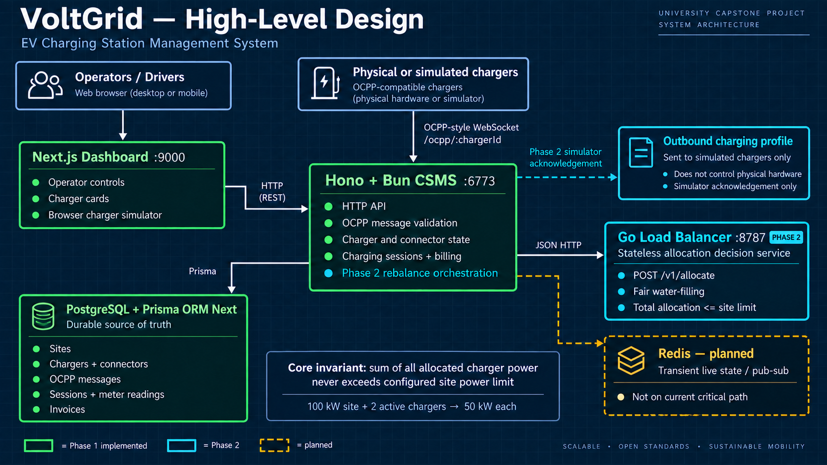
Fig. 1 VoltGrid system architecture
Table 3 Component responsibilities and data boundaries
Component | Responsibility | Data boundary
Operator dashboard | Station inventory, connector state, faults, sessions, meters, and allocations | HTTP reads and live updates from the CSMS
Driver view | Simulated session controls, live energy, history, and invoice view | Session and invoice data exposed by the CSMS
Hono CSMS | HTTP API, OCPP-style WebSocket handling, validation, orchestration, and billing | Owns external connections and service coordination
PostgreSQL | Sites, chargers, connectors, OCPP messages, sessions, meters, tariffs, and invoices | Durable source of truth
Redis | Planned presence, short-lived state, and pub/sub | Transient and recoverable; not on the current critical path
Go allocator | Phase 2 validation and deterministic setpoint calculation | Internal JSON request and response

4.2 Working Principle
Each physical or simulated charger opens an OCPP-style WebSocket connection to the Hono and Bun CSMS. The CSMS validates the frame, matches the message identifier to the request or response, and translates accepted operations into internal events. Durable state is committed to PostgreSQL before a dashboard update is published. This ordering allows a reconnecting client to rebuild its view from the durable database rather than relying only on a transient notification.
1. A simulator boots and identifies the charging station.
2. Status notifications update connector availability and fault state.
3. Authorization and transaction messages open an internal charging session.
4. Meter values update cumulative energy and trigger live display changes.
5. In Phase 2, the allocator recalculates when demand, eligibility, or the site budget changes.
6. A stop event finalizes the meter difference and creates one invoice from the stored tariff snapshot.
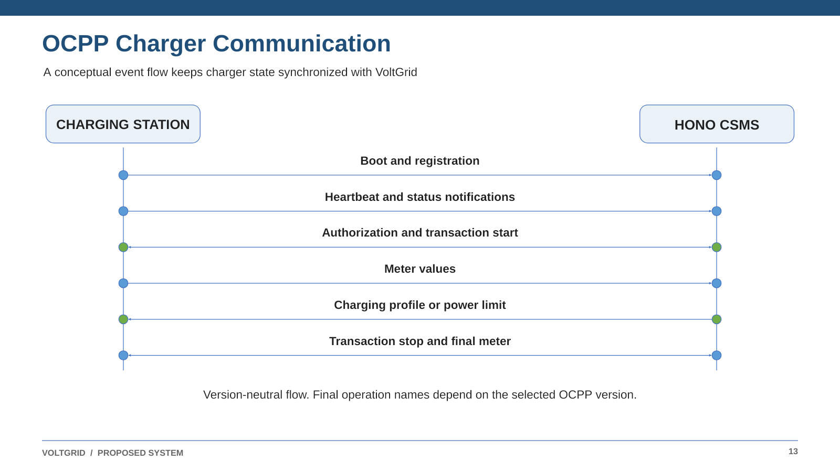
Fig. 2 OCPP charger communication flow

4.3 Smart Load Balancing
At each recalculation, the CSMS derives the charging budget from the configured site import limit after subtracting measured or estimated non-EV load and a reserve margin. Every connector request is capped by its hardware limit and any available vehicle or operator limit. The allocator must return non-negative values, must not assign more than a connector requested, and must keep the total at or below the available charging budget.
The first policy uses capped equal-priority water filling. It divides the remaining capacity equally among connectors that have not reached demand. A connector that reaches its demand leaves the next division. Integer-watt remainders follow stable connector order, so identical inputs always return identical outputs. The CSMS rejects a response that omits or duplicates an eligible connector or breaks either allocation limit.
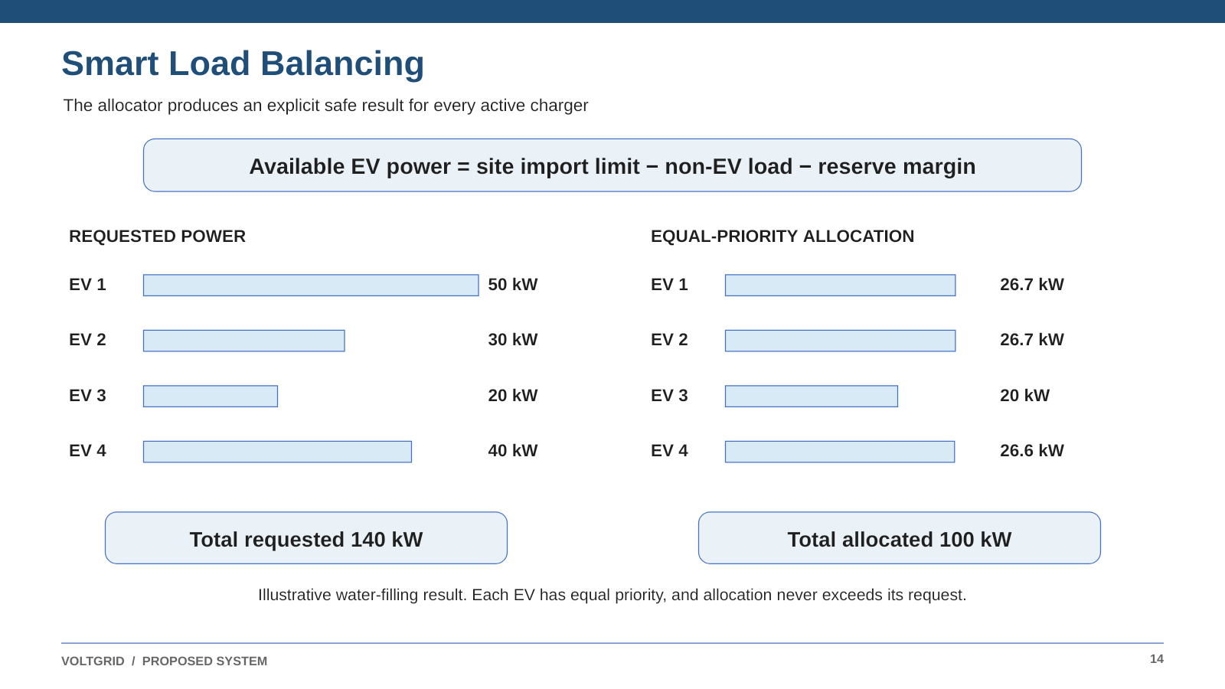
Fig. 3 Smart load balancing example
Table 4 Reproducible 100 kW allocation example
Connector | Request kW | Allocation kW | Reason
EV 1 | 50.0 | 26.7 | Equal share after EV 3 reaches demand
EV 2 | 30.0 | 26.7 | Equal share after EV 3 reaches demand
EV 3 | 20.0 | 20.0 | Demand cap is below the final water level
EV 4 | 40.0 | 26.6 | Receives the deterministic rounding remainder
Total | 140.0 | 100.0 | Allocation equals the available budget

This example verifies one hypothetical allocation snapshot. It does not establish charger compliance or grid performance. The implementation must recalculate when a connector joins or leaves, a request changes, the site limit changes, or a setpoint fails. A sudden reduction in site capacity must bypass normal debounce and reduce limits immediately.

4.4 Charging Sessions, Metering and Billing
VoltGrid maps protocol messages to pending, active, stopping, completed, and failed session states. Connector status does not replace transaction state. State-changing handlers use idempotency keys so retries after timeouts do not create duplicate sessions, meter effects, or invoices.
The session energy equals the non-negative difference between the final and starting cumulative energy after unit normalization. Meter readings are stored with the session, and the invoice stores the tariff used for the calculation so the result remains reproducible. Session completion, final meter selection, and invoice creation are kept consistent through database transactions and a unique invoice-per-session constraint.
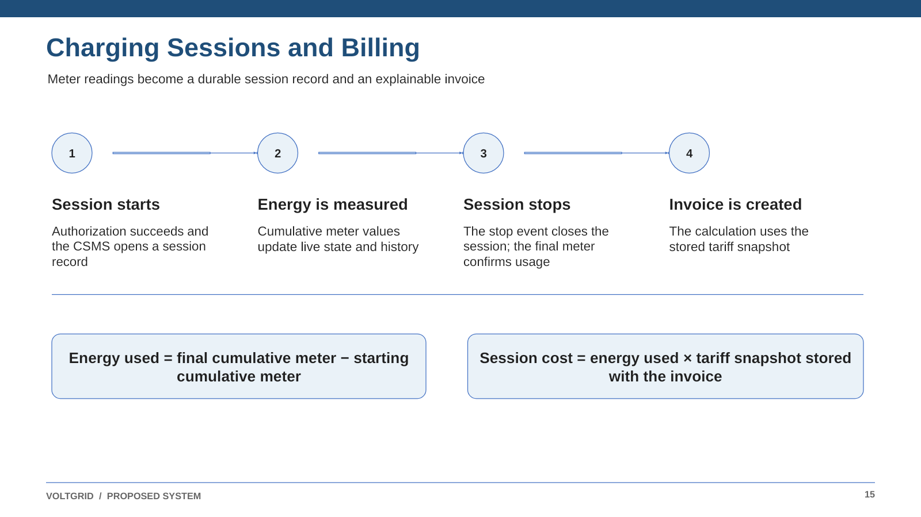
Fig. 4 Charging sessions and billing flow

4.5 Monitoring, Reliability and Security
The operator view shows heartbeat age, connection state, connector status, fault code, active-session identifier, latest meter timestamp, measured power, requested power, assigned power, and the latest allocation reason. Liveness checks report whether a process is running. Readiness checks also verify required dependencies and the OCPP endpoint.
If Redis becomes unavailable, durable events remain in PostgreSQL and clients can resynchronize. If the Go allocator becomes unavailable, the CSMS may retain existing limits only when their verified total remains within the current budget. Otherwise it must apply a conservative predefined split or suspend charging. The project also requires charger authentication, schema validation, role checks, rate limits, bounded message processing, and audit records for tariff, invoice, and power-limit changes.
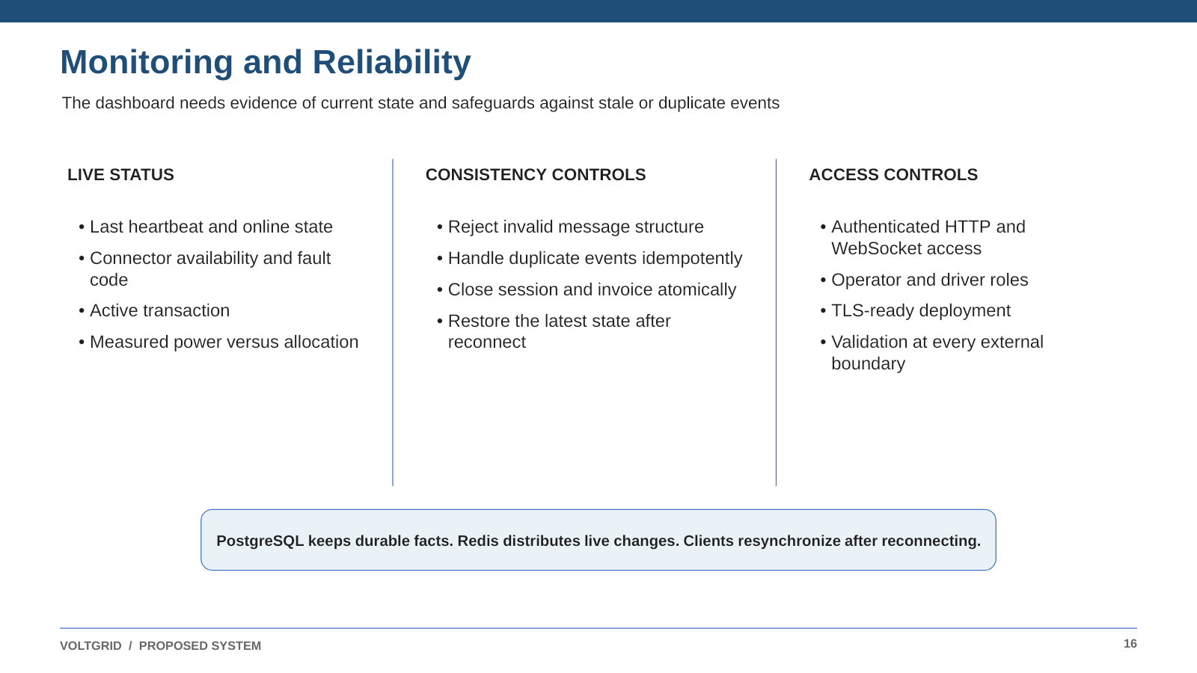
Fig. 5 Monitoring and reliability controls

4.6 Results and Discussion
The Phase 1 result is a working CSMS foundation and a testable design for the Phase 2 smart-charging extension. The demonstration must show simulated charger connectivity, session creation, meter persistence, billing, and dashboard state. Phase 2 will then evaluate the 100 kW allocation example across changing simulator states. The key safety result is that total allocated power must remain at or below the configured site limit.
Table 5 Phase-I acceptance criteria
Area | Test | Required evidence
Connectivity | Multiple simulators boot and one reconnects | Boot response, status state, connection log, and restored dashboard state
Session lifecycle | Start, meter, stop, and invoice | One coherent session record and one invoice per transaction
Duplicate handling | Replay an inbound message or stop event | No duplicate durable event, session effect, or invoice
Dashboard | Show multiple simulated chargers and live state | Charger cards, connector status, session state, and latest invoice
Billing | Use known meter readings and tariff | Invoice matches the independent energy and tariff calculation
Phase 2 load safety | Change demand under a configured site limit | Total allocation remains at or below the site limit
Phase 2 allocator contract | Call the Go allocation endpoint | Every eligible charger receives one valid allocation
Recovery | Reconnect the dashboard or simulator | Durable records remain available and state can be rebuilt

4.7 Limitations
The Phase 1 model uses simulated chargers, unidirectional charging, and one simplified site power budget. It does not include physical vehicle hardware, mobile applications, roaming networks, payment-gateway integration, dynamic pricing, machine-learning optimization, phase imbalance, transformer thermal behavior, renewable forecasts, battery storage, departure deadlines, state of charge, or vehicle-to-grid operation. Phase 2 focuses on the deterministic Go allocation service and its software control loop. More advanced scheduling and additional OCPP versions remain future work.

Individual Contribution by members
The following member-wise contributions describe the assigned work, supporting sections of this report, and the technical learning associated with each project area.

Member 1 Ronak Kamboj (23BCE10263)
Primary responsibility: Go smart load balancer
Contribution: Ronak designed the Phase 2 Go allocation service. The service receives a validated site-power snapshot and returns deterministic per-charger limits using capped equal-priority water filling. Its response is checked so the total allocation never exceeds the configured site limit and no charger receives more than its request or configured maximum. The service remains stateless and communicates with the Hono CSMS through an internal JSON HTTP contract.
Evidence: Sections 3.2 and 4.3; Fig. 3; Table 4; and the Phase 2 load-safety criteria.
Individual learning: Ronak learned to express a power-allocation policy through explicit invariants, deterministic arithmetic, and a service boundary that can be tested independently.

Member 2 Aditya Chaudhary (23BCE10237)
Primary responsibility: Hono CSMS implementation
Contribution: Aditya worked on the Hono and Bun CSMS boundary. This area accepts HTTP requests, upgrades charger connections to OCPP-style WebSockets, validates incoming messages, dispatches protocol operations, and coordinates charger state, sessions, meter readings, and invoices. The CSMS also communicates with the Go allocator in Phase 2 and sends live state to the dashboard.
Evidence: Sections 3.2, 4.2, 4.4, and 4.5; Fig. 1; Fig. 2; and Table 3.
Individual learning: Aditya learned how a CSMS protects an external protocol boundary while coordinating durable database records and transient dashboard state.

Member 3 Siddharth Sharma (23BCE10224)
Primary responsibility: Next.js dashboard development
Contribution: Siddharth worked on the Next.js dashboard used for operator controls, charger cards, connection status, session monitoring, and simulator actions. The dashboard reads backend state through HTTP and displays live charger and session changes so the demonstration can be performed without physical vehicle hardware.
Evidence: Sections 3.1 and 4.5; Table 2; Table 3; and the Phase 1 dashboard and connectivity criteria.
Individual learning: Siddharth learned how frontend state, backend contracts, charger simulation, and live operational feedback are combined in a CSMS interface.

Member 4 Yuvraj Singh (23BCE10296)
Primary responsibility: Session and invoice interface
Contribution: Yuvraj contributed to the driver-oriented dashboard flow, including simulated charger controls, active session information, meter readings, session completion, and invoice display. This work connects the data produced by the CSMS to a clear charging workflow and supports the Phase 1 demonstration of session and billing behavior.
Evidence: Sections 3.1 and 4.4; Fig. 4; Table 2; and Table 3.
Individual learning: Yuvraj learned how charging-session state, cumulative meter readings, tariff snapshots, and invoice results are presented as one user workflow.

CHAPTER 5: CONCLUSION

5.1 Project Screenshots and Evidence
The Phase 1 demonstration should include screenshots of the Next.js dashboard, connected simulated chargers, charger and connector states, an active session, meter readings, and a generated invoice. Phase 2 evidence should additionally show the Go allocator response, the applied charging profile, and the total allocation remaining within the site limit.

5.2 Final Outcome
VoltGrid addresses a real engineering problem within an established product category. Commercial and open-source systems already connect chargers, manage transactions, expose dashboards, and support smart charging. Phase 1 therefore presents a compact OCPP-style CSMS foundation with simulated chargers, durable sessions, reproducible billing, and observable station state. Phase 2 extends that foundation with a separate Go service for deterministic site-power allocation.
For the 100 kW example, capped equal-priority water filling assigns 26.7, 26.7, 20.0, and 26.6 kW to requests of 50, 30, 20, and 40 kW. The total remains 100 kW and no connector exceeds its request. The implementation will succeed when these limits remain valid across changing simulator states, durable records remain consistent after retries and reconnects, invoices reproduce known calculations, and authorization rules reject forbidden access.
The resulting plan gives Group 124 a clear implementation and evaluation path. It does not claim to introduce a new CSMS protocol or a globally optimal charging algorithm. It demonstrates how charger communication, durable transaction records, live status, billing, and safe site-power control can be combined under stated constraints.

Reference and Publication
[1] Open Charge Alliance, ‘OCPP protocols,’ accessed September 9, 2026. https://openchargealliance.org/protocols/open-charge-point-protocol/
[2] Open Charge Alliance, ‘Certification OCPP 2.0.1,’ accessed September 9, 2026. https://openchargealliance.org/certificationocpp/certification-ocpp-2-0-1/
[3] Open Charge Alliance, ‘OCPP 1.6 Security Whitepaper,’ 4th ed., 2026. https://openchargealliance.org/ocpp-info-whitepapers/ocpp-1-6-security-whitepaper-4th-edition/
[4] Ministry of Power, Government of India, ‘Guidelines for Installation and Operation of Electric Vehicle Charging Infrastructure 2024,’ September 17, 2024. https://beeindia.gov.in/sites/default/files/Guidelines%20and%20Standards%20for%20EVCI%20dated%2017-09-2024_compressed.pdf
[5] NITI Aayog, ‘Electric Vehicle Charging Infrastructure and its Grid Integration in India,’ 2023. https://www.niti.gov.in/sites/default/files/2023-05/Final-smaller_Electric-Vehicles-Charging-Infrastructure.pdf
[6] NITI Aayog, Ministry of Power, Department of Science and Technology, BEE, and WRI India, ‘Handbook of Electric Vehicle Charging Infrastructure Implementation,’ 2021. https://www.niti.gov.in/node/341
[7] L. Gan, U. Topcu, and S. H. Low, ‘Optimal decentralized protocol for electric vehicle charging,’ IEEE Transactions on Power Systems, vol. 28, no. 2, pp. 940-951, 2013. https://doi.org/10.1109/TPWRS.2012.2210288
[8] Z. Ma, D. S. Callaway, and I. A. Hiskens, ‘Decentralized charging control of large populations of plug-in electric vehicles,’ IEEE Transactions on Control Systems Technology, vol. 21, no. 1, pp. 67-78, 2013. https://doi.org/10.1109/TCST.2011.2174059
[9] I. Chandra, N. K. Singh, and P. Samuel, ‘A comprehensive review on coordinated charging of electric vehicles in distribution networks,’ Journal of Energy Storage, vol. 89, 111659, 2024. https://doi.org/10.1016/j.est.2024.111659
[10] Q. Wang, X. Liu, J. Du, and F. Kong, ‘Smart charging for electric vehicles: A survey from the algorithmic perspective,’ IEEE Communications Surveys and Tutorials, vol. 18, no. 2, pp. 1500-1517, 2016. https://doi.org/10.1109/COMST.2016.2518628
[11] Z. Garofalaki, D. Kosmanos, S. Moschoyiannis, D. Kallergis, and C. Douligeris, ‘Electric vehicle charging: A survey on the security issues and challenges of OCPP,’ IEEE Communications Surveys and Tutorials, vol. 24, no. 3, pp. 1504-1533, 2022. https://doi.org/10.1109/COMST.2022.3184448
[12] SteVe Community, ‘SteVe OCPP server implementation in Java,’ GitHub repository, accessed September 9, 2026. https://github.com/steve-community/steve
[13] CitrineOS, ‘CitrineOS Core,’ project documentation and GitHub repository, accessed September 9, 2026. https://github.com/citrineos/citrineos-core
[14] Driivz, ‘EV charging management software platform,’ accessed September 9, 2026. https://driivz.com/
[15] AMPECO, ‘EV charging software platform,’ accessed September 9, 2026. https://www.ampeco.com/
[16] ChargeLab, ‘EV charging software platform,’ accessed September 9, 2026. https://chargelab.co/
[17] Hono, ‘Documentation and WebSocket Helper,’ accessed September 9, 2026. https://hono.dev/docs/helpers/websocket
[18] I. Fette and A. Melnikov, ‘The WebSocket Protocol,’ RFC 6455, IETF, December 2011. https://www.rfc-editor.org/rfc/rfc6455
[19] PostgreSQL Global Development Group, ‘PostgreSQL documentation,’ accessed September 9, 2026. https://www.postgresql.org/docs/current/
[20] Redis, ‘Redis Pub Sub,’ accessed September 9, 2026. https://redis.io/docs/latest/develop/interact/pubsub/
[21] Docker, ‘Docker Compose documentation,’ accessed September 9, 2026. https://docs.docker.com/compose/

Member 5 Mohd Hammad (23BCE10210)
Primary responsibility: Research and literature review
Contribution: Mohd worked on the research and literature review for the Phase 1 report. His work examined OCPP material, Indian EV-charging guidance, comparable commercial and open-source systems, and coordinated-charging research. This review positions VoltGrid as a compact and testable reference implementation rather than a new charging protocol or a globally optimal optimization algorithm.
Evidence: Chapter 2; Table 1; Sections 1.1, 4.1, and 4.7; and References [1]-[21].
Individual learning: Mohd learned to distinguish source-backed claims from project design decisions and to compare existing systems using scope, architecture, and evaluation criteria.

