Bug Report Document Example :

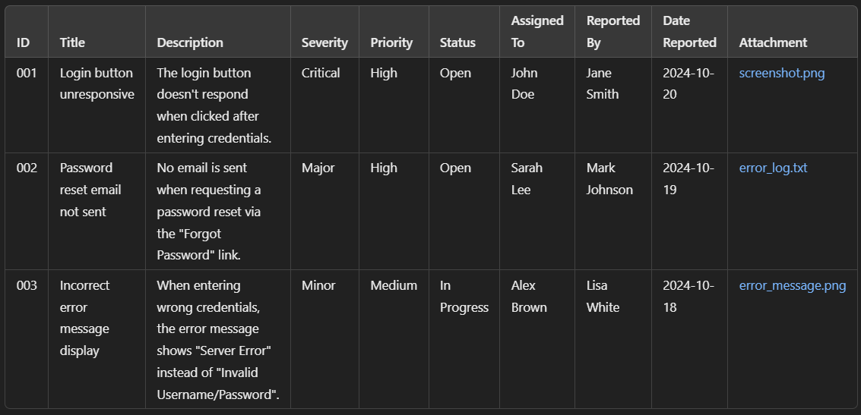

| ID | TC | Title | Description | Severity | Priority | Status | Assigned to | Reported By | Date Reported | Attachment |
| --- | --- | --- | --- | --- | --- | --- | --- | --- | --- | --- |
|  |  |  |  |  |  |  |  |  |  |  |
|  |  |  |  |  |  |  |  |  |  |  |