Lab Activities:

Part 1: Capturing HTTP Traffic.
Task 1: Start Wireshark and capture packets.
- Complete.

Task 2: Filter HTTP packets and analyze them.
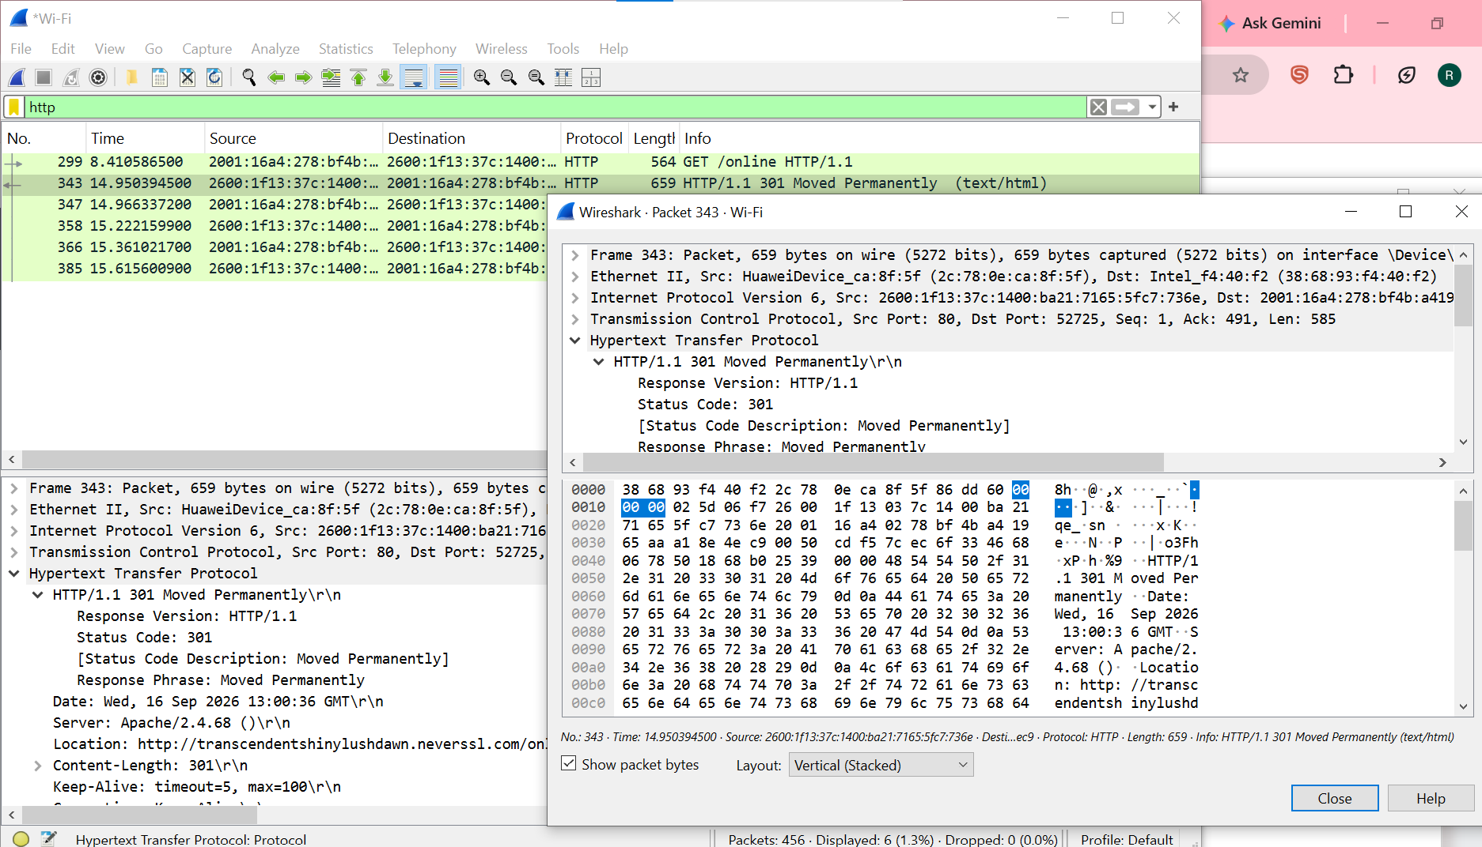
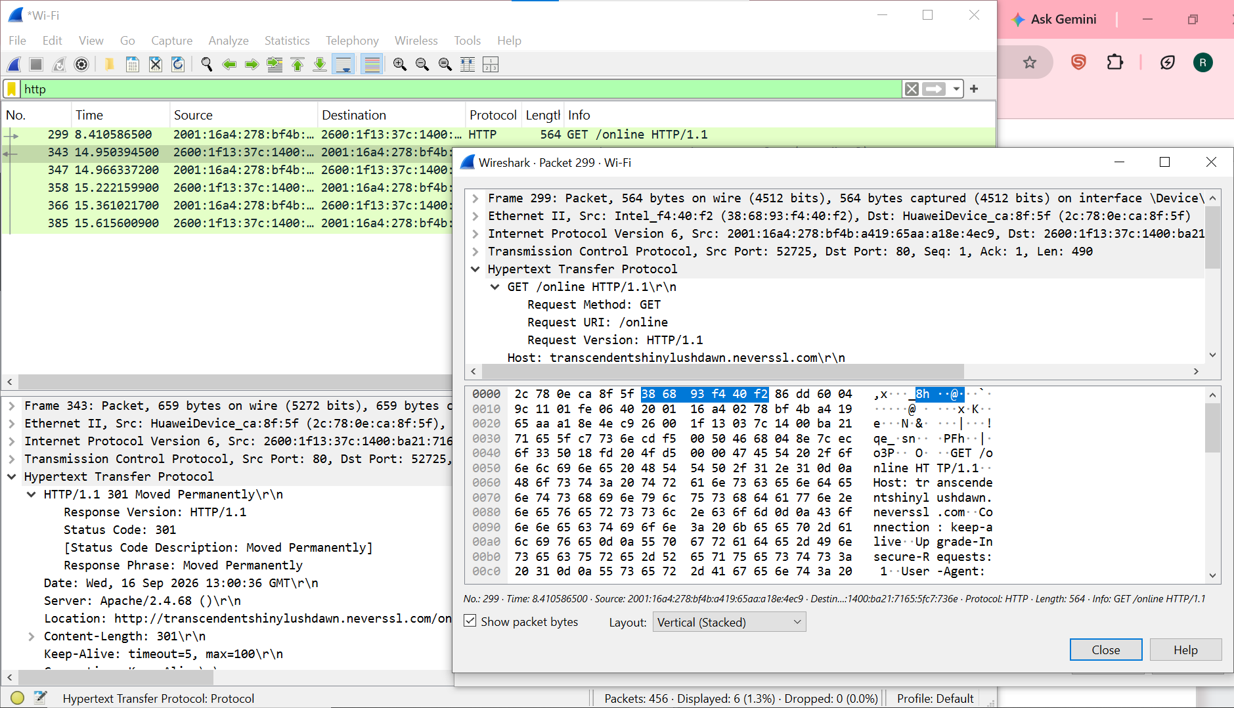

Part 2: Analyzing TCP/IP Traffic.
Task 1: Filter TCP packets
GET /online HTTP/1.1
Host: transcendentshinylushdawn.neverssl.com
Connection: keep-alive
Upgrade-Insecure-Requests: 1
User-Agent: Mozilla/5.0 (Windows NT 10.0; Win64; x64) AppleWebKit/537.36 (KHTML, like Gecko) Chrome/152.0.0.0 Safari/537.36
Accept: text/html,application/xhtml+xml,application/xml;q=0.9,image/avif,image/webp,image/apng,*/*;q=0.8,application/signed-exchange;v=b3;q=0.7
Referer: http://neverssl.com/
Accept-Encoding: gzip, deflate
Accept-Language: en-US,en;q=0.9

HTTP/1.1 301 Moved Permanently
Date: Wed, 16 Sep 2026 13:00:36 GMT
Server: Apache/2.4.68 ()
Location: http://transcendentshinylushdawn.neverssl.com/online/
Content-Length: 301
Keep-Alive: timeout=5, max=100
Connection: Keep-Alive
Content-Type: text/html; charset=iso-8859-1

<!DOCTYPE HTML PUBLIC "-//W3C//DTD HTML 4.01//EN" "http://www.w3.org/TR/html4/strict.dtd">
<html><head>
<title>301 Moved Permanently</title>
</head><body>
<h1>Moved Permanently</h1>
<p>The document has moved <a href="http://transcendentshinylushdawn.neverssl.com/online/">here</a>.</p>
</body></html>

GET /online/ HTTP/1.1
Host: transcendentshinylushdawn.neverssl.com
Connection: keep-alive
Upgrade-Insecure-Requests: 1
User-Agent: Mozilla/5.0 (Windows NT 10.0; Win64; x64) AppleWebKit/537.36 (KHTML, like Gecko) Chrome/152.0.0.0 Safari/537.36
Accept: text/html,application/xhtml+xml,application/xml;q=0.9,image/avif,image/webp,image/apng,*/*;q=0.8,application/signed-exchange;v=b3;q=0.7
Referer: http://neverssl.com/
Accept-Encoding: gzip, deflate
Accept-Language: en-US,en;q=0.9

HTTP/1.1 200 OK
Date: Wed, 16 Sep 2026 13:00:37 GMT
Server: Apache/2.4.68 ()
Last-Modified: Wed, 29 Jun 2022 00:23:22 GMT
ETag: "8be-5e28b29291e10-gzip"
Accept-Ranges: bytes
Vary: Accept-Encoding
Content-Encoding: gzip
Content-Length: 1173
Keep-Alive: timeout=5, max=99
Connection: Keep-Alive
Content-Type: text/html; charset=UTF-8

..........uVQo.6.~.~..{..X..,i.....Y.....(.T.$J.L..IEU....Q.....@.y.....N...Q.8....zF;/.....A...=$P..J].`:......b..
c.....(.L1....J.}Rb#............ ..q h%.%8...cY...U'..-\.~y.[.Q.n..../l5h+.........\x...j....p..3....D.M...u.eFjG N3.'..-6Hs.C:..e._.^.......t.pC...7..p.bQ....%..L..m;....+.hv.a~...t.....].........%D.b==.K.&.<....I.....5
|@{.O"s.b..o.v....i%}.eDJ...Oy?......^....Eq.y~.aqu}ww.........$Hn5.g..d.c!..v.|.\.s..c..p.b.\....:....F.d...g..}.=..?X....S..g...e.?....*..Z..B_...........{.Ef.i ..S)...
~5z ..qd4 .......%;..h.kn..[.q)..V...'.5...b..q$59#..2kz..g.:. C;...3E..0S.CS..VNw.v..../...@...........T..I...wp|..1..&.....z. j..[Ci.............|...$t...lE!15.Z..........2.....Ek..|.yg....w..a...2....W.t...:..UTD0..NO.."..^.h!+....dIQBA".#...S.&i.J.n..8..(...>...R..p.S..JP.,...'.....XP.8.3..I@....jj.s.j....J.i.JFv]^_.....Jy..... .{....,C6@!J...k..._S.S...<....#.Un..>z.e...[...5:.Zc...L..@.^..q...f..h....w$.8L.O.u..9.'.7x..&....u.6D$;%.L^.....y.,xV......H....AG..j.83B.Q..<xl...h,h....})I!..4.9.p%...M*=7.T ".2f..u6.V.hD..iv.y...e.;....C.y ....y&L../jl.2.s....y....M.|k.vjnK.g)=7..y.1QK.'8.O(.8r.v'1...F.P...y.+.O[...S?...<b..{.....y..9.......]........yD.....
GET /favicon.ico HTTP/1.1
Host: transcendentshinylushdawn.neverssl.com
Connection: keep-alive
User-Agent: Mozilla/5.0 (Windows NT 10.0; Win64; x64) AppleWebKit/537.36 (KHTML, like Gecko) Chrome/152.0.0.0 Safari/537.36
Accept: image/avif,image/webp,image/apng,image/svg+xml,image/*,*/*;q=0.8
Referer: http://transcendentshinylushdawn.neverssl.com/online/
Accept-Encoding: gzip, deflate
Accept-Language: en-US,en;q=0.9

HTTP/1.1 200 OK
Date: Wed, 16 Sep 2026 13:00:37 GMT
Server: Apache/2.4.68 ()
Last-Modified: Wed, 29 Jun 2022 00:26:43 GMT
ETag: "7c-5e28b351ffe27"
Accept-Ranges: bytes
Content-Length: 124
Keep-Alive: timeout=5, max=98
Connection: Keep-Alive
Content-Type: image/vnd.microsoft.icon

.PNG
.
...
IHDR...0...0.....
5......PLTE...B...*.?...1IDATh...1
....0....${v.wg_4M.4M.4M.4M...........9.....0.P....IEND.B`.

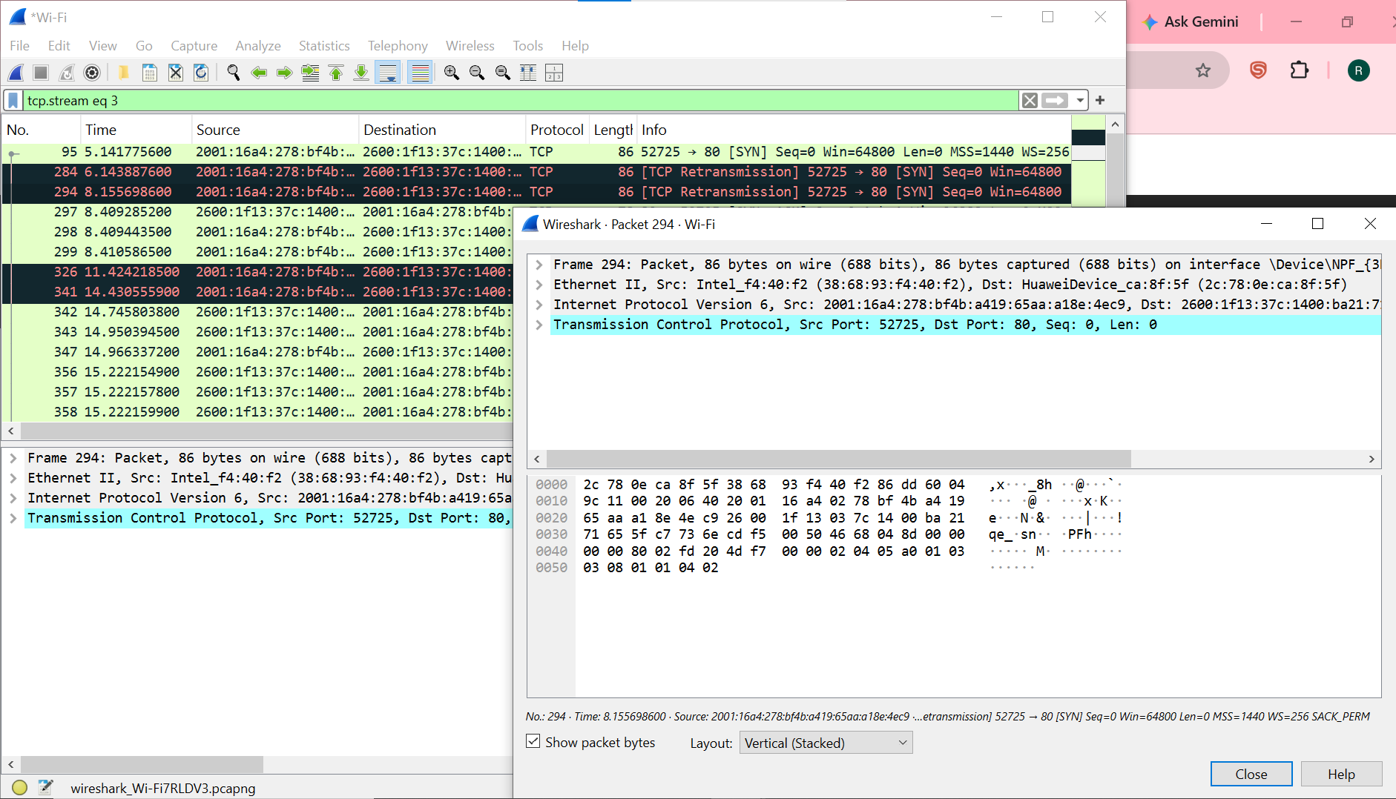
Task 2: Analyze TCP handshake and investigate Data Transfer and Termination
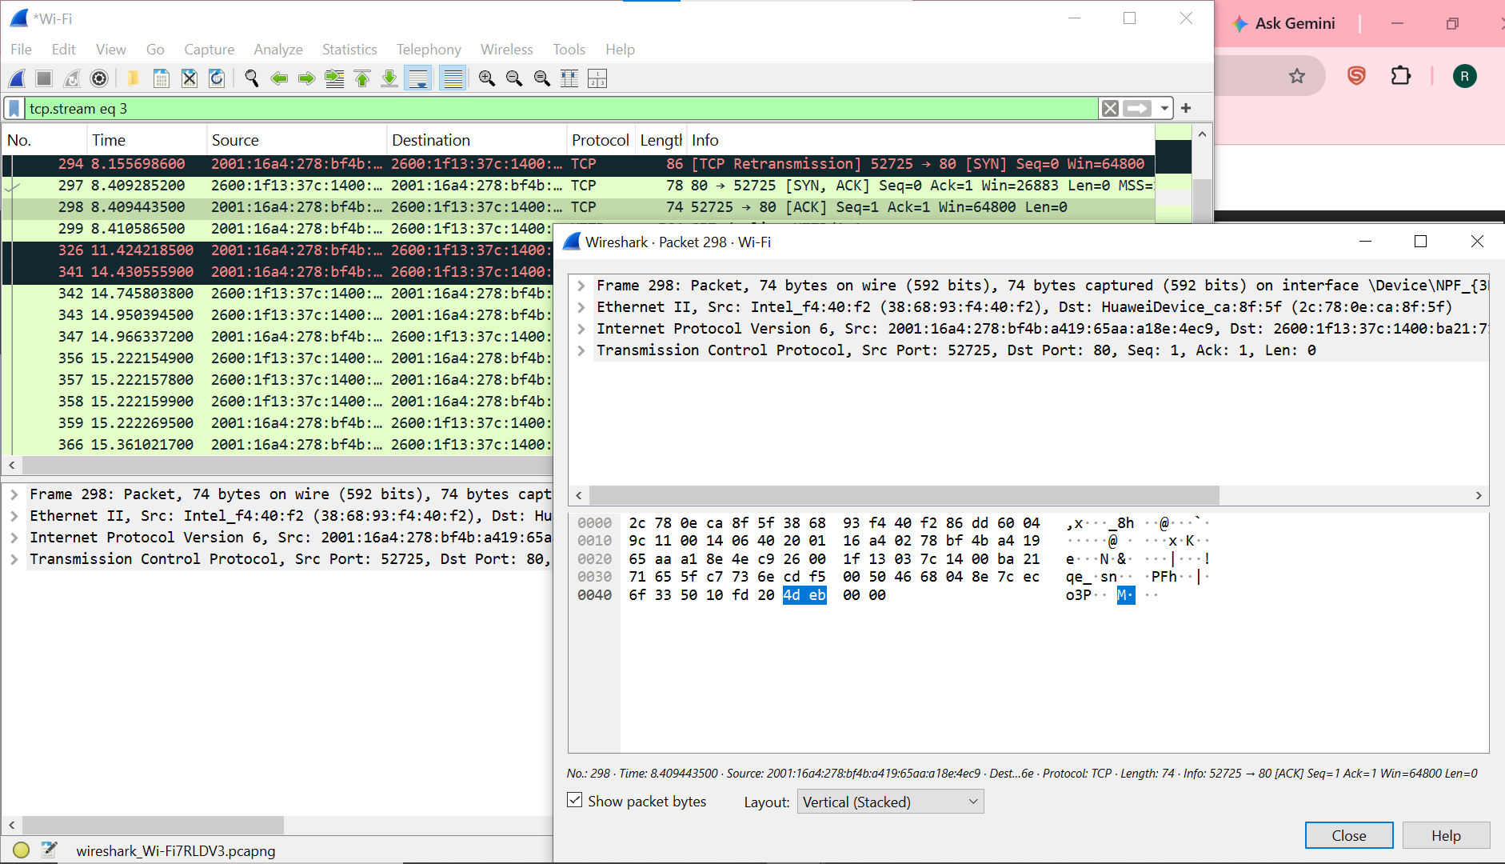
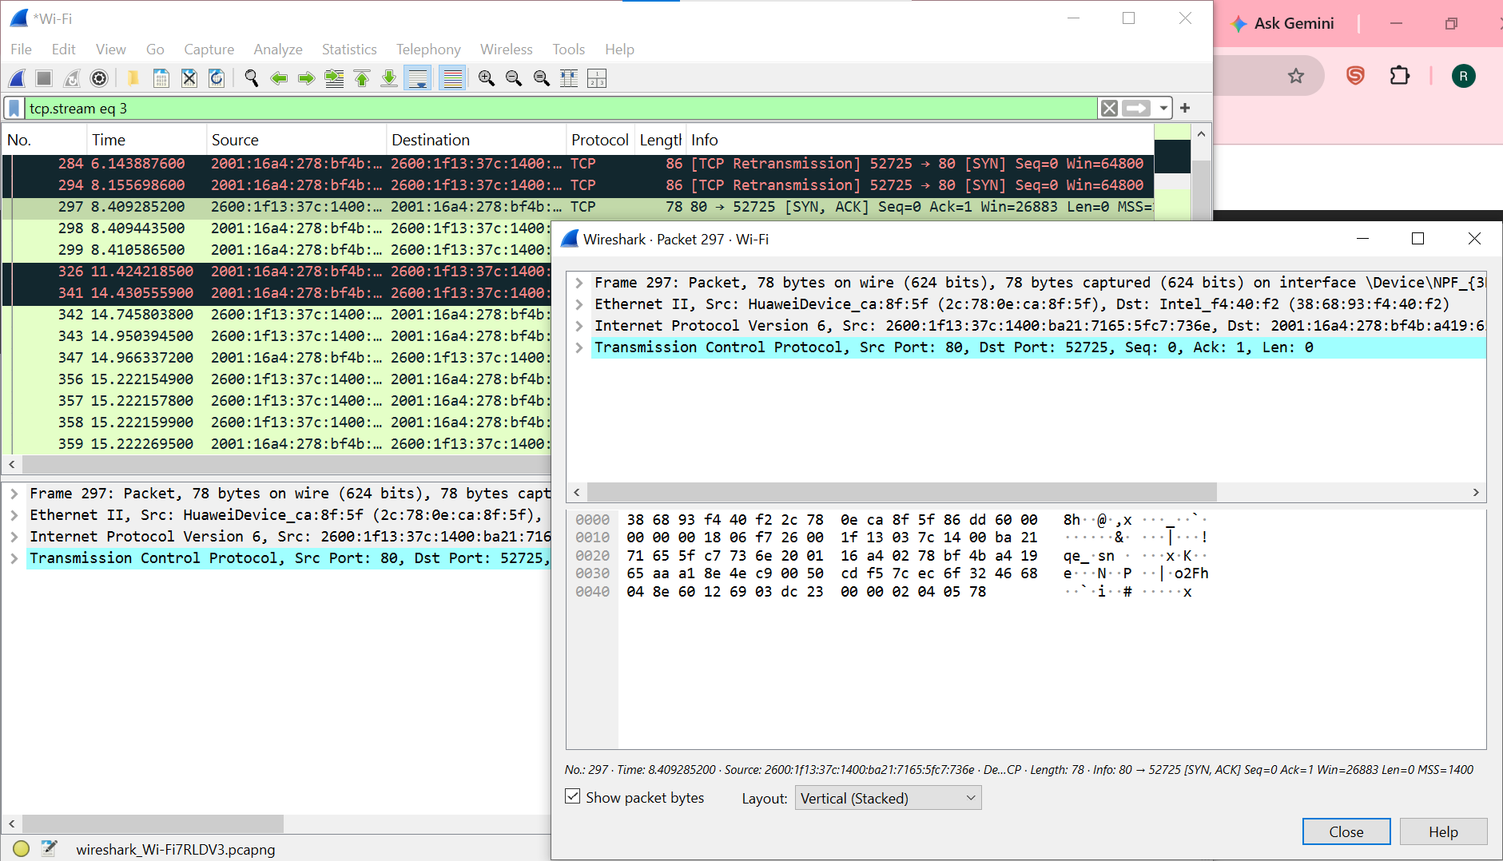
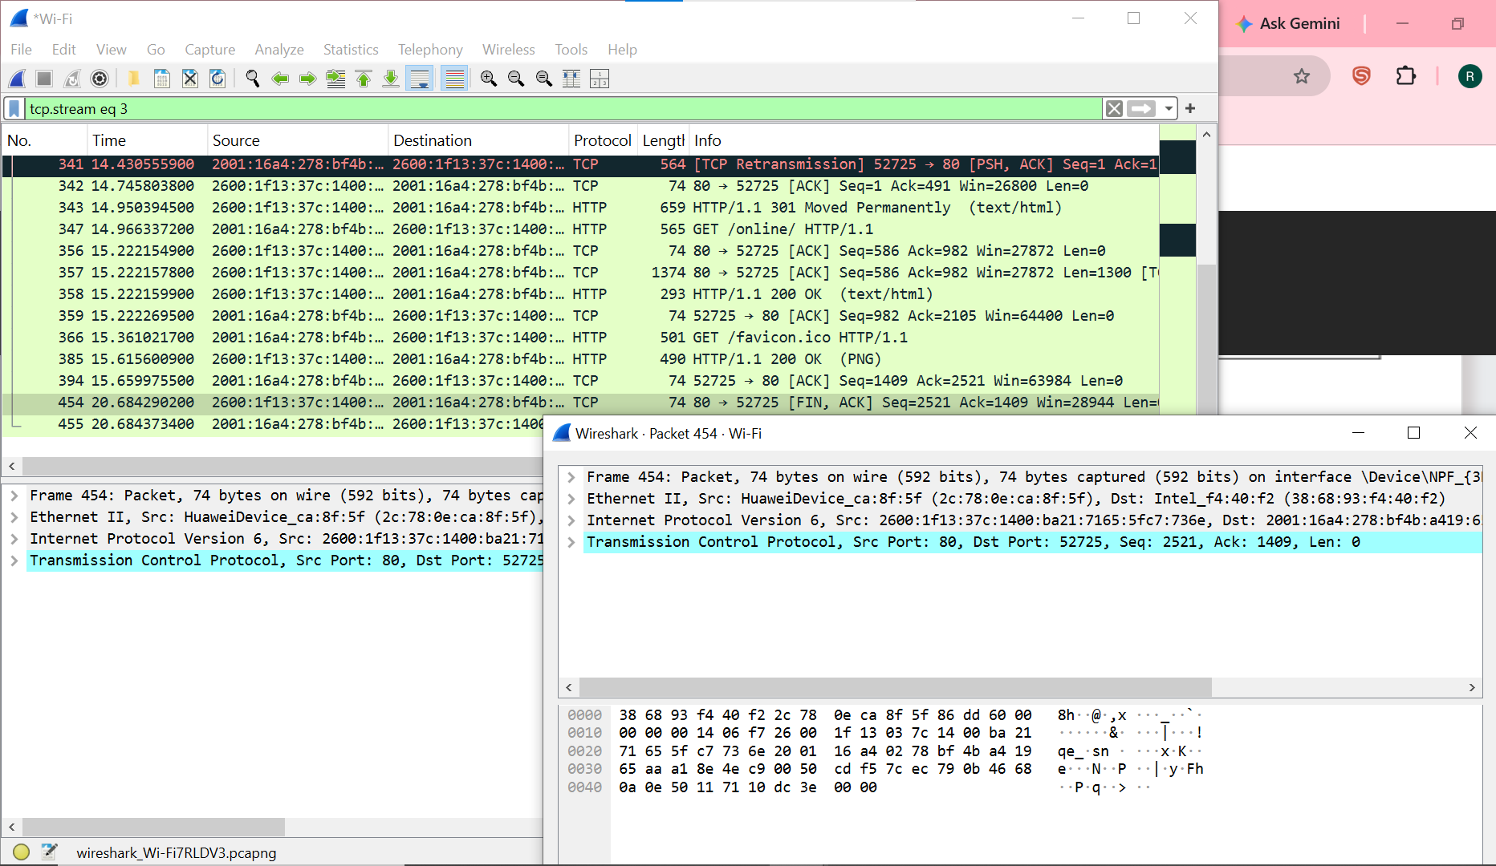
Part 3: Capturing and Analyzing UDP Traffic
Task 1: Generate UDP traffic and capture packets
- Complete.

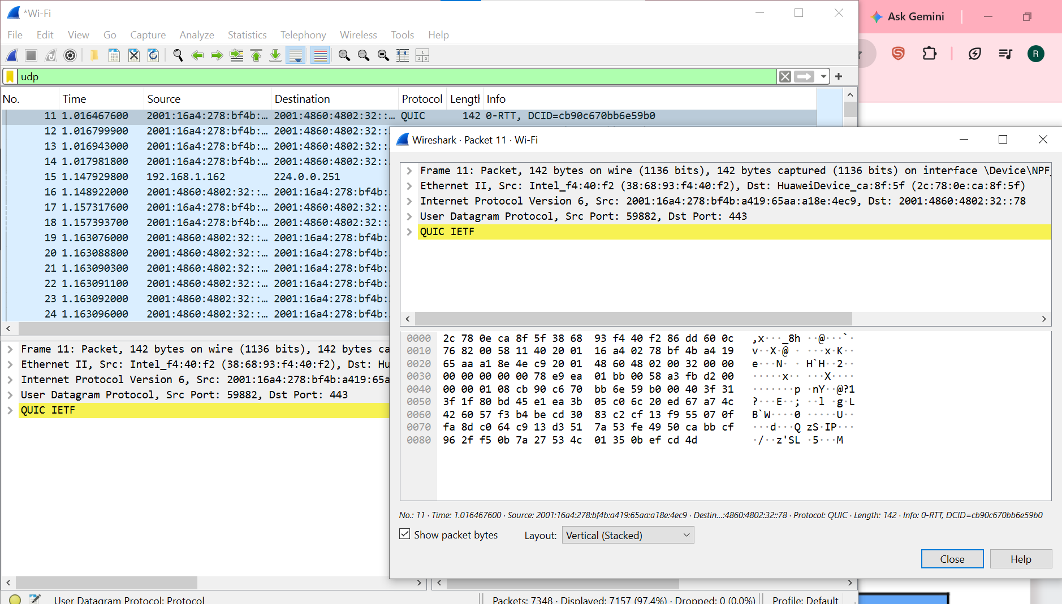
Task 2: Filter and analysis UDP Packets

Part 4: Comparing TCP and UDP by filling in the following tables. Save your work (e.g., in an MS Word document), and upload it to your online git repo.
Task 1: Fill in the following table and provide reasons.

 | TCP or UDP | Reasons
Reliability and Connection Establishment | TCP | TCP uses three-way handshake for connection establishment and acknowledgments for reliability
Data Integrity and Ordering | TCP | TCP uses seq #s to assure data completeness and data order

Task 2: Identify the use Cases and Performance of TCP and UDP.

 | TCP | UDP
Use cases | Web browsing like when we visited the neverssl.com website | Video streaming like when we visited YouTube and played a video
Performance | It may be slow but the data is complete and correct | No delivery-guarantees but it provides fast response

