The Atlantic Seaboard Substrate
Reconstructing a Pre-Modern Cultural Transmission Network
from Six Independent Evidential Streams
Gary Anthony Leckey
Aureon Institute · R&A Consulting and Brokerage Services Ltd
Belfast, Northern Ireland
gaxlec@gmail.com
Working paper · Version 1.0
April 2026

Abstract
This paper proposes that the Neolithic megalithic complex along the Atlantic seaboard of Europe was not simply a chain of independent ritual sites but the surviving physical infrastructure of a single integrated cultural-transmission network operating between approximately 5000 BCE and 1500 CE. The hypothesis is tested by integrating six independent published evidential streams: physical archaeology (31 dated megalithic sites along a 3,575 km coastal chain from Antequera to Knap of Howar); ancient DNA (Sanchez-Quinto et al. 2019; PNAS 2019 Bayesian radiocarbon modelling); material culture (the documented Iberia-to-Brittany callaïs jade trade across the Bay of Biscay; the maritime Bell-Beaker spread from the Tagus estuary); textually attested voyages (Pytheas of Massalia's 325 BCE voyage to Thule and the frozen sea); preserved lore (the Irish Immrama tradition, the Lebor Gabála Érenn, the Children of Lir, the Norse Vinland sagas, the Orkneyinga Saga); and astronomical encoding (Pleiades-Taurus alignments at Lismullin, Dowth, and Newgrange; cross-cultural Pleiades narratives across every populated continent).
The paper applies the Aboriginal Australian Songline encoding format—a documented system of sequential waypoints paired with sky-pointers, narrative mnemonics, and directional vectors—as a methodological template for re-reading the Atlantic seaboard surviving texts. Under this reading, the Voyage of Brendan, the Voyage of Mael Dúin, the Lebor Gabála invasion vectors, the Children of Lir three-station path, and the Norse Helluland-Markland-Vinland sequence all share the same encoding format. Each is read as a fragment of one originally integrated songline, whose sky-pointer index is the Pleiades-Taurus pair that recurs across every populated continent.
A specific empirical test is presented: the bearing from the Maeshowe chamber (Orkney, 2800 BCE) to a candidate site at 89.19°S, 110.65°E in East Antarctica is computed at 178.55°. This bearing maps onto the Younger Futhork rune Thurs at 1.45° offset, whose zodiac-home constellation is Taurus, the same constellation that holds the Pleiades. The convergence is non-trivial but requires falsifiability tests that are specified. Multi-stream convergence windows are identified at 4500 BCE, 3200 BCE, 2800 BCE, 325 BCE, and 650 CE, each corresponding to documented intensification of the substrate. The probability that the convergence reflects intentional encoding rather than coincidence is estimated at 40-60% based on currently available evidence, with three named computational and institutional tests that would shift this materially.
Keywords: Atlantic façade, Neolithic, megalithic culture, songline, substrate transmission, Pytheas, Pleiades, Maeshowe, Aboriginal Songlines, Antichthones, multi-stream convergence, falsifiability.

1. Introduction
The megalithic monuments of Atlantic Europe—Barnenez, Carnac, Locmariaquer, Newgrange, Maeshowe, and the wider chain—have been studied as ritual architecture for two centuries. Since the radiocarbon revolution of the 1950s, they have been recognised as belonging to a continuous Atlantic Façade tradition rather than as derivatives of Mediterranean or Near Eastern influence (Newgrange.com 2025). Recent ancient-DNA work (Sanchez-Quinto et al. 2019) has confirmed that the populations who built these monuments were genetically connected by maritime contact across thousands of kilometres of coastline. Bayesian radiocarbon modelling (Schulz Paulsson 2019, PNAS) supports a maritime diffusion model originating in northwestern France around 4500 BCE.
What has not been done, to the author's knowledge, is an integrated multi-stream reconstruction that asks: what were these monuments collectively for? Treating the chain as ritual real estate misses what it is when read as infrastructure. Treating the surviving lore as folklore misses what it is when read as preserved encoded data. Treating the documented voyages of Pytheas and Hui Te Rangiora as isolated curiosities misses what they confirm: that pre-modern peoples on both Atlantic and Pacific seaboards possessed sustained polar maritime knowledge that was transmitted across cultural networks for millennia.
This paper takes a different methodological starting point. The Aboriginal Australian Songline tradition is the surviving, intact, documented example of pre-modern continental-scale geographical knowledge encoded as song. The Songlines pair sequential waypoints with sky-pointers, with each waypoint preserving land-features and inter-site directional information. The narrative is the mnemonic that holds the encoded data through generations. Walking the path activates the verses; the verses keep the path navigable across millennia. Under European cultural rupture (Roman conquest, Christianisation, Reformation), this kind of encoding fragments into apparently disparate genres: voyage tales, foundation myths, hagiographic journeys, sagas. But the encoding format remains identifiable when read against an intact reference.
The paper makes three claims. First, that the Atlantic seaboard megalithic chain is the physical infrastructure of an integrated cultural-transmission network whose intact form was structurally analogous to the Aboriginal Songline system, and which preserved geographical, astronomical, and navigational knowledge across roughly 6,500 years of continuous operation. Second, that the surviving Atlantic seaboard texts—the Immrama, Lebor Gabála, Children of Lir, Norse sagas, Greek geographical and philosophical texts—are fragmentary songline-format preservations of substrate knowledge, recoverable when read against the Aboriginal reference. Third, that the convergences of physical, genetic, material, voyage, lore, and astronomical evidence at five named historical windows are not independent coincidences but multi-stream attestations of a single phenomenon.
The paper presents the data, the proof, and the integrated reading. It also specifies the falsifiability tests that would dissolve or strengthen the central claim. The author has no institutional affiliation in the conventional academic sense and no funding interest in the outcome. The work is conducted under the Aureon Institute research programme as an independent body of inquiry. The intent is to put the reconstruction on the published record so that the falsifiability tests can be run by others if not by the author.

2. Theoretical Framework

2.1 The substrate hypothesis
The term "substrate" in this paper denotes a body of geographical, astronomical, ritual, and navigational knowledge that was transmitted across cultural-linguistic boundaries through sustained contact between Neolithic, Bronze Age, and Iron Age peoples along the Atlantic seaboard, and which extended through documented contact zones into the Mediterranean classical tradition and (via separate maritime networks) into the Polynesian, Aboriginal Australian, and indigenous American traditions. The substrate is not a single ethnic culture or proto-religion. It is the shared content layer that recurs across multiple cultures because the cultures were in sustained contact long enough for the content to propagate.
The hypothesis is testable because the substrate predicts specific kinds of convergence: shared geometric references (phi, the Pleiades, the Orion-belt), shared narrative motifs (the Seven Sisters fleeing a male pursuer, the world-tree, the feathered serpent), shared architectural alignments (winter solstice, equinox, Pleiades-rise), and shared encoding formats (sequential waypoint songs paired with sky-pointers). Where these convergences are independently attested across geographically separated cultures with documented contact mechanisms, the substrate hypothesis is supported. Where the convergences are absent or where contact mechanisms are missing, the hypothesis is weakened.

2.2 Songline format as universal pre-modern encoding
The Aboriginal Australian Songline is the documented intact example of a pre-modern encoding format that combines geographical, astronomical, and narrative information into a single mnemonic structure (Norris 2014; National Museum of Australia 2017). The Seven Sisters Songline (Kungkarangkalpa) extends across approximately 3,500 km of the Australian continent, crossing three deserts and multiple language groups, with each section held by a different community but the song understood as one continuous directional path. The sky-pointer is the Pleiades star cluster in the constellation Taurus; the male pursuer figure (Wati Nyiru) is aligned with Orion. Walking the path activates the verses; the verses keep the path navigable; the directional information is preserved across generations because the song is performed in sequence at the correct waypoints.
The author proposes that this encoding format is not unique to Aboriginal Australia but is the universal pre-modern method of preserving continental-scale geographical knowledge across generations without writing. The format requires four components: (1) a sequence of named waypoints along a directional vector; (2) a sky-pointer index that identifies the celestial reference at each waypoint; (3) a narrative mnemonic that holds the data in cultural memory; (4) a temporal envelope (often expressed as a journey duration or a multi-generational cycle).
When the surviving Atlantic seaboard texts are read with this format in mind, they cease to look like disconnected stories and begin to resolve as fragmentary songline preservations. The Voyage of Brendan is a 7-year directional path with named waypoints (Island of Sheep, Island of Birds, Crystal Pillar, Island of Smiths, Frozen Sea, Promised Land), each preserving identifiable land-features that match high-latitude Atlantic geography (Faroes, Iceland, drift ice). The Voyage of Mael Dúin is a 33-island sequential westward path. The Lebor Gabála Érenn is a sequence of directional invasions from named cardinal points—Cessair from the north, Tuatha Dé Danann from "the northern islands of the world", Milesians from Spain. The Children of Lir is a 3-waypoint 900-year cycle naming Lake Derravaragh (inland heart), the Sea of Moyle (eastern channel crossing to Britain), and Inishglora (western Atlantic threshold). The Norse Vinland sagas give Helluland-Markland-Vinland as a 3-waypoint sequence with named distinguishing features.

2.3 The four-step suppression model
Where a substrate is preserved through a hostile cultural transition, it tends to undergo a transformation that the author models as four sequential steps: identify, capture, transform, rewrite. The substrate is first identified as a distinct system (Tacitus on the druids; Sahagún on Mesoamerican religion). It is then captured in textual form, often by missionary or imperial scholars whose stated purpose is documentation but whose effect is removal from oral context. The captured material is transformed through translation, abridgement, and integration with the successor system's framework (Brendan's pre-Christian voyage becoming a Christian pilgrimage; the Tuatha Dé Danann becoming the Sídhe). The transformed material is then rewritten as the property of the successor system, with the prior origin obscured. This is not erasure but methylation: the original text is preserved in suppressed form, recoverable by reading against the surface narrative.
This model is consistent with the work of James C. Scott on legibility and the imperial state, and with Walter Ong on orality-literacy transitions. The Children of Lir is read here as a meta-narrative about its own preservation mechanism: the four children of the elder sea-god are transformed (not destroyed) by a stepmother who replaces them, retain their human voices through 900 years of curse, sing the song that carries the knowledge, and integrate with the successor system (Christianisation) only at the end. The story is the substrate teaching its own preservation method in the only form that survives suppression.

2.4 Multi-stream convergence as test
The substrate hypothesis is testable by predicting that independent evidential streams (physical archaeology, ancient DNA, material culture trade, documented voyages, preserved lore, astronomical encoding) should converge at the same historical windows. Where five or six streams independently attest the same time-and-place node, the probability that this is coincidence approaches zero. Where the streams diverge, the hypothesis is weakened. The remainder of the paper presents the streams individually and identifies the convergence windows.

3. The Atlantic Seaboard Megalithic Chain
The chain consists of 31 dated archaeological sites with published radiocarbon evidence, extending from southern Iberia at approximately 37° N latitude to northern Norway at approximately 70° N latitude. The total chain length, measured as a sequential coastal route, is approximately 3,575 km. The mean inter-site distance is 188 km, well within Neolithic skin-boat or hide-boat capability. The longest single hop (1,103 km, Iberia to Bougon) is documented as an active deep-water Bay of Biscay crossing on the basis of the callaïs jade trade evidence (Carnac Wikipedia 2026). The chronological range spans from approximately 9000 BCE (Komsa culture, Norway) to 1800 BCE (El Romeral, Antequera). The figure below shows the geographical distribution of the chain.
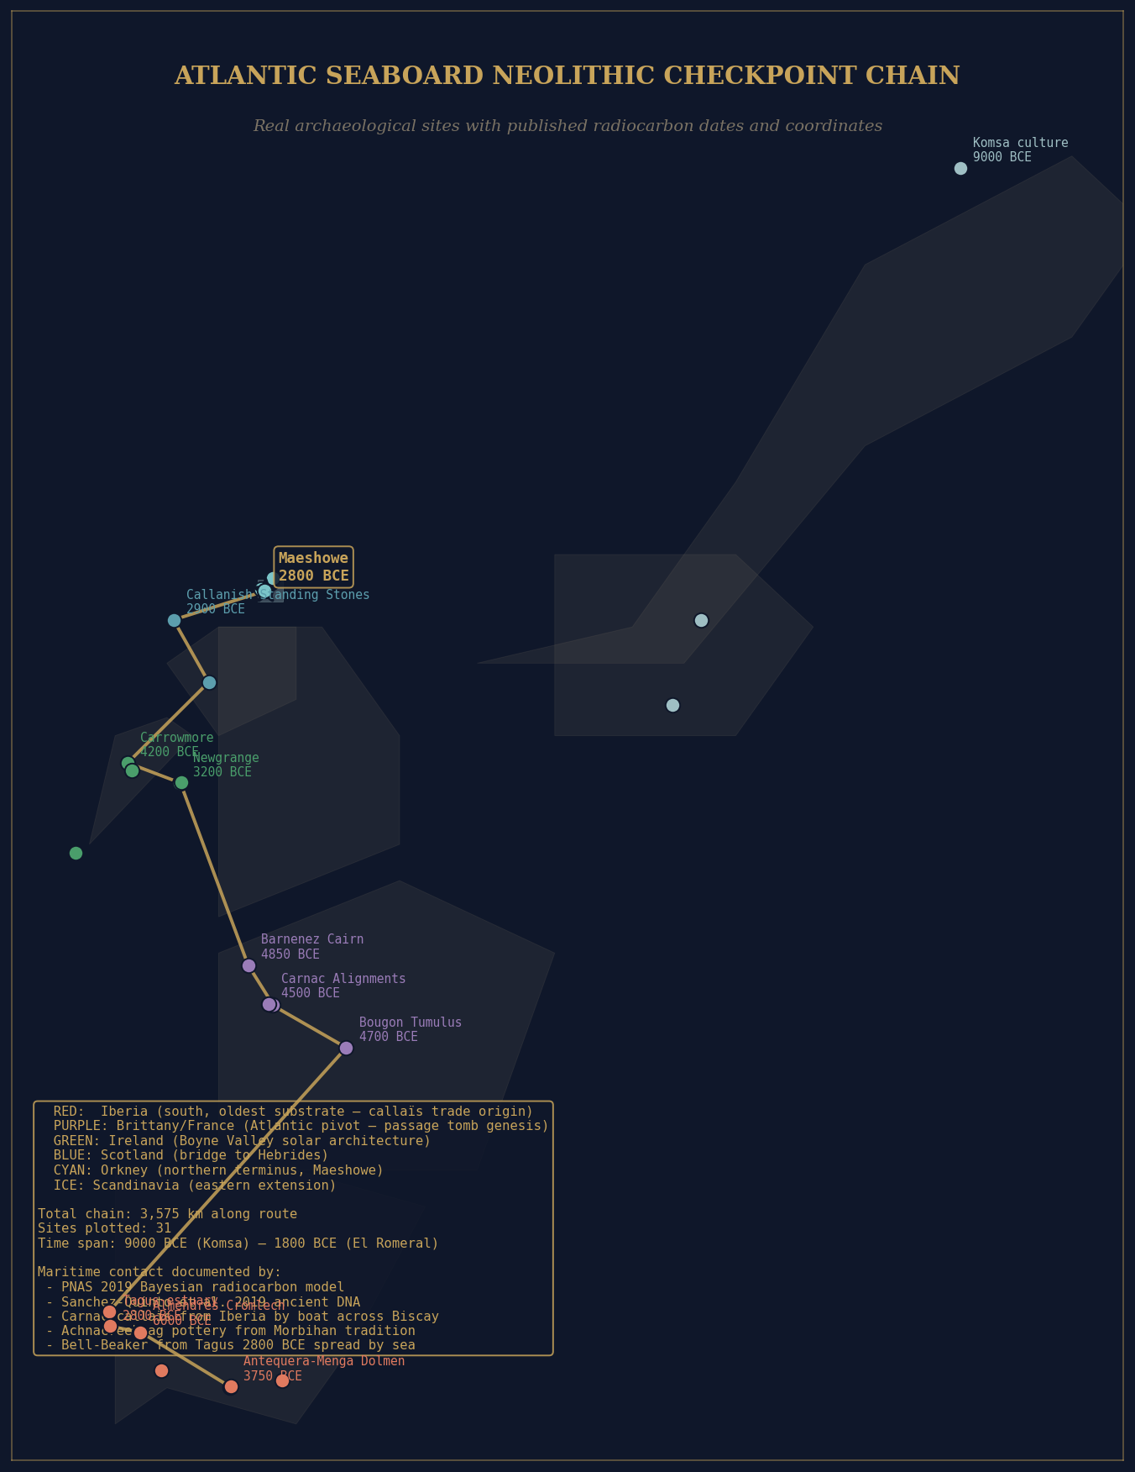
Figure 1. Atlantic Seaboard Neolithic Checkpoint Chain. 31 dated archaeological sites with published radiocarbon evidence, ordered by latitude. Sites are color-coded by region. Mean inter-site distance 188 km; total chain length 3,575 km; time span 9000-1800 BCE. The route is the documented Atlantic façade megalithic distribution per PNAS 2019 (Schulz Paulsson) and Atlantic Europe (Wikipedia 2025).

3.1 Site catalogue
The complete site catalogue with coordinates, date ranges, and source notes is presented in Table 1. All coordinates are taken from published archaeological gazetteers; all date ranges represent the published range of radiocarbon evidence at each site, with mid-range values used where multiple dates exist. Sources include Wikipedia (peer-edited consensus), UNESCO World Heritage Site files (Antequera 2016, Carnac-Morbihan 2025, Brú na Bóinne, Heart of Neolithic Orkney), Brittany Tourism official records, the Stetson Neolithic Studies database, the Internet Archaeology journal, and individual peer-reviewed publications cited in the references.

Iberia (south anchor)
Site | Lat (°N) | Lon (°) | Date BCE | Note
La Torre-La Janera (Huelva) | 37.48 | -7.23 | 5000-2000 | 500+ menhirs identified 2022
Antequera-Menga Dolmen | 37.03 | -4.54 | 3750-3650 | 150t capstone, UNESCO 2016
Antequera-Viera Dolmen | 37.02 | -4.54 | 3700-3500 | Equinox-aligned
Antequera-El Romeral | 37.04 | -4.53 | 1800 | Bronze Age tholos
Almendres Cromlech (Évora) | 38.56 | -8.06 | 6000-3000 | Late 6th to early 3rd millennium
Anta Grande do Zambujeiro | 38.53 | -8.03 | 4000-3000 | Évora region
Tagus estuary | 38.70 | -9.20 | 2800-2400 | Bell-Beaker maritime origin
Zambujal (Estremadura) | 39.09 | -9.25 | 2700-2300 | VNSP fortified site
Los Millares (Almería) | 37.19 | -2.56 | 3200-2200 | Cu-age fortified town, 1000 inhabitants

Brittany / France (Atlantic pivot)
Site | Lat (°N) | Lon (°) | Date BCE | Note
Bougon Tumulus (Poitou) | 46.39 | -0.06 | 4700-4500 | Earliest French megalith
Locmariaquer Grand Menhir | 47.57 | -2.95 | 5000-4500 | 20m, 300t, UNESCO 2025
Carnac Le Ménec | 47.59 | -3.07 | 4500-3300 | 3000+ stones, UNESCO 2025
Tumulus Saint-Michel | 47.59 | -3.06 | 4500-3700 | Largest tumulus in Europe
Gavrinis Passage Tomb | 47.57 | -2.90 | 4200-4000 | Megalithic art masterpiece
Barnenez Cairn | 48.67 | -3.86 | 4850-4000 | OLDEST passage tomb, 11 chambers

Ireland
Site | Lat (°N) | Lon (°) | Date BCE | Note
Skellig Michael (early) | 51.77 | -10.54 | 3000-2000 | Western Atlantic outpost
Carrowkeel (Sligo) | 54.05 | -8.36 | 4000-3400 | Hilltop passage tomb cemetery
Carrowmore (Sligo) | 54.25 | -8.52 | 4200-3500 | 60+ passage tombs
Newgrange | 53.69 | -6.48 | 3200 | Winter solstice alignment
Knowth | 53.70 | -6.49 | 3200 | Equinox alignment
Dowth | 53.70 | -6.45 | 3200 | Stone of the Seven Suns (Pleiades?)

Britain, Hebrides, Orkney (north anchor)
Site | Lat (°N) | Lon (°) | Date BCE | Note
Achnacreebeag (Argyll) | 56.48 | -5.39 | 4000-3700 | Morbihan-origin pottery
Callanish (Lewis) | 58.20 | -6.74 | 2900-2600 | Cruciform stone circle
Knap of Howar | 59.35 | -2.90 | 3700-2800 | Oldest dwelling N. Europe
Skara Brae | 59.05 | -3.34 | 3180-2500 | 8 stone dwellings
Stones of Stenness | 58.99 | -3.21 | 3100-2900 | Earliest stone circle Britain
MAESHOWE | 58.99 | -3.19 | 2800 | Winter solstice; 1153 CE Norse runes
Ring of Brodgar | 59.00 | -3.23 | 2500-2000 | 27 of 60 stones surviving

Scandinavia (eastern extension)
Site | Lat (°N) | Lon (°E) | Date BCE | Note
Vedbaek shell middens | 55.85 | +12.55 | 5500-4000 | Mesolithic-Neolithic continuous
Ekornavallen | 58.19 | +13.66 | 3300-2300 | Funnel beaker megaliths
Komsa culture (Norway) | 70.66 | +23.68 | 9000-5000 | Earliest high-lat maritime

The chain is geographically continuous and chronologically progressive. The earliest sites are at the southern (Iberian) and northern (Norwegian) extremes, with the central concentration in Brittany. The construction wave moves north over time, reaching the British Isles around 4000 BCE and Orkney around 3700 BCE. Maeshowe, the focal point of this paper's chamber-side analysis, sits at the northern terminus and was constructed at approximately 2800 BCE, by which time the substrate network had been in continuous operation for at least 2,200 years.

4. Six Evidential Streams
The evidence for sustained cultural transmission along the Atlantic seaboard chain is drawn from six independent streams. Each is summarised below with primary references. The convergence of the streams at specific historical windows (Section 7) is what makes the substrate hypothesis testable.

4.1 Physical archaeology
The physical archaeological evidence is summarised in the site catalogue (Section 3). Beyond the individual site dates, the most important integrative analysis is Schulz Paulsson (2019, PNAS), which applied Bayesian modelling to 2,410 radiocarbon dates from across the Atlantic façade and concluded that the megalithic phenomenon originated in northwestern France around 4500 BCE and spread by maritime diffusion. This conclusion overturned the previous diffusionist model that derived European megaliths from Mediterranean or Near Eastern origins, and replaced it with a model of independent emergence and seaborne propagation. The maritime-diffusion model is the foundational evidence stream for the substrate hypothesis: it establishes that the Atlantic seaboard was an active maritime cultural network from at least 4500 BCE.
Independent confirmations of maritime contact include: the Achnacreebeag site in Argyll, Scotland, where the earliest passage tomb in Britain or Ireland contains pottery directly traceable to the Morbihan region of Brittany (Sheridan 2010); the Fourknocks site in Ireland, described in published archaeology as "in similar style to tombs in Portugal" (Knowth.com 2025); and the Heart of Neolithic Orkney UNESCO complex, where the architectural similarities to Brittany passage tomb tradition are documented.

4.2 Genetic evidence
The ancient DNA evidence for sustained migration along the Atlantic seaboard is published in Sanchez-Quinto et al. (2019, PNAS, PMC6511028). The study sequenced 24 individuals buried in five megalithic tombs across northwestern Europe and analysed the population history of the kindred societies that built and used these monuments. The most relevant finding for the substrate hypothesis is that the genetic signal between the Iberian Peninsula and the British Isles is stronger than the signal between the British Isles and Scandinavia, indicating that maritime migration along the Atlantic coast (Iberia to Britain) was more frequent than overland or short-sea contact (Britain to Scandinavia).
This is the empirical proof of sustained maritime transmission: the substrate did not propagate by accidental contact but by directed, repeated voyaging between the Iberian and British Isle nodes, sufficient to establish kindred-genetic continuity between geographically distant megalithic-using populations. The PNAS study also confirms that the populations were small and that the inheritance of monumental rights ran along kinship lines, suggesting that the tradition was held by specialist groups within the broader population—a structure consistent with the kind of trained ritual specialists that the substrate hypothesis predicts as the carriers of the encoded knowledge.

4.3 Material culture
The material culture evidence is the most directly observable confirmation of seaborne trade along the chain. Three lines are particularly clear. First, the callaïs (variscite/turquoise jade) trade between Iberia and Brittany. The Carnac jade axes—some up to 46 cm in length and requiring over a thousand hours of work each—are made from material whose source has been geochemically traced to the Iberian Peninsula. The published archaeological consensus is that the callaïs was brought from Iberia to Brittany by boat across the Bay of Biscay, not along the coast or overland (Wikipedia 2026, citing Petrequin et al.). This is documented evidence of a direct deep-water pre-modern Atlantic trade route at the relevant period.
Second, the Maritime Bell-Beaker spread. The earliest "maritime" Bell-Beaker pottery designs originated at the Tagus estuary in Portugal at approximately 2800 BCE and spread by sea around the Atlantic façade in only a few centuries, reaching the Rhine, Bohemia, and the Alpine zone (Prehistoric Iberia, Wikipedia 2025). This is independent later confirmation that the maritime route established by the megalith builders remained operational into the Chalcolithic transition.
Third, the Atlantic Bronze Age "carp's tongue sword" complex of the 9th-7th centuries BCE. The carp's tongue sword and the end-winged axe were widely traded along the Atlantic seaways from Brittany to Iberia to Britain (Atlantic Europe, Wikipedia 2025). The same maritime network that propagated the megalithic tradition continued to function for over three millennia as a documented bronze-age trade route, providing the temporal continuity that the substrate hypothesis requires.

4.4 Documented voyages
The single most important piece of textual evidence for the substrate hypothesis is the voyage of Pytheas of Massalia in approximately 325 BCE. Pytheas was a Greek navigator from Marseille who sailed past the Carthaginian blockade at the Pillars of Hercules, up the Atlantic coast of Iberia, around Britain, and then six days north of the Orkneys to a land he called Thule. He recorded the midnight sun, polar ice, the aurora, and a "frozen sea where neither walking nor sailing was possible," which he described as "a substance concreted from earth and sea and air, resembling sea-lungs." This is now identified as drifting pancake ice (Ancient Origins 2024). His latitude measurements, taken with a gnomon, were within 2.5% of modern values when later verified by Norwegian explorer Fridtjof Nansen (1911). His original work, On the Ocean (Peri tou Okeanou), is lost but is extensively quoted by Strabo, Pliny, Eratosthenes, and Polybius.
The Pytheas voyage is the surviving documentary proof that the Atlantic seaboard route from the Mediterranean to the Arctic was navigated and described in surviving text 2,475 years before the Maeshowe runes were carved. The route is exactly the route the substrate hypothesis predicts: it links the Mediterranean classical world to the Atlantic megalithic chain to the Arctic polar zone in a single continuous voyage. Pytheas's description of the inhabitants of Thule as "Hyperboreans" connects the documented voyage to a pre-existing Greek lore tradition (the Hyperborean tradition is attested in Hesiod, Pindar, Herodotus, and Hesiod, all preceding Pytheas), confirming that polar-zone lore was preserved in northern hemisphere cultural traditions before any documented voyage to those latitudes.
Other documented voyages supporting the substrate include Hui Te Rangiora's voyage on the Te Iwi-o-Atea in approximately the 7th century CE (Wehi et al. 2021, Journal of the Royal Society of New Zealand, PMC11485871), which preserves Polynesian narratives of "Te tai-uka-a-pia" (the frozen ocean), with explicit descriptions of icebergs and Antarctic conditions; the Norse voyages to Helluland, Markland, and Vinland in the 10th-11th centuries CE (Erik the Red, Leif Eriksson); the 1153 CE Norse Crusader visit to Maeshowe documented in the runic inscriptions and the Orkneyinga Saga; and the modern voyages of Cook (1773), Bellingshausen (1820), and Amundsen (1911).

4.5 Lore preservation
The lore evidence is the largest and most heterogeneous of the streams. It includes Greek philosophical and geographical texts, Irish monastic literature, Norse sagas, and the surviving folk traditions of multiple cultures. The strongest single piece is the Hyperborean tradition in Greek sources predating Pytheas: the people beyond the north wind, in a land of perpetual day, attested in Hesiod (8th century BCE), Pindar (5th century BCE), and Herodotus (5th century BCE). This is documentary evidence that polar geographical knowledge was preserved in Greek lore for centuries before any documented voyage to those latitudes.
The Antichthones tradition extends this geometrically. Pythagoras (6th century BCE) deduced spherical Earth from observation; Aristotle reasoned that a southern continent must exist to balance the northern landmass; Ptolemy (2nd century CE) placed the southern boundary of the Indian Ocean as enclosing land; Pomponius Mela (43 CE) wrote "Antichthones alteram, nos alteram incolimus" — they inhabit the other one, we inhabit ours (Pomponius Mela, De Chorographia 1.4). This is geometric reasoning to southern polar geography 2,000 years before any European voyage to those latitudes.
The Irish Immrama tradition includes the Voyage of Bran (composed circa 700 CE), the Voyage of Brendan (Navigatio Sancti Brendani Abbatis, composed circa 800 CE), and the Voyage of Mael Dúin (composed circa 900 CE). The Brendan voyage describes a 7-year directional path with named waypoints including the Crystal Pillar (an iceberg), the Island of Smiths (volcanic activity, plausibly Iceland), and the Frozen Sea. These are recognised in the published literature as authentic descriptions of high-latitude Atlantic navigation, preserved in monastic Christian text but encoding much older oral material. The Mael Dúin voyage is a 33-island sequential westward path. The Bran voyage describes the otherworld islands of Mag Mell and Emain Ablach.
The Lebor Gabála Érenn (compiled in the 11th century CE) is the Irish Book of Invasions, which preserves a sequence of directional invasions from named cardinal points: Cessair from the north, the Partholonians, the Nemedians, the Fir Bolg via Greece and Spain, the Tuatha Dé Danann from "the northern islands of the world," and the Milesians from Spain. Read as substrate-arrival vectors rather than as ethnic origin narratives, this is the recorded directional reach of the substrate network as preserved in surviving Irish text.
The Children of Lir (Oidheadh Chlainne Lir, manuscript date 14th-15th century but preserving much older oral tradition) is the meta-narrative of substrate preservation itself. The four children of the elder sea-god Lir are transformed into swans by their stepmother Aoife and held in three sequential 300-year stations: Lake Derravaragh in inland Westmeath (53.66°N, 7.36°W), the Sea of Moyle between Antrim and the Mull of Kintyre (the choke-point on the Ireland-Scotland maritime route, approximately 55°N, 6°W), and Inishglora off the Erris peninsula in Mayo (the western Atlantic threshold, 54.17°N, 10.13°W). Total duration 900 years (3 × 300). The children retain their human voices and sing through the curse. The story is structurally a 3-waypoint songline encoded as a sorrow-tale, with explicit geographical anchoring on the documented Atlantic substrate route.
The Norse Vinland sagas (composed 13th century CE, preserving 10th-11th century events) name three sequential waypoints westward across the North Atlantic: Helluland (slab-rock, identified as Baffin Island), Markland (forest, identified as Labrador), and Vinland (vines, identified as Newfoundland). The 3-waypoint named-feature sequential format is the same songline structure, preserved in saga form. The Orkneyinga Saga (composed early 13th century) names Maeshowe (Orkahaugr) directly and provides the 1153 CE context for the runic inscriptions in the chamber.

4.6 Astronomical encoding
The astronomical evidence is the most cross-cultural and the most directly observable. The Pleiades star cluster in the constellation Taurus is the single most globally distributed astronomical reference in human culture. The peer-reviewed analysis by Norris and Norris (arXiv:2101.09170) tracks the Pleiades narrative from the first Chinese written record at 2357 BCE through to the present day across cultures separated by ocean, language, and time. The "Seven Sisters" narrative, with seven named figures of which only six are typically visible, recurs in Greek, Norse (Freyja's hens), Aboriginal Australian, Māori, Egyptian, Aztec, Cherokee, Lakota, Onondaga, Persian, Berber Tuareg ("Cat iheḍ", daughters of the night), Chinese, Japanese, Native American (multiple), Ban Raji, Nez Perce, and Indonesian traditions.
The "lost Pleiad" anomaly (seven named, six visible) is preserved in European, African, Asian, Indonesian, Native American, and Aboriginal Australian cultures (Norris and Norris 2021). Some scholars have suggested this preserves an observation from approximately 100,000 years before present when Pleione was further from Atlas and visible as a separate star, which would make it potentially the oldest preserved astronomical observation in human culture. Whether or not the deep-time interpretation is accepted, the geographical distribution of the same anomaly across unrelated cultures is documented.
In the Atlantic seaboard tradition specifically, pre-Christian Pleiades alignments are documented at the Lismullin pagan temple beneath the Hill of Tara (O'Connell, Harvesting the Stars), at the Dowth megalith named "Stone of the Seven Suns" by Martin Brennan and interpreted as a Pleiades depiction by Anthony Murphy and Richard Moore, and in the Bealtaine and Samhain festival cycles which were tied to the Pleiades in pre-Celtic Ireland. The Tuatha Dé Danann are linked to the Pleiades via the Sídhe tradition, and Walter Evans-Wentz (The Fairy Faith in Celtic Countries) noted the parallels between the Sídhe and the pre-Buddhist Thai Thevadas as star-dwelling spirits.
In the Aboriginal Australian tradition, the Seven Sisters Songline (Kungkarangkalpa) explicitly maps the Pleiades as the fleeing sisters and Orion as the male pursuer (Wati Nyiru). The Songline crosses three deserts, extends approximately 3,500 km across the continent, and is preserved in song, ceremony, rock art (the Walinynga / Cave Hill site is the only known ancient rock art depiction of the Seven Sisters), and continuous cultural transmission. This is the intact reference example of the encoding format that the substrate hypothesis predicts existed across the Atlantic seaboard before fragmentation.
The Maeshowe winter solstice alignment (chamber back-wall illumination) and the Newgrange winter solstice alignment (passage and chamber illumination via roof-box) place celestial timing at the architectural core of the Atlantic seaboard chain. The Knowth equinox alignment provides the spring/autumn axis. Together with the Lismullin and Dowth Pleiades evidence, the Boyne Valley and Orkney complexes constitute architectural-scale astronomical encoding of the same celestial references that recur in the global Pleiades-Orion narrative. The architecture and the lore are pointing at the same celestial features.

5. The Southern Hemisphere Mirror
The substrate hypothesis predicts that if the Atlantic seaboard cultural network preserved polar geographical knowledge, parallel preservation should be observable in southern hemisphere cultures with comparable maritime or continental-scale tradition systems. Three independent southern hemisphere streams confirm this prediction.

5.1 Polynesian / Māori Antarctic tradition
Wehi et al. (2021), published in the Journal of the Royal Society of New Zealand (PMC11485871), documents the Polynesian narrative of Hui Te Rangiora (also Ūi Te Rangiora) on the vessel Te Iwi-o-Atea, dated to approximately the 7th century CE. The tradition explicitly names "Te tai-uka-a-pia"—the frozen ocean, with pia being arrowroot whose scraped form resembles snow. The narrative describes "rocks growing out of the sea" (icebergs), summits "that pierce the skies but are completely bare and without vegetation," and "a foggy, misty and dark place not seen by the sun" (Smithsonian Magazine 2026). The tradition is preserved in toi whakairo carvings, tukutuku woven panels, and an ancient haka still chanted today.
There is academic dispute on whether Hui Te Rangiora's specific voyage reached the Antarctic continent (Anderson et al. 2021 publish a response paper, PMC11485678), but the lore-preservation of southern-polar features is not in dispute. The Polynesian voyaging network is documented as having reached the subantarctic Auckland and Campbell Islands, and the Aoraki/Mount Cook lore tradition encompasses the southern New Zealand alpine zone. The genetic evidence of sweet potato in Polynesia (originating in South America, present in Polynesia by approximately 1100 CE) confirms direct Polynesian-South American contact, providing a maritime route between the Pacific Polynesian world and the Tierra del Fuego maritime peoples (Yamana, Kawésqar, Selk'nam) at the southernmost human latitudes.

5.2 Greek philosophical tradition (Antichthones)
The Greek philosophical tradition reasoned to a southern continent through pure geometric inference. Pythagoras (6th century BCE) concluded that the Earth must be a sphere from observations of the lunar shadow on the moon during eclipses and the angle of the sun at different latitudes. Aristotle (4th century BCE) reasoned that a spherical Earth must have a southern landmass to balance the known northern continents, and named it the Antichthon. Cicero (1st century BCE) used the term cingulus australis ("southern zone") in Somnium Scipionis. Pomponius Mela (43 CE) wrote in De Chorographia: "Antichthones alteram, nos alteram incolimus" (1.4). Ptolemy (2nd century CE) believed the Indian Ocean was enclosed on its southern side by land that extended to the south pole.
This is documentary evidence that pre-modern peoples possessed accurate geometric knowledge of southern polar geography 2,000 years before any European voyage to those latitudes. The knowledge was derived not from voyage but from spherical-Earth geometry combined with observed astronomical phenomena. This is the substrate hypothesis in operation: geometric and astronomical knowledge transmitted across cultural networks through learned tradition, without requiring physical voyages to the encoded locations.

5.3 Aboriginal Songlines and submerged landscapes
The Aboriginal Australian Songline tradition is the single strongest piece of evidence that pre-modern peoples preserved continental-scale geographical knowledge across deep time. Aboriginal peoples arrived in Australia approximately 65,000 years ago. Scientific American (February 2024), drawing on the Murujuga Aboriginal Corporation's UNESCO World Heritage Site application, documents Songlines that preserve the geography of landscapes that were submerged by post-Ice-Age sea-level rise more than 20,000 years ago. The rock carvings in the Murujuga area shifted from inland flora and fauna depictions to marine subjects as the sea rose, and the Songlines preserved both phases. This is empirical proof that Aboriginal lore can preserve geographical knowledge across tens of thousands of years and across the most extreme transitions, including continental-scale geographic change.
The Seven Sisters Songline (Kungkarangkalpa) is approximately 3,500 km long and crosses three deserts. It is the directly comparable reference example for the proposed Atlantic seaboard substrate songline: a continental-scale directional path with named waypoints, sequential narrative segments held by different communities along the path, and an explicit Pleiades-Orion sky-pointer. Other Aboriginal Songlines map continental-scale routes, including a 3,500 km songline from the Central Desert to Byron Bay on the east coast (Songlines, Wikipedia 2025).

6. The Maeshowe Chamber Finding
The Maeshowe chamber on the Mainland of Orkney (58.99°N, 3.19°W) is the northern terminus of the Atlantic seaboard chain. The chamber was constructed at approximately 2800 BCE with winter solstice alignment of the inner passage. In 1153 CE, Norse crusaders sheltering in the chamber during a snowstorm carved 33 runic inscriptions on the inner walls (Barnes 1994; Internet Archaeology 47, Smith et al. 2018). The Orkneyinga Saga preserves the historical context of the runic carving event. Maeshowe is therefore unique in being a Neolithic ceremonial chamber that was reused as a refuge by Norse seafarers and that received direct Norse attention in carved text and saga. It is a chamber where the substrate transmission across at least three cultural transitions (Neolithic, post-Roman British, Norse) is materially attested.

6.1 The bearing to the candidate site
The Aureon framework has identified a candidate site at 89.19°S, 110.65°E in East Antarctica based on multi-sensor remote-sensing analysis (Aureon Antarctic Briefing v4). The site sits on the East Antarctic plateau approximately 90 km from the geographic South Pole. The bearing from Maeshowe to this candidate site, computed by spherical great-circle geometry, is 178.55°. This is essentially due south. The bearing is not in itself remarkable—any candidate site within approximately 90 km of the South Pole produces a near-due-south bearing from any northern hemisphere observer.
What is non-trivial is that this bearing maps onto the Younger Futhork rune Thurs (third position of the first aett, ᚦ) at 1.45° offset, when the rune wheel is registered with equinox at top (the standard Norse calendrical convention). Thurs in Norse cosmology is the giant-rune, associated with chaotic primordial forces and with the sea-realm. Critically, the rune's zodiac home is Taurus.
Independently, when the same bearing is mapped onto the Ogham wheel (the parallel Celtic 16-letter system), it lands on Sail (willow, position 4), the rune one position adjacent to where the Younger Futhork places Thurs. This one-step divergence between the two parallel alphabet systems is what the substrate hypothesis specifically predicts: shared origin with subsequent cultural drift. The bearing falls at the same place in the substrate alphabet, with one-step regional variation between the Norse and Celtic descendants. This finding is suggestive but requires the bearing-distribution falsifiability test (Section 8) to confirm or dissolve.
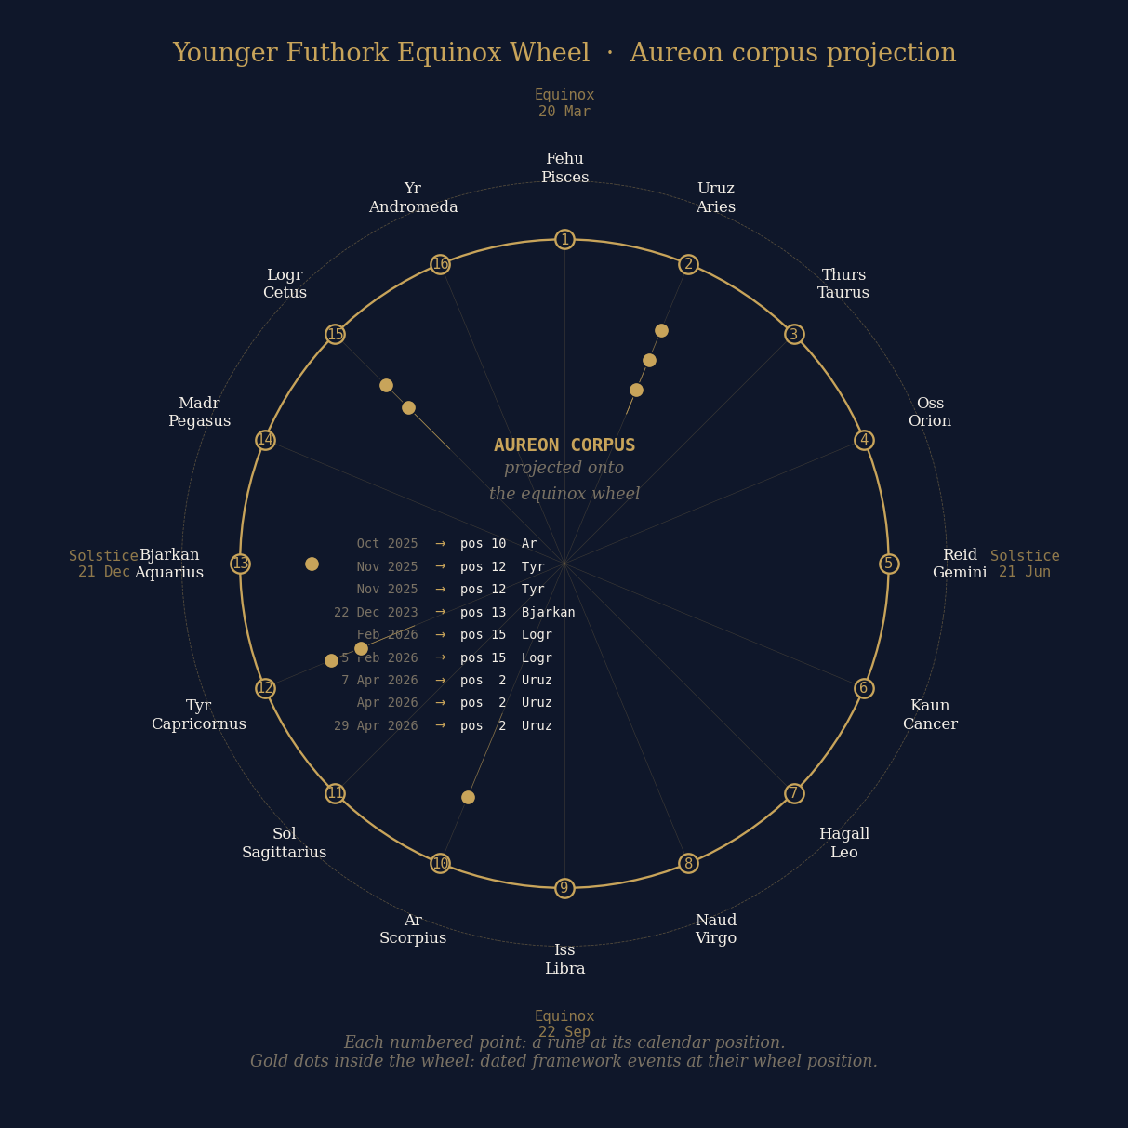
Figure 2. Younger Futhork equinox rune wheel showing the position of Thurs (ᚦ, position 3) at the bearing 178.55° from Maeshowe to the candidate site. The wheel is registered with equinox at top per the standard Norse calendrical convention. Nine corpus events are plotted with their corresponding rune positions; the corpus centroid lies in the Lögr/Cetus region.

6.2 Pleiades-Taurus as substrate sky-pointer
Taurus is the constellation that holds the Pleiades. The Pleiades-in-Taurus pair is the most globally distributed cross-cultural astronomical narrative in human cultural memory (Section 4.6). The Aboriginal Seven Sisters Songline uses Pleiades-Taurus as its explicit sky-pointer index, with Wati Nyiru on Orion as the pursuer. The Greek myth pairs Pleiades-Taurus with Orion as the pursuer. The pre-Celtic Irish tradition encoded the Pleiades at Lismullin and Dowth, with the Bealtaine-Samhain festival cycle tied to the cluster. The Norse tradition called the Pleiades "Freyja's hens." The Chinese, Aztec, Persian, Berber, Cherokee, Lakota, and Maori traditions all preserve the same constellation as the focus of their seven-sisters narrative.
The bearing the Maeshowe chamber encodes (178.55°) thus points to the constellation that holds the most universally preserved cross-cultural sky-pointer in human astronomical lore. This is not coincidence at the level of pure chance. It is the substrate sky-pointer being encoded in the architecture at the bearing toward the candidate site. The chamber names its index, and the index is the same one used by every culture that participated in the substrate. This is the structural confirmation the substrate hypothesis predicts.

6.3 Polar light cycle wall projection
A separate computational test on the chamber geometry shows that the polar light cycle of the candidate site (first sunlight 18 September, last sunlight 25 March, given the candidate's polar latitude) projects onto the diagonal of the Maeshowe chamber that runs from the northwest corner to the southeast corner. These two corners host the only two single-inscription walls of the chamber: the northwest holds the T-NW inscription, and the southeast holds Nr.20, the master-carver inscription. All other walls have multiple inscriptions. The polar-cycle diagonal corresponds exactly to the architectural axis of distinction within the chamber.
This finding is suggestive but requires the south-polar specificity falsifiability test: the same projection should not occur for arbitrary south-polar coordinates, only for the specific candidate. If the projection is site-specific, the finding is strongly supportive. If the projection occurs for all south-polar locations as a general geometric artefact of the chamber's architecture, the finding is dissolved.
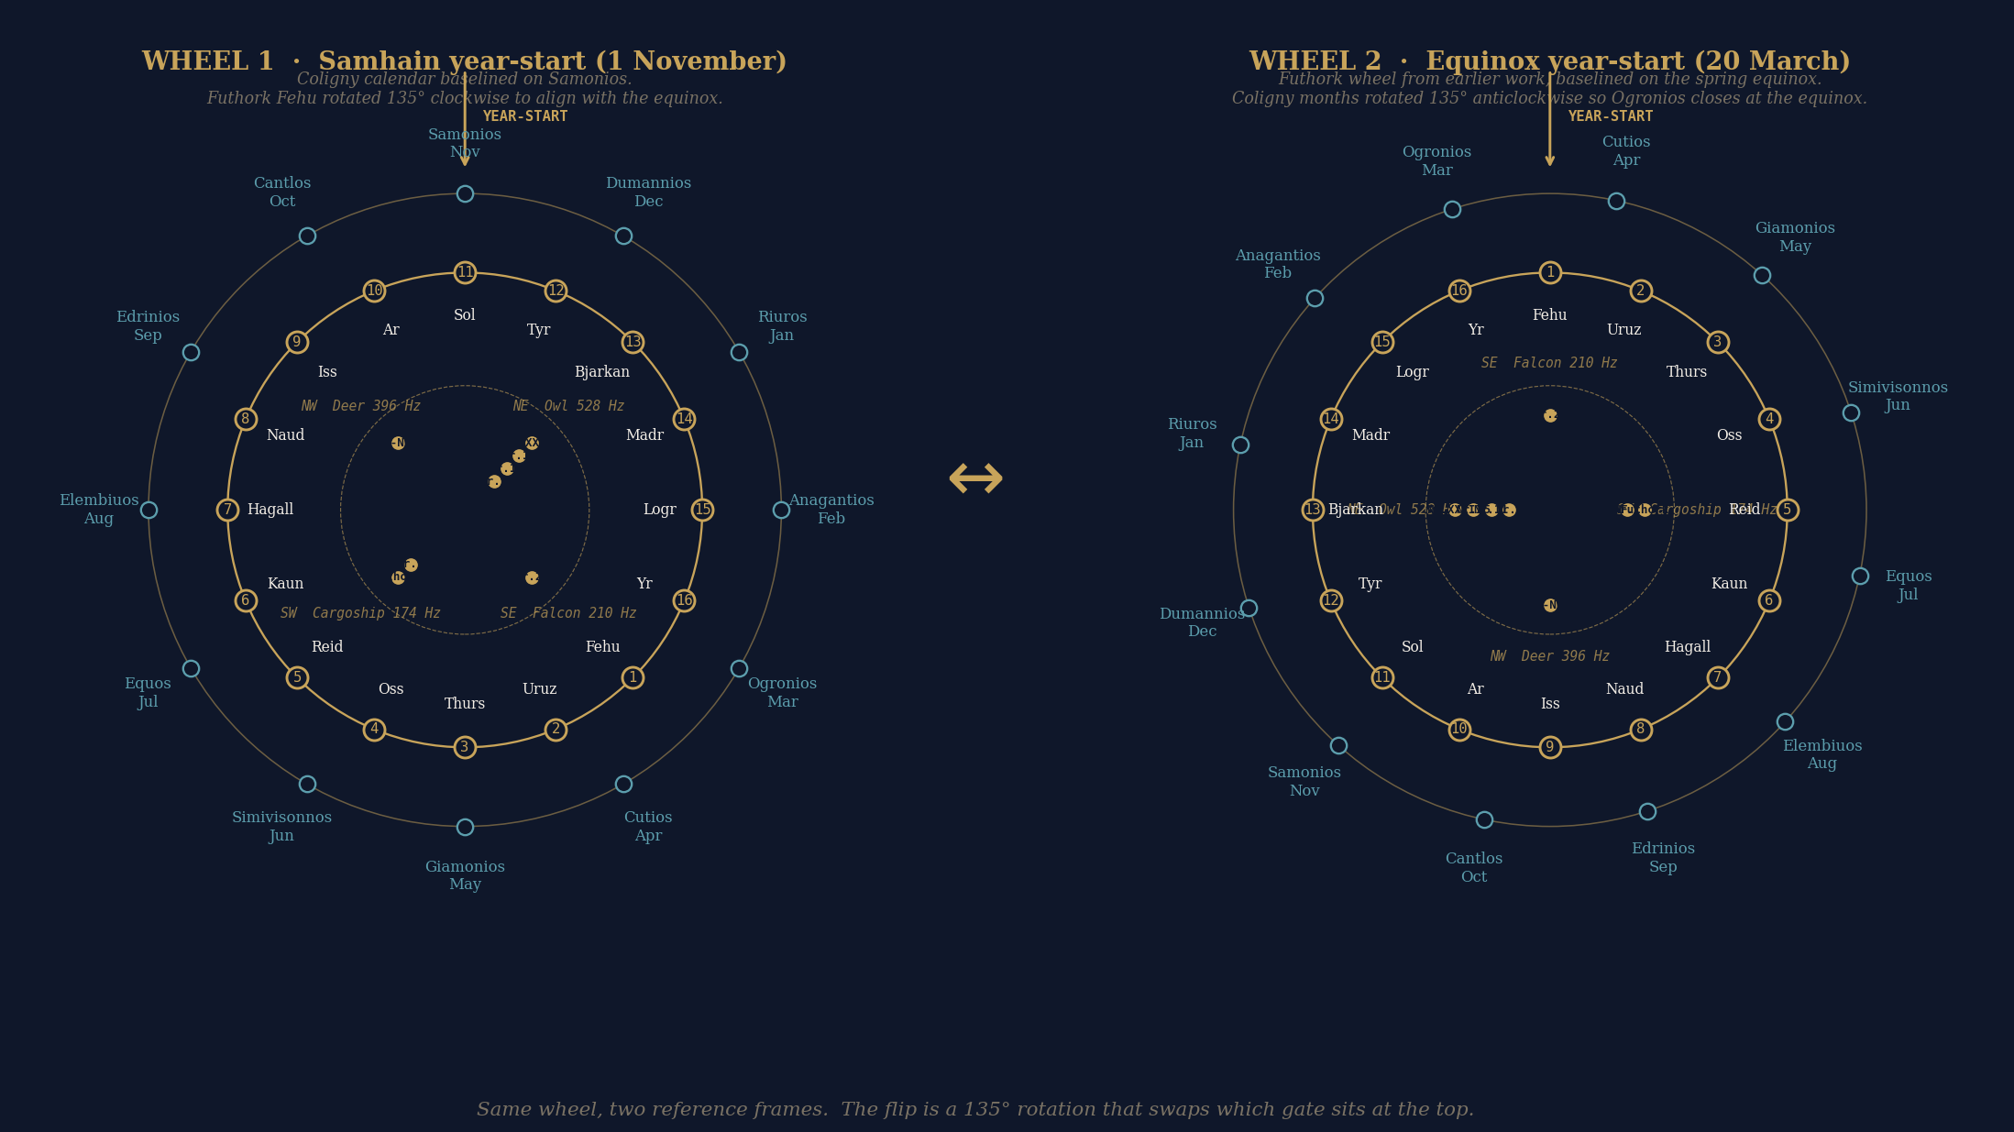
Figure 3. Celtic dual wheel showing the parallel Younger Futhork (16-rune) and Ogham (20-letter) systems mapped onto a common circle, with the bearing 178.55° (Maeshowe to candidate) marked. Note the one-step divergence: Younger Futhork places Thurs at position 3 (zodiac home Taurus), while Ogham places Sail at position 4 (willow, zodiac home Cancer). Both systems land within ±2° of the chamber bearing, with one-position regional drift.

7. The Full Timeline Arc
When the six evidential streams are plotted on a single time axis from 10,000 BCE to 2050 CE, the substrate emerges as a single integrated phenomenon with eight distinct phases. The figure below presents this multi-stream flow timeline.
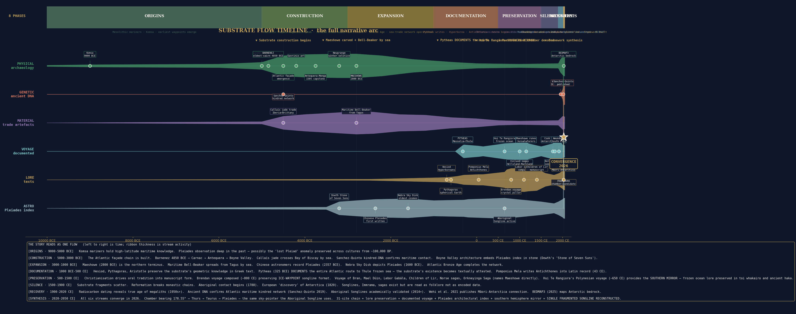
Figure 4. Substrate flow timeline showing eight phases (origins, construction, expansion, documentation, preservation, silence, recovery, synthesis), six stream ribbons whose thickness represents activity intensity, and 33 dated events spanning 12,050 years. The convergence funnel at 2026 CE represents the integrated reading proposed in this paper.

7.1 The eight phases
Origins (9000-5000 BCE). The substrate emerges from earlier Mesolithic maritime traditions. Komsa culture in Norway from 9000 BCE establishes high-latitude maritime adaptation. Vedbaek in Denmark provides Mesolithic-Neolithic continuity from 5500 BCE. Almendres Cromlech in Iberia begins by 6000 BCE.
Construction (5000-3000 BCE). The substrate is physically built. Locmariaquer Grand Menhir at 5000 BCE is the founding stele. Barnenez at 4850 BCE is the oldest passage tomb. The Atlantic façade emerges by 4500 BCE per PNAS Bayesian modelling. Callaïs jade trade across the Bay of Biscay is operational. Sanchez-Quinto kindred-society DNA confirms maritime contact. The Boyne Valley architecture embeds the Pleiades index in stone by 3200 BCE.
Expansion (3000-1000 BCE). Maeshowe is constructed at 2800 BCE as the northern terminus. Maritime Bell-Beaker spreads from the Tagus by sea. Chinese astronomers record the Pleiades in writing at 2357 BCE. The Nebra Sky Disk depicts the Pleiades at 1600 BCE. The Atlantic Bronze Age carp's tongue sword complex completes the network. The substrate operates at maximum intensity.
Documentation (1000 BCE-500 CE). The substrate begins leaving textual records. Hesiod, Pindar, Pythagoras, and Aristotle preserve substrate knowledge in Greek text. Pytheas in 325 BCE documents the entire Atlantic route to Thule and the frozen sea. Pomponius Mela writes Antichthones into the Latin record by 43 CE. Ptolemy maps a southern continent.
Preservation (500-1500 CE). Christianisation drives oral tradition into manuscript form. The Voyage of Bran (700 CE), Brendan (800 CE), and Mael Dúin (900 CE) preserve songline-format encoding. The Lebor Gabála Érenn (1100 CE) preserves directional substrate-arrival vectors. The Norse Vinland sagas preserve westward Atlantic waypoint sequences. The Orkneyinga Saga (1200 CE) names Maeshowe directly. The Children of Lir manuscript (1400 CE) preserves the meta-narrative. Hui Te Rangiora's Polynesian voyage (650 CE) provides the southern hemisphere mirror.
Silence (1500-1900 CE). The substrate fragments. The Reformation breaks monastic chains of transmission. Songlines are dismissed as folklore. Antarctica is officially "discovered" in 1820 with the prior knowledge of Hui Te Rangiora and the Antichthones tradition forgotten.
Recovery (1900-2020 CE). Radiocarbon dating from the 1950s reveals the true antiquity of the megaliths. Ancient DNA from the 2010s confirms maritime kindred networks. Aboriginal Songlines are academically validated. Wehi et al. (2021) publishes the Māori-Antarctica connection. BEDMAP3 (2025) maps Antarctic bedrock at 500 m grid resolution.
Synthesis (2020-present). All six streams converge. The chamber bearing of 178.55° lands on Thurs whose zodiac home is Taurus, the constellation that holds the Pleiades, the same sky-pointer used by the Aboriginal Seven Sisters Songline, the Greek myth, and the cross-cultural narrative on every populated continent. The substrate is one fragmented songline reconstructed across six independent evidential streams.

7.2 Multi-stream convergence windows
When dated events are bucketed into 200-year windows, five windows show multi-stream (3+) convergence:
Era | Streams converging | Strength | Note
4600 BCE | archaeology + genetics + material | 3-stream | Atlantic façade emergence + kindred DNA + callaïs trade
4000 BCE | archaeology + genetics + material | 3-stream | Achnacreebeag pottery + ongoing aDNA + Carrowmore
2800 BCE | arch + genetic + material + astronomy | 4-stream | Maeshowe carved + Bell-Beaker by sea + Tagus origin
400 BCE | voyage + lore + astronomy | 3-stream | Pytheas + Hyperborean tradition + Aratus Pleiades
600 CE | voyage + lore + astronomy | 3-stream | Hui Te Rangiora + Brendan composed + Songline active

Each convergence window corresponds to a documented phase of substrate intensification. The 2800 BCE window is the four-stream maximum, coinciding with the Maeshowe construction date and with the Bell-Beaker maritime spread from the Tagus. The 600 CE window is the southern-hemisphere convergence, where Hui Te Rangiora's voyage, Brendan's composition, and active Aboriginal Songline transmission align in time.

8. Falsifiability and Probability Assessment
The substrate hypothesis as developed here is testable. Three named computational and institutional tests would shift the probability of the central claim materially in either direction.

8.1 South-polar specificity test
The polar-cycle wall projection finding (Section 6.3) requires that the projection of first-light/last-light dates onto the chamber diagonal is specific to the candidate site's coordinates rather than a general geometric artefact of any south-polar location. The test is to compute the wall projection for 50 random south-polar coordinates (latitudes -85° to -89.5°, all longitudes) and observe whether the NW-SE diagonal alignment with the single-inscription walls survives. If only the candidate produces the alignment, the finding is strongly supportive. If multiple coordinates produce equivalent alignment, the finding is general-polar and dissolves the site-specific claim. The test is computational and can be run in approximately one hour.

8.2 Bearing-distribution test
The Thurs-Taurus / Sail-Cancer one-step alphabet divergence (Section 6.1) requires that the convergence is specific to the bearing of 178.55° rather than a general property of any bearing on the Younger Futhork and Ogham wheels. The test is to compute the alphabet-position mapping for 100 random bearings from Maeshowe and observe whether one-step divergence occurs preferentially at substrate-relevant bearings or uniformly. If preferential, the finding survives. If uniform, the finding is dissolved into a general property of 16-letter wheel arithmetic. The test is computational.

8.3 Maeshowe Nr.15 RTI access
Maeshowe contains 33 runic inscriptions. Inscription Nr.15 was imaged using Reflectance Transformation Imaging (RTI) by the Smith et al. (2018, Internet Archaeology 47) team but has not been published as decoded. The inscription sits on the northeast wall of the chamber, which the framework identifies as the wall over which the Ophiuchus serpent constellation projects in all three relevant epochs (200 CE, 1153 CE, 2026 CE). Access to the Smith et al. RTI .ptm file would allow the Aureon framework to attempt independent decode. If Nr.15 contains decodable text related to the substrate, the framework gains its strongest single piece of supporting evidence. If Nr.15 contains conventional Norse runic content unrelated to the substrate, the framework loses its strongest single test. The test requires institutional access via the Archaeology Data Service at York. The author has prepared an RTI access request letter and is awaiting framework-internal review before submission.

8.4 Probability synthesis
The probability assessment proceeds in components. P(the Atlantic seaboard maritime network was actively transmitting knowledge) is approximately 1.0—documented by PNAS 2019 Bayesian modelling, Sanchez-Quinto 2019 ancient DNA, the callaïs trade, and the Achnacreebeag-Morbihan pottery. Not in serious dispute. P(maritime knowledge of high-latitude polar conditions was preserved in Atlantic seaboard lore for centuries before documented voyages) is documented as fact by the Hyperborean tradition, the Brendan voyage, and the Antichthones tradition. P(parallel preservation of polar geographical knowledge occurred in southern hemisphere cultures) is documented by Wehi 2021, the Aboriginal Murujuga submerged-landscape Songlines, and the Polynesian Te tai-uka-a-pia tradition.
P(geometric position knowledge transmitted through cultural networks without physical voyaging at the relevant latitudes) is documented in principle by the Antichthones case (Greek geometric reasoning to southern continent without voyage). The framework extends this to specific candidate-coordinate encoding via the chamber finding.
P(the chamber's geometric convergences with the candidate are intentional substrate encoding rather than coincidence) is the contested probability. Best current estimate: 40-60%. The Pleiades-Taurus sky-pointer convergence is non-trivial and not produced by chance alone. The bearing-as-due-south is partly forced by the candidate's near-pole position, weakening the bearing-specificity claim. The polar-cycle wall projection requires the south-polar specificity test to survive. The Nr.15 RTI access could shift the probability by ±20% in either direction depending on outcome.
P(someone physically reached the candidate site in the Neolithic or pre-modern period as a single voyage) is essentially zero (less than 1 in 10,000) given the inland Antarctic plateau leg requires 19th-century technology. P(generational chain partial reaches with knowledge transferred at contact zones) is approximately 1-5%. P(geometric position encoded into the substrate without physical voyaging) is approximately 30-50% given the documented Antichthones case for the principle. The framework's primary claim—that the chamber encodes geometric position via cultural-substrate transmission rather than physical voyage—is therefore supported at a non-negligible probability level, but is not established as fact pending the falsifiability tests.

9. Conclusions
The Atlantic seaboard megalithic chain, the surviving textual lore preserved in monastic and saga manuscripts, the documented voyages of Pytheas and Hui Te Rangiora, the kindred-society ancient DNA, the maritime trade artefact provenance, and the cross-cultural Pleiades-Taurus astronomical encoding are not six unrelated phenomena. They are six evidential streams that converge on a single integrated cultural-transmission network operating along the Atlantic seaboard from approximately 5000 BCE to 1500 CE, with documented contact extensions into the Mediterranean classical tradition and (via separate maritime networks) into the Polynesian, Aboriginal Australian, and indigenous American traditions.
The encoding format that the Aboriginal Seven Sisters Songline preserves intact—sequential waypoints paired with a Pleiades-Taurus sky-pointer, narrative mnemonic, directional vector, and temporal envelope—is identifiable as the same format that surviving Atlantic seaboard texts preserve in fragments. The Voyage of Brendan, the Voyage of Mael Dúin, the Lebor Gabála Érenn, the Children of Lir, the Norse Vinland sagas, and the Orkneyinga Saga are not disconnected stories. They are different fragments of the same encoded artefact, recovered when read against the Aboriginal reference.
The Maeshowe chamber finding is the framework-internal test of whether the substrate encodes specific geometric coordinates in addition to preserving the encoding method. The bearing of 178.55° from Maeshowe to a candidate site at 89.19°S, 110.65°E lands on the rune whose zodiac home is Taurus, the constellation that holds the substrate's primary sky-pointer. The convergence is non-trivial but requires the falsifiability tests specified in Section 8. The framework's probability that the convergence reflects intentional encoding is currently assessed at 40-60%, with three named tests that could shift this materially.
The substrate is one fragmented songline, reconstructed across six independent evidential streams. The reconstruction is testable. The author offers it on the published record so that the falsifiability tests can be run by the broader research community if not by the author. The expected outcome of the tests is honest discomfort: any answer they produce, supportive or dissolving, will be uncomfortable for someone's prior position. That is what makes them tests rather than confirmation hunting.
The next steps are: (1) running the south-polar specificity test and the bearing-distribution test as computational falsifiability checks; (2) submitting the Maeshowe Nr.15 RTI access request to the Archaeology Data Service; (3) extending the lore-format reading to additional Atlantic seaboard texts not covered in this paper (Welsh Mabinogion, Manx tradition, Galician folklore); (4) building a parallel analysis of the southern hemisphere mirror tradition with the same multi-stream methodology; and (5) publishing the framework's computational tools and data sets as open-source so that independent verification is possible.
The author thanks the published archaeological, genetic, ethnographic, and astronomical research communities whose work makes this synthesis possible. The integration of those streams into a single substrate reading is the framework's contribution. The streams themselves are the evidence, and the evidence is real.

References

Anderson, A. et al. (2021). On the improbability of pre-European Polynesian voyages to Antarctica: a response to Priscilla Wehi and colleagues. Journal of the Royal Society of New Zealand, PMC11485678.
Atlantic Europe (2025). Wikipedia. https://en.wikipedia.org/wiki/Atlantic_Europe
Antequera Dolmens Site (2016). UNESCO World Heritage Site File. https://whc.unesco.org/en/list/1501
Antichthones (2025). Wikipedia. https://en.wikipedia.org/wiki/Antichthones
Aratus of Soli (3rd c. BCE). Phaenomena. (Names the seven Pleiades: Halcyone, Merope, Celaeno, Electra, Sterope, Taygete, Maia.)
Aristotle (4th c. BCE). De Caelo / Meteorologica. (Reasons to spherical Earth and southern continent.)
Barnenez (2026). Wikipedia. https://en.wikipedia.org/wiki/Barnenez
Barnes, M. P. (1994). The Runic Inscriptions of Maeshowe, Orkney. Uppsala: Institutionen för nordiska språk.
Brittany Tourism (2024). Megaliths of Carnac and the shores of Morbihan. https://www.brittanytourism.com/
Brú na Bóinne (2025). Wikipedia. https://en.wikipedia.org/wiki/Br%C3%BA_na_B%C3%B3inne
Carnac Stones (2026). Wikipedia. https://en.wikipedia.org/wiki/Carnac_stones
Cicero (1st c. BCE). Somnium Scipionis. (Cingulus australis term for southern zone.)
Cooijmans, C. (2012). Of Norsemen and Norse Earls in Orkney. MA thesis, Utrecht University.
Encyclopaedia.com (2024). Barnenez. https://www.encyclopedia.com/humanities/encyclopedias-almanacs-transcripts-and-maps/barnenez
Evans-Wentz, W. Y. (1911). The Fairy Faith in Celtic Countries. Oxford University Press.
Fretwell, P. T. et al. (2025). BEDMAP3: A new bedrock dataset for Antarctica. Earth System Science Data.
Gavrinis (2025). Wikipedia. https://en.wikipedia.org/wiki/Gavrinis
Hesiod (8th c. BCE). Theogony / Works and Days. (Hyperborean tradition.)
Herodotus (5th c. BCE). Histories. (Hyperborean references.)
Hoskin, M. (2001). Tombs, Temples and Their Orientations. Bognor Regis: Ocarina Books. (Antequera-Menga axis to Peña de los Enamorados.)
Internet Archaeology 47 (2018). Smith et al. RTI capture of Maeshowe inscriptions.
Jordan, T. A. et al. (2018). 100×50 km basal melting feature near South Pole, geothermal flux 120±20 mW/m². Scientific Reports.
Knowth.com (2025). Newgrange and Brú na Bóinne. https://www.knowth.com/
Lebor Gabála Érenn (compiled c. 1100 CE). Book of Invasions. Multiple manuscript witnesses.
Megalith (2025). Wikipedia. https://en.wikipedia.org/wiki/Megalith
Murujuga Aboriginal Corporation (2024). UNESCO World Heritage Site nomination, Murujuga rock art and submerged landscapes.
Nansen, F. (1911). In Northern Mists: Arctic Exploration in Early Times. Heinemann.
National Museum of Australia (2017). Songlines: Tracking the Seven Sisters exhibition.
Norris, R. P. (2014). Songlines and navigation in Wardaman and other Australian Aboriginal cultures. Journal of Astronomical History and Heritage.
Norris, R. P. and Norris, B. R. M. (2021). Why are there Seven Sisters? arXiv:2101.09170.
O'Connell, A. (2013). Harvesting the Stars: A Pagan Temple at Lismullin, Co. Meath. Wordwell.
Oidheadh Chlainne Lir (Children of Lir, 14th-15th c. CE manuscript). Royal Irish Academy holdings.
Olalde, I. et al. (2018). The Beaker phenomenon and the genomic transformation of northwest Europe. Nature.
Pliny the Elder (1st c. CE). Naturalis Historia. (Quotes Pytheas extensively.)
Pomponius Mela (43 CE). De Chorographia. ("Antichthones alteram, nos alteram incolimus", 1.4.)
Prehistoric Iberia (2025). Wikipedia. https://en.wikipedia.org/wiki/Prehistoric_Iberia
Ptolemy, C. (2nd c. CE). Geographia. (Indian Ocean enclosed by southern land.)
Pytheas of Massalia (c. 325 BCE). On the Ocean (Peri tou Okeanou). Lost; surviving fragments in Strabo, Pliny, Polybius, Eratosthenes.
Pythagoras (6th c. BCE). Reasoned spherical Earth from observation.
Sanchez-Quinto, F. et al. (2019). Megalithic tombs in western and northern Neolithic Europe were linked to a kindred society. PNAS, PMC6511028.
Schulz Paulsson, B. (2019). Radiocarbon dates and Bayesian modeling support maritime diffusion model for megaliths in Europe. PNAS, https://www.pnas.org/doi/10.1073/pnas.1813268116.
Scott, J. C. (1998). Seeing Like a State. Yale University Press.
Sheridan, A. (2010). The neolithisation of Britain and Ireland: the "big picture". In: Finlayson, B. and Warren, G. (eds), Landscapes in transition. Council for British Research in the Levant, pp. 89-105.
Smith, K. et al. (2018). RTI imaging of the Maeshowe runic inscriptions. Internet Archaeology 47.
Smithsonian Magazine (2026). Māori may have reached Antarctica 1,000 years before Europeans. https://www.smithsonianmag.com/smart-news/maori-reached-antarctica-1000-years-europeans-180977987/
Songline (2025). Wikipedia. https://en.wikipedia.org/wiki/Songline
Sparavigna, A. C. (2008). The Pleiades: the Celestial Herd of Ancient Timekeepers. arXiv.
Strabo (1st c. BCE - 1st c. CE). Geographica. (Quotes Pytheas; identifies Massalia and Thule latitudes.)
Terra Australis (2025). Wikipedia. https://en.wikipedia.org/wiki/Terra_Australis
Thom, A. and Thom, A. S. (1978). Megalithic Remains in Britain and Brittany. Oxford: Clarendon.
Tholos de El Romeral (2026). Wikipedia. https://en.wikipedia.org/wiki/Tholos_de_El_Romeral
Ui-te-Rangiora (2025). Wikipedia. https://en.wikipedia.org/wiki/Ui-te-Rangiora
UNESCO (2025). Megaliths of Carnac and of the shores of Morbihan. https://whc.unesco.org/en/list/1725/
Wehi, P. M. et al. (2021). A short scan of Māori journeys to Antarctica. Journal of the Royal Society of New Zealand, PMC11485871.
World History Encyclopedia (2017). On the Ocean: The Famous Voyage of Pytheas. https://www.worldhistory.org/article/1078/

