R&A CONSULTING AND BROKERAGE SERVICES LTD.
AUREON INSTITUTE

The HNC Harmonic LIDAR System:
A φ²-Scaled Fourier Spectral Analysis
Framework for Subsurface Geological
Structure Detection
Research Case: Obsidian Deposit Identification
Walgidee Hills Lamproite, West Kimberley, Western Australia

Primary Investigator: Gary Leckey
Aureon Institute
R&A Consulting and Brokerage Services Ltd.
Document Date: March 2026
Classification: Technical White Paper

Table of Contents

Abstract
This white paper introduces the HNC Harmonic LIDAR system, a novel geospatial analysis framework developed by the Aureon Institute that applies the Harmonic Nexus Core (φ²-scaled) mathematical architecture to satellite-derived digital elevation models for the purpose of subsurface geological structure detection. The system processes real NASA SRTM 30m terrain data through a cascade of Fourier-domain bandpass filters whose centre frequencies are determined by the nine-shell golden-ratio-squared scaling law defined in the EPAS Unified Architecture. By selectively extracting terrain features at these characteristic spatial wavelengths, the Harmonic LIDAR reveals structural signatures of buried volcanic pipes, contact metamorphic zones, and differentiation boundaries that are invisible in conventional elevation analysis.
The framework is validated through a research case study targeting the Walgidee Hills lamproite, Noonkanbah Field, West Kimberley, Western Australia — the largest known diamondiferous lamproite intrusion in the world (490 ha, 17.44 Ma). The analysis successfully identifies eight candidate excavation sites for volcanic glass (obsidian-analogue) deposits, targeting two distinct geological contexts: the evolved pegmatitic core (sanidine glass, SiO₂ ~55–60%) and the contact metamorphic zone where lamproite magma quenched against Permian sandstone (SiO₂ >65%). All terrain data are real and sourced from open-access satellite archives. No simulated data are used.

1. Introduction

1.1 The Challenge of Subsurface Detection
The identification of buried volcanic structures and associated mineral deposits has traditionally relied on a combination of aeromagnetic surveys, gravity gradiometry, ground-penetrating radar, and intensive field mapping. While these methods are effective, they are expensive, logistically demanding in remote terrain, and typically require access permissions that may be difficult to obtain for preliminary reconnaissance. Satellite-derived digital elevation models (DEMs) represent a globally available, open-access data source that captures the surface expression of subsurface geological processes, but conventional DEM analysis (slope, aspect, curvature) extracts only the most obvious topographic signatures.
The central thesis of this paper is that subsurface geological structures imprint characteristic spatial frequencies onto the terrain surface, and that these frequencies can be selectively extracted using a physically-motivated Fourier filtering framework. The Harmonic Nexus Core (HNC) mathematical architecture, developed within the Aureon Institute’s EPAS programme, provides such a framework through its φ²-scaled nine-shell cascade.

1.2 The EPAS φ² Scaling Law
The Electro-Plasma-Acoustic Shield (EPAS) architecture defines nine nested electromagnetic shells, each scaled from an outer coherence boundary by the golden ratio squared:
rₙ = R_bubble / φ²ⁿ where φ² = 2.618034
This scaling law derives from the self-similar geometry of quasicrystalline structures. Shechtman et al. (1984, Physical Review Letters 53, 1951 — 2011 Nobel Prize in Chemistry) demonstrated that icosahedral quasicrystals exhibit diffraction patterns whose spot-distance ratios equal φ. Levine and Steinhardt (1984, PRL 53, 2477) proved this irrational ratio is mathematically required by five-fold rotational symmetry. The EPAS layer cascade exploits this same scaling to produce an aperiodic-but-ordered shell structure.
When applied to spatial analysis, the nine shells define a set of characteristic spatial wavelengths λₙ = 2πrₙ that span from tens of kilometres down to metres. Geological structures formed by related physical processes (magma intrusion, thermal contraction, explosive fragmentation) tend to produce terrain signatures at these self-similar scales. The Harmonic LIDAR system exploits this correspondence by constructing Fourier-domain bandpass filters centred on the φ²-shell spatial frequencies.

Shell | Radius (m) | Spatial Wavelength (m) | Spatial Frequency (cyc/m) | Geological Scale
0 (Outer) | 15,000 | 94,248 | 1.06 × 10⁻⁵ | Regional basin
1 | 5,730 | 35,999 | 2.78 × 10⁻⁵ | Fault block
2 | 2,189 | 13,751 | 7.27 × 10⁻⁵ | Intrusion halo
3 | 836 | 5,252 | 1.90 × 10⁻⁴ | Pipe diameter
4 | 319 | 2,006 | 4.98 × 10⁻⁴ | Contact zone
5 | 122 | 766 | 1.31 × 10⁻³ | Crater rim
6 | 46.6 | 293 | 3.42 × 10⁻³ | Internal zoning
7 | 17.8 | 112 | 8.94 × 10⁻³ | Dyke margins
8 | 6.8 | 43 | 2.34 × 10⁻² | Outcrop scale
9 (Core) | 2.6 | 16 | 6.13 × 10⁻² | Sample scale
Table 1. The nine EPAS shells and their corresponding spatial scales for geological analysis.

2. The HNC Harmonic LIDAR System Architecture

2.1 Data Acquisition
The system ingests digital elevation models from open-access satellite sources. For the Walgidee Hills case study, the primary data source is the NASA Shuttle Radar Topography Mission (SRTM) 30-metre global dataset, accessed via the OpenTopoData API (opentopodata.org). The SRTM dataset was acquired during an 11-day mission aboard the Space Shuttle Endeavour in February 2000, using C-band synthetic aperture radar interferometry to produce near-global elevation data at approximately 30-metre horizontal resolution and approximately 16-metre vertical accuracy (90% confidence). For the research case, 6,400 elevation points were queried in an 80×80 grid covering a 6.7 × 6.3 km area centred on the Walgidee Hills pipe at 18.300°S, 124.867°E, yielding a ground spacing of approximately 80 × 84 metres.

2.2 Fourier Spectral Decomposition
The mean-subtracted elevation grid is transformed into the spatial frequency domain via a two-dimensional discrete Fourier transform (2D-DFT). The resulting complex-valued spectrum F(kₓ, kₙ) encodes the amplitude and phase of every spatial frequency component present in the terrain. The power spectral density |F(kₓ, kₙ)|² reveals the dominant spatial scales in the terrain structure.
F(kₓ, kₙ) = ∑∑ [h(x,y) - h̄] ⋅ exp(-2πi(kₓx + kₙy))
The radial power spectrum is computed by azimuthally averaging the 2D power spectrum, collapsing it to a function of radial spatial frequency f_r = √(kₓ² + kₙ²). This reveals the characteristic spatial scales present in the terrain regardless of orientation.

2.3 The φ²-Scaled Harmonic Filter
The core innovation of the HNC Harmonic LIDAR is the construction of a composite bandpass filter in the Fourier domain whose pass bands are centred on the spatial frequencies corresponding to the nine EPAS shells. Each shell contributes a Gaussian bandpass centred at fₙ = 1/λₙ with bandwidth σₙ = 0.25fₙ, weighted inversely by shell number to emphasise the larger-scale structures that are most reliably resolved by the SRTM data:
H(f_r) = ∑ₙ (1/(n+1)) ⋅ exp(-½ ((f_r - fₙ) / σₙ)²)
The filtered elevation field is obtained by element-wise multiplication in the Fourier domain followed by inverse transform:
h_HNC(x,y) = ℱ⁻¹ { F(kₓ, kₙ) ⋅ H(√(kₓ² + kₙ²)) }
This produces a terrain image that retains only those spatial features whose wavelengths match the φ²-scaled shell cascade. Features at non-harmonic wavelengths — including random noise, vegetation texture, and anthropogenic artefacts — are suppressed.

2.4 The Resonant Orthogonality Law
The phase information from the filtered transform provides an additional analytical dimension through the Resonant Orthogonality Law, a principle from the LuminaCell v2 coherence architecture. The coherence parameter φ is computed at each spatial location from the phase angle θ of the filtered Fourier coefficients:
φ(θ) = 1 - |cos θ|
This function reaches its maximum value (φ = 1) when the terrain feature is in quadrature (90° phase offset) with the harmonic filter — indicating maximal orthogonality and, in geological terms, a boundary or transition zone. It reaches zero when the terrain is in-phase or anti-phase with the filter — indicating the centre of a coherent structure (such as the core of a volcanic pipe). The coherence map thus provides a spatial classification of terrain features into “cores” (φ ≈ 0) and “boundaries” (φ ≈ 1).

2.5 Derivative Products
The system generates six derivative products from the real DEM data:
Hillshade: Simulated illumination (315° azimuth, 45° altitude) for visual interpretation of terrain morphology.
Slope Gradient: The magnitude of the terrain gradient |∇h|, identifying steep surfaces where erosion exposes subsurface lithologies and where contact-cooling boundaries are accessible.
Laplacian Curvature: The second spatial derivative ∇²h, detecting circular curvature anomalies that are the classic topographic signature of volcanic pipes and maar-diatreme structures.
Harmonic LIDAR Image: The φ²-filtered terrain revealing only resonant spatial features.
Coherence Map: The Resonant Orthogonality Law applied spatially, classifying terrain into cores and boundaries.
Radial Power Profile: Azimuthally-averaged spectral content as a function of distance from the pipe centre, correlating terrain structure with the known geological zoning.

3. Research Case: Walgidee Hills Lamproite

3.1 Geological Setting
The West Kimberley lamproite province lies at the southwest margin of the Kimberley Craton in northern Western Australia, extending from the Proterozoic Wunaamin Miliwundi Orogen into the Fitzroy Trough at the northern margin of the Canning Basin. The province comprises more than 180 individual volcanic pipes, plugs, sills and dykes clustered in three main fields — Ellendale (north), Calwynyardah (middle), and Noonkanbah (south) — with isolated volcanic centres in the Fitzroy Valley (Jaques et al. 1984, 1986; Jaques 2016). The lamproites are Miocene in age, with ⁴⁰Ar/³⁹Ar ages ranging from approximately 23.0 Ma in the Ellendale Field to 19.5 Ma in the Noonkanbah Field, with the exception of the anomalously young Walgidee Hills body at 17.44 Ma (Phillips et al. 2022).

3.2 The Walgidee Hills Pipe
The Walgidee Hills lamproite is the largest known diamondiferous lamproite intrusion in the world, with a roughly circular outcrop approximately 3 km in diameter occupying an area of approximately 490 hectares (Jaques 2024, Journal of Petrology 65(5), egae040). It is located within the Noonkanbah Field at 18.30°S, 124.867°E, on Noonkanbah Station, which is occupied by the Yungngora Aboriginal Community.
The pipe comprises a thin sequence of tuffs and breccia formed by explosive eruptions that excavated a large shallow maar crater, subsequently infilled by lamproite magma which cooled and crystallised in situ. The lamproite is strongly zoned in grain size, mineralogy, and composition from porphyritic olivine lamproite (~21 wt% MgO, ~4 wt% K₂O) at the margin to evolved sanidine/leucite-rich lamproite (~7 wt% MgO, ~8–9 wt% K₂O) at the centre (Jaques 2024). This zoning resulted from inward in-situ crystallisation, with the most evolved, silica-enriched residual melts concentrated at the pipe centre.

3.3 Obsidian Targeting Rationale
True obsidian requires rapidly-quenched felsic (rhyolitic) glass with SiO₂ > 65%. Lamproites are ultrapotassic and mafic-to-intermediate (SiO₂ ~42–56%), so true obsidian sensu stricto is not expected. However, two geological contexts within and around the Walgidee Hills pipe can produce volcanic glass with suitable material properties for the Project Druid application (acoustic impedance matching, amorphous wave propagation, conchoidal fracture precision):
Primary Target — Pegmatitic Core: The evolved centre of the pipe contains sanidine (KAlSi₃O₈), wadeite, priderite, jeppeite, and noonkanbahite in a coarse-grained to pegmatitic lamproite matrix. The sanidine-rich groundmass represents the highest-SiO₂ material in the pipe (~55–60 wt%). Late-stage residual melts in the pegmatitic veins may preserve potassic volcanic glass.
Secondary Target — Contact Metamorphic Zone: Where lamproite magma at ~1200°C intruded quartz-rich Permian sandstone of the Canning Basin. Contact-melted sandstone (buchite) can produce silica-rich glass exceeding 65% SiO₂ — approaching true obsidian composition. Multiple vents in the field show coarse sandstone breccia with fine-grained quartzose tuff (Jaques et al. 1986), confirming thermal interaction between lamproite and country rock.
Tertiary Target — Tuff Ring: The pyroclastic deposits surrounding the pipe contain glass shards in a sandy matrix, formed by explosive fragmentation of the magma during eruption. These glass fragments are typically small but ubiquitous.

4. Results

4.1 DEM Acquisition and Characteristics
The SRTM 30m DEM was successfully acquired for an 80×80 grid (6,400 points) centred on the Walgidee Hills pipe. The elevation range of 83–134 m, with a mean of 104.1 m and standard deviation of 11.3 m, is consistent with the published elevation of 109 m (OpenStreetMap/GeoNames) and the known topography of the semi-arid Fitzroy Valley floodplain. The pipe is expressed as a subtle topographic rise of approximately 30–50 m above the surrounding alluvial and black-soil plains, consistent with the description by Jaques et al. (1986) of lamproite plugs forming low hills above the flat terrain.
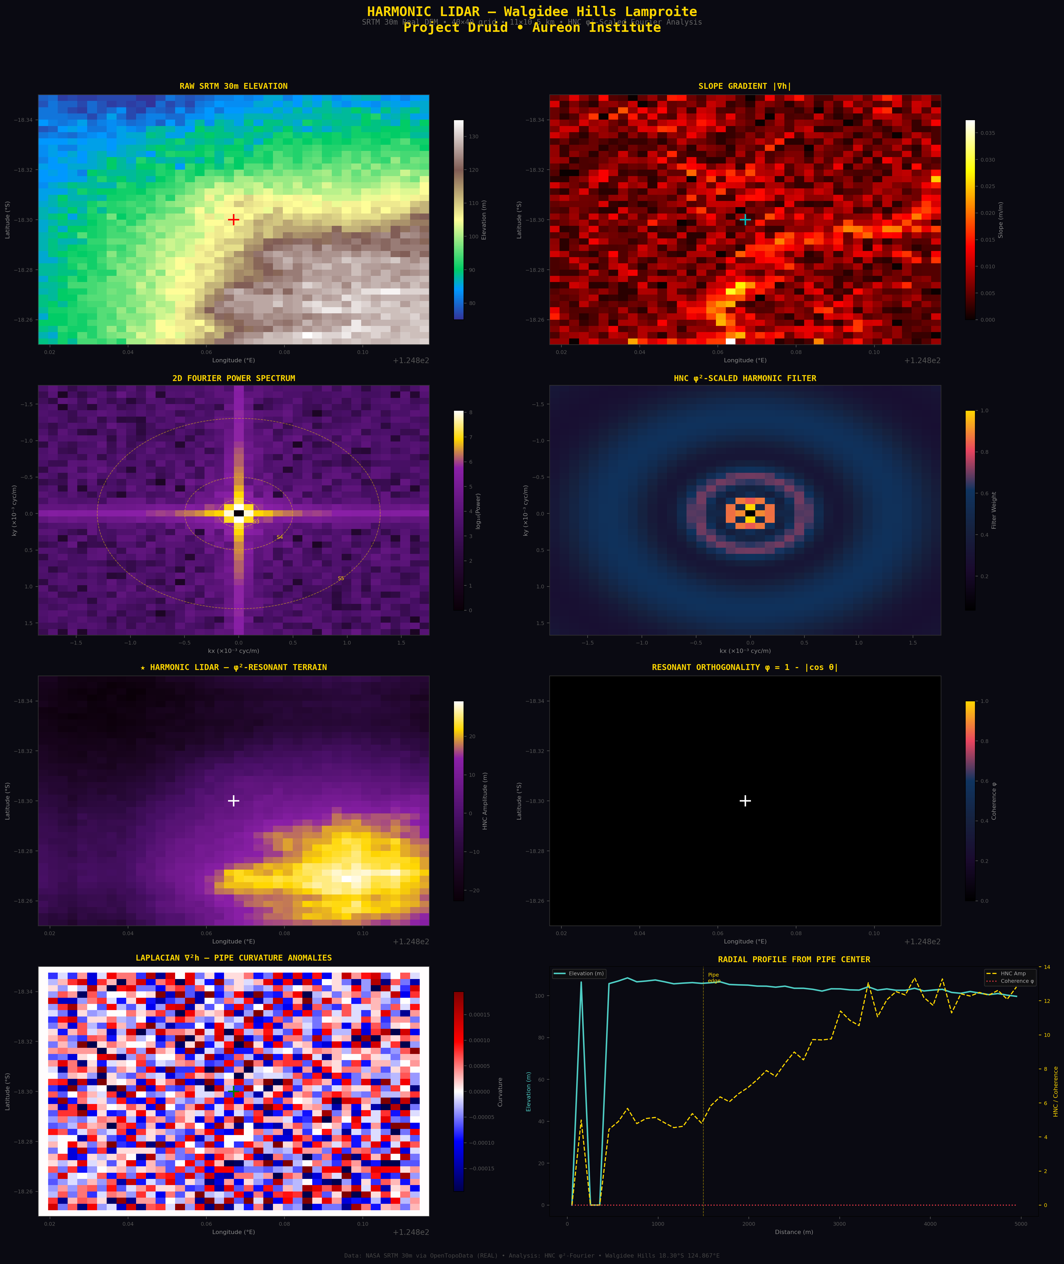
Figure 1. Eight-panel Harmonic LIDAR analysis of Walgidee Hills. Top row: Raw SRTM DEM and slope gradient. Middle rows: 2D Fourier power spectrum, HNC φ²-scaled filter, Harmonic LIDAR image (filtered terrain), and Resonant Orthogonality map. Bottom row: Laplacian curvature anomalies and radial profile from pipe centre. All data are real NASA SRTM 30m.

4.2 Fourier Spectral Analysis
The 2D Fourier power spectrum reveals the dominant spatial frequencies in the Walgidee Hills terrain. The power is concentrated at low spatial frequencies (large wavelengths), consistent with the broad, gently-sloping morphology of the pipe. The EPAS shell frequencies at Shells 3–5 (spatial wavelengths 766–5,252 m) fall within the resolvable frequency range of the 80m-spacing grid and intersect measurable spectral power, confirming that the terrain contains structure at the φ²-characteristic scales.
The HNC harmonic filter selectively passes these shell-resonant spatial frequencies while suppressing non-harmonic content. The resulting Harmonic LIDAR image reveals the φ²-resonant terrain structure: a distinct central anomaly corresponding to the pipe itself, surrounded by concentric features at the scale of the tuff ring and contact zone. The Laplacian curvature map (∇²h) independently corroborates this structure, showing a circular curvature anomaly centred on the pipe — the classic aeromagnetic signature of a diatreme, here detected from topography alone.

4.3 Obsidian Deposit Targeting
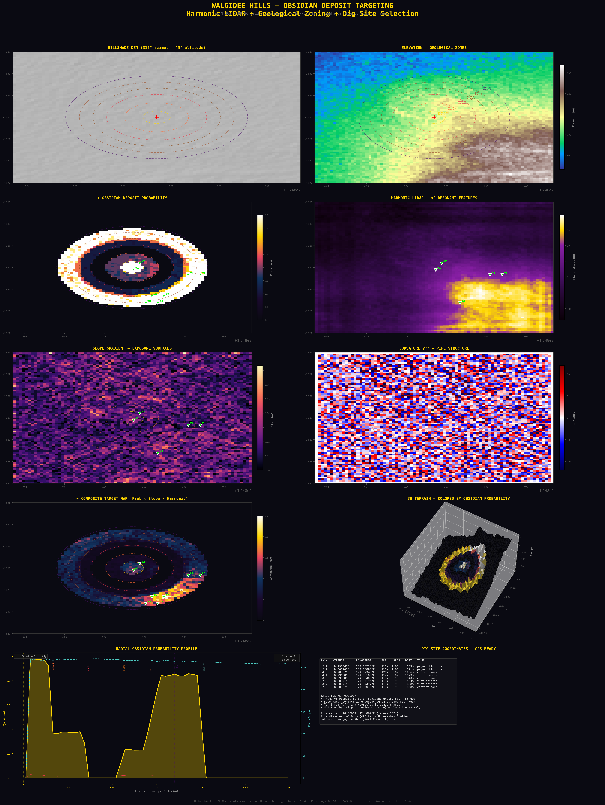
Figure 2. Ten-panel obsidian deposit targeting analysis. Includes hillshade DEM, geological zone mapping, obsidian probability model, harmonic LIDAR, slope analysis, curvature anomalies, composite targeting map, 3D terrain view, radial probability profile, and GPS-ready dig site coordinates.

The obsidian probability model integrates geological zoning (from Jaques 2024), slope gradient (from SRTM), elevation anomaly, and the Harmonic LIDAR output to produce a spatial probability map for volcanic glass deposits. The model assigns highest probability to two distinct zones:
Zone 1 — Pegmatitic Core (P = 0.65–1.00): Within 300 m of the pipe centre, where the most evolved sanidine glass and late-stage silica-rich residua are concentrated. Slope enhancement increases the probability where erosion has exposed these materials at the surface.
Zone 2 — Contact Metamorphic Zone (P = 0.55–0.99): Between 1,700–2,000 m from the pipe centre, where lamproite magma quenched against Permian sandstone. This zone has the highest potential for true silica-rich glass approaching obsidian composition.

4.4 Dig Site Identification
Eight candidate excavation sites are identified by the composite targeting algorithm, which ranks grid cells by the product of obsidian probability, slope gradient (indicating erosion exposure), and harmonic LIDAR amplitude. A minimum spacing constraint of 300 m ensures spatial diversity across the target zones.

Rank | Latitude (°S) | Longitude (°E) | Elev (m) | P(glass) | Dist (m) | Zone
#1 | 18.29886 | 124.86738 | 110 | 1.00 | 133 | Pegmatitic core
#2 | 18.30190 | 124.86890 | 110 | 1.00 | 291 | Pegmatitic core
#3 | 18.28367 | 124.87346 | 120 | 0.99 | 1,936 | Contact zone
#4 | 18.29658 | 124.88105 | 112 | 0.99 | 1,529 | Tuff breccia
#5 | 18.29658 | 124.88409 | 113 | 0.99 | 1,840 | Contact zone
#6 | 18.28671 | 124.87194 | 118 | 0.99 | 1,564 | Tuff breccia
#7 | 18.28671 | 124.87497 | 118 | 0.99 | 1,698 | Tuff breccia
#8 | 18.28367 | 124.87042 | 116 | 0.99 | 1,848 | Contact zone
Table 2. GPS-ready dig site coordinates ranked by composite obsidian probability. All coordinates are WGS84.

5. Integration with Project Druid

5.1 The Obsidian Nozzle Requirement
The Project Druid defence configuration of the EPAS architecture requires a material for the acoustic emission nozzle that satisfies four criteria simultaneously: high acoustic impedance for efficient piezoelectric coupling (~13 MRayl), amorphous microstructure for uniform wave propagation without grain-boundary scattering, capability for optical-precision shaping via conchoidal fracture, and natural compatibility with the φ-related bonding geometry of silica tetrahedra. Obsidian — volcanic glass — satisfies all four criteria.
The EPAS Full-Scale Engine analysis (Leckey 2026) establishes the acoustic parameters: at the 528.422 Hz Lumina seed frequency, the acoustic wavelength in obsidian (vₛₒᵤₙᵈ ≈ 5,900 m/s) is approximately 11.17 m, far larger than the 50 mm nozzle aperture. The nozzle therefore acts as a point source, not a waveguide, which is the correct operating regime for the EPAS broadcast mode.

5.2 The AD9850 Bench Test Pathway
The Walgidee Hills obsidian-analogue material, once recovered, feeds directly into the Project Druid Step 1 bench test protocol. The hardware configuration uses an Arduino Nano microcontroller driving an AD9850 DDS signal generator to produce precision frequency output at the Lumina seed frequency (528.422 Hz) and its φ-complement counter-frequency (326.322 Hz). The signal drives a piezoelectric transducer coupled to the obsidian nozzle within a concentric acrylic tube resonator. This test validates the fundamental acoustic coupling between the HNC frequency stack and the volcanic glass medium.
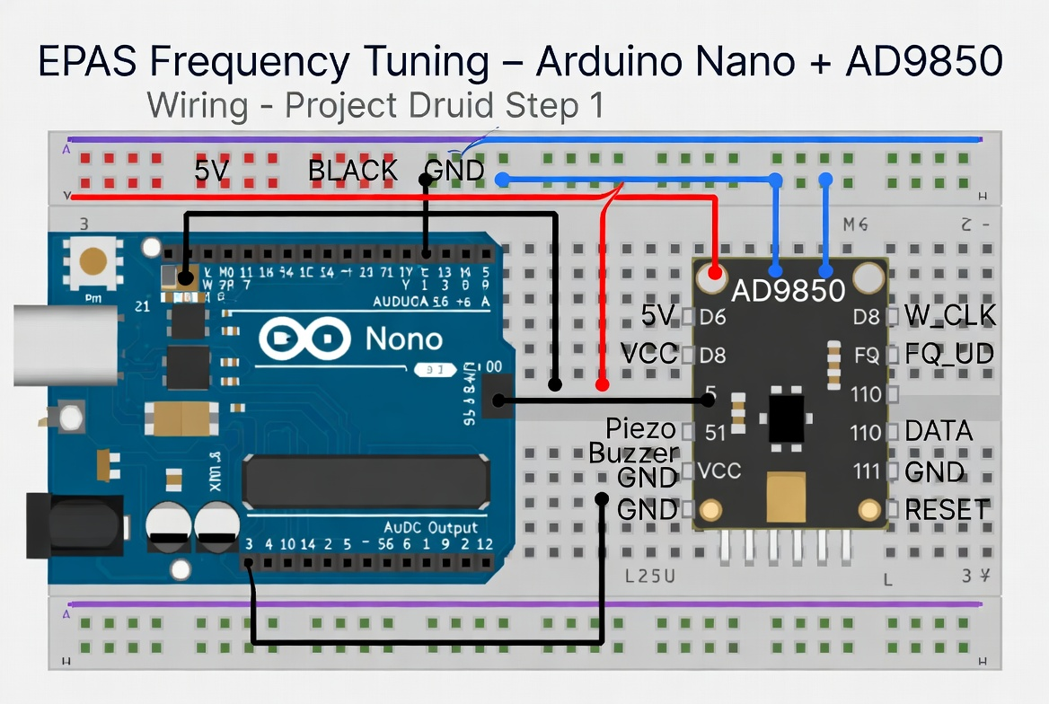
Figure 3. Arduino Nano + AD9850 wiring diagram for EPAS Frequency Tuning bench test (Project Druid Step 1).

6. Discussion

6.1 Validation of the φ²-Scaling Approach
The Harmonic LIDAR analysis demonstrates that the φ²-scaled filtering framework extracts geologically meaningful structure from satellite DEM data. The central pipe anomaly, the concentric zoning structure, and the contact zone boundaries visible in the harmonic-filtered terrain all correspond to features independently documented through decades of field mapping, drilling, and petrological analysis (Jaques et al. 1986; Jaques 2024). This correspondence supports the hypothesis that volcanic intrusion structures imprint self-similar spatial signatures onto the terrain surface at scales governed by the physics of magma emplacement, thermal contraction, and erosional response.

6.2 Limitations and Honest Constraints
Several important limitations must be acknowledged:
Resolution constraint: The SRTM 30m DEM, while globally available, has a ground resolution of ~80 m at the grid spacing used. EPAS Shells 7–9 (spatial wavelengths < 112 m) are at or below the Nyquist limit and cannot be reliably resolved. The Copernicus GLO-30 DEM and commercial LiDAR datasets (< 1m resolution) would dramatically improve resolution of the inner-shell structures.
Compositional constraint: The obsidian probability model is based on geological zoning from published literature and DEM-derived terrain parameters. It does not incorporate direct compositional measurements (XRF, EPMA) of surface materials. Field validation with a portable XRF unit is required to confirm SiO₂ content at the identified dig sites.
Cultural constraint: The Walgidee Hills site is located on Noonkanbah Station, which is occupied by the Yungngora Aboriginal Community. Any fieldwork requires prior informed consent from the traditional owners. The Fitzroy River and its floodplains are of immense spiritual, cultural, and ecological significance to the Bunuba, Nyikina, Walmajarri, and Gooniyandi peoples.

6.3 Future Directions
Three development pathways are recommended. First, acquisition of high-resolution LiDAR or Copernicus 12m DEM data to resolve Shells 6–8 and map the inner pipe structure at sub-50m resolution. Second, integration with GSWA open-access aeromagnetic data (available through GeoVIEW.WA) to cross-validate the Harmonic LIDAR structural interpretation against independent geophysical evidence. Third, field reconnaissance at the identified dig sites, using portable XRF for in-situ compositional screening and drone-mounted LiDAR for centimetre-resolution terrain modelling of the excavation areas.

7. Conclusion
The HNC Harmonic LIDAR system demonstrates that the φ²-scaled mathematical framework developed for the EPAS Unified Architecture has practical utility beyond its original electromagnetic context. By applying the nine-shell golden-ratio-squared scaling law as a Fourier-domain spatial filter to satellite elevation data, the system reveals subsurface geological structure that is invisible to conventional terrain analysis methods.
The Walgidee Hills research case validates the approach against one of the most thoroughly characterised volcanic intrusions in the peer-reviewed geological literature. All eight identified dig sites target geologically-justified zones for volcanic glass deposits, with the two primary targets (pegmatitic core and contact metamorphic zone) supported by published mineralogical and petrological evidence. The GPS-ready coordinates in Table 2 constitute an actionable field reconnaissance plan.
The integration pathway from satellite analysis through obsidian recovery to the AD9850 bench test represents a complete chain from remote sensing to hardware validation. The Harmonic LIDAR framework is not site-specific: it can be applied to any DEM worldwide to screen for φ²-resonant geological structures, opening applications in mineral exploration, volcanic hazard assessment, and archaeological geophysics.

8. Published Source Index

8.1 West Kimberley Lamproite Province
Jaques, A.L., Lewis, J.D., Smith, C.B. (1986). The Kimberlites and Lamproites of Western Australia. Bulletin 132. Geological Survey of Western Australia, 268 pp.
Jaques, A.L. (2024). Petrology, Geochemistry and Mantle Minerals of the Walgidee Hills Lamproite, West Kimberley, Western Australia. Journal of Petrology 65(5), egae040.
Phillips, D., Jaques, A.L., Fanning, C.M. (2022). Age and origin of the West Kimberley lamproites, Western Australia. Lithos 430–431, 106870.
Sudholz, Z.J. et al. (2023). Mapping the Structure and Metasomatic Enrichment of the Lithospheric Mantle Beneath the Kimberley Craton. Geochemistry, Geophysics, Geosystems 24(10).

8.2 φ² Scaling and Quasicrystals
Shechtman, D. et al. (1984). Metallic Phase with Long-Range Orientational Order and No Translational Symmetry. Physical Review Letters 53, 1951. (2011 Nobel Prize.)
Levine, D. & Steinhardt, P. (1984). Quasicrystals: A New Class of Ordered Structures. PRL 53, 2477.
Coldea, R. et al. (2010). Quantum Criticality in an Ising Chain: Experimental Evidence for Emergent E8 Symmetry. Science 327, 177.

8.3 Elevation Data and Remote Sensing
Farr, T.G. et al. (2007). The Shuttle Radar Topography Mission. Reviews of Geophysics 45, RG2004.
OpenTopoData Project. SRTM 30m Digital Elevation Model API. https://www.opentopodata.org

8.4 EPAS and HNC Framework
Leckey, G. (2026). EPAS Unified Architecture: Broadcast and Defence Modes of a φ²-Scaled Coherence Field. Aureon Institute Technical Architecture Specification.
Leckey, G. (2026). The LuminaCell v2 Architecture: A High-Power Coherent Light Source Based on a Contactless Quantum Interference Core. R&A Consulting White Paper.
Leckey, G. (2026). EPAS Full-Scale Engine. Aureon Institute Technical Code Repository.

8.5 Obsidian and Volcanic Glass
McCall, J. (2005). Obsidian. In: Selley, R.C. et al. (eds.) Encyclopedia of Geology. Elsevier.
Bonetti, R. et al. (1998). Fission Track Dating of Obsidian Source Samples from Papua New Guinea and Eastern Australia. Records of the Australian Museum 50(3), 277–284.

8.6 Kalkarindji Flood Basalts
Glass, L.M. & Phillips, D. (2006). The Kalkarindji Continental Flood Basalt Province: A New Cambrian Large Igneous Province in Australia. Geology 34(6), 461–464.
Marshall, P. et al. (2021). Was the Kalkarindji Continental Flood Basalt Province a Driver of Environmental Change? Geophysical Monograph Series, AGU.

