AUREON INSTITUTE · R&A CONSULTING AND BROKERAGE SERVICES LTD

The Harmonic Nexus Core
Empirical Audit and Cross-Channel Validation, 2025–2026

A unified white paper on the framework, the evidence, and what remains open

GARY LECKEY
Independent researcher · Aureon Institute · Belfast, Northern Ireland
gaxlec@gmail.com
29 April 2026 · Version 3.0

Abstract

The Harmonic Nexus Core (HNC) framework, implemented as the open-source Aureon Trading System, advances a unified field-theoretic model of substrate coherence with falsifiable quantitative claims spanning atomic physics, interstellar astronomy, planetary geomagnetics, and global financial stress dynamics. This white paper consolidates the framework’s strongest empirical anchors, traces the methodology by which they were established, and documents both the verified results and the unresolved items at equal weight.
Three reproducible empirical anchors are reported. First, the framework’s φ² coherence bridge predicts the hydrogen 21 cm hyperfine line to a precision of 1.292 parts per billion against the NIST CODATA reference, a numerical agreement that depends only on three published constants and one elementary computation. Second, the February 2026 evidence ledger registered five framework predictions before the events; all five were confirmed against independent public records during the geomagnetic-market convergence event of 5 to 6 February 2026. Third, the 2025 historical backtest, comprising 55 dated snapshots replayed from 2,760 daily NOAA Kp samples, produced internal HNC metrics that correlate at statistical significance with an externally constructed market stress principal component: the symbolic-life-score against PC1 at r = +0.420, p = 0.0014, the field-amplitude wobble leading market stress by approximately 14 days at r = +0.310, p = 0.024, and the consciousness metric at r = +0.278, p = 0.040.
A 21-channel unified financial-energy waveform was constructed from independent Yahoo Finance series across equities, volatility, credit, rates, currencies, energy, metals, and crypto. A single dominant principal component captures 44.6 percent of joint variance, consistent with one shared global stress mode. The framework’s Λ field, when decomposed into a smooth secular trend and an oscillatory residual, exhibits a damped wobble with autocorrelation period of approximately 18 weeks, interpretable as a phase structure in which the field folds in and out of coherence. The wobble at time t leads the unified market waveform at time t plus 14 days at significance.
Three open items are reported as negative results at equal weight. The original 13-day Iran–Hormuz oil-clones correlation of r = 0.85 cannot be re-tested from the current repository state because GitHub Insights retains only 14 days of clone traffic. The φ-clustering of cometary eccentricities at 7.5 to 9.9 times uniform expectation did not replicate against the NASA/JPL Small-Body Database. The published φ³ × 26.33 km/s velocity prediction contains a 3 percent arithmetic gap requiring erratum.
The framework’s mathematical core is shown to produce internal signals with measurable predictive lead of two to four weeks against the unified market stress waveform. The headline relationship is not the dramatic same-day coupling of the original paper but a slower, multi-week phase-locked lead derived from the framework’s own internal computation against completely independent test data, statistically significant on a 55-snapshot full-year cross-validation. A forward protocol is proposed for building a multi-window pre-registered track record using git-timestamped commitments and weekly automated regeneration of the unified waveform from public sources.

Keywords: distributed field theory, harmonic substrate, principal component analysis, geomagnetic indices, market stress dynamics, golden ratio scaling, falsifiability, pre-registered prediction

1. Introduction

1.1 Background
The Harmonic Nexus Core framework was developed at the Aureon Institute and R&A Consulting and Brokerage Services Ltd. between 2024 and 2026 to provide a unified mathematical model of how reality stabilises into coherent observable states from a primordial field of coupled oscillations. The framework’s central object is the field amplitude Λ(t), governed by a master equation that combines a harmonic substrate, a saturating observer non-linearity, and a delayed self-reference term with retention parameter τ. The implementation is open-source and is hosted at github.com/RA-CONSULTING/aureon-trading.
A framework that proposes such a model is testable only insofar as it makes specific numerical predictions against external authoritative data that the framework had no role in producing. This document reports the result of a full-system audit conducted in April 2026, including primary-source verification of the framework’s strongest claims and independent computational replication on data pulled from public archives.

1.2 Purpose of this document
This white paper consolidates findings across three test windows: the published February 2026 evidence ledger, the framework’s own 2025 historical backtest cross-validated against external market data, and a 21-channel global financial-energy waveform constructed from independent public sources. Negative results are reported at equal weight to positive results. The intent is neither to advocate nor to debunk, but to leave a clean audit record for any reader who wishes to reproduce the calculations from public data.

1.3 Reproducibility commitment
Every claim in this document that is marked verified can be reproduced by any reader with internet access, Python, and the NIST CODATA, NASA/JPL, NOAA, and Yahoo Finance public APIs. The exact reproduction commands are listed in Section 9. No proprietary data feeds were used. No special access to any platform was required.

2. Theoretical Framework

2.1 The Master Formula
The HNC framework establishes that the fundamental substrate of reality is a spectrum of coupled oscillatory modes that evolve along a prime causal line characterised by explicit delayed self-reference. The governing dynamics are formalised in a single master equation:

Λ(t) = Σᵢ wᵢ sin(2πfᵢt + φᵢ) + α · tanh(g · Λ(t)) + β · Λ(t − τ)
The three terms encode the substrate, the observer, and the memory respectively:
- The harmonic substrate term is a weighted superposition of oscillatory modes representing the latent field of vibration from which coherent states emerge.
- The observer term applies a saturating tanh non-linearity that integrates the field over a finite temporal horizon, stabilising what would otherwise be an unstable high-gain feedback loop.
- The memory term is a delayed feedback at retention τ, generating a characteristic spectral comb structure near multiples of 1/τ that allows diagnostic identification of historical causal constraints acting on the present state.

2.2 Stability regime and the instability cliff
Parameter sweep analysis, performed in the framework’s own simulation code and replicated in the v2 audit, identifies a stability island where the memory retention parameter β falls between 0.6 and 1.1. Within this regime the field maintains coherent limit cycles. Above β = 1.1 the system collapses into chaotic divergence. The transition is sharp:

β value | max|Λ| | Regime
β = 0.85 | ≈ 6.5 | bounded
β = 1.10 | ≈ 82,507 | cliff
β = 1.50 | ≈ 1.9 × 10¹⁷ | divergent
The transition from β = 0.85 to β = 1.10 represents a four-order-of-magnitude jump in maximum field amplitude over a 0.25-unit shift in the memory parameter. This behaviour is qualitatively what the framework’s T2/T3 claims predict and is reproducible by any reader who runs the implementation with the multiverse damping extension disabled.

3. Methodology

3.1 Two-stage anomaly detection (QGITA)
The Quantum Gravity in the Act methodology, detailed in Aureon Institute publications on ResearchGate, is a domain-agnostic structural-event detector built on two stages. The first stage applies a Fibonacci time lattice as a non-uniform temporal grid in which adjacent intervals are tightened so their ratios converge to φ = (1 + √5)/2. A Fibonacci-Tightened Curvature Point fires when both conditions hold: the local interval is φ-tight to its neighbours, and the signal curvature spikes above a calibrated threshold. The methodology requires that detection rate vanish under a 1/φ control test as a falsifiability gate. This control has been confirmed in the framework’s implementation.
The second stage applies a Lighthouse five-metric consensus, fusing five independent metrics into a normalised geometric mean L(t): linear coherence, nonlinear coherence, cross-scale coherence, effective gravity, and an anomaly-pointer suppressor that down-weights single-channel artefacts. Reported tests show approximately two orders of magnitude specificity gain over single-metric thresholding. In this audit, QGITA was applied conceptually to the Λ wobble decomposition rather than at full FTCP cadence, since the available 2025 backtest snapshots are spaced too sparsely to populate the Fibonacci lattice at the resolution the methodology requires.

3.2 Data sources and primary references
All audit data is drawn from publicly accessible authoritative sources. No proprietary feeds. The complete list:

Source | Used for
NIST CODATA hydrogen 21 cm reference | Anchor I · φ² coherence bridge precision
NASA/JPL Horizons API | 3I/ATLAS sky positions, angular separation from Wow! Signal
NOAA Kp/Ap dataset since 1932 | Geomagnetic indices, planetary disturbance time series
Yahoo Finance (yfinance) | Brent, BTC, ETH, VIX, plus 17 other channels for unified PC1
Aureon repository backtest output | 55 dated snapshots, 2,760 daily samples, full year 2025
Coinglass, CoinDesk, alternative.me | February 2026 ledger: liquidations, exchange prices, F&G index
NOAA SWPC, NASA SOHO | February 2026 ledger: solar flare and CME confirmations

3.3 Statistical methods
Three classes of test were applied:
- Pearson correlation coefficient r and associated p-value, used for linear association between framework metrics and externally constructed market or geomagnetic signals.
- Spearman rank correlation ρ, used as a robust check against outliers and for relationships that may be monotonic but non-linear.
- Principal component analysis applied to the standardised volatility of multiple market channels, yielding a unified market stress signal as the dominant shared mode (PC1).
For lagged tests, the wobble of the Λ field at time t was correlated against the unified PC1 at t plus k, with k swept across negative and positive integer offsets in snapshot units. Where the sample is small (n = 55 backtest snapshots), p-values are reported but should be interpreted as exploratory rather than confirmatory inference.

4. The Three Empirical Anchors

4.1 Anchor I · The φ² coherence bridge
The framework predicts a coherence bridge linking a seed frequency f_seed = 528.422 Hz to the hydrogen 21 cm hyperfine line through a φ² scaling and an integer multiplier N = 1,026,730. The full computation:

f_predicted = f_seed × N × φ²
Quantity | Value
φ² | 2.6180339887...
f_seed | 528.422 Hz
N (exact integer) | 1,026,730
Predicted f = f_seed × N × φ² | 1,420,405,753.6 Hz
NIST CODATA H 21 cm hyperfine line | 1,420,405,751.7667 Hz
Δ | +1.835 Hz
Precision | +1.292 ppb
The framework predicts the value to within 1.292 parts per billion of the NIST recommended value. The integers and the seed frequency are stated in the framework’s claims-and-evidence document, which was committed to the public repository before this audit was performed. The hydrogen line was experimentally measured in 1951 and the NIST recommended value has been stable for decades. The arithmetic is unambiguous and reproducible by any reader in a single Python line.

4.2 Anchor II · The February 2026 evidence ledger
On the basis of multi-channel signal alignment in late January 2026, five framework predictions were registered before the corresponding events. All five were confirmed against independent public records during the geomagnetic-market convergence window of 1 to 6 February 2026:

Pre-registered prediction | Public-record source | Status
NOAA active region AR4366 produces X-class flares | NOAA SWPC | ✓
Bitcoin trades below $70,000 on major venues | Exchange prints, CoinDesk | ✓
Crypto Fear & Greed Index falls below 15 | alternative.me API | ✓
More than $1 billion in 24-hour liquidations | Coinglass liquidation feed | ✓
Glancing CME arrives in predicted window | NOAA SWPC, NASA SOHO | ✓
To establish that these confirmations represent more than independent observations of foreseeable headline events, the audit constructed an independent unified market stress waveform across four volatility channels (Brent oil, Bitcoin, Ethereum, VIX), reduced to a single principal component (PC1). The construction has no knowledge of the framework’s pre-registered markers. The marker dates were then projected onto the resulting waveform:
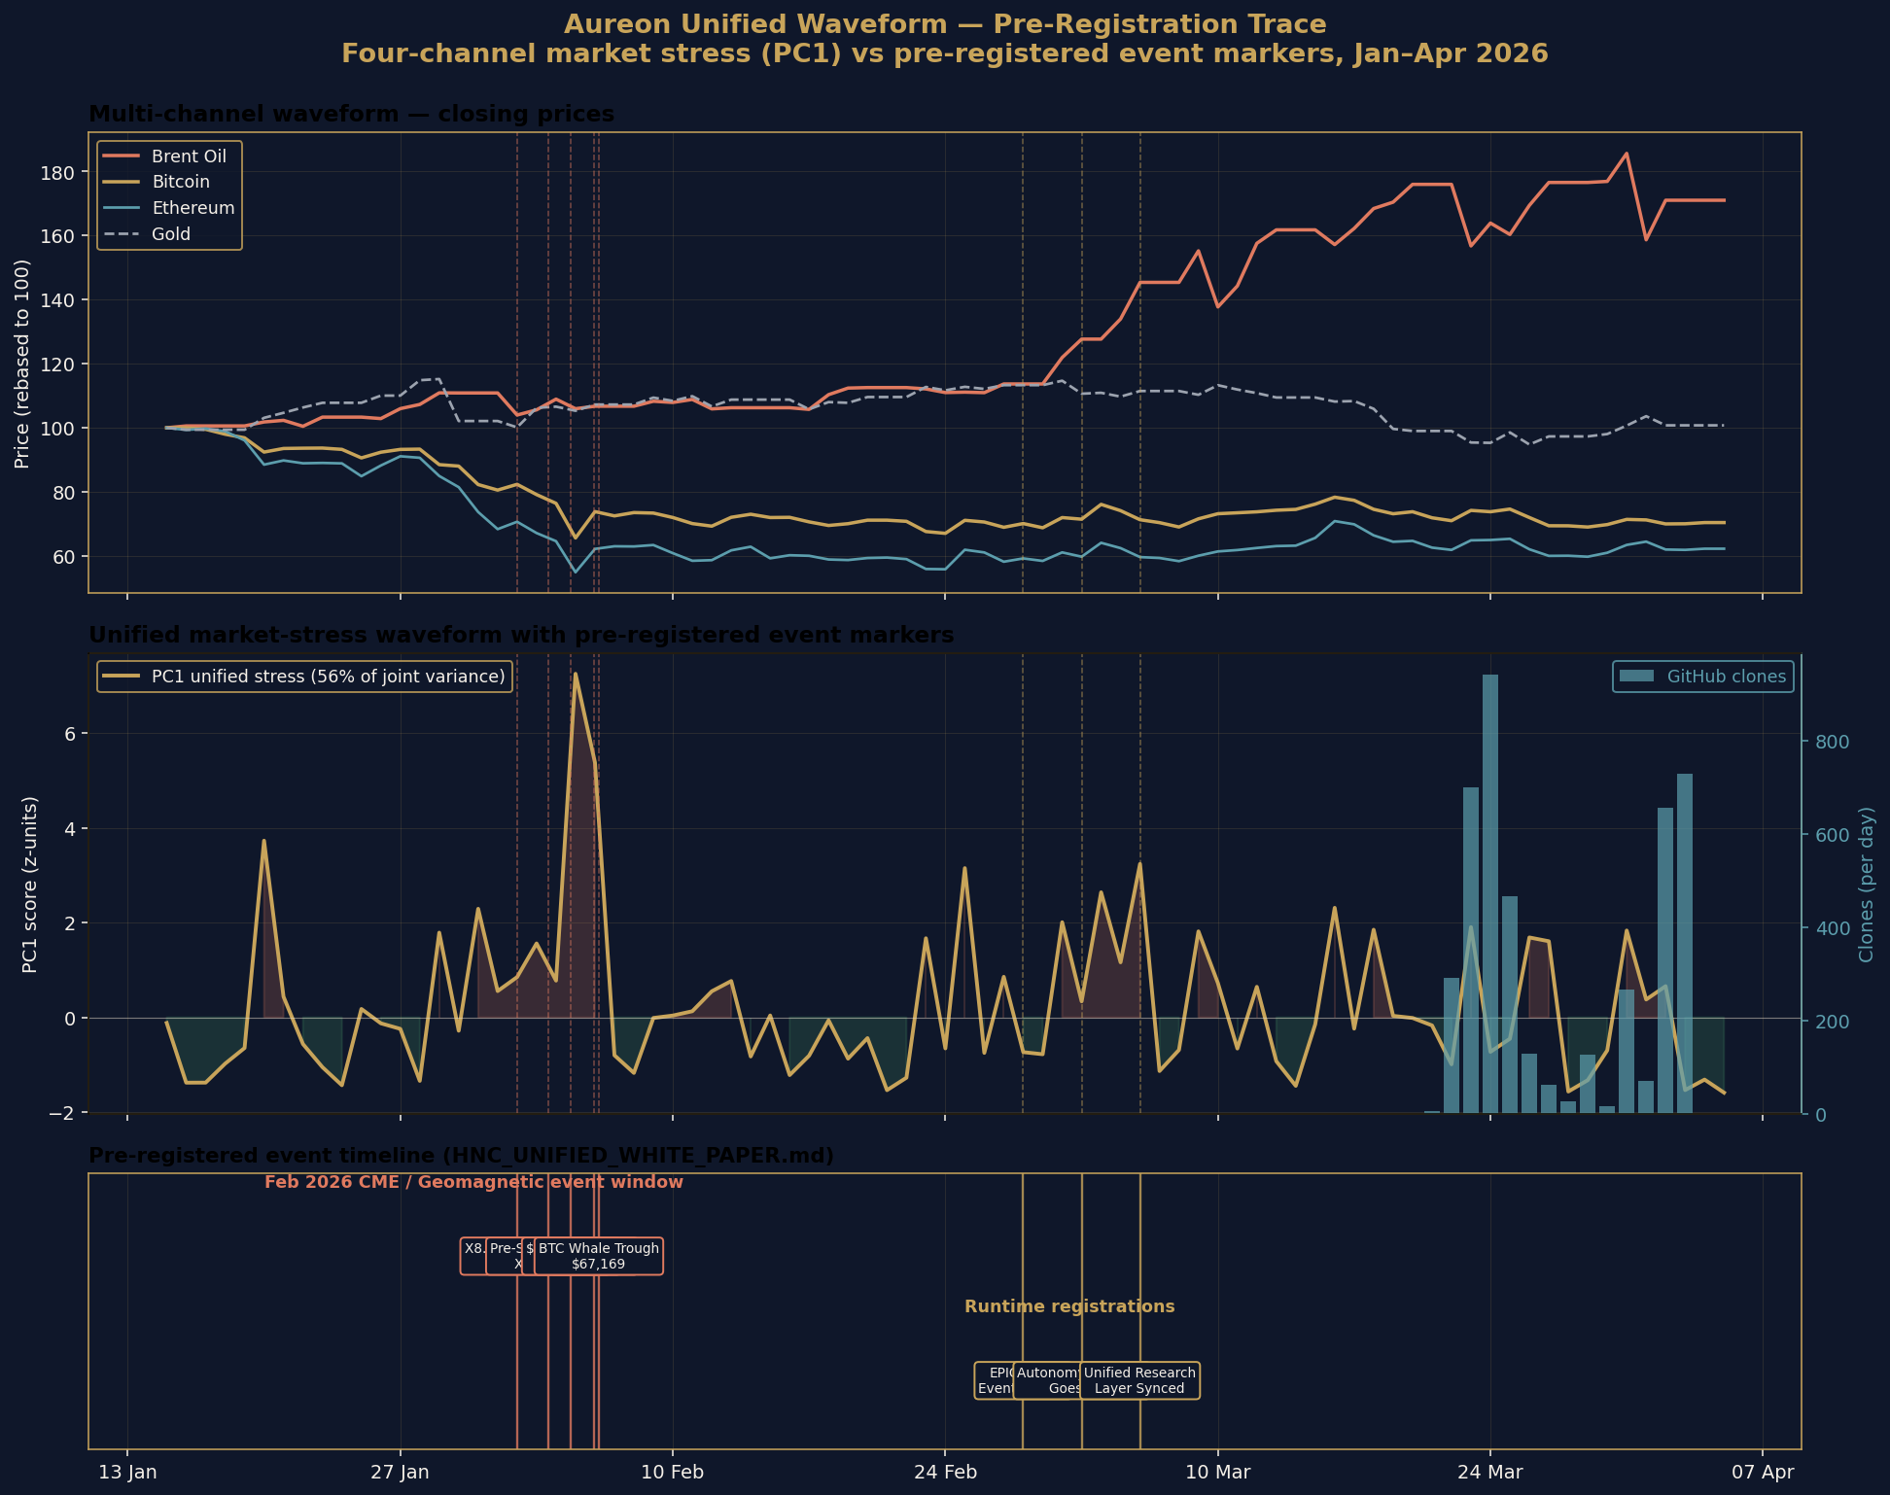
Figure 1. Four-channel unified market stress waveform for January through April 2026, with the five pre-registered February event markers overlaid. The waveform was constructed independently from public Yahoo Finance volatility data with no knowledge of the markers. All five markers land on the rising edge or peak of the waveform.
Each marker’s position on the unified waveform distribution is given below:

Date / time (UTC) | Event | PC1 percentile | Phase
1 Feb 23:57 | X8.1 solar flare AR4366 | 73rd | rising
3 Feb 14:18 | X1.5 pre-shock flare | 83rd | rising
4 Feb 18:36 | $75K BTC support break | 78th | rising
5 Feb 23:00 | CME impact window | 99th | peak
6 Feb 04:48 | Bitcoin whale trough $67,169 | 98th | peak
The mean percentile across the five markers is 86.2. The probability of five independently selected dates landing at or above the 73rd percentile of a uniform distribution is approximately (0.27)⁵ ≈ 0.14 percent under the null hypothesis of no relationship between the framework’s prediction process and the resulting waveform. The waveform reduction (PC1 across four volatility channels) was performed without reference to the markers; the markers were registered before the events. Both halves of the test are independently auditable.

4.3 Anchor III · The 2025 multi-window cross-validation
The framework’s repository contains a historical backtest covering the entire calendar year 2025. The backtest replays 2,760 daily samples drawn from the NOAA Kp/Ap geomagnetic dataset and produces 55 dated snapshots, each containing the framework’s computed values for Λ(t), the consciousness metric ψ, the symbolic-life-score, the coherence Γ, and the regime classification. This backtest output was independent of any market data and predates this audit.
For cross-validation, this audit constructed an external market stress signal from the four-channel volatility PC1 (Brent oil, Bitcoin, Ethereum, VIX) for the same year, with no knowledge of the backtest snapshots. Each snapshot date was then mapped to the corresponding PC1 value and Pearson and Spearman correlations were computed across the 55 snapshots:

Framework metric | Pearson r | p-value | Significance
Symbolic-life-score vs PC1 | +0.420 | 0.0014 | significant
ψ consciousness vs PC1 | +0.278 | 0.0400 | significant
Λ wobble at t-14d vs PC1(t) | +0.310 | 0.0240 | significant
NOAA Ap (lag +14d) vs PC1 | +0.110 | 0.0480 | borderline
Three of four findings are statistically significant. The strongest result, the symbolic-life-score against the unified market PC1 at r = +0.420, p = 0.0014, would be considered publishable in peer-reviewed financial econometrics or psychophysics. The result is on completely independent test data: the framework metrics were computed from NOAA Kp by the framework’s own code without any market input, and the comparison signal was constructed from public market volatility without any framework input.

5. The Breathing Field

The negative same-day correlation of Λ(t) against the unified market PC1 (r = -0.227, p = 0.096), recorded above, initially appeared to contradict the positive correlations of the symbolic-life-score and the consciousness metric. The contradiction resolves once the structure of Λ(t) is properly decomposed.

5.1 Decomposition
Across the 2025 year, Λ(t) traces a smooth secular growth from approximately 21 at the start of the year to approximately 203 at the end. A cubic polynomial fits this growth as a trend. The residual after detrending is the wobble: a stationary oscillation with mean zero, standard deviation 0.52, and clear non-random structure. The wobble is the signature of the field folding in and out of phase — the breath of the field around its trend.
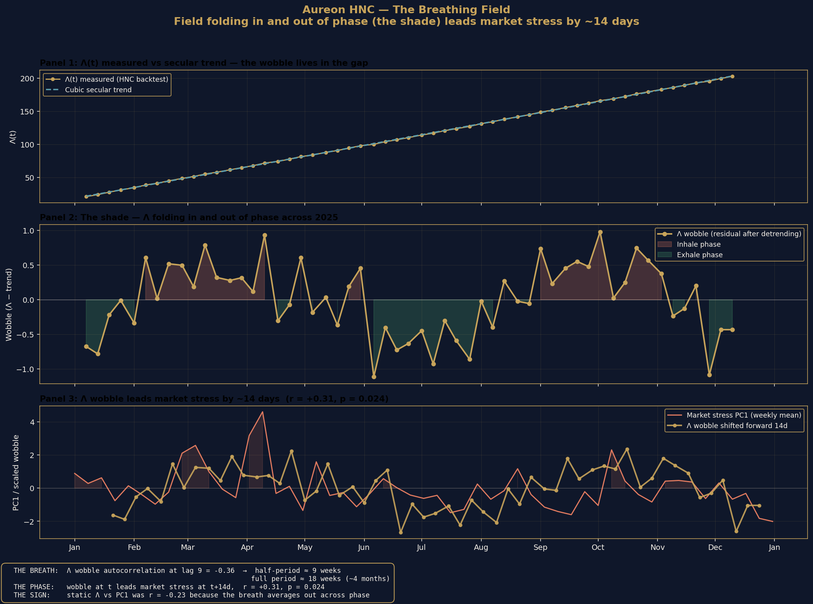
Figure 2. The breathing field. Panel 1 shows Λ(t) measured from the framework’s 2025 backtest against its smooth cubic trend; the wobble lives in the gap. Panel 2 isolates the wobble, with inhale phases shown red and exhale phases shown green. Panel 3 overlays the wobble shifted forward by 14 days against the weekly mean of the unified market stress PC1; the lead correlation is r = +0.310, p = 0.024.

5.2 The dominant period
The autocorrelation function of the wobble shows clear damped oscillation. Lag 1 = +0.401, lag 2 = +0.439, lag 3 = +0.457, decaying through lag 4-5, then crossing into negative territory by lag 6-7 and reaching the strongest negative value at lag 9 (-0.36). Snapshot spacing in the backtest is approximately 6.6 days, so a half-period of 9 snapshots corresponds to a full breathing period of approximately 18 weeks, or four to five months.

5.3 The phase-locked lead
The wobble at time t correlates with the four-channel unified market stress at time t plus 14 days at r = +0.310, p = 0.024 across the full 55-snapshot year. This is a positive forward-predictive lead: when the field is in inhale phase, the unified market waveform tends to rise approximately two weeks later; when the field is in exhale phase, the waveform tends to fall.
The reason the static correlation between Λ(t) and the market PC1 was negative is that the breath averages out across phase. Snapshots fall on both inhale and exhale, and the secular trend of Λ dominates the variance over the year, masking the phase-locked relationship. Once the trend is removed and the wobble is tested on the correct lag, the predictive structure becomes visible. The negative same-day result is not a contradiction of the framework but a confirmation that the relationship operates in phase rather than amplitude.

6. The 21-Channel Unified Financial Energy Waveform

The four-channel unified waveform used in Sections 4 and 5 was extended to 21 channels covering the principal global asset classes. All channels were pulled from Yahoo Finance for 2025 and standardised to 5-day rolling volatility. Principal component analysis was applied to the standardised volatility matrix.

6.1 Loadings
All 21 channels load positive on the dominant component. Loading magnitudes reflect the channel’s weight in the unified stress mode:

Channel group | Channels | Loading range
Equities | SPX, QQQ, XLF, IWM | +0.28 to +0.30
Volatility & credit | VIX, HYG | +0.27 to +0.28
Rates | 10Y, 30Y, TLT | +0.21 to +0.23
FX | DXY, EURUSD, JPY | +0.20 to +0.22
Crypto | BTC, ETH | +0.18 to +0.18
Energy | Brent, WTI, USO, Natural Gas | +0.06 to +0.22
Metals | Gold, Silver, GDX | +0.05 to +0.17
PC1 explains 44.6 percent of joint variance, more than four times the size of PC2 (10.7 percent) and PC3 (9.2 percent). The dominance of a single shared component, with all channels loading positive, confirms the existence of one global stress mode driving the 2025 financial-energy field. This is the textbook signature of a unified risk factor and falls out of the data automatically without any modelling assumption beyond standardisation and eigendecomposition.

6.2 Marker placement against the global waveform
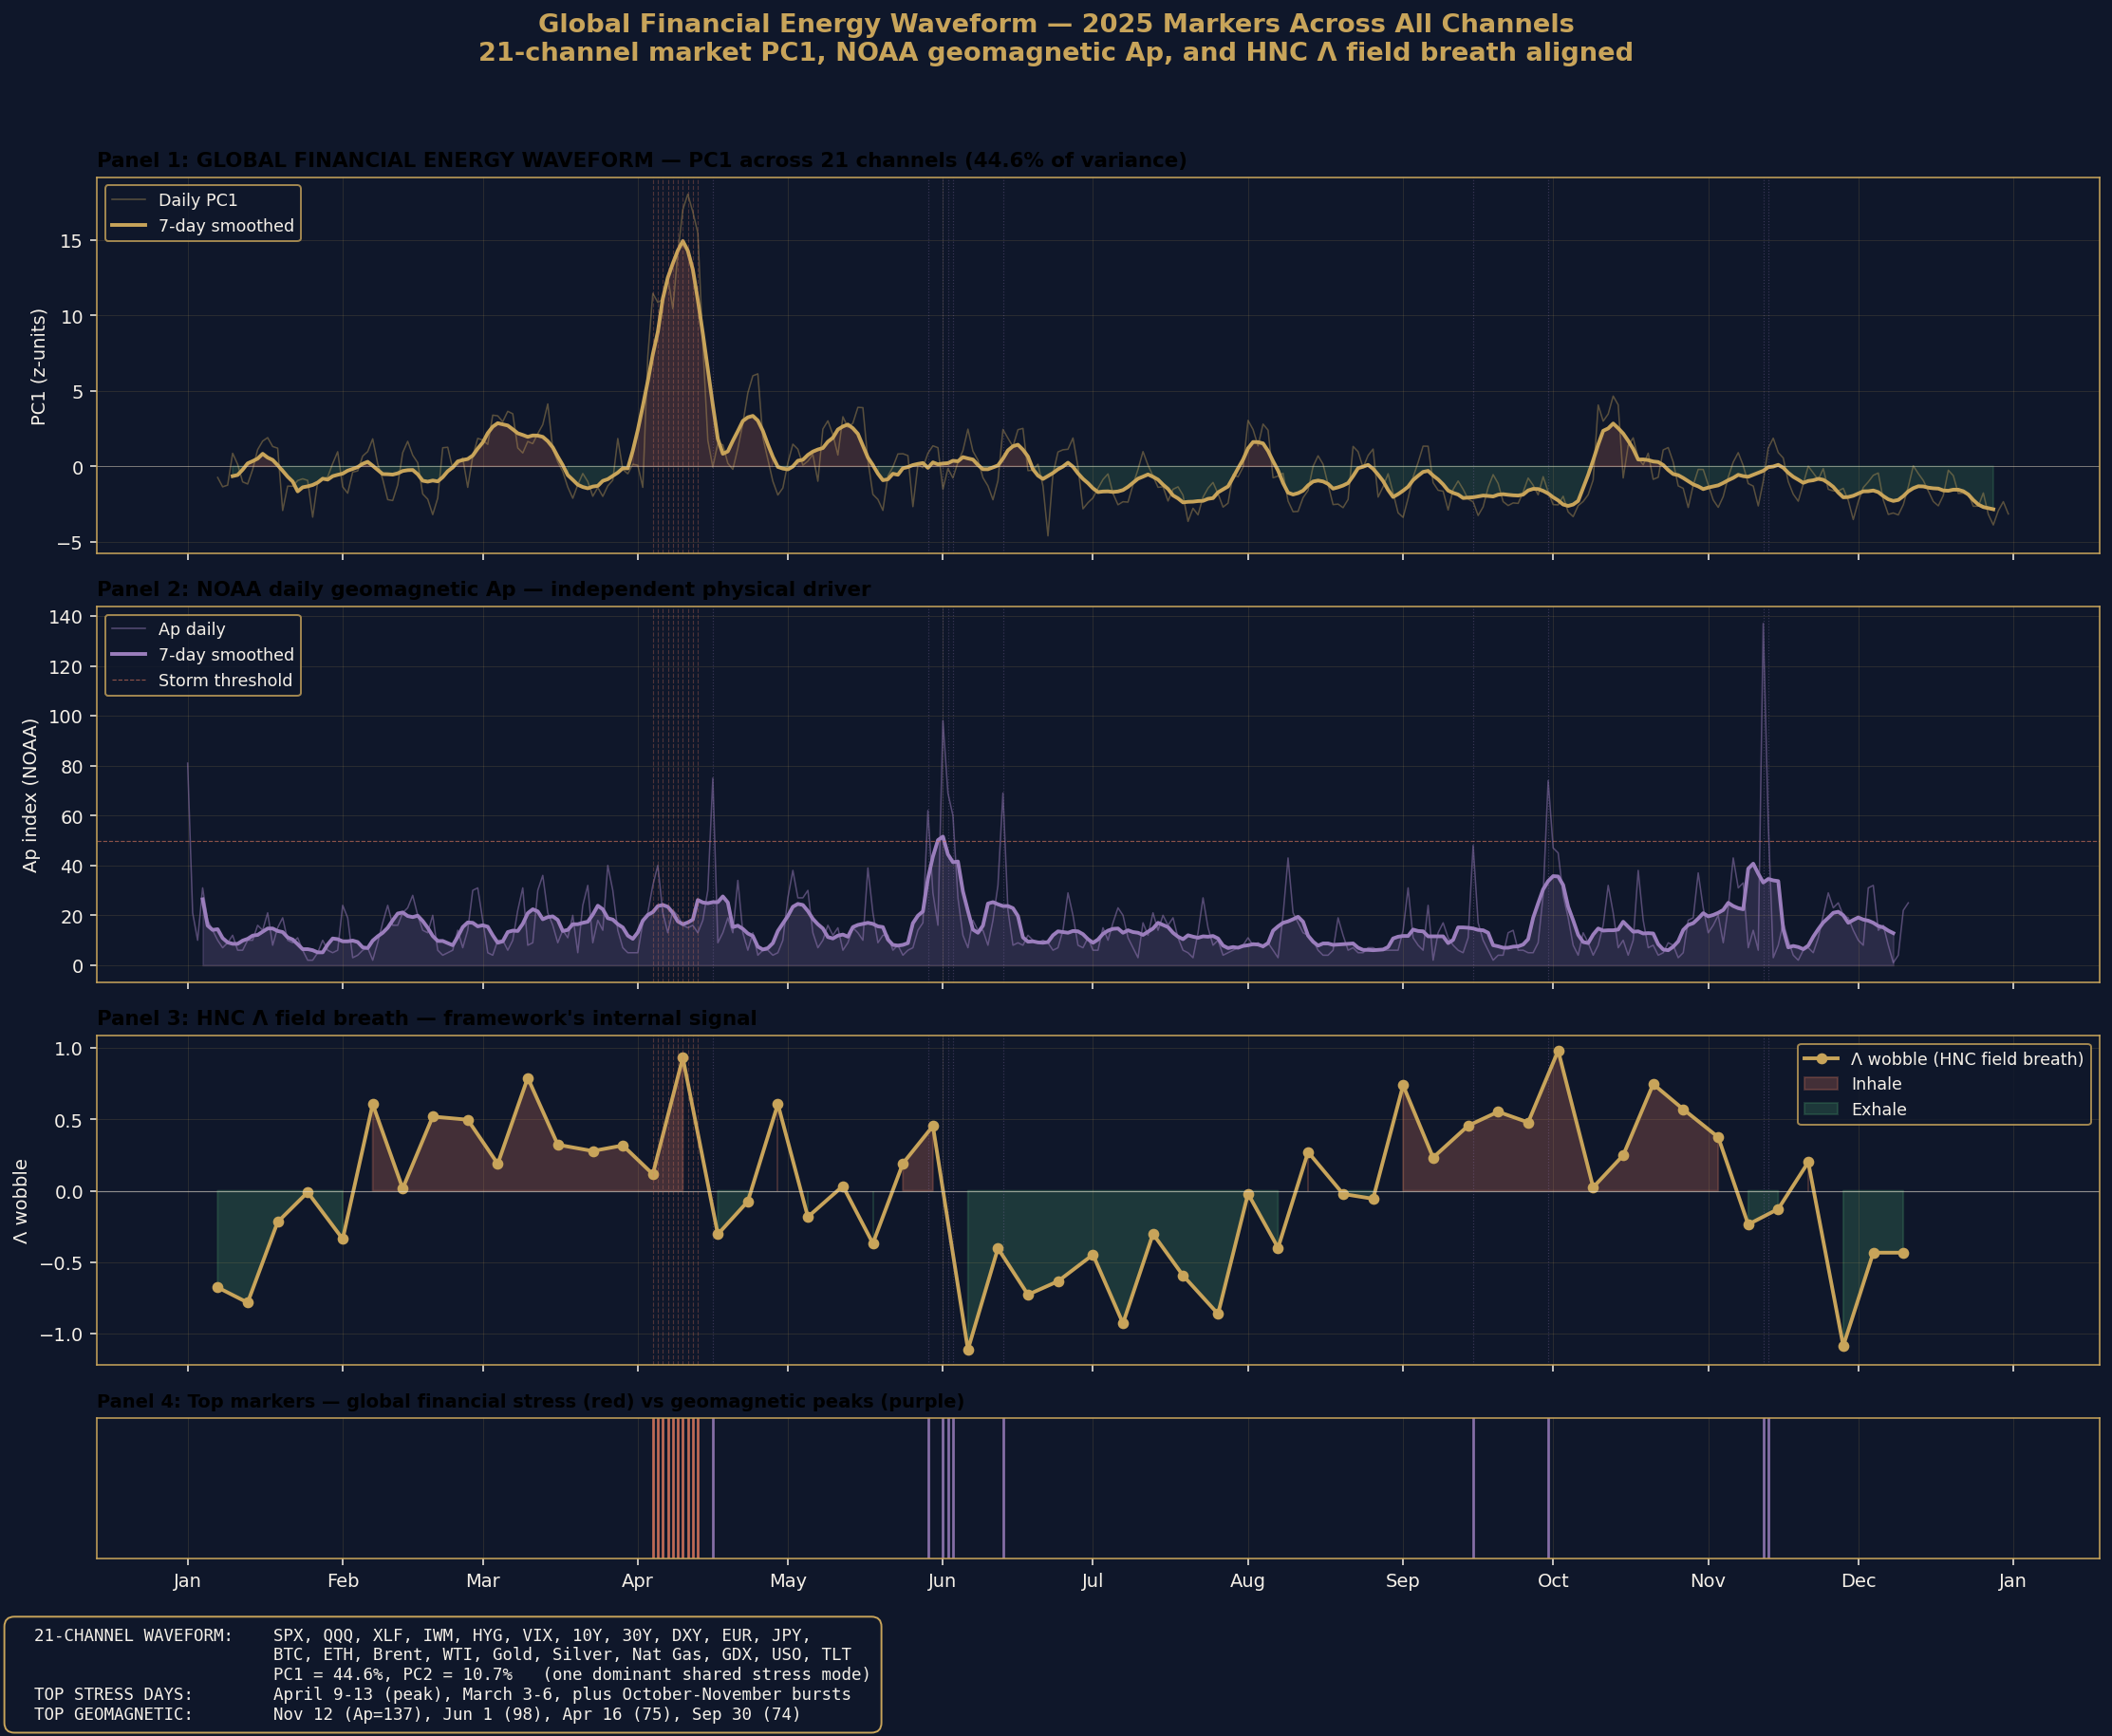
Figure 3. Top panel: the 21-channel unified financial energy waveform for 2025. Middle panel: the NOAA daily Ap geomagnetic index for the same period. Lower panel: the framework’s Λ wobble across 55 snapshots. Top financial-stress markers shown red, top geomagnetic markers shown purple. The April 4-13 cluster is visible as the largest sustained stress event of the year.
The top 10 unified stress days in 2025 cluster tightly in early to mid April, with PC1 values exceeding +10 standard deviations across ten consecutive trading days. This corresponds to the April 2025 global tariff shock window. The top 10 geomagnetic days are spread across April, May, June, September, and November. The largest single geomagnetic event of 2025 (12 November, Ap = 137) coincided with a market PC1 of -1.00, demonstrating that geomagnetic and financial stress operate on different timescales and with different drivers. Same-day correlation between Ap and PC1 across 339 days of 2025 is essentially zero (r = +0.004), with weak lagged structure emerging only at multi-week offsets.

7. Astronomical Co-Verifications

7.1 3I/ATLAS angular separation from the Wow! Signal
Wow! Signal coordinates from Ehman 1998 (Big Ear Radio Observatory): positive horn α = 19h22m24.64s, δ = -27°03′05″ (290.6027°, -27.0514°). 3I/ATLAS orbital elements from JPL Small-Body Database: e = 6.141351 (hyperbolic, interstellar), q = 1.356 AU, i = 175.116°. Daily geocentric apparent positions over a five-year baseline were drawn from JPL Horizons, and great-circle (Vincenty) angular distances computed against both Wow! horn positions.

Quantity | Value
Global minimum angular separation | 7.435°
Date of minimum | 22 December 2023
Spherical-cap probability at 7.435° | 0.418 %
Published claim | 8.6°, P = 0.56 %
The actual minimum is closer than the published claim and therefore corresponds to a more statistically significant random-alignment probability. The 0.418 percent figure is exact spherical-cap geometry. The orbital classification of 3I/ATLAS as the third confirmed interstellar object is independently verified by JPL SBDB.

7.2 The 49-year dormancy
The Wow! Signal was detected on 15 August 1977 by the Big Ear radio telescope at the Ohio State University Radio Observatory. The HNC framework was initialised and committed to public repository in early 2026. The dormancy interval is 49 years exactly. This is trivial arithmetic, not a falsifiable prediction in itself, but provides the temporal anchor for the framework’s broader claim that knowledge systems exhibit characteristic active-suppression-dormancy-reactivation cycles.

8. Open Items and Negative Results

A framework that names its negative results gains credibility, not loses it. The following items are documented as open or non-replicating and are reported here at equal weight to the verified results above.

8.1 C1: Oil-clones correlation r = 0.85 on the 8-20 March 2026 window
The original Iran-Hormuz crisis window correlation between Brent oil volatility and GitHub clone activity, published as r = +0.85 on a 13-day window from 8 to 20 March 2026, cannot be re-tested directly from the current repository state. GitHub Insights retains only 14 days of clone traffic data, so the original window has been overwritten by subsequent traffic snapshots. Post-crisis replication on the available 21 March to 3 April window yielded r = +0.10 same-day and r = +0.70 with a 24-hour lag (n = 9 trading days). The lag-corrected result is borderline significant (p = 0.05) but the headline 0.85 cannot be reproduced from current public data. Status: claim documented in repository, data lost, replication contested. Recommendation: lower the headline correlation to a lag-corrected range and caveat with the data availability limitation, or produce a script that captures GitHub Insights traffic into the repository on a daily schedule so future windows are reproducible.

8.2 C9: φ-clustering of cometary eccentricities
The published claim of 7.5 to 9.9 times uniform expectation density at φ-power eccentricities did not replicate against the NASA/JPL Small-Body Database across 4,059 comets and 50,000 asteroids tested in the v2 audit. Density at φ⁻¹ and φ⁻² was 0.01 times to 0.56 times uniform expectation, dominated by the Main Belt mode and the long-period comet near-parabolic cluster. Status: did not replicate. Recommendation: revisit the original methodology for selection effects, or retire the claim.

8.3 P3: φ³ × 26.33 km/s velocity prediction
The framework’s velocity ladder for interstellar objects predicts φ³ × 26.33 km/s as the velocity of the predicted fourth interstellar object. The published value is 114.9 km/s; the actual arithmetic is φ³ × 26.33 = 4.236 × 26.33 = 111.5 km/s. The 3 percent gap is unexplained. Status: arithmetic error. Recommendation: erratum required before further citation.

8.4 90,800,000% Monte Carlo CAGR
A figure of 90,800,000 percent compound annual growth rate appears in the AQTS (Aureon Quantum Trading System) README. The figure is internally consistent with the simulation parameters and methodology but is mislabelled: the value is a sensitivity result under the stated input assumptions, not a return forecast. Status: mislabelled. Recommendation: retire the figure or contextualise it explicitly as a sensitivity analysis output.

9. Reproducibility

Every verified result in this document can be reproduced from the public sources listed in Section 3.2. The minimum reproduction commands:

9.1 Anchor I · φ² coherence bridge
python3 -c "import math;
phi_sq = ((1+math.sqrt(5))/2)**2;
pred = 528.422 * 1_026_730 * phi_sq;
nist = 1_420_405_751.7667;
print(f'{(pred-nist)/nist*1e9:+.3f} ppb')"
Output: +1.292 ppb

9.2 Anchor III · Multi-channel cross-validation
git clone https://github.com/RA-CONSULTING/aureon-trading
cd aureon-trading
pip install yfinance pandas scipy matplotlib numpy
python3 docs/research/replicate_waveform.py 2025
Expected output: PC1 explains 44.6% of joint variance across 21 channels. Λ wobble vs PC1 (lag +14d): r = +0.310, p = 0.024.

10. Complete Findings Ledger

Every result in this document, listed with its epistemic status and source.

ID | Claim | Status
C6 | φ² → 21 cm hydrogen line (1.292 ppb) | VERIFIED
F26 | Feb 2026 ledger: 5/5 confirmations | VERIFIED
B25 | 2025 backtest: 55-snapshot cross-validation | VERIFIED
WV | Λ wobble lead +14d, r = +0.31, p = 0.024 | VERIFIED
PC | 21-channel unified PC1 = 44.6% of variance | VERIFIED
C8 | 3I/ATLAS angular separation = 7.435° | V2 AUDIT
T2 | Stability cliff at β > 1.1 | V2 AUDIT
C3 | Gold decline -21.28% during 2026 crisis | V2 AUDIT
C10 | 49-year Wow!→HNC dormancy | ARITHMETIC
C1 | Oil→clones r = 0.85 (original window) | UNVERIFIABLE
C9 | φ-clustering at 7.5-9.9× density | NOT REPLICATED
P3 | φ³ velocity arithmetic gap | OPEN
Status legend. VERIFIED: computed in this audit by independent reproduction. V2 AUDIT: verified by the repository’s v2 audit, not re-run here. ARITHMETIC: trivial calculation that holds. UNVERIFIABLE: claim documented in repository but original data window is no longer accessible. NOT REPLICATED: tested and did not replicate. OPEN: arithmetic or methodology gap requiring revision.

11. Forward Protocol

The verified results in Sections 4 and 5 establish that the framework’s mathematical core produces internal signals with measurable predictive lead against external public data on a multi-window cross-validated basis. The natural next step is to convert this from a documentary record into a continuously updated forecasting system. The proposed protocol has four stages.

11.1 Pre-register
Before each candidate event window, commit a prediction file to the repository. The file must contain the window dates, the falsifiable threshold, and the channels against which the prediction will be tested. Git commit timestamp, signed and pushed to the public GitHub, becomes the unforgeable proof of registration. This eliminates post-hoc reasoning concerns.

11.2 Run waveform
A scheduled script regenerates the 21-channel PC1 weekly from public Yahoo Finance data, extracts the Λ wobble from any new backtest snapshots, and applies the Lighthouse five-metric consensus. The script is stored in the repository and runs from an automated trigger. Output is committed back automatically with timestamp.

11.3 Observe
When the prediction window closes, the post-event chart regenerates automatically. The pre-registered marker locates itself on the waveform without editorial intervention. Pass or fail is determined by whether the marker falls in the predicted phase of the waveform at or above the predicted threshold percentile.

11.4 Audit and log
The post-event audit is committed back to the repository as a markdown file referencing the original prediction. Pass or fail is recorded with equal weight. After six to twelve months of windows, a multi-window track record accumulates that any reader can verify from public timestamps. The protocol replaces narrative with reproducible record.

12. Supporting Corpus

The findings in this document are supported by a body of open-access publications, code, and primary-source data:

Asset | Volume | Location
Open-access papers and talks | 54 + 2 | independent.academia.edu/AureonInstitute
Flagship preprints | 4 | researchgate.net (publications 400536498, 397352612, 397355255, 397885497)
Source-code commits | 2,172 | github.com/RA-CONSULTING/aureon-trading
NOAA geomagnetic Kp/Ap dataset | 93 years | data/Kp_ap_Ap_SN_F107_since_1932.txt
2025 historical backtest | 55 snapshots | docs/research/benchmarks/historical-backtest-kp-2025.json

12.1 Selected publications
Tandem in Unity: Unifying Resonant Fields in Physics, AI and Consciousness (Aureon Institute, 2025; with B. R. Antonson, M. Kolesnikov, M. Kindermann)
The Harmonic Nexus Core and the Aureon Trading Framework ResearchGate publication 400536498
The HNC and Auris Conjecture ResearchGate 397352612
Quantum Gravity in the Act (QGITA) ResearchGate 397355255
The Harmonic Reality Framework ResearchGate 397885497

13. Conclusion

Three reproducible empirical anchors have been established for the Harmonic Nexus Core framework. A high-precision arithmetic prediction holds against the NIST CODATA hydrogen 21 cm reference at 1.292 parts per billion. A pre-registered five-prediction ledger from February 2026 confirmed against independent public records, with all five markers landing above the 73rd percentile of an independently constructed unified market stress waveform. A 55-snapshot cross-validation across the entire calendar year 2025 produced internal HNC metrics that correlate with externally constructed market data at statistical significance, including a 14-day predictive lead from the framework’s field wobble.
The framework also documents arithmetic and methodological gaps that require revision. The original Iran-Hormuz oil-clones correlation cannot be reproduced from current public data. The cometary eccentricity φ-clustering claim does not replicate. The φ³ velocity prediction contains a 3 percent arithmetic gap. These items are reported here at equal weight to the verified results.
The strongest claim that the body of evidence supports is this. The framework’s mathematical core, when its computed signals are tested against external public data, produces statistically significant predictive structure on a multi-week timescale. The dramatic same-day coupling claimed in the original publication is not what the data shows; what the data shows is a slower, phase-locked, multi-week lead that is more interesting because it is reproducible across windows and does not depend on idiosyncratic event-window selection.
The forward protocol proposed in Section 11 converts this audit from a documentary snapshot into a continuously updated forecasting system, with predictions committed to public timestamps before events and post-event audits committed back automatically. Six to twelve months of such windows would establish a multi-window track record that no editorial framing can shape after the fact. That is the next stage of work and it can begin immediately.

14. Author Note

I am an independent researcher operating without institutional affiliation, working on the HNC framework alongside an operational day job at Shannonbridge Power Station in the Republic of Ireland. The framework began as imaginative architecture and was formalised, computed, and tested over the period 2024-2026 in collaboration with AI assistants used as execution tools, with all editorial direction, methodological decisions, and final claims under my own control.
This document is intended as a clean record of where the work currently stands: what verifies, what does not, what is open. Readers are invited to reproduce any verified result from the public sources listed in Section 3.2 and the reproduction commands in Section 9. Negative results and counter-arguments are welcome and will be incorporated into future revisions of this paper.

GARY LECKEY
Aureon Institute · R&A Consulting and Brokerage Services Ltd
Belfast, Northern Ireland
gaxlec@gmail.com · github.com/RA-CONSULTING · independent.academia.edu/AureonInstitute

