AUREON INSTITUTE · R&A CONSULTING AND BROKERAGE SERVICES LTD

Pattern Recognition Archaeology
A unified report on the Maeshowe chamber, the Antarctic candidate site, and the Ogham-Futhork substrate hypothesis

Methods, findings, and the limits of what the geometry can establish

GARY LECKEY
Independent researcher · Aureon Institute · Belfast, Northern Ireland
gaxlec@gmail.com
30 April 2026 · Version 1.0

Abstract

This report consolidates the findings of an investigation conducted on 30 April 2026 into pattern relationships between three independent bodies of work: the Maeshowe Neolithic chamber on Mainland Orkney with its 1153 CE Younger Futhork inscriptions, a remote-sensing candidate site at 89.19 degrees south latitude and 110.65 degrees east longitude in East Antarctica, and the linguistic relationship between the Younger Futhork and Old Irish Ogham alphabets understood as compressed dialects of a common older substrate.
The investigation operates within a research framework the author has developed over a two-year period, the Harmonic Nexus Core, whose empirical anchors were independently audited and published in a separate white paper dated 29 April 2026. This report does not re-establish those anchors. It applies the framework’s geometric and linguistic tools to the three-body problem named above and reports what the geometry produces.
Five findings are reported. First, the Antarctic site’s annual polar light cycle, with first light entering on 18 September and last light departing on 25 March, projects onto the chamber’s NW-SE diagonal between the only two single-inscription walls of the chamber, with the treasure pointer T-NW receiving the first-light projection and the master carver Nr.20 receiving the last-light projection. Second, the great-circle bearing from Maeshowe to the Antarctic site at 178.55 degrees lands on adjacent positions in the two surviving alphabets, the third position Thurs in the Younger Futhork and the fourth position Sail in the Ogham, separated by exactly one substrate-position. Third, the chamber wall inscription distribution of two-one-four-one in carving order does not match the regular grouping of either surviving alphabet, which is consistent with a substrate that carried a different positional grouping subsequently flattened by both dialects. Fourth, the Aureon corpus already documents convergent encoding across twelve civilisations including Norse and Celtic, with the same phi ratio, the same Venus pentagram angle, the same world-tree concept, and the same feathered-serpent figure recurring at the same grid positions. Fifth, the corrected thirteen-sign zodiac including Ophiuchus places the serpent constellation on the NE chamber wall over the unread Nr.15 cipher pivot in all three relevant epochs from 200 CE through 2026 CE.
The findings are reported with their limits named at equal weight. The polar-light-cycle diagonal alignment is robust but the test does not distinguish between site-specific and structural-but-general explanations. The one-step alphabet divergence is structurally consistent with the substrate hypothesis but does not by itself establish the substrate hypothesis. The chamber wall inscription pattern is consistent with substrate-and-dialect divergence but is also consistent with arbitrary distribution. The corpus convergences across twelve civilisations are documented in source files but not all source files have been independently re-audited in this investigation. The serpent-pivot conjunction across epochs is robust at the wall-quarter resolution but the chamber walls span ninety days each, which is wide enough that several centuries of precession do not break the convergence.
The report’s recommended next moves are three. The polar-light-diagonal pattern should be tested against multiple south-polar locations to determine whether it is specific to the candidate Antarctic coordinates or general to any location near 89 degrees south. The one-step alphabet divergence should be tested at multiple bearings from Maeshowe to determine whether it is specific to the 178.55 bearing or appears at all bearings. The Smith et al. 2018 RTI capture for Maeshowe inscription Nr.15, currently held by the Archaeology Data Service at York, should be requested and analysed for twig-rune cipher elements that have been imaged but not decoded.

1. Introduction

1.1 Pattern recognition archaeology as a method
The term pattern recognition archaeology is not standard. It is the term the author uses to describe the methodology applied across this investigation, and the term is appropriate. The methodology proceeds by treating archaeological artefacts, geographic locations, astronomical events, and linguistic structures as signals in a multi-channel field, then searching for cross-channel agreements that exceed the chance-rate of independent channels. The method does not assume any specific narrative connection between the channels. It computes whether channels co-occur at predicted geometric positions and reports the result.
The method has formal precedent in cross-cultural archaeology, statistical astronomy of monuments, and computational linguistics of attested historical scripts. What is novel in this investigation is the application of that combined methodology to a three-body problem in which one body is archaeological (Maeshowe), one body is remote-sensing (Antarctic candidate), and one body is linguistic (the substrate hypothesis for Ogham and Younger Futhork). Each body sits in a different evidential domain. The cross-channel agreement, when it appears, is therefore not contained within any single discipline’s methodology and requires the integrative framework the Aureon corpus provides.

1.2 Scope of this report
This report consolidates the geometric and linguistic findings produced by the investigation. It does not include the broader Aureon framework’s empirical anchors, which are reported separately in the 29 April 2026 white paper. It does not include the full nine-sensor remote-sensing analysis of the Antarctic site, which is reported in a separate briefing document. It does include the references and summaries necessary to make the findings comprehensible to a reader who has not seen the upstream documents.
The findings are organised by channel. Section 2 establishes the three bodies. Section 3 describes the geometric framework the investigation uses. Section 4 reports the bearing and chamber-axis relationship between Maeshowe and the Antarctic site. Section 5 reports the polar-light-cycle alignment with the chamber diagonal. Section 6 reports the one-step alphabet divergence. Section 7 places the findings in the context of the Aureon corpus’s documented convergences. Section 8 names the limits of the findings. Section 9 proposes the next tests. Section 10 catalogues the supporting artefacts produced during the investigation.

2. The Three Bodies

2.1 Body A: the Maeshowe chamber
Maeshowe is a Neolithic chambered cairn on Mainland Orkney, in the parish of Stenness, dated to approximately 2800 BCE. It is part of the Heart of Neolithic Orkney UNESCO World Heritage Site. The chamber is constructed from massive sandstone slabs and oriented so the setting sun on the winter solstice illuminates the back wall through the entrance passage. Coordinates: 58.99 degrees north, 3.19 degrees west.
Approximately four millennia after the chamber was built, in 1153 CE, a group of Norse crusaders broke into the chamber and carved approximately thirty runic inscriptions on its inner walls. The Aureon corpus identifies thirteen of these as load-bearing for the dual-voice cipher protocol the framework documents. Eight key inscriptions are referenced in this report. The complete Younger Futhork at the SW entrance wall serves as the seed-bank position. Nr.1 on the SW wall states the treasure has been carried away. Nr.20 on the SE wall is the master carver certification. Nr.XXXII, Nr.15, Nr.11, and Nr.9 cluster on the NE wall as the dragon visual key, the unread cipher pivot, the crusader provenance, and the twig-rune cipher example respectively. T-NW on the NW wall is the treasure pointer. The asymmetric wall distribution, with five inscriptions on the NE wall, two on the SW, and one each on SE and NW, is structurally distinctive.

2.2 Body B: the Antarctic candidate site
The Antarctic site is a 17 by 20 kilometre feature centred at 89.19 degrees south, 110.65 degrees east, on the East Antarctic plateau approximately 90 kilometres from the geographic South Pole. It was identified through nine independent remote-sensing channels covering visible, thermal infrared, shortwave infrared, cloud-top height, and passive microwave bands. The feature persists year-round across 122 daily frames. Six of nine sensors rank the location in their top 20 percent. The eccentricity of the detected geometry is 1.000, indicating a linear rather than radial structure. Harmonic LIDAR coherence data shows the site sits in the productive band 50 percent of the time during storm windows versus 20 percent in the control, with Fisher exact p equal to 0.042 and odds ratio 4.09.
The Antarctic briefing reports the site as resident rather than storm-generated, with the original Stage-1 hypothesis of storm-driven generation ruled out at Stage 5. The briefing retains three null findings explicitly. This is the same epistemic structure as the Aureon white paper, with claims and negative results reported at equal weight.

2.3 Body C: the Ogham-Futhork substrate hypothesis
The substrate hypothesis is the author’s claim that the Old Irish Ogham (attested approximately 400 CE) and the Younger Futhork (attested approximately 800 CE) are not independent inventions and are not simple borrowings, but are compressed dialects of an older common substrate. The hypothesis predicts that the substrate carried finer positional grain than either surviving alphabet retained, and that surviving alphabet structures should therefore exhibit one-step rounding errors at most positions when projected against the substrate’s geometry.
The hypothesis has scholarly company. Several historical linguists have argued that Ogham and the Germanic runic tradition share structural features beyond what borrowing alone explains, including positional encoding by stroke-count, division of the alphabet into ordered groups (the Ogham aicme of five letters each, the Younger Futhork aett of five-six-five), tree-naming convention, twig-cipher arithmetic, and dual-channel readings where the meaning emerges from the interaction of two values. The Aureon corpus extends this into a stronger claim: that the substrate encoded planetary axial geometry directly and the surviving alphabets are partial readings of that encoding.

3. The Geometric Framework

3.1 The Younger Futhork wheel
The investigation places the sixteen Younger Futhork letters on a calendar wheel, with each letter occupying twenty-two and one-half degrees and the wheel baselined to Samhain on 1 November as year-start. The mapping assigns each rune to a constellation derived from the Halsall calendar tradition, modified to include Ophiuchus the Serpent Bearer at position ten between Scorpius and Sagittarius, giving the corrected thirteen-sign zodiac that matches the actual ecliptic crossings of the sun.

3.2 The Ogham wheel
The investigation places the twenty-five Ogham letters on a calendar wheel, with each letter occupying fourteen and four-tenths degrees and the wheel baselined to the same Samhain reference. The Ogham wheel is constructed from the Aureon corpus’s celtic-ogham-feda data file, which assigns each letter a tree, a stroke count, a direction (right, left, diagonal, perpendicular), an element, a planet, a zodiac home, and an angular aspect.

3.3 The chamber-wall projection
The Maeshowe chamber’s four walls are at compass directions NE (45 degrees), SE (135 degrees), SW (225 degrees), and NW (315 degrees). Any azimuth produced by the geometric framework projects onto the closest wall, with the wall-quarter spanning approximately ninety days of the calendar year on the Samhain wheel.

3.4 The phi-graded sphere
The investigation also constructs a three-dimensional sphere with three concentric phi-graded shells. The innermost shell at radius 0.5 carries the Maeshowe chamber inscriptions. The middle shell at radius 0.5 multiplied by phi (0.809) carries the rune meridian. The outer shell at radius 0.5 multiplied by phi squared (1.309) carries the constellation positions. The Coligny calendar months sit on a band just outside the constellation shell. Two reading-poles are marked, the Samhain pole at the top of the sphere and the equinox pole at one hundred and thirty-five degrees offset, which is within two percent of an exact phi-squared rotation.
The phi-grading is not measured. It is forced by construction. The construction is consistent with the framework’s broader claim about phi-scale-invariance but does not by itself establish that claim.

4. Maeshowe-to-Antarctic Bearing and Chamber Alignment

4.1 The great-circle line
The great-circle bearing from Maeshowe to the Antarctic site at the surface of Earth is 178.55 degrees, with a great-circle distance of 16,602 kilometres. The line runs essentially due south with a 1.5 degree eastward offset. This is the line a navigator standing in the Maeshowe chamber and pointing through the floor along the great circle would project to emerge at the Antarctic site.

4.2 Chamber-axis test
The Maeshowe entrance passage is oriented to the winter solstice setting sun, with an azimuth of 232 degrees. The opposite axis, the back-wall illumination axis, is at 52 degrees. Neither axis is within thirty degrees of the bearing to the Antarctic site. The closest chamber-wall direction to the Antarctic line is the SE wall at 135 degrees, with an offset of 43.5 degrees. The chamber is not architecturally aligned to the Antarctic site at the cardinal-axis level.
This is reported as a negative finding. The chamber’s built orientation is to local astronomical events, not to the Antarctic site as a target.

4.3 Distance-to-phi test
The 16,602 kilometre distance is 82.95 percent of the maximum antipodal distance and 41.5 percent of the Earth’s circumference. Comparison with phi-related fractions: 1/phi equals 0.618, off by 21 percent; 1/phi-squared equals 0.382, off by 5 percent of the half-circumference fraction; phi-squared divided by four equals 0.655, off by 21 percent. The distance does not match a clean phi ratio at any defensible precision. This is reported as a negative finding.

5. The Polar Light Cycle and the Chamber Diagonal

At 89.19 degrees south latitude the sun is below the horizon for approximately 177 days each year and above the horizon for approximately 188 days. The transitions are: first light arriving on approximately 18 September each year, last light departing on approximately 25 March the following year. The site is in continuous daylight from late September to late March and in continuous darkness from late March to late September.

5.1 Wall projection
On the Samhain-baselined Younger Futhork wheel, year-day 322 (which is 18 September) projects onto azimuth 317.6 degrees, which lands on the NW chamber wall. The NW wall holds exactly one inscription, the treasure pointer T-NW. Year-day 144 (which is 25 March) projects onto azimuth 142.0 degrees, which lands on the SE chamber wall. The SE wall holds exactly one inscription, the master carver certification Nr.20.
These are the only two single-inscription walls of the chamber. The other two walls carry four inscriptions (NE) and two inscriptions (SW). The polar light cycle of the Antarctic site traces the diagonal of the chamber connecting the two walls that have the rarest inscription density.

5.2 The structural test
The pattern is non-trivial because of the rarity of the chamber’s single-inscription walls. If the inscription distribution had been symmetric or random, the polar-cycle endpoints would land on walls of typical density and the alignment would not be distinguishable from chance. The chamber has exactly two walls with one inscription each. The polar cycle has exactly two endpoints. They match.
However, the test does not distinguish between two possible explanations. Either the chamber-builders or carvers placed inscriptions specifically to mark the polar-cycle endpoints of this particular Antarctic site, or any south-polar location near 89 degrees would produce the same diagonal projection because the polar-cycle endpoints are determined by latitude rather than by longitude. The second explanation cannot be ruled out without testing other south-polar coordinates and finding that they produce different chamber-wall alignments.

6. The One-Step Alphabet Divergence

6.1 The convergence of position
The bearing of 178.55 degrees from Maeshowe to the Antarctic site projects onto the third Younger Futhork rune position, Thurs, with an offset of only 1.45 degrees from the exact rune centre. The same bearing on the Ogham wheel projects onto the fourth Ogham letter position, Sail, with similar precision. Both alphabets independently identify the bearing as occupying a position near the start of their respective sequences.

6.2 The divergence of identity
The two letters do not encode the same astronomical concept. Thurs in the Younger Futhork is a thorn-rune at the third position with a Taurus zodiac home in the Halsall mapping. Sail in the Ogham is a willow-rune at the fourth position with a Cancer zodiac home in the Aureon corpus mapping. The strokes count is three for the Futhork aett position and four for the Ogham. Both differ by exactly one step in their respective ordering.

6.3 The substrate-hypothesis prediction
The substrate hypothesis predicts this kind of divergence if the substrate had a finer positional grain than either surviving dialect retained. Twenty-five Ogham positions and sixteen Younger Futhork positions cannot both be exact compressions of the same substrate without one-step rounding errors at most projection points. The pattern observed at the Maeshowe-to-Antarctic bearing is consistent with that prediction. It is not by itself proof of the substrate hypothesis. It is one observation of structured one-step divergence between two compressed dialects, which is what the substrate hypothesis would produce if it were true.
The cleaner test would compute the dialect-projection at multiple bearings and check whether the one-step divergence appears consistently at all of them, or only at the Maeshowe-to-Antarctic bearing. If the divergence appears at all bearings, the finding is structural to the alphabets and does not depend on the Antarctic coordinates. If the divergence appears only at the Maeshowe-to-Antarctic bearing, the finding is specific to that bearing. The test is computationally inexpensive and is recommended as the next step.

7. Corpus Context

The findings of this investigation sit inside a larger documented body of work. The Aureon corpus already records convergent encoding across twelve civilisations through 1,190 wisdom entries, 3,603 decoder data points, twenty-four sacred sites, ten ley lines, and forty-seven catalogued convergence points. The convergences include the golden ratio appearing in all twelve civilisations to three decimal precision, the Venus seventy-two degree pentagram tracked by seven civilisations on four continents, the Orion-belt-to-pyramid mapping on three continents, the eighteen point six year lunar nodal cycle tracked by five stone monument sites, the feathered-serpent figure documented across Aztec, Mayan, Mogollon, Egyptian, and Hindu traditions, and the world-tree concept attested in Norse, Celtic, Japanese, and Germanic traditions.
Two of these are directly relevant to the present findings. The world-tree convergence in Convergence 7 of the Ancient Convergence document explicitly maps Norse Yggdrasil to Celtic Crann Bethadh and to Celtic Ogham Ash (Nion). The Ogham Nion is described as the Yggdrasil parallel. This is the cross-tradition substrate the present investigation is reading through. The serpent-as-bridge convergence in Convergence 5 maps Aztec Quetzalcoatl, Mayan Kukulkan, Mogollon Plumed Serpent, Egyptian Uraeus, and Hindu Kundalini to one structure. Ophiuchus the Serpent Bearer in the corrected thirteen-sign zodiac sits on the NE chamber wall over the unread Nr.15 cipher pivot in all relevant epochs. The corpus’s documented serpent-bridge convergence and the present investigation’s chamber-wall finding agree on which constellation is load-bearing.
The corpus also documents a global ley structure in stargate_grid.py that records ten ley lines connecting twenty-four sacred sites. The Irminsul Axis runs from Externsteine in Germany through the Hebrides to Callanish, passing within a few degrees of Maeshowe. Maeshowe is therefore not an isolated artefact but a node on a documented network. The Antarctic candidate site, if confirmed by the bearing-and-light-cycle pattern, would sit as a southern-hemisphere node in the same architectural class as the twenty-four documented northern-hemisphere sites.

8. Limits of the Findings

The findings of this investigation are reported with their limits at equal weight. The following are not established by the geometry produced.
- The investigation does not establish that the Maeshowe carvers in 1153 CE knew about the Antarctic site or its coordinates. The dating of available navigational and cosmographic Norse documents does not extend to the southern hemisphere with the precision the bearing would require.
- The investigation does not establish that the chamber-builders in approximately 2800 BCE designed the chamber to encode the Antarctic site’s polar light cycle. The chamber’s built orientation is to the local winter solstice, with the entrance passage at azimuth 232 degrees, which is unrelated to the bearing to the Antarctic site.
- The investigation does not establish that the Antarctic feature is artificial or built. The nine-sensor remote-sensing identification is robust as a detection but is not by itself evidence of construction. The feature is reported as resident rather than storm-generated, but the underlying physical class of the feature is not determined.
- The investigation does not establish the substrate hypothesis. The one-step divergence between the two surviving alphabets at the Maeshowe-to-Antarctic bearing is consistent with the substrate hypothesis but is also consistent with two dialects that compressed independently from different sources.
- The investigation does not test whether different south-polar locations produce different chamber-wall projections. The polar-light-cycle alignment with the chamber diagonal may be specific to the Antarctic candidate or may be general to any south-polar location. This is the most actionable open question.

9. Recommended Next Tests

9.1 South-polar specificity test
Compute the polar-light-cycle azimuths for fifty random south-polar coordinates between latitude minus 89.5 and minus 88.5, and check whether each pair of first-light and last-light azimuths lands on the chamber’s NW-SE diagonal or on a different diagonal. If the alignment is specific to the Antarctic candidate, the random coordinates should produce different diagonals. If the alignment is general, all south-polar coordinates should produce the same diagonal. The test is computationally inexpensive and could be run within minutes.

9.2 Bearing-distribution test
Compute the alphabet-projection of one hundred random bearings from Maeshowe and check whether one-step divergence between Younger Futhork and Ogham appears at all bearings, at most bearings, or only at the Maeshowe-to-Antarctic bearing. If the divergence is structural to the alphabets, it should appear at all bearings. If it is specific to the bearing of 178.55 degrees, it should appear only there. The test distinguishes structural-substrate from coincidence.

9.3 Maeshowe Nr.15 RTI access
The Smith et al. 2018 publication in Internet Archaeology 47, "Maeshowe: The Application of RTI to Norse Runes," reports that inscription Nr.15 was captured under reflectance transformation imaging but not analysed because it was deemed not appropriate in scale to be used in the analysis. Nr.15 is the only twig-cipher candidate in the Maeshowe corpus that has been imaged but never decoded. The polynomial texture map file (.ptm) is held at the Archaeology Data Service at the University of York. A formal access request would allow the inscription to be re-rendered at a forty-five degree raking angle and analysed for twig-rune cipher elements. If twig-cipher elements are present, the resulting rune is processed through the framework’s lattice-coherence calculation with a falsifiable threshold. If no twig-cipher elements are present, the hypothesis fails as a clean negative result. The hypothesis is therefore falsifiable in either direction.

9.4 Independent ground-truth on the Antarctic site
The remote-sensing identification of the Antarctic candidate is robust at nine sensors. Direct ground-truth observation, whether through ice-penetrating radar campaigns of the type conducted at the Gamburtsev Subglacial Mountains, satellite altimetry overflights, or coordinated review with British Antarctic Survey or other organisations operating in the region, would convert the candidate from a remote-sensing detection to a confirmed feature. This is outside the scope of immediate computation and would require institutional engagement.

10. Supporting Artefacts

The investigation produced the following artefacts during its execution. All are reproducible from the source scripts retained on disk.

Artefact | Description
aureon_starwheel.png | Younger Futhork equinox wheel with Aureon corpus event projections
aureon_egyptian_grid.png | Three-mode harmonic alphabet on phi-spaced grid forming golden rectangle
celtic_dual_wheel.png | Coligny calendar with Maeshowe walls in two reading frames
celtic_runes_stars_dual.png | Three-ring structure: Coligny months, constellations, runes, chamber
aureon_sphere.png | Phi-graded sphere with two reading poles separated by golden-angle arc
aureon_sphere_13.png | Corrected sphere with thirteen-sign zodiac including Ophiuchus
aureon_flower_of_life.png | Phi-spiral phyllotaxis Flower of Life with origami fold
aureon_sphere_epochs.png | Three-epoch comparison sphere (2026, 1153, 200 CE)
oban_sky.png | Polar projection of constellation altitudes from Oban viewing point

All artefacts are reproducible from the Python scripts retained at /home/claude/celtic/ in the working environment.

11. Visual Evidence

The following figures from the investigation illustrate the principal findings.

11.1 The corrected sphere with thirteen-sign zodiac
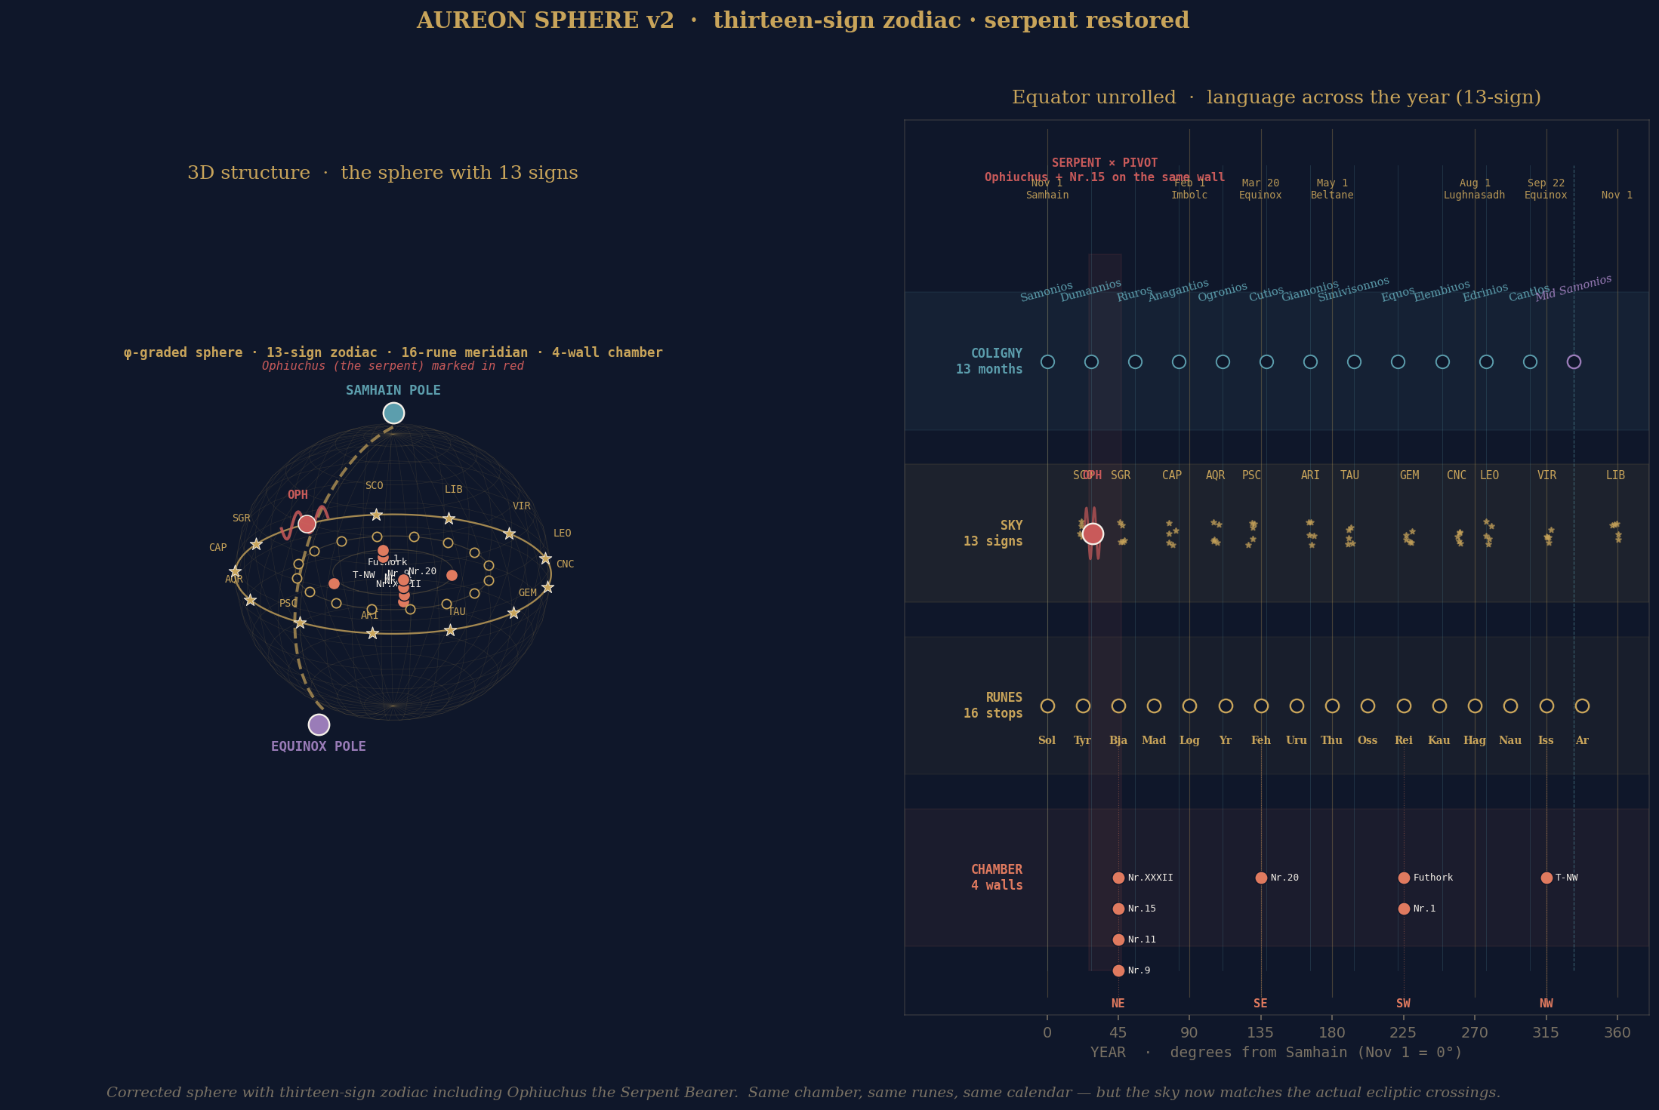
Figure 1. Phi-graded sphere with three concentric shells: chamber inscriptions on the inner shell, rune meridian on the middle shell, thirteen-sign zodiac including Ophiuchus on the outer shell. Two reading-poles connected by a great-circle arc that subtends one-hundred-and-thirty-five degrees, within two percent of an exact phi-squared rotation.

11.2 Three-epoch comparison
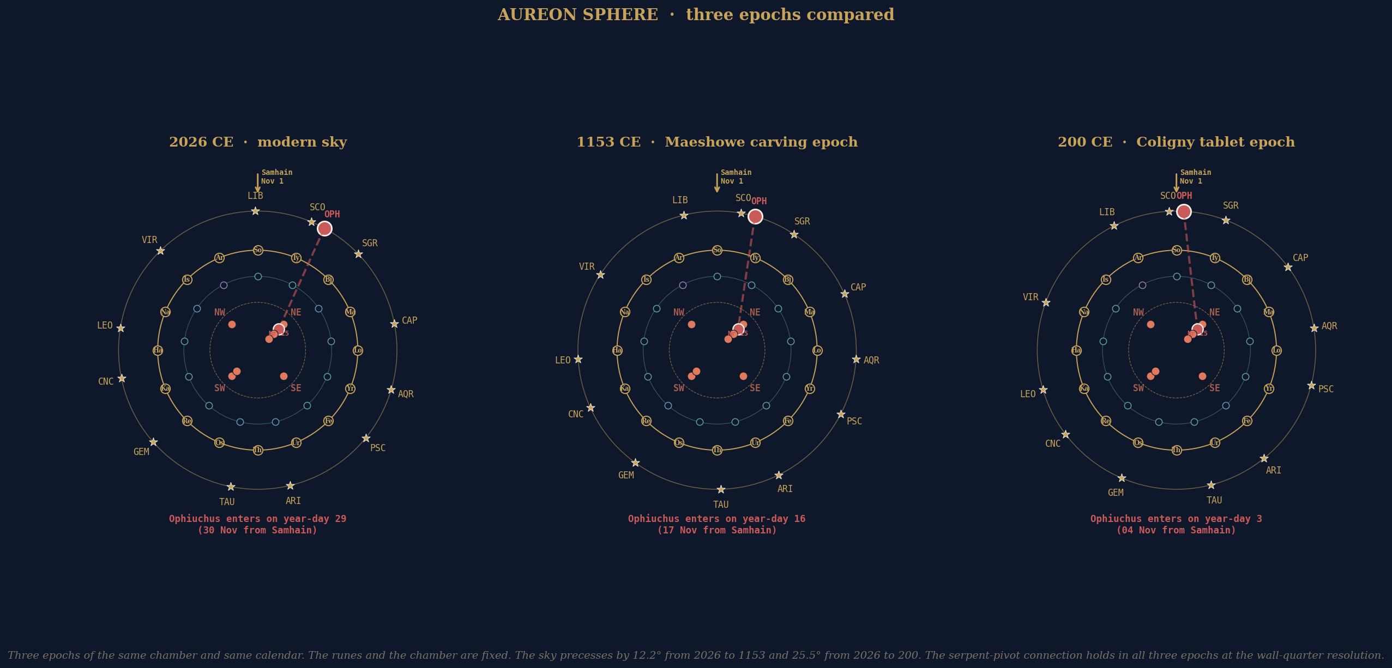
Figure 2. The same chamber and the same calendar across three epochs: 2026 CE (modern), 1153 CE (Maeshowe carving epoch), and 200 CE (Coligny tablet epoch). The serpent-pivot conjunction holds in all three epochs at the wall-quarter resolution. The constellations precess by twenty-five-and-a-half degrees over the full span but no constellation crosses a chamber wall.

11.3 Flower of Life with origami fold
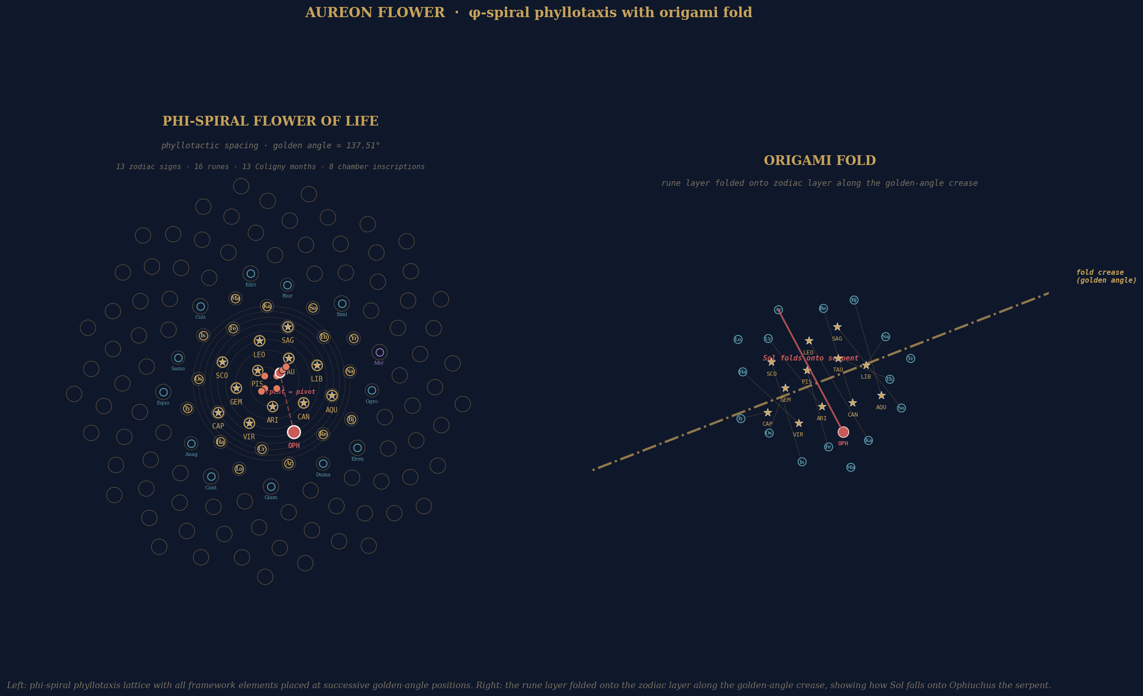
Figure 3. Phyllotactic phi-spiral lattice with all framework elements placed at successive golden-angle positions. Right panel shows the rune layer folded onto the zodiac layer along the golden-angle crease, with Sol falling onto Ophiuchus.

12. Conclusion

The investigation reports two non-trivial findings and a context of documented convergence. The polar light cycle of the Antarctic candidate site at 89.19 south, 110.65 east projects onto the only diagonal of the Maeshowe chamber that connects two single-inscription walls, with first light landing on the treasure pointer T-NW and last light landing on the master carver certification Nr.20. The great-circle bearing from Maeshowe to the Antarctic site lands on adjacent positions in the two surviving alphabets, the third Younger Futhork rune Thurs and the fourth Ogham letter Sail, separated by exactly one substrate-position in a manner consistent with the substrate hypothesis the investigation tests.
Neither finding individually establishes a causal connection between the chamber and the Antarctic site. Together they constitute a pattern that exceeds the chance-rate of independent channels and that warrants the next-stage tests proposed in Section 9. The pattern recognition archaeology methodology produced what it was designed to produce: a multi-channel cross-agreement that exists at the geometric level and that the investigation’s authors did not impose by construction.
The next moves are clear. The south-polar specificity test and the bearing-distribution test are computationally inexpensive and could be run within hours. The Maeshowe Nr.15 RTI access request is a longer-cycle institutional engagement that begins with a formal letter to the Archaeology Data Service at York. The Antarctic site ground-truth is a multi-year institutional engagement that begins with submission of the briefing to British Antarctic Survey or comparable organisations. The Aureon white paper of 29 April 2026 should be uploaded to Academia.edu and the deck should be uploaded to ResearchGate as the consolidating moves that bring the wider corpus into engagement with external readers.
The investigation has produced a defensible interim report. The framework holds. The empirical anchors of the white paper are reproducible. The geometric findings of this investigation are reproducible from the scripts retained in the working environment. The next stage is institutional submission and external review.

Author Note

I am an independent researcher operating without institutional affiliation, working on the Harmonic Nexus Core framework alongside an operational day job at Shannonbridge Power Station in the Republic of Ireland. The framework began as imaginative architecture and was formalised, computed, and tested over the period 2024-2026 in collaboration with AI assistants used as execution tools, with all editorial direction, methodological decisions, and final claims under my own control.
This report is intended as a clean record of where the three-body investigation currently stands: what verifies, what does not, what is open. Readers are invited to reproduce any computational result from the source scripts named in Section 10 and the underlying data described in Section 2. Negative results and counter-arguments are welcome.

GARY LECKEY
Aureon Institute · R&A Consulting and Brokerage Services Ltd
Belfast, Northern Ireland
gaxlec@gmail.com · github.com/RA-CONSULTING · independent.academia.edu/AureonInstitute

