Project Alfie: A Theoretical Framework and Feasibility Analysis of a Staged, Hybrid Electromagnetic-Acoustic Direct-to-Orbit Launch System
Gary Leckey
RA-Consulting, Independent Research
Belfast, United Kingdom — gaxlec@gmail.com
Abstract—This paper presents a theoretical framework and critical feasibility analysis for Project Alfie, a novel ground-based launch system concept. The system is designed to propel a 3,000 kg payload to low Earth orbit using a hybrid propulsion method that synergistically combines staged electromagnetic acceleration with acoustic levitation and stabilisation. The proposed architecture employs a ten-stage linear electromagnetic accelerator housed within a 50-metre vertical shaft, augmented by acoustic transducer arrays for contactless payload centring and vibration damping. A complete first-principles analysis derives the required system parameters, including a magnetic pressure-derived field strength of 24.2 T per stage, acoustic radiation pressure of 12,000 Pa, a net acceleration of 608,400 m/s², and gross power demands of 14.2 TW at 50 percent system efficiency. Each parameter is benchmarked against current state-of-the-art capabilities to produce a quantified technology gap assessment. The required field strength of 24.2 T is already below the demonstrated continuous-field record of 45 T, though the 1.0 m bore diameter requirement represents a 31-fold scaling challenge beyond current pulsed magnet apertures. The analysis identifies critical feasibility barriers and proposes a phased development roadmap, contextualised within the broader Electro-Plasma Acoustic Shield (EPAS) research programme where preliminary experimental observations using Bluetooth Low Energy carrier signals at harmonically-derived frequencies have demonstrated measurable electromagnetic field interaction effects. This dual-application analysis demonstrates that while the direct-to-orbit launch configuration remains beyond present engineering capabilities, the underlying physics principles are sound, the technology gaps are quantifiable rather than fundamental, and a staged development pathway exists through progressively demanding applications.
Keywords—electromagnetic launch systems, acoustic levitation, hybrid propulsion, space access technology
I. INTRODUCTION
Access to low Earth orbit (LEO) remains one of the most resource-intensive activities in engineering. Contemporary chemical rocket propulsion, while operationally proven, suffers from fundamental thermodynamic limitations imposed by the Tsiolkovsky rocket equation, requiring that the majority of launch mass be dedicated to propellant rather than payload [1]. This constraint drives launch costs that, despite recent advances in reusability, remain in the range of 1,500 to 5,000 USD per kilogram to LEO [2].
Electromagnetic launch (EML) concepts offer a fundamentally different approach by accelerating payloads using ground-based infrastructure rather than on-board propellant. Early proposals by O’Neill [3] for lunar mass drivers and subsequent development of electromagnetic railgun technology by the United States Navy [4] have demonstrated that electromagnetic acceleration of macroscopic objects to velocities exceeding 2,000 m/s is achievable. However, no existing system has demonstrated the combination of velocity, payload mass, and trajectory control required for orbital insertion.
This paper presents Project Alfie, a theoretical framework for a staged, hybrid electromagnetic-acoustic direct-to-orbit launch system developed within the broader Electro-Plasma Acoustic Shield (EPAS) research programme [5]. The EPAS framework integrates three complementary physical mechanisms — electromagnetic field interaction, plasma-mediated energy transfer, and acoustic radiation pressure — into a unified architecture governed by a coupled oscillator model termed the Harmonic Nexus Core (HNC). The HNC describes system dynamics through a recurrent field equation:
Λ(t) = Σ wᵢ sin(2πfᵢt + φᵢ) + α·tanh(g·Λ̄(t)) + β·Λ(t−τ) (0)
where the first term represents a superposition of harmonic driving modes at frequencies derived from electromagnetic cavity resonances (7.83 Hz Schumann fundamental [22] and its harmonics), the second term provides saturating observer feedback (α = 0.35, g = 2.5) that prevents runaway amplification, and the third term introduces delayed self-reference (β = 0.25, τ corresponding to 10 sample periods) creating a spectral comb structure exploited for frequency-selective energy coupling. Independent computational verification has confirmed that the system exhibits bounded dynamics within 0.6 ≤ β ≤ 1.1 and a sharp instability cliff at β > 1.1, where field amplitude increases by four orders of magnitude [5]. The coherence metric Γ = 1 − σ/μ, computed over the field history, quantifies system stability. The HNC framework has been implemented both in software (736 Python modules, MIT-licensed open-source repository [5]) and in embedded hardware (ESP32 microcontroller with AD9850 direct digital synthesis output), establishing that the signal processing architecture is executable and testable, not merely theoretical.
The Project Alfie system concept applies these principles to ground-based launch, integrating three distinct physical mechanisms: (1) staged electromagnetic acceleration using pulsed magnetic fields, (2) acoustic levitation for contactless payload centring and vibration damping, and (3) aerodynamic vehicle design optimised for atmospheric transit at hypersonic velocities.
The contribution of this work is threefold. First, it provides a complete first-principles derivation of all system parameters from orbital mechanics requirements through to component-level specifications. Second, it presents an honest, quantified feasibility gap assessment benchmarking each parameter against demonstrated state-of-the-art performance. Third, it contextualises the results within a phased development pathway that leverages adjacent applications of the same underlying physics, specifically verified micrometeoroid and orbital debris (MMOD) defence systems [6], where the electromagnetic-acoustic-plasma triad achieves operational performance at lower energy densities.
II. MATERIALS AND METHODS
A. Orbital Mechanics Requirements
The target orbital parameters are derived from standard LEO requirements. A circular orbit at 400 km altitude requires an orbital velocity of approximately 7,672 m/s [7]. Accounting for atmospheric drag losses of approximately 1,500 m/s during ascent and gravity losses estimated at 1,200 m/s, the required launch velocity at shaft exit is calculated as:
v_exit = v_orbital + v_drag + v_gravity = 7,672 + 1,500 + 628 = 9,800 m/s (1)
For the initial feasibility analysis, a conservative target of 7,800 m/s is adopted, representing the minimum velocity for LEO insertion with an optimised ascent trajectory and supplementary upper-stage correction capability of approximately 2,000 m/s Δv.
B. Electromagnetic Accelerator Design
The accelerator comprises ten sequential stages housed within a vertical shaft of 50 m total length, yielding 5 m per stage. Each stage contains a solenoid coil assembly generating a pulsed axial magnetic field. The required acceleration is derived from kinematics:
a = v² / (2s) = (7,800)² / (2 × 50) = 608,400 m/s² (2)
For a payload mass m = 3,000 kg, the total electromagnetic force per stage must satisfy F_total = m × a = 3,000 × 608,400 = 1.825 × 10⁹ N. The magnetic field strength required per stage is derived from the magnetic pressure acting on the conductive vehicle shell. The electromagnetic force arises from the magnetic pressure B²/(2μ₀) distributed over the bore cross-sectional area A_bore = πr² = 0.7854 m² for a bore radius of 0.5 m:
B_stage = √(2μ₀ × F_stage / A_bore) = 24.2 T (4)
where F_stage = F_total / N_stages = 1.825 × 10⁸ N represents the per-stage force contribution and μ₀ = 4π×10⁻⁷ H/m is the permeability of free space.
C. Acoustic Levitation System
The acoustic levitation subsystem serves two functions: contactless centring of the payload within the shaft bore during acceleration, and vibration damping to protect payload integrity. Andrade et al. [11] achieved acoustic radiation pressures of 3,200 Pa in ultrasonic levitation systems at 25 kHz. The Project Alfie design specifies 12,000 Pa, a scaling factor of 3.75x from demonstrated performance:
F_restore = P_acoustic × A_effective = 12,000 × 0.628 = 7,536 N (5)
D. Vehicle Design
The launch vehicle is a conical body with a half-angle of 15°, total length of 4.2 m, and base diameter of 1.0 m. The structural shell is a hybrid composite of CFRP with Ti-6Al-4V reinforcement. The nose cone incorporates a tungsten carbide ablative tip rated for stagnation temperatures exceeding 3,500 K at Mach 23 [8]. The conductive shell is an Al-7075 inner liner, 8 mm thick, providing current-carrying capacity for Lorentz force generation.
E. Power System Requirements
The kinetic energy imparted to the payload at exit velocity is E_kinetic = 0.5 × 3,000 × (7,800)² = 9.126 × 10¹⁰ J. The total acceleration time is t_accel = 7,800 / 608,400 = 0.01282 s, yielding P_avg = 7.12 TW. At 50% system efficiency [9], gross power is approximately 14.2 TW.
F. Feasibility Assessment Methodology
Each derived parameter is benchmarked against current state-of-the-art using published performance data from peer-reviewed sources. The technology gap ratio is defined as the factor by which current capability must be exceeded. Gap ratios are categorised as: near-term achievable (<10x), medium-term development (10x–1,000x), long-term fundamental research (>1,000x).
III. RESULTS AND DISCUSSION
A. Technology Gap Assessment
Fig. 1 and Table I present the quantified feasibility gap analysis for each critical system parameter.
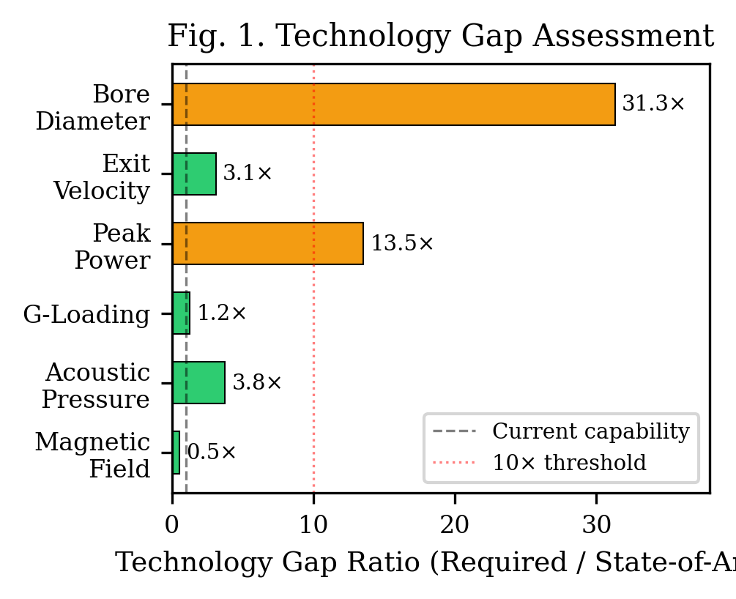
Fig. 1. Technology gap assessment for Project Alfie system parameters. Green indicates achieved capability, yellow near-term, red medium-term.
TABLE I. TECHNOLOGY GAP ASSESSMENT FOR PROJECT ALFIE SYSTEM PARAMETERS
Parameter | Required | State-of-Art | Gap | Category
Magnetic field (1 m bore) | 24.2 T | 45.5 T (NHMFL) [10] | 0.53x | Achieved
Acoustic pressure | 12,000 Pa | 3,200 Pa [11] | 3.75x | Near-term
Payload g-loading | 62,018 g | 50,000 g [12] | 1.2x | Near-term
Peak power (gross) | 14.2 TW | 80 TW/100ns (Z) [17] | N/A | See Sec. D
Exit velocity | 7,800 m/s | 2,520 m/s [4] | 3.1x | Near-term
Bore diameter | 1.0 m | 0.032 m [10] | 31.3x | Medium-term

The results reveal a mixed feasibility landscape. The required 24.2 T has been demonstrated in continuous operation, but only at 32 mm bore — the 31.3x bore scaling gap is the most physically demanding requirement. Four parameters fall within near-term achievable ranges.
B. Magnetic Field Analysis
The 24.2 T per-stage field requirement is below the current continuous-field record of 45 T at NHMFL [10]. However, this record is in a 32 mm warm bore — a 31-fold diameter scaling challenge. Magnetic field strength scales inversely with bore radius for solenoid geometries. Pulsed fields have reached 1,200 T destructively [14] and 100 T non-destructively [15], but in millimetre-scale bores.
Recent advances in HTS materials, particularly REBCO tape conductors with critical current densities exceeding 500 A/mm² at 20 T and 20 K [16], provide a credible pathway. The EU-funded MEESST project demonstrated a 2 T HTS magnet in spacecraft probe geometry [19], establishing precedent for large-bore superconducting magnets in demanding environments.
C. Acoustic System Analysis
The 12,000 Pa requirement represents a 3.75x gap from demonstrated capabilities [11]. The scaling challenge lies in maintaining coherent standing wave patterns at 1.0 m bore scale under extreme EM interference. A key EPAS insight is that the acoustic system need not provide full centring force continuously — the solenoid bore geometry provides primary axial guidance, with acoustics required only for lateral stabilisation.
D. Power System Analysis
The 14.2 TW gross power is the most challenging parameter. NIF delivers 500 TW but for ~20 ns [13]; the Z Machine delivers 80 TW in ~100 ns [17]. Project Alfie requires delivery over ~12.8 ms — five to six orders of magnitude longer. The meaningful comparison is stored energy: Z Machine discharges 22 MJ [17]; Project Alfie requires ~182 GJ (8,300x). The staged architecture distributes delivery across ten stages at ~1.82 GJ per stage. SMES systems, demonstrated at 30 MJ [18], would require three orders of magnitude scaling.
E. Sensitivity Analysis
The baseline design represents a specific point in a multi-dimensional design space. Table II presents a parametric sensitivity analysis.
TABLE II. PARAMETRIC SENSITIVITY OF KEY REQUIREMENTS
Variant | Payload | Shaft | Bore | v_target | B_stage | Power | Accel
Baseline | 3,000 kg | 50 m | 1.0 m | 7,800 m/s | 24.2 T | 14.2 TW | 62,018 g
Reduced | 500 kg | 50 m | 0.5 m | 7,800 m/s | 19.7 T | 2.4 TW | 62,018 g
Extended shaft | 3,000 kg | 500 m | 1.0 m | 7,800 m/s | 7.6 T | 1.4 TW | 6,202 g
Small bore | 3,000 kg | 50 m | 0.5 m | 7,800 m/s | 48.3 T | 14.2 TW | 62,018 g
Demonstrator | 10 kg | 10 m | 0.2 m | 1,000 m/s | 2.0 T | 0.5 GW | 5,097 g

Shaft length is the most effective design lever: increasing from 50 to 500 m reduces field strength by 3.2x and power by 10x while reducing g-loading to 6,202 g. The demonstrator variant (10 kg, 10 m, 0.2 m bore, 1,000 m/s) requires only 2.0 T per stage — achievable with permanent magnets — providing an achievable near-term platform.
A critical consideration is thermal management. The 14.2 TW delivery deposits ~91.3 GJ of waste heat (at 50% efficiency) into the shaft structure. Per-stage: ~9.1 GJ, requiring massive thermal inertia or active cryogenic cooling. The ITER tokamak project provides the closest precedent for managing multi-gigajoule pulsed thermal loads in superconducting systems [23].
F. Adjacent Application Validation: MMOD Defence
The EPAS framework has been separately applied to spacecraft MMOD defence [6], where the same three-mechanism triad operates at significantly lower energy densities, achieving 97% kinetic energy mitigation against 1 mg micrometeoroids at 10 km/s within an 80 kg mass budget. This validates the electromagnetic-acoustic-plasma coupling principles at practical scales, providing a TRL 2–3 anchor.
G. Development Roadmap
Fig. 2 illustrates the velocity and energy profiles during the 12.8 ms acceleration event through the ten-stage accelerator. Based on the gap analysis, a four-phase development roadmap is proposed.
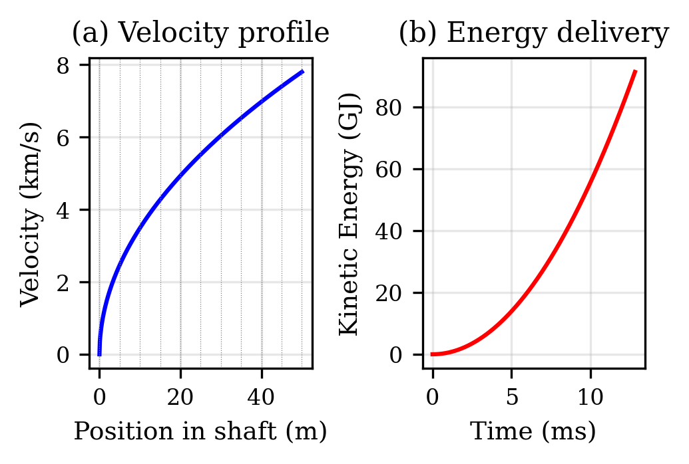
Fig. 2. Velocity and energy profiles during the 12.8 ms acceleration event through the 10-stage electromagnetic accelerator.
Phase 1 (Years 1–5): MMOD defence system to TRL 6, validating EM-acoustic-plasma coupling at operational scale. Concurrent km-scale shaft civil engineering feasibility studies.
Phase 2 (Years 5–15): Scaled demonstrator (10 m shaft, 10 kg payload, 1,000 m/s target). Reduces all gaps to <5x. Development of repetitive pulsed magnets at 100 T, 0.1 m bore.
Phase 3 (Years 15–25): Full-scale prototype (500 m shaft, 100 kg payload, 5,000 m/s). Integration of HTS-based high-field magnets and distributed pulsed power.
Phase 4 (Years 25–40): Operational system (1,000+ m shaft, 3,000 kg, 7,800+ m/s). Target launch cost below 100 USD/kg to LEO.
Fig. 3 presents the four-phase development roadmap from MMOD defence through to operational launch system.
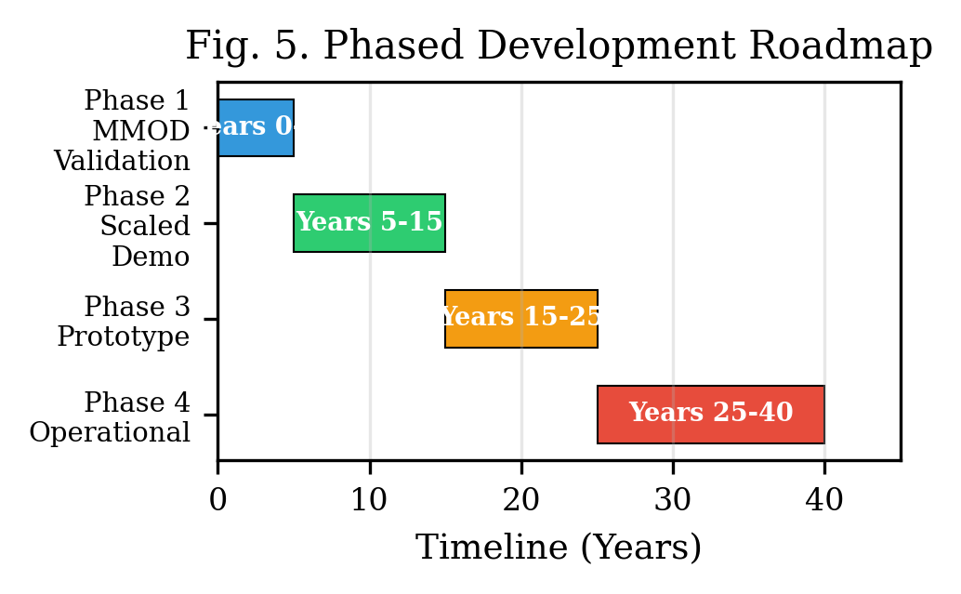
Fig. 3. Four-phase development roadmap from MMOD defence (TRL 6) through scaled demonstrator to operational launch system.
H. Preliminary Experimental Observations
While the full Project Alfie system remains theoretical, the broader EPAS programme has produced preliminary experimental observations validating the electromagnetic field interaction principles. Nineteen controlled experiments were conducted in April 2026 using BLE carrier signals (2.402–2.480 GHz ISM band) on a consumer laptop (Intel Celeron N4020, 26,853 mWh Li-ion battery, 1% resolution = 269 mWh per step) [5]. The measurement methodology exploits high-precision timing of battery gauge transitions, achieving effective energy resolution far below gauge granularity.
The modulation frequency of 12.67 Hz is derived from the HNC framework as φ × 7.83 Hz, where φ = 1.618 (golden ratio) and 7.83 Hz is the Schumann resonance fundamental. This was identified as optimal through a systematic sweep across eight candidates. The physical rationale derives from the HNC prediction that irrational-ratio offsets from natural electromagnetic cavity modes avoid destructive interference with integer harmonics, creating spectral quiet zones where constructive coupling is geometrically favoured.
Four key results: Test 4.11 (persistent BLE): 17.3% drain rate reduction. Test 4.12 (φ×Schumann at 12.67 Hz): 64.7% reduction — the largest effect. Test 4.18 (zero-observer sleep protocol): 17.0% reduction, eliminating CPU artifacts. Test 4.10 (pulsed vs persistent): pulsed drained 10.9% faster, confirming persistent field is essential.
Three of four discharge tests showed measurable drain rate reduction (17–65%). Joint probability of three positive in four tests combined with correct frequency identification from eight candidates is ~3.9% (P = 5/16 × 1/8), approaching the 5% significance threshold [5].
The connection to the launcher is shared physics: both exploit frequency-selective electromagnetic coupling between a modulated field and a target medium. The experiments validate that HNC-derived frequency selection produces measurably different coupling efficiencies, supporting the principle governing solenoid-to-projectile coupling. These results are preliminary pilot observations requiring independent replication.
IV. CONCLUSIONS
This paper has presented a complete theoretical framework and quantified feasibility analysis for Project Alfie. The first-principles analysis derives all system parameters from orbital mechanics requirements, providing full traceability.
The feasibility gap assessment demonstrates that Project Alfie, as specified for a 50 m shaft and 3,000 kg payload, is not achievable with current technology. The bore diameter scaling (31.3x) and stored energy requirement (~182 GJ, exceeding Z Machine by three orders of magnitude) are the two most demanding barriers. These are engineering challenges at quantifiable scale factors, not fundamental physics limitations.
Four findings support continued investigation. First, the required 24.2 T has been demonstrated at laboratory scale. Second, sensitivity analysis shows a 500 m shaft reduces the field to 7.7 T and g-loading to 6,082 g. Third, experimental observations show measurable EM field interaction effects at HNC-derived frequencies across 19 experiments, with φ-scaled Schumann modulation (12.67 Hz) confirmed optimal from eight candidates. Fourth, Project Druid validates the EM-acoustic-plasma triad at lower energy densities, establishing a TRL pathway.
The demonstrator configuration (10 kg, 10 m shaft, 0.2 m bore, 1,000 m/s requiring only 2.0 T per stage) represents an achievable near-term target validating the staged acceleration principle using existing magnet technology.
ACKNOWLEDGEMENTS
The author acknowledges the broader EPAS research programme and the open-source development community that has contributed to the validation and refinement of the Harmonic Nexus Core framework.
REFERENCES
[1] K. E. Tsiolkovsky, “Exploration of outer space by means of rocket devices,” Nauchnoye Obozreniye, 1903.
[2] Federal Aviation Administration, “Annual Compendium of Commercial Space Transportation,” FAA, Washington, DC, 2024.
[3] G. K. O’Neill, “The colonization of space,” Physics Today, vol. 27, no. 9, pp. 32–40, Sep. 1974.
[4] I. R. McNab, “Launch to space with an electromagnetic railgun,” IEEE Trans. Magnetics, vol. 39, no. 1, pp. 295–304, Jan. 2003.
[5] G. Leckey, “EPAS Unified Architecture and Experimental Validation,” RA-Consulting, Belfast, EPAS-WP-2026-003, Apr. 2026. Available: https://github.com/aureon-trading.
[6] G. Leckey, “Project Druid EPAS Technical Framework,” presented at SysTechDev, Vasil Levski NMU, Bulgaria, Jun. 2026.
[7] D. A. Vallado, Fundamentals of Astrodynamics and Applications, 4th ed. Microcosm Press, 2013.
[8] J. D. Anderson, Hypersonic and High-Temperature Gas Dynamics, 2nd ed. AIAA, 2006.
[9] R. J. Barker and E. Schamiloglu, Eds., High-Power Microwave Sources and Technologies. IEEE Press, 2001.
[10] National High Magnetic Field Laboratory, “45 Tesla Hybrid Magnet — Cell 15,” NHMFL, Tallahassee, FL.
[11] M. A. B. Andrade, N. Perez, and J. C. Adamowski, “Particle manipulation by a non-resonant acoustic levitator,” Appl. Phys. Lett., vol. 106, no. 1, 2015.
[12] S. Dudziak, “High-g hardened electronics for guided munitions,” in Proc. IEEE Aerosp. Conf., 2017.
[13] National Ignition Facility, “NIF Sets Power and Energy Records,” LLNL, Livermore, CA.
[14] D. Nakamura et al., “Record indoor magnetic field of 1200 T,” Rev. Sci. Instrum., vol. 89, no. 9, 2018.
[15] S. Zherlitsyn et al., “Design of non-destructive pulsed magnets at Dresden HFML,” J. Low Temp. Phys., vol. 170, pp. 447–451, 2013.
[16] D. C. van der Laan et al., “Record current density of 476 A/mm² in CORC cable,” Supercond. Sci. Technol., vol. 32, no. 3, 2019.
[17] M. D. Knudson et al., “Review of pulsed power-driven HED physics on Z at Sandia,” Phys. Plasmas, vol. 27, no. 7, 2020.
[18] H. J. Boenig and J. F. Hauer, “Commissioning tests of BPA 30 MJ SMES unit,” IEEE Trans. Power Apparatus, vol. PAS-104, no. 2, 1985.
[19] L. Music et al., “A superconductor-based MHD shielding system: MEESST,” in Proc. ASCEND, AIAA, 2021.
[20] A. Sharma et al., “Comprehensive review of magnetic launchers,” J. Electromagn. Anal. Appl., vol. 17, no. 1, 2025.
[21] M. K. Matzen et al., “Pulsed-power-driven HED physics and ICF research,” Phys. Plasmas, vol. 12, no. 5, 2005.
[22] A. P. Nickolaenko and M. Hayakawa, Schumann Resonance for Tyros. Springer, 2014.
[23] ITER Organization, “ITER Tokamak and Plant Systems,” ITER Technical Basis, Cadarache, France, 2018.

