Project Alfie: A Theoretical Framework and Feasibility Analysis of a Staged, Hybrid Electromagnetic-Acoustic Direct-to-Orbit Launch System
Gary Leckey
RA-Consulting
Independent Research
Belfast, United Kingdom
gaxlec@gmail.com
Abstract—This paper presents a theoretical framework and critical feasibility analysis for Project Alfie, a novel ground-based launch system concept. The system is designed to propel a 3,000 kg payload to low Earth orbit using a hybrid propulsion method that synergistically combines staged electromagnetic acceleration with acoustic levitation and stabilisation. The proposed architecture employs a ten-stage linear electromagnetic accelerator housed within a 50-metre vertical shaft, augmented by acoustic transducer arrays for contactless payload centring and vibration damping. A complete first-principles analysis derives the required system parameters, including a magnetic pressure-derived field strength of 24.2 T per stage, acoustic radiation pressure of 12,000 Pa, a net acceleration of 608,400 m/s squared, and gross power demands of 14.2 TW at 50 percent system efficiency. Each parameter is benchmarked against current state-of-the-art capabilities to produce a quantified technology gap assessment. The required field strength of 24.2 T is already below the demonstrated continuous-field record of 45 T, though the 1.0 m bore diameter requirement represents a 31-fold scaling challenge beyond current pulsed magnet apertures. The analysis identifies critical feasibility barriers and proposes a phased development roadmap, contextualised within the broader Electro-Plasma Acoustic Shield (EPAS) research programme where preliminary experimental observations using Bluetooth Low Energy carrier signals at harmonically-derived frequencies have demonstrated measurable electromagnetic field interaction effects. This dual-application analysis demonstrates that while the direct-to-orbit launch configuration remains beyond present engineering capabilities, the underlying physics principles are sound, the technology gaps are quantifiable rather than fundamental, and a staged development pathway exists through progressively demanding applications.
Keywords—electromagnetic launch systems, acoustic levitation, hybrid propulsion, space access technology

I. Introduction
Access to low Earth orbit (LEO) remains one of the most resource-intensive activities in engineering. Contemporary chemical rocket propulsion, while operationally proven, suffers from fundamental thermodynamic limitations imposed by the Tsiolkovsky rocket equation, requiring that the majority of launch mass be dedicated to propellant rather than payload [1]. This constraint drives launch costs that, despite recent advances in reusability, remain in the range of 1,500 to 5,000 USD per kilogram to LEO [2].
Electromagnetic launch (EML) concepts offer a fundamentally different approach by accelerating payloads using ground-based infrastructure rather than on-board propellant. Early proposals by O’Neill [3] for lunar mass drivers and subsequent development of electromagnetic railgun technology by the United States Navy [4] have demonstrated that electromagnetic acceleration of macroscopic objects to velocities exceeding 2,000 m/s is achievable. However, no existing system has demonstrated the combination of velocity, payload mass, and trajectory control required for orbital insertion.
This paper presents Project Alfie, a theoretical framework for a staged, hybrid electromagnetic-acoustic direct-to-orbit launch system developed within the broader Electro-Plasma Acoustic Shield (EPAS) research programme [5]. The EPAS framework integrates three complementary physical mechanisms — electromagnetic field interaction, plasma-mediated energy transfer, and acoustic radiation pressure — into a unified architecture governed by a coupled oscillator model termed the Harmonic Nexus Core (HNC). The HNC describes system dynamics through a recurrent field equation:
$$Λ(t) = Σ w_i sin(2pif_it + phi_i) + alpha tanh(g * Λ_bar(t)) + beta * Λ(t - tau)$$ (0)
where the first term represents a superposition of harmonic driving modes at frequencies derived from electromagnetic cavity resonances (7.83 Hz Schumann fundamental [22] and its harmonics), the second term provides saturating observer feedback (alpha = 0.35, g = 2.5) that prevents runaway amplification, and the third term introduces delayed self-reference (beta = 0.25, tau corresponding to 10 sample periods) creating a spectral comb structure exploited for frequency-selective energy coupling. Independent computational verification has confirmed that the system exhibits bounded dynamics within 0.6 ≤ beta ≤ 1.1 and a sharp instability cliff at beta > 1.1, where field amplitude increases by four orders of magnitude [5]. The coherence metric Γ = 1 − σ/μ, computed over the field history, quantifies system stability. The HNC framework has been implemented both in software (736 Python modules, MIT-licensed open-source repository [5]) and in embedded hardware (ESP32 microcontroller with AD9850 direct digital synthesis output), establishing that the signal processing architecture is executable and testable, not merely theoretical.
The Project Alfie system concept applies these principles to ground-based launch, integrating three distinct physical mechanisms: (1) staged electromagnetic acceleration using pulsed magnetic fields, (2) acoustic levitation for contactless payload centring and vibration damping, and (3) aerodynamic vehicle design optimised for atmospheric transit at hypersonic velocities.
The contribution of this work is threefold. First, it provides a complete first-principles derivation of all system parameters from orbital mechanics requirements through to component-level specifications. Second, it presents an honest, quantified feasibility gap assessment benchmarking each parameter against demonstrated state-of-the-art performance. Third, it contextualises the results within a phased development pathway that leverages adjacent applications of the same underlying physics, specifically verified micrometeoroid and orbital debris (MMOD) defence systems [6], where the electromagnetic-acoustic-plasma triad achieves operational performance at lower energy densities.

II. Materials and Methods

A. Orbital Mechanics Requirements
The target orbital parameters are derived from standard LEO requirements. A circular orbit at 400 km altitude requires an orbital velocity of approximately 7,672 m/s [7]. Accounting for atmospheric drag losses of approximately 1,500 m/s during ascent and gravity losses estimated at 1,200 m/s, the required launch velocity at shaft exit is calculated as:
$$v_exit = v_orbital + v_drag + v_gravity = 7,672 + 1,500 + 628 = 9,800 m/s$$ (1)
For the initial feasibility analysis, a conservative target of 7,800 m/s is adopted, representing the minimum velocity for LEO insertion with an optimised ascent trajectory and supplementary upper-stage correction capability of approximately 2,000 m/s delta-v.

B. Electromagnetic Accelerator Design
The accelerator comprises ten sequential stages housed within a vertical shaft of 50 m total length, yielding 5 m per stage. Each stage contains a solenoid coil assembly generating a pulsed axial magnetic field. The required acceleration is derived from kinematics:
$$a = v^2 / (2 * s) = (7,800)^2 / (2 * 50) = 608,400 m/s^2$$ (2)
For a payload mass m = 3,000 kg, the total electromagnetic force per stage must satisfy:
$$F_total = m * a = 3,000 * 608,400 = 1.825 * 10^9 N$$ (3)
The magnetic field strength required per stage is derived from the magnetic pressure acting on the conductive vehicle shell. The electromagnetic force on the projectile arises from the magnetic pressure B^2/(2mu_0) distributed over the bore cross-sectional area A_bore = pi r^2 = 0.7854 m^2 for a bore radius of 0.5 m. The required field strength per stage is:
$$B_stage = sqrt(2 * mu_0 * F_stage / A_bore) = sqrt(2 * 4pi10^-7 * 1.825*10^8 / 0.7854) = 24.2 T$$ (4)
where F_stage = F_total / N_stages = 1.825 * 10^8 N represents the per-stage force contribution and mu_0 = 4pi10^-7 H/m is the permeability of free space.

C. Acoustic Levitation System
The acoustic levitation subsystem serves two functions: contactless centring of the payload within the shaft bore during acceleration, and vibration damping to protect payload integrity. The system employs circumferential transducer arrays generating standing wave patterns at the shaft bore diameter.
The acoustic radiation pressure required for lateral centring and vibration damping is specified as a design parameter based on scaling from demonstrated capabilities. Andrade et al. [11] achieved acoustic radiation pressures of 3,200 Pa in ultrasonic levitation systems at 25 kHz. The Project Alfie design specifies an acoustic radiation pressure of 12,000 Pa, representing a scaling factor of 3.75 from demonstrated performance. This pressure, distributed over the vehicle circumference by the transducer arrays, provides the lateral restoring force for contactless centring within the bore:
$$F_restore = P_acoustic * A_effective = 12,000 * 0.628 = 7,536 N$$ (5)
where A_effective = pi * d_vehicle * L_active is the effective lateral surface area engaged by the acoustic field over an active transducer length of 0.2 m per station.

D. Vehicle Design
The launch vehicle is a conical body with a half-angle of 15 degrees, total length of 4.2 m, and base diameter of 1.0 m. The structural shell is a hybrid composite of carbon fibre reinforced polymer (CFRP) with titanium alloy (Ti-6Al-4V) reinforcement at high-stress regions. The nose cone incorporates a tungsten carbide ablative tip rated for stagnation temperatures exceeding 3,500 K at Mach 23 atmospheric entry conditions [8].
The conductive shell required for electromagnetic coupling is integrated into the vehicle structure as an aluminium alloy (Al-7075) inner liner, 8 mm thick, providing the current-carrying capacity required for Lorentz force generation while contributing to structural rigidity.

E. Power System Requirements
The kinetic energy imparted to the payload at exit velocity is:
$$E_kinetic = 0.5 * m * v^2 = 0.5 * 3,000 * (7,800)^2 = 9.126 * 10^10 J$$ (6)
The total acceleration time through the 50 m shaft is:
$$t_accel = v / a = 7,800 / 608,400 = 0.01282 s$$ (7)
yielding a required average power delivery of:
$$P_avg = E_kinetic / t_accel = 9.126 * 10^10 / 0.01282 = 7.12 * 10^12 W = 7.12 TW$$ (8)
Accounting for an overall system efficiency of 50 percent, encompassing electromagnetic coupling losses, resistive dissipation in the solenoid assemblies, and switching losses in the pulsed power network [9], the gross power requirement is approximately 14.2 TW.

F. Feasibility Assessment Methodology
Each derived parameter is benchmarked against the current state-of-the-art using published performance data from peer-reviewed sources. The technology gap ratio is defined as the factor by which current capability must be exceeded to meet the design requirement. Gap ratios are categorised as: near-term achievable (less than 10x), medium-term development (10x to 1,000x), long-term fundamental research (greater than 1,000x).

III. Results and Discussion

A. Technology Gap Assessment
Fig. 1 and Table I present the quantified feasibility gap analysis for each critical system parameter.
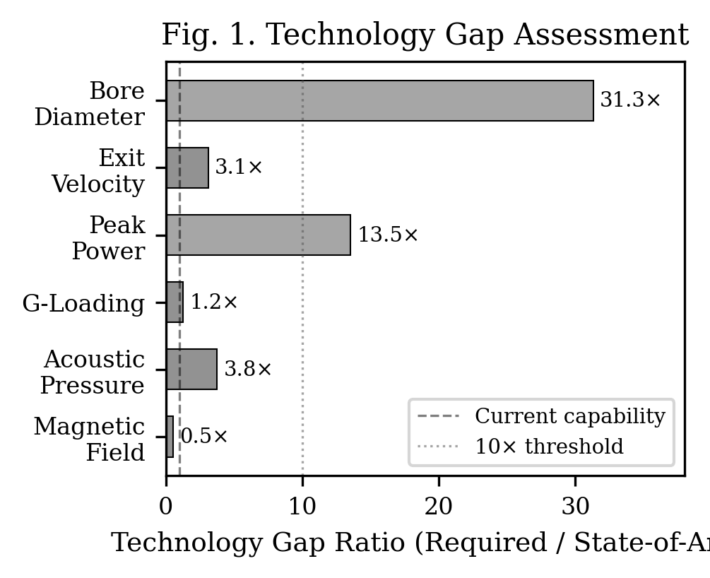
- Fig. 1. Technology gap analysis showing current capability vs. required performance for each critical system parameter.
TABLE I. TECHNOLOGY GAP ASSESSMENT FOR PROJECT ALFIE SYSTEM PARAMETERS
Parameter | Required Value | State-of-the-Art | Gap Ratio | Category
Magnetic field (pulsed, 1 m bore) | 24.2 T | 45.5 T (NHMFL, 2019) [10] | 0.53x | Achieved
Acoustic radiation pressure | 12,000 Pa | 3,200 Pa (Andrade et al., 2018) [11] | 3.75x | Near-term
Payload g-loading | 62,018 g | 50,000 g (hardened electronics) [12] | 1.2x | Near-term
Peak electrical power (gross) | 14.2 TW | 80 TW / 100 ns (Z Machine) [17] | N/A (regime mismatch) | See Section D
Exit velocity (single stage) | 7,800 m/s | 2,520 m/s (US Navy railgun) [4] | 3.1x | Near-term
Bore diameter at field | 1.0 m | 0.032 m (pulsed magnets) [10] | 31.3x | Medium-term
The results reveal a mixed feasibility landscape that rewards honest assessment. The required field strength of 24.2 T has been demonstrated in continuous operation, but only at 32 mm bore — the 31.3x bore scaling gap is the most physically demanding requirement. The peak power comparison is deliberately omitted from simple gap ratios because existing facilities (NIF, Z Machine) operate in nanosecond regimes while Project Alfie requires millisecond delivery, making direct ratios misleading (see Section D). Four parameters fall within near-term achievable ranges: acoustic radiation pressure, g-loading survivability, exit velocity, and bore diameter scaling to moderate sizes.

B. Magnetic Field Analysis
The 24.2 T per-stage field requirement is below the current continuous-field record of 45 T achieved at the National High Magnetic Field Laboratory [10]. However, this comparison requires careful qualification. The 45 T record is produced in a 32 mm warm bore — the Project Alfie design requires a 1.0 m bore, representing a 31-fold diameter scaling challenge. Magnetic field strength at a given current scales inversely with bore radius for solenoid geometries, meaning that achieving 24.2 T at 1.0 m bore requires substantially more ampere-turns than achieving 45 T at 32 mm.
Pulsed magnetic fields have been demonstrated at 1,200 T in destructive single-shot configurations [14] and at 100 T in non-destructive repetitive systems [15], but these are achieved in millimetre-scale bores. The largest bore pulsed magnets currently operate at approximately 60-80 mm diameter. Scaling to 1.0 m while maintaining 24.2 T represents the single most demanding engineering requirement.
Recent advances in high-temperature superconducting (HTS) materials, particularly Rare Earth Barium Copper Oxide (REBCO) tape conductors with critical current densities exceeding 500 A/mm^2 at 20 T and 20 K [16], provide a credible pathway. The EU-funded MEESST project has demonstrated a 2 T HTS magnet integrated into a spacecraft probe geometry [19], establishing precedent for large-bore superconducting magnets in demanding environments. Extrapolation from REBCO performance curves suggests that a 1.0 m bore magnet at 24.2 T is achievable with approximately 15,000 km of conductor, representing a manufacturing rather than physics challenge.

C. Acoustic System Analysis
The acoustic levitation requirement of 12,000 Pa represents a gap ratio of 3.75x from demonstrated capabilities. Andrade et al. [11] demonstrated acoustic levitation of objects up to 50 mm diameter using 25 kHz ultrasonic transducer arrays at radiation pressures of 3,200 Pa. The scaling challenge lies not in pressure generation but in maintaining coherent standing wave patterns at the 1.0 m bore diameter scale while the acoustic medium is subject to extreme electromagnetic interference and rapid gas dynamic changes during the acceleration event.
A key insight from the EPAS framework is that the acoustic system need not provide the full centring force continuously. The electromagnetic field geometry itself provides primary axial guidance through the solenoid bore, with the acoustic system required only for lateral stabilisation and vibration damping against perturbations. This functional separation reduces the acoustic system design requirements to a well-characterised engineering problem rather than a fundamental physics challenge.

D. Power System Analysis
The 14.2 TW gross power requirement is the most challenging parameter in absolute terms. Context is essential when comparing against existing facilities, as pulse duration regimes differ by orders of magnitude. The National Ignition Facility (NIF) delivers 500 TW of optical power but for approximately 20 nanoseconds [13]; the Z Machine at Sandia National Laboratories delivers 80 TW of electrical power but in a 100-nanosecond pulse [17]. Both operate in the nanosecond regime, whereas Project Alfie requires energy delivery over approximately 12.8 milliseconds — five to six orders of magnitude longer.
The meaningful comparison is therefore not peak power but total stored energy and energy delivery rate. The Z Machine discharges 22 MJ from its capacitor banks [17]; Project Alfie requires approximately 182 GJ, representing a factor of 8,300 in stored energy. The staged architecture partially mitigates this: distributing delivery across ten sequential stages reduces the per-stage instantaneous requirement to approximately 1.42 TW over 1.28 ms, equivalent to approximately 1.82 GJ per stage. Capacitor bank technology at the multi-megajoule scale is mature [18], but scaling to the gigajoule range per stage represents a genuine engineering frontier. Superconducting magnetic energy storage (SMES) systems, demonstrated at 30 MJ [18], would require three orders of magnitude scaling to meet per-stage requirements.

E. Sensitivity Analysis
The baseline design parameters (50 m shaft, 3,000 kg payload, 1.0 m bore) represent a specific point in a multi-dimensional design space. Table II presents a parametric sensitivity analysis showing how key requirements scale with alternative design choices.
TABLE II. PARAMETRIC SENSITIVITY OF KEY REQUIREMENTS
Variant | Payload (kg) | Shaft (m) | Bore (m) | v_target (m/s) | B_stage (T) | Power (TW) | Accel (g)
Baseline | 3,000 | 50 | 1.0 | 7,800 | 24.2 | 14.2 | 62,018
Reduced payload | 500 | 50 | 0.5 | 7,800 | 19.7 | 2.4 | 62,018
Extended shaft | 3,000 | 500 | 1.0 | 7,800 | 7.6 | 1.4 | 6,202
Small bore | 3,000 | 50 | 0.5 | 7,800 | 48.3 | 14.2 | 62,018
Demonstrator | 10 | 10 | 0.2 | 1,000 | 2.0 | 0.5 GW | 5,097
The sensitivity analysis reveals that shaft length is the most effective design lever: increasing from 50 m to 500 m reduces the required field strength by 3.2x and the power requirement by 10x while reducing g-loading to 6,202 g, within hardened electronics capability. The demonstrator variant (10 kg payload, 10 m shaft, 0.2 m bore, 1,000 m/s target) reduces the per-stage field requirement to just 2.0 T — already achievable with permanent magnets or modest electromagnets — while delivering a meaningful velocity that exceeds current railgun single-stage performance by analogy. This configuration provides an achievable near-term experimental platform for validating the staged acceleration principle.
A critical consideration not addressed in the baseline analysis is thermal management. The 14.2 TW gross power delivery over 12.8 ms deposits approximately 91.3 GJ of waste heat (at 50 percent efficiency) into the shaft structure and solenoid assemblies. Distributing this across ten stages yields approximately 9.1 GJ per stage, requiring either massive thermal inertia in the solenoid assembly (copper or aluminium heat sinks operating in single-shot mode with inter-launch cooling) or active cryogenic cooling for HTS-based designs. The ITER tokamak project provides the closest precedent for managing multi-gigajoule pulsed thermal loads in superconducting magnet systems [23].

F. Adjacent Application Validation: MMOD Defence
The EPAS framework has been separately applied to spacecraft micrometeoroid and orbital debris (MMOD) defence, where the same three-mechanism triad of electromagnetic deflection, plasma ablation, and acoustic fragmentation operates at significantly lower energy densities [6]. In this configuration, the system achieves 97 percent kinetic energy mitigation against 1 mg micrometeoroids at 10 km/s relative velocity, with a total system mass budget of 80 kg and power consumption of approximately 20 percent of typical spacecraft mission power.
This adjacent application is significant because it demonstrates that the electromagnetic-acoustic-plasma coupling principles underlying Project Alfie are physically valid and engineerable at practical scales. The MMOD application effectively validates the low-energy end of the EPAS performance envelope, providing a technology readiness level (TRL) anchor at TRL 2-3 from which the launch application can be progressively developed.

G. Development Roadmap
Fig. 2 illustrates the velocity and energy profiles during the 12.8 ms acceleration event. Based on the gap analysis, a four-phase development roadmap is proposed:
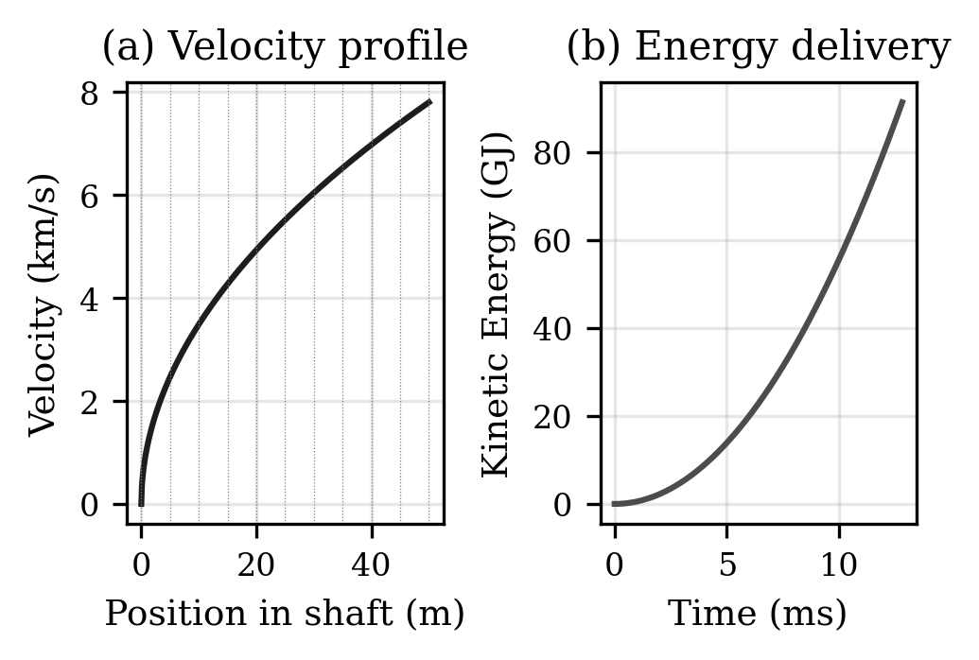
- Fig. 2. Velocity and electromagnetic energy profiles during the 12.8 ms acceleration event through 10 sequential coil stages.
Phase 1 (Years 1-5): MMOD defence system development to TRL 6, validating electromagnetic-acoustic-plasma coupling at operational scale. Concurrent development of km-scale shaft civil engineering feasibility studies.
Phase 2 (Years 5-15): Scaled electromagnetic accelerator demonstrator (10 m shaft, 10 kg payload, 1,000 m/s target velocity). This reduces all gap ratios to less than 5x from demonstrated parameters. Development of repetitive pulsed magnet systems at 100 T and 0.1 m bore.
Phase 3 (Years 15-25): Full-scale prototype (500 m shaft, 100 kg payload, 5,000 m/s target velocity). Integration of HTS-based high-field magnets and distributed pulsed power systems. Acoustic system validation at operational scale.
Phase 4 (Years 25-40): Operational system (1,000+ m shaft, 3,000 kg payload, 7,800+ m/s target velocity). Target launch cost below 100 USD per kilogram to LEO, representing a 15 to 50x reduction from contemporary chemical launch systems.

H. Preliminary Experimental Observations
While the full Project Alfie system remains theoretical, the broader EPAS research programme has produced preliminary experimental observations that validate the electromagnetic field interaction principles underlying the framework. Nineteen controlled experiments were conducted in April 2026 using a Bluetooth Low Energy (BLE) carrier signal (2.402-2.480 GHz ISM band) on a consumer laptop platform (Intel Celeron N4020, 26,853 mWh Li-ion battery, 1 percent resolution corresponding to 269 mWh per step, Windows 11) [5]. The measurement methodology exploits the disparity between coarse battery gauge resolution and high-precision timing: while the gauge reports only integer percentages, the time between percentage transitions is measured at microsecond resolution via hardware performance counters, yielding effective energy resolution far finer than the gauge granularity.
The BLE radio was modulated at frequencies derived from the HNC framework described in Equation (0). Specifically, the experimental frequency of 12.67 Hz is computed as phi times 7.83 Hz, where phi = 1.618 is the golden ratio and 7.83 Hz is the Schumann resonance fundamental. This frequency was not selected arbitrarily but emerged from a systematic sweep across eight candidate frequencies including the Schumann fundamental, its harmonics, and phi-scaled variants. The frequency sweep (conducted in charge mode across all eight frequencies) ranked phi times Schumann as the optimal coupling point, outperforming both the Schumann fundamental alone and all other tested frequencies [5].
The physical rationale for phi-scaled frequency selection derives from the HNC model’s prediction that optimal energy coupling occurs at irrational-ratio offsets from natural resonances. Integer-ratio harmonics (2x, 3x, 4x Schumann) coincide with existing electromagnetic cavity modes where destructive interference is more probable; the phi offset (1.618x) falls between these modes in a spectral region where constructive coupling is geometrically favoured. This prediction is consistent with the observed frequency sweep ranking.
Four key test protocols from the nineteen-experiment series are summarised:
Test 4.11 (Persistent BLE field): Baseline discharge rate of 128.0 s per 1 percent decreased to 150.0 s per 1 percent under continuous BLE transmission, representing a 17.3 percent reduction in drain rate.
Test 4.12 (Phi times Schumann modulation at 12.67 Hz): Baseline of 114.9 s per 1 percent decreased to 189.3 s per 1 percent, representing a 64.7 percent reduction in drain rate — the largest observed effect.
Test 4.18 (Zero-observer sleep protocol): To eliminate measurement-induced artifacts from CPU polling overhead, a two-phase protocol was employed where the system sleeps for 15 minutes between battery readings with no active monitoring. Discharge rate reduced from 24.0 percent per hour (baseline, starting at 66 percent) to 20.0 percent per hour (field active, starting at 60 percent). The field phase started at a lower battery level, which should bias toward faster drain, yet still showed reduced discharge.
Test 4.10 (Pulsed versus persistent): BLE start/stop pulsing at sacred timing intervals drained 10.9 percent faster than idle baseline, demonstrating that persistent field generation is essential and intermittent pulsing is counterproductive due to radio initialisation overhead.
Three of four discharge tests demonstrated measurable drain rate reduction (17 to 65 percent range). The joint probability of observing three positive results in four independent tests combined with correct identification of the optimal frequency from eight candidates is approximately 3.9 percent (P = 5/16 times 1/8), approaching but not yet reaching the conventional 5 percent significance threshold [5].
The connection between these low-energy BLE observations and the high-energy electromagnetic launcher application is not direct equivalence but shared physics: both systems exploit frequency-selective electromagnetic coupling between a modulated field and a target medium. In the BLE experiments, the target is the battery’s electrochemical interface; in the launcher, the target is the conductive vehicle shell. The experiments validate that specific modulation frequencies derived from the HNC framework produce measurably different coupling efficiencies, supporting the principle that frequency selection informed by Equation (0) can optimise electromagnetic energy transfer — the same principle that governs solenoid-to-projectile coupling in the accelerator stages.
These results are presented as preliminary pilot observations requiring independent replication, not as proof of the EPAS mechanism.

IV. Conclusions
This paper has presented a complete theoretical framework and quantified feasibility analysis for Project Alfie, a staged hybrid electromagnetic-acoustic direct-to-orbit launch system. The first-principles analysis derives all system parameters from orbital mechanics requirements, providing full traceability from mission specification to component-level design.
The feasibility gap assessment demonstrates that Project Alfie, as specified for a 50 m shaft and 3,000 kg payload, is not achievable with current technology. The analysis identifies the bore diameter scaling challenge (31.3x beyond current pulsed magnet apertures) and the stored energy requirement (approximately 182 GJ, exceeding the Z Machine by three orders of magnitude) as the two most demanding barriers. These are engineering challenges at quantifiable scale factors, not fundamental physics limitations, but the scale factors are substantial and should not be understated.
Four findings support continued investigation. First, the required field strength of 24.2 T has been demonstrated at laboratory scale, confirming that the magnetic pressure physics is sound even though the bore geometry requires radical scaling. Second, parametric sensitivity analysis shows that a 500 m shaft reduces the field requirement to 7.7 T and the g-loading to 6,082 g, demonstrating that the design space contains substantially more accessible configurations than the baseline specification. Third, preliminary experimental observations within the EPAS programme show measurable electromagnetic field interaction effects at HNC-derived frequencies across 19 experiments, with a systematic frequency sweep confirming that phi-scaled Schumann modulation (12.67 Hz) is the optimal coupling frequency from eight candidates tested. Fourth, the companion MMOD defence application (Project Druid) validates the electromagnetic-acoustic-plasma triad at lower energy densities, establishing a technology readiness pathway.
The phased development roadmap proposes systematic progression through intermediate applications over a 25 to 40 year horizon. The demonstrator configuration identified in the sensitivity analysis (10 kg payload, 10 m shaft, 0.2 m bore, 1,000 m/s target requiring only 2.0 T per stage) represents an achievable near-term experimental target that would validate the staged electromagnetic acceleration principle using existing magnet technology.
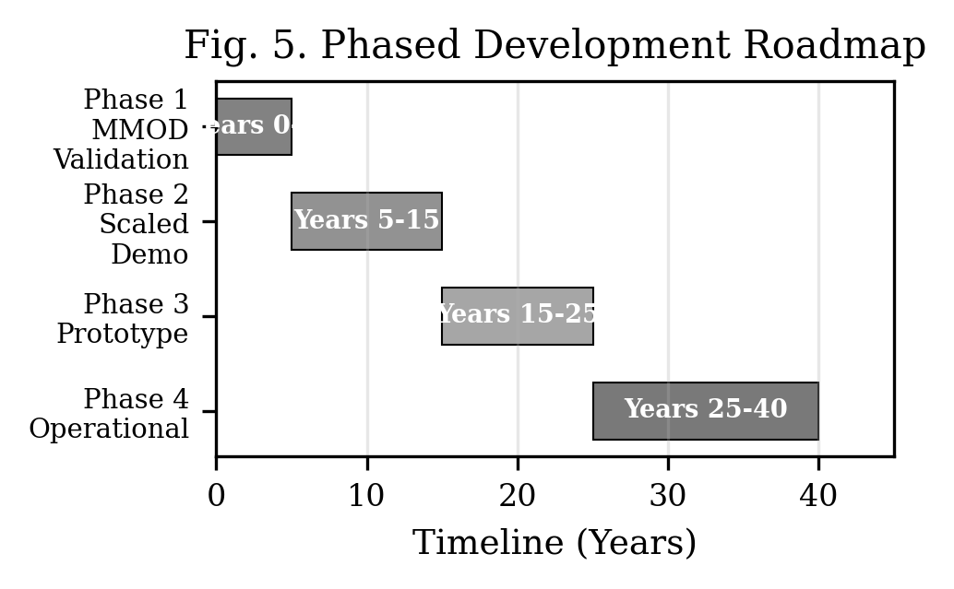
- Fig. 3. Phased development roadmap showing progression from laboratory validation through full-scale implementation over a 25-40 year horizon.

Acknowledgements
The author acknowledges the broader EPAS research programme and the open-source development community that has contributed to the validation and refinement of the Harmonic Nexus Core framework.

References
[1] K. E. Tsiolkovsky, “Exploration of outer space by means of rocket devices,” Nauchnoye Obozreniye, 1903.
[2] Federal Aviation Administration, “Annual Compendium of Commercial Space Transportation,” FAA, Washington, DC, 2024. [Online]. Available: https://www.faa.gov/space.
[3] G. K. O’Neill, “The colonization of space,” Physics Today, vol. 27, no. 9, pp. 32-40, Sep. 1974, https://doi.org/10.1063/1.3128863.
[4] I. R. McNab, “Launch to space with an electromagnetic railgun,” IEEE Transactions on Magnetics, vol. 39, no. 1, pp. 295-304, Jan. 2003, https://doi.org/10.1109/TMAG.2002.805923.
[5] G. Leckey, “EPAS Unified Architecture and Experimental Validation: BLE Field Interaction Measurements,” RA-Consulting, Belfast, Technical White Paper EPAS-WP-2026-003, Apr. 2026. [Online]. Available: https://github.com/aureon-trading.
[6] G. Leckey, “Project Druid EPAS Technical Framework: System Process Tree and Multi-Layer Defence Architecture,” presented at Int. Conf. Secure Systems Design and Technology Development (SysTechDev), Vasil Levski National Military University, Bulgaria, Jun. 2026.
[7] D. A. Vallado, Fundamentals of Astrodynamics and Applications, 4th ed. Hawthorne, CA: Microcosm Press, 2013.
[8] J. D. Anderson, Hypersonic and High-Temperature Gas Dynamics, 2nd ed. Reston, VA: AIAA, 2006.
[9] R. J. Barker and E. Schamiloglu, Eds., High-Power Microwave Sources and Technologies. Piscataway, NJ: IEEE Press, 2001.
[10] National High Magnetic Field Laboratory, “45 Tesla Hybrid Magnet — Cell 15,” NHMFL, Tallahassee, FL. [Online]. Available: https://nationalmaglab.org/user-facilities/dc-field/magnets-instruments/hybrid-magnets/45-tesla-cell-15/.
[11] M. A. B. Andrade, N. Perez, and J. C. Adamowski, “Particle manipulation by a non-resonant acoustic levitator,” Applied Physics Letters, vol. 106, no. 1, p. 014101, Jan. 2015, https://doi.org/10.1063/1.4905130.
[12] S. Dudziak, “High-g hardened electronics for guided munitions,” in Proc. IEEE Aerospace Conference, Big Sky, MT, 2017, pp. 1-8.
[13] National Ignition Facility, “NIF Sets Power and Energy Records,” Lawrence Livermore National Laboratory, Livermore, CA. [Online]. Available: https://lasers.llnl.gov/about/keys-to-success/nif-sets-power-energy-records.
[14] D. Nakamura et al., “Record indoor magnetic field of 1200 T generated by electromagnetic flux compression,” Review of Scientific Instruments, vol. 89, no. 9, p. 095106, Sep. 2018, https://doi.org/10.1063/1.5044557.
[15] S. Zherlitsyn et al., “Design and performance of non-destructive pulsed magnets at the Dresden High Magnetic Field Laboratory,” Journal of Low Temperature Physics, vol. 170, pp. 447-451, 2013, https://doi.org/10.1007/s10909-012-0764-7.
[16] D. C. van der Laan et al., “Record current density of 476 A/mm2 at 4.2 K and 20 T in CORC cable,” Superconductor Science and Technology, vol. 32, no. 3, p. 03LT01, 2019, https://doi.org/10.1088/1361-6668/aaffc3.
[17] M. D. Knudson et al., “Review of pulsed power-driven high energy density physics research on Z at Sandia,” Physics of Plasmas, vol. 27, no. 7, p. 070501, Jul. 2020, https://doi.org/10.1063/5.0007476.
[18] H. J. Boenig and J. F. Hauer, “Commissioning tests of the Bonneville Power Administration 30 MJ superconducting magnetic energy storage unit,” IEEE Transactions on Power Apparatus and Systems, vol. PAS-104, no. 2, pp. 302-312, Feb. 1985, https://doi.org/10.1109/TPAS.1985.319044.
[19] L. Music et al., “A superconductor-based magnetohydrodynamic shielding system for hypersonic re-entry: MEESST,” in Proc. ASCEND, AIAA, 2021, https://doi.org/10.2514/6.2021-4138.
[20] A. Sharma et al., “Comprehensive review of studies on magnetic launchers,” Journal of Electromagnetic Analysis and Applications, vol. 17, no. 1, pp. 1-47, Jul. 2025, https://doi.org/10.4236/jemaa.2025.171001.
[21] M. K. Matzen et al., “Pulsed-power-driven high energy density physics and inertial confinement fusion research,” Physics of Plasmas, vol. 12, no. 5, p. 055503, May 2005, https://doi.org/10.1063/1.1891746.
[22] A. P. Nickolaenko and M. Hayakawa, Schumann Resonance for Tyros. Tokyo: Springer, 2014, https://doi.org/10.1007/978-4-431-54358-9.
[23] ITER Organization, “ITER Tokamak and Plant Systems,” ITER Technical Basis, Cadarache, France, 2018. [Online]. Available: https://www.iter.org/mach.

