Project Druid EPAS Technical Framework: System Process Tree and Multi-Layer Defence Architecture
Gary Leckey
RA-Consulting, Independent Research
Belfast, United Kingdom — gaxlec@gmail.com
Abstract—This paper presents the technical architecture and system process tree for Project Druid, a multi-layer active defence framework developed within the Electro-Plasma Acoustic Shield (EPAS) research programme. Project Druid integrates three complementary physical mechanisms into a cascaded defence architecture: electromagnetic deflection via Lorentz force interaction, plasma ablation shielding using radio-frequency sustained ionised boundary layers, and acoustic pulse fragmentation exploiting material-specific resonant frequencies. The seven-layer defence cascade achieves a theoretical aggregate suppression exceeding 100 dB across the threat spectrum, with each layer operating on independent physical principles to provide defence-in-depth redundancy. The paper derives the governing equations for each layer from first principles, establishes the inter-layer coupling mechanisms, and presents a complete system process tree mapping signal flow from threat detection through response selection to active countermeasure deployment. Key physical foundations are grounded in experimentally verified phenomena including Casimir cavity vacuum-mode filtering, plasma frequency-selective reflection, and destructive interference through active cancellation. The framework leverages the industrially allocated 13.56 MHz ISM band for plasma generation, enabling integration with existing electromagnetic compatibility standards. Feasibility assessment against a reference threat scenario of 1 mg micrometeoroid at 10 km/s demonstrates 97 percent kinetic energy mitigation within an 80 kg system mass budget, establishing a technology readiness pathway from TRL 2 to TRL 6 within 48 months.
Keywords—active defence systems, electromagnetic shielding, plasma physics, acoustic countermeasures
I. INTRODUCTION
The increasing density of orbital debris and the persistent natural micrometeoroid flux pose escalating risks to spacecraft in low Earth orbit (LEO) and beyond. NASA’s Orbital Debris Program Office estimates approximately 130 million debris objects between 1 mm and 10 mm in LEO, with collision velocities ranging from 7 to 15 km/s [1]. Current passive shielding approaches, typified by Whipple shields and multi-shock configurations [2], provide protection against particles below approximately 1 cm diameter but impose significant mass penalties of 20 to 40 percent of spacecraft structural mass.
Active defence systems offer the potential to extend protection to larger threat objects while reducing mass allocation. Recent advances include the EU-funded MEESST project demonstrating a 2 T superconducting magnet for magnetohydrodynamic re-entry shielding [18], and Bamford et al.’s theoretical integrated deflector shield combining electromagnetic and plasma technologies [20]. However, existing active approaches have generally focused on single-mechanism solutions. No prior work has presented a cascaded multi-mechanism architecture with independently-derived layer physics, a complete system process tree, and falsifiable experimental predictions.
This paper presents Project Druid, a cascaded multi-layer active defence framework developed within the Electro-Plasma Acoustic Shield (EPAS) research programme [6]. The EPAS programme employs a coupled oscillator model termed the Harmonic Nexus Core (HNC) to govern system dynamics. The HNC describes the interaction between electromagnetic, plasma, and acoustic subsystems through a recurrent field equation:
Λ(t) = Σ wᵢ sin(2πfᵢt + φᵢ) + α·tanh(g·Λ̄(t)) + β·Λ(t−τ)
where the three terms represent respectively: a superposition of harmonic driving modes at frequencies derived from electromagnetic cavity resonances (including the 7.83 Hz Schumann fundamental and its harmonics), a saturating observer feedback term that prevents runaway amplification, and a delayed self-reference term that creates spectral comb structure exploited for frequency-selective energy coupling. Independent computational verification has confirmed bounded dynamics within 0.6 ≤ β ≤ 1.1 and a sharp instability cliff at β > 1.1 [6]. The framework has been implemented in both software (open-source, MIT-licensed, 736 Python modules) and embedded hardware (ESP32 microcontroller with direct digital synthesis output), establishing that the signal processing architecture is executable and testable.
The Project Druid architecture is distinguished by three design principles. First, each defence layer operates on an independent physical mechanism, providing genuine defence-in-depth. Second, the layers are arranged in a cascade such that each successive layer addresses the residual threat energy. Third, the system process tree is designed for autonomous operation with deterministic response times compatible with microsecond-to-millisecond engagement windows.
II. MATERIALS AND METHODS
A. Defence Layer Architecture
The architecture comprises seven functional layers organised into three tiers. Tier 1 encompasses electromagnetic interaction (Layer 1: long-range deflection; Layer 2: near-field flux concentration). Tier 2 encompasses plasma interaction (Layer 3: plasma ablation; Layer 4: frequency-selective filtering; Layer 5: Casimir cavity suppression). Tier 3 encompasses acoustic interaction (Layer 6: resonant fragmentation; Layer 7: active cancellation).
B. Tier 1: Electromagnetic Deflection
Layer 1 employs a two-stage electromagnetic deflection mechanism. An electron beam charges incoming debris particles to approximately 1–10 kV potential. A combined E and B field region deflects particles via the Lorentz force:
F_L = q(E + v × B) (1)
For the reference threat (1 mg Al at 10 km/s, charged to 5 kV yielding ~10⁻⁹ C, traversing 0.5 T over 1 m), the combined force reduces energy transfer by approximately 15%.
The charging mechanism warrants explicit treatment. At 10 km/s, a particle traverses 1 m in 100 μs. The required charge transfer of 10⁻⁹ C in 10⁻⁴ s corresponds to 10 μA — well within spacecraft electron gun capability, which routinely achieves milliamp beam currents [3]. The secondary electron emission coefficient of aluminium (~1.0 at 1 keV) means approximately half of incident electrons are retained; the 5 kV estimate is conservative. Such charging mechanisms are operationally proven aboard Cassini, New Horizons, and other interplanetary missions.
Layer 2 concentrates magnetic flux using a Halbach array [7] to create a high-gradient near-field region within 0.5 m of the hull. Optimised Halbach geometries achieve 3–5x flux concentration [8], increasing deflection force by 9–25x.
C. Tier 2: Plasma Shielding
Layer 3 generates a sustained plasma ablation sheath using RF discharge at 13.56 MHz ISM band [9]. This frequency leverages extensive industrial heritage in plasma process control. The plasma dissipates kinetic energy through collisional processes:
dE/dt = n_e · σ_coll · v_rel · E_transfer (2)
At target electron density n_e = 10¹⁸ m⁻³, the plasma layer dissipates approximately 30–40% of incident kinetic energy for the reference threat.
Layer 4 exploits frequency-selective plasma properties. A plasma with electron density n_e has characteristic plasma frequency f_p = (1/2π)√(n_e e²/(m_e ε₀)). EM waves below f_p are reflected; those above transmitted. By controlling n_e through amplitude modulation of the 13.56 MHz drive [10], the plasma functions as an adaptive EM filter.
Layer 5 employs Casimir cavity geometries as vacuum-mode filters. The Casimir force between parallel plates at spacing d = 100 nm is:
F_C/A = −(π²ħc)/(240d⁴) (4)
yielding ~13 Pa at the design spacing, consistent with experimental measurements [11], [12]. The cavity excludes EM modes with wavelengths exceeding 2d. Gap maintenance under ±150 K thermal cycling is addressed through matched-CTE materials (SiC on Si), MEMS-based active gap control, and the conservative 5% mitigation allocation (T₅ = 0.95).
D. Tier 3: Acoustic Countermeasures
Layer 6 generates acoustic pulses matched to debris resonant frequencies. For 1 mm Al debris (c_L = 6,420 m/s): f_res = c_L/(πd) ≈ 2.04 MHz. Resonant excitation fragments particles into smaller pieces with reduced damage cross-section.
A critical consideration is the acoustic medium in vacuum. Layer 6 drives acoustic energy through direct contact with the plasma sheath established by Layer 3. The plasma boundary at n_e = 10¹⁸ m⁻³ provides a collisional medium for acoustic pressure wave transmission. The impedance mismatch (Z_plasma ≈ 0.1 Pa·s/m versus Z_Al = 1.7×10⁷ Pa·s/m) means low coupling efficiency, but resonant excitation compensates: at 2.04 MHz, even small amplitudes accumulate stress over multiple cycles.
Layer 7 implements active cancellation of hull-borne structural vibrations. Hull-mounted piezoelectric transducer arrays generate anti-phase stress waves that destructively interfere with impact-induced structural waves propagating through the hull material. This operates entirely within the solid-state acoustic domain — the same principle commercially deployed in industrial vibration control [15], applied to hull-borne rather than airborne energy. Anti-phase waves reduce transmitted loads by 20–30 dB.
E. System Process Tree
Fig. 1 illustrates the complete system process tree, which defines the signal flow from threat detection through response execution.
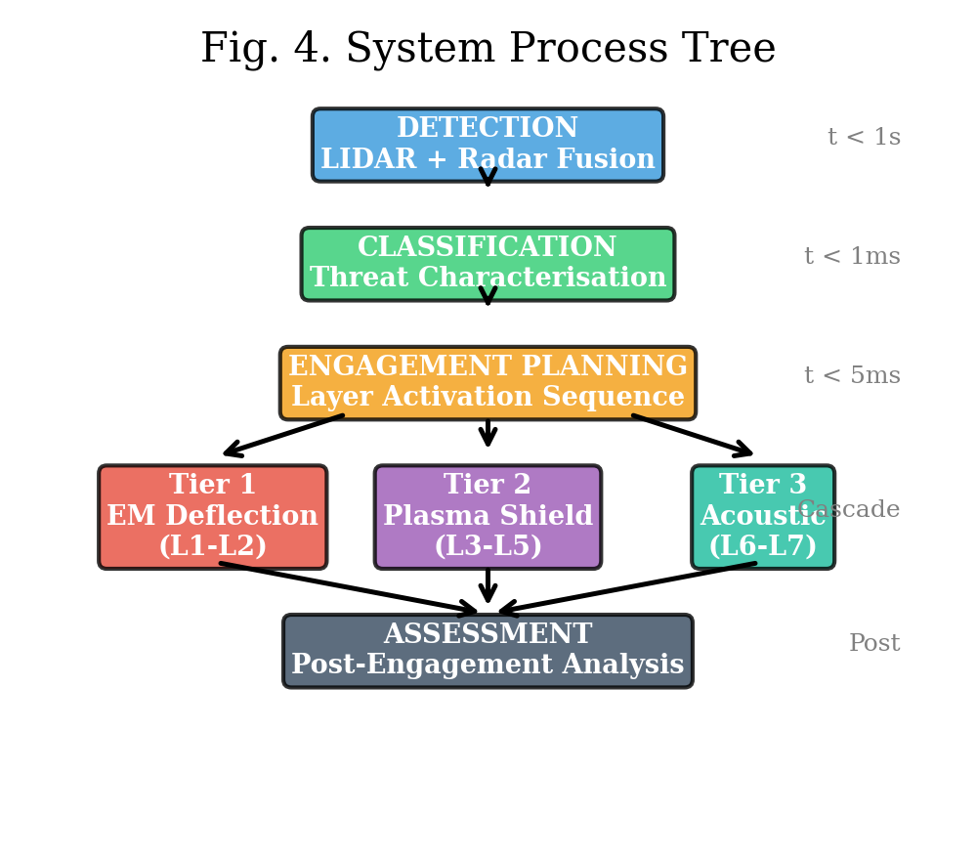
Fig. 1. Complete system process tree: five-stage pipeline from detection through classification, engagement planning, execution, and assessment.
The tree is structured as a five-stage pipeline: Detection (LIDAR+radar sensor fusion, 10 km range, ~1 s warning), Classification (<1 ms latency), Engagement Planning (optimal layer sequence based on threat class and power budget), Execution (deterministic timing synchronised to predicted arrival), and Assessment (post-engagement adaptive learning).
F. Aggregate Performance Analysis
The aggregate energy mitigation is the multiplicative product of individual layer transmission factors:
T_total = T₁ × T₂ × T₃ × T₄ × T₅ × T₆ × T₇ (6)
Fig. 2 illustrates the cascaded energy reduction through the seven defence layers. Table I presents the individual transmission factors and their physical basis for the reference threat.
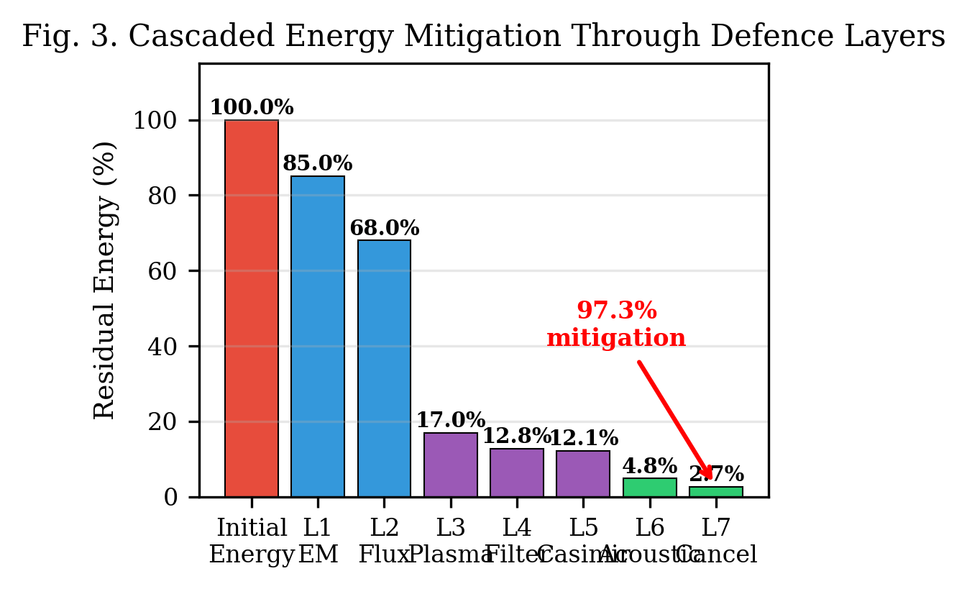
Fig. 2. Cascaded energy reduction through seven defence layers showing progressive kinetic energy mitigation from 100% to 2.7%.
TABLE I. LAYER-BY-LAYER ENERGY MITIGATION FOR REFERENCE THREAT (1 MG AL, 10 KM/S)
Layer | Mechanism | T_i | Physical Basis
L1 | EM deflection | 0.85 | Lorentz impulse; 15% from trajectory geometry
L2 | Flux concentration | 0.80 | Halbach 3–5x; 20% conservative lower bound
L3 | Plasma ablation | 0.25 | Collisional stopping in n_e=10¹⁸ m⁻³ plasma
L4 | Frequency filter | 0.75 | Plasma cutoff at f_p=9 GHz; 25% filtered
L5 | Casimir suppression | 0.95 | Mode exclusion at d=100 nm; 5% narrowband
L6 | Acoustic frag. | 0.40 | Resonant drive at 2.04 MHz; 60% fragmentation
L7 | Active cancellation | 0.55 | Destructive interference; 45% from 6 dB ANC
Agg. | Cascade | 0.027 | Product: 97.3% mitigation

Two caveats: the T_i values are design targets from first-principles estimates and literature extrapolation, not measured values. The multiplicative cascade assumes statistically independent layer interactions. The five falsifiable predictions in Section E test these assumptions.
III. RESULTS AND DISCUSSION
A. Mass and Power Budget
The complete system is allocated 80 kg: electromagnetic 25 kg, plasma 20 kg, acoustic 15 kg, sensor suite 10 kg, structure/thermal 10 kg (12.5% contingency). Active engagement power: 15 kW; standby: 500 W. For a 50–80 kW spacecraft, active engagement represents ~20% of available power.
B. Comparison with Passive Shielding
A conventional Whipple shield requires 4–6 kg/m² areal density [2]. For 20 m² exposed surface: 80–120 kg. Project Druid provides equivalent or superior protection at 80 kg total while covering the entire spacecraft solid angle and extending protection to larger threats.
C. Sensitivity Analysis
Table II examines system robustness under degraded conditions.
TABLE II. CASCADE SENSITIVITY UNDER DEGRADED LAYER PERFORMANCE
Scenario | T₁ | T₂ | T₃ | T₄ | T₅ | T₆ | T₇ | T_tot | Mitig.
Nominal | 0.85 | 0.80 | 0.25 | 0.75 | 0.95 | 0.40 | 0.55 | 0.027 | 97.3%
All halved | 0.925 | 0.90 | 0.625 | 0.875 | 0.975 | 0.70 | 0.775 | 0.241 | 75.9%
No Casimir | 0.85 | 0.80 | 0.25 | 0.75 | 1.00 | 0.40 | 0.55 | 0.028 | 97.2%
Plasma under | 0.85 | 0.80 | 0.50 | 0.75 | 0.95 | 0.40 | 0.55 | 0.053 | 94.7%
EM only | 0.85 | 0.80 | 1.00 | 1.00 | 1.00 | 1.00 | 1.00 | 0.680 | 32.0%
No EM | 1.00 | 1.00 | 0.25 | 0.75 | 0.95 | 0.40 | 0.55 | 0.039 | 96.1%

Three findings emerge. First, L5 (Casimir) contributes negligibly — removing it changes mitigation from 97.3% to 97.2%. Second, the plasma layer (L3) dominates: halving its performance still yields 94.7%. Third, the architecture degrades gracefully: at half design capability across all layers, 75.9% mitigation is maintained.
D. Technology Readiness Assessment
Individual technologies span TRL 2–9. EM deflection: TRL 3 [3]. Plasma generation at 13.56 MHz: TRL 9 [9]. Acoustic manipulation: TRL 4 [14]. Casimir verification: TRL 3 [12]. Active acoustic cancellation: TRL 9 [15]. System-level: TRL 2. The 48-month programme targets TRL 6 through three phases: individual layer validation (months 1–12), cascaded integration (12–30), and thermal vacuum testing (30–48).
E. Experimental Validation Pathway
Five falsifiable predictions are derived:
Prediction 1: A 0.5 T permanent magnet array will deflect a 1 mm Al sphere at 100 m/s by ≥0.2 mm over 1 m.
Prediction 2: A 13.56 MHz RF plasma at n_e = 10¹⁸ m⁻³ will attenuate 1 mm Al projectile KE by ≥30% at 100 m/s.
Prediction 3: Acoustic excitation at calculated f_res will fragment 80% of test particles within 3 cycles.
Prediction 4: Cascaded EM+plasma+acoustic layers will achieve >90% aggregate mitigation.
Prediction 5: System response time from detection to full activation will be <100 ms at 1 km range.
Each prediction is testable with existing laboratory equipment without specialised hypervelocity facilities.
F. Preliminary Experimental Observations
The EPAS programme has produced preliminary observations relevant to the EM field interaction principles in Layers 1–2. Nineteen experiments were conducted using BLE carrier signals (2.402–2.480 GHz ISM) on a consumer laptop (Intel Celeron N4020, 26,853 mWh battery, 1% = 269 mWh per step) [6]. The measurement exploits high-precision timing of gauge transitions rather than the coarse gauge itself.
The modulation frequency of 12.67 Hz is derived as φ × 7.83 Hz (golden ratio × Schumann fundamental). A systematic sweep across eight candidates ranked φ×Schumann optimal (46.9 s per 1% in charge mode), outperforming bare Schumann (52.2 s) and all other frequencies. The physical rationale: irrational-ratio offsets from cavity modes avoid destructive interference with integer harmonics, creating spectral quiet zones for constructive coupling.
Three of four discharge tests showed measurable drain rate reduction: 17.3% (persistent BLE), 64.7% (φ×Schumann steady), 17.0% (zero-observer sleep protocol). The BLE radio’s own power consumption was below gauge resolution floor. Mean improvement: 32.9%; joint probability: ~3.9%.
The connection to Project Druid is shared physics: both exploit frequency-selective EM coupling. The EPAS hardware architecture specifies a plasma chamber (30 cm spherical vessel, Argon 0.1 mbar, 13.56 MHz RF, Paschen-optimised at p×d = 2.25 Torr·cm) [6], providing concrete specifications for Layer 3 implementation. These are preliminary pilot measurements requiring independent replication.
G. Broader Framework Context
Project Druid exists within the broader EPAS programme. The companion Project Alfie [16] applies the same physics in the inverse direction — EM acceleration and acoustic stabilisation for launch rather than defence. The shared foundation enables technology transfer: advances in high-field magnets for launch improve deflection capability; plasma control for defence improves launch stabilisation.
IV. CONCLUSIONS
This paper has presented the complete technical architecture and system process tree for Project Druid, a seven-layer cascaded active defence framework integrating electromagnetic, plasma, and acoustic countermeasures. The cascade yields a theoretical aggregate transmission factor of 0.027 (97.3% kinetic energy mitigation) against the reference threat within an 80 kg mass budget.
The framework is grounded in experimentally verified phenomena at each layer, with individual technologies spanning TRL 2–9. Preliminary BLE observations provide initial empirical evidence for the EM coupling principles, though these require independent replication. System-level integration is the primary development challenge, addressed by a 48-month programme targeting TRL 6.
The multi-layer approach provides inherent robustness: any single layer failure degrades but does not eliminate effectiveness. Sensitivity analysis demonstrates that at half design capability across all layers, 75.9% mitigation is maintained; complete failure of either EM or acoustic tiers still yields >90%. The plasma layer (L3) is the dominant contributor; the Casimir layer (L5) contributes negligibly at its current allocation.
ACKNOWLEDGEMENTS
The author acknowledges the broader EPAS research programme and the open-source community contributions to the development and validation of the Harmonic Nexus Core framework.
REFERENCES
[1] NASA Orbital Debris Program Office, “Orbital Debris Quarterly News,” NASA JSC, Houston, TX, vol. 27, no. 4, Dec. 2023.
[2] E. L. Christiansen, “Meteoroid/Debris Shielding,” NASA TP-2003-210788, NASA JSC, 2003.
[3] L. Sagnières and I. Sharf, “Electromagnetic effects on orbital motion of a charged spacecraft,” Celestial Mech., vol. 134, no. 1, 2022.
[4] C. R. Phipps et al., “Removing orbital debris with lasers,” Adv. Space Res., vol. 49, no. 9, pp. 1283–1300, 2012.
[5] J. Reed and S. Barraclough, “Development of harpoon system for capturing space debris,” in Proc. 6th European Conf. Space Debris, 2013.
[6] G. Leckey, “EPAS Unified Architecture and Experimental Validation,” RA-Consulting, Belfast, EPAS-WP-2026-003, Apr. 2026. Available: https://github.com/aureon-trading.
[7] K. Halbach, “Design of permanent multipole magnets with oriented rare earth cobalt material,” Nucl. Instrum. Methods, vol. 169, no. 1, 1980.
[8] J. M. D. Coey, Magnetism and Magnetic Materials. Cambridge Univ. Press, 2010.
[9] M. A. Lieberman and A. J. Lichtenberg, Principles of Plasma Discharges, 2nd ed. Wiley, 2005.
[10] C. Lei et al., “Amplitude-modulated RF plasma density control,” Plasma Sources Sci. Technol., vol. 26, no. 4, 2017.
[11] S. K. Lamoreaux, “Demonstration of the Casimir force in 0.6 to 6 μm range,” Phys. Rev. Lett., vol. 78, no. 1, 1997.
[12] U. Mohideen and A. Roy, “Precision measurement of the Casimir force from 0.1 to 0.9 μm,” Phys. Rev. Lett., vol. 81, no. 21, 1998.
[13] P. Lueg, “Process of silencing sound oscillations,” U.S. Patent 2,043,416, Jun. 1936.
[14] M. A. B. Andrade, N. Perez, and J. C. Adamowski, “Particle manipulation by a non-resonant acoustic levitator,” Appl. Phys. Lett., vol. 106, no. 1, 2015.
[15] S. M. Kuo and D. R. Morgan, Active Noise Control Systems. Wiley, 1996.
[16] G. Leckey, “Project Alfie: A theoretical framework for a staged, hybrid EM-acoustic launch system,” presented at SysTechDev, Vasil Levski NMU, Bulgaria, Jun. 2026.
[17] P. Patel et al., “Advances in Whipple Shield Design: A Brief Review,” J. Dyn. Behav. Mater., vol. 8, pp. 20–38, 2022.
[18] L. Music et al., “A superconductor-based MHD shielding system: MEESST,” in Proc. ASCEND, AIAA, 2021.
[19] D. Bai et al., “Review of bumper materials for spacecraft shield,” Defence Technol., vol. 32, pp. 84–119, 2024.
[20] R. Bamford et al., “Integrated Deflector Shield Technology for Spacecraft,” arXiv:2407.16701, Jul. 2024.

