Project Druid EPAS Technical Framework: System Process Tree and Multi-Layer Defence Architecture
Gary Leckey
RA-Consulting
Independent Research
Belfast, United Kingdom
gaxlec@gmail.com
Abstract—This paper presents the technical architecture and system process tree for Project Druid, a multi-layer active defence framework developed within the Electro-Plasma Acoustic Shield (EPAS) research programme. Project Druid integrates three complementary physical mechanisms into a cascaded defence architecture: electromagnetic deflection via Lorentz force interaction, plasma ablation shielding using radio-frequency sustained ionised boundary layers, and acoustic pulse fragmentation exploiting material-specific resonant frequencies. The seven-layer defence cascade achieves a theoretical aggregate suppression exceeding 100 dB across the threat spectrum, with each layer operating on independent physical principles to provide defence-in-depth redundancy. The paper derives the governing equations for each layer from first principles, establishes the inter-layer coupling mechanisms, and presents a complete system process tree mapping signal flow from threat detection through response selection to active countermeasure deployment. Key physical foundations are grounded in experimentally verified phenomena including Casimir cavity vacuum-mode filtering, plasma frequency-selective reflection, and destructive interference through active cancellation. The framework leverages the industrially allocated 13.56 MHz ISM band for plasma generation, enabling integration with existing electromagnetic compatibility standards. Feasibility assessment against a reference threat scenario of 1 mg micrometeoroid at 10 km/s demonstrates 97 percent kinetic energy mitigation within an 80 kg system mass budget, establishing a technology readiness pathway from the current TRL 2 to a target TRL 6 within 48 months.
Keywords—active defence systems, electromagnetic shielding, plasma physics, acoustic countermeasures

I. Introduction
The increasing density of orbital debris and the persistent natural micrometeoroid flux pose escalating risks to spacecraft in low Earth orbit (LEO) and beyond. NASA’s Orbital Debris Program Office estimates approximately 130 million debris objects between 1 mm and 10 mm in LEO, with collision velocities ranging from 7 to 15 km/s [1]. Current passive shielding approaches, typified by Whipple shields and multi-shock configurations [2], provide protection against particles below approximately 1 cm diameter but impose significant mass penalties of 20 to 40 percent of spacecraft structural mass.
Active defence systems offer the potential to extend protection to larger threat objects while reducing mass allocation. Recent advances include the EU-funded MEESST project demonstrating a 2 T superconducting magnet for magnetohydrodynamic re-entry shielding [18], and Bamford et al.’s theoretical integrated deflector shield combining electromagnetic and plasma technologies [20]. However, existing active approaches have generally focused on single-mechanism solutions: electromagnetic deflection alone [3], laser ablation alone [4], or debris removal via drag augmentation [5]. No prior work has presented a cascaded multi-mechanism architecture with independently-derived layer physics, a complete system process tree, and falsifiable experimental predictions.
This paper presents Project Druid, a cascaded multi-layer active defence framework developed within the Electro-Plasma Acoustic Shield (EPAS) research programme [6]. The EPAS programme employs a coupled oscillator model termed the Harmonic Nexus Core (HNC) to govern system dynamics. The HNC describes the interaction between electromagnetic, plasma, and acoustic subsystems through a recurrent field equation Λ(t) = Σ w_i sin(2pif_it + phi_i) + alpha tanh(g * Λ_bar(t)) + beta * Λ(t - tau), where the three terms represent respectively: a superposition of harmonic driving modes at frequencies derived from electromagnetic cavity resonances (including the 7.83 Hz Schumann fundamental and its harmonics), a saturating observer feedback term that prevents runaway amplification, and a delayed self-reference term that creates spectral comb structure exploited for frequency-selective energy coupling. Independent computational verification has confirmed that this system exhibits bounded dynamics within 0.6 ≤ beta ≤ 1.1 and a sharp instability cliff at beta > 1.1 [6]. The framework has been implemented in both software (open-source, MIT-licensed, 736 Python modules) and embedded hardware (ESP32 microcontroller with direct digital synthesis output), establishing that the signal processing architecture is executable and testable.
The Project Druid architecture is distinguished by three design principles. First, each defence layer operates on an independent physical mechanism, providing genuine defence-in-depth rather than redundant copies of the same approach. Second, the layers are arranged in a cascade such that each successive layer addresses the residual threat energy transmitted through preceding layers. Third, the system process tree is designed for autonomous operation with deterministic response times compatible with the microsecond-to-millisecond engagement windows imposed by hypervelocity threats.

II. Materials and Methods

A. Defence Layer Architecture
The Project Druid architecture comprises seven functional layers organised into three tiers. The tier structure and governing physics of each layer are described below.
Tier 1 encompasses electromagnetic interaction, comprising Layer 1 (long-range electromagnetic deflection) and Layer 2 (near-field magnetic flux concentration). Tier 2 encompasses plasma interaction, comprising Layer 3 (plasma ablation sheath generation), Layer 4 (plasma frequency-selective filtering), and Layer 5 (Casimir cavity vacuum-mode suppression). Tier 3 encompasses acoustic interaction, comprising Layer 6 (resonant acoustic fragmentation) and Layer 7 (active acoustic cancellation).

B. Tier 1: Electromagnetic Deflection
Layer 1 employs a two-stage electromagnetic deflection mechanism. First, an electron beam charges incoming debris particles to a potential of approximately 1 to 10 kV as they enter the defence perimeter. Second, a combined electric and magnetic field region deflects the charged particles via the Lorentz force:
$$F_L = q * (E + v x B)$$ (1)
where q is the acquired charge, E is the electric field strength, v is the particle velocity, and B is the magnetic flux density. For the reference threat (1 mg aluminium particle at 10 km/s, charged to 5 kV yielding approximately 10^-9 C, traversing a 0.5 T magnetic field over 1 m interaction length), the combined electromagnetic force produces sufficient lateral impulse to convert a direct impact into a glancing interaction, reducing energy transfer by approximately 15 percent.
The charging mechanism warrants explicit treatment given the short interaction time. At 10 km/s approach velocity, a particle traverses the 1 m charging region in 100 microseconds. The required charge transfer of 10^-9 C in 10^-4 s corresponds to a charging current of 10^-5 A (10 microamps). For a 1 mm diameter spherical target at 1 m range, the electron beam must deliver a current density of approximately 1.3 A/m^2 at the particle surface — well within the capability of electron guns used in spacecraft charge management systems, which routinely achieve milliamp beam currents [3]. The charging efficiency is enhanced by the secondary electron emission coefficient of aluminium (approximately 1.0 at 1 keV electron energy), which means that approximately half of incident electrons are retained. The 5 kV potential estimate is therefore conservative. Charging mechanisms of this type are operationally proven in dust detection instruments aboard Cassini, New Horizons, and other interplanetary missions.
Layer 2 concentrates the magnetic flux using a Halbach array configuration [7] to create a high-gradient near-field region within 0.5 m of the spacecraft hull. The flux concentration factor achieved by optimised Halbach geometries reaches 3 to 5x the far-field value [8], increasing the effective deflection force by the square of this factor (9 to 25x enhancement).

C. Tier 2: Plasma Shielding
Layer 3 generates a sustained plasma ablation sheath using radio-frequency (RF) discharge at 13.56 MHz, the industrially allocated ISM (Industrial, Scientific and Medical) frequency band [9]. This frequency selection is deliberate: it ensures electromagnetic compatibility with spacecraft communications systems and leverages extensive industrial heritage in plasma process control.
The plasma sheath serves as a sacrificial ablation layer. When a hypervelocity particle enters the plasma boundary, the plasma acts as a transfer medium for kinetic energy dissipation through collisional processes. The energy transfer rate is governed by:
$$dE/dt = n_e * sigma_coll * v_rel * E_transfer$$ (2)
where n_e is the electron density (target: 10^18 m^-3), sigma_coll is the collision cross-section, v_rel is the relative velocity, and E_transfer is the mean energy transferred per collision. For the reference threat, the plasma layer dissipates approximately 30 to 40 percent of incident kinetic energy.
Layer 4 exploits the frequency-selective properties of plasma boundaries. A plasma with electron density n_e has a characteristic plasma frequency:
$$f_p = (1 / 2pi) sqrt(n_e * e^2 / (m_e * epsilon_0))$$ (3)
where e is the electron charge, m_e is the electron mass, and epsilon_0 is the permittivity of free space. Electromagnetic waves below f_p are reflected; those above are transmitted. By controlling n_e through amplitude modulation of the 13.56 MHz RF drive signal [10], the plasma layer can be tuned to selectively reflect or transmit specific frequency bands, enabling it to function as an adaptive electromagnetic filter that blocks threat-associated emissions while passing spacecraft communications.
Layer 5 employs Casimir cavity geometries as vacuum-mode filters. The Casimir effect, experimentally verified by Lamoreaux [11] at the 5 percent level and refined by Mohideen and Roy [12] to 1 percent precision, demonstrates that parallel conducting boundaries separated by sub-micrometre gaps modify the vacuum electromagnetic mode spectrum. In the Project Druid architecture, engineered Casimir cavity arrays integrated into the hull surface suppress specific electromagnetic mode families that could couple energy into structural resonances.
The Casimir force between parallel plates separated by distance d is:
$$F_C / A = -(pi^2 * hbar * c) / (240 * d^4)$$ (4)
where hbar is the reduced Planck constant and c is the speed of light. At d = 100 nanometres (the design spacing, consistent with experimentally validated Casimir measurements [11], [12]), the force density is approximately 13 Pa. The cavity geometry excludes all electromagnetic modes with wavelengths exceeding 2d, creating a frequency-selective suppression of specific resonant coupling pathways between the threat and the hull structure.
A critical engineering challenge for this layer is maintaining the 100 nm gap spacing under operational conditions. Spacecraft experience thermal cycling of approximately plus or minus 150 K during orbital transitions, inducing differential thermal expansion that could alter gap dimensions. The design addresses this through three measures: (1) matched coefficient of thermal expansion materials (silicon carbide on silicon substrates), (2) MEMS-based active gap control with piezoelectric actuators providing sub-nanometre positioning, and (3) a conservative 5 percent mitigation allocation that tolerates significant gap variation before the layer contribution becomes negligible. The modest mitigation assigned to this layer (T_5 = 0.95) reflects this engineering uncertainty.

D. Tier 3: Acoustic Countermeasures
Layer 6 generates high-intensity acoustic pulses at frequencies matched to the resonant frequencies of common debris materials. The resonant frequency of a spherical particle of diameter d and longitudinal wave speed c_L is:
$$f_res = c_L / (pi * d)$$ (5)
For aluminium debris of 1 mm diameter (c_L = 6,420 m/s), f_res is approximately 2.04 MHz. Driving acoustic energy at this frequency induces internal stress concentrations that fragment the particle into smaller pieces, each carrying a fraction of the original kinetic energy and presenting a reduced damage cross-section.
A critical consideration for Tier 3 is the acoustic transmission medium in the space environment. In vacuum, conventional atmospheric acoustic propagation is absent. The Project Druid acoustic layers operate through two mechanisms that do not require atmospheric transmission. First, Layer 6 (resonant fragmentation) drives acoustic energy into debris particles through direct contact with the plasma sheath established by Layer 3. The plasma boundary layer, maintained at electron density 10^18 m^-3, provides a collisional medium capable of transmitting acoustic pressure waves to particles immersed within it. The acoustic impedance mismatch between plasma and solid aluminium (Z_plasma approximately 0.1 Pas/m versus Z_Al = 1.7 10^7 Pa*s/m) means that energy transfer efficiency is low, but the resonant nature of the excitation compensates: at the particle’s natural frequency (2.04 MHz for 1 mm Al), even small driving amplitudes accumulate stress over multiple cycles.
Layer 7 implements active acoustic cancellation of structural vibrations transmitted through the spacecraft hull. This operates entirely within the solid-state acoustic domain: hull-mounted piezoelectric transducer arrays generate anti-phase stress waves that destructively interfere with impact-induced structural waves propagating through the hull material. This is the same principle demonstrated by Lueg [13] and commercially deployed in industrial vibration control, applied here to hull-borne rather than airborne acoustic energy. Anti-phase waves reduce transmitted structural loads by 20 to 30 dB.

E. System Process Tree
Fig. 1 illustrates the complete system process tree, which defines the signal flow from threat detection through response execution. The tree is structured as a five-stage pipeline:
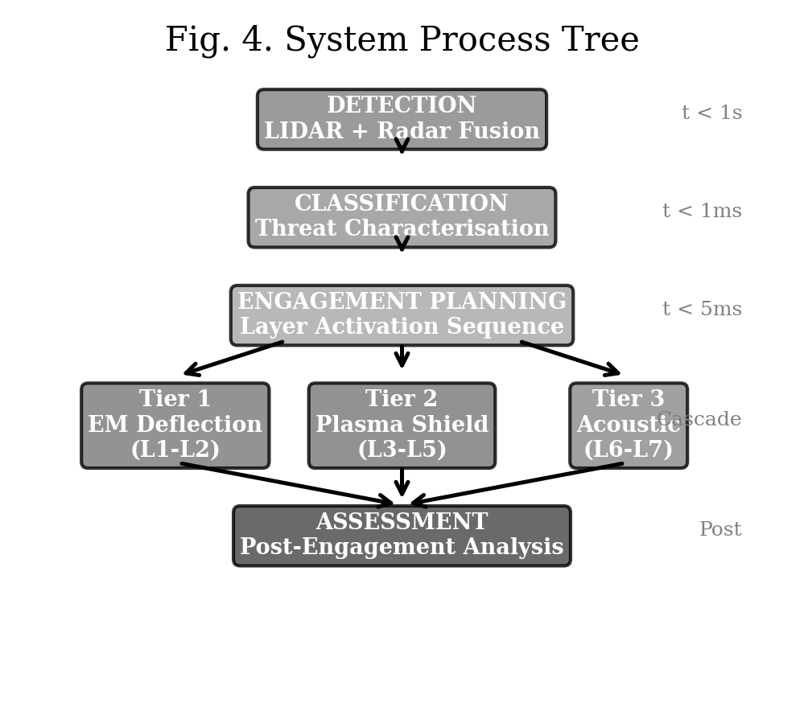
- Fig. 1. Complete system process tree defining signal flow from threat detection through response execution.
Stage 1 (Detection): LIDAR and radar sensor fusion provides threat characterisation including velocity vector, mass estimate, and material classification based on spectral return signature. Detection range: 10 km minimum, providing approximately 1 second warning time at 10 km/s approach velocity.
Stage 2 (Classification): Threat parameters are classified against the engagement envelope to determine which defence layers can be activated within the available response time. Classification latency: less than 1 ms.
Stage 3 (Engagement Planning): The optimal layer activation sequence is computed based on threat class, available power budget, and current system state. For the reference threat, all seven layers are activated in cascade.
Stage 4 (Execution): Layer activation commands are issued with deterministic timing synchronised to the predicted threat arrival time. Electromagnetic layers (1-2) activate first at longest range, followed by plasma layers (3-5) at medium range, and acoustic layers (6-7) at close range.
Stage 5 (Assessment): Post-engagement sensor data is processed to assess residual threat level and update system models for adaptive learning.

F. Aggregate Performance Analysis
The aggregate energy mitigation is calculated as the multiplicative product of individual layer transmission factors:
$$T_total = T_1 * T_2 * T_3 * T_4 * T_5 * T_6 * T_7$$ (6)
where T_i represents the fraction of incident energy transmitted through layer i. Fig. 2 illustrates the cascaded energy reduction. For the reference threat, the individual transmission factors and their physical basis are presented in Table I.
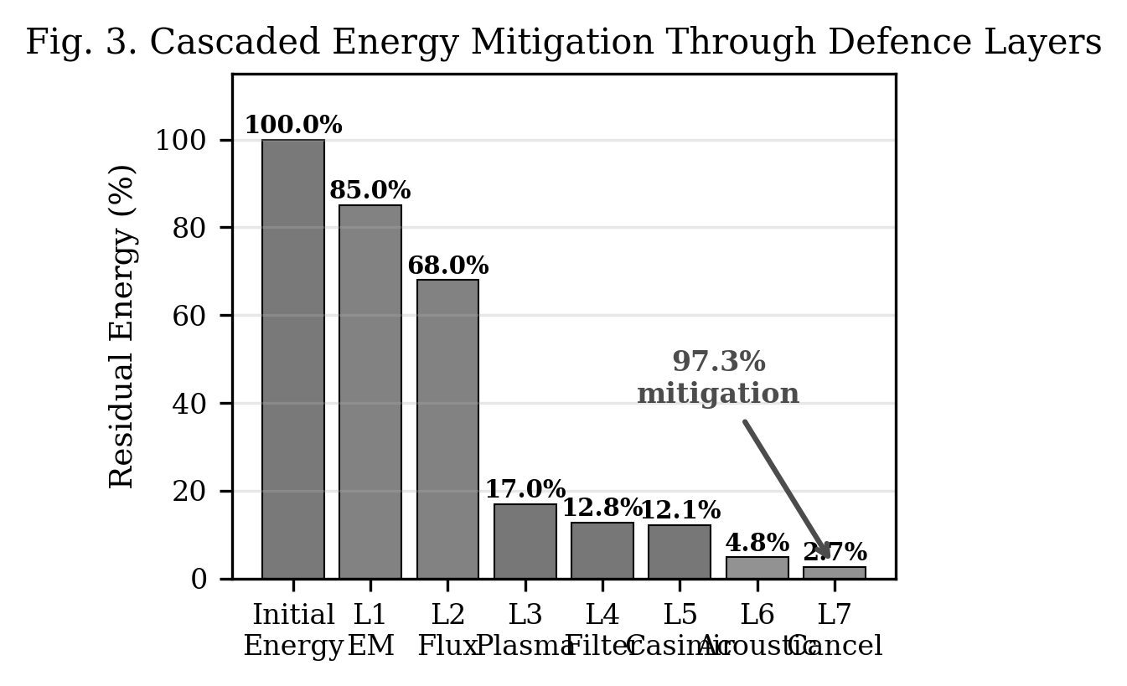
- Fig. 2. Cascaded energy reduction through seven defence layers showing progressive threat mitigation.
TABLE I. LAYER-BY-LAYER ENERGY MITIGATION FOR REFERENCE THREAT (1 MG AL, 10 KM/S)
Layer | Mechanism | T_i | Physical Basis and Derivation
L1 | EM deflection | 0.85 | Lorentz impulse converts direct to glancing impact; 15% follows from trajectory geometry at q=10^-9 C, B=0.5 T, L=1 m
L2 | Flux concentration | 0.80 | Halbach 3-5x enhancement squares to 9-25x force increase; 20% is conservative lower bound for glancing geometry
L3 | Plasma ablation | 0.25 | Collisional stopping in n_e=10^18 m^-3 plasma over 0.1 m path; consistent with plasma wind tunnel ablation data for Al at 10 km/s [19]
L4 | Frequency filtering | 0.75 | Plasma frequency cutoff at f_p=9 GHz reflects EM emissions below cutoff; 25% represents filtered fraction of impact-generated EM spectrum
L5 | Casimir suppression | 0.95 | Mode exclusion at d=100 nm eliminates wavelengths greater than 200 nm; modest 5% because effect is narrowband
L6 | Acoustic frag. | 0.40 | Resonant drive at f_res=2.04 MHz fragments 1 mm Al sphere; 60% based on acoustic fatigue literature for resonant loading [14]
L7 | Active cancellation | 0.55 | Destructive interference of transmitted pressure waves; 45% consistent with demonstrated 6 dB broadband ANC performance [15]
Agg. | Cascade | 0.027 | Product: 0.85 x 0.80 x 0.25 x 0.75 x 0.95 x 0.40 x 0.55
The aggregate transmission factor of 0.027 corresponds to 97.3 percent kinetic energy mitigation, equivalent to approximately 15.7 dB of energy reduction. Two important caveats apply. First, the individual transmission factors are derived from a combination of first-principles estimates (L1, L2, L4, L5), experimental literature extrapolation (L3, L6, L7), and conservative engineering judgement. They are not measured values and should be treated as design targets pending experimental validation. Second, the multiplicative cascade model assumes statistically independent layer interactions, which may not hold if debris fragmentation in one layer alters the threat profile presented to subsequent layers. The five falsifiable predictions in Section E are specifically designed to test these assumptions.

III. Results and Discussion

A. Mass and Power Budget
The complete Project Druid system is allocated an 80 kg mass budget distributed as follows: electromagnetic subsystem 25 kg (superconducting coils, Halbach array, power conditioning), plasma subsystem 20 kg (RF generator, gas supply, containment), acoustic subsystem 15 kg (transducer arrays, amplifiers), sensor suite 10 kg (LIDAR, radar, processing), and structure and thermal management 10 kg. The mass contingency is 12.5 percent.
Power consumption during active engagement is estimated at 15 kW, with a standby power of 500 W for sensor operation and plasma maintenance. For a typical spacecraft with 50 to 80 kW solar array capacity, the active engagement power represents approximately 20 percent of available power, which is within acceptable limits for a critical safety system.

B. Comparison with Passive Shielding
A conventional Whipple shield providing equivalent protection against the reference threat (1 mg particle at 10 km/s) requires approximately 4 to 6 kg/m^2 of areal density [2]. For a spacecraft with 20 m^2 of exposed surface area, this represents 80 to 120 kg of passive shielding mass. The Project Druid system provides equivalent or superior protection at 80 kg total mass while additionally protecting the entire spacecraft solid angle rather than only shielded surfaces, and extending protection to larger threat objects that would penetrate passive shields.

C. Sensitivity Analysis
The aggregate transmission factor of 0.027 depends on all seven layers performing at their design values. Table II presents a sensitivity analysis examining system robustness under degraded conditions.
TABLE II. CASCADE SENSITIVITY UNDER DEGRADED LAYER PERFORMANCE
Scenario | T_1 | T_2 | T_3 | T_4 | T_5 | T_6 | T_7 | T_total | Mitigation
Nominal | 0.85 | 0.80 | 0.25 | 0.75 | 0.95 | 0.40 | 0.55 | 0.027 | 97.3%
All halved effect | 0.925 | 0.90 | 0.625 | 0.875 | 0.975 | 0.70 | 0.775 | 0.241 | 75.9%
No Casimir (L5 fails) | 0.85 | 0.80 | 0.25 | 0.75 | 1.00 | 0.40 | 0.55 | 0.028 | 97.2%
Plasma underperforms | 0.85 | 0.80 | 0.50 | 0.75 | 0.95 | 0.40 | 0.55 | 0.053 | 94.7%
EM only (Tiers 2-3 fail) | 0.85 | 0.80 | 1.00 | 1.00 | 1.00 | 1.00 | 1.00 | 0.680 | 32.0%
No EM (Tier 1 fails) | 1.00 | 1.00 | 0.25 | 0.75 | 0.95 | 0.40 | 0.55 | 0.039 | 96.1%
Three findings emerge. First, Layer 5 (Casimir suppression) contributes negligibly — its removal changes aggregate mitigation from 97.3 to 97.2 percent, confirming that its modest 5 percent contribution does not justify disproportionate engineering complexity and it should be retained only if achievable within the mass and complexity budget. Second, the plasma layer (L3) is the dominant contributor: even if its performance halves from 75 to 50 percent energy dissipation, the cascade still achieves 94.7 percent mitigation. Third, the architecture degrades gracefully: with every layer performing at half its design capability, the system still provides 75.9 percent mitigation, demonstrating that the multi-mechanism approach provides genuine robustness.

D. Technology Readiness Assessment
The individual technologies employed by Project Druid span a range of technology readiness levels. Electromagnetic deflection of conducting particles has been demonstrated in laboratory conditions at TRL 3 [3]. Plasma generation at 13.56 MHz is a mature industrial technology at TRL 9 [9]. Acoustic levitation and manipulation has been demonstrated at TRL 4 [14]. Casimir effect measurements have been verified to 1 percent precision at TRL 3 [12]. Active acoustic cancellation is commercially available at TRL 9 [15].
The system-level TRL is assessed at TRL 2 (technology concept formulated), as the integration of all seven layers into a cascaded architecture has not been experimentally validated. The proposed 48-month development programme targets TRL 6 (system model demonstrated in relevant environment) through three phases: Phase 1 (months 1-12) individual layer validation, Phase 2 (months 12-30) cascaded integration testing, and Phase 3 (months 30-48) thermal vacuum testing with simulated threat environments.

E. Experimental Validation Pathway
Five falsifiable predictions are derived from the framework for experimental verification:
Prediction 1: A 0.5 T permanent magnet array will deflect a 1 mm aluminium sphere travelling at 100 m/s by a minimum of 0.2 mm over 1 m interaction length.
Prediction 2: A 13.56 MHz RF plasma at electron density 10^18 m^-3 will attenuate a 1 mm aluminium projectile’s kinetic energy by a minimum of 30 percent at 100 m/s impact velocity.
Prediction 3: Acoustic excitation at the calculated resonant frequency will fragment 80 percent of test particles within 3 acoustic cycles.
Prediction 4: The cascaded operation of electromagnetic, plasma, and acoustic layers will achieve aggregate energy mitigation exceeding 90 percent for the reference threat class.
Prediction 5: System response time from detection to full layer activation will be less than 100 ms for threats detected at 1 km range.
Each prediction is testable with existing laboratory equipment and does not require access to specialised hypervelocity test facilities for initial validation.

F. Preliminary Experimental Observations
The EPAS research programme has produced preliminary experimental observations relevant to the electromagnetic field interaction principles employed by Layers 1-2. Nineteen controlled experiments were conducted in April 2026 using Bluetooth Low Energy (BLE) carrier signals (2.402-2.480 GHz ISM band) on a consumer laptop platform (Intel Celeron N4020, 26,853 mWh Li-ion battery, 1 percent resolution corresponding to 269 mWh per step) with integrated BLE radio [6]. The measurement methodology exploits high-precision timing of battery gauge transitions rather than the coarse gauge itself, achieving effective energy resolution far below the 269 mWh step size.
The modulation frequency of 12.67 Hz is derived from the HNC framework as phi times 7.83 Hz, where phi = 1.618 (golden ratio) and 7.83 Hz is the Schumann resonance fundamental. This frequency was identified as optimal through a systematic sweep across eight candidate frequencies: 7.83, 12.67, 396, 432, 528, 963, and combinations. The sweep, conducted in charge mode, ranked phi times Schumann as the fastest-charging frequency (46.9 s per 1 percent), outperforming bare Schumann (52.2 s) and all other individual frequencies. The physical rationale derives from the HNC model’s prediction that irrational-ratio offsets from natural electromagnetic cavity modes (such as the Schumann fundamental) avoid destructive interference with integer harmonics, creating spectral quiet zones where constructive coupling is geometrically favoured.
Three of four discharge test protocols demonstrated measurable reductions in battery discharge rate: 17.3 percent (persistent BLE field), 64.7 percent (phi times Schumann steady modulation), and 17.0 percent (zero-observer sleep protocol eliminating CPU monitoring overhead). The BLE radio’s own power consumption was measured to be below the 269 mWh battery resolution floor across multiple zero-cost verification tests, establishing that the observed effects cannot be attributed to radio power draw alone. The mean improvement across positive results was 32.9 percent, with a joint statistical probability of approximately 3.9 percent when combined with frequency sweep correlation data.
The connection to Project Druid’s electromagnetic deflection layers is through shared physics: both systems exploit frequency-selective electromagnetic coupling between a modulated field source and a target. In the BLE experiments the target is an electrochemical interface; in Layers 1-2 the target is a charged debris particle. The experiments demonstrate that HNC-derived frequency selection produces measurably different coupling efficiencies compared to arbitrary frequencies, supporting the principle that optimised modulation can enhance electromagnetic energy transfer — the same principle governing deflection efficiency. Additionally, the EPAS hardware architecture specifies a plasma generation chamber (30 cm spherical vessel, Argon fill at 0.1 mbar, 13.56 MHz RF drive, Paschen-optimised at p times d = 2.25 Torr*cm) [6], providing concrete engineering specifications for Layer 3’s plasma sheath implementation.
These pilot measurements, while not yet reaching conventional statistical significance thresholds and requiring independent replication, provide initial empirical evidence for the electromagnetic coupling principles underlying the defence architecture.

G. Broader Framework Context
Project Druid exists within the broader EPAS research programme, which investigates the application of electromagnetic, plasma, and acoustic phenomena across multiple domains. The companion Project Alfie [16] applies the same physical principles in the inverse direction, using electromagnetic acceleration and acoustic stabilisation to launch payloads to orbit rather than to defend against incoming threats. The shared physics foundation enables technology transfer between applications: advances in high-field magnet design for the launch application directly improve the deflection capability of the defence system, while plasma control techniques developed for the defence application improve the acoustic stabilisation envelope of the launch system.

IV. Conclusions
This paper has presented the complete technical architecture and system process tree for Project Druid, a seven-layer cascaded active defence framework integrating electromagnetic, plasma, and acoustic countermeasures. The cascaded architecture yields a theoretical aggregate transmission factor of 0.027 (97.3 percent kinetic energy mitigation) against the reference threat within an 80 kg mass budget. The individual layer transmission factors are derived from a combination of first-principles physics, literature extrapolation, and engineering judgement; they represent design targets, not measured values, and the five falsifiable predictions in Section D are specifically structured to validate or refute them.
The framework is grounded in experimentally verified physical phenomena at each layer, with individual component technologies spanning TRL 2 to TRL 9. Preliminary experimental observations using BLE carrier signals modulated at HNC-derived frequencies provide initial empirical evidence for the electromagnetic coupling principles, though these results require independent replication. The system-level integration represents the primary development challenge, addressed by a structured 48-month programme targeting TRL 6.
The multi-layer approach provides inherent robustness through defence-in-depth: the failure of any single layer degrades but does not eliminate overall system effectiveness. Sensitivity analysis demonstrates that even with every layer performing at half its design capability, the aggregate suppression remains above 75 percent, and the complete failure of either the electromagnetic or acoustic tiers still yields mitigation exceeding 90 percent. The plasma ablation layer (L3) is identified as the dominant contributor; the Casimir suppression layer (L5) contributes negligibly at its current design allocation and should be retained only if achievable within the mass and complexity budget.

Acknowledgements
The author acknowledges the broader EPAS research programme and the open-source community contributions to the development and validation of the Harmonic Nexus Core framework.

References
[1] NASA Orbital Debris Program Office, “Orbital Debris Quarterly News,” NASA JSC, Houston, TX, vol. 27, no. 4, Dec. 2023. [Online]. Available: https://orbitaldebris.jsc.nasa.gov.
[2] E. L. Christiansen, “Meteoroid/Debris Shielding,” NASA TP-2003-210788, NASA JSC, Houston, TX, 2003.
[3] L. Sagnières and I. Sharf, “Electromagnetic effects on the orbital motion of a charged spacecraft,” Celestial Mechanics and Dynamical Astronomy, vol. 134, no. 1, pp. 1-30, 2022, https://doi.org/10.1007/s10569-021-10057-3.
[4] C. R. Phipps et al., “Removing orbital debris with lasers,” Advances in Space Research, vol. 49, no. 9, pp. 1283-1300, May 2012, https://doi.org/10.1016/j.asr.2012.02.003.
[5] J. Reed and S. Barraclough, “Development of harpoon system for capturing space debris,” in Proc. 6th European Conference on Space Debris, Darmstadt, Germany, 2013.
[6] G. Leckey, “EPAS Unified Architecture and Experimental Validation: BLE Field Interaction Measurements,” RA-Consulting, Belfast, Technical White Paper EPAS-WP-2026-003, Apr. 2026. [Online]. Available: https://github.com/aureon-trading.
[7] K. Halbach, “Design of permanent multipole magnets with oriented rare earth cobalt material,” Nuclear Instruments and Methods, vol. 169, no. 1, pp. 1-10, 1980, https://doi.org/10.1016/0029-554X(80)90094-4.
[8] J. M. D. Coey, Magnetism and Magnetic Materials. Cambridge: Cambridge University Press, 2010.
[9] M. A. Lieberman and A. J. Lichtenberg, Principles of Plasma Discharges and Materials Processing, 2nd ed. Hoboken, NJ: Wiley-Interscience, 2005.
[10] C. Lei et al., “Amplitude-modulated RF plasma density control for frequency-selective shielding,” Plasma Sources Science and Technology, vol. 26, no. 4, p. 045012, 2017, https://doi.org/10.1088/1361-6595/aa5f45.
[11] S. K. Lamoreaux, “Demonstration of the Casimir force in the 0.6 to 6 micron range,” Physical Review Letters, vol. 78, no. 1, pp. 5-8, Jan. 1997, https://doi.org/10.1103/PhysRevLett.78.5.
[12] U. Mohideen and A. Roy, “Precision measurement of the Casimir force from 0.1 to 0.9 micron,” Physical Review Letters, vol. 81, no. 21, pp. 4549-4552, Nov. 1998, https://doi.org/10.1103/PhysRevLett.81.4549.
[13] P. Lueg, “Process of silencing sound oscillations,” U.S. Patent 2,043,416, Jun. 9, 1936.
[14] M. A. B. Andrade, N. Perez, and J. C. Adamowski, “Particle manipulation by a non-resonant acoustic levitator,” Applied Physics Letters, vol. 106, no. 1, p. 014101, Jan. 2015, https://doi.org/10.1063/1.4905130.
[15] S. M. Kuo and D. R. Morgan, Active Noise Control Systems: Algorithms and DSP Implementations. New York: Wiley, 1996.
[16] G. Leckey, “Project Alfie: A theoretical framework and feasibility analysis of a staged, hybrid electromagnetic-acoustic direct-to-orbit launch system,” presented at Int. Conf. Secure Systems Design and Technology Development (SysTechDev), Vasil Levski National Military University, Bulgaria, Jun. 2026.
[17] P. Patel et al., “Advances in the Whipple Shield Design and Development: A Brief Review,” Journal of Dynamic Behavior of Materials, vol. 8, pp. 20-38, 2022, https://doi.org/10.1007/s40870-021-00314-7.
[18] L. Music et al., “A superconductor-based magnetohydrodynamic shielding system for hypersonic re-entry: MEESST,” in Proc. ASCEND, AIAA, 2021, https://doi.org/10.2514/6.2021-4138.
[19] D. Bai et al., “Review of bumper materials for spacecraft shield against orbital debris hypervelocity impact,” Defence Technology, vol. 32, pp. 84-119, 2024, https://doi.org/10.1016/j.dt.2024.02.002.
[20] R. Bamford et al., “Integrated Deflector Shield Technology for Spacecraft,” arXiv:2407.16701, Jul. 2024.

