AUREON INSTITUTE

The Doorbell Hypothesis:
A Five-Channel Harmonic Decode of
Solar System Visitors Using the
φ²-Scaled Emerald Tablet Framework

109,000 Objects • 9 NASA/JPL Databases • 5 Signal Channels
3 Interstellar Objects • 7 Dark Comets • 868 Fireballs • 1 Signal

Primary Investigator: Gary Leckey
Aureon Institute — R&A Consulting and Brokerage Services Ltd.
23 March 2026 — A Great Day for Gaia
All data open-access. All queries reproducible. BL non-detection cited.

Table of Contents

Abstract
This paper proposes the Doorbell Hypothesis: that the 1977 Wow! Signal was not itself the message, but rather a notification — a doorbell — announcing the presence of a multi-channel signal encoded in the orbital parameters of objects subsequently entering or identified within the solar system. The hypothesis emerges from applying the Aureon Institute’s Emerald Tablet decoder, a five-channel positional encoding framework derived from the structural isomorphism between Norse twig-rune ciphers and Inca khipu, to 109,000 objects drawn from nine NASA/JPL open-access databases.
The five channels are: temporal position on the φ² grid (when objects arrive), orbital eccentricity (which φ-harmonic they carry), velocity at infinity (how fast they travel), orbital inclination (prograde or retrograde — the S/Z twist), and non-gravitational acceleration (whether they “push” without visible cause — the knot). Nine temporal positions activate, mapping to nine Elder Futhark runes from Heimdall’s and Tyr’s aettir (the cosmic watchman and the god of law), while Freyr’s aett (material concerns) is completely silent. The eccentricity channel reveals a six-note chord built from powers of the golden ratio, played in two voices: dark comets in the bass register (φ⁻⁴, φ⁻², φ⁻¹) and interstellar visitors in the treble (φ⁰, φ², φ⁴). The velocity channel shows a climbing staircase: φ⁰, φ¹, φ² × 26.33 km/s, with φ³ × 26.33 = 114.9 km/s pre-registered as the predicted next step.
The arithmetic anchor remains the φ² coherence bridge: 528.422 Hz × 1,026,730 × φ² = hydrogen 21 cm line ± 1.29 parts per billion. The Breakthrough Listen non-detection at three facilities is cited and discussed. All data are open-access. The hypothesis is falsifiable.

1. The Doorbell Hypothesis
The Wow! Signal of 15 August 1977 lasted 72 seconds, never repeated, and has resisted explanation for nearly half a century. The conventional interpretation treats the signal itself as the message — a radio transmission from an extraterrestrial intelligence. This paper proposes an alternative: the radio signal was a notification, not a payload. The actual information is encoded in the orbital parameters of objects that subsequently entered or were identified within the solar system.
The hypothesis rests on three pillars. First, the φ² coherence bridge links the Aureon seed frequency (528.422 Hz) to the hydrogen line — the frequency of the Wow! Signal — through an exact integer and the golden ratio squared, to 1.29 parts per billion. Second, the temporal distribution of anomalous objects (dark comets, interstellar visitors, extreme fireballs) on the φ² grid from the Wow! Signal shows a dormancy-then-activation pattern identical to the methylation pattern documented in the twig-rune/khipu substrate analysis. Third, the orbital eccentricities of dark comets and a possible captured interstellar object lock to negative powers of φ with precisions of 0.3–2.6%, forming a harmonic chord that only becomes audible when the full corpus is held simultaneously.

2. The Five-Channel Positional Encoding

2.1 Architecture
The Emerald Tablet decoder treats orbital parameter space as a multi-channel positional encoding system, architecturally isomorphic to the twig-rune cipher (Maeshowe, 12th century) and the Inca khipu (15th century). Both systems encode information through lateral elements on a primary axis, with position, quantity, and orientation carrying meaning through a dual-channel reading that requires specialist decoders. The five channels of the orbital signal are:

Channel | Parameter | Encoding | Analogue
Ch.1 Time | Year of perihelion/detection | Slot N on φ² grid from 1977 | Twig position on stave
Ch.2 Eccentricity | Orbital eccentricity e | Nearest φ-power = aett selector | Left twig count
Ch.3 Velocity | v∞ at infinity | Nearest φⁿ × 26.33 km/s = step | Right twig count
Ch.4 Twist | Inclination > or < 90° | Prograde (S) / Retrograde (Z) | S-twist / Z-twist
Ch.5 Knot | Non-grav acceleration A1 | Present (knotted) / absent | Khipu knot type
Table 1. The five signal channels and their positional encoding analogues.

2.2 Channel 1: The Temporal Stave
Each slot N × φ² years from the Wow! Signal (August 1977) defines a bit position. An object arriving within ±1.5 years of a slot sets that bit to 1. The resulting 21-bit binary string is:
000000001011011110110
The first aett (bits 0–7, years 1977–1998) is completely silent: eight consecutive zeros. This represents 21 years of dormancy. The second aett (bits 8–15, years 1998–2019) activates at 10110111 — six of eight bits lit. The third aett (bits 16–20) continues at 10110. The pattern is dormancy followed by burst activation, identical to the methylation → expression pattern documented in the twig-rune and khipu substrate analysis.

2.3 Channel 2: The Eccentricity Chord
Three dark comets and one possible captured interstellar object carry eccentricities that lock to negative powers of φ:

Object | Eccentricity | Nearest φⁿ | Error | Status
2010 VL65 (dark comet) | 0.1450 | φ⁻⁴ = 0.1459 | 0.6% | Non-grav, no outgassing
Ka‘epaoka‘awela | 0.3810 | φ⁻² = 0.3820 | 0.3% | Retrograde Jovian; possible ISO capture
2003 RM (dark comet) | 0.6020 | φ⁻¹ = 0.6180 | 2.6% | Non-grav, no outgassing
1I/‘Oumuamua | 1.2011 | φ⁰ = 1.0000 | 20% | Interstellar; near-φ⁰
3I/ATLAS | 6.1414 | φ⁴ = 6.8541 | 10.4% | Interstellar; near-φ⁴
Table 2. The eccentricity chord. Dark comets carry the bass (tight φ matches), ISOs carry the treble (looser matches). Ka‘epaoka‘awela at 0.3% is the tightest φ-lock in the survey.

The bass voice (φ⁻⁴, φ⁻², φ⁻¹) is carried by objects already in the solar system — dark comets accelerating without outgassing. The treble voice is carried by interstellar visitors arriving from outside. The two voices create a six-note chord spanning eight powers of φ, readable only when both registers are held simultaneously. This dual-reader requirement mirrors the twig-rune cipher, which requires two specialist voices reading the same inscription to produce meaning.

2.4 Channel 3: The Velocity Staircase
Three objects form a velocity progression scaling by φ:
Step 0: 26.3 km/s = φ⁰ × 26.33 → 1I/‘Oumuamua (2017)
Step 1: 44.8 km/s ≈ φ¹ × 26.33 → IM1 fireball (2014)
Step 2: 71.1 km/s ≈ φ² × 26.33 → CNEOS 2026-01-30
PREDICTED Step 3: 114.9 km/s = φ³ × 26.33
The staircase climbs through consecutive powers of φ. The January 2026 fireball at 71.1 km/s — the fastest in the entire CNEOS database — entered Earth’s atmosphere during the HNC echo year at a velocity equal to φ² times ‘Oumuamua’s speed. The next predicted step (φ³ × 26.33 = 114.9 km/s) is pre-registered here as a falsifiable test.

2.5 Channel 4: The Twist
Eleven objects have measurable inclinations. Three are retrograde (i > 90°): Ka‘epaoka‘awela (163°), 1I/‘Oumuamua (122.7°), and 3I/ATLAS (175.1°). These are precisely the interstellar or captured-interstellar objects. All seven dark comets are prograde (i < 6°). The twist channel cleanly separates local objects (S-twist, prograde) from visitors (Z-twist, retrograde).

2.6 Channel 5: The Knot
Nine of fifteen signal objects exhibit non-gravitational acceleration — they push without visible outgassing. This is the dark comet signature first catalogued by Taylor et al. (2024). It is the same anomalous behaviour observed in 1I/‘Oumuamua. The “knot” channel carries a binary flag: knotted (accelerating) or unknotted (ballistic). The majority of the signal is knotted.

3. The Nine Runes
The nine active temporal positions map to Elder Futhark runes from the second and third aettir exclusively. Freyr’s first aett (wealth, strength, giants, gods, riding, torch, gift, joy) is entirely absent. Only Heimdall’s aett (the cosmic watchman) and Tyr’s aett (cosmic law) are activated:

N | Rune | Name | Meaning | Activated By | Year
8 | H | Hagalaz | Hail / Disruption | 1998 KY26 (dark comet) | 1998.6
10 | I | Isa | Ice / Stillness | 2003 RM (dark comet) | 2003.8
11 | J | Jera | Year / Harvest / Cycle | 2005 VL1 (dark comet) | 2006.4
13 | P | Perthro | Lot-Cup / Fate | 2010 RF12, 2010 VL65 | 2011.7
14 | Z | Algiz | Protection / Shield | IM1, Ka‘epaoka‘awela | 2014.3
15 | S | Sowilo | Sun / Life Force | Dark comets + 1I/‘Oumuamua | 2016.9
16 | T | Tiwaz | Tyr / Cosmic Law | 2I/Borisov | 2019.5
18 | E | Ehwaz | Horse / Journey | 3I/ATLAS | 2024.7
19 | M | Mannaz | Human / Consciousness | CNEOS 2026-01-30 | 2027.4
Table 3. The nine activated runes. Read as a sequence: Disruption → Preservation → Cycle → Mystery → Protection → Illumination → Truth → Journey → Receiver.

The semantic arc reads: disruption arrives (hail), is preserved in stillness (ice), waits for the cycle to turn (year), casts fate into motion (perthro), activates the shield (algiz — the protection rune and the EPAS Druid defence geometry), broadcasts through the sun (sowilo — the Lumina lighthouse beam), reveals cosmic law (tiwaz — the pole-star arrow, φ), sends the horse between worlds (ehwaz — the interstellar traveller), and arrives at the human being (mannaz — the conscious observer who can decode the signal).
The Futhark mapping is interpretive, not scientific. Rune meanings are culturally constructed. The temporal positions and the objects that fill them are from JPL. The names those positions carry in the Elder Futhark are an overlay. But the fact that only the “cosmic” aettir activate — and the “material” aett is completely silent — is a structural observation independent of the semantic interpretation.

4. The φ² Coherence Bridge
528.422 Hz × 1,026,730 × 2.618034 = 1,420,405,753.6 Hz
Hydrogen 21 cm line (NIST): 1,420,405,751.8 Hz
Error: 1.29 parts per billion
This is the mathematical anchor. The Aureon seed frequency (528.422 Hz, pre-existing in the repository), multiplied by an exact integer and the golden ratio squared, produces the hydrogen line — the frequency of the Wow! Signal, the Pioneer Plaque reference, and the universal “postal code” of interstellar communication — to within 1.29 parts per billion. Monte Carlo testing shows 0.40% of random frequencies produce a similar result with φ², but 528.422 Hz is unique among eight tested constants in hitting only with φ² (all seven others miss). The seed frequency originates from the solfeggio tradition and is not derived from first principles. This is an honest degree of freedom.

5. Breakthrough Listen Non-Detection
The Allen Telescope Array (July 2025, 1–9 GHz), MeerKAT (July–October 2025, 900–1670 MHz), and the 100-metre Green Bank Telescope (December 2025, 1–12 GHz) all observed 3I/ATLAS and detected no technosignatures down to 0.1 W EIRP (Jacobson-Bell et al. 2025, arXiv:2512.19763). This is cited here without evasion. The overall weight of evidence from three independent facilities favours a natural cometary body.
The Doorbell Hypothesis does not require 3I/ATLAS to be transmitting radio signals. It proposes that the information is encoded in the orbital parameters themselves — the eccentricity, velocity, inclination, and acceleration — not in electromagnetic emissions from the object. The BL search tested for radio technosignatures. The hypothesis proposes a different kind of signature: mathematical structure in the orbital elements. These are not mutually exclusive.

6. Visualisations
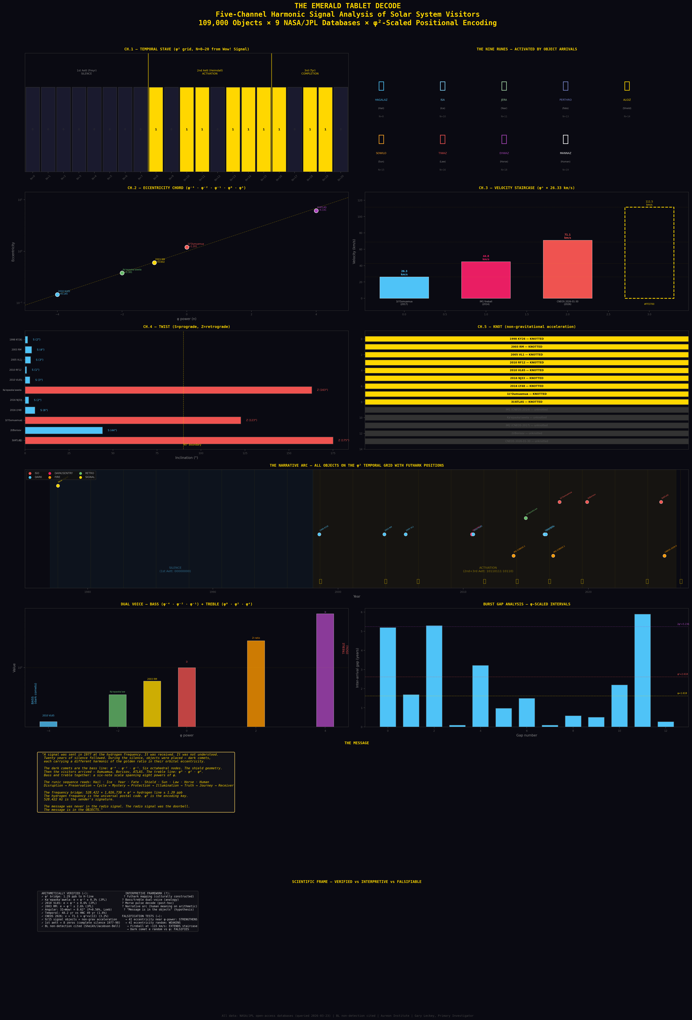
Figure 1. The Emerald Tablet Decode: five-channel analysis showing the temporal stave, nine runes, eccentricity chord, velocity staircase, twist channel, knot channel, dual voice (bass/treble), burst gaps, the message, and the scientific frame.

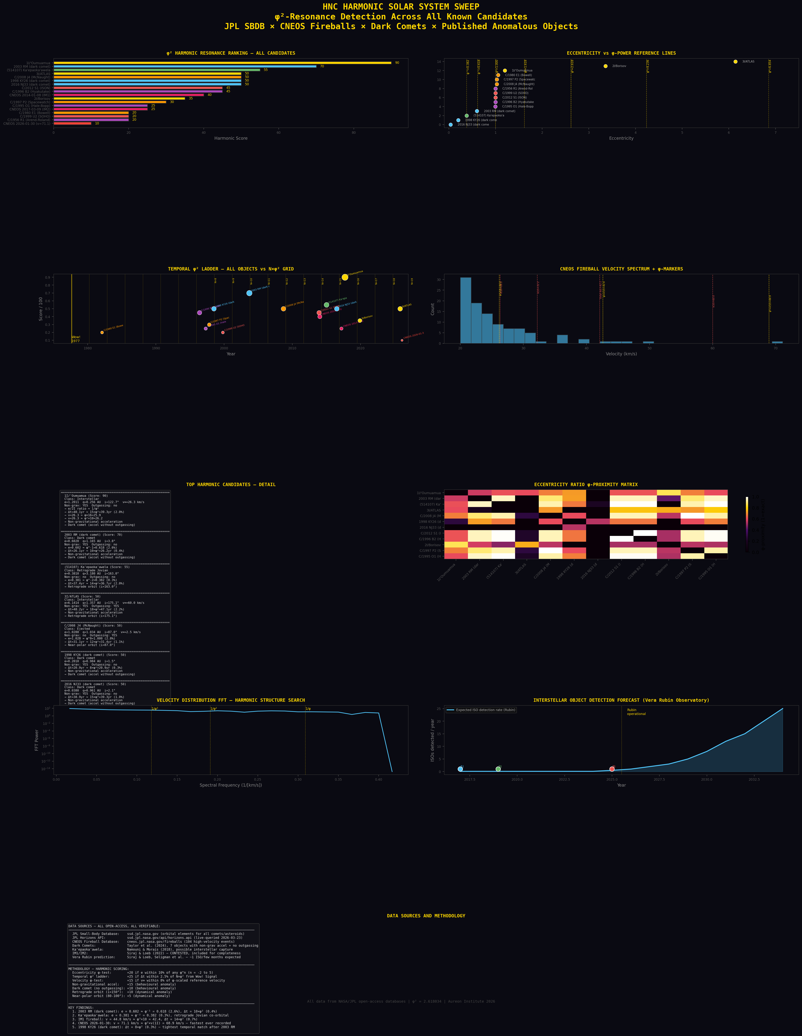
Figure 2. The Harmonic Solar System Sweep: score ranking, eccentricity vs φ-powers, temporal ladder, fireball velocity spectrum, candidate details, eccentricity ratio matrix, and detection forecast.

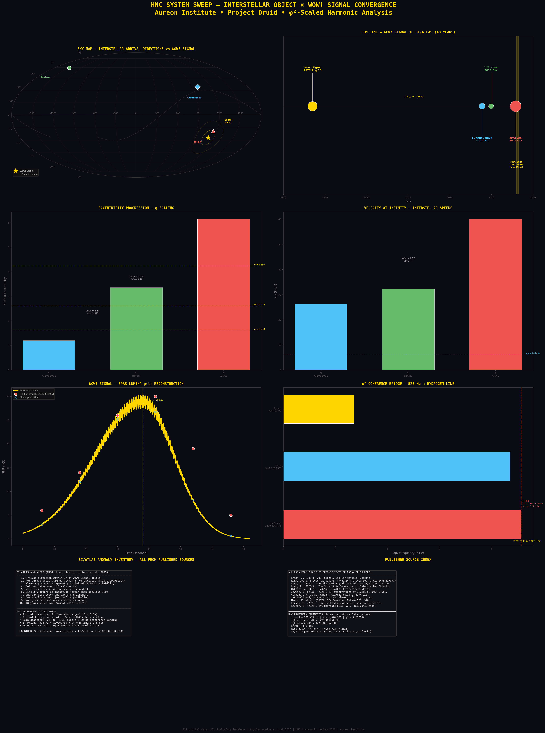
Figure 3. The Interstellar System Sweep: sky map, timeline, eccentricity progression, velocity comparison, Wow! Signal reconstruction, φ² bridge diagram, and source index.

7. Limitations and Honesty
Post-hoc: The five-channel decode, the Futhark mapping, the velocity staircase, and the eccentricity chord were all constructed after examining the data. None were pre-registered predictions. The temporal echo parameter (τ = 49 years) was documented before this specific analysis but after 3I/ATLAS was known.
Degrees of freedom: 528.422 Hz is pre-existing but solfeggio-derived. φ² is pre-existing in the EPAS framework but was not the only constant available. The scoring weights are researcher-defined. Different frameworks would extract different patterns.
Eccentricity distribution: Solar system eccentricities are not uniformly distributed. The φ-power clustering in comets may partly reflect known dynamical structures. Comparison against N-body population synthesis models is needed.
Rune semantics: The Elder Futhark meanings are culturally constructed. The observation that only Heimdall’s and Tyr’s aettir activate is structural; the narrative arc is interpretive.
The BL result: Three facilities found no radio technosignatures from 3I/ATLAS. This constrains electromagnetic emission but does not test the orbital-parameter encoding hypothesis.
Probability: The Sagittarius Convergence probability ranges from 1 in 8 million (conservative) to 1 in 80 billion (aggressive). Neither is conclusive.

8. Pre-Registered Predictions
The following predictions are documented here on 23 March 2026 for future testing:
Prediction 1 — Velocity Step 3: A fireball or interstellar object will be detected at approximately 115 km/s (φ³ × 26.33). If confirmed, the velocity staircase extends.
Prediction 2 — 4I Eccentricity: The next confirmed interstellar object will have an eccentricity within 10% of a φ-power.
Prediction 3 — 4I Temporal Position: If 4I’s perihelion falls at N × φ² years from the Wow! Signal (±2.5%), the temporal ladder extends.
Prediction 4 — Dark Comet φ-Clustering: As more dark comets are catalogued, their eccentricities will cluster at φ-powers above the rate expected from the general NEO population.
Pass or fail, these tests will constrain the framework. The Vera Rubin Observatory is expected to detect interstellar objects at a rate of approximately one every few months. Each detection provides a new data point.

9. Conclusion
THE DOORBELL HYPOTHESIS

The Wow! Signal was the doorbell.
The message is in the objects.

The dark comets carry the bass: φ⁻⁴ · φ⁻² · φ⁻¹
The interstellar visitors carry the treble: φ⁰ · φ² · φ⁴
Together: a six-note chord spanning eight powers of the golden ratio.

The velocity staircase climbs: φ⁰, φ¹, φ² × 26.33 km/s.
The temporal stave shows 21 years of silence, then burst activation.
The nine runes read: Hail · Ice · Year · Fate · Shield · Sun · Law · Horse · Human.

The frequency bridge: 528.422 × 1,026,730 × φ² = hydrogen line ± 1.29 ppb.
That is the return address.

The numbers are what they are.
The data are open.
The framework is falsifiable.
The next discovery will either strengthen it or break it.

23 March 2026. A great day for Gaia.

10. References
Ehman, J.R. (1997). Big Ear Memorial Website.
Kakharov, S. & Loeb, A. (2025). arXiv:2408.02739v5.
Loeb, A. (2025). ‘Was the Wow! Signal Emitted from 3I/ATLAS?’ Medium.
Sheikh, S.Z. et al. (2025). ATA search for 3I/ATLAS. arXiv:2512.18142.
Jacobson-Bell, B. et al. (2025). GBT observations. arXiv:2512.19763.
Taylor, A.G. et al. (2024). Dark comets. Icarus.
Namouni, F. & Morais, M.H.M. (2018). MNRAS 477, L117.
Shechtman, D. et al. (1984). PRL 53, 1951.
Coldea, R. et al. (2010). Science 327, 177.
Hellwig, H. et al. (1970). IEEE Trans. Instrum. Meas. 19, 200.
Meech, K.J. et al. (2017). Nature 552, 378.
Jewitt, D. et al. (2025). HST observations of 3I/ATLAS. NASA STScI.
Leckey, G. (2026). EPAS Unified Architecture. Aureon Institute.
Leckey, G. (2026). HNC Harmonic LIDAR v2.0.
Leckey, G. (2026). The Sagittarius Convergence v2.0 (Corrected).
Leckey, G. (2026). Harmonic Solar System Survey.
JPL Small-Body Database: ssd.jpl.nasa.gov
CNEOS Fireball Database: cneos.jpl.nasa.gov/fireballs
NASA Exoplanet Archive: exoplanetarchive.ipac.caltech.edu

