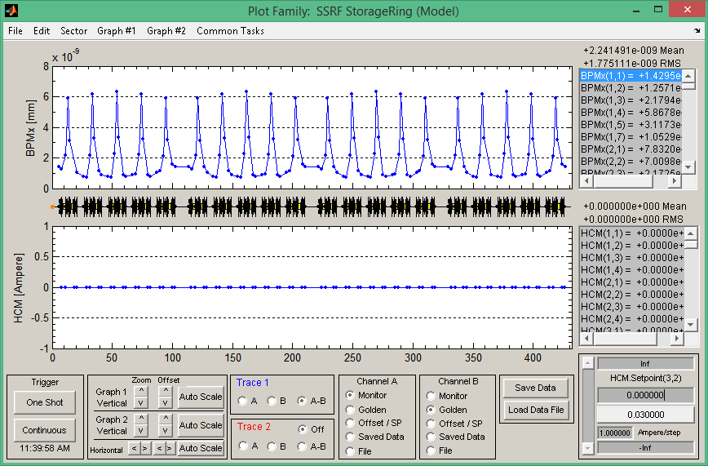

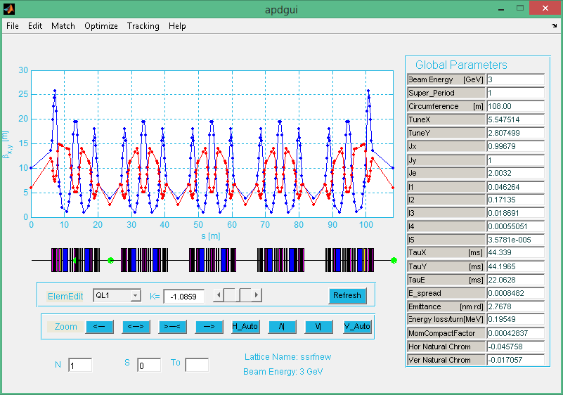

Lattice file: ssrfwithfit.m

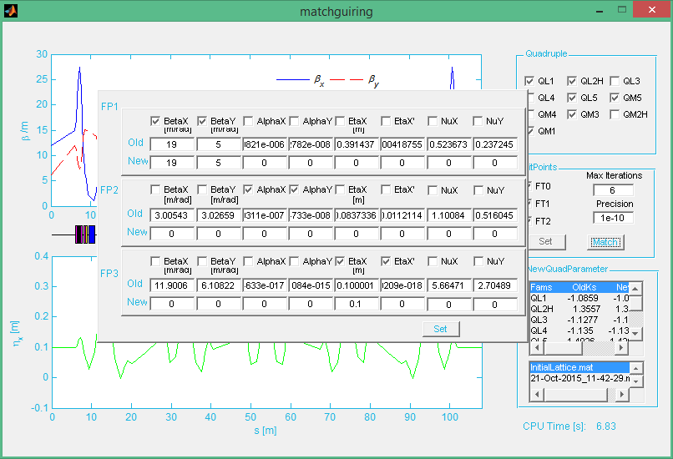

Match function.

Choose quadruple QL1, QL2H, QL5, QM5, QM3, QM1.

FT1: BetaX, BetaY; FT2: AlphaX, AlphaY; FT3: EtaX, EtaX’