DBMS LAB RECORD

**NAME:** B S KARTHIK KRISHNAN **ROLL NO:** 160121733035 **SECTION:** CSE-1

**COURSE CODE:** 20CSC17



**INDEX**

|  |  |  |
| --- | --- | --- |
| **S.No** | **Program** | **Page No.** |
| 1 | Write the queries for Data Manipulation and Data  Definition Language. | 2 |
| 2 | Write SQL queries for single row functions and  general functions. | 8 |
| 3 | Write SQL queries for evaluating group functions. | 18 |
| 4 | Write SQL queries using group by clause. | 20 |
| 5 | Write SQL queries using constraints. | 22 |
| 6 | Write SQL queries to demonstrate joins and views  and subqueries. | 28 |
| 7 | Write programs by the use of PL/SQL | 48 |
| 8 | Write programs on procedures and functions | 53 |
| 9 | Write programs on cursors | 56 |
| 10 | Write programs on exception handling and triggers | 61 |

|  |  |  |  |
| --- | --- | --- | --- |
| **CHAITANYA BHARATHI INSTITUTE OF TECHNOLOGY** | | | |
| **DBMS LAB RECORD** | | | |
|  | **Course Name.: DBMS Lab** | **Experiment No.** 1 | |
| **Course Code : 20CSC17**  **Faculty : Smt.Ch.Vijaya Lakshmi** | **Branch:** CSE | **Semester:** IV |

**AIM:** Write the queries for Data Manipulation and Data Definition Language.

## THEORY:

**DDL:** A **data definition language** or **data description language** (**DDL**) is syntax similar to a computer programming language for defining data structures, especially database schemas.-

Commands in DDL are:

1. CREATE
2. DROP
3. RENAME
4. ALTER

## DDL COMMANDS:

**SYNTAX:**

CREATE Statement: *CREATE TABLE tablename (attribute_1 data type, attribute_2 data type, …… attribute_n data type);*

DROP Statement:*DROP TABLE table_name;*

RENAME Statement:*RENAME table_name to new_name;*

ALTER Statement:

Add column to Table: *ALTER TABLE table_name ADD column_name column-definition*; Modify column in Table: *ALTER TABLE table_name MODIFY column_name column_type;* Drop column in Table*: ALTER TABLE table_name DROP COLUMN column_name;*

## DDL QUERIES:

**Q1.Write a query to create a table student1 with sid, sname, and ssec. Code:**

create table student1

( sid varchar(10),sname varchar(20),ssec varchar(4) );

## Output:

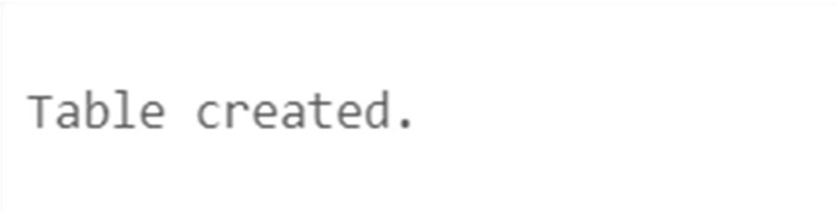

**Q2. Write a query to modify the datatype of sid to varchar. Code:**

Alter table student1 modify sid char(10);

## Output:

**Q3. Write a query to add column age to the table student1. Code:**

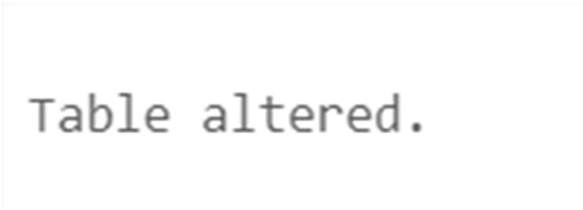Alter table student1 Add age Number **Output:**

## Q4. Write a query to drop the column age from student1. Code:

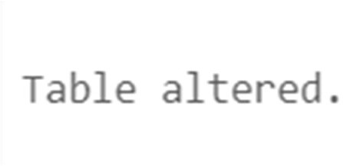Alter table student1 drop column age; **Output:**

## Q5. Write a query to rename the table to Lab1. Code:

Rename student1 to Lab1

## Output:

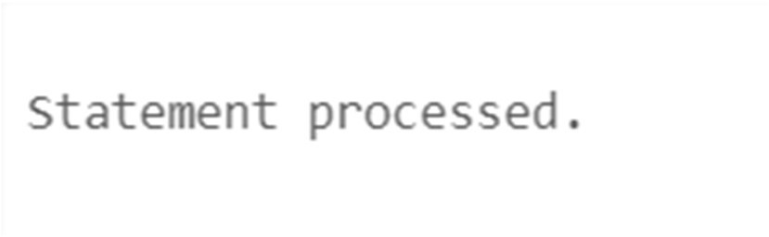

**Q6. Write a Query to drop the emp Code:**

DROP table emp;

## Output:

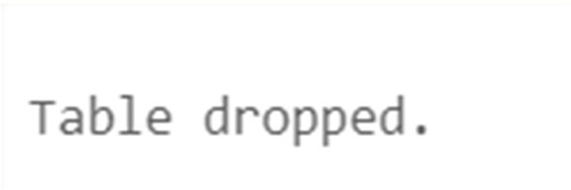

**THEORY:**

DML: A **data manipulation language** (**DML**) is a family of syntax elements similar to a computer programming language used for selecting, inserting, deleting and updating data in a database. Performing read-only queries of data is sometimes also considered a component of DML. Commands in DML are:

1. INSERT
2. UPDATE
3. DELETE
4. SELECT

## DML COMMANDS:

**SYNTAX:**

INSERT Statement:

*Single Row into a Table: INSERT INTO table – name [column- identifier-comma-list)] VALUES (column-valuecomma-list);*

*Multiple Row into a Table: insert into <table name> values (&col1, &col2, ….);*

UPDATE Statement: *UPDATE table-name SET update- column-list [WHERE search- condition];*

DELETE Statement: *DELETE FROM table-name [WHERE search- condition];*

**DML QUERIES:**

**Q1.**Write a query to create a table

# Code:

*create table Student( id number(8), name varchar2(20), branch char(3),*

*emailid varchar2(30) );*

# Output:



**Q2.**Write a query to insert 5 rows

# Code:

*insert into Student values(35,'Karthik','CSE','ugs21035@cbit.org.in'); insert into Student values(36,'Nikky','CSE','ugs21036@cbit.org.in'); insert into Student values(37,'Shreyak','CSE','ugs21037@cbit.org.in'); insert into Student values(38,'Shambu','CSE','ugs21038@cbit.org.in'); insert into Student*

*values(39,'Lokesh','CSE','ugs21039@cbit.org.in');*

***Output:***

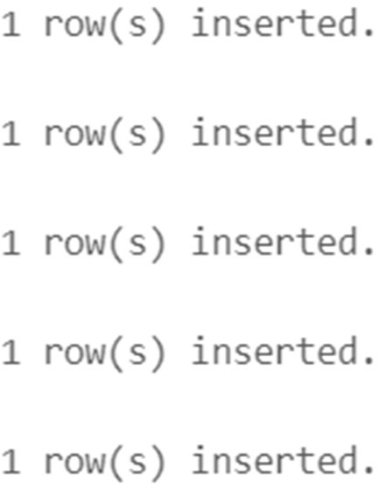

**Q3.**Write a Query to insert null

# Code:

*insert into Student values(null,'Noname','Non','Noemail');*

# Output:

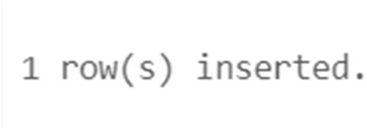

**Q4.**Write a query to display the created database

# Code:

*select \**

*from Student;*

# Output:

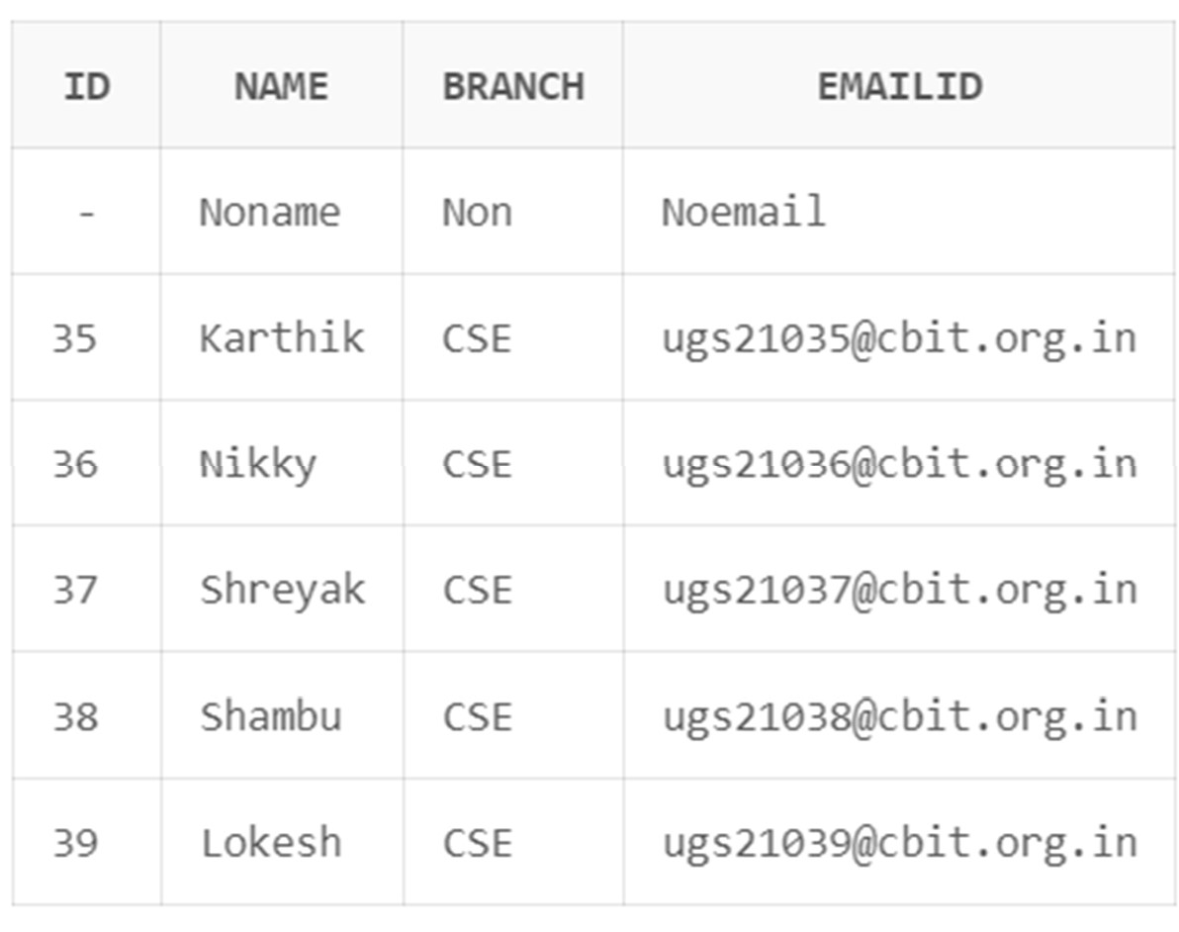

**Q5.**Write a query to delete the tuple

# Code:

*delete from Student where name='Noname' ;*

# Output:



**Q6.**Write a query to demonstrate concatenate operator

# Code:

*select name || ' RollNo. is: ' || id as "Student Details" from Student*

*ORDER BY id;*

# Output:

|  |  |  |  |
| --- | --- | --- | --- |
| **CHAITANYA BHARATHI INSTITUTE OF TECHNOLOGY** | | | |
| **DBMS LAB RECORD** | | | |
|  | **Course Name.: DBMS Lab** | **Experiment No.** 2 | |
| **Course Code : 20CSC17**  **Faculty : Smt.Ch.Vijaya Lakshmi** | **Branch:** CSE | **Semester:** IV |

**AIM:** Write the queries for evaluating single row functions.

## THEORY:

Single row functions are the one who work on single row and return one output per row. For example, length and case conversion functions are single row functions. Single row functions can be character functions, numeric functions, date functions, and conversion functions. Note that these functions are used to manipulate data items. These functions require one or more input arguments and operate on each row, thereby returning one output value for each row. Argument can be a column, literal or an expression. Single row functions can be used in SELECT statement, WHERE and ORDER BY clause.

Single row functions are of five types:

1. Character Functions
2. Number Functions
3. Date Functions
4. Conversion functions
5. General Functions

## Character Functions:

These are subdivided into – Case Manipulation Functions and Character Manipulation Functions.

Case Manipulation Functions - Accepts character input and returns a character value. Functions under the category are UPPER, LOWER and INITCAP.

* UPPER function converts a string to upper case.
* LOWER function converts a string to lower case.
* INITCAP function converts only the initial alphabets of a string to upper case.

Character Manipulation Functions – Accepts character input and returns number or character value. Functions under the category are CONCAT, LENGTH, SUBSTR, INSTR, LPAD, RPAD, TRIM and REPLACE.

* CONCAT function concatenates two string values.
* LENGTH function returns the length of the input string.
* SUBSTR function returns a portion of a string from a given start point to an end point.
* INSTR function returns numeric position of a character or a string in a given string.
* LPAD and RPAD functions pad the given string upto a specific length with a given character.
* TRIM function trims the string input from the start or end.
* REPLACE function replaces characters from the input string with a given character.

## Number Functions :

Accepts numeric input and returns numeric values. Functions under the category are ROUND, TRUNC, and MOD.

* ROUND and TRUNC functions are used to round and truncate the number value.
* MOD is used to return the remainder of the division operation between two numbers.

## Date Functions :

Date arithmetic operations return date or numeric values. Functions under the category are MONTHS_BETWEEN, ADD_MONTHS, NEXT_DAY, LAST_DAY, ROUND and TRUNC.

* MONTHS_BETWEEN function returns the count of months between the two dates.
* ADD_MONTHS function add 'n' number of months to an input date.
* NEXT_DAY function returns the next day of the date specified.
* LAST_DAY function returns last day of the month of the input date.
* ROUND and TRUNC functions are used to round and truncates the date value.

## Conversion Functions :

Type conversion can be either implicitly done by Oracle or explicitly done by the programmer.

Implicit Type Conversion – A VARCHAR2 or CHAR value can be implicitly converted to NUMBER or DATE type value by Oracle. Similarly, a NUMBER or DATA type value can be automatically converted to character data by Oracle server. Note that the impicit interconversion happens only when the character represents the a valid number or date type value respectively.

Explicit Type Conversion – SQL Conversion functions are single row functions which are capable of typecasting column value, literal or an expression . TO_CHAR, TO_NUMBER and TO_DATE are the three functions which perform cross modification of data types.

* TO_CHAR function is used to typecast a numeric or date input to character type with a format model (optional). Dates can be formatted in multiple formats after converting to character types using TO_CHAR function.

Example Formats for dates :

|  |  |
| --- | --- |
| **Format Model** | **Description** |
| YYYY | Full year in number |
| Year | Year spelled out |
| MM | Two digit value for month |
| Month | Full name of month |
| DD | Numeric day of month |

|  |  |
| --- | --- |
| DAY | Full name of day the week |
| TH | Produces ordinal number |
| SP | Spell out the number. |
| SPTH | Spell out the ordinal number. |

Example formats for Numbers:

|  |  |
| --- | --- |
| **Format Model** | **Description** |
| , | It returns a comma in the specified position. You can specify multiple commas in a number format model. |
| . | Returns a decimal point, in the specified position. |
| $ | Returns value with a leading dollar sign |
| 0 | Returns leading zeros. |
| 9 | Returns value with the specified number of digits |
| L | It is used for local currency symbol |

* The TO_NUMBER function converts a character value to a numeric datatype. If the string being converted contains nonnumeric characters, the function returns an error.
* The function takes character values as input and returns formatted date equivalent of the same. The TO_DATE function allows users to enter a date in any format, and then it converts the entry into the default format used by Oracle server.

## General Functions :

General functions are used to handle NULL values in database. The objective of the general NULL handling functions is to replace the NULL values with an alternate value. We shall briefly see through these functions below.

* NVL – The NVL function substitutes an alternate value for a NULL value. NVL(arg, replace_with)
* NVL2 – NVL2 function can be used to substitute an alternate value for NULL as well as non NULL value. NVL2(arg, value_if_not_null,value_if_null);
* NULLIF – The NULLIF function compares two arguments expr1 and expr2. If expr1 and expr2 are equal, it returns NULL; else, it returns expr1. Unlike the other null handling function, first argument can't be NULL. NULLIF(exp1,exp2)
* COALESCE function, a more generic form of NVL, returns the first non-null expression in the argument list. It takes minimum two mandatory parameters but maximum arguments has no limits. COALESCE (exp1,exp2,……,expn)

**QUERIES:**

**Q1:**To demonstrate Case Manipulation Functions.

# Code:

select lower('DBMS') from dual;

# Output:

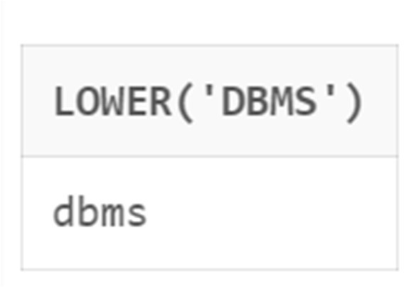

**Code:**

select upper('project-k') from dual;

# Output:

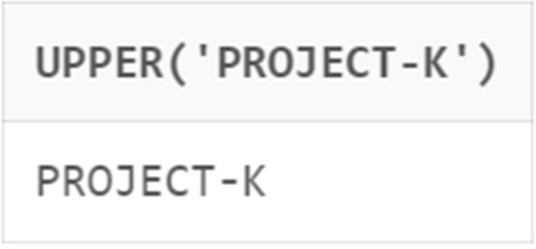

**Code:**

select initcap('SPIRIT') from dual;

# Output:

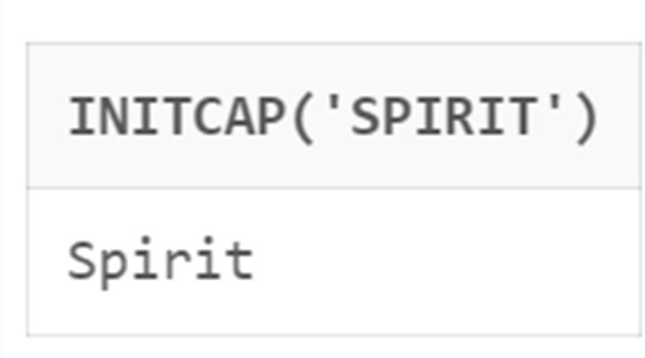

**Q2:**To demonstrate Character Manipulation Functions.

# Code:

select concat('Hello','Darling') from dual;

# Output:

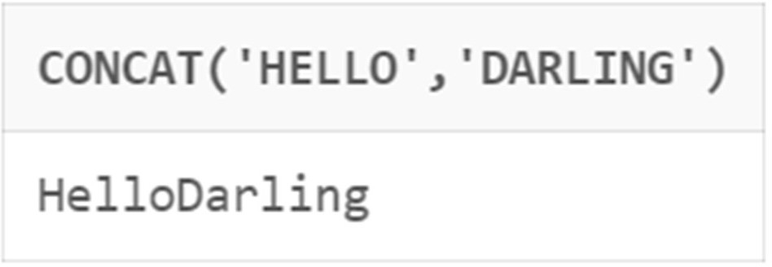

**Code:**

select length('Cricket') from dual;

# Output:

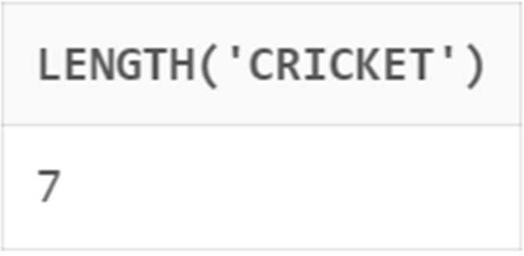

**Code:**

select instr('Infinite','i') from dual;

# Output:

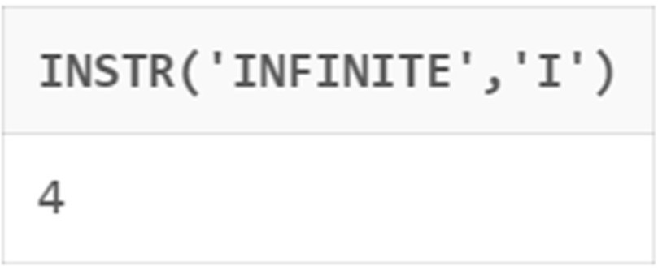

**Code:**

select substr('Bukminsterfullerene',2,10) from dual;

# Output:

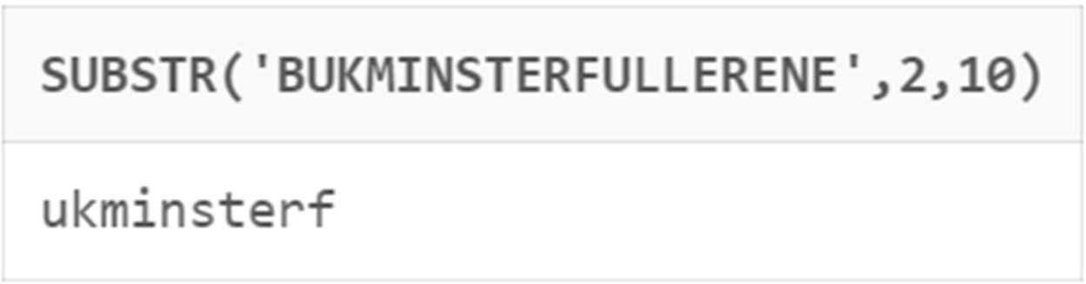

**Code:**

select lpad(1234,10,'$') from dual;

# Output:

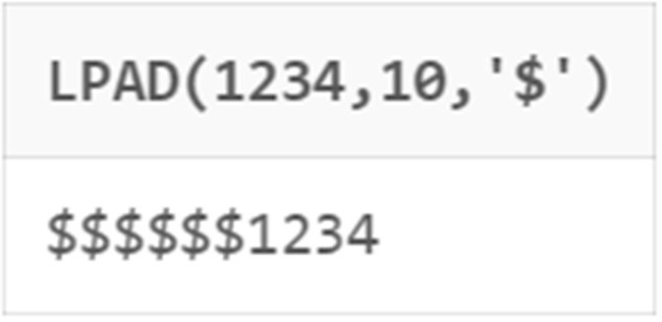

**Code:**

select rpad(1234,10,'$') from dual;

# Output:

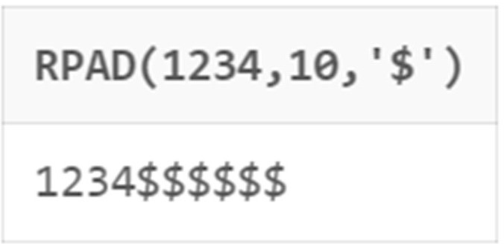

**Code:**

select trim('l' from 'HelloWorld') from dual;

# Output:

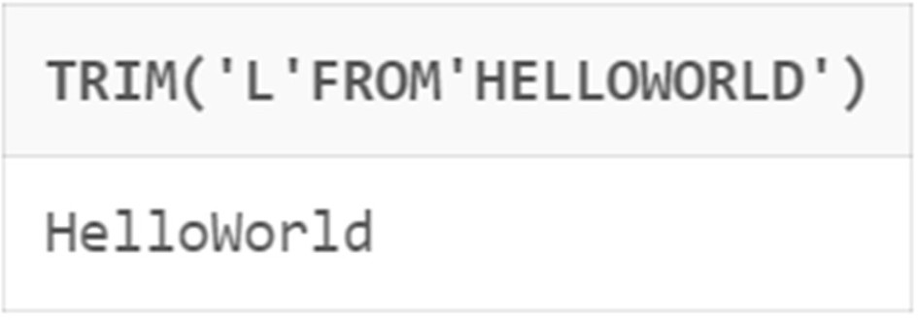

**Q3:**To demonstrate Number Functions.

# Code:

select round(60.923,1) from dual;

# Output:

**Code:**

select trunc(60.923,1) from dual;

# Output:

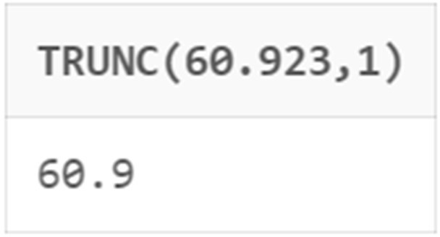

**Q4:**To demonstrate Date Functions.

# Code:

select add_months(sysdate,2) from dual;

# Output:

**Code:**

select months_between(sysdate,'10-Sep-2003') from dual;

# Output:

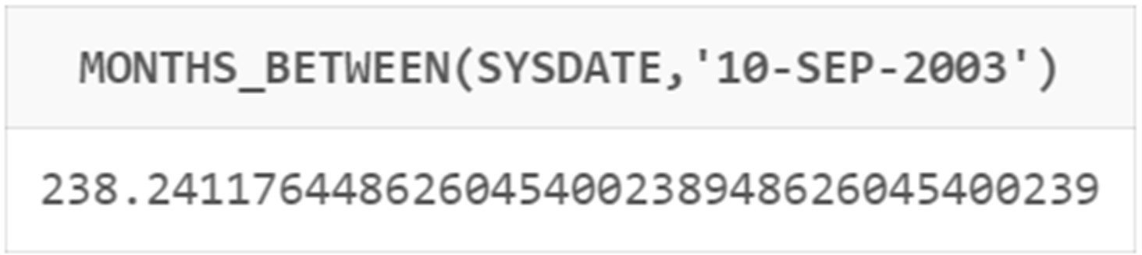

**Code:**

select next_day(sysdate,'Saturday') from dual;

# Output:

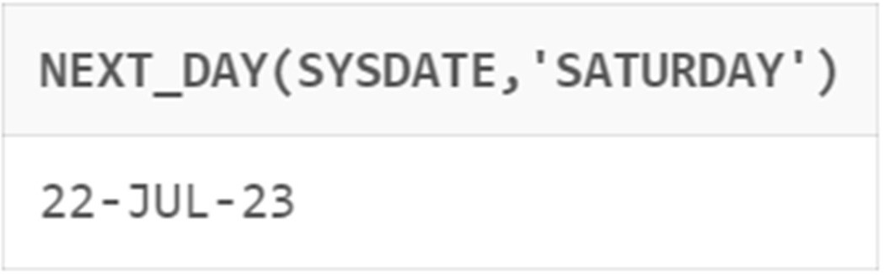

**Code:**

select last_day(sysdate) from dual;

# Output:

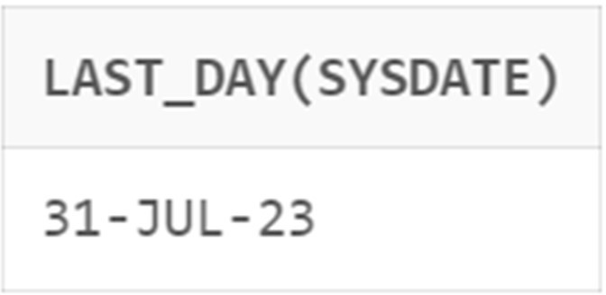

**Code:**

select round(sysdate,'Year') from dual;

# Output:

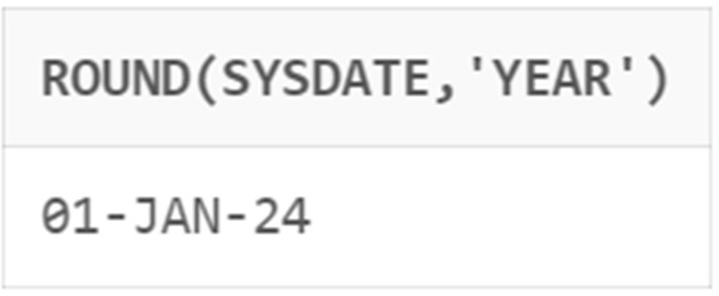

**Code:**

select trunc(sysdate,'Month') from dual;

# Output:

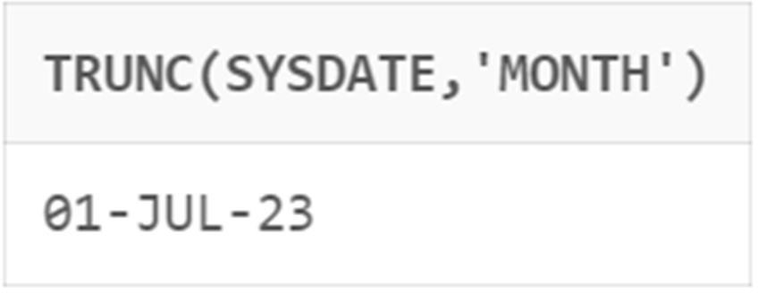

**Q5:**To demonstrate Conversion Functions.

# Code:

select to_char(sysdate,'Year') from dual;

# Output:

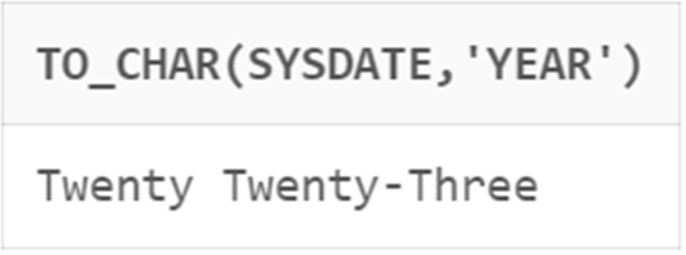

**Code:**

select to_Number('$11.3','$99.9') from dual;

# Output:

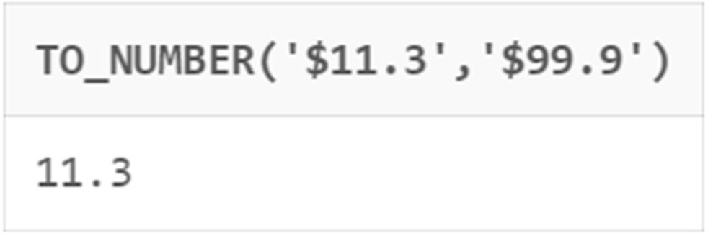

**Code:**

select to_Date('10 of September,2023','DD "of" MONTH,YYYY') from dual;

# Output:

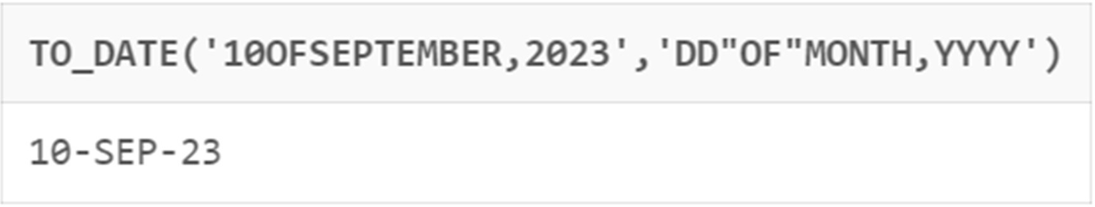

**Q6.Write queries to demonstrate all the general functions.**

**Aim:**To Demonstrate NVL Function.

# Code:

SELECT Name, NVL(Bonus, 0) AS UpdatedSalary FROM Employees;

# Output:

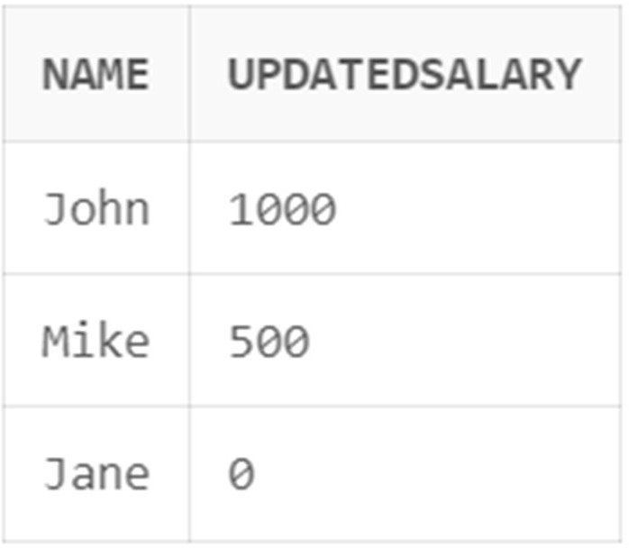

**Aim:**To Demonstrate NVL2 Function.

# Code:

SELECT Name, NVL2(Address, 'Address available', 'No address provided') AS AddressStatus FROM Customers;

# Output:

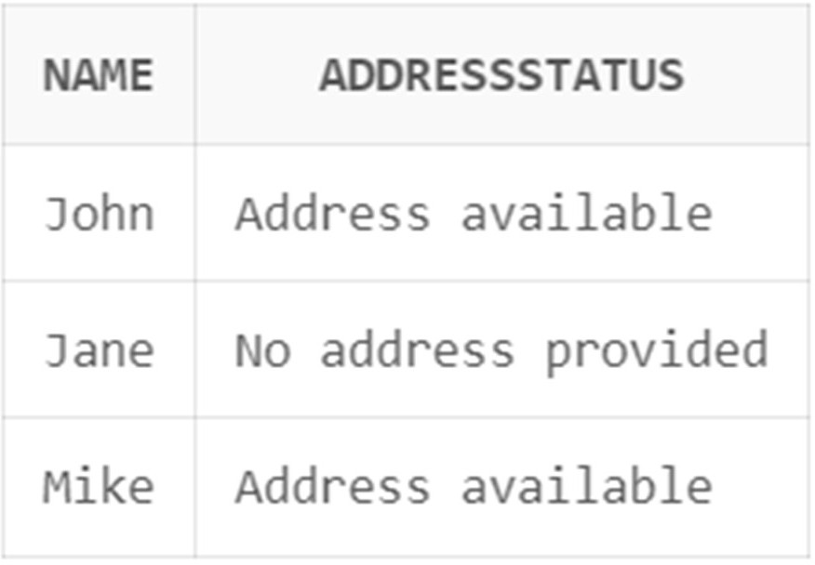

**Aim:**To Demonstrate NULLIF Function.

# Code:

SELECT ProductID, NULLIF(ProductName, 'Not available') AS UpdatedProductName

FROM Products;

# Output:

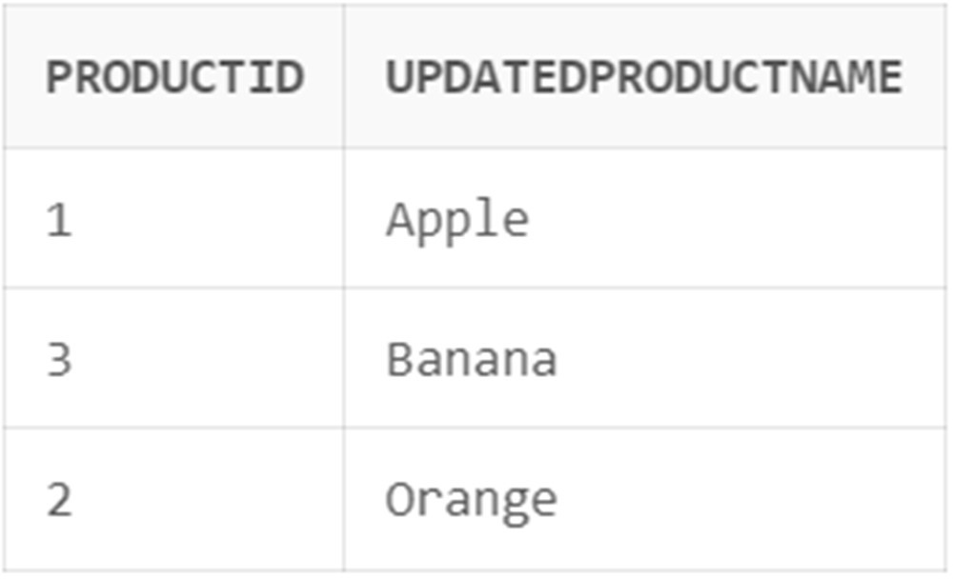

**Aim:**To Demonstrate COALESCE Function.

# Code:

SELECT Name, COALESCE(Salary + Bonus, Salary, Bonus, 0) AS TotalCompensation

FROM Employees;

# Output:

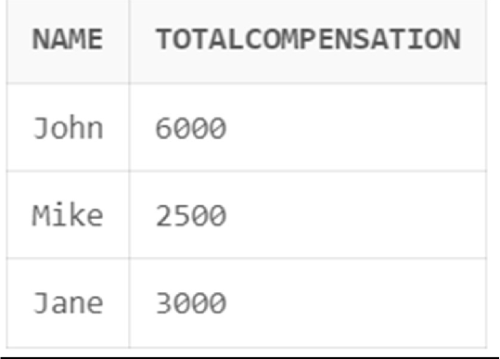

|  |  |  |  |
| --- | --- | --- | --- |
| **CHAITANYA BHARATHI INSTITUTE OF TECHNOLOGY** | | | |
| **DBMS LAB RECORD** | | | |
|  | **Course Name.: DBMS Lab** | **Experiment No.** 3 | |
| **Course Code : 20CSC17**  **Faculty : Smt.Ch.Vijaya Lakshmi** | **Branch:** CSE | **Semester:** IV |

**AIM:** Write the queries for evaluating group functions.

## THEORY:

Group functions are built-in SQL functions that operate on groups of rows and return one value for the entire group. These functions are: COUNT, MAX, MIN, AVG, SUM, DISTINCT

* COUNT (): This function returns the number of rows in the table that satisfies the condition specified in the WHERE condition. If the WHERE condition is not specified, then the query returns the total number of rows in the table.
* MAX(): This function is used to get the maximum value from a column.
* MIN(): This function is used to get the minimum value from a column.
* AVG(): This function is used to get the averagevalue of a numeric column.
* SUM(): This function is used to get the sum of a numeric column

**QUERIES:**

**Q1:**Write a query to find out the average of grades

# Query:

select avg(all grade) from customer; **Output:**

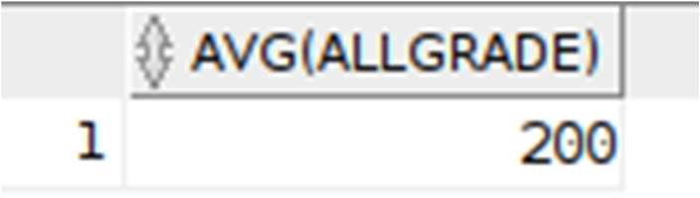

**Q2:**Write a query to find out the sum of grades

# Query:

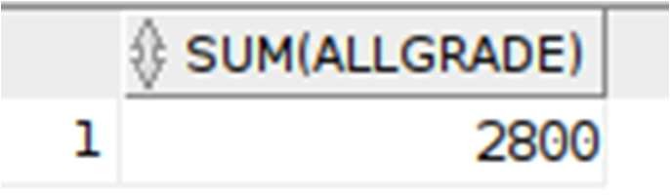select sum(all grade) from customer; **Output:**

**Q3:**Write a query to find out the minimum of grades

# Query:

select min(all grade) from customer; **Output:**

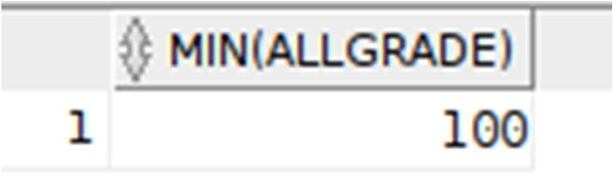

**Q4:**Write a query to find out the maximum of grades

# Query:

select min(all grade) from customer; **Output:**

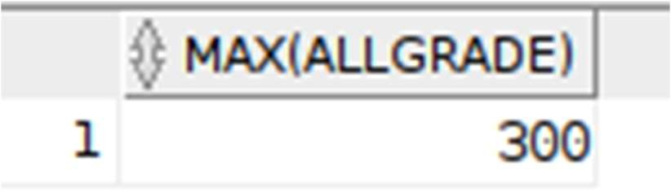

**Q5:**Write a query to find out the count of grades

# Query:

select count(all grade) from customer; **Output:**

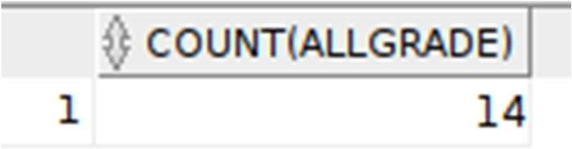

|  |  |  |  |
| --- | --- | --- | --- |
| **CHAITANYA BHARATHI INSTITUTE OF TECHNOLOGY** | | | |
| **DBMS LAB RECORD** | | | |
|  | **Course Name.: DBMS Lab** | **Experiment No.** 4 | |
| **Course Code : 20CSC17**  **Faculty : Smt.Ch.Vijaya Lakshmi** | **Branch:** CSE | **Semester:** IV |

**AIM:** Write the SQL queries using ‘groupby’ function.

## THEORY:

The SQL **GROUP BY** clause is used in collaboration with the SELECT statement to arrange identical data into groups. This GROUP BY clause follows the WHERE clause in a SELECT statement and precedes the ORDER BY clause. We know that WHERE clause is used to place conditions on columns but what if we want to place conditions on groups the HAVING clause comes into use. We can use HAVING clause to place conditions to decide which group will be the part of final result-set. Also we can not use the aggregate functions like SUM(), COUNT() etc. with WHERE clause. So we have to use HAVING clause if we want to use any of these functions in the conditions.

## SYNTAX:

SELECT *column_name(s)* FROM *table_name* WHERE *condition*

GROUP BY *column_name(s)*

ORDER BY *column_name(s);*

**QUERIES:**

**Q1:**Write a query to demonstrate groupby class.

# Query:

select count(all grade),city from customer

group by(city);

# Output:

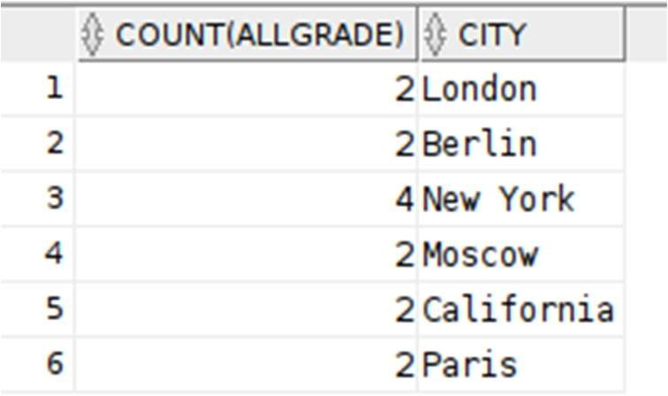

**Q2:**Write a query to demonstrate group function without using groupby class

# Query:

select count(all grade),city from customer;

# Output:

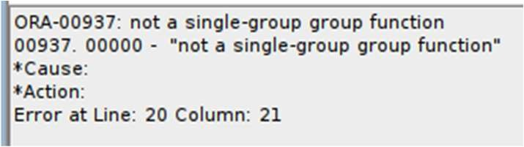

**Q3:**Write a query to demonstrate having class

# Query:

select count(all grade),city from customer

group by(city)

having city in 'New York';

# Output:

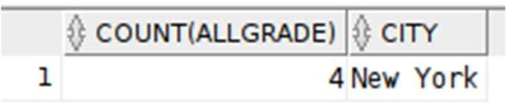

**Q4:**Write a query to demonstrate nesting function.

# Query:

select city,avg(NVL(grade,0)) from customer

group by city;

# Output:

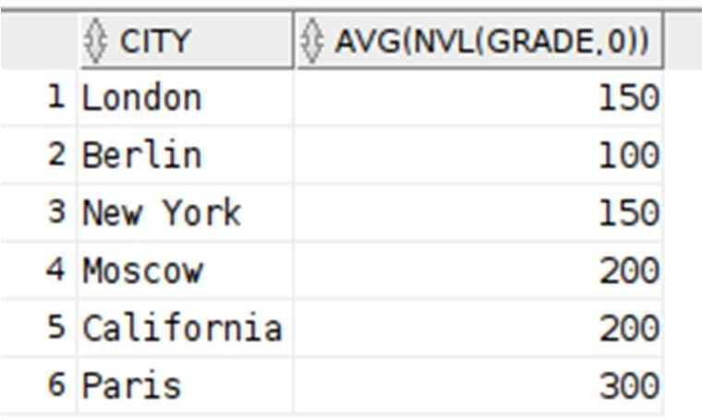

|  |  |  |  |
| --- | --- | --- | --- |
| **CHAITANYA BHARATHI INSTITUTE OF TECHNOLOGY** | | | |
| **DBMS LAB RECORD** | | | |
|  | **Course Name.: DBMS Lab** | **Experiment No.** 5 | |
| **Course Code : 20CSC17**  **Faculty : Smt.Ch.Vijaya Lakshmi** | **Branch:** CSE | **Semester:** IV |

**AIM:** Write the queries to demonstrate various constraints in SQL.

## THEORY:

Constraints are the rules enforced on the data columns of a table. These are used to limit the type of data that can go into a table. This ensures the accuracy and reliability of the data in the database.

Constraints could be either on a column level or a table level. The column level constraints are applied only to one column, whereas the table level constraints are applied to the whole table.

Following are some of the most commonly used constraints available in SQL.

* NOT NULL Constraint − Ensures that a column cannot have NULL value.
* UNIQUE Constraint − Ensures that all values in a column are diﬀerent.
* PRIMARY Key − Uniquely identifies each row/record in a database table.
* FOREIGN Key − Uniquely identifies a row/record in any of the given database table.
* CHECK Constraint − The CHECK constraint ensures that all the values in a column satisfies certain conditions.

Constraints can be specified when a table is created with the CREATE TABLE statement or you can use the ALTER TABLE statement to create constraints even after the table is created.

# QUERIES:

**Q1.** NOT NULL AND UNIQUE

# CODE:

create table student1 (

sid number(15) not null, sname varchar2(20) unique,

ctno number(20)

);

insert into student1 values(35,'Karthik',8522060065);

select * from student1;

# OUTPUT:

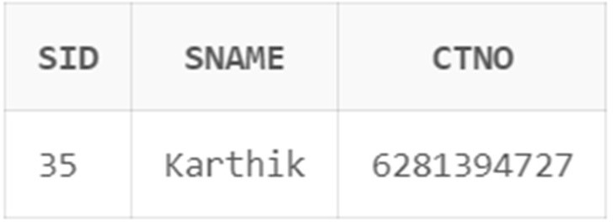

**CODE :**

insert into student1 values(NULL,'Siri',8308309498);

ERROR

# CODE:

insert into student1 values(35,'Karthik',9319319310);

ERROR

**Q2.** PRIMARY KEY

# CODE:

create table dept (

did number(10) primary key, dname varchar2(20),

HOD char(20) );

insert into dept values(10,'CSE','MSD'); insert into dept values(20,'IT','VK'); insert into dept

values(30,'EEE','FAF');

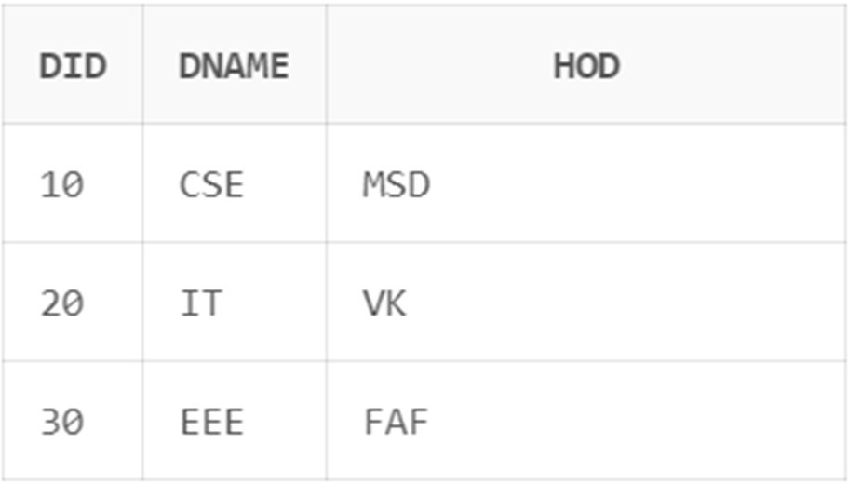select * from dept; TABLE

**Q3.**FOREIGN KEY

# CODE:

create table emp (

eid number(10) primary key, ename char(20),

sal number(9),

did number(10), constraint emp_did_fk foreign key(did) References dept(did)

);

insert into emp values(1,'Karthik',55555,30); insert into emp values(2,'Virat',50555,30); insert into emp values(3,'Faf',51555,20); insert into emp values(4,'Max',54555,10);

select * from emp;

TABLE

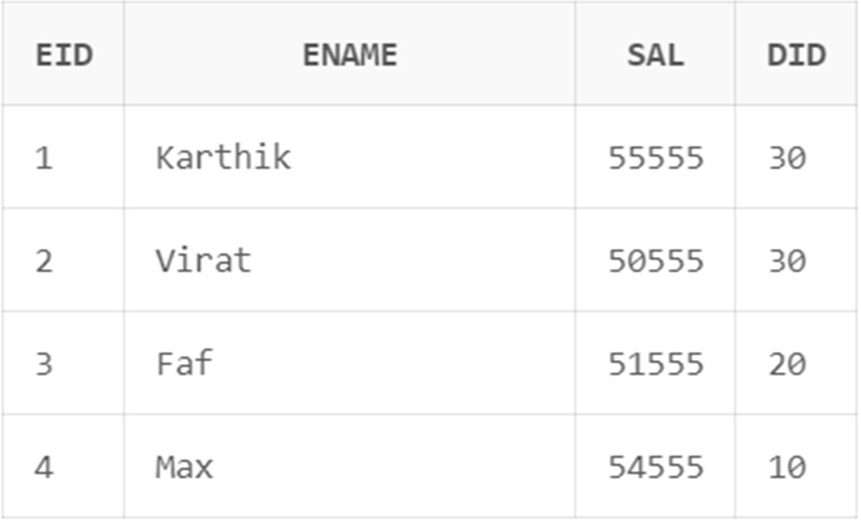

# CODE:

insert into emp values(5,'DK',56555,40);

ERROR

**Q4.**ON DELETE CASCADE

# CODE:

delete from dept where did=30;

ERROR

# CODE:

delete from dept where did=30; select *

from emp; select * from dept;

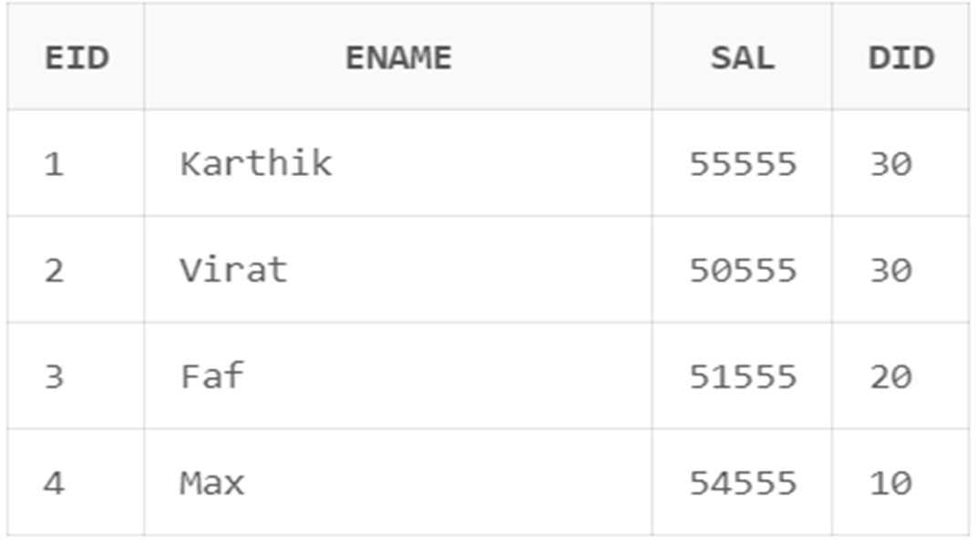DEPT TABLE

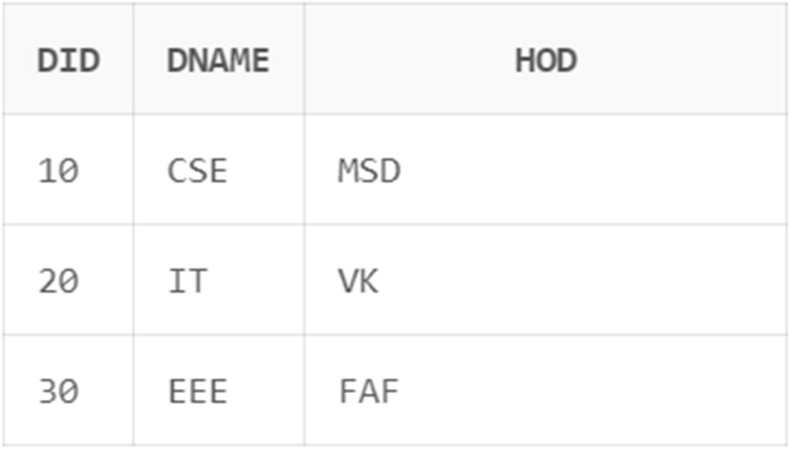EMP TABLE

**Q5.**ON DELETE SET NULL

# CODE:

delete from dept where did=30;

select * from emp; select

* from DEPT;

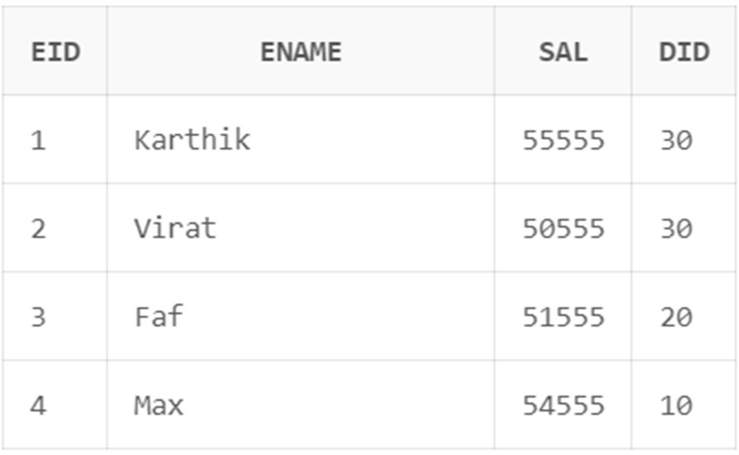EMP TABLE

DEPT TABLE

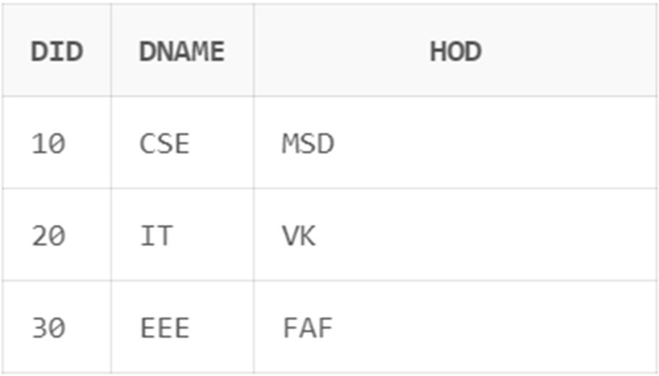

**Q6.**CHECK

# CODE:

create table student2( sid int,

smarks int check (smarks<=100));

insert into student2 values(1,125);

ERROR

|  |  |  |  |
| --- | --- | --- | --- |
| **CHAITANYA BHARATHI INSTITUTE OF TECHNOLOGY** | | | |
| **DBMS LAB RECORD** | | | |
|  | **Course Name.: DBMS Lab** | **Experiment No.** 6 | |
| **Course Code : 20CSC17**  **Faculty : Smt.Ch.Vijaya Lakshmi** | **Branch:** CSE | **Semester:** IV |

**AIM:** Write the queries to demonstrate various joins and views in SQL.

## THEORY:

The SQL Joins clause is used to combine records from two or more tables in a database. A JOIN is a means for combining fields from two tables by using values common to each.

Here are the different types of the JOINs in SQL:

* CROSS JOIN:Returns all rows in first table joined to all rows in second table.
* (INNER) JOIN: Returns records that have matching values in both tables
* LEFT (OUTER) JOIN: Return all records from the left table, and the matched records from the right table
* RIGHT (OUTER) JOIN: Return all records from the right table, and the matched records from the left table
* FULL (OUTER) JOIN: Return all records when there is a match in either left or right table
* EQUI JOIN: Returns records based on the equality condition specified.
* NATURAL JOIN: Automatically joins the matching columns in two tables and retuens matching records.

A view is nothing more than a SQL statement that is stored in the database with an associated name. A view is actually a composition of a table in the form of a predefined SQL query.

A view can contain all rows of a table or select rows from a table. A view can be created from one or many tables which depends on the written SQL query to create a view.

Views, which are a type of virtual tables allow users to do the following −

* Structure data in a way that users or classes of users find natural or intuitive.
* Restrict access to the data in such a way that a user can see and (sometimes) modify exactly what they need and no more.

The WITH CHECK OPTION is a CREATE VIEW statement option. The purpose of the WITH CHECK OPTION is to ensure that all UPDATE and INSERTs satisfy the condition(s) in the view definition.

**QUERIES: Q1.JOINS:**

# CROSS JOIN

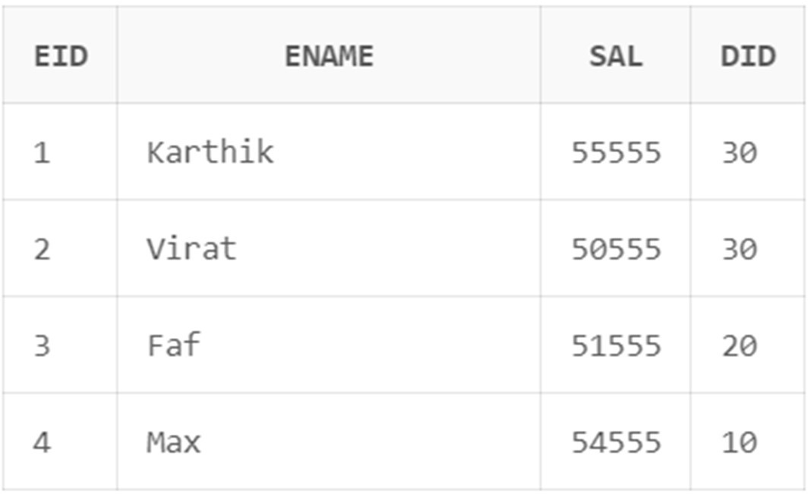EMP TABLE

DEPT TABLE

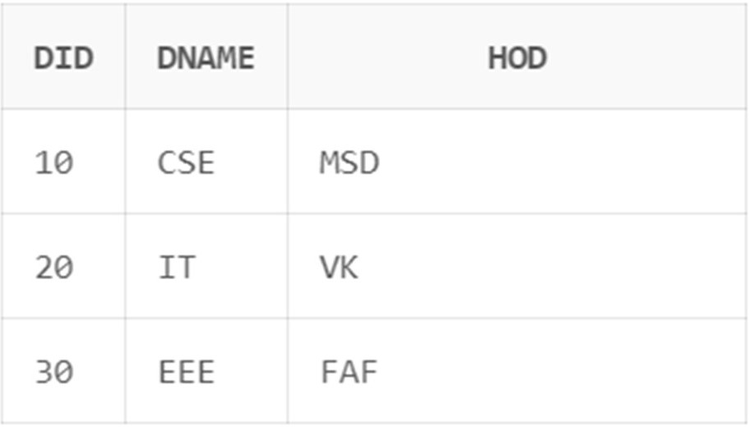

# CODE:

OLDER VERSION

select eid,ename,dname from emp,dept;

# OUTPUT:

**NEW VERSION**

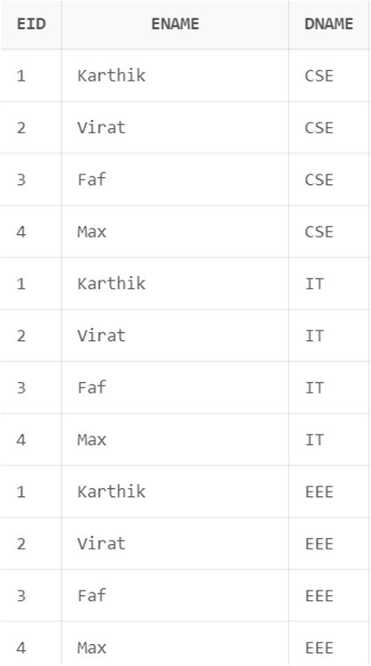select eid,ename,dname from emp cross join dept; **OUTPUT**

# NATURAL JOIN / EQUI JOIN OLDER VERSION CODE

select eid,ename,dname from emp,dept where emp.DID = dept.DID;

# OUTPUT

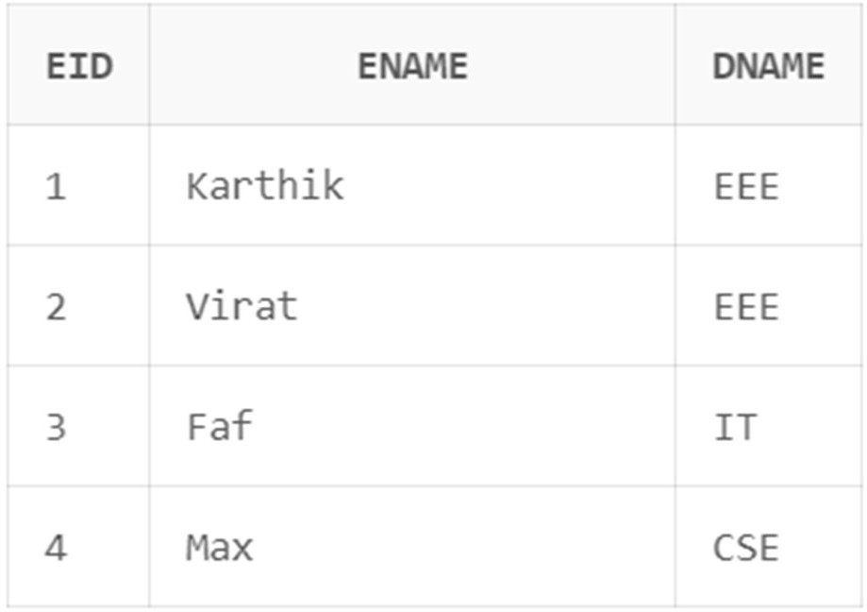

**NEW VERSION CODE**

select eid,ename,dname from emp natural join dept;

# OUTPUT

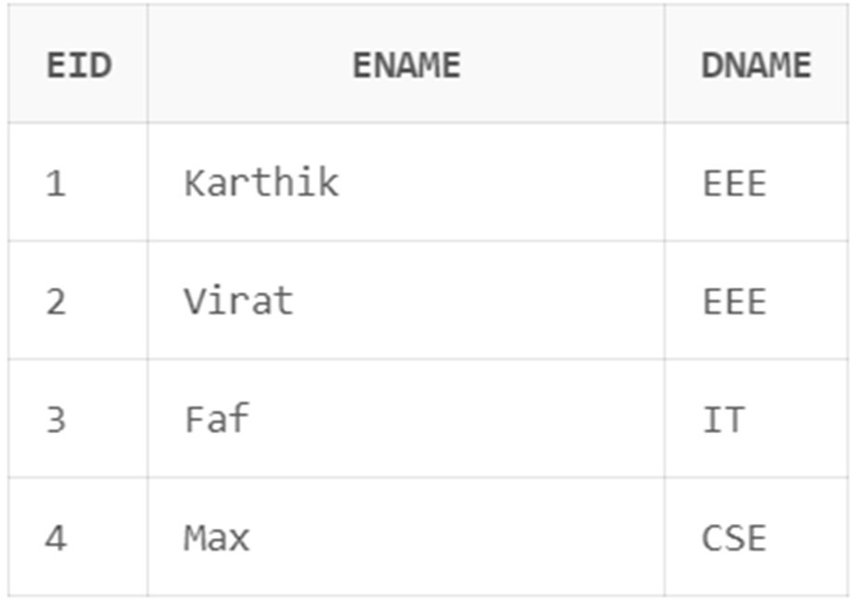

1. **ON CLAUSE**

# NEW VERSION CODE

select eid,ename,dname from emp join dept on emp.DID = dept.DID;

# OUTPUT

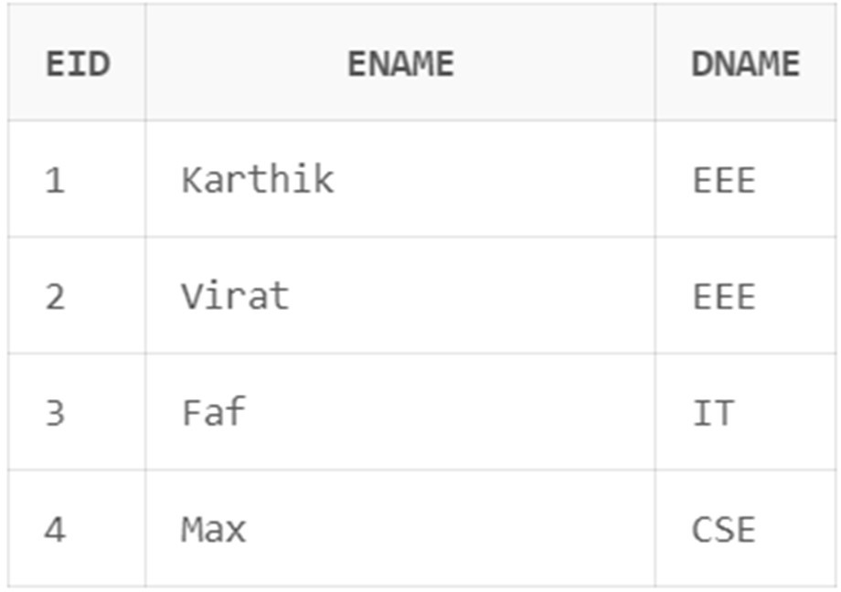

GRADES TABLE

create table grades ( grade char(1), lowest number(6), highest number(6)

);

insert into grades values('A',50000,52000); insert into grades values('B',52001,54000); insert into grades values('C',54001,56000); select * from grades;

# OUTPUT

1. **NON-EQUI JOIN OLDER VERSION**

Select eid,ename,sal,grade From emp,grades

Where sal between lowest and highest;

# OUTPUT

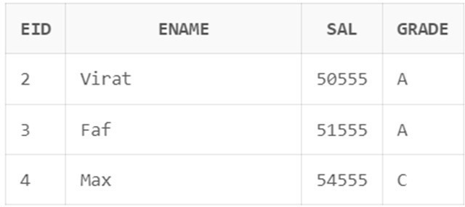

1. **LEFT OUTER JOIN CODE:**

select eid,ename,e.did from emp e,dept d where (e.did=d.did(+));

# OUTPUT:

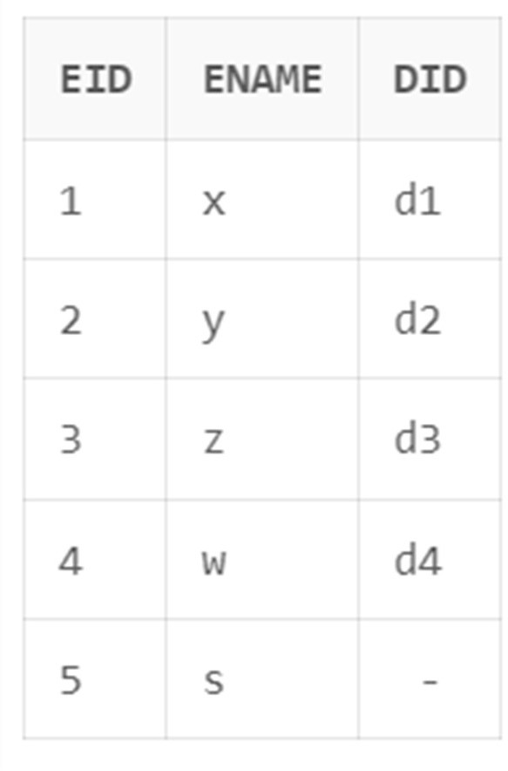

1. **RIGHT OUTER JOIN CODE:**

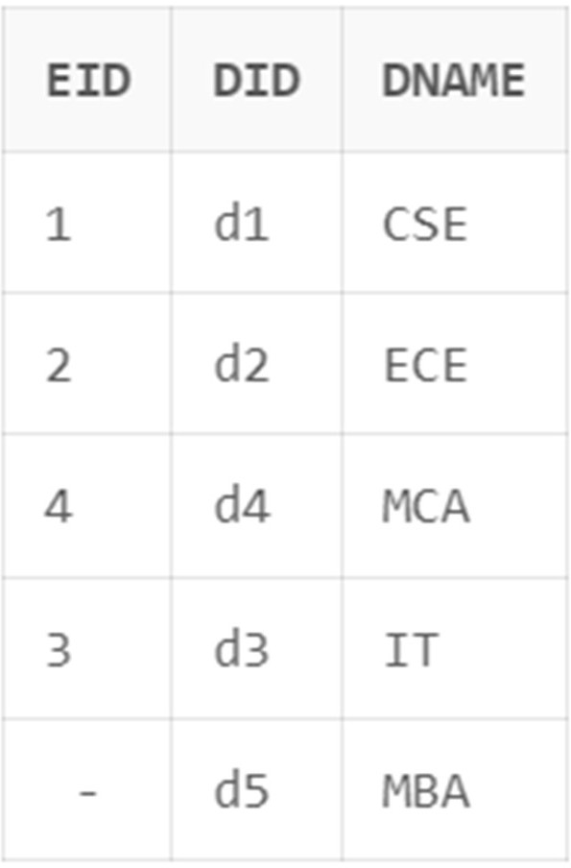select eid,did,dname from emp e,dept d where (e.did(+)=d.did); **OUTPUT:**

**Q2.VIEWS:**

1. **Aim:** Create a view to display all employees.

# Code:

*create or replace view emp_d1 as*

*select * from emp1*

# Output:

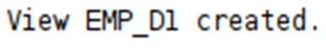

1. **Aim:**Inserting into created view

# Code:

*insert into emp_d1 values(18000,5,'a','d4');*

# Output:

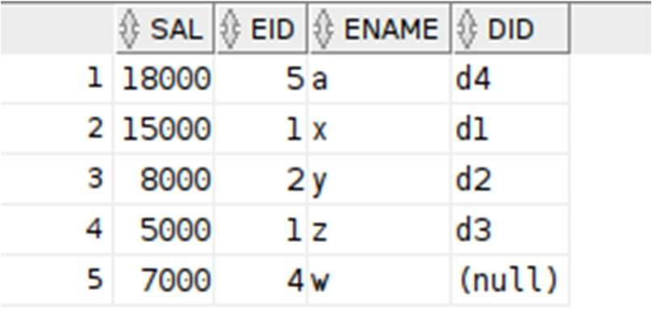

1. **Aim:**Updating the created view.

# Code:

*update emp_d1 set sal=18001 where did='d4';*

# Output:

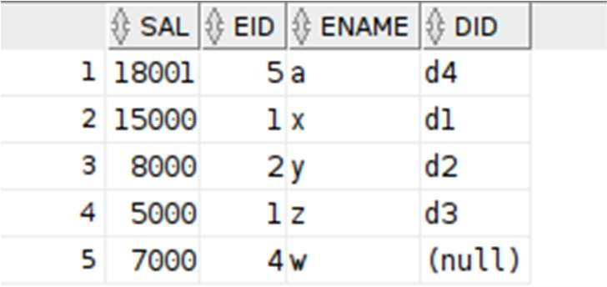

1. **Aim:**Deleting the view.

# Code:

*delete from emp_d1 where did is null;*

# Output:

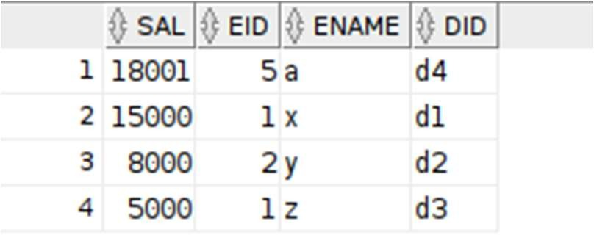

1. **Aim:**

Inserting the data into view that contain groupfn.

# Code:

*create or replace view emp_grpfn as select min(sal) as Minimum_S from emp1;*

*select \**

*from emp_grpfn;*

*insert into emp_grpfn values(18999);*

# Output:

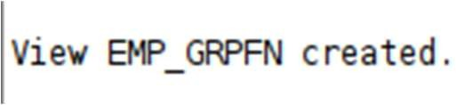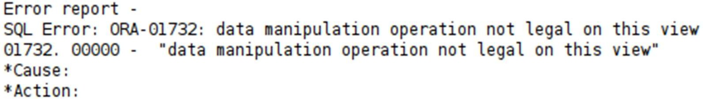

**Q3.SUB-QUERIES:**

# AIM:

From the salesman and orders tables, find all the orders issued by

the salesman 'Paul Adam', Return ord_no, purch_amt, ord_date, customer_id and salesman_id.

# CODE:

*SELECT \**

*FROM orders*

*WHERE salesman_id = (SELECT salesman_id FROM SALESPEOPLE*

*WHERE name='paul adam');*

# OUTPUT:



1. **AIM:**

From the salesman and orders tables, find all the orders, which are generated by those salespeople, who live in the city of London.Return ord_no, purch_amt, ord_date, customer_id, salesman_id.

# CODE:

*select * from orders*

*where SALESMAN_ID=(select salesman_id from SALESPEOPLE*

*where city='london');*

# OUTPUT:



1. **AIM:**

From the orders table, find the orders generated by the salespeople who works for customers whose id is 3007. Return ord_no, purch_amt, ord_date, customer_id, salesman_id. A customer can works only with a salespeople.

# CODE:

*SELECT \**

*FROM orders*

*WHERE salesman_id =*

*(SELECT DISTINCT salesman_id FROM orders*

*WHERE customer_id =3007);*

# OUTPUT:

1. **AIM:**

From the orders table, find the order values greater than the average order value of 10th October 2012. Return ord_no, purch_amt, ord_date, customer_id, salesman_id.

# CODE:

*SELECT \**

*FROM orders WHERE purch_amt >*

*(SELECT AVG(purch_amt) FROM orders*

*WHERE ord_date ='10-Oct-2012');*

# OUTPUT:

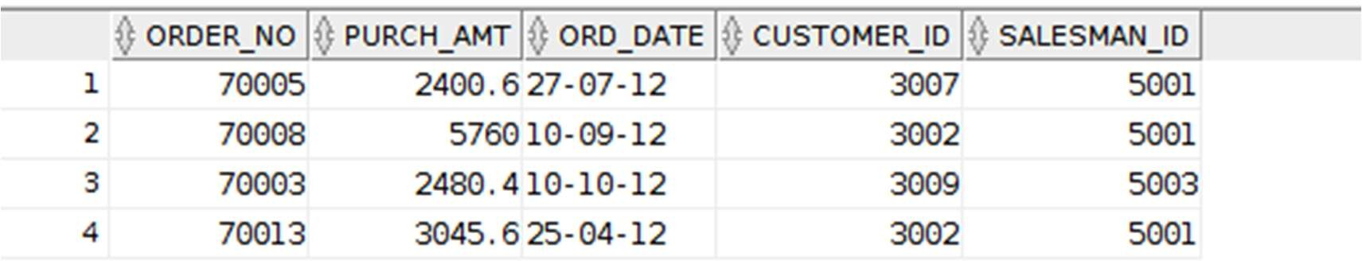

1. **AIM:**

From the salesman and orders tables, find all the orders generated in New York city. Return ord_no, purch_amt, ord_date, customer_id and salesman_id.

# CODE:

*select * from orders*

*where SALESMAN_ID=(select salesman_id from SALESPEOPLE*

*where city='new york');*

# OUTPUT:

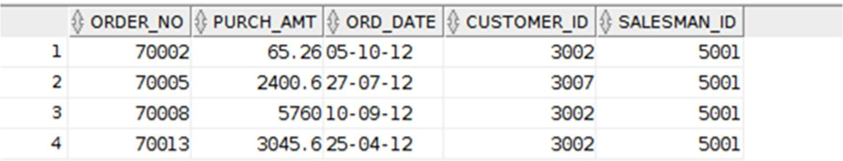

1. **AIM:**

From the customer and salesman tables, find the commission of the salespeople work in Paris City. Return commission.

# CODE:

*select commision from SALESPEOPLE*

*where SALESMAN_ID in (select salesman_id from CUSTOMER*

*where city='Paris');*

# OUTPUT:



1. **AIM:**

Write a query to display all the customers whose id is 2001 bellow the salesman ID of Mc Lyon.

# CODE:

*SELECT \**

*FROM customer WHERE customer_id =*

*(SELECT salesman_id -2001 FROM SALESPEOPLE*

*WHERE name = 'mc lyon');*

# OUTPUT:



1. **AIM:**

From the customer table, count number of customers with grades above the average grades of New York City. Return grade and count.

# CODE:

*SELECT grade, COUNT (*) FROM customer*

*GROUP BY grade HAVING grade >*

*(SELECT AVG(grade)*

*FROM customer*

*WHERE city = 'New York');*

# OUTPUT:

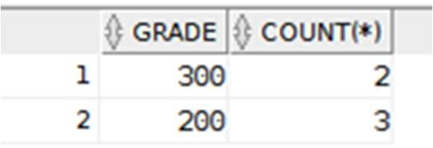

1. **AIM:**

From the salesman and orders tables, find those salespeople who earned the maximum commission. Return ord_no, purch_amt, ord_date, and salesman_id.

# CODE:

*SELECT order_no, purch_amt, ord_date, salesman_id FROM orders*

*WHERE salesman_id IN( SELECT salesman_id FROM salespeople WHERE commision = ( SELECT MAX(commision) FROM salespeople));*

# OUTPUT:

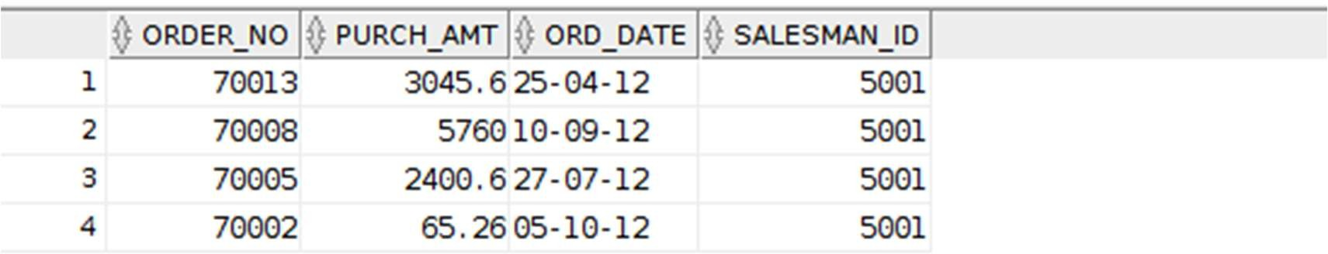

1. **AIM:**

From the customer and orders tables, find the customers whose orders issued on 17th August, 2012. Return ord_no, purch_amt, ord_date, customer_id, salesman_id and cust_name.

# CODE:

*SELECT b.*, a.cust_name FROM orders b, customer a*

*WHERE a.customer_id=b.customer_id AND b.ord_date='17-Aug-2012';*

# OUTPUT:

1. **AIM:**

From the customer and salesman tables, find the salespeople who had more than one customer. Return salesman_id and name.

# CODE:

*SELECT salesman_id,name FROM SALESPEOPLE a WHERE 1 <*

*(SELECT COUNT(*)*

*FROM customer*

*WHERE salesman_id=a.salesman_id);*

# OUTPUT:

1. **AIM:**

From the orders table, find those orders, which are equal or higher than average amount of the orders. Return ord_no, purch_amt, ord_date, customer_id and salesman_id.

# CODE:

*select * from orders*

*where PURCH_AMT>=( select avg(purch_amt) from orders);*

# OUTPUT:

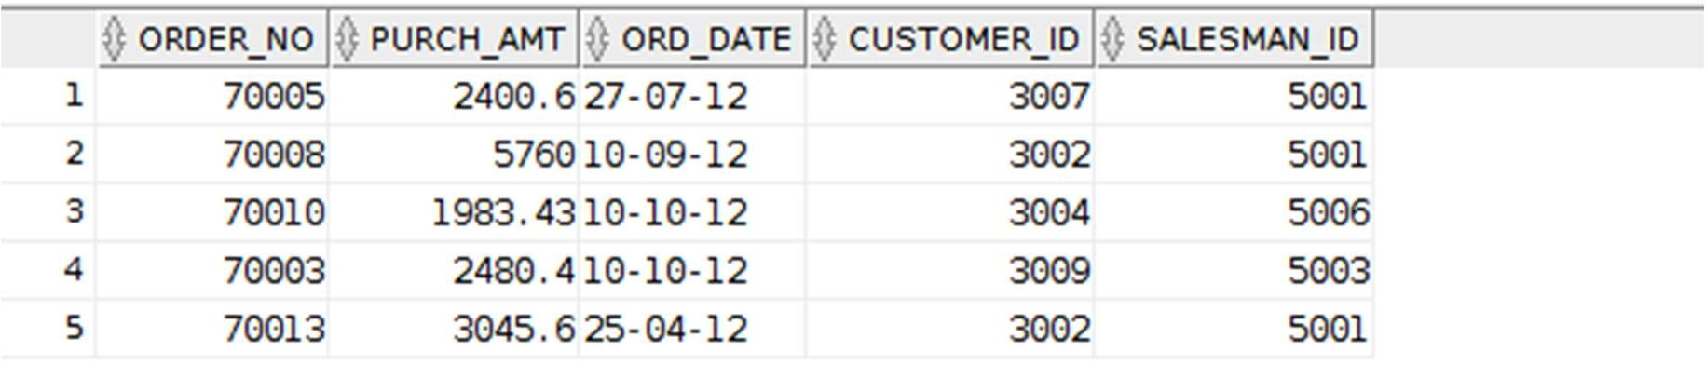

1. **AIM:**

From the customer and salesman tables, find the salespeople who deal a single customer. Return salesman_id, name, city and commission.

# CODE:

*SELECT \**

*FROM SALESPEOPLE a WHERE 1 =*

*(SELECT COUNT(*)*

*FROM customer*

*WHERE salesman_id=a.salesman_id);*

# OUTPUT:

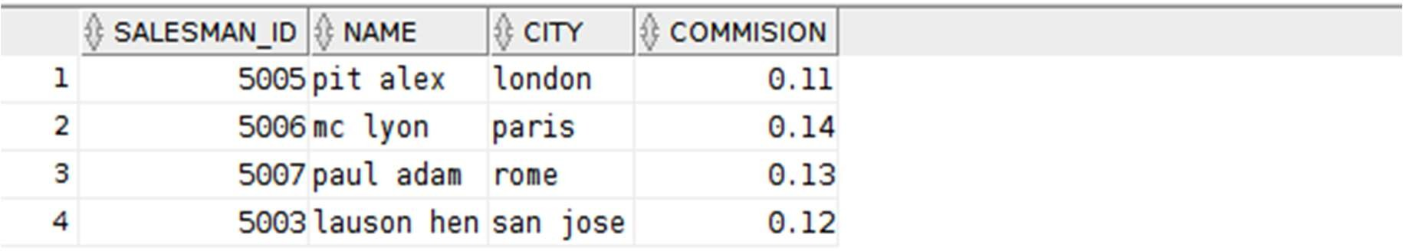

1. **AIM:**

From the salesman and orders tables, find the salespeople who deal the customers with more than one order. Return salesman_id, name, city and commission.

# CODE:

*SELECT \**

*FROM SALESPEOPLE a WHERE 1 <*

*(SELECT COUNT(*) FROM ORDERS*

*WHERE salesman_id=a.salesman_id);*

# OUTPUT:

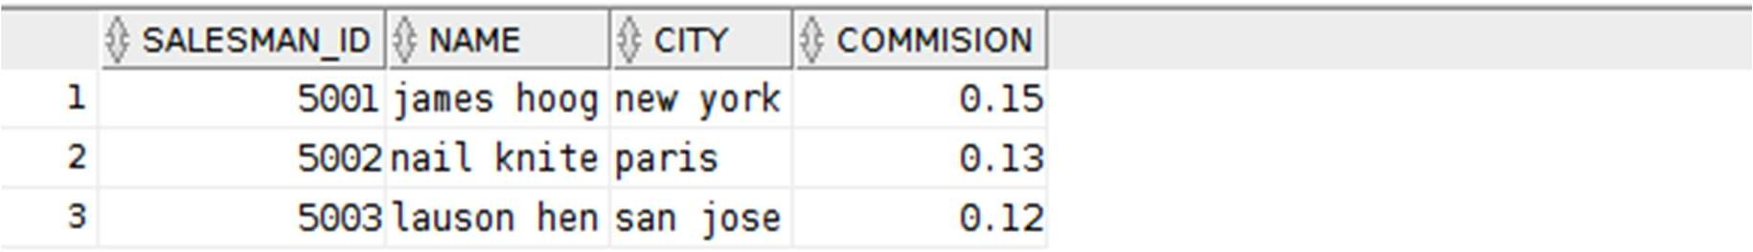

1. **AIM:**

From the customer and salesman tables, find the salespeople who deals those customers who live in the same city. Return salesman_id, name, city and commission.

# CODE:

*select * from sales*

*where city in (select city from customer);*

# OUTPUT:

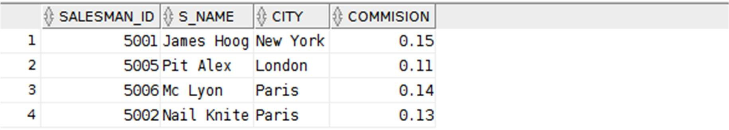

1. **AIM:**

From the customer and salesman tables, find the

salespeople whose place of living (city) matches with any of the city where customers live. Return salesman_id, name, city and commission.

# CODE:

*select * from sales*

*where city in (select city from customer);*

# OUTPUT:

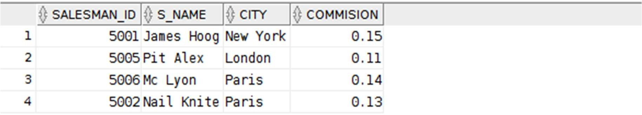

1. **AIM:**

From the orders table, find all those orders whose order amount greater than at least one of the orders of September 10th 2012. Return ord_no, purch_amt, ord_date, customer_id and salesman_id.

# CODE:

*SELECT \**

*FROM orders*

*WHERE purch_amt >ANY (SELECT purch_amt FROM orders*

*WHERE ord_date ='10-Sep-2012');*

# OUTPUT:

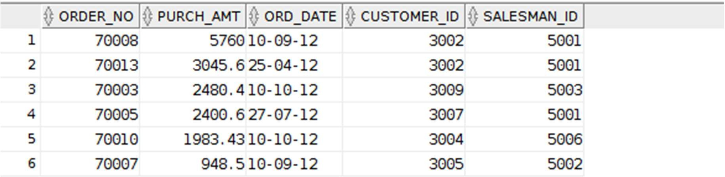

1. **AIM:**

From the customer and orders tables, find those orders where an order amount less than any order amount of a customer lives in London City. Return ord_no, purch_amt, ord_date, customer_id and salesman_id.

# CODE:

*select * from orders*

*where PURCH_AMT <ANY (SELECT purch_amt FROM orders a, customer b*

*WHERE a.customer_id=b.customer_id AND b.city='London');*

# OUTPUT:

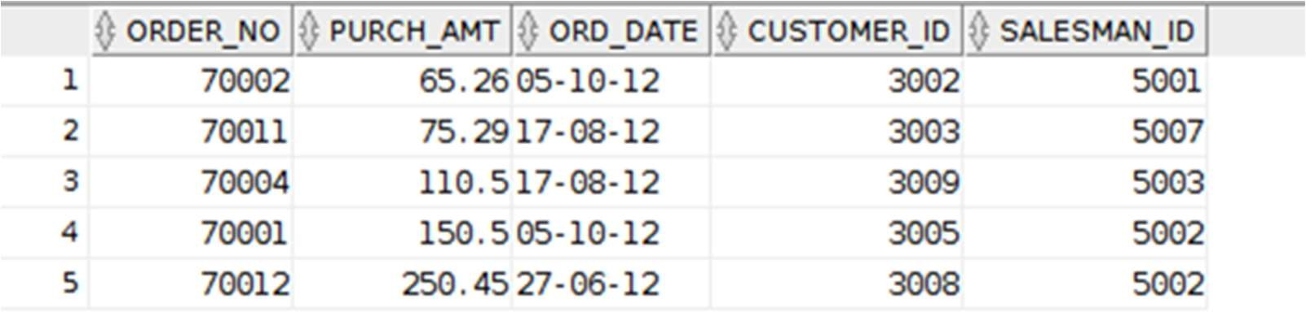

1. **AIM:**

From the customer and orders tables, find those orders where every order amount less than the maximum order amount of a customer lives in London City. Return ord_no, purch_amt, ord_date, customer_id and salesman_id.

# CODE:

*SELECT \**

*FROM orders WHERE purch_amt <*

*(SELECT MAX (purch_amt)*

*FROM orders a, customer b*

*WHERE a.customer_id=b.customer_id AND b.city='London');*

# OUTPUT:

1. **AIM:**

From the customer table, find those customers whose grade are higher than customers living in New York City. Return customer_id, cust_name, city, grade and salesman_id.

# CODE:

*select \**

*from CUSTOMER*

*where grade>ANY ( select grade from customer*

*where city='New York');*

# OUTPUT:

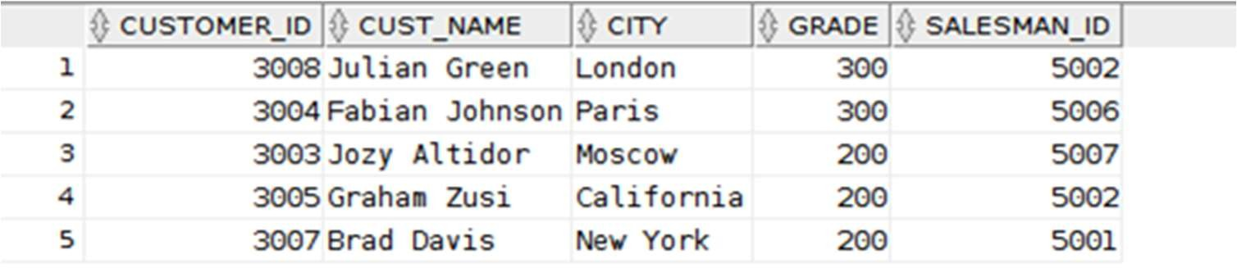

1. **AIM:**

From the customer table, find those customers whose grade doesn't same of those customers live in London City. Return customer_id, cust_name, city, grade and salesman_id.

# CODE:

*select \**

*from CUSTOMER*

*where grade<>ANY ( select grade from customer*

*where city='London');*

# OUTPUT:

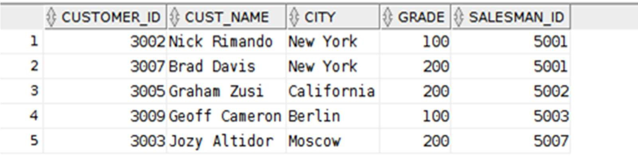

1. **AIM:**

From the customer table, find those customers whose grade are not same of those customers living in Paris. Return customer_id, cust_name, city, grade and salesman_id.

# CODE:

*select \**

*from CUSTOMER*

*where grade<>ANY ( select grade from customer*

*where city='Paris');*

# OUTPUT:

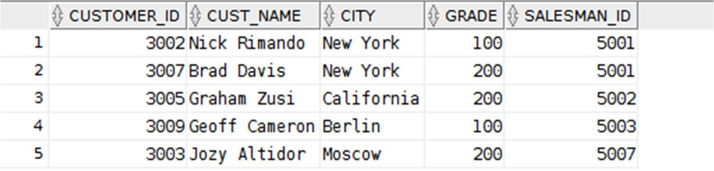

1. **AIM:**

From the employee department and employee details tables, find those employees who work for the department where the department allotment amount is more than Rs. 50000. Return emp_fname and emp_Iname.

# CODE:

*SELECT emp_fname, emp_lname FROM emp_details*

*WHERE emp_dept IN (SELECT dpt_code*

*FROM emp_dept*

*WHERE dpt_allotment > 50000);*

# OUTPUT:

1. **AIM:**

From the employee department table, find the departments where the sanction amount is higher than the average sanction amount of all the departments. Return dpt_code, dpt_name and dpt_allotment.

# CODE:

*SELECT \**

*FROM emp_dept WHERE dpt_allotment > (*

*SELECT AVG(dpt_allotment) FROM emp_dept*

*);*

# OUTPUT:

1. **AIM:**

From the employee department and employee details tables, find the departments where more than two employees work. Return dpt_name.

# CODE:

*select dpt_name from emp_dept*

*where dpt_code in ( select emp_dept from EMP_DETAILS*

*group by emp_dept having count(*)>2);*

# OUTPUT:

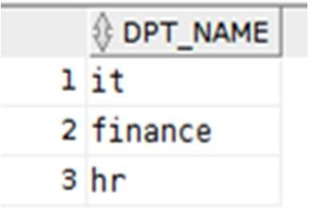

|  |  |  |  |
| --- | --- | --- | --- |
| **CHAITANYA BHARATHI INSTITUTE OF TECHNOLOGY** | | | |
| **DBMS LAB RECORD** | | | |
|  | **Course Name.: DBMS Lab** | **Experiment No.** 7 | |
| **Course Code : 20CSC17**  **Faculty : Smt.Ch.Vijaya Lakshmi** | **Branch:** CSE | **Semester:** IV |

**AIM:** Implementation of PL/SQL queries.

## THEORY:

PL/SQL is a combination of SQL along with the procedural features of programming languages. It was developed by Oracle Corporation in the early 90's to enhance the capabilities of SQL. PL/SQL is one of three key programming languages embedded in the Oracle Database, along with SQL itself and Java.

* Applications written in PL/SQL are fully portable.
* PL/SQL provides high security level.
* PL/SQL provides access to predefined SQL packages.
* PL/SQL provides support for Object-Oriented Programming.
* PL/SQL provides support for developing Web Applications and Server Pages.

Syntax:

Declare

-variables, cursors, user defined exceptions

Begin

-SQL statements

-PL/SQL statements

Exception (optional)

-Action performed

End;

**QUERIES:**

**Q1:**Write a basic query to demonstrate print statement.

# Code:

*set SERVEROUTPUT ON;*

*begin*

*DBMS_OUTPUT.PUT_LINE('Hello World This is Karthik'); END;*

# Output:

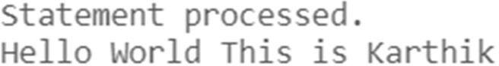

**Q2:**Write a query to demonstrate Retrieving data from database servers.

# Code:

*set SERVEROUTPUT ON;*

*declare*

*v_name char(10); v_branch char(10); begin*

*select name,branch into v_name,v_branch from student*

*where id=37;*

*DBMS_OUTPUT.PUT_LINE('Hello CBIT '||v_name||v_branch); END;*

# Output:

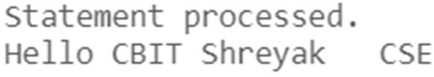

**Q3:**Write a query to demonstrate for creating variable dependent on another variable.

# Code:

set SERVEROUTPUT ON;

declare

v_name Student.name%type:='Vidyanand'; v_branch Student.branch%type:='CSE'; v_id Student.id%type:='306';

v_mail Student.emailid%type:='ugs21306@cbit.org.in'; begin

INSERT INTO Student VALUES(v_id,v_name,v_branch,v_mail);

DBMS_OUTPUT.PUT_LINE('Hello CBIT '||v_name||' '||v_branch||' '||v_id||' '||v_mail); end;

# Output:



**Q4:**Write a query to demonstrate Implicit Cursor.

# Code:

set SERVEROUTPUT ON; DECLARE

v_num_rows NUMBER; BEGIN

-- Update salaries of employees UPDATE employees

SET salary = salary * 1.1 WHERE department_id = 10;

-- Get the number of updated rows v_num_rows := SQL%ROWCOUNT;

-- Print the number of updated rows DBMS_OUTPUT.PUT_LINE('Number of updated rows: ' || v_num_rows);

END;

# Output:

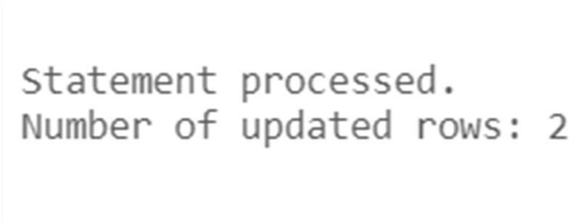

**Q5.**Write a query to demonstrate conditional statements.

# Code:

set SERVEROUTPUT ON; DECLARE

v_employee_name employees.last_name%TYPE := 'Smith'; v_employee_salary employees.salary%TYPE;

BEGIN

-- Retrieve the salary of the employee SELECT salary INTO v_employee_salary FROM employees

WHERE last_name = v_employee_name;

-- Check if the employee exists

IF v_employee_salary IS NOT NULL THEN

-- Print the employee name and salary

DBMS_OUTPUT.PUT_LINE('Employee: ' || v_employee_name || ', Salary: ' || v_employee_salary);

ELSE

-- Handle the case when the employee doesn't exist DBMS_OUTPUT.PUT_LINE('Employee not found.');

END IF; END;

# Output:

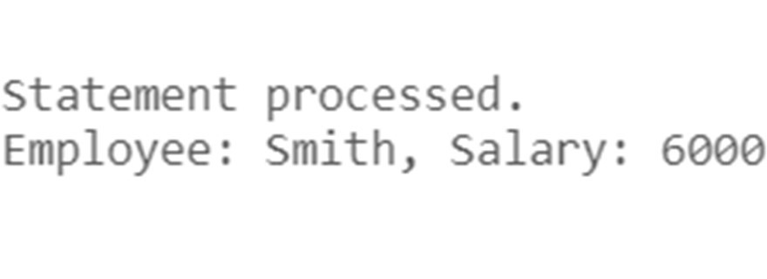

**Q6:**Write a query to demonstrate looping statements.

# Code:

set SERVEROUTPUT ON; DECLARE

v_counter NUMBER := 1; BEGIN

-- Loop from 1 to 5

WHILE v_counter <= 5 LOOP

-- Print the counter value DBMS_OUTPUT.PUT_LINE('Counter: ' || v_counter);

-- Increment the counter v_counter := v_counter + 1;

END LOOP; END;

# Output:

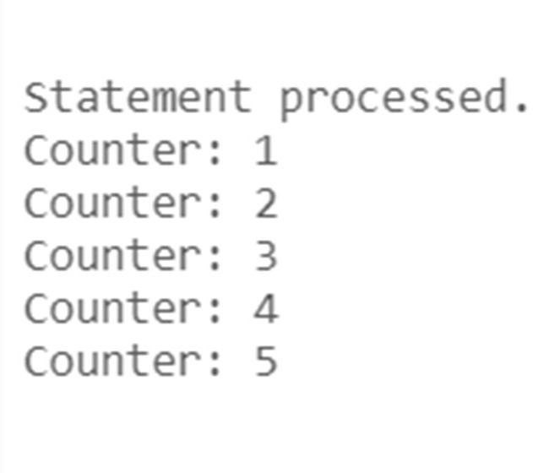

|  |  |  |  |
| --- | --- | --- | --- |
| **CHAITANYA BHARATHI INSTITUTE OF TECHNOLOGY** | | | |
| **DBMS LAB RECORD** | | | |
|  | **Course Name.: DBMS Lab** | **Experiment No.** 8 | |
| **Course Code : 20CSC17 Faculty : Smt.Ch.Vijaya Lakshmi** | **Branch:** CSE | **Semester:** IV |

**AIM:** write the queries for procedures and functions in pl/sql

## THEORY:

**PROCEDURES:**

*A procedure is a program that performs a specific action.A procedure has two parts: specification and body.Procedure specification begins with the keyword ‘PROCEDURE’ and ends with the procedure ‘name’ or a ’parameter list’.*

*The procedure body begins with the keyword ‘IS’ and ends with the keyword ‘END’.*

*The procedure body has three parts a declarative part, an executable part and an optional exception handling part.*

***Syntax for creating a procedure:-*** *Procedure name [(parameter list)] [Local declaration]*

*Begin*

*Executable statements Exception*

*Exception handlers End [<procedure name>]* ***Calling a procedure:-***

*Procedure_name (parameter list);*

### FUNCTIONS:

*A function is a sub program that computes a value.They have a return clause.A function has two parts: specification and body.Function specification begins with the keyword ‘FUNCTION’ and ends with the ’return clause’, which specifies the data type of the return value.The function body begins with the keyword ‘IS’ and ends with the keyword ‘END’.The function body has three parts a declarative part, an executable part and an optional exception handling part.The return statement immediately ends the execution of a sub program and returns control to the caller.Execution continues with the statement following the sub program call.*

### Syntax for creating a function:-

*Function <function name> [arguments..]*

*Return data type is [(Local declaration)]*

*Begin*

*Executable statements*

*Exception*

*Exception handlers End [<function name>]*

***QUERIES:***

**Q1.**Write a query to demonstrate Procedures.

# Code:

set SERVEROUTPUT ON;

CREATE OR REPLACE PROCEDURE print_employee_salary (employee_id IN employees.employee_id%TYPE) AS

v_employee_salary employees.salary%TYPE; BEGIN

-- Retrieve the salary of the employee SELECT salary INTO v_employee_salary FROM employees

WHERE employee_id = employee_id;

-- Print the employee ID and salary

DBMS_OUTPUT.PUT_LINE('Employee ID: ' || employee_id || ', Salary: ' || v_employee_salary);

END;

# Output:

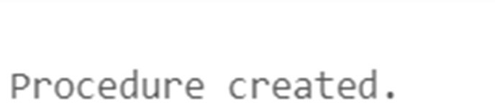

**Q2:**Write a query to demonstrate Functions.

# Code:

set SERVEROUTPUT ON;

CREATE OR REPLACE FUNCTION calculate_bonus (salary IN NUMBER) RETURN NUMBER AS v_bonus NUMBER;

BEGIN

-- Calculate bonus based on salary IF salary > 5000 THEN

v_bonus := salary * 0.1; -- 10% bonus ELSE

v_bonus := salary * 0.05; -- 5% bonus END IF;

RETURN v_bonus; END;

/

SELECT employee_id, salary, calculate_bonus(salary) AS bonus FROM employees;

# Output:

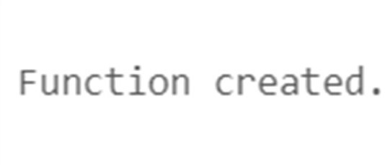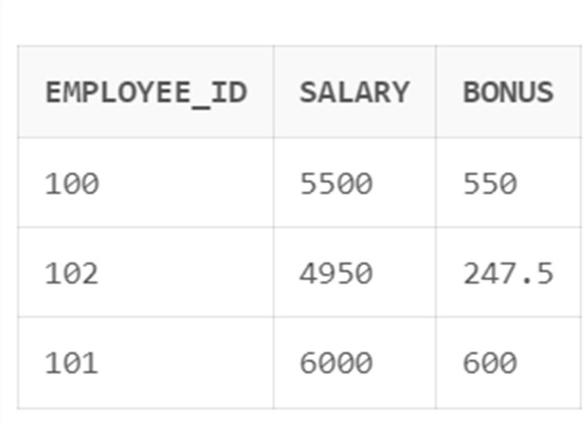

|  |  |  |  |
| --- | --- | --- | --- |
| **CHAITANYA BHARATHI INSTITUTE OF TECHNOLOGY** | | | |
| **DBMS LAB RECORD** | | | |
|  | **Course Name.: DBMS Lab** | **Experiment No. 9** | |
| **Course Code : 20CSC17**  **Faculty : Smt.Ch.Vijaya Lakshmi** | **Branch:** CSE | **Semester:** IV |

**AIM:** write the queries for cursors and in pl/sql

## THEORY:

A place where we can have active set of commands.It allows you to name a work area and access its stored information.There are two types of cursors: -

* Implicit cursors
* Explicit cursors

## Implicit cursors: -

**Explicit cursors: -**

Declaring the cursor:

* Defined by the oracle server.
* They don’t have any name.
* It releases the memory allocated when the SQL statements execution is completed.
* In this we can’t use open, fetch and close commands.
  + It is defined by the user.
  + It is used by the user to process multiple rows returned by a select statement.
  + Steps for defining an explicit cursor:
    - Declare the cursor.
    - Open the cursor.
    - Fetch data from the cursor.
    - Close the cursor.

SynTax: Cursor <cursor name> is SQL statement.

Example: cursor c1 is

Select * from emp where sid between 100 and 110;

* + - * Opening the cursor includes:

Allocating memory

Parse the SQL statement for execution.

* + - * The rows which are selected and stored in an Active Set and this active set are stored in the memory. The active set always points to the first row in the active set.
      * Fetch: To retrieve data from the active set and is stored in the variables.

E.g.: fetch ename into a;

* + - * After the fetch instruction the active set is checked. If it is empty it enables the close else it moves the cursor to the next row in the

active set and continues until the last row is reached. Once the last row is reaches it enables the close.

* + - * So, close will be enabled in two cases:
        + When active set is empty
        + When active set is pointing to the last row in the active set. SynTax: close <cursor name>;

**Queries:**

**Q1:**Write a query to demonstrate Implicit Cursor.

# Code:

set SERVEROUTPUT ON; DECLARE

v_num_rows NUMBER; BEGIN

-- Update salaries of employees UPDATE employees

SET salary = salary * 1.1 WHERE department_id = 10;

-- Get the number of updated rows v_num_rows := SQL%ROWCOUNT;

-- Print the number of updated rows DBMS_OUTPUT.PUT_LINE('Number of updated rows: ' || v_num_rows);

END;

# Output:

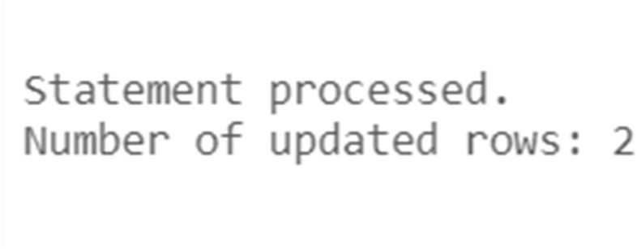

**Q2.**Write a query to show the use of %notfound attribute.

* 1. Declare

X integer (10);

A char (10);

Name varchar2 (20);

Begin

For I in 140.. 149

Loop

End;

Select first_name into name from employees where employee_id=i; End loop;

X: =sql%rowcount;

DBMS_OUTPUT.PUT_LINE ('no. of rows selected: '||x);

## Output:

No. of rows selected: 1 Statement processed.

* 1. declare

vname employees.ename %type; vsal employees.salary %type;

begin

end;

select ename,salary into vname,vsal from employees where emp_id=100; dbms_output.put_line('No of rows effected '||to_char(sql%rowcount));

## Output:

No of rows effected 1

PL/SQL procedure successfully completed.

## Q3.Explicit cursor [pl/sql block to retrieve 10 employees’ details using cursor].

Declare

begin

Vname employees.ename %type; Vjid employees.job_id %type;

Cursor emp_det is

select ename,job_id into vname,vjid from employees where emp_id between 100 and 175;

open emp_det ; for i in 1..10 loop

end;

fetch emp_det into vname,vjid ;

dbms_output.put_line (i||'.Name is : '||vname||',Job id is : '||vjid); end loop;

close emp_det;

## Output:

1. Name is : king, Job id is : ad_pres 2.Name is : kochhar, Job id is : ad_vp 3.Name is : de haan, Job id is : ad_vp 4.Name is : hunold, Job id is : it_prog 5.Name is : emst, Job id is : it_prog 6.Name is : mourgos, Job id is : st_man 7.Name is : rajs, Job id is : st_clk 8.Name is : davies, Job id is : st_clk 9.Name is : zlotkey, Job id is : sa_man 10.Name is : able, Job id is : sa_rep

PL/SQL procedure successfully completed.

## Q4.Write a pl/sql block using %rowcount attribute in explicit cursor:

Declare

vname employees.ename %type; vjid employees.job_id %type;

cursor emp_det is

select ename,job_id into vname,vjid from employees where emp_id=174 ;

begin

end;

open emp_det ;

fetch emp_det into vname,vjid; dbms_output.put_line(to_char(emp_det%rowcount)); close emp_det;

## Output:

1

PL/SQL procedure successfully completed.

## Q5.Write a pl/sql block using % not found attribute in explicit cursor:

declare

vname employees.ename %type; vjid employees.job_id %type;

cursor emp_det is

select ename,job_id into vname,vjid from employees where emp_id=174 ;

begin

open emp_det ;

fetch emp_det into vname,vjid; if emp_det%notfound then

dbms_output.put_line('NOT found is true');

else

end if;

dbms_output.put_line('NOT found is false');

close emp_det;

end;

## Output:

NOT found is false

PL/SQL procedure successfully completed.

## Q6.Write a pl/sql block using %found attribute in explicit cursor

declare

vname employees.ename %type; vjid employees.job_id %type;

cursor emp_det is

select ename,job_id into vname,vjid from employees where emp_id=174 ;

begin

open emp_det ;

fetch emp_det into vname,vjid; if emp_det%found then

dbms_output.put_line('found is true');

else

end if;

dbms_output.put_line(' found is false');

close emp_det;

end;

## Output:

found is true

PL/SQL procedure successfully completed.

|  |  |  |  |
| --- | --- | --- | --- |
| **CHAITANYA BHARATHI INSTITUTE OF TECHNOLOGY** | | | |
| **DBMS LAB RECORD** | | | |
|  | **Course Name.: DBMS Lab** | **Experiment No.** 10 | |
| **Course Code : 20CSC17**  **Faculty : Smt.Ch.Vijaya Lakshmi** | **Branch:** CSE | **Semester:** IV |

**AIM:** write the queries for exception handling and in pl/sql

## THEORY:

**Exception handling:**

* An exception is an identifier which is raised when an oracle error occurs in pl/sql block.
* Warning or error condition is called an exception
* When an error occurs an exception is raised i.e.; the normal execution stops and the control transfers to the exception handling block of the PL/SQL block.
* The ‘throw’ and ‘try’ keywords which were normally used in exceptional handling have their functionalities in DBMS as ‘raise’ and ‘exception’.
* Exceptional block is not present in the declare .
* Exceptional block has exceptional handling statements.
* Exceptions can be three types:
  + Predefined exceptions
  + Non predefined exceptions
  + User defined exceptions

## Predefined exceptions:

* One of the approximately 20 errors that occurs in oracle PL/SQL block/code
* No need to declare the exception or raise the exception explicitly.
* E.g.: ora_010001 invalid cursor Ora_01403 no data found

## Non-predefined exception:

* Any other standard errors other than the predefined 20 come under non predefined exceptions.
* Needs to declare the exception explicitly in the declarative section.
* Allow the oracle server to raise that exception implicitly.
* Syntax:

Exception_name exception;

PRAGMA_exception_INIT (Exception_name, error number);

## User defined exceptions:

* In this, the user has to explicitly declare the exception, raise an exception as well as handle the exception.
* Steps for creating the user defined exception
  + declare the exception
  + raise the exception
  + Use reference name to handle the exception.

## Raise_application_error procedure:

* It is used to raise the user defined exceptions.
* It can be used inside PL/SQL block and an exception block

## Raise an exception in oracle:

There are two ways to raise an exception.

* 1. When an oracle error occurs, the associated error is automatically raised by the oracle server.

E.g. when no roes are selected by the select statement then oracle server raises ‘no data found’ exception.

* 1. User can explicitly raise an exception by using ‘raise’ statement or ‘Raise_application_error’ statement.

## Handling the exception:

* + 1. Trapping the exception: if an exception is raised, control is passed to the exception section of block. The exception will be trapped if it is handled in that exception block itself.
    2. Propagating an exception: if the exception is not handled in the outer block, it is propagated / forwarded to the enclosed block*.*

## Queries:

### Exception handling:

**1.write a predefined exception for cursor_already_open**:-When you open a cursor that is already open(ORA-06511)

Declare

name employee.ename%type; sal employee.salary%type;

cursor c1 is

select ename, salary from employee where eid between 101 and 105;

begin

open c1; loop

fetch c1 into name,sal; Dbms_output.put_line (name||sal); exit when c1%notfound;

end loop; open c1;

exception

when cursor_already_open then Dbms_output.put_line ('cursor already open');

end;

## OUTPUT:

Mohan rao 34000

Raja ram 3500

Meena Roy 6500

David 10000

Janaki 20000

Janaki 20000 Cursor already open

Statement processed.

**2..write a predefined exception for invalid cursor:**-When you perform an invalid operation on a cursor like closing a cursor, fetch data from a cursor that is not opened (ORA-01001).

Declare

begin

id number(10); cursor c1 is

select employee_id from employees;

open c1; close c1;

fetch c1 into id;

Exception

when invalid_cursor then

Raise_application_error(-20003,'invalid cursor to fetch');

end;

ORA-20003: invalid cursor to fetch

**3..write a predefined exception for NO_DATA_FOUND**:-When a SELECT...INTO clause does not return any row from a table (ORA-01403).

set serveroutput on declare

begin

vname employ2.lastname%type; vsal employ2.salary%type;

select lastname,salary into vname,vsal from employ2 where eid=810;

exception

when no_data_found then DBMS_output.put_line('no rows selected');

end;

no rows selected.

**4..write a predefined exception for TOO_MANY_ROWS:-**When you SELECT or fetch more than one row into a record or variable (ORA-01422).

set serveroutput on declare

begin

vname employ2.lastname%type; vsal employ2.salary%type;

select lastname,salary into vname,vsal from employ2

where salary between 10000 and 40000; exception

when too_many_rows then DBMS_output.put_line('too many rows selected');

end;

too many rows selected

**5.write a predefined exception for ZERO_DIVIDE**:-When you attempt to divide a number by zero (ORA-01476)

Declare

Begin

Var1 number (3):=0;

Var2 number (4):=100;

vsal employees.salary%type;

Update employees

Set salary= salary+ (var2/var1);

Exception

When ZERO_DIVIDE then

Dbms_output.put_line ('divide by zero exception');

end; Output:

divide by zero exception Statement processed.

**6..write a predefined exception for case_not_found:**-this exception is raised when the else block isn’t use.

declare

begin

name varchar2(10); sal number(10,2); did number(5);

select ename,salary,dept_id into name,sal,did

from employee where eid=106; case

end;

when did=204 then dbms_output.put_line('Meeting at 2 p.m.'); when did=205 then dbms_output.put_line('meeting at 3 p.m.');

end case; DBMS_OUTPUT.PUT_LINE(name||sal||did);

OUTPUT:

ORA-06592: CASE not found while executing CASE statement

**User defined exceptions:**

**1.write a userdefined exception for restricting employees based on experience**

declare

begin

name varchar2(20); experience number(10); no_promotion exception;

select first_name||last_name,round(months_between(sysdate,hire_date)/12,0) into name,experience

from employees where employee_id=107; case

when experience>15 then dbms_output.put_line(name||'elligible for promotion category');

when experience=15 then dbms_output.put_line(name||'get prepared for promotion test');

when experience<15 then raise no_promotion; end case;

Exception

when no_promotion

then

end;

dbms_output.put_line(name||'-experience is='||experience ||'yrs-'||'CANT BE PROMOTED---EXPERIENCE < 15yrs');

## OUTPUT:

DianaLorentz-experience is=13yrs-CANT BE PROMOTED---EXPERIENCE < 15yrs

**RAISE_APPLICATION_ERROR:**

This is used to convey user define message to the end user.

## RAISE_APPLICATION_ERROR inside the EXCEPTION BLOCK

set serveroutput on declare

vname employ2.lastname%type; vsal employ2.salary%type;

begin

select lastname,salary into vname,vsal from employ2 where eid=810;

exception

when no_data_found then raise_application_error(-20101,'no rows selected');

end;

## output:

declare

*

ERROR at line 1:

ORA-20111: no rows selected ORA-06512: at line 12

## RAISE_APPLICATION _ERROR using cursors

declare

vname employ2.lastname%type; vsal employ2.salary%type; cursor c1 is

select lastname,salary into vname,vsal from employ2 where eid=220;

begin

open c1;

fetch c1 into vname,vsal; if c1%notfound then

raise_application_error(-20111,'no rows selected');

end; **Output:** declare

*

close c1; end if;

ERROR at line 1:

ORA-20111: no rows selected ORA-06512: at line 12.