Query-1:
Output:

create table student
(stid number(8),
sname varchar(20),
branch char(3),
emailid varchar(30));

Output:

Table STUDENT created.

Query-2:

desc student;

Output:

Name Null? Type
------- ----- ------------
STID NUMBER(8)
SNAME VARCHAR2(20)
BRANCH CHAR(3)
EMAILID VARCHAR2(30)

Query-3:

insert into student
values(1,'Ray','CSE','Ray@gmail.com');

Output:

1 row inserted.

Output:

insert into student
values(2,'Ak','IT','Ak@gmail.com');

Output:

1 row inserted.

insert into student
values(3,'Rim','ECE','Rim@gmail.com');

Output:

1 row inserted.

Query-4:

select *
from student;

Output:

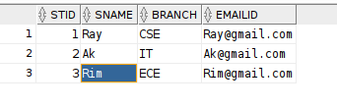

Query-5:

update student
set sname='Rayyan'
where stid=1;

Output:

1 row updated.

Query-6:

select *
from student;

Output:

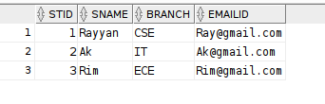

Query-7:

insert into student
values(4,'vij','ai','vij@outlook.com');

Output:

1 row inserted.

Query-8:

select *
from student;

Output:

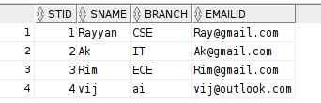

Query-9:

insert into student
values(5,'har','CSE','har@outlook.com');

Output:
1 row inserted.

Query-10:

select *
from student;

Output:

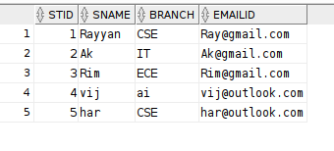

Query-11:
select distinct branch,stid
from student;

EXERCISES:

create table student
(stid number(8),
sname varchar(20),
branch char(3),
emailid varchar(30));

desc student;

insert into student
values(1,'Ray','CSE','Ray@gmail.com');

insert into student
values(2,'Ak','IT','Ak@gmail.com');

insert into student
values(3,'Rim','ECE','Rim@gmail.com');

select *
from student;

update student
set sname='Rayyan'
where stid=1;

insert into student
values(4,'vij','ai','vij@outlook.com');

select *
from student;

insert into student
values(5,'har','CSE','har@outlook.com');

select *
from student;

select distinct
from student;

insert into student
values(NULL,'raye','ece','raye@gmail.com');

insert into student
values(6,'rayes',NULL,'raye@gmail.com');

select distinct branch
from student;

create table salesman
(salesamn_id number(4),
saname varchar(30),
city varchar(30),
commision float(4));

insert into salesman
values(5001,'James Hoog','New York',0.15);

insert into salesman
values(5002,'Nail Knite','Paris',0.13);

insert into salesman
values(5005,'PIt Alex','London',0.11);

insert into salesman
values(5006,'Mc Lyon','Paris',0.14);

insert into salesman
values(5007,'Paul Adam','Rome',0.13);

insert into salesman
values(5003,'Lauson Hen','San JOse',0.12);

select * from salesman;

delete from salesman;

create table customer
(customer_id number(4),
cust_name varchar(20),
city varchar(20),
grade number(3),
salesman_id number(4));

insert into customer
values(3002,'Nick Rimando','New York',100,5001);

insert into customer
values(3007,'Brad Davis','New York',200,5001);

insert into customer
values(3005,'Graham Zusi','California',200,5002);

insert into customer
values(3008,'JUlian Green','LOndon',300,5002);

insert into customer
values(3004,'Fabian Johnson','Paris',300,5006);

insert into customer
values(3009,'Geoff Cameron','Berlin',100,5003);

insert into customer
values(3003,'Jozy ALtidor','Moscow',200,5007);

insert into customer
values(3003,'Brad GUzan','London',NULL,5005);

SELECT * FROM CUSTOMER;

SELECT customer_id

select salesamn_id,saname,city,commision
from salesman
where commision between 0.12 and 0.14;

