Week 2

q5.

select salesamn_id,saname,city,commision
from salesman
where commision between 0.12 and 0.14;

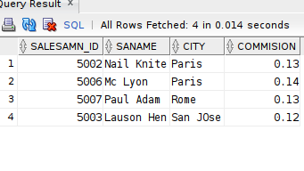

q6.

insert into orders
values(70001,150.5,'05-10-2012',3005,5002);

insert into orders
values(70009,270.65,'10-09-2012',3001,5005);

insert into orders
values(70002,65.26,'05-10-2012',3002,5001);

insert into orders
values(70004,110.5,'17-08-2012',3009,5003);

//insert into orders
values(70007,948.5,'10-09-2012',3005,5002);

insert into orders
values(70005,2400.6,'27-07-2012',3007,5001);

insert into orders
values(70008,5760,'10-09-2012',3002,5001);

insert into orders
values(70010,1983.43,'10-10-2012',3004,5006);

insert into orders
values(70003,2480.4,'10-10-2012',3009,5003);

insert into orders
values(70012,250.45,'27-06-2012',3008,5002);

insert into orders
values(70011,75.29,'17-08-2012',3003,5007);

insert into orders
values(70013,3045.6,'25-04-2012',3002,5001);

select ord_no,purch_amt,ord_date,customer_id,salesman_id
from orders
where purch_amt between 500 and 4000 and not in(948.50,1983.43);

q7.
select salesamn_id,saname,city,commision
from salesman
where saname>'A' and sanamE<'L';

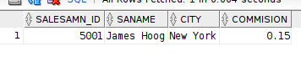

q8.

select salesamn_id,saname,city,commision
from salesman
where saname not between 'A' and 'L';
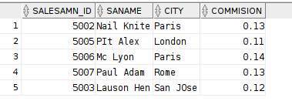

q9.
select customer_id,cust_name,city,grade,salesman_id
from customer
where cust_name like 'B%';
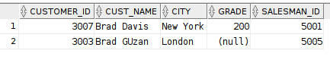

q10.

select customer_id,cust_name,city,grade,salesman_id
from customer
where cust_name like '%n';

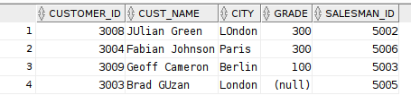

q11.
select salesamn_id,saname,city,commision
from salesman
where saname like 'N__f%';

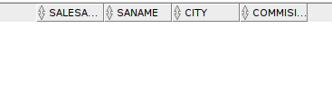

Q12.

select customer_id,cust_name,city,grade,salesman_id
from customer
where grade IS NULL;

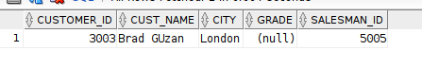

q13.
create table emp_details
(emp_idno number,
emp_fname varchar(20),
emp_lname varchar(20),
emp_dept number(2));

insert all
into emp_details values(127323,'Michale','Robbin',57)
into emp_details values(526689,'Michale','Rbin',63)
into emp_details values(843795,'Michale','RObin',57)
into emp_details values(328717,'Michale','RObin',63)
into emp_details values(444327,'Michale','RObin',47)
into emp_details values(659831,'Michale','RObin',47)
into emp_details values(847674,'Michale','RObin',57)
into emp_details values(748681,'Michale','RObin',47)
into emp_details values(555935,'Michale','RObin',57)
into emp_details values(539569,'Michale','RObin',27)
into emp_details values(733843,'Michale','RObin',63)
into emp_details values(631548,'Michale','RObin',27)
into emp_details values(839139,'Michale','Robin',57)

Lq1.
select customer_id,cust_name,city,grade,salesman_id
from customer
where grade>100;

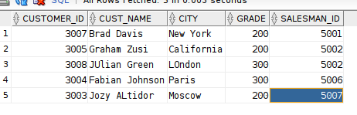

Lq2.
select customer_id,cust_name,city,grade,salesman_id
from customer
where grade>100 and city='New York';

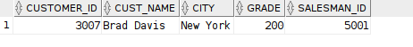

Substitution operator:

select customer_id,&col_name
from orders;

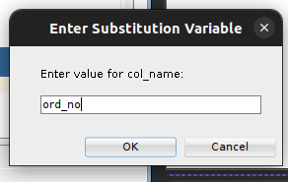

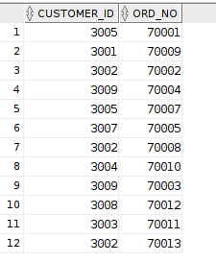

using reuse substitution operator and order by clause

select &&col_name,purch_amt,customer_id,salesman_id
from orders
order by &col_name;

