Week 4- Lab Programs (Observation)

Roll Number: 160121733033

Using Single Row Functions

Creating a Student Database and Adding Tuples

create table StudentDB
(sid number(20),
sname varchar2(20),
branch char(3),
email_id varchar2(20));

insert all
into StudentDB values(1601, 'Akil', 'CSE', 'a@gmail.com')
into StudentDB values(1602, 'Nikhil', 'CSM', 'n@gmail.com')
into StudentDB values(1603, 'Suresh', 'EEE', 'su@gmail.com')
into StudentDB values(1604, 'Prani', 'ECE', 'p@gmail.com')
select * from dual;

OUTPUT:
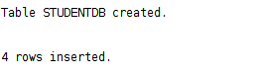

Case Manipulation

lower(column/expression)

select lower(sname)
from StudentDB;
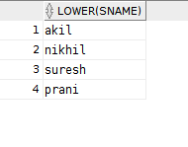

select lower('HELLO')
from dual;
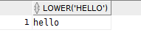

upper(column/expression)

select upper(sname)

from StudentDB;
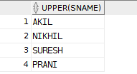

select upper('hello')
from dual;
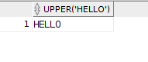

InitCap(column/expression)

select INITCAP(sname)
from StudentDB;
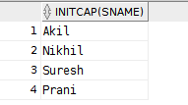

select INITCAP('hello world')
from dual;
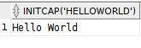

Character Manipulation

concat(str1, str2)
select concat('Hello ', sname)
from StudentDB;
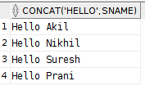

length(str)
select length('Hello World')
from dual;
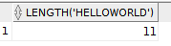

instr(str, search_character, starting position)
select instr('Hello World', 'l', 2)
from dual;
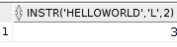

substr(str, starting position, ending position)
select substr('Hello World', 1,8)
from dual;
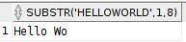

lpad(str, number, padding char)
select lpad(sname, 10, '*')
from StudentDB;
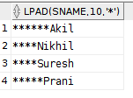

rpad(str, number, padding char)
select rpad(sname, 10, '*')
from StudentDB;
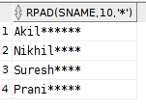

trim(lead/prior/both, char from str)
select trim('H' from 'Hello There') as "Trimming Function Usage"
from dual;
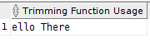

Number Functions

round(num, n)
select round(45.3229, 3)
from dual;
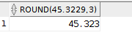

select round(45.3229,2)
from dual;
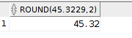

select round(45.3229, -1)
from dual;
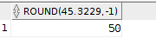

trunc(num, n)
select trunc(29.221, 3)
from dual;
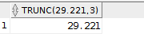

select trunc(229.237, 2)
from dual;
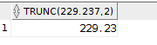

select trunc(229.1121, -1)
from dual;
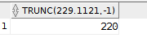

mod(num1, num2)
select mod(10, 3) as "Reminder of 10 and 3"
from dual;

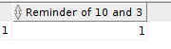

Date Functions

add_months(date, months)
select add_months(sysdate, 5) as "5 months from now"
from dual;
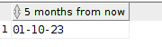

months_between(month1, month2)
select MONTHS_BETWEEN(sysdate, '01-Dec-2020') "Months Between"
from DUAL;
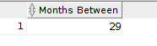

next_day(date, day)
select next_day(sysdate, 'Tuesday')
from dual;
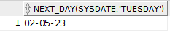

last_day(date)
select last_day(sysdate)
from dual;
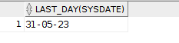

round(date, n)
select round(SYSDATE, 'MONTH')
from dual;
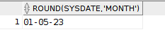

select round(SYSDATE, 'Year')
from dual;
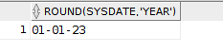

trunc(date, n)
select trunc(SYSDATE, 'MONTH')
from dual;
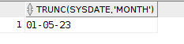

select trunc(SYSDATE, 'Year')
from dual;
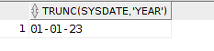

Conversion Functions

To_Char()

select TO_CHAR(TO_DATE('02-May-2023'), 'y') from dual;
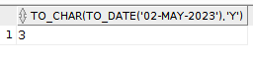

select TO_CHAR(TO_DATE('02-May-2023'), 'yy') from dual;
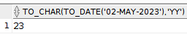

select TO_CHAR(TO_DATE('02-May-2023'), 'yyy') from dual;
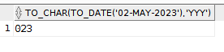

select TO_CHAR(TO_DATE('02-May-2023'), 'yyyy') from dual;
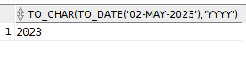

select TO_CHAR(TO_DATE('02-May-2023'), 'Year') from dual;
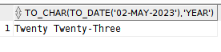

select TO_CHAR(TO_DATE('02-May-2023'), 'iyyy') from dual;
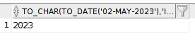

select TO_CHAR(TO_DATE('02-May-2023'), 'mm') from dual;
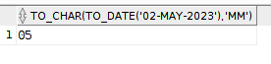

select TO_CHAR(TO_DATE('02-May-2023'), 'MON') from dual;
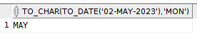

select TO_CHAR(TO_DATE('02-May-2023'), 'Month') from dual;
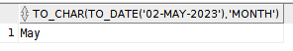

select TO_CHAR(TO_DATE('02-May-2023'), 'D') from dual;
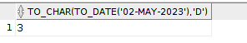

select TO_CHAR(TO_DATE('02-May-2023'), 'DD') from dual;
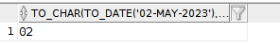

select TO_CHAR(TO_DATE('02-May-2023'), 'DAY') from dual;
