EXERCIES-1.Pdf JUNE 20, 2023

Query-1:

create table DEPARTMENTS
(DEPARTMENT_ID NUMBER(4) NOT NULL,
DEPARTMENT_NAME VARCHAR2(24) NOT NULL,
MANAGER_ID NUMBER(6),
LOCATIONG_ID NUMBER(4));

Output:

Table DEPARTMENTS created

insert all
into DEPARTMENTS values(10,'Administration',200,1700)
into DEPARTMENTS values(20,'Marketing',201,1800)
into DEPARTMENTS values(50,'Shipping',124,1500)
into DEPARTMENTS values(60,'IT',103,1400)
into DEPARTMENTS values(80,'Sales',149,2500)
into DEPARTMENTS values(90,'Executive',100,1700)
into DEPARTMENTS values(110,'Accounting',205,1700)
into DEPARTMENTS values(190,'Contracting',NULL,1700)
select * from dual;

Output:

8 rows inserted.

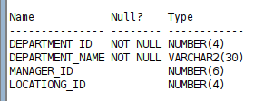
Query:

desc departments;

Query: Select * from departments;

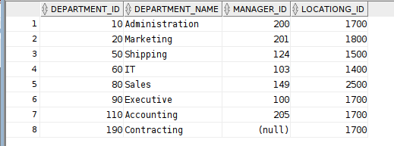

Query-2:

create table EMPLOYEES
(EMPLOYEE_ID NUMBER(5) NOT NULL,
FIRST_NAME VARCHAR2(20) ,
LAST_NAME VARCHAR2(25) NOT NULL,
EMAIL VARCHAR2(25) NOT NULL,
PHONE_NUMBER VARCHAR(20),
HIRE_DATE DATE NOT NULL,
JOB_ID VARCHAR2(10) NOT NULL,
SALARY NUMBER(8,2),
COMMISION_PCT NUMBER(2,2),
MANAGER_ID NUMBER(6),
DEPARTMENT_ID NUMBER(4));

Output:
Table EMPLOYEES created.

query:
desc EMPLOYEES;

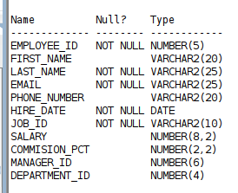

output:

query:
insert all
into employees(EMPLOYEE_ID,LAST_NAME,EMAIL,JOB_ID,HIRE_DATE)values(100,'King','King@gmail.com','AD_PRES','17-JUN-87')
into employees(EMPLOYEE_ID,LAST_NAME,EMAIL,JOB_ID,HIRE_DATE)values(101,'Kochhar','Kochhar@gmail.com','AD_VP','21-SEP-89')
into employees(EMPLOYEE_ID,LAST_NAME,EMAIL,JOB_ID,HIRE_DATE)values(102,'De Haan','Dehaan@gmailcom','AD_VP','12-JAN-93')
into employees(EMPLOYEE_ID,LAST_NAME,EMAIL,JOB_ID,HIRE_DATE)values(103,'Hunold','hunold@gmail.com','IT_PROG','03-JAN-90')
into employees(EMPLOYEE_ID,LAST_NAME,EMAIL,JOB_ID,HIRE_DATE)values(104,'Ernst','ernst@gmail.com','IT_PROG','21-MAY-91')
into employees(EMPLOYEE_ID,LAST_NAME,EMAIL,JOB_ID,HIRE_DATE)values(107,'Lorentz','lorentz@gmail.com','IT_PROG','07-FEB-99')
into employees(EMPLOYEE_ID,LAST_NAME,EMAIL,JOB_ID,HIRE_DATE)values(124,'Mourgos','mourgos@gmail.com','ST_MAN','16-NOV-99')
into employees(EMPLOYEE_ID,LAST_NAME,EMAIL,JOB_ID,HIRE_DATE)values(141,'Rajs','rajs@gmail.com','ST_CLERK','17-OCT-95')
into employees(EMPLOYEE_ID,LAST_NAME,EMAIL,JOB_ID,HIRE_DATE)values(142,'Davies','davies@gmail.com','ST_CLERK','29-JAN-97')
into employees(EMPLOYEE_ID,LAST_NAME,EMAIL,JOB_ID,HIRE_DATE)values(143,'Matos','matos@gmail.com','ST_CLERK','15-MAR-96')
into employees(EMPLOYEE_ID,LAST_NAME,EMAIL,JOB_ID,HIRE_DATE)values(144,'Vargas','vargas@gmail.com','ST_CLERK','09-JUL-90')
into employees(EMPLOYEE_ID,LAST_NAME,EMAIL,JOB_ID,HIRE_DATE)values(149,'Abel','abel@gmail.com','SA_REP','11-MAY-96')
into employees(EMPLOYEE_ID,LAST_NAME,EMAIL,JOB_ID,HIRE_DATE)values(176,'Taylor','taylor@gmail.com','SA_REP','24-MAR-96')
Select * from dual;

output:
13 rows inserted.

Query:
SELECT EMPLOYEE_ID,LAST_NAME,JOB_ID,TO_CHAR(HIRE_DATE,'DD-MON-YY') STARTDATE
FROM EMPLOYEES;

Output:
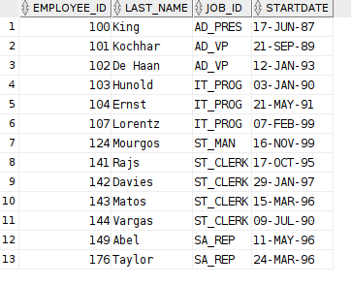

Exercises:

1. SELECT distinct job_id JOB_CODES from employees;

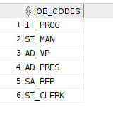
Output:

2.

ALTER TABLE employees
RENAME COLUMN EMPLOYEE_ID to "EMP #";

ALTER TABLE employees
RENAME COLUMN LAST_NAME to EMPLOYEE;

ALTER TABLE employees
RENAME COLUMN JOB_ID to JOB;

ALTER TABLE employees
RENAME COLUMN HIRE_DATE to "Hire Date";

output:

Table EMPLOYEES altered.

Table EMPLOYEES altered.

Table EMPLOYEES altered.

Table EMPLOYEES altered.

