**RASHI BHARDWAJ MAJOR ASSIGNMENT(SQL) SOLUTIONS**

***1. Create a table “Station” to store information about weather observation stations*:**

CREATE TABLE STATION

(ID NUMBER PRIMARY KEY,

CITY CHAR(20),

STATE CHAR(2),

LAT_N NUMBER,

LONG_W NUMBER);

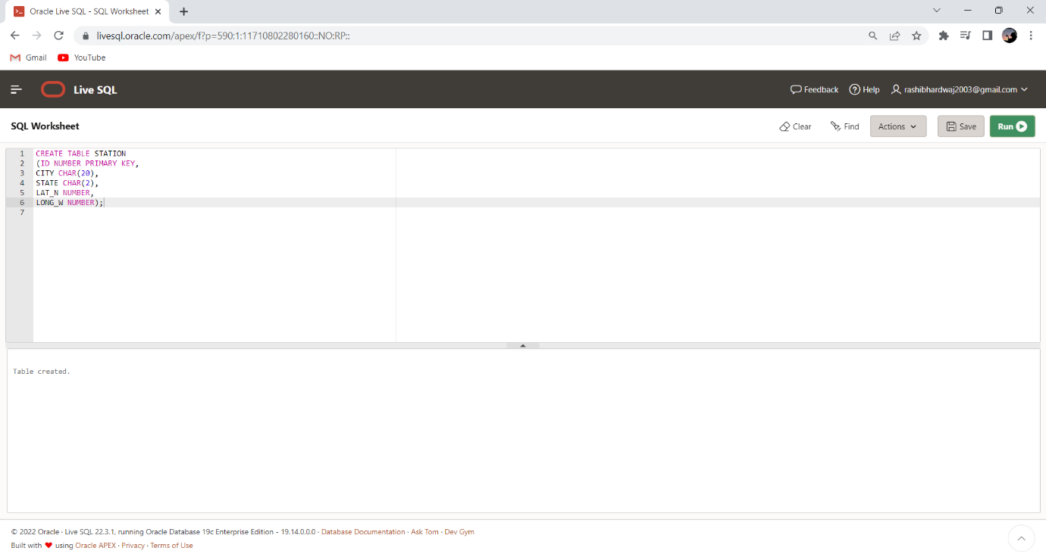

***2. Insert the following records into the table:***

INSERT INTO STATION VALUES (13, 'Phoenix', 'AZ', 33, 112);

INSERT INTO STATION VALUES (44, 'Denver', 'CO', 40, 105);

INSERT INTO STATION VALUES (66, 'Caribou', 'ME', 47, 68);

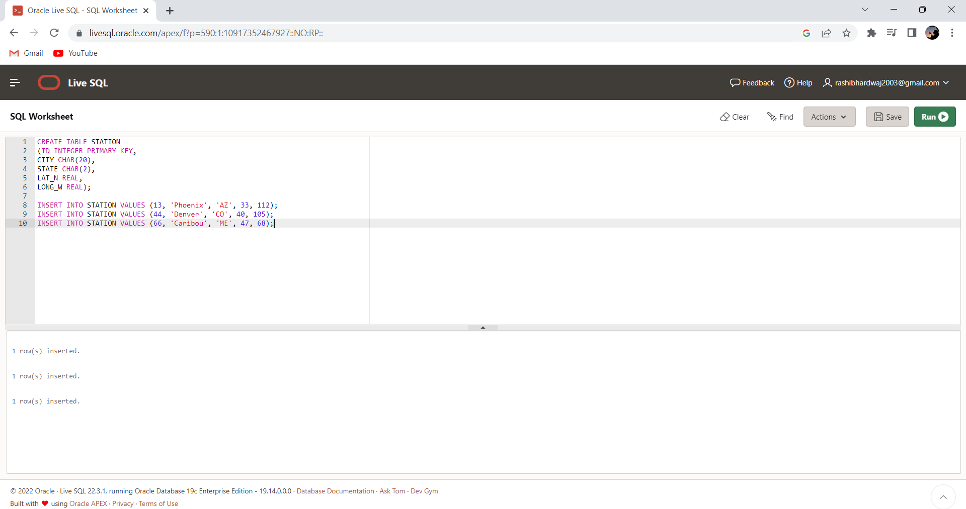

***3. Execute a query to look at table STATION in undefined order*.**

Select * from STATION ;

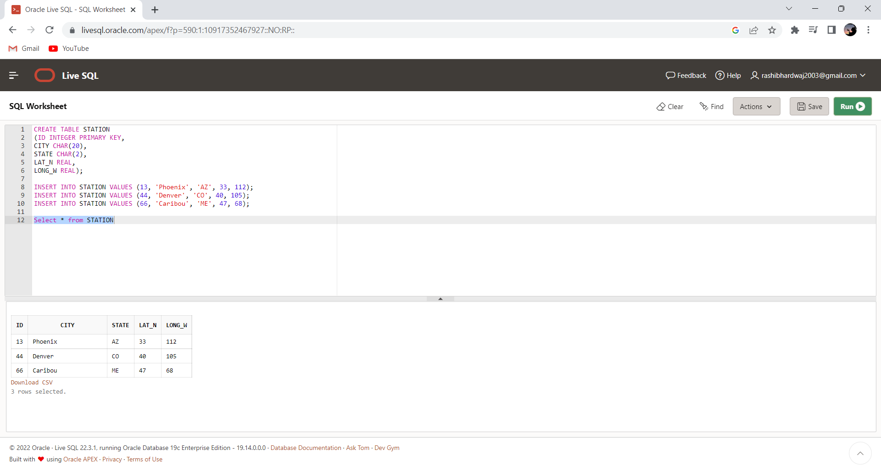

***4. Execute a query to select Northern stations (Northern latitude >***

***39.7).***

Select * from STATION

WHERE LAT_N > 39.7 ;

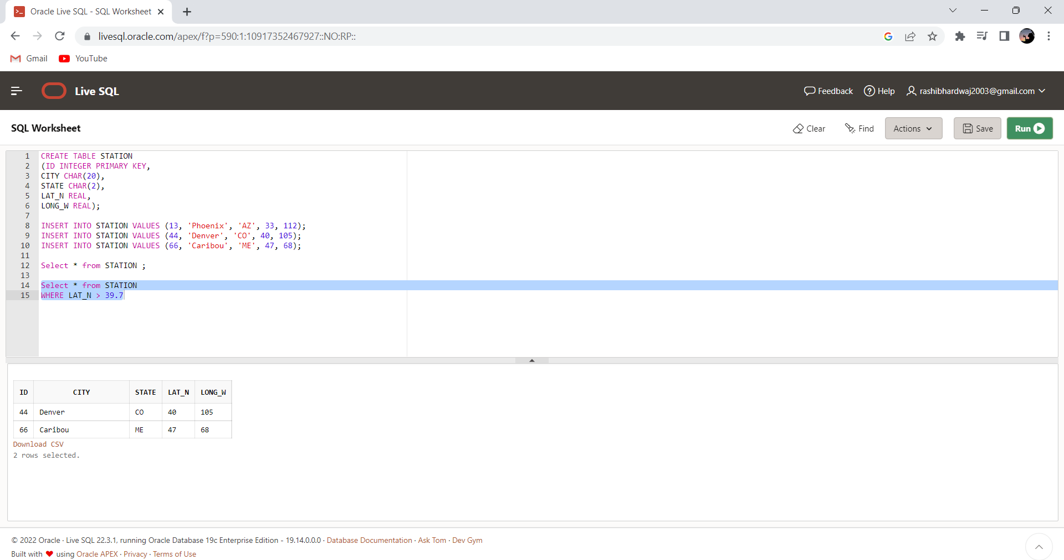

***5. Create another table, ‘STATS’, to store normalized temperature and***

***precipitation data***:

CREATE TABLE STATS

(ID NUMBER,

MONTH NUMBER CHECK (MONTH BETWEEN 1 AND 12),

TEMP_F NUMBER CHECK (TEMP_F BETWEEN -80 AND 150),

RAIN_I NUMBER CHECK (RAIN_I BETWEEN 0 AND 100),

PRIMARY KEY (ID, MONTH));

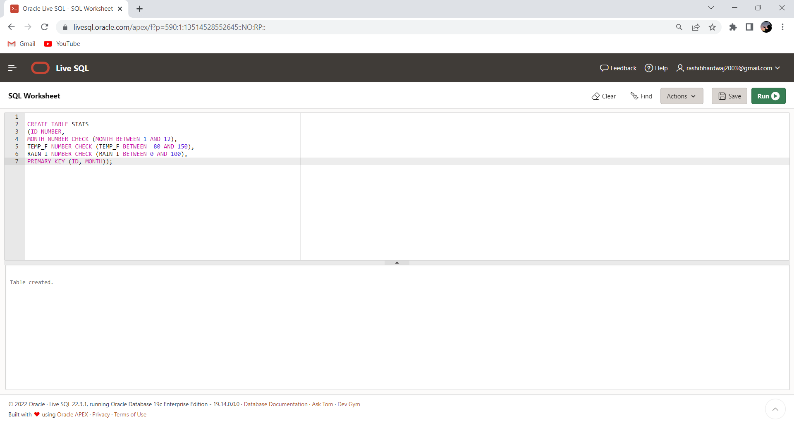

***6. Populate the table STATS with some statistics for January and July:***

INSERT INTO STATS VALUES (13, 1, 57.4, 0.31);

INSERT INTO STATS VALUES (13, 7, 91.7, 5.15);

INSERT INTO STATS VALUES (44, 1, 27.3, 0.18);

INSERT INTO STATS VALUES (44, 7, 74.8, 2.11);

INSERT INTO STATS VALUES (66, 1, 6.7, 2.10);

INSERT INTO STATS VALUES (66, 7, 65.8, 4.52);

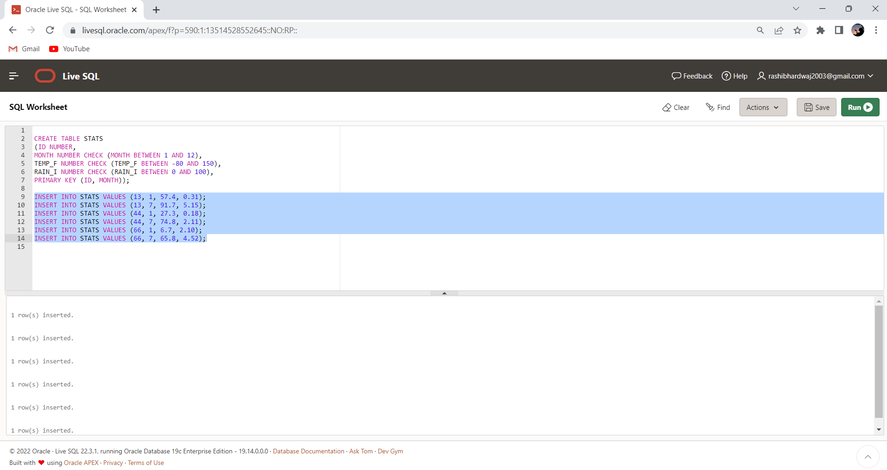

***7. Execute a query to display temperature stats (from STATS table) for***

***each city (from Station table).***

SELECT SN.CITY,SS.TEMP_F

FROM STATS SS

INNER JOIN STATION SN

ON SS.ID=SN.ID

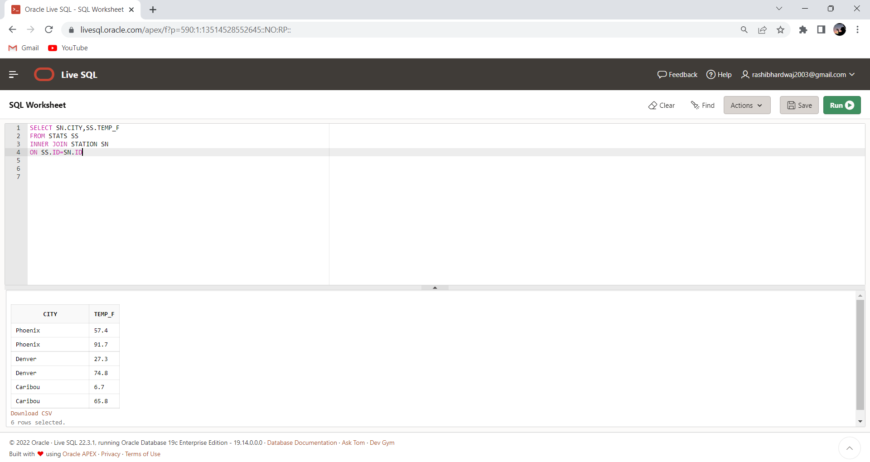

***8. Execute a query to look at the table STATS, ordered by month and***

***greatest rainfall, with columns rearranged. It should also show the***

***corresponding cities***

SELECT SS.MONTH , SN.CITY, SS.ID, SS.RAIN_I, SS.TEMP_F

FROM STATS SS

INNER JOIN STATION SN

ON SS.ID = SN.ID

ORDER BY SS.MONTH, SS.RAIN_I DESC ;

OUTPUT:

|  |  |  |  |  |
| --- | --- | --- | --- | --- |
| **MONTH** | **CITY** | **ID** | **RAIN_I** | **TEMP_F** |
| 1 | Caribou | 66 | 2.1 | 6.7 |
| 1 | Phoenix | 13 | .31 | 57.4 |
| 1 | Denver | 44 | .18 | 27.3 |
| 7 | Phoenix | 13 | 5.15 | 91.7 |
| 7 | Caribou | 66 | 4.52 | 65.8 |
| 7 | Denver | 44 | 2.11 | 74.8 |
|  | | | | |  |  |  |  |
|  | | | | |  |  |  |  |

***9. Execute a query to look at temperatures for July from table STATS,***

***lowest temperatures first, picking up city name and latitude.***

SELECT SS.ID, SN.CITY,SS.TEMP_F,SN.CITY,SN.LAT_N FROM STATS SS

JOIN STATION SN

ON SS.ID = SN.ID

WHERE SS.MONTH = 7

ORDER BY SS.TEMP_F ASC

OUTPUT:

|  |  |  |  |  |
| --- | --- | --- | --- | --- |
| **ID** | **CITY** | **TEMP_F** | **CITY** | **LAT_N** |
| 66 | Caribou | 65.8 | Caribou | 47 |
| 44 | Denver | 74.8 | Denver | 40 |
| 13 | Phoenix | 91.7 | Phoenix | 33 |

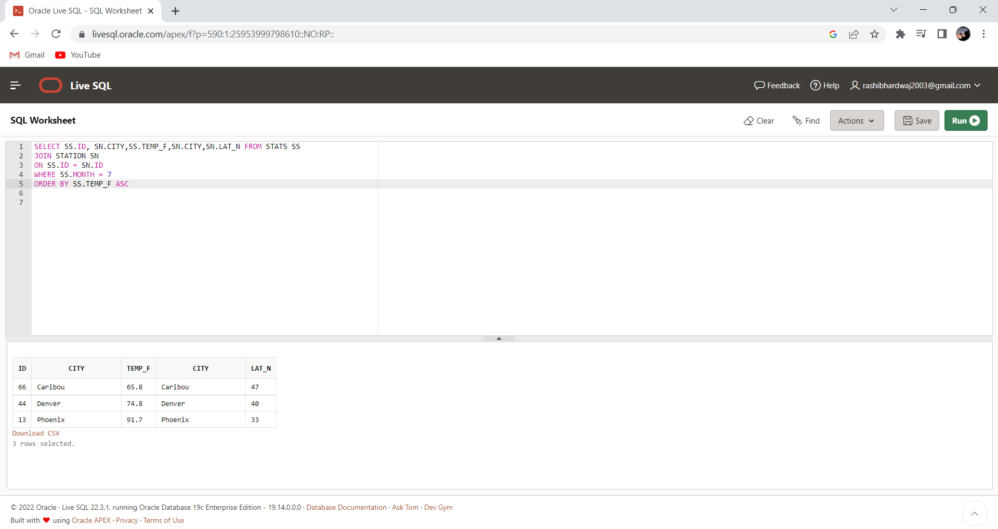

***10. Execute a query to show MAX and MIN temperatures as well as***

***average rainfall for each city.***

SELECT MAX(TEMP_F), MIN(TEMP_F), AVG(RAIN_I), SN.CITY

FROM STATS SS

INNER JOIN STATION SN

ON SS.ID=SN.ID

GROUP BY CITY

OUTPUT:

|  |  |  |  |
| --- | --- | --- | --- |
| **MAX(TEMP_F)** | **MIN(TEMP_F)** | **AVG(RAIN_I)** | **CITY** |
| 65.8 | 6.7 | 3.31 | Caribou |
| 74.8 | 27.3 | 1.145 | Denver |
| 91.7 | 57.4 | 2.73 | Phoenix |

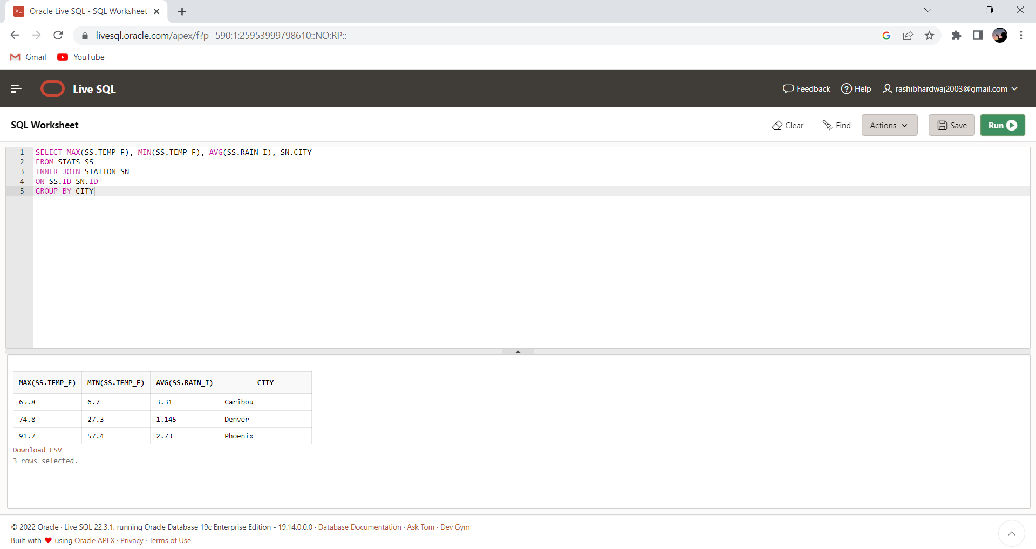

***11. Execute a query to display each city’s monthly temperature in***

***Celcius and rainfall in Centimeter***

SELECT SN.ID, SN.City,

SS.MONTH,

ROUND((TEMP_F - 32) * 5 /9) As TEMP_CELCIUS,

ROUND(RAIN_I * 0.3937) As RAINFALL_CENTIMETER

FROM STATS SS

JOIN STATION SN

ON SN.ID = SS.ID ;

OUTPUT:

|  |  |  |  |  |
| --- | --- | --- | --- | --- |
| **ID** | **CITY** | **MONTH** | **TEMP_CELCIUS** | **RAINFALL_CENTIMETER** |
| 13 | Phoenix | 1 | 14 | 0 |
| 13 | Phoenix | 7 | 33 | 2 |
| 44 | Denver | 1 | -3 | 0 |
| 44 | Denver | 7 | 24 | 1 |
| 66 | Caribou | 1 | -14 | 1 |
| 66 | Caribou | 7 | 19 | 2 |

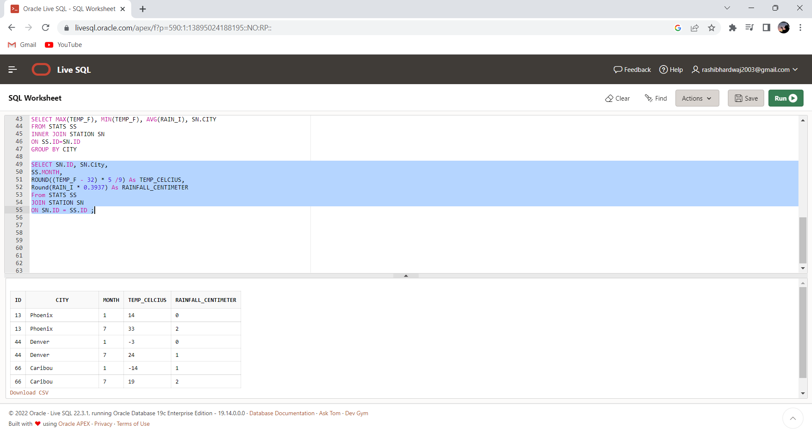

***12. Update all rows of table STATS to compensate for faulty rain gauges***

***known to read 0.01 inches’ low.***

UPDATE STATS SET RAIN_I = RAIN_I + 0.01;

SELECT * FROM STATS

OUTPUT:

|  |  |  |  |
| --- | --- | --- | --- |
| **ID** | **MONTH** | **TEMP_F** | **RAIN_I** |
| 13 | 1 | 57.4 | .33 |
| 13 | 7 | 91.7 | 5.17 |
| 44 | 1 | 27.3 | .2 |
| 44 | 7 | 74.8 | 2.13 |
| 66 | 1 | 6.7 | 2.12 |
| 66 | 7 | 65.8 | 4.54 |

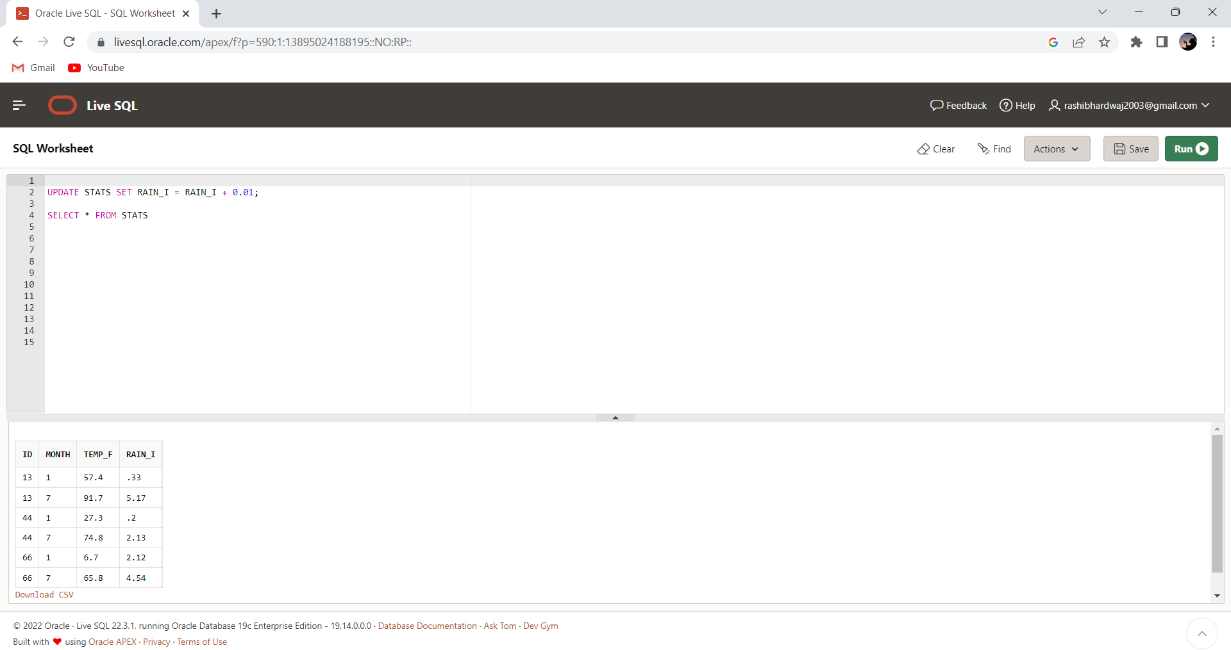

***13. Update Denver's July temperature reading as 74.9***

UPDATE STATS SET TEMP_F = 74.9

WHERE ID = 44 AND MONTH = 7;

SELECT * FROM STATS

OUTPUT:

|  |  |  |  |
| --- | --- | --- | --- |
| **ID** | **MONTH** | **TEMP_F** | **RAIN_I** |
| 13 | 1 | 57.4 | .33 |
| 13 | 7 | 91.7 | 5.17 |
| 44 | 1 | 27.3 | .2 |
| 44 | 7 | 74.9 | 2.13 |
| 66 | 1 | 6.7 | 2.12 |
| 66 | 7 | 65.8 | 4.54 |

