

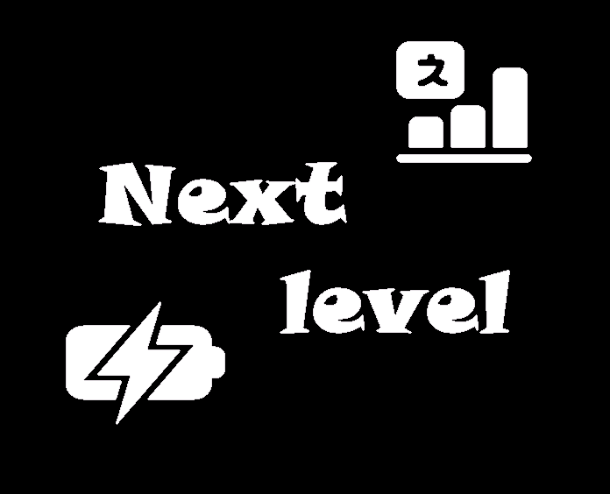

Table of Contents

1. Project idea and work on the project 2

2. Team members 3

3. Stages of the project 3

4. Difficulties encountered 4

5. Means used 4

6. Conclusion 4

7. Block diagram 4

# Project idea and work on the project

The idea of our project is to orient for which class the children’s knowledge is.

1. Getting a basic idea of the project:

We got the team together, kicked around ideas and finally settled on one that appealed to everyone.

1. Early and late stages of the project:

We worked differently each in his own way and each helped with what he could. The last few days were hard work.

1. Presentation of the project:

We took a good look around our project for mistakes and only left to present.

# Team members

|  |  |
| --- | --- |
| № | Roles in the team |
| 1. | Radomir Aleksandrov – Scrum Trainer – RAAleksandrov21@codingburgas.bg |
| 2. | Asparuh Georgiev-BackendDeveloper-AZGeorgiev22@codingburgas.bg |
| 3. | Petko Kovachev-BackendDeveloper-PPKovachev22@codingburgas.bg |
| 4. | Kaloyan Petrov- BackendDeveloper-KSPetrov22@codingburgas.bg |
| 5. | Jasmina Valkova-QA documentation-ZIValkova21@codingburgas.bg |
|  | |

# Stages of the project

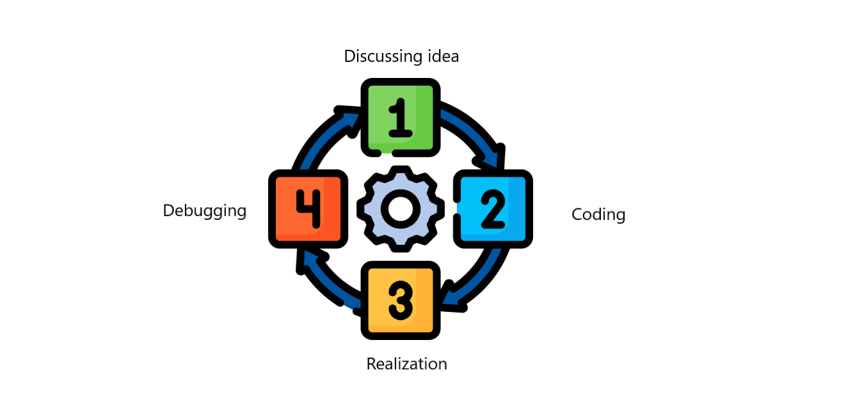

# Difficulties encountered

|  |  |
| --- | --- |
| **Making of the team** | **10/10** |
| **Making the code** | **9/10** |
| **Distributing the roles** | **10/10** |
| **Communication** | **10/10** |

# Means used

|  |  |
| --- | --- |
| Word | Tool for making the documentation |
| Power Point | Tool for making the presentation |
| Teams | Communication tool |
| Paint | Making the team logo |
| Excel | Tool for making the QA table |
| Visual studio | Tool for writing the code |
| GitHub | Tool for the synchronization |
| C++ | Tool for creating the app |

# Conclusion

By this project the children can orient about their knowledge and that they may not wear out material.

# Block diagram

