

E-project Documentation

**La Imperial**



By: shehryar ahmed subhani

roll no: 1067001

batch no:OV201709D

24th January 2017 - 24th february 2017

ACKNOWLEDGEMENT

I would like to acknowledge all those who have helped me throughout the development of this website, especially the staff and administration at ApTech Rawalpindi; not only have they given me opportunity to collaborate on this project with them, they have given me continuous support and excellent guidance.

I would also like to thank all websites whose presentation of similar appliances helped provide inspiration throughout the duration of the project.

My colleagues here at ApTech have also provided great support and assistance towards the completion of this project and I am wholeheartedly grateful for their punctuality and sincerity.

PREFACE

The following documentation provides insight about our e-Project, including source code and screenshots of all webpages. Included are the layout of the website, both using sitemaps and fully-developed UX screenshots. These are supported by sitemaps and wireframes finally leading to a copy of the front-end source code and user functionality of the website.

Table of Contents

FRONT-END FUNCTIONALITY 1

SITEMAP/USER GUIDE 1

COMMON FEATURES 2

WEBSITE DESCRIPTION 3

Home Page: 3

Appliance Page: 6

Appliance Details Page: 7

WEBSITE CONTROL FLOW 8

Home Page: 8

Appliance Page: 9

Table of Figures

Figure 1: Home Page Wireframe 4

Figure 2: Home Page Screenshot 5

Figure 3: Appliance Page Wireframe 6

Figure 4: Appliance Page Screenshot 6

Figure 5: Appliance Details Page Wireframe 7

Figure 6: Appliance Details Page Screenshot 7

Figure 7: Home Page Flowchart 8

Figure 8: Appliance Page Flowchart 9

SYNOPSIS

La Imperial is into selling Appliances. The Company has been selling these products for last 20 years. They have a wide range of appliances. The company advertises by distributing pamphlets, advertising on television and so on. Due to rapid development in the internet field, the company decides to launch a website where people will get all the information about the various products offered easily.

**Requirements:**

1. Home page should contain logo of the site with proper sections and details of appliances with suitable images.
2. The site should display a menu which will contain the options for brief introduction about the various appliances available, location of the shop and any other information if required.
3. The information should be categorized according to the brand names of the products like if a user wants to see only “Haier” products or any other company’s products then he/she can click on a link/button/menu etc. and can see only that brand’s products.
4. Another category option for different appliances, like ‘washers & dryers’ etc. Should be created and accordingly the products should be listed.
5. When a user selects any particular brand, a list of products for that brand will be displayed
6. A brief summary of features of individual products should be displayed on the web page along with the product but detailed features should be stored in individual word documents which can be downloaded or viewed by the user who wishes to see them.
7. The user should also be able to compare the various products of different as well as similar brands.
8. There should be a “contact us” page which will have the address of the company which is as follows and the mail address which when clicked will invoke the local mail client from where they can send an email.

# FRONT-END FUNCTIONALITY

## SITEMAP/USER GUIDE

1. **Home**
2. **Appliances**
   1. **Kitchen Appliances**
      1. Fridges
      2. Food Factories
      3. Microwave Ovens
      4. Water Dispensers
   2. **Home Comfort**
      1. Televisions
      2. Air Conditioners
      3. Washing Machines
      4. Irons
   3. **Brands**
      1. LG
      2. Samsung
      3. Haier
      4. Philips
      5. Dawlance
3. **Our Shops**
4. **Contact Us**

## COMMON FEATURES

* Best appliances can be found on the homepage using sliders.
* Allows sorting of appliances based on brand and/or appliance type.
* Detailed view of appliance can be seen by clicking on them.
* Zooming into appliances to see minute details.
* Downloadable .docx files to view even more details
* Compare different appliances
* Interactive Menus
* Monochrome design
* Appliances of 5 brands are available

## WEBSITE DESCRIPTION

### Home Page:

After landing on the page, the user sees a menu that has hover able icons. These icons either lead to different webpages or to existing sections in the current page. Scrolling down, there is a slider that displays the most popular appliances on the website, followed by customer reviews and a mural of awards received. All buttons in this section are clickable. There is also another section that has a classification for the appliances, based on their preferences i.e. brands and/or appliance type.

Scrolling further down there is a social media tab and a Google Maps API that displays the locations of the website.

*(Wireframe and screenshots on the next page)*

[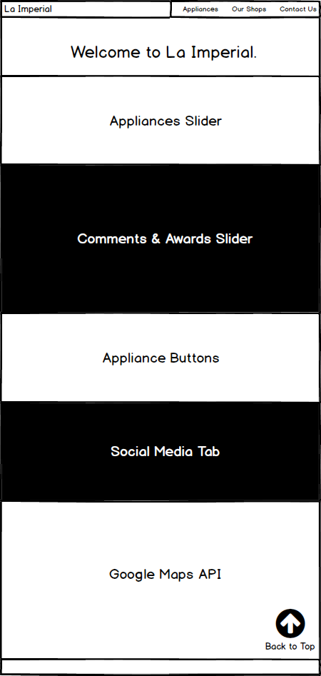](homepageWireframe.png)

Figure : Home Page Wireframe

[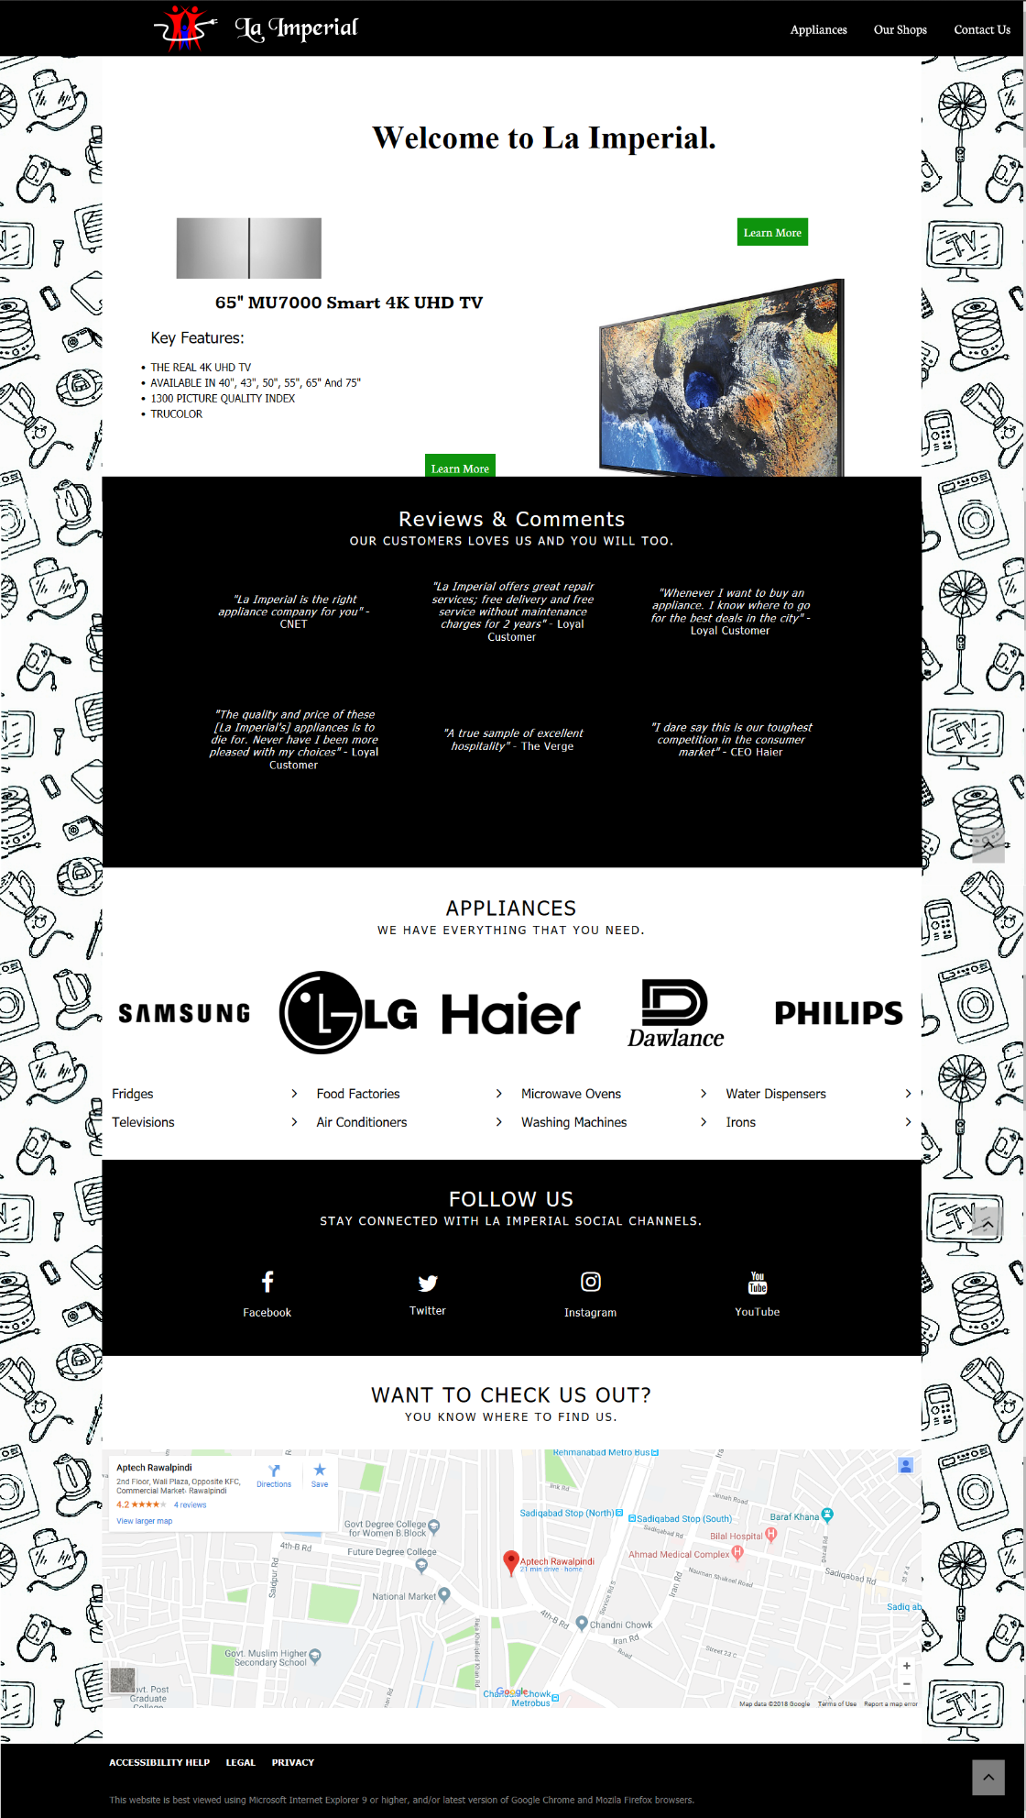](homepageSC.png)

Figure : Home Page Screenshot

### Appliance Page:

After landing on the page, there are many appliances for the user to choose from. The user can click on individual appliances to view more details about them or click on the “Where to buy” button to view a Google Maps frame to know the detailed location of the store itself.

[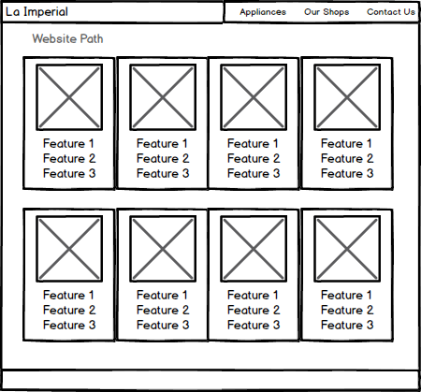](applianceWireframe.png)

Figure : Appliance Page Wireframe

[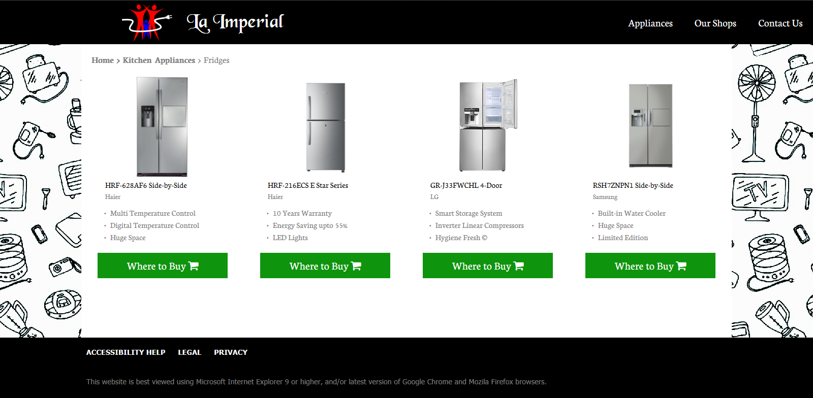](applianceSC.png)

Figure : Appliance Page Screenshot

### Appliance Details Page:

After landing on the page, the user can view a magnified version of the appliance simply by hovering on it. There are 6 labels and details about every appliance and the user can download further specifications by clicking on the “Download” button that downloads a .docx file that has more details.

The user can also click on the “Compare” button that allows the user to compare upto 3 appliances of the same type, of the same and different brands. There is also a “Where to Buy” button that provides a link to an enlarged map of the location of the store

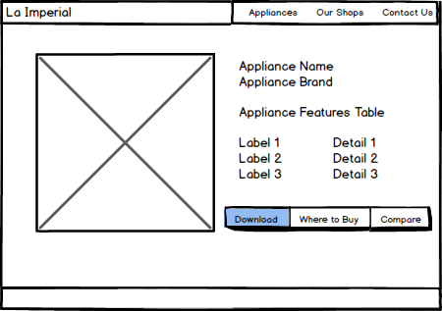

Figure : Appliance Details Page Wireframe

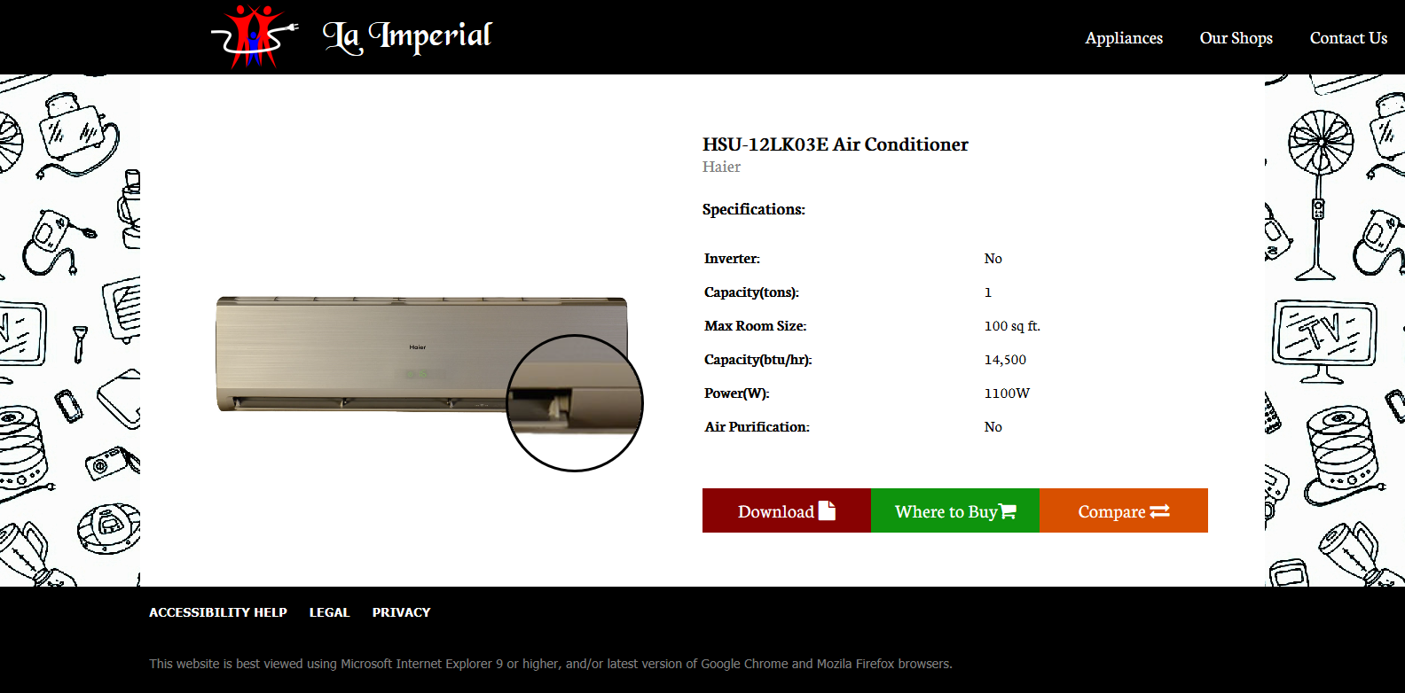

Figure : Appliance Details Page Screenshot

## WEBSITE CONTROL FLOW

### Home Page:

[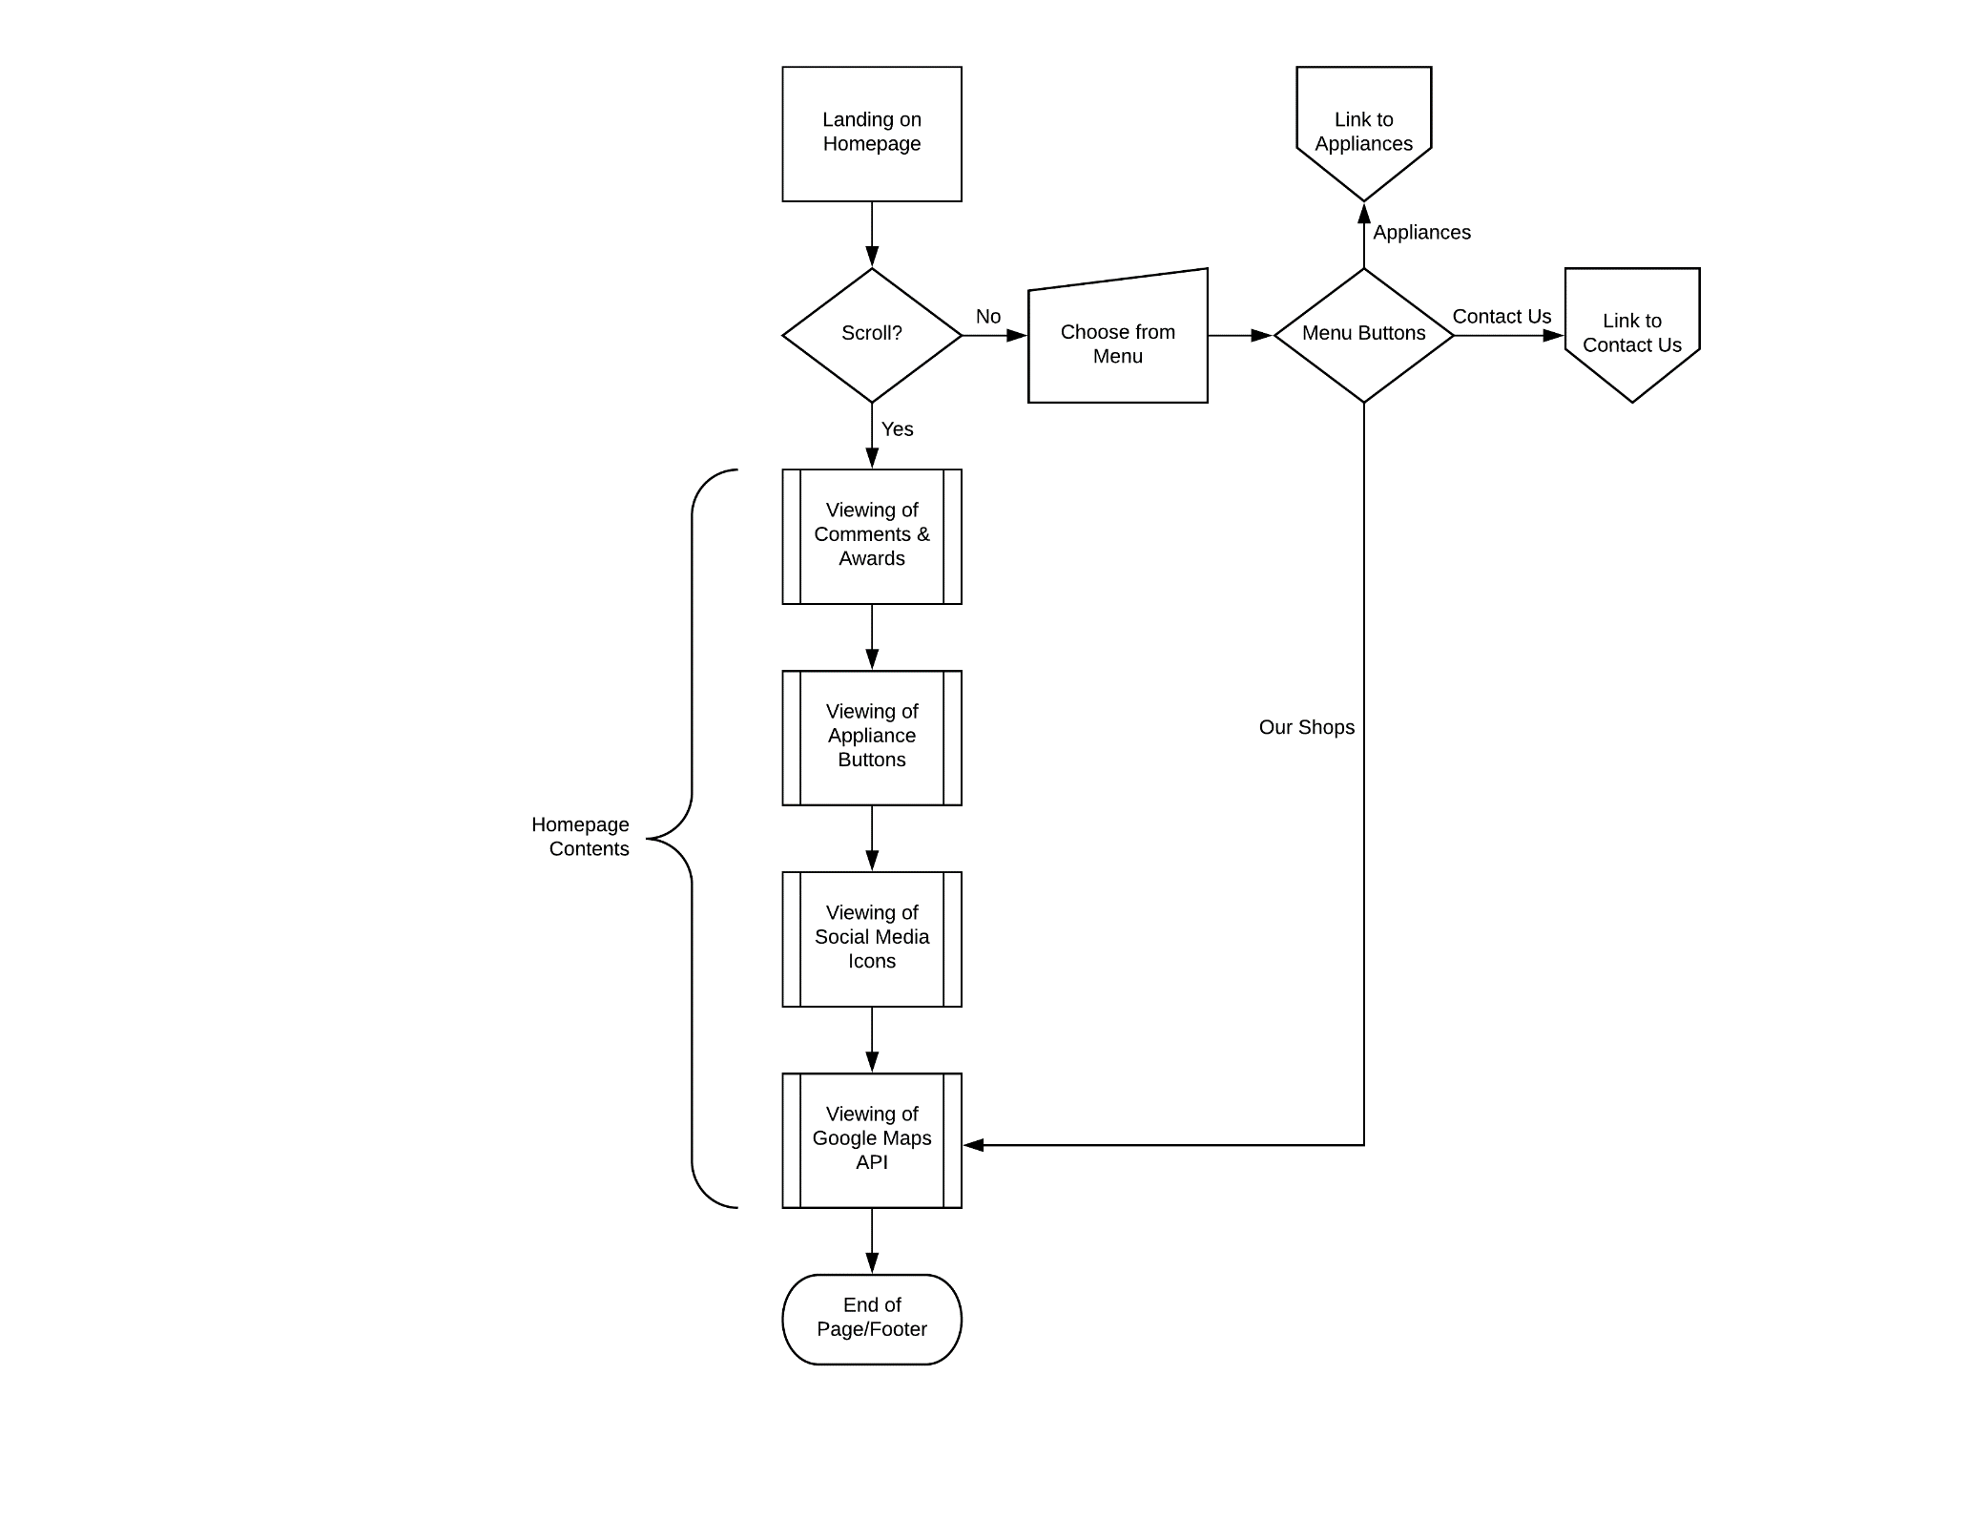](flowChartHome.png)

Figure : Home Page Flowchart

### Appliance Page:

[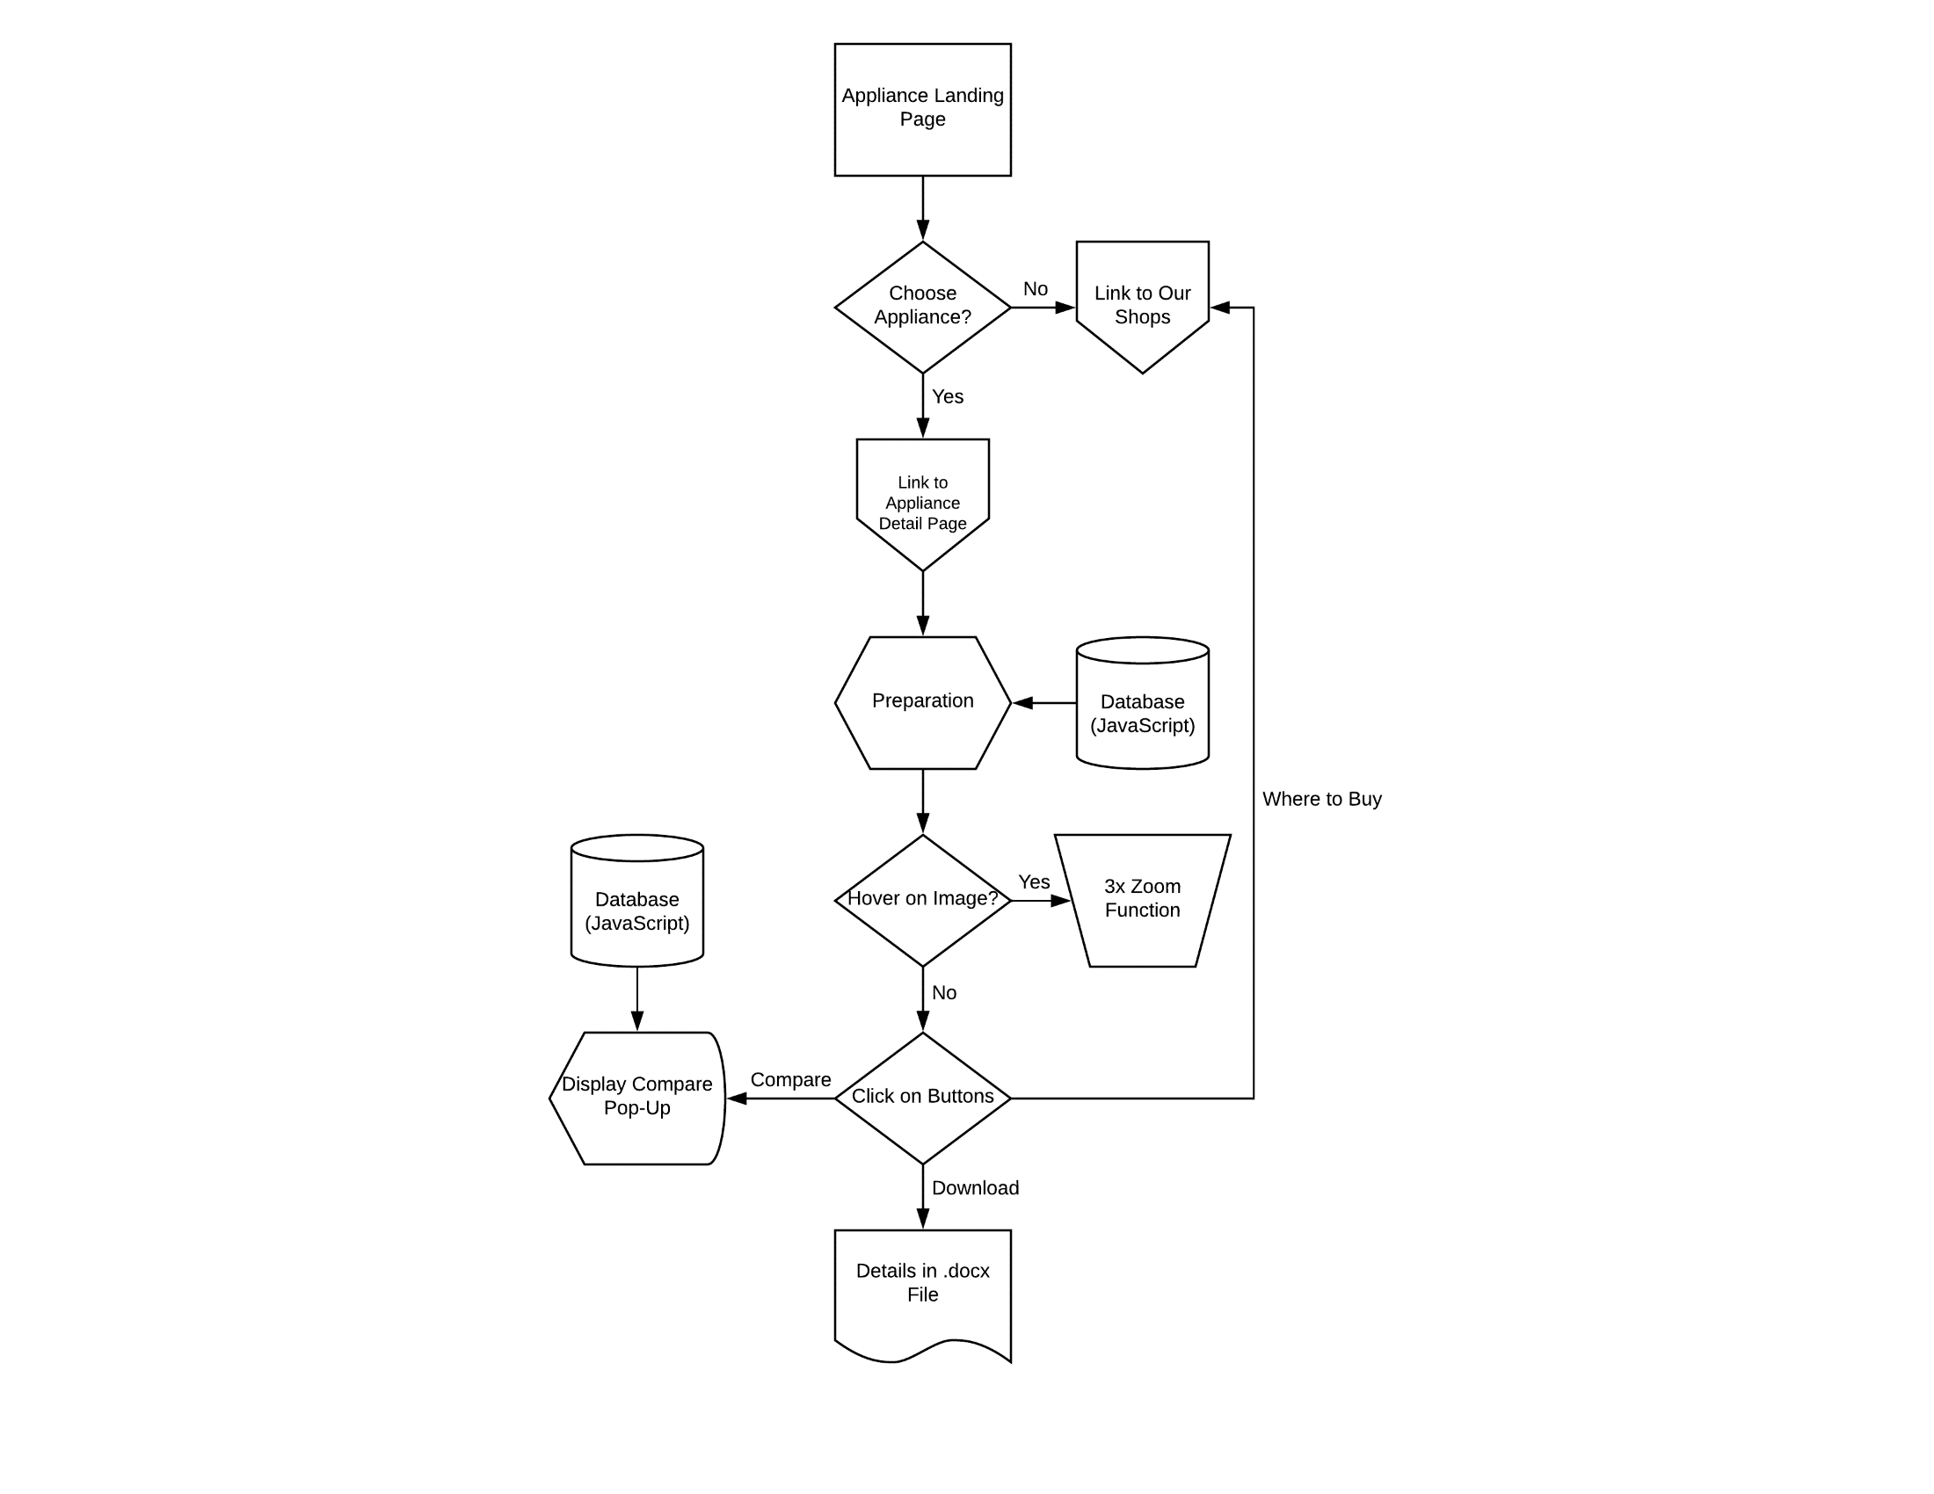](flowChartAppliance.png)

Figure : Appliance Page Flowchart