**Philips PerfectCare Azur Steam Iron**

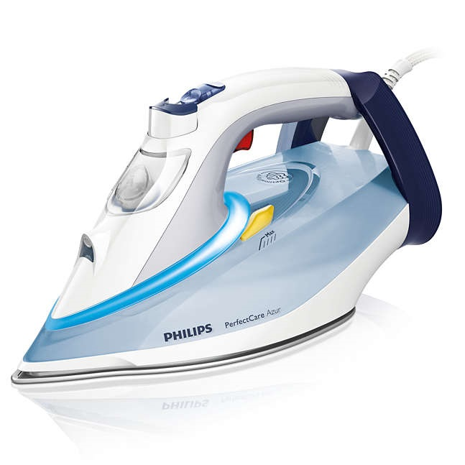

|  |  |  |  |  |  |  |
| --- | --- | --- | --- | --- | --- | --- |
|  |  | |  | |  | |
| **Soleplate Material:** | | SteamGlide Plus | |
| **Power Consumption:** | | Fixe12400 | |
| **Water tank size(ml):** | | 350 | |
| **Control type:** | | Control Freedom | |
| **Comfort handle:** | | Yes | |
| **Cord length(cm):** | | 180 | |
| **Indicator/Display:** | | Light | |
| **Vertical steam:** | | No | |
|  | **Steam burst:** | | Yes(45g/min) | |  | |
|  | **Variable steam:** | | No | |  | |
|  | **Auto shut-off:** | | No | |  | |
|  | **Spray mist:** | | Yes | |  | |
|  |  | |  | |  | |
|  | |  |  | | |  | |
|  | |  |  | | |  | |
|  | | | |
|  | | | |
|  | | | |
|  | | | |
|  | | | |
|  | | | |
|  | | | |
|  | | | |