**Haier 42" LED B8500 Series**

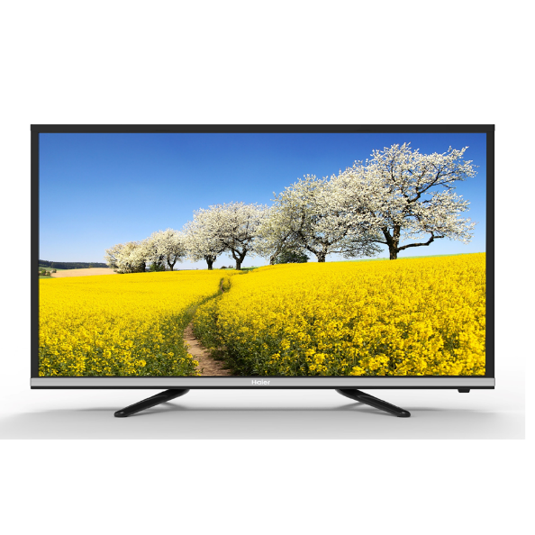

|  |  |  |
| --- | --- | --- |
|  | **TV Type:** | DLED |
| **Aspect Ratio:** | 16:9 |
| **Resolution:** | 1920 x 1080 |
| **Refresh Rate:** | 60Hz |
| **Contrast:** | 1000:1 |
| **Picture Modes:** | Standard/Dynamic/Mild/User |
|  | **Digital Comb Filter** | Yes |
|  | **Noise Reduction** | Yes |
|  | **Audio Mode** | Standard/Music/Movie/Sports |
|  | **Dolby Digital Recording** | Yes |
|  | **Auto-Volume Leveler** | Yes |
|  | **Audio Output Power** | 2*8W |
|  | **HDMI** | 3 |
|  | **USB** | 2 |
|  | **USB Clone** | Yes |