**4K HDR Smart LED AI Super UHD TV**

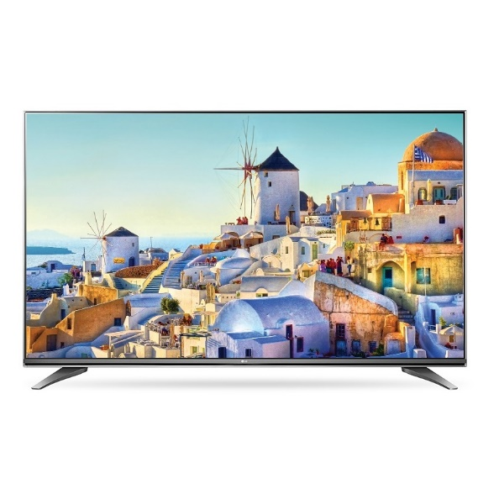

|  |  |
| --- | --- |
| **4K Ultra HD (3,840 x 2,160)** | Yes |
| **Processor** | α7 Intelligent Processor |
| **Refresh Rate** | TruMotion 240 (Refresh Rate 120Hz) |
| **Nano Cell Display** | Yes |
| **IPS Technology** | Yes |
| **4K Cinema HDR** | Yes |
| **HDR Format Support** | Dolby Vision®, Advanced HDR by Technicolor®, HDR10, HLG |
| **Nano Cell Color** | Pro |
| **Billion Rich Colors** | Yes (10-bit) |
| **True Color Accuracy** | Yes |
| **Nano Cell Black** | Yes |
| **Local Dimming** | Full Array Dimming |
| **ULTRA Luminance** | Pro |
| **4K Upscaler** | Yes |