**Samsung 65" MU7000 Smart 4K UHD TV**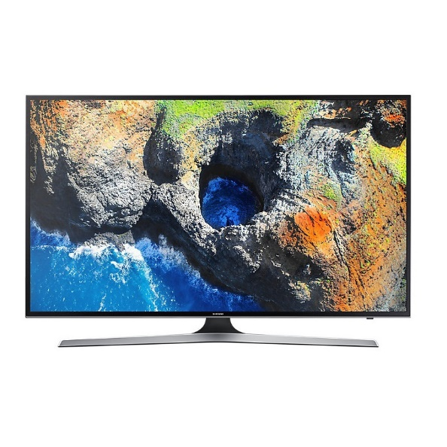

|  |  |  |
| --- | --- | --- |
|  | **Screen Size:** | 65” |
| **Aspect Ratio:** | 16:9 |
| **Resolution:** | 3840 x 2160 |
| **Picture Engine:** | UHD Up-Scaling |
| **Motion Rate** | 100 |
| **Picture Quality Index** | 1,300 |
|  | **PurColor** | Yes |
|  | **Noise Reduction** | Yes |
|  | **Audio Mode** | Standard/Music/Movie/Sports |
|  | **Contrast Enhancer** | Yes |
|  | **Auto-Volume Leveler** | Yes |
|  | **Audio Output Power** | 20W |
|  | **HDMI** | 3 |
|  | **USB** | 2 |
|  | **HDMI Quick Switch** | Yes |