**Samsung 32" HD Flat TV J4100111**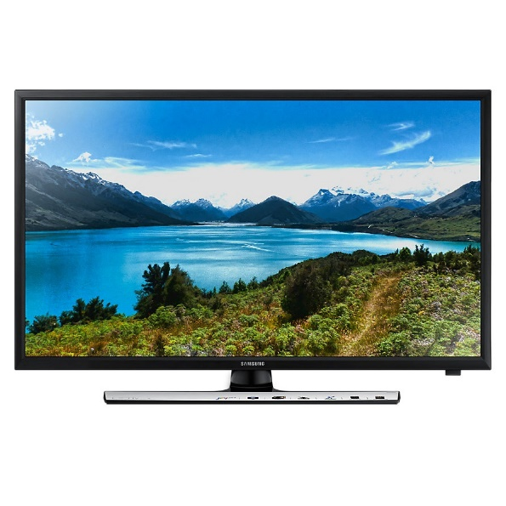

|  |  |  |
| --- | --- | --- |
|  | **Screen Size:** | 65” |
| **Aspect Ratio:** | 16:9 |
| **Resolution:** | 1366 x 768 |
| **Picture Engine:** | Hyper Real |
| **Motion Rate** | 50Hz |
| **Picture Quality Index** | Mega Contrast |
|  | **PurColor** | Yes |
|  | **Virtual Surround** | Yes |
|  | **Audio Mode** | Standard/Music/Movie/Sports |
|  | **Contrast Enhancer** | Yes |
|  | **Auto-Volume Leveler** | No |
|  | **Audio Output Power** | 20W |
|  | **HDMI** | 2 |
|  | **USB** | 2 |
|  | **HDMI Quick Switch** | Yes |