**Haier HRF-216ECS E Star Series**

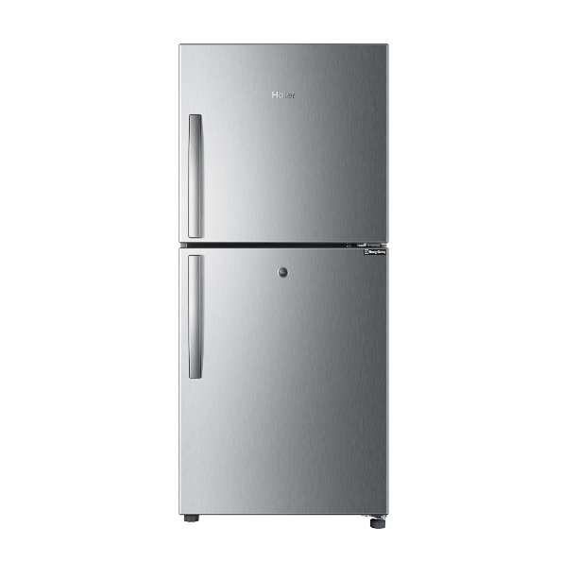

|  |  |  |  |
| --- | --- | --- | --- |
|  | **cooling system:** | Direct Cooling |  |
| **refrigerant:** | R134a |
| **total net capacity(l):** | 186 |
| **net refrigerator capacity(l):** | 109 |
| **net freezer capacity(l):** | 77 |
| **unit dimension(H*W*D)MM:** | 1240x550x540 |
| **Door hinge:** | Right |
| **Main color of product:** | VCM SS |

|  |  |  |  |
| --- | --- | --- | --- |
|  |  |  |  |
| **climate class:** | T |  | |
| **Voltage (V):** | 220V |
| **Frequency (Hz):** | 50Hz |
| **temperature of refrigerator:** | 5℃ |
| **temperature of freezer:** | -25℃ |
| **fast cooling:** | Yes |
| **Noise level(dB):** | <42dB |

|  |  |  |  |
| --- | --- | --- | --- |
|  |  |  |  |
| **type of handle:** | Exterior |
| **door lock:** | Yes |
| **water dispenser:** | No |