**Haier HRF-628AF6 Side-by-Side**

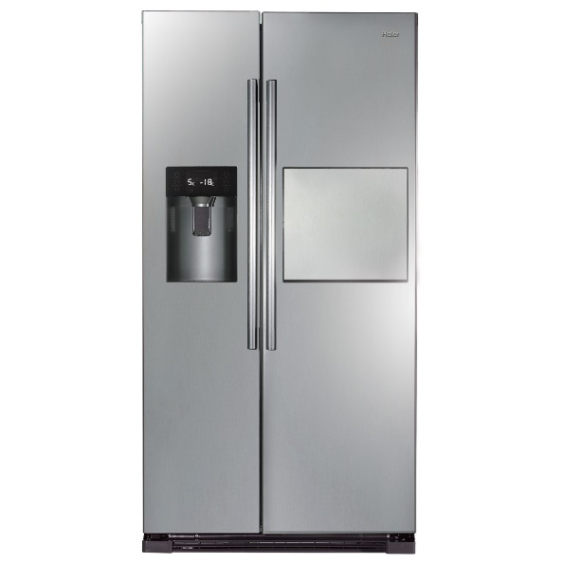

|  |  |  |  |
| --- | --- | --- | --- |
|  | **cooling system:** | No Frost |  |
| **refrigerant:** | R134a |
| **total net capacity(l):** | 540 |
| **net refrigerator capacity(l):** | 370 |
| **net freezer capacity(l):** | 170 |
| **unit dimension(H*W*D)MM:** | 1780x910x730 |
| **Door hinge:** | Side-by-Side |
| **Main color of product:** | VCM SS |

|  |  |  |  |
| --- | --- | --- | --- |
|  |  |  |  |
| **climate class:** | T |
| **Voltage (V):** | 187V~252V |
| **Frequency (Hz):** | 50 |
| **temperature of refrigerator:** | 0℃~7℃ |
| **temperature of freezer:** | ≤-18℃ |
| **fast cooling:** | Yes |
| **Noise level(dB):** | <42dB |

|  |  |  |  |
| --- | --- | --- | --- |
|  |  |  |  |
| **type of handle:** | Exterior |
| **door lock:** | No |
| **water dispenser:** | Yes |