### **LG GR-J33FWCHL 4-Door**

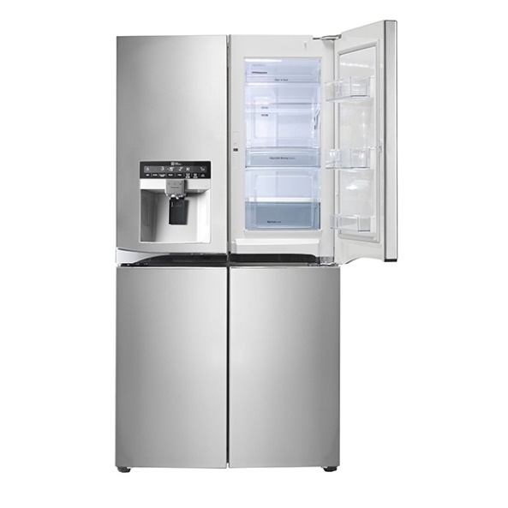

|  |  |  |  |
| --- | --- | --- | --- |
|  | **Color:** | Shiny Modern Steel |  |
| **Compressor Type:** | R134a |
| **Door-in-door:** | Yes |
| **net refrigerator capacity(l):** | 109 |
| **net freezer capacity(l):** | 77 |
| **unit dimension(H*W*D)MM:** | 1240x550x540 |
| **Door hinge:** | Right |
| **Main color of product:** | VCM SQ |

|  |  |  |  |
| --- | --- | --- | --- |
|  |  |  |  |
| **climate class:** | V |  | |
| **Voltage (V):** | 180V-250 |
| **Frequency (Hz):** | 60Hz |
| **temperature of refrigerator:** | 1℃ |
| **temperature of freezer:** | -30℃ |
| **fast cooling:** | Yes |
| **Noise level(dB):** | <42dB |

|  |  |  |  |
| --- | --- | --- | --- |
|  |  |  |  |
| **type of handle:** | Exterior |
| **door lock:** | Yes |
| **water dispenser:** | Yes |