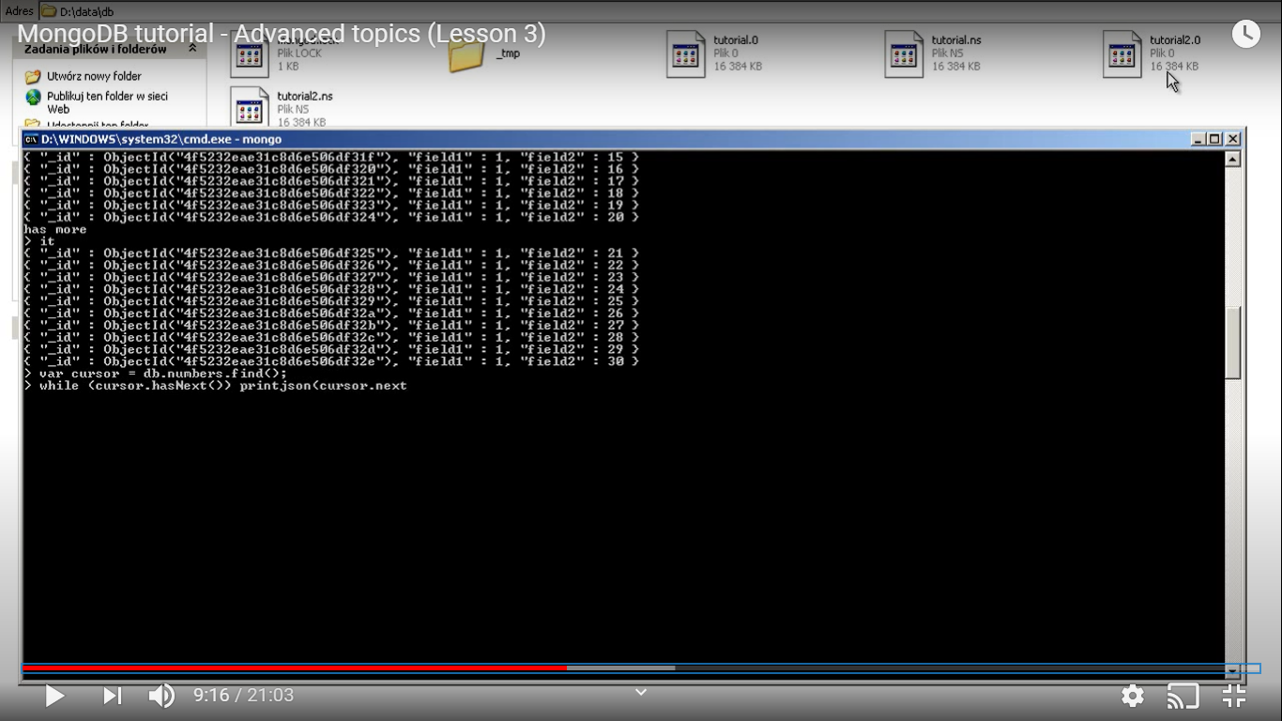
05/26/20 07:07:34 AM

source: https://www.youtube.com/watch?v=XqaehoPVBsg

while(cursor.hasNext()) printjson(cursor.next())

Ensure I know how to use thabove command

