# ACKNOWLEDGEMENT

The satisfaction that accompanies the successful completion of this project would be incomplete without mentioning the people who made it possible, without whose constant guidance and encouragement would have made efforts go in vain. I consider myself privileged to express gratitude and respect towards all those who have guided through the completion of projects.

We convey thanks to our project guide **Ms Shivani Vora**, Computer Engineering and Information Technology department, CGPIT for providing encouragement, constant support and guidance which was of a great help to complete this project work successfully.

We are grateful to **Ms Purvi Tandel**, Head of the Department, Computer Engineering and Information Technology, CGPIT for giving us the support and encouragement that was necessary for the completion of this project.

We would also like to express our gratitude to **Dr Rajkumar V. Patil**, Director, Chhotubhai Gopalbhai Patel Institute of Technology for providing us a congenial environment to work in.

We would like to thank all the faculty members for their patience, understanding and guidance that gave us strength and will power to work through the long tedious hours for developing a project and preparing the report.

Last but not least, We would also like to thank our colleagues, friends, who have co-operated during the preparation of our report and without them, this project has not been possible. Their ideas helped me a lot to improve our project report.

**Hiren Ramani(201503100810066)**

**Sanket Diyora(201503100810074)**

**Gaurav Koradiya(201503100810009)**

**Kartik Bhalala(201503100810072)**

# ABSTRACT

*Nowadays Educational institutions are concerned about the regularity of student attendance. This is mainly due to students’ overall academic performance is affected by his or her attendance at the institute. Mainly there are two conventional methods of marking attendance which is calling out the roll call or by taking student sign on paper. They both were more time consuming and difficult. Hence, there is a requirement of computer-based student attendance management system which will assist the faculty for maintaining attendance record automatically.*

*In this project, we have implemented the automated attendance system using Computer Vision. We have projected our ideas to implement “Automated Attendance System Based on Facial Recognition”, in which it imbibes large applications. The application includes face identification, which saves time and eliminates chances of proxy attendance because of the face authorization. Hence, this system can be implemented in a field where attendance plays an important role.*

*The system is designed using the Python platform. The proposed system uses the Local Binary Pattern Histogram (LBPH) algorithm. This algorithm compares the test image and training image and determines students who are present and absent. The attendance record is maintained in an excel sheet which is updated automatically in the system.*

**TABLE OF CONTENTS**

ACKNOWLEDGEMENT iii

ABSTRACT iv

LIST OF FIGURES vii

LIST OF TABLES viii

Chapter 1 Introduction 1

1. Background 1
2. Problem Definition 1
3. Motivation 1
4. Objective 1
5. Scope……………………………………………………………………………..2
6. Applications 2

Chapter 2 System Planning 3

1. Project Development Approach 3
2. System Modules 4
   * 1. Gathering User’s Data 4
     2. Training User’s Data 4
     3. Maintain Attenance Register……………………………………………….4
3. Functional Requirements 4
4. Non Functional Requirements 5
5. Hardware and Software Requirements 5
6. Timeline Chart 5

Chapter 3 System Design 6

1. Database Schema 6
2. Use Case Diagram 7
3. Sequence Diagram 8
4. Activity Diagram 9
5. Data Flow Diagram 10

Chapter 4 Implementation and Testing 11

1. Snapshots 12
2. Test case 14

**Chapter 5 Methodology………………………………………………………………...16**

1. LBPH Algorithm……………………………………………………………… .16

2. Accuracy Analysis 17

**Conclusion and Future Scope…………………………………………………………**22

**References** 23

# LIST OF FIGURES

Figure 2.1: Timeline Chart.......................................................................................................

Figure 3.1: Directory Structure ................................................................................................

Figure 3.: Use Case Diagram ...............................................................................................

Figure 3.3: Sequence Diagram .................................................................................................

Figure 3.4: Activity Diagram ..................................................................................................

Figure 3.5.1: Level-0 DFD Diagram……………………………………………………….. .

Figure 3.5.2: Level-1 DFD Diagram……………………………………………………….. .

Figure 4.1: Home Window.......................................................................................................

Figure 4.2: Atendance register………....................................................................................

Figure 4.3 : Preprocessing Images…………………………………………………………..

Figure 4.4: Face Tracking……………………………………………………………………

Figure 4.5 Records For Present Students…………………………………………………….

Figure 5.1 The example square represents a 3x3 pixels square……………………….…….

Figure 5.2 Accuracy Analysis……………………………………………………………….

# LIST OF TABLES

Table 3.1: Student Information Table .....................................................................................

Table 3.2: Attendance Register Table .....................................................................................

# Chapter 1 Introduction

## Background

The current method that colleges use is that the professor passes a sheet or make roll calls and mark the attendance of the students and this sheet further goes to the admin department with updates the final excel sheet. This process is quite hectic and time-consuming. Also, for professors or employees at institutes or organizations, the biometric system serves one at a time. So, we can shift to an automated attendance system which works on face recognition technique. Be it a classroom or entry gates it will mark the attendance of the students, professors, employees, etc.

## Problem Definition

Attendances of every student are being maintained by every school, college and university. Empirical evidence has shown that there is a significant correlation between students’ attendances and their academic performances. There was also a claim stated that the students who have poor attendance records will generally link to poor retention. Therefore, the faculty has to maintain a proper record for the attendance. The manual attendance record system is not efficient and requires more time to arrange a record and to calculate the average attendance of each student. Hence there is a requirement of a system that will solve the problem of student record arrangement and student average attendance calculation. One alternative to making student attendance system automatic is provided by facial recognition.

## Motivation

The main motivation for us to go for this project was the slow and inefficient traditional manual attendance system. This made us think why not make it automated fast and much efficient. Also, such face detection techniques are in use by department like crime investigation where they use CCTV footages and detect the faces from the crime scene and compare those with the criminal database to recognize them.

## Objective

The overall objective is to develop an automated class attendance management system comprising of a desktop application working in conjunction with a mobile application to perform the following tasks:

* To detect faces real time.
* To recognize the detected faces by the use of a suitable algorithm.
* To update the class attendance register after a successful match.
* To design an architecture that constitutes the various components working harmoniously.

## Scope

We are setting up to design a system comprising of two modules. The first module (face detector) is a mobile component, which is basically a camera application that captures student faces and stores them in a file using computer vision face detection algorithms and face extraction techniques. The second module is a desktop application that does face recognition of the captured images (faces) in the file, marks the students register and then stores the results in a database for future analysis.

## Applications

* Criminal Identification
* Security System
* Image and Film Processing

# Chapter 2 System Planning

## Project Development Approach

Each project needs to be developed with software model which makes the project with high quality, reliable and cost-effective so for our project we have selected Iterative model.

* The advantage of this model is that there is a working model of the system at a very early stage of development, which makes it easier to find functional or design flaws. Finding issues at an early stage of development enables to take corrective measures in a limited budget and whenever any problem occurs we can resume work at that point no need to backtrack the whole process.
* Advantages of the iterative model are some working functionality can be developed quickly and early in the life cycle and we need not go from the first if any problem occurs we can continue from that point only.so, this model is reliable too.

**Agile model:**

Agile SDLC model is a combination of iterative and incremental process models with a focus on process adaptability and customer satisfaction by rapid delivery of working software product. Agile Methods break the product into small incremental builds. These builds are provided in iterations. Each iteration typically lasts from about one to three weeks. Iteration involves cross-functional teams working simultaneously on various areas like planning, requirements analysis, design, coding, unit testing, and acceptance testing. At the end of the iteration, a working product is displayed to the customer and important stakeholders. Here is a graphical illustration of the Agile Model:

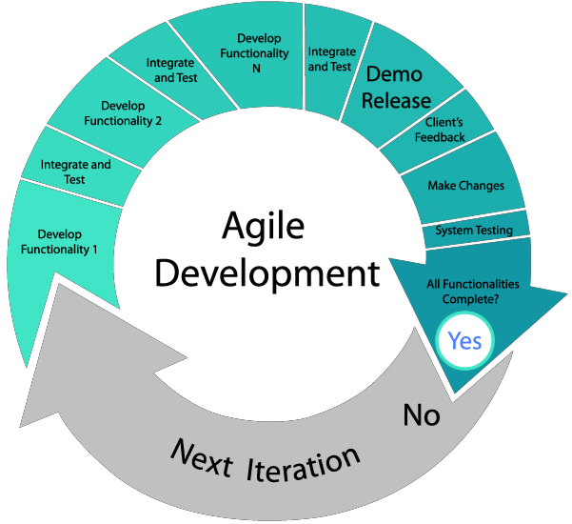

## System Modules

### Gathering user’s data

* + - * Admin will gather user’s data for building a model.
      * There are 50 photos converted in fixed size dimension per person and it arranges in the directory structure.

### Training User’s data

* + - * The Model will be trained on GPU for process a frame from the camera.
      * There is an algorithm for trained or build a classifier.
      * The weight generated by the algorithm is stored in a file for the recognition process.

### Maintain Attendance Sheet

### There is an Excel sheet which keeps the record of student’s presents.

### The system will auto-generate an Excel sheet on daily based on time.

### Attendance sheet contains information of present student like StudentID, date & time of presents in the classroom.

1. **Functional Requirements**

|  |  |
| --- | --- |
| **ID** | **Title & Description** |
|  |  |
| *FR1* | *Title: Image gathering & Preprocessing* |
|  | *Desc: This module will collect images from a live recording of the camera.* |
|  |  |
| *FR2* | *Title: Image Training & Feature extraction* |
|  | *Desc: This module will perform a face recognition algorithm to train user image with their ID’s and append their weights to files.* |
|  |  |
|  |  |
| *FR3* | *Title: Verification* |
|  | *Desc: This module will recognise the user’s face when user come in front of camera and Gives correct label.* |
|  |  |
|  |  |
| *FF4* | *Title: Maintain attendance register* |
|  | *Desc: This module will create and update class register when the user appears in to live camera during testing.* |
|  |  |
|  |  |
| *FF5* | *Title : Alert & Notification* |
|  | *Desc: This module will provide a summary of attendance and notify users.* |
|  |  |

## Non Functional Requirements

*Portability: This System is very much portable for any operating system because it uses*

*an opensource library.*

*Security: Only admin can manage this system.*

*Reliability: This system should give a good accuracy.*

*Serviceability: It should take less time to consume and save human efforts.*

## Hardware and Software Requirements

Hardware Requirement

* *High Definition Camera*
* *CPU, GPU*

Software Requirement

* *Spyder(Python IDE Tool)*

## Timeline Chart

## 

Figure 2.1: Timeline Chart

**Chapter 3 System Design**

## Database Schema

## Table 3.1: Student Information

|  |  |  |  |
| --- | --- | --- | --- |
| **Column Name** | **Data Type** | **Size** | **Description** |
| **Id** | INT | 5 | ID No. |
| **User_name** | VARCHAR | 50 | Label |

Table 3.2: Attendance Register

|  |  |  |  |
| --- | --- | --- | --- |
| **Column Name** | **Data Type** | **Size** | **Description** |
| **Id** | INT | 5 | ID No. |
| **name** | VARCHAR | 50 | Label |
| **date&time** | DATE | 50 | date & time of presents |

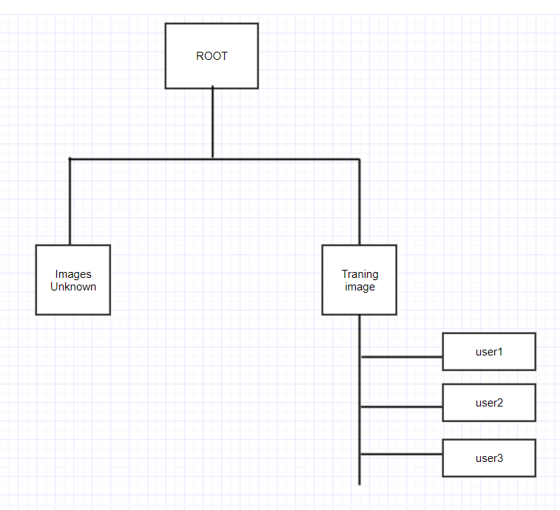

Figure 3.1 Directory Structure

## Use Case Diagram

A use case diagram at its simplest is a representation of a user’s interaction with the system that shows the relationship between the user and the different use cases in which the user is involved.

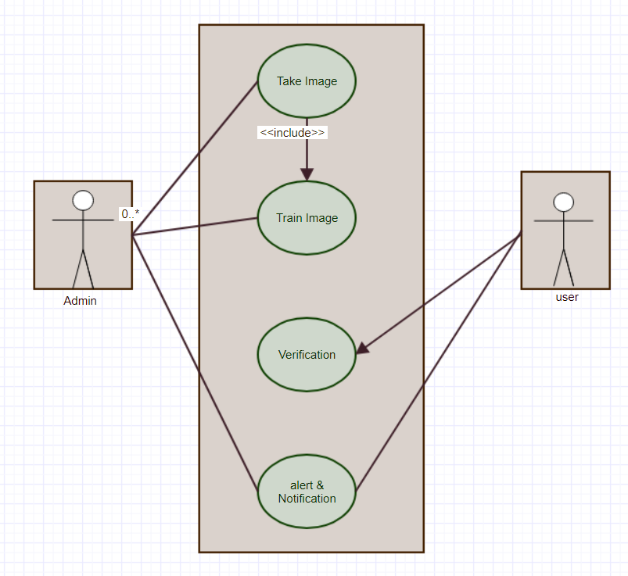

Figure 3.2: Use Case Diagram

## Sequence Diagram

A sequence diagram shows object interactions arranged in time sequence. It depicts the objects and classes involved in the scenario and the sequence of messages exchanged between the objects needed to carry out the functionality of the scenario.

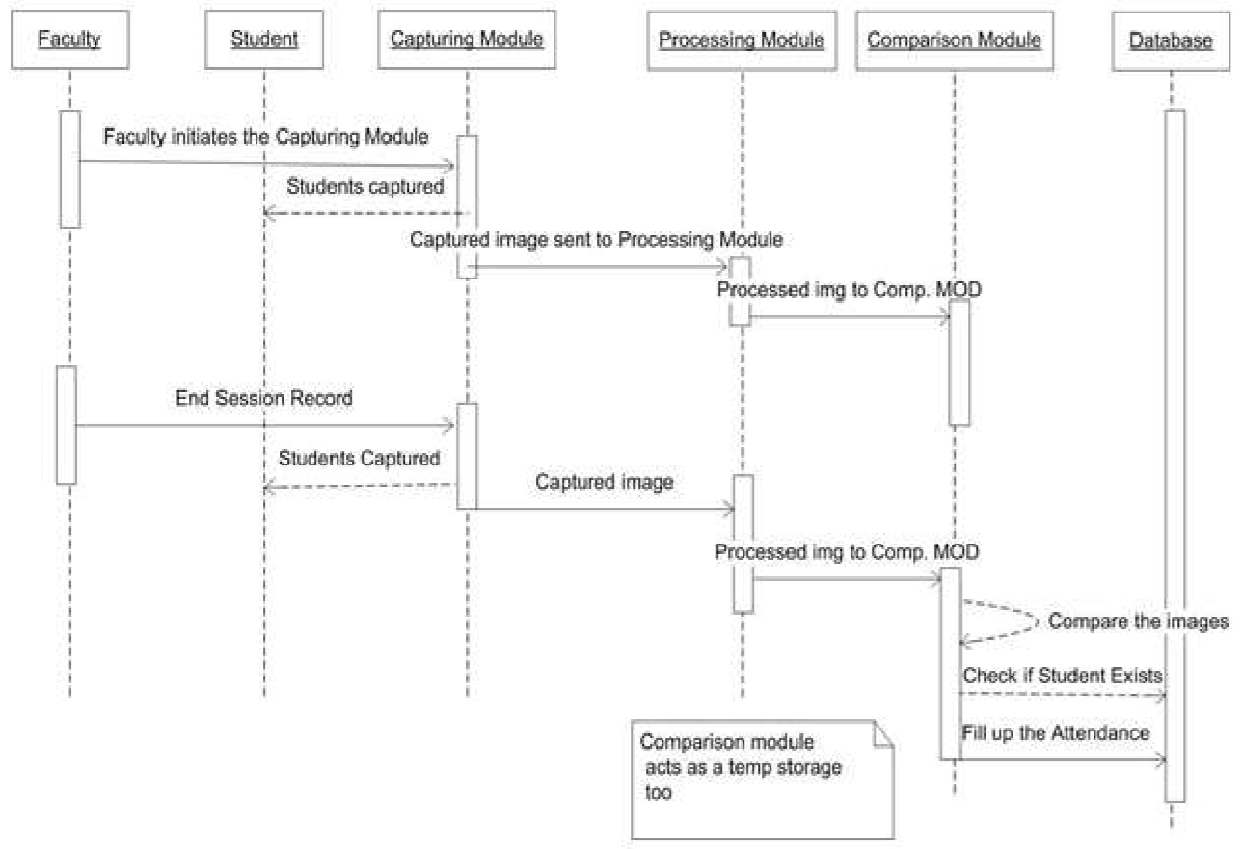

Figure 3.3: Sequence Diagram

## Activity Diagram

Activity diagrams are graphical representations of workflows of stepwise activities and actions with support for choice, iteration and concurrency.

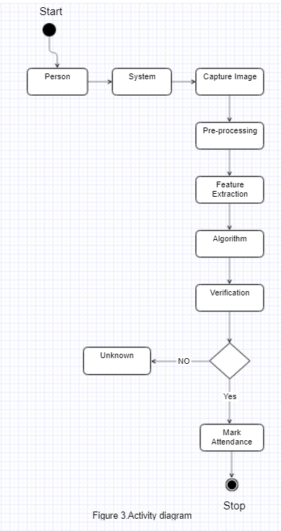

Figure 3.4: Activity Diagram

## Data Flow Diagram

A Data Flow Diagram(DFD) is a graphical representation of the "flow" of data through an information system, modelling its process aspects. A DFD is often used as a preliminary step to create an overview of the system without going into great detail, which can later be elaborated.

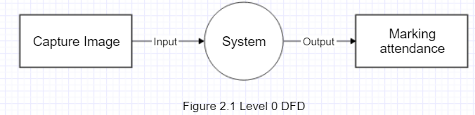

Figure 3.5.1: Level-0 DFD 1

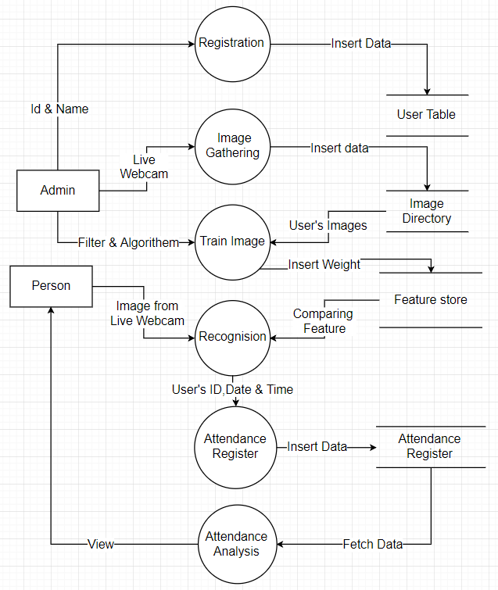

Figure 3.5.2 : Level-1 DFD

# Chapter 4 Implementation and Testing

## Snapshots

* + **Home Window**

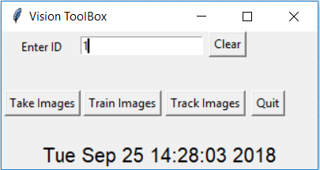

Figure 4.1 Home Window

This is a Home GUI build in Tkinter in which admin can register images of a student by entering the Id of student and press “Take Images” button. There are a “train images” button will train images taken by admin and “take images” will track image or identify the face from image camera and give a label.

* + **Attendance Register**

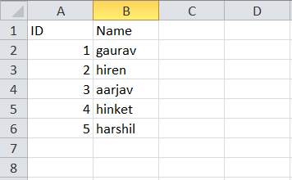

Figure 4.2 Attendance Register

Above figure represents a register for a student which is entered by admin manually with a unique ID.

* + **Pre-processed Images**

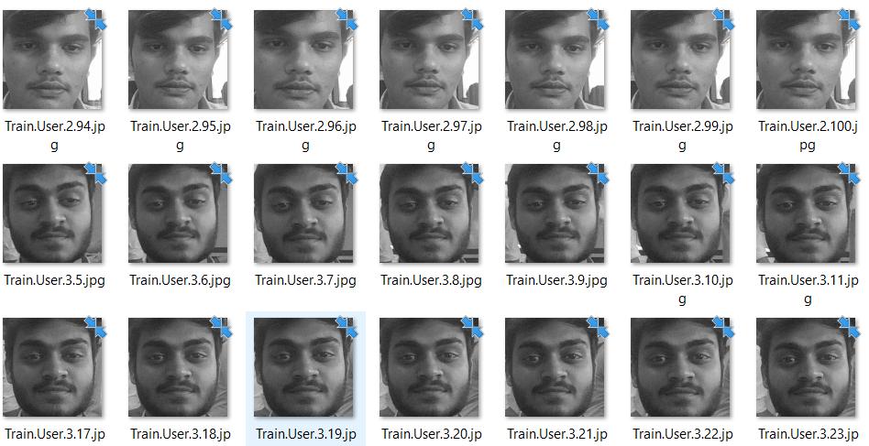

Figure 4.3 Pre-processing images

There is a directory which contains pre-processed images with following a certain format of extension in such a way that image has an ID of a student with no. of the image for that student and stored into a directory with .jpg extension used for a train model.

* + **Tracking Images**

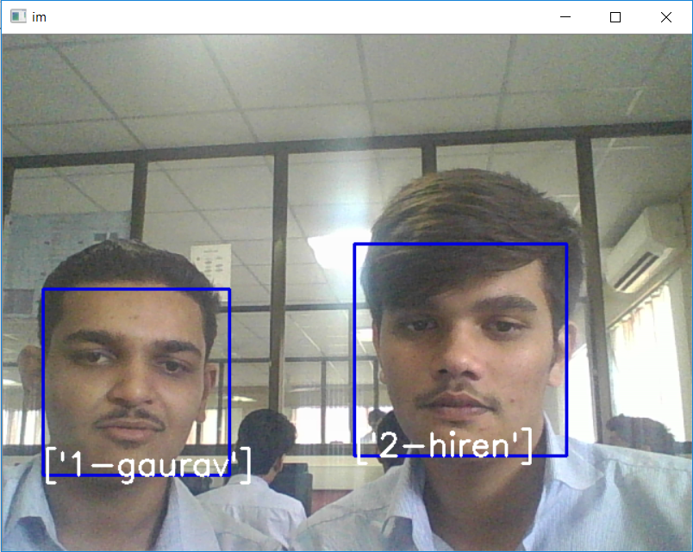

Figure 4.4 Face tracking

In this images, Identification of student can be made by a model which detect a Faces from the camera and recognized a student based on the trained model. It gives a label in such a way that student can check whether it’s recognised or not.

* + **Maintain Presents of Student**

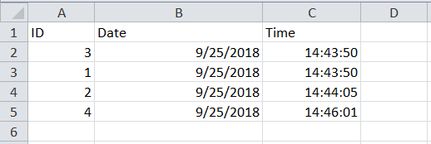

Figure 4.5 Records For Present Students

There is an excel file which is auto-generated by the system based on Current Date in which keep the record for students who are recognised by model and keep their information with ID which are recognised and date&time when they were recognised.

## Test Cases

Sample test cases are given as below:

|  |  |  |  |  |  |
| --- | --- | --- | --- | --- | --- |
| **Test ID** | **Case** | **Test Data** | **Expected Result** | **Actual**  **Result** | **Pass/Fail** |
| 1 | Capturing Image | - User’s Images | The camera will capture the image then it will store in the training folder with preprocessed image | The preprocess image store to a particular training folder with a certain extension. | Pass |
| 2 | Training Images | - Captured user’s Images | The model should train images and generate weights that will store in to file. | Model trains user’s images using proper ML algorithm and generating the weights into the file. | Pass |
| 3 | Track User | -Live capturing user’s image | the Model should detect and recognize the user’s face. | The model accurately recognizes user's face. | Pass |
| 4 | Attendance  Register | - | The model should generate an attendance register with user’s Id and Date & Time. | The model successfully keeps the attendance record. | Pass |
| 5 | Notification  System | Records of Attendance Register | A system able to notify a user about the statistics of attendance using email. | The system successfully generates statistics of attendance of the user but don’t notify via email. | Fail |

# Chapter 5 Methodology

# Local Binary Patterns Histograms (LBPH)

# This algorithm also requires grayscale pictures for processing the training. In contrast to the previous algorithms, this one is not a holistic approach. The aim of LBPH (Ahonen, Hadid, & Pietik, 2004) (Mäenpää, Pietikäinen, & Ojala, 2000) (Wagner, 2011) is to work by blocks of 3x3 pixels. The pixel in the center is compared to its neighbors. Each neighbor which is smaller than the pixel in the middle, the value 0 will be added to the thresholded square (figure 6) which is in charge to store the results, otherwise, a 1 will be added. The thresholded square and weights square are not present in the picture, they are only a representation to understand the process. When all the comparisons have been completed, each result will be multiplied by a weight. Each pixel has a weight to the power of two from 2x to 2y. Each pixel in the center of a 3x3 square has 8 neighbors. These eight pixels represent one byte which explains the reason of using these weights. The weights are affected in a circular order. It does not matter which weight is affected to which pixel, however, the weight of a pixel does not change. For example, if the pixel top left has a weight of 128, it will keep this weight for all the comparisons in the picture. Then, the sum of the weights is calculated and becomes the value of the pixel in the middle of the square. Figure 6 shows the results of the comparisons and the weight which is related to each pixel.

# 

Figure 5.1 The example square represents a 3x3 pixels square.

# When this process has been completed for each part of the picture, the picture is divided into a certain number of regions. Then, a histogram is extracted from each region and all the histograms are concatenated. For recognizing a face, exactly the same process is performed, and the final histogram is compared to each final histogram in the training data. The label related to the closest histogram is the prediction of the algorithm. As for the hog detector, this algorithm is not sensitive to a variation of luminosity. LBPH has been modified in different ways (what-when-how). One of them is called Extended LBPH. This extension is using a circular neighborhood which is composed of a radius and a number of sampling points. This approach allows a pixel to have more than eight neighbors. Depending on the radius (figure 7), the pixel in the middle could be compared to some pixels which are not next to it. Another extension is called uniform pattern (what-when-how). This extension takes into consideration the number of transition in the result byte. One transition is represented by a change in the byte from a 0 to a 1 or a1 to a 0. For example, 00000001 has one transition and, 00011000 has two transitions. It has been shown that patterns with a number of transitions from 0 to 2 are the most common (Ahonen & al., 2004). The patterns with two or fewer transitions usually have a specific signification how it can be seen in figure 7. All histograms with more than two transitions are regrouped together. This modification makes the vector representing the histograms smaller.

# Accuracy Analysis

# 

Figure 4.5 These tables represent the results obtained only for all the pictures contained in the tests with 5 subjects where the pictures were taken in the same environment. All these images are also present in the tests with more subjects.

# Conclusion and Future Scope

It can be concluded from that a reliable, secure, fast and an efficient system has been developed replacing a manual and unreliable system. This system can be implemented for better results regarding the management of attendance and leaves. The system will save time, reduce the amount of work the administration has to do and will replace the stationery material with electronic apparatus and reduces the amount of human resource required for the purpose.The advantage of this system is that provide digital solution for attendance process automatically and save in storage for Future use. It can be extended to video surveillance to detect frauds at crowded areas such as bus stands, theatres, railway stations where in by face recognition techniques, the identity of the culprits can be found. The limitation of project is to require an physical equipment and processing power for better output.

**Future work** could also include adding several well-structured attendance registers for each class and the capability to generate monthly attendance reports and automatically email them

to appropriate student or staff and give alert and analysis of attendance by visualization.

# References

### Web reference

1. [www.opencv.org/face-recognition/](http://www.opencv.org/face-recognition/)
2. [www.tensorflow.com/face-recognition/](http://www.tensorflow.com/face-recognition/)

**Research Paper Reference**

1. V. Shehu and A. Dika, “Using Real-Time Computer Algorithms in Automatic Attendance Management Systems.” IEEE, pp. 397 – 402, Jun. 2010.
2. FaceNet: A Unified Embedding for Face Recognition and Clustering. Florian Schroff, Dmitry Kalenichenko, James Philbin. s.l. : IEEE Xplore, 2015. pp. 815-823.

**Image Reference**

1. https:// medium.com/max/1600/1*J16_DKuSrnAH3WDdqwKeNA.png
2. https://www.researchgate.net/profile/Madeena_Sultana/publication/285582143/figure/

ig10/AS:302487312584713@1449130003574/Recognition-rate-of-Eigenface-fisherface-LBP-and-the-proposed-method-on-FERET.png