<< The layout and format of the guide is subject to change; the text will remain the same>>

Welcome to the PAPrKA Study

<<Content table>>

In the PAPrKA study we hope to learn more about people’s recovery and improvement after knee replacement so that in the future patients and doctors can make better informed decisions about knee replacement surgery. Thank you for helping us do this.

<<Tutorial PAPrKA Study Guide video based on this document, hyperlink underlined text>>

Quick take: how to join and take part the study
How to join and take part in the study is described in the box below.

Getting Started
1. Click the Join Study button – check if you can take part
2. Participant Information Sheet – find out how you will be involved
3. Consent - sign a consent form
4. Registration - Create a study account
Taking Part
1. Log in – with your study account email and password
2. Complete task 1 - tell us about your knee replacement
3. Complete task 2 – tell us about you
4. Complete task 3 - connect your device
5. Complete task 4 (optional) - tell us what you think about taking part
6. Finish – click to finish

Welcome to PAPrKA website
Arrive on PAPrKA website home page. From the homepage you can go to the ‘about’ page and ‘FAQs’ page by clicking on the tabs on the top right on the website.

- Home Page
- Go to the PAPrKA website: https://dev.radarbasedev.co.uk/kratos-ui/paprka
  - On the homepage you can read about the study, who can take part, and what you can expect if you decide to take part. There is also information about the study team.

- Cookies
  - Our website uses cookies to help us understand how people use the site e.g. what pages they might click on and how they move from one page to another. This can help us work out if the site is easy to follow and if not, how we might improve it. You can help us do this by selecting ‘Accept All’.
  - If you choose ‘essential cookies’ to ‘reject all’ cookies you can still take part. The PAPrKA team will not learn about your experience using the website
- Participant Information Sheet
  - Near the bottom of the Home page, you’ll find the link for Participant Information Sheet – This explains why we are doing the research, your rights and the information we will collect about you.
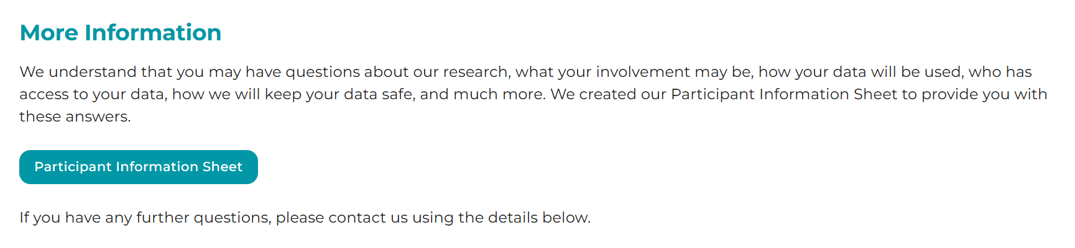
- About page
  - Click on the About page in the top menu.
  - This section explains who’s behind the PAPrKA study and what it’s all about. The research team at the University of Manchester is working with people who’ve had knee surgery to understand recovery using data from fitness trackers. The aim is to learn what real-life recovery looks like and how we can support it better.
- FAQs
  - Click on the FAQs page in the top menu.
  - This section answers common questions, like:
    - What do I need?
    - Can I leave the study?
    - What about my data?
    - How long will my data be kept?
  - Still have questions? Our contact details are at the bottom of the homepage.



Guidance on how to join and take part in the study

1. Click “Join Study”
If you’re ready to take part, please click the Join Study button. This will take you to the who can take part check.
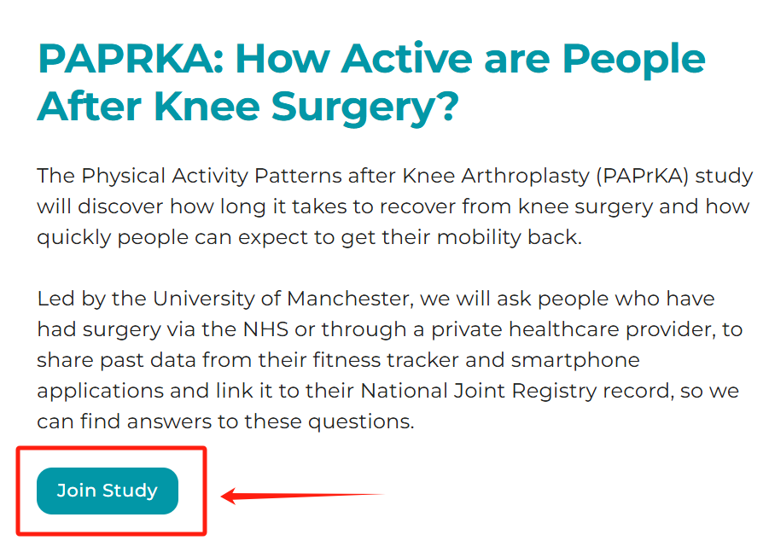

2. Checking if you can join
- Answer the questions
The website will ask 4 questions, one at a time: <screenshot>
    - Have you had knee replacement (total, or partial), either through the NHS or a private healthcare provider, between 1st January 2017 and 31st December 2023?
    - Were you over 18 years of age at the time of your knee replacement?
    - Did you use a Fitbit, iPhone, Apple Watch, Garmin or Oura Ring to track your activity six months or more before your knee replacement? Click Yes, if you use an iPhone, it automatically collects physical activity data.
    - Did you use a Fitbit, iPhone, Apple Watch, Garmin or Oura Ring to track your activity one year or more after your knee replacement? Click Yes, if you use an iPhone, it automatically collects physical activity data.

- Continue if you answered ‘Yes’ to all 4 questions
  - You must select Yes to each question to continue.
  - If you answer “No” to any of the questions, you will not be able to take part.
- Click “Next”
  - If you answer “Yes,” to all the questions click Next to see the Participant Information Sheet.

3. Study Information page: Please read the Participant Information Sheet
- Participant Information Sheet (PIS)
  - To find out about this research and your role in it, please read the Participant Information Sheet (PIS) thoroughly. If you have any questions, please feel free to contact the PAPrKA team at paprka@manchester.ac.uk or via [Teams Account].
  - If you would like to join the study, please click Next to sign the consent form
<screenshot>

4. Consent Page: understanding and agreeing to the study
- Things you must agree to
  - You will see a set of statements about what you are being asked to agree to when you take part in the study.
  - You must select “Yes” for all these statements to join.
<screenshot>
- Things you can choose
  - You will see another set of statements that you can chose Yes or No to
and still take part
<screenshot>
- Adding an electronic signature
  - Scroll to the bottom where you see “Click to sign.”
    - First, you will need to type your name where you see ‘First name’ and ‘Last name’.
    - Next, use your mouse, finger, or trackpad to draw your e-signature in the signature box. Or if you prefer you can type in your name, and press save.
  - Click Next to finish.
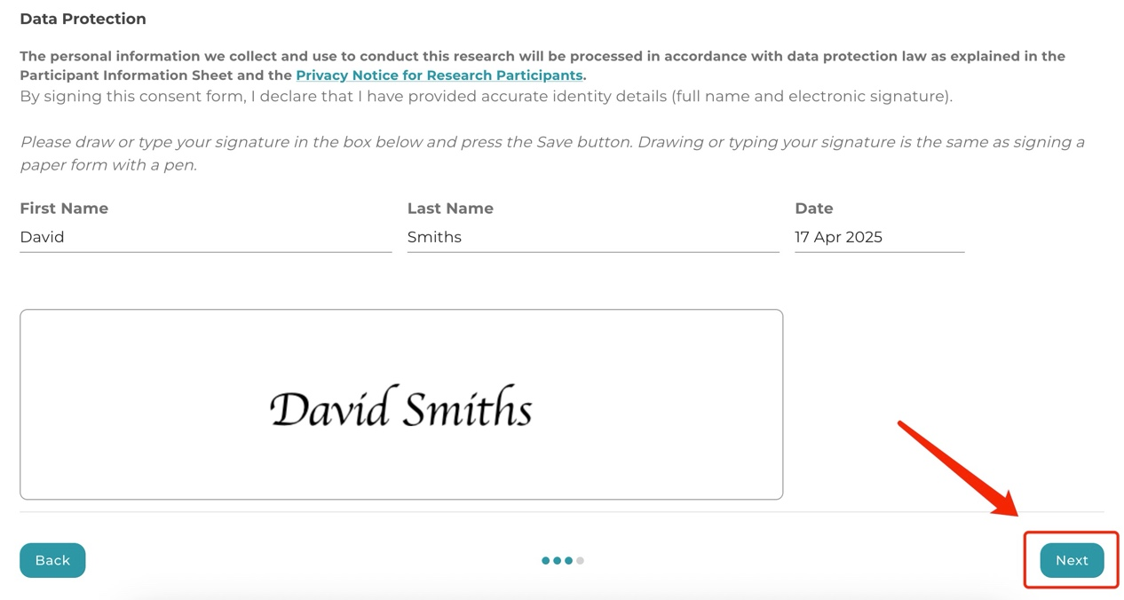

5. Create your account:
Set up your study account by providing an email address and creating a password. You will get an email asking you to verify your account.

A. Enter your email and password
  - Email: Please use a valid, active email address.
  - Password: You need to Choose a password that has at least 12 characters.
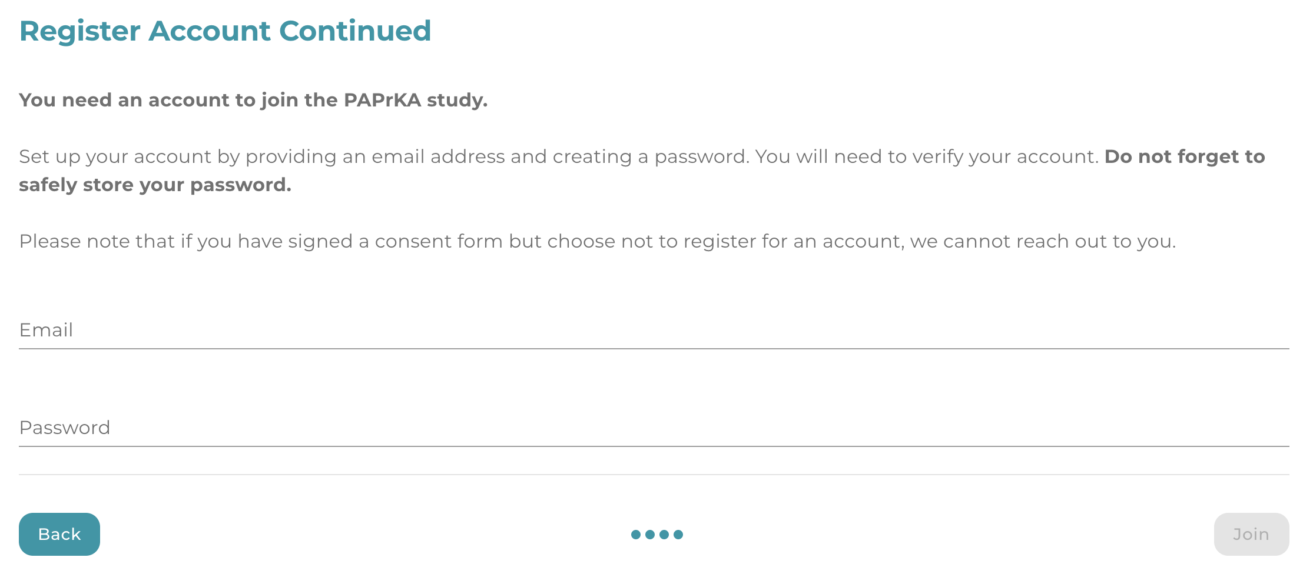

B. Click “Join”
  - To continue to the next step: verifying your account.

C. Verify your account
  - You will receive an email containing a verification code. Please note the code expires after 1 hour.
  - Type or paste the code into the field provided on the website.
  - Click “Submit”
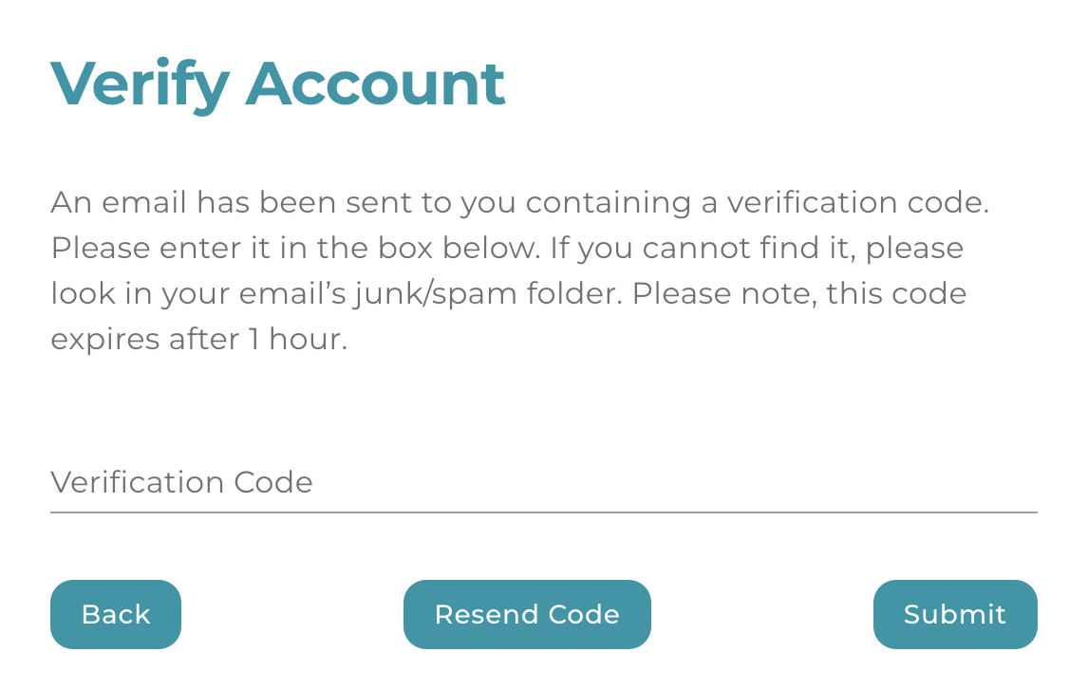

D. If the verification code times out
- Go back to the ‘verify account’ page and click ‘Resend code’.

E. Resetting your password
  - If you need to reset your password, go to the homepage and click the Sign In button in the top-right corner.
<screenshot>
  - On the sign-in page, select “Forgot Your Password?”, then enter the email address you used to create your account. Click Submit, and you’ll receive an email with a reset link to set a new password.
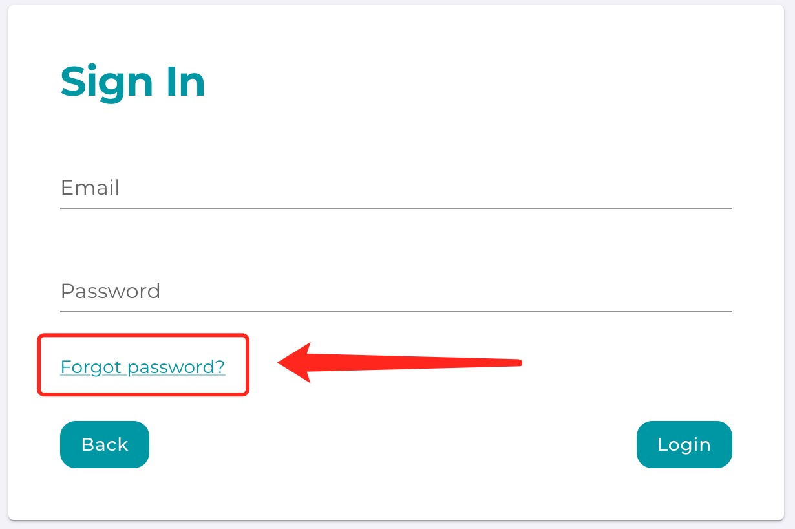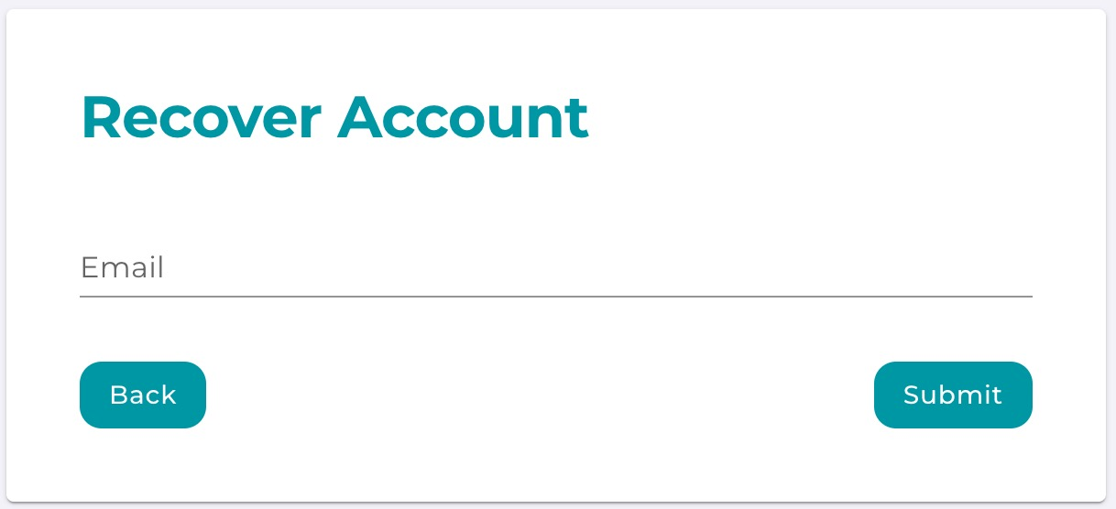
Tip: Your account lets you pause and return later. If you need a break, simply log out and come back whenever you want.

6. Using the Portal
Top tips for completing the study tasks given in the table below
Task 1 | - You will be asked the month and year of your knee replacement surgery
Task 2 | - You will be asked your NHS number  - You can find your NHS number here: https://www.nhs.uk/nhs-services/online-services/find-nhs-number/ or sign into your NHS App or check any letter from your GP.
Task 3 (for Fitbit, Garmin or Oura Ring users) | - You will need your login details for your Fitbit or Garmin or Oura Ring.
Task 3 (for iPhone or Apple watch users) | - To login into the study app you will need to type:  - PAPrKA [study name]  - Email address [you used for your PAPrKA study account]  - Password [you used for your PAPrKA study account]  You may want to write this information down.  To share your iPhone or Apple Watch data we recommend you are connected to WIFI
Task 4 | - You will be asked to tell us your thought on how easy or difficult it was to join the study

Each task has a “ToDo” label if it’s not done yet, and “Done” once you complete it. A counter at the top (such as, 0/3) tracks your progress on the tasks you need to do.
When you have completed the task, click the "Finished" button on the top right.
Once you click the finish button you will not be able to change your responses, but you will be able to see them.
<screenshot>

Task 1: ABOUT MY KNEE REPLACEMENT
- Open the ‘About My Knee Replacement’ card
  - Click the “Todo” button under Task 1.
<screenshot>
- Provide knee replacement details
  - Surgery date: Use the calendar to select your most recent surgery date for month and year only.
  - What knee Choose left or right knee
  - Satisfaction level: Choose your satisfaction rating (for example, Very Satisfied, Somewhat Satisfied).
<screenshot>

  - Second knee surgery: If you’ve had more than one knee replacement, please select ‘Yes’ and provide the details of your second surgery—this includes the date, and which knee was operated on.
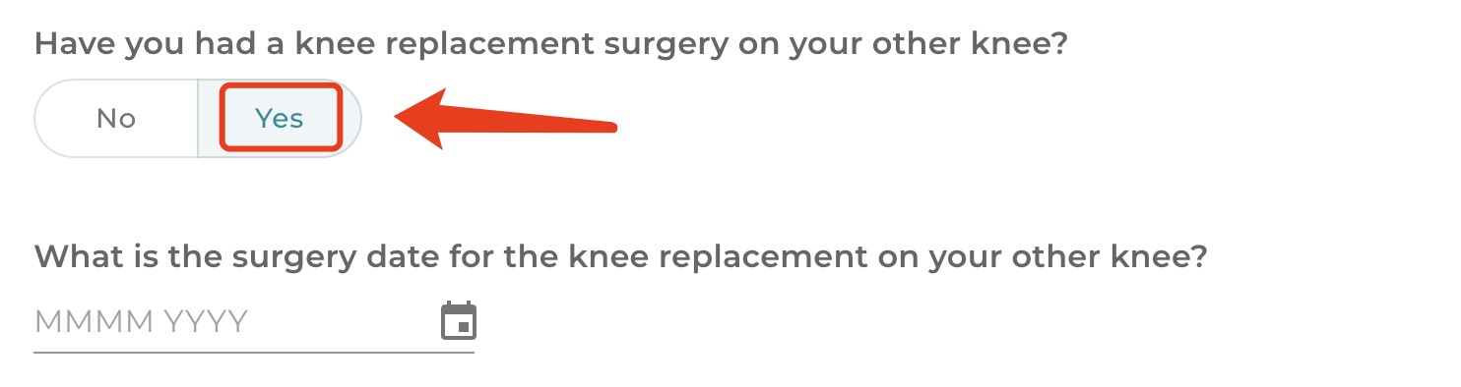
  - Education level: Select from the list (for example, no formal qualifications, GCSEs, degree).
  - Work status: Indicate whether you are employed, retired, or out of work.
<screenshot>
- Click “Submit”
  - This saves your surgery information and changes this task to “Done.”

Task 2: ABOUT YOU
- Open the ‘About You’ Card
  - Click “Todo” under Task 2.
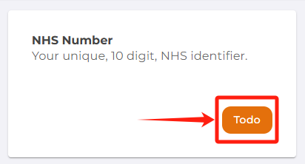
- Enter your information:
- We ask for this information to help us find your record in the National Joint Registry.
- Date of Birth
- Sex (Male or Female or prefer not to say)
- Postcode

- Enter your 10-Digit NHS number
  - If you don’t know it, the page provides tips (e.g., the NHS website, your GP surgery, NHS app, or documents).
<screenshot>

- Click “Submit”
  - Once submitted, the task becomes “Done.”

Task 3: CONNECT MY DEVICES
- Open the ‘Connect My Devices’ card
  - Click “ToDo” under Task 3.
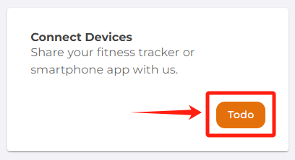
- Choose a device
  - Options might include Fitbit, Apple Health, Garmin, or Oura.
  - Select your device and click ‘Connect’.
<screenshot>

- Follow the instructions on the specific device pages.
  - PAPrKA study Fitbit guide <<hyper link on the underlined text>>
  - PAPrKA study Garmin guide<<hyper link on the underlined text>>
  - PAPrKA study Oura guide<<hyper link on the underlined text>>
  - PAPrKA study iPhone and Apple Watch guide<<hyper link on the underlined text>>

Task 4 (Optional): Feedback
- Open the ‘Feedback’ card ()
  - Click “Todo” under “Feedback,” if you want to share your thoughts.
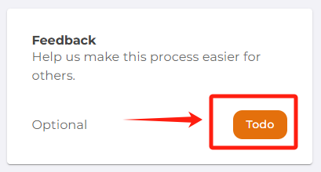
- Answer a few questions
  - How easy was the data collection process? (choose from a dropdown)
  - Where did you hear about this study? (another dropdown)
  - Provide any extra comments or suggestions in the text box.
<screenshot>
- Click “Submit”
  - This step is completely optional, but it will help us to improve the experience of people taking part in research.

6. Finishing up
- Check your progress
  - Each completed required task will say “Done” instead of “ToDo.”
  - The counter (for example, 3/3) tells you how many essential tasks you’ve finished.
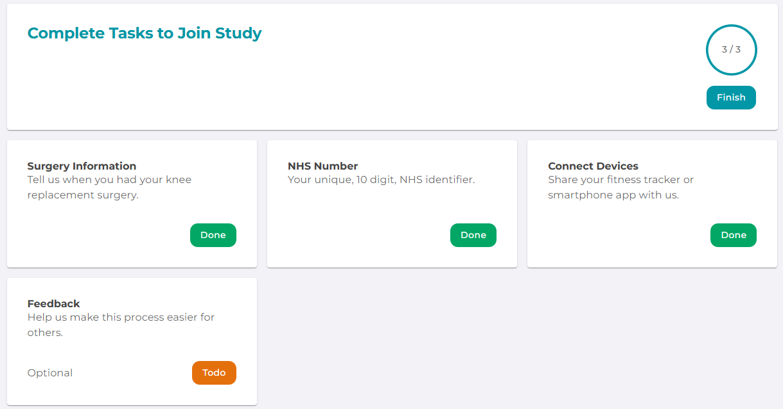
- Click “Finish”
  - Once you have all three required tasks marked as Done, a Finish button becomes active.
  - Click it to finish taking part

- Completing the study
  - You will see a message confirming you have successfully joined the PAPrKA study.
  - You can still go back and leave-optional Feedback if you haven’t already. Otherwise, you’re all set!
<screenshot>

7. Need help? We're here for you
If you have any issues during the process, please email the PAPrKA study team: PAPrKA@manchester.ac.uk for assistance. We’re here to help you troubleshoot and get back on track as quickly as possible.

8. Want to know more about how we manage your data
Find out more about how we handle your data in the University of Manchester Privacy Policy <hyperlink underlined text> and FAQs <hyperlink underlined text> and Participant Information Sheet<hyperlink underlined text>.

