<< The layout and format of the guide is subject to change; the text will remain the same>>

PAPrKA Study Fitbit Guide

<<content table>>

Welcome
Welcome to the PAPrKA study Fitbit guide. This guide provides step-by-step guidance on how to share your Fitbit physical activity information with the PAPrKA study team.

Quick take: how to share your Fitbit data
Step 1: Go to Fitbit's website by clicking ‘Link Fitbit’.
Step 2: Login to your Fitbit account.
Step 3: Select the data you want to share, and click ‘Allow’ to share them
Step 4: Add another device or finish.

Connect your Fitbit: what you will see when you click into it
The page details each step, providing images of what you will see as you go through steps 1-4.
<<Screenshot of Fitbit front page>>

Let us take you through the four steps

Step 1: Go to Fitbit’s website by clicking the "Link Fitbit" button

      - This will redirect you away from the PAPrKA website to Fitbit's website.
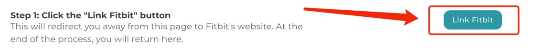

Step 2: Log in to your Fitbit account

      - If you are not already logged in to your Fitbit account, you will be redirected to a sign in page. Please log in with your Fitbit account details: your Fitbit account’s username and password.

Step 3: Select the data you want to share and click “Allow” to share them.

      - Once you have logged in to your account you will see a screen called Fitbit. Tick all 3 boxes, and then click “Allow” at the bottom to share your physical activity information with the study team. This includes:
        - Profile [needed to find out how physical activity is measured by your device]
        - Activities and Exercise [includes physical activity measures such as distance travelled, step count, time doing activities]
        - Heart Rate [needed because it indicates how intense the activities were performed]
<<Screenshot of Fitbit data list>>

Step 4: Add another device or Finish
You will receive a ‘thank you’ message once you have completed all three steps. The message will ask you if you want to ‘link another device’, or if you are ‘done’.

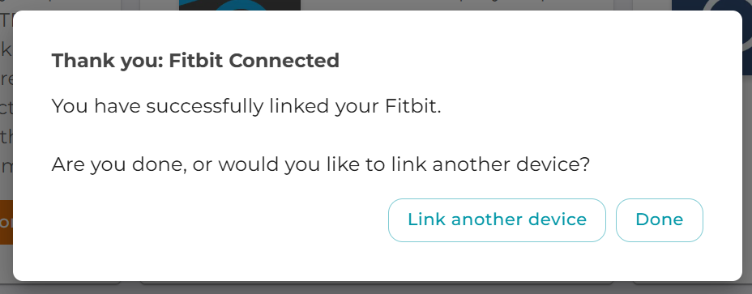

If you want to share data from another device, click the “link another device” button, this will take you to the Connect Device page. From there you can chose which other device you want to share ‘iPhone or Apple Watch’, ‘Garmin’ or ‘Oura Ring’. Please remember you need to have used that device to track your activities within the study’s time-period of the 1st July 2016 - 31st December 2024.
<<Screenshot connect device page>>

If you do not want to share data from another device, click the “Done” button. You will be taken to the Portal page where you can complete any outstanding tasks.
<<Screenshot portal page>>

PAPrKA study guides
- PAPrKA study iPhone and Apple watch guide <<hyper link on the underlined text>>
- PAPrKA study Garmin guide<<hyper link on the underlined text>>
- PAPrKA study Oura guide<<hyper link on the underlined text>>

Thank you for taking part in the PAPrKA study

Troubleshooting
If you are having trouble sharing your Fitbit data, try the following solutions:
- I can’t access the Fitbit website
  - Make sure you have a stable internet connection
  - Try using a different browser (e.g. Chrome, Safari, Firefox)
  - Disable any browser extensions that may block pop-ups or redirects
- I can’t log in to my Fitbit account
  - Double-check your email and password
  - If you’ve forgotten your login details, use the "Forgot Password?" option on the Fitbit login page
- I don’t see the screen to allow data sharing
  - Make sure you’ve followed the link from the PAPrKA study portal
  - If the page doesn’t load correctly, try refreshing or restarting your browser

Still having issues? Please contact the PAPrKA study team at paprka@manchester.ac.uk and we’ll be happy to help.

