<< The layout and format of the guide is subject to change; the text will remain the same>>

PAPrKA Study Garmin Guide
<<content table>>

Welcome
Welcome to the PAPrKA study Garmin guide. This guide provides step-by-step guidance on how to share your Garmin physical activity information with the PAPrKA study team.

Quick take: how to share your Garmin data
Step 1: Go to Garmin’s website by clicking ‘Link Garmin’.
Step 2: Login to your Garmin account.
Step 3: Select the data you want to share and click “Save” to share them.
Step 4: Add another device or finish.

Connect your Garmin: what you will see when you click into it
The page details each step, providing imagines of what you will see as you go through steps 1-4.
<<Screenshot front page>>

Let us take you through the four steps

Step 1: Go to Garmin’s website by clicking the "Link Garmin" button.
  - This will redirect you away from the PAPrKA website to Garmin's website.
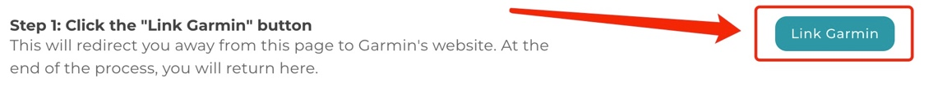

Step 2: Log in
  - If you are not already logged in to your Garmin account, you will be redirected to a sign in page. Please log in with your Garmin account details: your Garmin account’s username and password.

Step 3: Select the data you want to share and click “Save” to share them.
  - Once you have logged in to your account you will see a screen called “Control the information you share”. Tick both boxes (Activities and Daily Health Stats), and then click “Save” at the bottom to share your physical activity information with the study. This includes:
- Activities [includes physical activity measures such as distance travelled, moving duration, speed, time doing activities]
- Daily Health Stats [includes physical activity measures such as step count, intensity minutes and heart rate (indicator of how hard an activity is performed)]
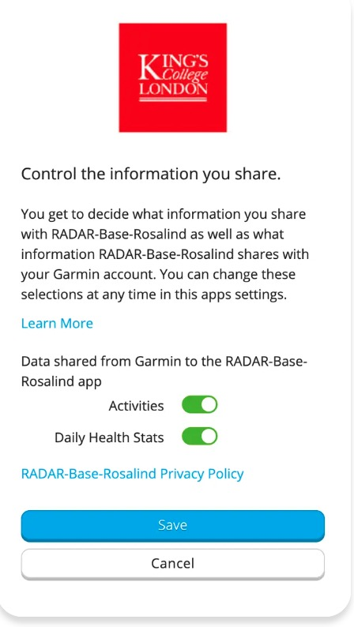

Step 4: Add another device or Finish
You will receive a ‘thank you’ message once you have completed all three steps. The message will ask you if you want to ‘link another device’, or if you are ‘done’.

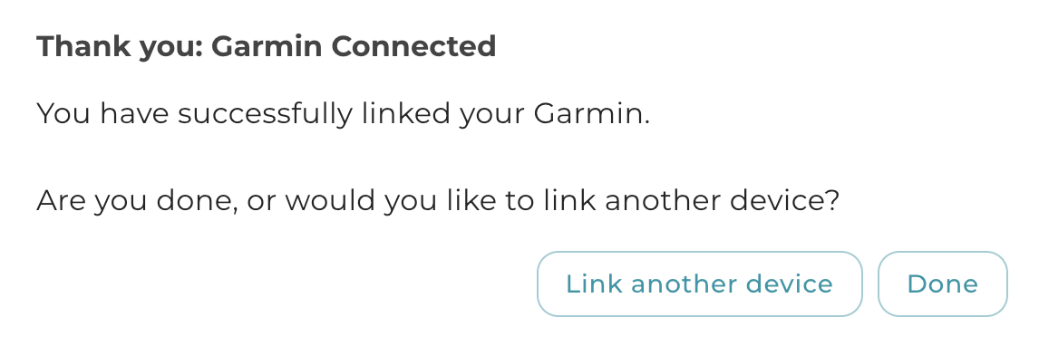

If you want to share data from another device, click the “link another device” button, this will take you to the Connect Device page. From there you can chose which other device you want to share ‘iPhone or Apple Watch’, ‘Fitbit’ or ‘Oura Ring’. Please remember you need to have used that device to track your activities within the study’s time-period of the 1st July 2016 - 31st December 2024.
<<Screenshot connect device page>>

If you do not want to share data from another device, click the “Done” button. You will be taken to the Portal page where you can complete any outstanding tasks.

<<Screenshot portal page>>
PAPrKA study guides
- PAPrKA study iPhone and Apple watch guide <<hyper link on the underlined text>>
- PAPrKA study Fitbit guide<<hyper link on the underlined text>>
- PAPrKA study Oura guide<<hyper link on the underlined text>>
Thank you for taking part in the PAPrKA study

Troubleshooting
If you are having trouble sharing your Garmin data, try the following solutions:
- I can’t access the Garmin website
  - Make sure you have a stable internet connection
  - Try using a different browser (e.g. Chrome, Safari, Firefox)
  - Disable any browser extensions that may block pop-ups or redirects
- I can’t log in to my Garmin account
  - Double-check your email and password
  - If you’ve forgotten your login details, use the "Forgot Password?" option on the Garmin login page
- I don’t see the screen to allow data sharing
  - Make sure you’ve followed the link from the PAPrKA study portal
  - If the page doesn’t load correctly, try refreshing or restarting your browser

Still having issues? Please contact the PAPrKA study team at paprka@manchester.ac.uk and we’ll be happy to help.

